Staff and Managers’ Experience of Working to Support People with Disabilities in Congregated Settings and in the Community

Easy-to-Read Summary
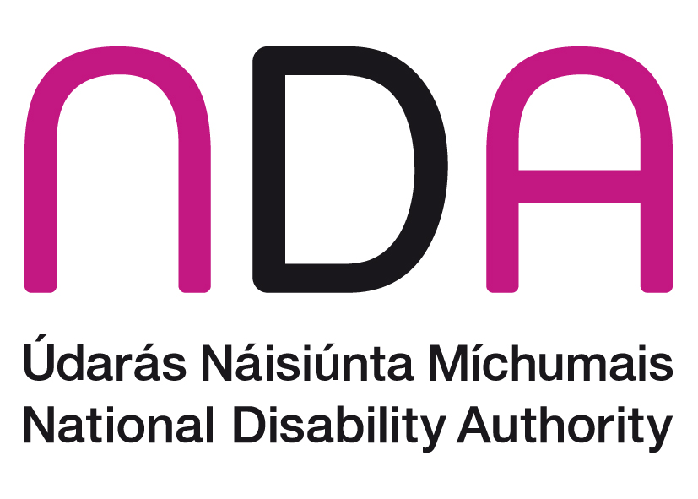

Table of Contents
Introduction 2
Theme 1: The way staff and managers work 6
Theme 2: Leadership 8
Theme 3: Getting ready for transition 8
Theme 4: Training 9
Theme 5: Communication 10
Theme 6: Staff support 13
Theme 7: Impact of the Transition 13
Conclusion 16

 | Introduction
What is this document about?
A congregated setting is a place where 10 or more people live together.
 | There is lots of research about the benefits of living in homes in the community instead of congregated settings.
 | Research means collecting new information.
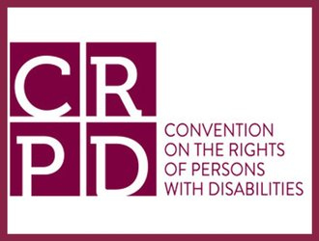 | There is a document called the United Nations Convention on the Rights of Persons with Disabilities.
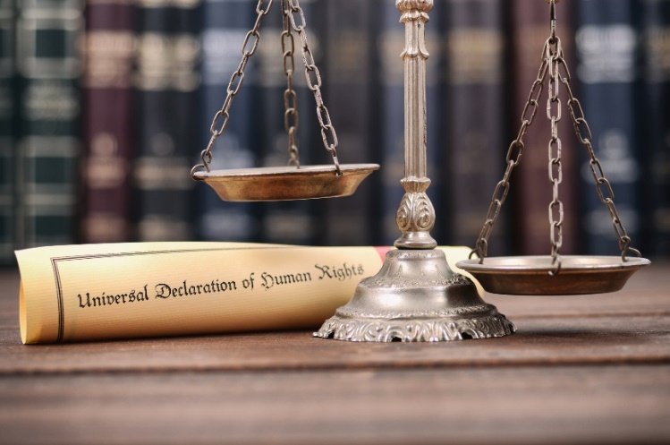 | This is called the UNCRPD for short.  The UNCRPD is a legal document about human rights for persons with disabilities.
 | The UNCRPD says it is important for people with disabilities to live in the community.
People with disabilities moved to different homes in the community.
Four people with disabilities or less live in each of these homes in the community.
 | For many years persons with disabilities have been moving out of congregated settings.
 | This document is about the experience of staff and managers during the transition.
A transition is a change.
The transition in this document is about persons with disabilities and staff moving out of congregated settings to homes in the community.
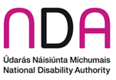 | Who wrote this document?  The National Disability Authority wrote this document.  The National Disability Authority is called the NDA for short.
 | The NDA is an organisation that gives information and advice about disability issues to the Government of Ireland.
 | The NDA did interviews with staff and managers in 4 residential disability services.
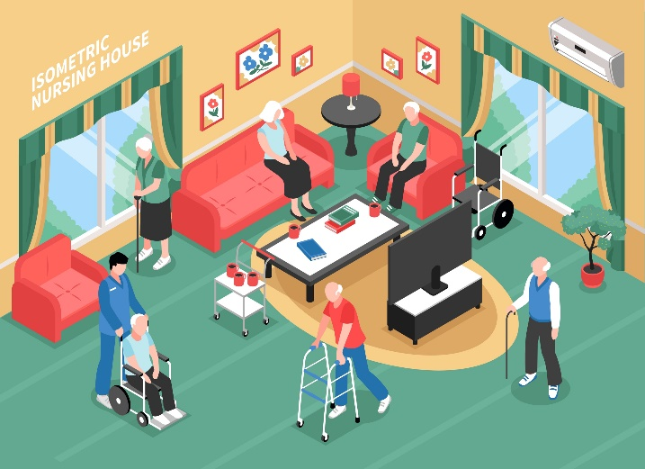 | Residential means a place where people called residents live.  In this document residents are persons with disabilities.
 | The NDA also did interviews with other people who work in the disability sector.
The NDA put all the information from the interviews together.
There are 7 main messages called themes.
 | The information can help us to understand more about the best way to transition to community homes.
 | Theme 1: The Way Staff and Managers Work
Staff and managers talked about a change in the way they work.
They talked about a change from the medical model of disability to a social model of disability.
 | The medical model of disability says that a person’s disability is the reason a person cannot fully take part in the community.
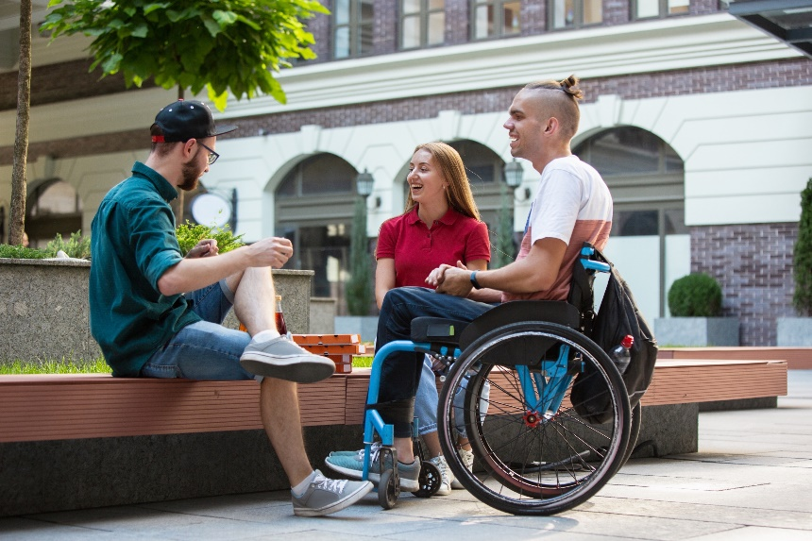 | The social model of disability talks about the barriers that make it hard for people with disabilities to fully take part in the community.
 | The social model also says that attitudes towards people with a disability can be a barrier.
The social model of disability needs services to be person-centered.
A person-centered service makes sure that services focus on each individual person.
Some staff are worried about moving to work in the community.
Some nurses are worried about other staff giving medicines to persons with disabilities.
Some staff are not happy about changes to the hours they work.
Some staff are not happy about working on smaller teams.
Some staff are not happy about working on their own.
 | The transition is easier for staff and managers who understand human rights.
 | It is very important that staff and managers support the transition to homes in the community.
 | Theme 2: Leadership
Everyone agreed that good leadership will help transitions to go well.
Some people felt that their organization was not well supported.
Some people felt like nobody in Ireland was in charge of transitions.
Some managers did not have enough staff or resources.
This made managers feel stressed and worried.
 | Many managers were strong leaders and worked hard to make good transitions happen.

Theme 3: Getting ready for transition
Some disability organisations were ready for change but some were not ready.
Some mangers found it hard to get ready for the transition because there were other big issues to work on at the same time.
These were issues like writing new policies.
Policies are plans of action.
Some managers said that it is important to think about how staff will get along when working on smaller teams.

Theme 4: Training
There was not enough training for staff and managers about the social model of disability and how to work in the community.
Staff and managers had to learn a lot on the job.
In some services new staff were employed to help prepare the residents to move to the community
Some staff felt unhappy about this.
They felt they could have helped more to plan transitions with residents
Managers agreed that it was a mistake to not let staff help more.
Staff did not get the chance to learn about transitioning from other staff who had already moved.

Theme 5: Communication
Everyone agreed that communication with staff, residents and relatives was very important.
Communicating with each resident and their family was the best way to share information.
Managers worked hard to communicate with all of the people involved in the transitions.
Some staff felt there was not enough communication.
Some staff are members of unions.
Unions make sure that staff are treated in a fair way at work.
Some managers talked to the unions about the transitions and this was positive.
Some other managers found the unions hard to work with.

 | Theme 6: Supporting staff to transition
 | Some staff believed that persons with disabilities would have better lives in homes in the community.
Some other staff did not support the transition.
They were worried about the residents and the new way staff had to work.
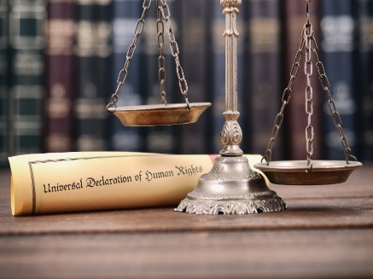 | Managers said that some staff needed education about human rights for people with disabilities.  Managers said that staff helping to plan transitions would help staff to accept change.  Managers knew they had to lead by example.  Managers sometimes had to challenge some attitudes of staff.

Theme 7: Impact of the Transition
Most staff found the transition positive.
Some staff said they could never go back to working in a congregated setting.
Most staff said managers were a good support.
There were still issues with the hours staff work.
These issues are being worked on.
Some staff are not happy that their job has changed.

Some staff are happy about the changes.
Some staff talked about sharing the jobs they have to do with colleagues

Some staff say it is hard to find opportunities for residents to take part in the community.
Managers have to make sure that homes in the community are person-centered.
All the staff and managers said that residents who moved are happier and communicating better.
Some relatives are visiting residents more since they moved to the community.
Staff said that relatives think that their family member has a better life in homes in the community.

Conclusion
The NDA will work with the HSE to make leaflets for managers about the transition of residents to homes in the community.

This study might help staff and managers in other services to avoid problems with future transitions.

More training for staff might avoid problems with future transitions.

