Experiences of Support for Return to Work among people with Acquired Disabilities or Conditions
September 2021
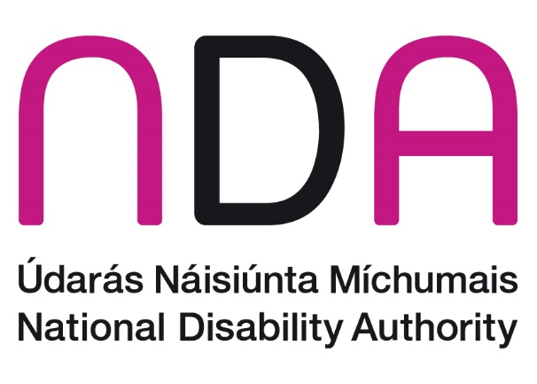

Acknowledgements
Thank you to everyone who took part in the survey and case studies that resulted in this report. We appreciate you taking the time and effort to share your experiences with us.

Table of Contents
Acknowledgements 2
Executive Summary 4
Introduction 4
Methodology 5
Key Findings 5
Conclusion 8
Introduction 9
Methodology 10
Survey 10
Case Study 10
Survey Findings 10
Description of sample 10
Employment situation after acquiring disability 11
Ease of getting information and services to support them back to work 13
Supports after acquiring a disability 14
Government actions to help in journey back to work 20
Experience of returning, or not returning, to work after acquiring disability 22
Case Studies 24
Case Study 1 – Holly’s Experience 24
Case Study 2 – Dennis’s Experience 26
Case Study 3 – Jenny’s Experience 28
Case Study 4 – John’s Experience 30
Case Study 5 – Sinead’s Experience 32
Case Study 6 – Mark’s Experience 34
Conclusion 36
Appendix A. List of specific supports that respondents said would help them in returning to work 40

Executive Summary

Introduction
The Comprehensive Employment Strategy for Persons with Disabilities 2015-2024 (CES) was developed as a whole-of-government response to challenges experienced by persons with disabilities in finding and retaining employment. Strategic priority 4 of the CES is centred on job retention and re-entry to work for individuals who acquire a disability during their working years. Vocational rehabilitation is key to supporting people who have acquired illnesses or disabilities to return to and stay in work. The Association of Occupational Therapists of Ireland (AOTI) define vocational rehabilitation as “a process that enables individuals to overcome the barriers they face when accessing, remaining or returning to work following injury, illness or impairment.” Successive Organisation for Economic Cooperation and Development (OECD) reports, and a 2015 NDA-commissioned international research study have highlighted that Ireland has, at present, a poorly developed vocational rehabilitation system.
Under the second three-year action plan of the CES the NDA committed to ‘work with relevant departments to develop policy advice for a national programme of Vocational Rehabilitation (VR) with due regard to medical/neuro models currently being implemented’. In order to help inform this policy advice, the NDA conducted a consultation with people about their experiences of support in returning to work (or not) after acquiring their disability or condition. This consultation took the form of a survey and a small number of interviews to develop case studies and this report presents the findings of the consultation. The NDA Policy Advice on Vocational Rehabilitation Provision in Ireland can be found at www.nda.ie. The policy advice paper sets out the current provision of, and gaps in, support for people returning to work after acquiring a condition or disability and proposes an overarching framework for a national programme of vocational rehabilitation.

Methodology

Survey
The survey asked people about the disability/condition they had acquired, whether they returned to or started work after acquiring their disability/condition, if they had received any of seven key supports that have been identified as common elements of vocational rehabilitation and what supports they would have liked to have received. The survey was available online for a 6 week period in March and April 2021. It was disseminated by email to relevant organisations with a request to share with potential participants, via Twitter @NDAIreland and through the NDA newsletter. One hundred and fifteen people completed the survey.

Case Studies
Respondents to the survey were asked if they would like to take part in a case study for this consultation, and if so, to email the NDA. The purpose of the case study interviews was to give respondents an opportunity to tell us about their experiences in greater depth. Fourteen people contacted the NDA, and half were randomly selected for case studies, with 6 eventually participating in June 2021 via a telephone or Zoom interview, or by sending a written account of their experience. Written summaries of these case study interviews were sent to participants to confirm their accuracy. The names used in the case studies are pseudonyms.

Key Findings

Respondents
Of the 115 people who took part in the survey, the majority of them, just over three quarters, had one disability while the rest had two or more disabilities. The most common disabilities reported by respondents were a vision impairment (31%), an acquired brain injury (27%) and a neurological condition (26%). The other disabilities and conditions reported included mental health conditions (17%), other conditions (not specified) (15%), physical disabilities (13%), and deafness or hard of hearing (6%). Almost two thirds of the sample (65%) had acquired their disability or condition five or more years previous, while the remaining 35% had acquired theirs less than 5 years ago. Over one quarter of respondents were based in Dublin (27%), 13% were in Cork and the remaining 60% were based in 20 other counties.

Returning to work after acquiring a disability or condition
A minority of respondents returned to work or started work after acquiring their disability (37%). Most of these returned to their original job, and the rest returned to a different role in the same or different organisation or became self-employed. It is significant that of those who did not return to work, over half of them said they would have liked to. Around two in every three of these respondents who would have liked to return to work would prefer part-time work, compared to about one in three who would like to return to full-time work.
Some respondents shared the challenges of working with a disability, including how difficult, stressful and worrying it can be. Some did not disclose their disability in work. Others discussed challenges in getting supports, such as having to ‘beg’ and ‘fight’ for reasonable accommodations, and having to source their own equipment and technologies for work. This is particularly concerning considering employers have an obligation to provide reasonable accommodations under the Employment Equality Acts 1998-2015. Employers also have a duty to make reasonable accommodations under European Union law and the United Nations Convention on the Rights of Persons with Disabilities. Two of our case study participants give stark descriptions of the challenges of returning to work to employers who lacked the knowledge and/or motivation to appropriately support people in this type of situation. One of them noted:
I had to fight for everything and it is so draining. Especially when that energy would be better spent recovering or feeling well.

Supports received after acquiring a disability or condition
For the most part, respondents found it challenging to find information and services to support them back to work after acquiring their disability or condition, with 47% finding it very difficult or difficult. While the majority of respondents had received at least one of the seven key vocational rehabilitation supports asked about in the survey, just over one third of them had not received any. None of these supports stood out as being commonly available, as only a minority of respondents had received each one (see Figure ES1).
Figure ES1 – Supports received by respondents after acquiring disability or condition

Support needs for return to work after acquiring a disability or condition
Of note is that many of the support needs expressed by respondents aligned with the vocational rehabilitation pathway being proposed by the NDA, including:
- Outreach, structure and coordination of services and supports for those who acquire a disability
- Specific supports to enter into and navigate employment or self-employment including for example, a phased return and flexible hours
- Access to clear and accessible advice, guidance and information on acquired disabilities and supports and services
- Support for daily living and recovery, including for example, personal assistance and therapeutic support
- Access to training
- Individualised supports relevant to the person’s needs and capabilities.
Respondents also referred to the need for supports to help overcome current barriers to working including the complexity of disability payments, transport and a lack of awareness, attitudes and knowledge of others, especially employers, about disabilities. Respondents wanted:
- Improved access to transport, including better roll out of transport schemes and transportation subsidies, including for work travel
- Clarity on and changes to the benefits and entitlements system, particularly if people want to enter into employment or education, and
- Greater awareness, representation, normalisation, acceptance and understanding of disabilities, particularly by employers.

Conclusion
The findings from this consultation support previous assertions that there is no coherent national approach to vocational rehabilitation in Ireland. On a positive note, when people did receive vocational rehabilitation supports, they overwhelmingly found them useful. People’s experiences have been shaped by a myriad of factors including the impact of their disability or condition on their lives and the information and supports, or lack thereof, which they were given after acquiring their disability. Their experiences have also been shaped by how employers and colleagues responded to their change in circumstances, if they had family to help them, and general attitudes towards people with disabilities. The case studies provide insight into the experience of working with an acquired disability or condition when the right supports are in place, but for the most part provide insight into how difficult it can be when employers are not supportive, or do not seem to know how to be supportive. Given the challenges faced by people who have acquired disabilities or conditions, and that many of them still want to work, support to help them enter into appropriate roles and to navigate employment or self-employment is critical. One of the respondents who has tried repeatedly to return to work noted:
Not working only adds to the comorbid conditions associated with my disability - depression, anxiety, fatigue - which increase your visits to the doctor/hospital (+ costs to state), more medication, less brain stimulation, increased fatigue, increased isolation and so on. It's a recipe for disaster, a vicious circle, on an individual level, societal level and at a cost level.
The findings from this consultation will be used to inform the NDA Policy Advice on Vocational Rehabilitation Provision in Ireland and in future considerations of the vocational rehabilitation system.

Introduction
The Comprehensive Employment Strategy for Persons with Disabilities 2015-2024 (CES) was developed as a whole-of-government response to challenges experienced by persons with disabilities in finding and retaining employment. Strategic priority 4 of the CES is centred on job retention and re-entry to work for individuals who acquire a disability during their working years. Vocational rehabilitation is key to supporting people who have acquired illnesses or disabilities to return to and stay in work. The Association of Occupational Therapists of Ireland (AOTI) define vocational rehabilitation as “a process that enables individuals to overcome the barriers they face when accessing, remaining or returning to work following injury, illness or impairment.” Successive Organisation for Economic Cooperation and Development (OECD) reports, and a 2015 NDA-commissioned international research study have highlighted that Ireland has, at present, a poorly developed vocational rehabilitation system.
Under the second three-year action plan of the CES the NDA committed to ‘work with relevant departments to develop policy advice for a national programme of Vocational Rehabilitation (VR) with due regard to medical/neuro models currently being implemented’. In order to help inform this policy advice, the NDA conducted a consultation with people about their experiences of support in returning to work (or not) after acquiring their disability or condition. This consultation took the form of a survey with a small number of interviews to develop case studies and this report presents the findings of the consultation. The NDA Policy Advice on Vocational Rehabilitation Provision in Ireland can be found at www.nda.ie. The policy advice paper sets out the current provision of and gaps in support for people returning to work after acquiring a condition or disability and proposes an overarching framework for a national programme of vocational rehabilitation.

Methodology

Survey
The survey was designed by the NDA and piloted with nine people with acquired disabilities/long-term health conditions. The survey was amended based on feedback from the pilot participants to improve clarity. It asked people about the disability/condition they had acquired, whether they returned to or started work after acquiring their disability/condition, whether they had received supports for doing this, and what supports they would have liked to have received. The survey was an opt-in survey available to be completed online through EU Survey for 6 weeks between March 12th and April 23rd 2021. The survey was disseminated via a number of channels, including through disability organisations with services in place to support people get back to work, unions, and social media.

Case Study
Respondents to the survey were asked if they would like to take part in a case study for this consultation, and if so, to submit their contact details to the NDA. This approach was used so as not to link people’s contact details to other personal information they had shared in the survey. Sixty-five people said they would be interested in participating in a case study, and 14 followed this up by contacting the NDA. Out of these 14, half were randomly selected for case studies, with 6 eventually participating in June 2021 via a telephone interview, a Zoom interview, or by sending a written account of their experience. Participants were sent an information sheet and consent form prior to participation. Written summaries of these case study interviews were sent to participants to confirm their accuracy. The names used in the case studies are pseudonyms.

Survey Findings

Description of sample
One hundred and fifteen respondents completed the online survey. Over one quarter of respondents were based in Dublin (n=31, 27%) and 13% were in Cork (n=15). The remaining 60% were based in 20 other counties. No one participated from counties Carlow, Cavan, Donegal or Offaly. The majority of respondents, just over three quarters, had one disability (n=88, 77%), 15% had two disabilities (n=17) and 9% had three or more disabilities (n=10). The most common disabilities reported by respondents were a vision impairment (31%), an acquired brain injury (27%) or a neurological condition (26%) (see Table 1). Just over 17% had a mental health condition, 15% had another condition (not specified), 13% had a physical disability and 6% were deaf or hard of hearing.
Table 1 - Type of disability or condition of respondents
Disability | N | %
Vision impairment | 36 | 31
Acquired brain injury | 31 | 27
A neurological condition | 30 | 26
Mental health condition | 20 | 17
Other | 17 | 15
Physical disability | 15 | 13
Deaf or hard of hearing | 7 | 6
Twenty seven percent of the sample acquired their disability between the ages of 16 and 19 (n=31), 30% between the ages of 20 and 35 (n=35) and similarly, 30% between the ages of 36 and 50 (n=34). Almost 14% acquired their disability between the ages of 51 and 70 (n=16). Almost two thirds of the sample had acquired their disability five or more years previous (n=75, 65%), 20% had acquired it between two and four years previous (n=23) and 15% had acquired it less than two years ago (n=17).

Employment situation after acquiring disability
After acquiring their disability, just over one in five respondents returned to their original job (n=26) (see Figure 1). This may have been the exact same job, or may have included an adapted version of their original job, for example with less responsibility or fewer hours. Six percent of respondents returned to a different job in the same organisation (n=7) and the same amount returned to a different job in a different organisation (n=7). Three percent became self-employed (n=3) and 6% had returned to education or entered training (n=7). Sixteen percent did not return to work (n=18), one in five were hoping to return to work or education (n=23) and 19% had not been in work before acquiring their disability and hadn’t taken up employment since (n=22). Overall, after acquiring their disabilities, 37% of respondents had started work, returned to work, or became self-employed (n=42).
Figure 1 - Employment situation after acquiring disability (%)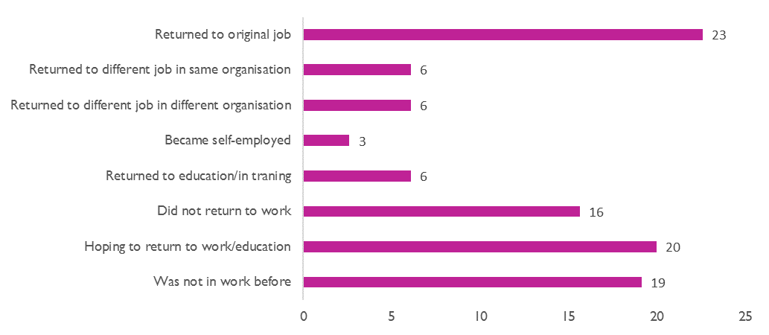
Respondents were asked would they have liked to return to work. Responses were analysed from anyone who did not return to or begin work after acquiring their illness or disability, and as a number of people in self-employment answered this question, they were also included (this constitutes 66% (n=76) of the respondents). Over half of respondents who did not return to work, or who were self-employed, would have liked to return to work, with 36% saying they would like to return to part-time work, and 18% saying they’d like to return to full-time work (see Table 2). Only 6% of these respondents said they would not have liked to return to work, and 34% said this question was not applicable to them-this was largely the group who had not been in employment before acquiring their disability.
Table 2 - Would respondents have liked to returned to work
Would you have liked to return to work | N | %
Yes, to full time work | 14 | 18
Yes, to part-time work | 27 | 36
No | 5 | 6
N/A | 26 | 34
Missing | 6 | 8

Ease of getting information and services to support them back to work
The majority of respondents, almost half, found it very difficult or difficult to find information and services to support them back to work (n=54, 47%), while 24% said it was very easy or easy to get information and supports (n=27) (Figure 2). Almost one quarter said it was neither easy or difficult (n=28, 24%).
Figure 2 - Ease of getting information and supports for returning to work
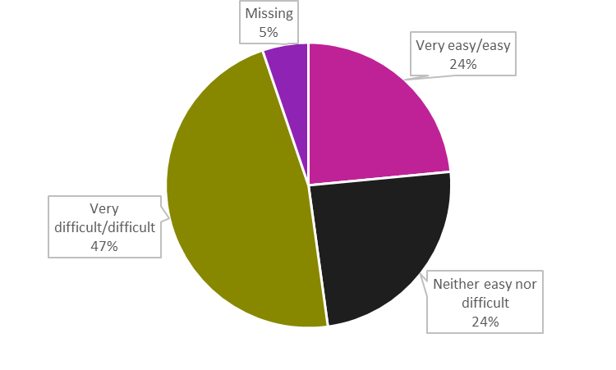

Supports after acquiring a disability
Respondents were asked about what supports they had received after acquiring a disability and if they had received any of seven key supports that have beenidentified as common elements of vocational rehabilitation.. They include:
- Assessment or evaluation
- Advice or guidance
- New skills training or education
- Health and wellbeing support
- On the job support
- Adaptations or technologies
- Service coordination.
Respondents were asked whether the support they received had been useful, which of these supports were of a priority to them and to mention other supports they had received. The findings from these questions are presented below and the summary findings across all support areas are presented in Figures 3 and 4 overleaf.

Assessment or evaluation
Respondents were asked whether they had received any assessment or evaluation regarding returning to work. This could have included an assessment to find out what work skills they could or couldn’t do, and suggestions on what training they might need to develop new work skills. Just over a third, 36% of respondents, had received an assessment or evaluation (n=41), while 61% had not (n=70). Of those who had received assessment and evaluation, almost two thirds of them found this support useful (n=26, 63%), 29% found it somewhat useful (n=12) and 7% did not find this support useful (n=3).

Advice or guidance
Respondents were asked if they received any advice or guidance about returning to work which could have included guidance or counselling about what was involved specifically for them to return to work. Just over a third (37%) of respondents had received advice or guidance (n=42) while 60% had not received any advice or guidance (n=69). Of those who had received advice or guidance, almost three quarters found this support useful (n=31, 74%), 21% found it somewhat useful (n=9), while 2% did not find it useful (n=1).

New skills training or education
Respondents were asked if they received any new skills training or education that specifically prepared them for going back to work. This may have included specialised work skills education or training. Three in ten respondents had received new skills training or education (n=35, 30%), while just over two thirds of respondents did not receive this support (n=77, 67%). Of those who had received this new skills training or education support, just over seven in ten found it useful (n=25, 71%), 23% found it somewhat useful (n=8), while 6% did not find it useful (n=2).

Health and wellbeing support
Respondents were asked if they received any health and wellbeing support to prepare them for going back to work. This could have included psychological supports or physical/functional capacity building supports. One third of respondents had received this type of support (n=38, 33%), while almost two thirds did not (n=75, 65%). Of those who did get health and wellbeing support, over three quarters found it useful (n=29, 76%), 18% found it somewhat useful (n=7), and 5% did not find it useful (n=2).

On the job support
Respondents were asked whether they had received on the job support after acquiring their disability. This support could have included access to a job coach, a supported employment specialist, or assistance with a job search. Almost three in ten respondents had received on the job support (n=34, 30%), while almost two thirds had not received any on the job support (n=75, 65%). Of those who did receive on the job support, almost three quarters found it useful (n=25, 74%), 18% found it somewhat useful (n=6), and 9% did not find it useful (n=3).

Adaptations or technologies
Respondents were asked whether they received any adaptations or technologies when they returned to work. This could mean any workplace adaptations, assistive technologies or a reasonable accommodation that specifically supported them. Just over one quarter received adaptations or technologies in the return to work (n=30, 26%), while three in ten did not receive any adaptations or technologies (n=34, 30%). Four in ten respondents answered that this question was not applicable to them (n=47, 41%). Of the 30 people who did get this support, 80% of them found the support useful (n=24), and 17% found it somewhat useful (n=5).

Service coordination
Respondents were asked whether they had received any service coordination to return to work. This could include, for example, a case manager who helped them to navigate the system. Almost one quarter of respondents had received service coordination (n=27, 23%), while over seven in ten had not (n=84, 73%). Of those who did get this support, 85% found it useful (n=23) and 15% found it somewhat useful (n=4).
Figure 3 - Supports received by respondents after acquiring disability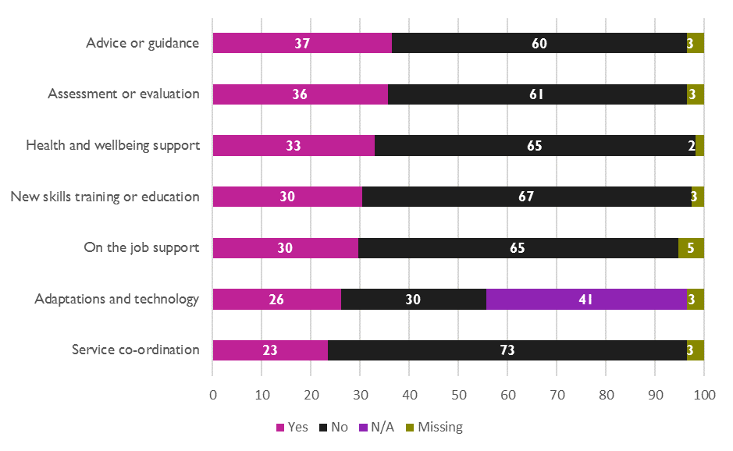

Figure 4 - Usefulness of supports received after acquiring disability 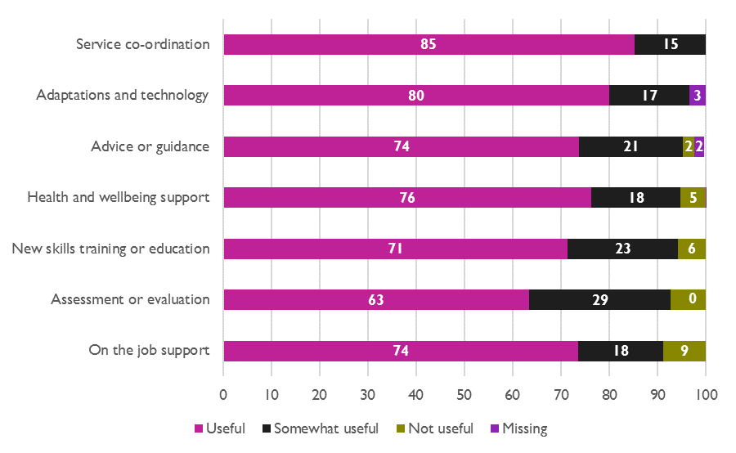

Number of supports received
Figure 5 shows that one third of respondents received none of these seven supports (n=39), meaning two thirds received at least one of these supports (n=76). One fifth received one support (n=23), and 9% received two supports (n=10). Just over 12% of respondents received three supports (n=14), 2% received four (n=2), 11% received five (n=13), 8% received six (n=9) and 4% of respondents to this survey reported having received all seven supports (n=5).
Figure 5 - Number of supports received by respondents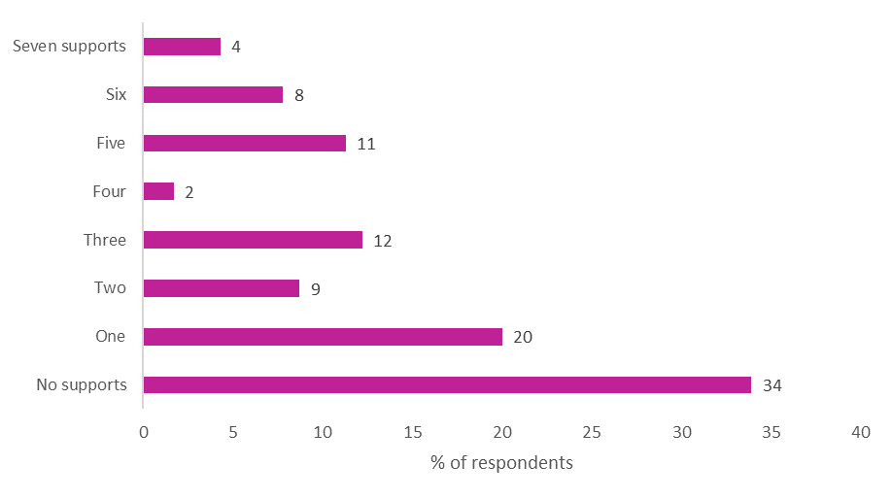

Priority supports
Respondents were asked to rank these supports as to which would be/would have been a key priority for them from 1 (highest priority) to 7 (lowest priority). Table 3 shows the average ranking given to each type of support, and is presented in descending order from the highest to the lowest priority support. The average rankings ranged from 3.3 to 4.1 out of 7. Advice and guidance was given the highest priority by respondents, followed by assessment and evaluation, health and wellbeing support, adaptation and technologies, and new skills education and training. On the job support and service coordination were ranked the same and were the lowest priorities. However, the small gap between the mean ranking indicates that all were considered important to some degree.
Table 3 - Priority of supports to respondents
Type of support | Mean ranking
1. Advice or guidance | 3.3
2. Assessment or evaluation | 3.4
3. Health and wellbeing support | 3.8
4. Adaptation or technologies | 3.9
5. New skills education and training | 4.0
6. On the job support | 4.1
7. Service coordination | 4.1

Other supports
Respondents were asked whether they received any other specific supports or had any other comments on the supports they received. Just over one quarter of respondents gave an answer to this question (n=31, 27%). Their responses broadly fell into the following four categories:
- Specific specialist supports they had received (n=16, 14%). Several of these respondents referred to the positive impact of these supports, for example:
Once I was linked in with Headway and then had a case worker support me specifically around vocational rehab and psychology support with Headway I found myself in a much better place emotionally, and in life in general….Before being linked in with them I found it very difficult…my employer was very helpful and I was trying my best to return but needed a lot more additional and professional support specific to brain injury. It was so vague trying to navigate my rehab until I met Headway... as for both me and my employer it was difficult to know what to do.
One person found their support useful in some areas, but not in others:
They were very helpful overall in other areas but in relation to education suggested courses/rehabilitative options far below my skill/experience level. More suited to people who hadn't completed school, low literacy skills etc. I found this even more depressing.
- Formal and informal supports within their workplace (n=9, 8%), with most referring to positive supports. These included understanding managers, close colleagues, open communication on their needs, reasonable accommodations including the ability to return on a phased basis, and a staff welfare officer who developed a back to work plan. Two respondents referred to challenges regarding support from employers, including a civil service employee experiencing difficulties in getting a reasonable accommodation and another who said:
…my organisation did not really support me well in returning to work or with the information gleaned from assessment.
- Supports they need or would have needed (n=7, 6%) including: knowing what supports are available to people after leaving hospital, shorter waiting lists for supports, knowledge of supports for employers and employees, proactive employers, additional and professional employment support, ongoing support and job evaluation in the workplace, support with words and practical work and outreach:
They should reach out more to people with visual impairments as I am rather lost on this journey with no aid.
Ten respondents (9%) gave other responses to this question, including that they had received no support, were waiting on support, had received good support on planning and the options available to them, had support from close friends, they self-taught and bought technology adaptations themselves, and the positive role AHEAD plays for people with disabilities in general. Two respondents referred to undergoing an occupational health assessment, with one commenting on issues with this process:
Occupational health assessment was available but was very irrelevant to nature of my disability and very ill informed. I knew more about accommodations and equipment than they did and [had] to persuade them to recommend the equipment I needed.

Government actions to help in journey back to work
Respondents were asked if there was anything the government could be doing that would have helped them in their journey back to work. Just over a third of respondents answered this question (n=42, 37%). Many of their responses fell broadly into the key components of the vocational rehabilitation pathway being proposed by the NDA, including:
- Outreach, structure and coordination of services and supports for those who acquire a disability (n=11, 10%).
- Specific supports to enter into and navigate employment or self-employment (n=10, 9%) including for example, reasonable accommodations, a room in a workplace for rests, and a work buddy/peer support scheme.
- Access to clear and accessible advice, guidance and information on acquired disabilities and supports and services (n=6, 5%),
- Support for daily living and recovery, including for example, personal assistance (n=6, 5%), and
- Access to training (n=5, 4%).
As well as specific vocational rehabilitation supports, respondents identified three further areas where the government could help them in their journey back to work:
- Awareness, representation, normalisation, acceptance and understanding of disability (n=6, 5%), generally, in relation to employment and on the rights of people with disabilities. One respondent referred to the need for understanding around the impact conditions can have on different people, for example, brain fog and fatigue.
- Clarity on and improvements to the benefits and entitlements system (n=5, 4%). Respondents referred to the need for the benefits system to be less complex and more user friendly.
Knowing I had disability payment was vital but the system was difficult to navigate as someone with a brain injury. Without family support I would probably have failed to access payments.
A few mentioned the need for clarity around the impact on their benefits if they were to become employed, self-employed, or to return to education, and for social welfare staff to be able to assist them in calculating this impact. Two specific suggestions were also made: pre-approval for Partial Capacity Benefit and the level you would receive when assessed for Invalidity Pension and a review of the illnesses on the Long Term Illness Scheme to support people with disabilities who have gone back to work pay for medical expenses.
- Transport improvements (4, 3%), including better roll out of transport schemes, larger public transport timetable boards, working sounds at traffic lights and transport subsidies, including for work travel:
Subsidised taxi fares. It’s hard enough to get a job being visually impaired and not able to drive…I’m basically working to pay my rent, can’t afford to take taxis into work when the days are short and I’m afraid for my life walking blind in the dark because the bus drops me off a 20 minute walk away from my workplace.
Five respondents (4%) gave other responses to this question, including the need for more funding and government schemes, for the government to listen to people with acquired disabilities and the services that support them, to act on their messages of respect, inclusion and equality, and that there are career-specific dilemmas following acquiring a disability or condition, for example that there are some careers you can’t do if you are in anyway visually impaired.

Experience of returning, or not returning, to work after acquiring disability
Respondents were asked if there was anything they would like to add about their experience of returning, or not returning, to work after acquiring their disability/long-term health condition. Just over one third of respondents answered this question (n=40, 35%). Their responses broadly fell into the following six categories:
- Challenges of working with a disability (n=10, 9%) including how hard and worrying it can be, that it may exacerbate symptoms, the challenge of travelling to work, and that it can be hard to seek help when your confidence is low. A number of respondents alluded to fears around disclosing their disability, with some concealing their disability or its effects. Two respondents had difficulty with reasonable accommodations provided to them, with one stating that the accommodations they received were “not specific and/or relevant to my needs”. A further two respondents felt they were discriminated against in the workplace because of their disability and one respondent felt there was a tension between the fitness to work approach taken by employers’ occupational health and the social model of disability.
- Issues around attitudes, knowledge and understanding of disabilities (n=6, 5%) including issues with attitudes towards and knowledge of particular disabilities or conditions in society and the workplace. One respondent discussed the particular challenge of having endometriosis, which they stated is not considered a significant illness by Medmark. Another felt that the experience of returning to work depended a lot on the understanding of managers and colleagues, while another described an interaction with a job coach who did not understand their capabilities:
Had some dealings with a job coach. Unfortunately the job coach gave me every reason why I shouldn't be working in places with a stairs. I'm blind, I can use the stairs.
- Barriers to returning to work (n=5, 4%), including having no help, not knowing what to do, communication difficulties, difficulties contacting companies, financial barriers, and being considered a high risk liability in work. Another person cited the Partial Capacity Benefit as a barrier to self-employment:
The ONLY reason I am not self employed and at the very least semi self supporting is because the risks of applying for partial capacity benefit are too great. The system gives no indication as to how you are judged mild/moderate etc. so there is a real possibility you will be judged mild and put on Jobseeker’s Allowance. Even though I can’t work at my old job, I certainly have skills I can continue to use in the industry and I know I could get freelance work.
- The importance of work or the negative impact of not working (n=5, 4%). A few of these respondents talked about their frustration at not being able to return to work or take up self-employment “I am truly depressed and frustrated at my situation” and another talked about the impact on them of not working:
Not working only adds to the comorbid conditions associated with my disability - depression, anxiety, fatigue - which increase your visits to the doctor/hospital (+ costs to state), more medication, less brain stimulation, increased fatigue, increased isolation and so on. It's a recipe for disaster, a vicious circle, on an individual level, societal level and at a cost level. I have tried many times to return to work.
On the other hand, two respondents noted it was important to them to return to work or training.
- Lack of knowledge around supports available (n=5, 4%) of employers or people with disabilities or conditions.
Seven respondents gave other responses (6%), including that there is inequity of supports and opportunities nationally and that educational institutions talk about, but do not practice, inclusion and equality. One felt that there is not much help from the government, that it’s up to employers to support people and another respondent is waiting for a guide dog for ‘mobility and freedom’. Finally, two respondents mentioned positive support they had received from the National Learning Network and from ABII.

Case Studies
Six case studies are presented below.

Case Study 1 – Holly’s Experience
Holly had a stroke several years ago, and spent around three weeks in hospital following this. Prior to this, she was working on a temporary contract in her profession. For a few reasons, including the hope that she would be kept on in this role, Holly returned to work only a few months after having the stroke.
I thought it best to get back to work ASAP to show I was still capable of being a good employee in order to be kept on.
In retrospect, Holly acknowledges that she returned prematurely. As well as hoping to be kept on in her role, she thinks that perhaps she was unconsciously trying to tell herself and those around her that she was well and able.
Something I may not have realised at the time, was being fit for work for me meant I was well and had a purpose…Somewhere at the back of my mind…’invalidity pension’ from a societal perspective means you are ‘invalid’ as a person. So I may have unconsciously taken on the world to show them I was still ‘valid’.
On returning to work, her GP advised she work part-time, and an Occupational Health doctor advised a phased return to work. Holly experienced significant challenges in the return to work in negotiating how a phased return would work financially. While she was working, management took several months to decide that she could be paid only for the days she worked, and for the others she would have to use annual leave or build up time that she would owe them and have to work back in the future. Following the decision she was ‘distraught’.
I felt this was unfair and was not conducive to a healthy recovery.
Holly started to work four days a week and used her annual leave for the rest of the week for a number of months until her annual leave ran out. At this point she was exhausted. Holly then started working five day weeks to keep her full-time contract, but realising she was not able for this, was eventually approved for a 4 day working week instead. Several months after she had her stroke, Holly referred herself to Headway. Over one year later, Headway were in a position to offer her vocational rehabilitation support. She found this support to be ‘really helpful’. Headway also liaised with her employer, but she was not involved in this engagement as a three way meeting including her could not be facilitated.
Holly did not feel supported by her manager over this time in a number of ways. She felt under pressure to decide whether she would return to a five day week or not, she was not given the necessary equipment to work from home during the Covid-19 pandemic, and she also felt her manager’s implementation of the supports recommended by Headway seemed like a tick box exercise.
[My manager] tried putting supports in place but tried changing too many things too quickly. It also seemed a bit of a tick box because at other times the authenticity was not there. On the one hand [they were] telling me to manage myself and on the other giving me more [work].
When Holly got a new job she was worried about disclosing her disability. However, since she disclosed it, her manager has been extremely supportive.
I did disclose it. [They] reported that I get an appointment with Occ health and get my ergonomics/equipment needs sorted as soon as possible…[They] have said for me to do what I need to do to manage myself and that [they expect] me to tell [them] if I feel I am not managing.
Since the stroke, Holly can have sensory and regulation difficulties.
My sensory preferences have changed and I can have regulation difficulties. I can experience sensory overload or a sensitivity.
For Holly, noisy environments are ‘tricky’, strong lighting can be ‘difficult’ and she can ‘become overheated and agitated’ in warm temperatures. Holly’s current work situation works well for her as she has her own office and has control over the temperature, lighting, and noise level within her office. She also has the autonomy within work to take ‘regular sensory/movement breaks’.
Holly believes that people’s experiences are influenced by their individual managers and that her experience in her previous role was particularly challenging and had a negative impact during an already difficult time in her life.
…I lost confidence in my abilities and my ‘brain injury’ was often referred to.
I feel it is really unfortunate what happened to me and how experiences can be different depending on the organisation or the manager involved…I had to fight for everything and it is so draining. Especially when that energy would be better spent recovering or feeling well.

Case Study 2 – Dennis’s Experience
Dennis is in his fifties and has had a chronic medical condition since he was a teenager. For a couple of decades, Dennis’ condition was manageable due to the medication he was on.
With medication I was able to live a reasonable normal life.
However, around 15 years ago Dennis developed another condition which significantly exacerbated his pre-existing condition. This resulted in a very challenging few years where Dennis was in and out of hospital and had to trial various medications to help him get back to a stable condition. Eventually he was put on a medication regimen, which while it helps his chronic condition, does have side effects.
Finally I got other medications which did the job. But the side effects of that was the state of my mind the following day was not great. When I wake up in the morning I have to come around.
Prior to this period, Dennis had been employed on temporary contracts in a range of jobs, but when this happened he was unable to work.
…during that time I was not in a position to work, my head was a fog, I was having difficulty remembering. I was alive for those years but with no memory.
Dennis has not received any support to get back into employment. He is linked in with a disability organisation but they are unable to provide that kind of support to him.
I’m in touch with [organisation] but they have limited support available to someone my age. They do have a few courses but few are relevant to me.
Dennis has not been in work for a long time and he has lost jobs because of his medical condition. He has undertaken a few courses but was unable to finish them. Dennis says he would love to work.
I would love to work in any way I can. The reality is I have been out of work for so many years that I can’t remember what my last job was.
While Dennis would like to work, he does not know where to begin and wonders whether he could get someone to hire him. He also doesn’t believe anything is available in the area he lives.
I lack the ability to look for something constructive. I am a people person but I have no one to talk to about what I can do.
My CV is not great.
I find myself stuck with how can I get someone to hire me. My work history is old…I would love to go into work to meet people.
Dennis also has a number of concerns about going back to work, including how long he would be able to work for and the impact of a job on his social welfare payments.
I would love to go back to work but I am not great in the morning, but in the afternoon and evening I would certainly be able to work. I don’t know for how long but maybe about 4 or 5 hours. If I go back to work will my household be financially worse off?
I’m afraid to lose my social welfare payments. It is all I have.
In recent years Dennis has been volunteering by giving talks about his journey and by talking to families of others with his condition, but he would like to be doing more with his time.
I do think I have a few more hours a week that I could do something useful.
Time passes slowly when you are not doing anything.

Case Study 3 – Jenny’s Experience
Jenny is in her forties and became visually impaired following a stroke. This has impacted on her ability to drive and on her depth perception. She has also had to deal with other conditions unrelated to her stroke since that time.
I have no depth perception if I am in unfamiliar territory. Sort of like Father Ted, far away, small. Steps etc., I cannot handle.
At the time she had the stroke, Jenny was self-employed. Due to the nature of the work involved in Jenny’s career, and the type of industry she worked in, her visual impairment made it impossible to return to her previous line of work. After acquiring her disability, Jenny received Illness Benefit and then got transferred to Invalidity Pension.
Jenny did not find the work supports from a disability organisation relevant to her acquired disability useful. In addition, during an employment webinar hosted by the organisation, Jenny felt condescended to by a member of the social welfare department when she asked about Partial Capacity Benefit.
I was totally patronised by them, it was so insulting.
Here is a person who wants to work and the attitude is awful.
Jenny says she would likely be distrustful and apprehensive of any supports for employment due to how she has felt treated in the past.
I would be mistrustful of someone who would be coming from a view of trying to catch you out rather than help you.
You find it hard to raise your head above the parapet, there is an element of patronising for someone with acquired disability.
Jenny ideally would like to return to being self-employed. She has developed business plans and financial projects but they have not progressed.
My goal was to get onto Partial Capacity Benefit and to be able to work freelance and do some consulting.
When Jenny was self-employed previously she received some accounting support from her local enterprise office. She would like to access these supports again in order to create an online presence for her business idea.
A key barrier to Jenny becoming self-employed is a fear of trying to transition from the Invalidity Pension to the Partial Capacity Benefit and what that would mean for her financially.
Partial Capacity Benefit so that I could start a business. The issue with this benefit is that you can be denied and put straight on to job seekers…I have to have a payment because I have a [redacted] year old child.
Jenny implies that transitioning to the Partial Capacity Benefit is a risk that requires courage, particularly with a young dependent:
If I didn’t have a child I could be braver, maybe when [they are older]?
She suggests that the focus of Partial Capacity Benefit could change, that if someone has an acquired disability that will not improve, or will only get worse, that they could be told immediately what level of Partial Capacity Benefit they could avail of if they choose to.
Because of other payments, the statutory regulation is that they are meant to be reviewed but why not pre approve people for Partial Capacity Benefit if they have a disability that is permanent? It should be done as a business exercise rather than having a fear that you are not disabled enough for the payment. One of the social welfare officers looked at me and the response was “my office has loads of hard cases like you”.
Ultimately, Jenny is very frustrated she can’t move forward with her business idea and needs more clarity on Partial Capacity Benefit, and would also benefit from information on the Back to Education Allowance.
In the past few years I have written to TDs, and have tried to access standard operating procedures for getting Partial Capacity Benefit.
I am fortunate that I can negotiate the system. But even I can’t get my head around the Partial Benefit System.
I was looking at Masters the other day, there are a couple of nice taught Masters in [redacted]. But I don’t know how much of the funding is covered.

Case Study 4 – John’s Experience
John is in his forties and following an incident several years ago, acquired a vision impairment and a brain injury. His vision has shown some recent improvement and his brain injury manifests in ways such as issues with his memory and completing tasks. Following this incident, which John says he was lucky to survive, he spent around one month in hospital and then was cared for at home by his family. After three months John got a place in the National Rehabilitation Hospital (NRH), where he stayed for a number of months. In the time before going to the NRH, John received a weekly visit from a speech and language therapist. He felt lucky to get this service but thought he would have benefitted from more support at this time.
I was capable of more than I was doing and it would have been a huge benefit to have more therapies and support.
Before John acquired these disabilities, he was working for a large company in another country. While in recovery, he was very focussed on returning to work. During his time in the NRH he received support from a vocational therapist. The therapist produced a vocational report regarding work but at the time John did not like the report or agree with it, feeling it did not focus enough on the workplace. However, his perspective on this report did change over time.
I felt looking back on it, it was a good involvement and very well done but at the time I was critical of it.
Over the past two years, John has received support from a Community Neuro-Rehabilitation Team (CNRT) and ABI Ireland. These support services made linkages with the NRH in an effort to start John’s journey back to work. He was happy with these supports.
…the team worked well in the CNRT and NRH.
The NRH’s vocational therapist got him into training and linked in with his employer. John’s employer was happy to work together with him on the return to work. His employer is based in another country, but he is being supported to work from home in Ireland. John is working part-time at present.
…from there I got back into work, working 8 hours a week and I am working longer hours 12 hours now.
At present, John receives regular peer support within work from a senior manager in his organisation, someone who he can discuss his work tasks with. John did have concerns that he would be put into a less senior role than before but this has not happened.
One of my fears was that I would go into a junior role. That would not do me any good, I am where I am and there will be room for improvement. My employer has taken that on board to a degree.
While John’s employer also has offices in Ireland, it was decided that while he is working from home through the Covid-19 pandemic, he would still be linked in with the office in a different country, due to the supports that could be offered to him there.
In [region other country is based] they have much more support to return to work, vocational rehabilitation etc. and very specific return to work policies.
John acknowledges what he has achieved by returning to work, but one of the challenges he is facing is how he can return to work in person, but in Ireland, and whether he will receive the same level of support in Ireland.
I feel that I have achieved a lot but there is a huge element of fear and concern as to what I will be able to do, where I will go. When I change to the Irish side they may not have the supports that they have in [region other country is based]. That was said to me by my employer…I want to get back out there to go to work.
John is able to discuss these fears and what might happen in the future with the Community Neuro-Rehabilitation Team, which he describes as ‘hugely helpful’. He is thankful for the support he has received, including from his family, but acknowledges that perhaps other people do not get these supports.
The journey that I was on was hard. I am thankful for the support that I got from the services. I was annoyed at myself that I did not know about these services. I had no idea about disabilities. The supports, we need more of them. I felt that I was lucky that I had support from my family at home. I am aware that other people maybe do not get these supports.

Case Study 5 – Sinead’s Experience
Sinead acquired a disability in her fifties. She spent a significant amount of time critically ill in hospital. Once Sinead was discharged her experience was that it was very much “fend for yourself” and she felt let down by the health system. Nine months after leaving hospital, Sinead was contacted by a HSE occupational therapist, but she found this engagement “irrelevant and inadequate” as it was focussed on basic care needs rather than anything more appropriate to her capability and circumstances.
The only engagement was a brief phonecall after 9 months during which I was asked if I could use the toilet. At no stage did I have a house visit from an OT.
It was only through the initiative of a “very supportive” relative that she was able to seek support during her recovery from a disability organisation. There was no referral from the hospital to the disability organisation or any information provided by them on any support organisations.
Before acquiring her disabilities, Sinead had been employed by a public sector body. During her recovery, she knew she wanted to return to work once she felt able. A support service she had engaged with warned her that there would likely be a tension between her needs and the preferences of her employer when it came to returning to work. At the time Sinead dismissed this, assuming that she would be supported by her employer given her previous positive working relationships and considering how profoundly her life had been impacted by her disability. She also assumed that because she worked for a public sector body that there would be an obligation to support her.
Oh no, my employer isn’t going to be like that.
In the end, her employer insisted she return back to full-time work one year after becoming ill if she wanted to retain her existing contract and conditions of employment. This was despite advice to the contrary from her medical team. Sinead felt forced back to work before she was ready and was given no choice but to work full-time, which she did not feel able for.
I knew myself it wasn’t going to work health-wise…I felt I wasn’t ready.
Before she returned to work, Sinead and one of her relatives describe the experiences of interacting with her employer, and individuals working on behalf of her employer, as “horrendous”, “intimidating” and “tantamount to bullying”.
I just wanted to be treated properly.
Sinead went back to work “as a different person” and “at the start found it very difficult, more emotionally than physically”. On her return, she did not receive adequate support from her employer in accommodating her disability. Several years later, a union representative advised her employer as to what Sinead needed to effectively continue in her role, but her employer did not take any action to arrange these accommodations. Ultimately, it has fallen to Sinead and a relative to spend significant time and effort sourcing equipment she needs to do her job. Her employer does pay for these supports. Over time, when it became apparent Sinead was unable to work five days a week, and after further challenging and upsetting engagement with her employers, it was agreed that she could work part-time.
I just wanted fairness.
Sinead is unsure if the lack of support she experienced was ineffectiveness on the part of her employer, a lack of desire to accommodate her disability, or a result of there being no key person responsible for offering support to her. Sinead feels there are a number of supports that would have made it easier for her to return to work and to make her working life easier. These include a conversation about retraining to take up a different role within her organisation and an assessment of her needs. Sinead would also benefit from one-to-one training for development in her current role but when she requested this she has been told this is not available to her. Finally, Sinead believes that one key person, like a disability officer, would have helped her secure the equipment and training she needs to support her in her role. She has been back in work a number of years but still does not know who to go to if she has an issue working with her disability.
One particular element Sinead still struggles with is that she had a good working history with her employer before acquiring her disability. Since then, she has felt her employer does not treat her “like a human being” and that there has been a lack of understanding and acceptance of her now that she has a disability.
What I don’t get…your world changes…but still deep down you’re the same person…I know the way people treat people with disabilities. They mightn’t mean it…
Sinead strongly believes that disability awareness training should be made compulsory in large public sector bodies – like her employer – for staff at every level. She believes that organisations should look beyond disability employment targets and seek to support their existing employees with disabilities in a more meaningful way.
Just because you have some form of disability does not mean you can’t work.

Case Study 6 – Mark’s Experience
Mark has had a chronic illness since he was a young child. Due to factors related to this illness, in adulthood, Mark has developed a vision impairment and a number of other significant health problems. In his 40s, Mark had a series of strokes and spent a significant amount of time in hospital as a result. From this, he also has a weakness on one side of his body and has trouble walking distances.
Prior to being hospitalised for a stroke, Mark had worked in his profession for decades. His work involved physical activity and operating heavy machinery. Once he came out of hospital, he was receiving Illness Benefit and then received early retirement on the grounds of ill health. Mark does have a strong desire to return work, but his vision impairment means that it is not possible to return to his previous profession.
I would give my left leg to go back to work but I can’t drive... The issue is getting transport to locations.
I can’t use the equipment as it would be dangerous.
Mark has received a lot of support from NCBI which he is very happy with, including support for daily activities like cooking and walking with a white stick, as well as helping him navigate applications for government grants and benefits.
NCBI have been fantastic to be fair to them.
NCBI are the only body to have suggested training in other vocational skills to Mark. However, Mark feels that with his vision impairment in combination with other health issues it is not possible for him to retrain into a different line of work.
I appreciate that you can adapt a workplace for someone who is blind but it is not something that I could do.
Mark appreciates the benefits of vocational training, but believes that nothing further could have been offered to him in terms of employment support that would have been helpful given his complex health problems.
Vocational training is excellent if you can use it, and is hugely helpful to other people. If I was just blind, I would 100% use it, but I have other issues to look at.
Mark’s quality of life has been severely impacted since his strokes and since his vision got worse. He is no longer working, can’t partake in his lifelong hobby and his role in his family as a son and as a parent has changed significantly. It is difficult for him to go out and about. Mark receives a lot of informal support from his elderly parents and a neighbour, and without them Mark’s life would be very challenging.
Someone who was out having the craic and living as best he could, to now a big day out is shopping with his father.
Mark says that the one support that would improve his quality of life would be a personal assistant. He is still able to take care of himself and doesn’t require a care assistant, but a personal assistant could for example, provide him with transport and bring him to appointments as he lives in a rural area.
[Regarding hospital appointments] How do I get up to Dublin?
Mark has experienced financial challenges after having to take early retirement as a result of his stroke. While his income has reduced, his regular bills and payments have not changed. Mark is frustrated at not being able to secure all of the financial supports available to a person who is blind because of his work pension.
Why not raise the threshold for the blind welfare allowance, so that those who have a work pension will not be penalised?
Mark has struggled with the cost and complexity of the application for a housing adaptation grant and found it frustrating that a professional occupational therapist needed to be hired to help fill out relevant parts of the application. Mark recommends that all local authorities employ an occupational therapist to carry out assessments for the housing adaptation grant.
Why are the local authorities not provided with an OT so the burden is not put on the person looking for a grant?
In 2020, Mark reached out to numerous political representatives with a range of queries relating to disability payments and grants. However, aside from one politician, no one got back to him beyond acknowledgement of his correspondence.
To get the basic response, or no response at all, from a politician is not enough.
Finally, Mark talked about the challenges for people with vision impairment using a white stick like himself to navigate the streets safely:
Barriers, street furniture, ropes I can’t see it and can’t feel it because it is not flat.

Conclusion
Respondents to this consultation had acquired a range of disabilities and conditions, and while most had one disability, around one quarter had multiple disabilities. People’s experiences appear to have been shaped by a myriad of factors including the impact of their disability or condition on their lives and the information and supports, or lack thereof, which they were given after acquiring their disability. Their experiences have also been shaped by how employers and colleagues responded to their change in circumstances, as well as general attitudes towards people with disabilities. Some people have shared their positive experiences, but for the most part, those who participated in this consultation shared the difficulties they have faced. While this may be because people who have had more challenging experiences were more inclined to participate in this consultation, it in no way diminishes the validity of what people have reported to us.
A minority of just over one in three respondents had returned to work or started work after acquiring their disability. Most of these had returned to their original job, and the rest returned to a different role in the same or different organisation or became self-employed.
Returning has been so important for me as a person and I contribute greatly to my organisation.
It is significant that of those who did not return to work, over half of them said they would have liked to. Around two in every three of these respondents would prefer part-time work compared to about one in three who would like to return to full-time work. Some respondents shared the challenges of working with a disability, including how difficult, stressful and worrying it can be, with one person noting that their job was exacerbating the symptoms of their disability. Others referred to the inherent challenges and safety concerns of travelling to a workplace.
…I love my job but sometimes I really think the journey to and from work is not worth risking my health over.
A number of respondents referred to the barriers posed by people’s attitudes, knowledge and understanding of disabilities. These included experiences of discrimination and perceived stigma of particular disabilities by employers. A number of respondents said they did not disclose their disability in work and some felt they had to conceal their disability or the effects of their disability. Respondents referred to a lack of understanding about the impact of conditions on people, and a lack of knowledge about particular conditions. A number of respondents referred to experiences of positive informal and formal supports within their workplace on their return to work, including understanding managers, close colleagues, open communication about their needs, and reasonable accommodations like a phased return to work. Others discussed challenges in getting supports, such as having to ‘beg’ and ‘fight’ for reasonable accommodations, and having to source their own equipment and technologies for work. This is particularly concerning considering employers have an obligation to provide reasonable accommodations under the Employment Equality Acts 1998-2015. Employers also have a duty to make reasonable accommodations under European Union law and the United Nations Convention on the Rights of Persons with Disabilities.
For the most part, respondents found it challenging to find information and services to support them back to work. Some respondents expected that there would be an outreach of support to them, which was not forthcoming. Others eventually realised that the onus was on them to seek out information and support, with many relying on family to do this.
In my case, I was discharged from a hospital in [county redacted], and sat at home before I realized that the onus was on me to seek out appropriate supports. Not good enough.
While the majority of respondents had received at least one of the seven vocational rehabilitation supports asked about in the survey, just over one third of them had not received any. None of these supports stood out as being commonly available, as only a minority of respondents had received each one. On a positive note, almost all of those who received any of the seven supports found them useful.
When asked to identify which elements of the vocational rehabilitation pathway were a priority for them personally, advice and guidance and assessment and evaluation were ranked as the two key priorities. However, the rest of the supports were still considered important to respondents. Of note, is that when asked an open question on what would have helped them in their journey back to work, the themes of responses largely aligned with the key components of the vocational rehabilitation pathway being proposed by the NDA. They wanted outreach, advice and guidance, support for recovery and daily living, a consideration of their work skills, access to training if needed, an organisation or individual to co-ordinate the different services in the journey back to work, and specific supports to enter into and navigate employment or self-employment. The NDA advice on vocational rehabilitation refers to the importance of ensuring that the individual and their particular requirements are at the centre of the vocational rehabilitation system. This is particularly important as a number of respondents referred to a misalignment between the supports they received or were offered, and their support needs or capabilities.
As well as needing positive supports to facilitate the journey into employment, respondents also referred to the need for supports to help overcome current barriers to working. These barriers include the complexity of disability payments, transport issues and a lack of awareness, attitudes and knowledge of others, especially employers, about disabilities. A number of respondents wanted a more user friendly benefits system, and clear information on the impact of employment, self-employment or going into education on their disability payments. Other respondents wanted support for travelling to work such as improvements in the transport options available to people with disabilities and transport subsidies. The critical importance of a supportive and understanding workplace was raised by a number of respondents. However, many of the responses to this consultation offered examples illustrating how challenging it can be when employers lack awareness, knowledge and understanding about living and working with a disability. There is a clear need to train employers to be competent in supporting people with disabilities in the workplace. Regarding what the government could do, one respondent stated:
Prioritising disability issues - employment, cityscapes, housing, spending, making them more visible in the media, promoting them within government and contractors - and therefore normalising disability and disabled people as part of the workforce and positions of power, not as a box to tick. Prioritising diversity and inclusion issues to include disability more to the fore - ensuring all their contractors and agents employ people with disabilities, and tenders request information regarding this (accessibility of workplace, disability policies, diversity and inclusion...)
To conclude, the findings from this consultation reinforce the argument that there needs to be a coherent national programme of vocational rehabilitation in place in Ireland. A minority of the people who took part in this consultation returned to work or started work after acquiring their disability, but many of the others said they would have liked to. Given the challenges faced by people who have acquired disabilities and long-term illnesses, and that many of them still want to work, support to help them enter into appropriate roles and to navigate employment or self-employment is critical. In the absence of a coherent vocational rehabilitation system we have heard how challenging it can be for people with acquired disabilities or conditions to even know where to begin in relation to returning to work, and for how difficult it can be when they return without the right formal and informal supports in place. The findings from this consultation will be used to inform the NDA Policy Advice on Vocational Rehabilitation Provision in Ireland and the NDA will also use the findings of this consultation in future considerations of the vocational rehabilitation system.

Appendix A. List of specific supports that respondents said would help them in returning to work

Outreach, structure and co-ordination of supports and services
- In a local office
- One individual, e.g., a disability officer in the workplace
- Is unbiased, and focused on needs of individual

Access to advice, guidance and information on acquired disabilities, supports and service
- Clear and accessible information
- Information on specific disabilities
- Information for employers and employees

Supports for daily living and recovery
- Shorter waiting lists for support
- Personal assistance or a support worker to help with administrative tasks, transport or self-care
- Therapeutic support
- Specialist support for their disability
- Peer support
- Financial support

Training
- Training and retraining for jobs
- Training accompanied by specialist supports
- Practical and rehabilitative training, including supports with words
- Training and retraining for jobs
- Training accompanied by specialist supports
- Practical (like old FAS course) and rehabilitative training
- Bring back the distance learning course through the NLN
- Access to training/internships in rural areas

Supports to enter into and navigate employment or self-employment
- Proactive employers
- Additional professional support for employees and employers
- Employer incentives
- Specific supports for self-employment
- Assessment for work
- Job testing and exploration of different job options
- A phased return to work
- Support to reintegrate into the workplace
- Ongoing review, support and job evaluation in the workplace
- Flexible working hours
- A room in a workplace for rests
- A work buddy/peer support scheme
- More centralised supports:
- A centralised disability/accessibility-specific fund for financing work equipment
- A centralised reasonable accommodation service
- For Intreo to signpost individuals to specialist services

Improved access to transport
- Better roll out of transport schemes
- Transportation subsidies, including for work travel
- Larger timetable boards for public transport
- Working traffic lights that beep when green

Clarity and changes to benefits and entitlements
- A more user friendly benefits system
- Clear information on the impact of people going back to education, going into employment, or becoming self-employed, on their disability payments
- Review the long-term illness list to help people who have gone back to work with a disability pay for medical expenses.
- Pre-approve people for Partial Capacity Benefit if they have a disability that is permanent
- Raise the threshold for the Blind Welfare Allowance, so that those who have a work pension will not be penalised
- Local authorities should employ an occupational therapist to carry out assessments for the housing adaptation grant so that the cost burden does not fall to the person applying for the grant

Increased awareness, representation, normalisation, acceptance and understanding of disability
- Awareness of employers
- Awareness of different disabilities
- Understanding of the impact of disabilities on people
- Prioritisation of disability issues across all spheres
- Prioritising diversity and inclusion issues to include disability more to the fore - ensuring all government contractors and agents employ people with disabilities, and tenders request information regarding this (accessibility of workplace, disability policies, diversity and inclusion)

Other government actions
- Increase funding
- More government schemes
- Listen to people with acquired disabilities and the services that support them
- Act on their messages of respect, inclusion and equality.

Government of Ireland. (2015) Comprehensive employment strategy for people with disabilities 2015-2024. Retrieved from http://www.justice.ie/en/JELR/Comprehensive%20Employment%20Strategy%20for%20People%20with%20Disabilities%20-%20FINAL.pdf/Files/Comprehensive%20Employment%20Strategy%20for%20People%20with%20Disabilities%20-%20FINAL.pdf
See OECD (2003) Transforming disability into ability: Policies to promote work and income security for disabled people. Paris, FR: Organisation for Economic Cooperation and Development. Retrieved from: http://www1.oecd.org/publications/ebook/8103021E.PDF108 and OECD (2010) Sickness, Disability and Work: Breaking the Barriers - A synthesis of findings across OECD countries. Retrieved from https://www.oecd.org/els/soc/46488022.pdf
WRC. (2016) International good practice in vocational rehabilitation: Lessons for Ireland. Retrieved from http://nda.ie/file-upload/international-good-practice-in-vocational-rehabilitation-lessons-for-ireland.pdf
Government of Ireland. (2019) Comprehensive employment strategy: Phase two action plan 2019-2021. Retrieved from http://www.justice.ie/en/JELR/CES_Action_Plan_2019_to_2021.pdf/Files/CES_Action_Plan_2019_to_2021.pdf
Assessment or evaluation, advice or guidance, new skills training or education, health and wellbeing support, on the job support, adaptations or technologies, and service coordination.
WRC. (2016) International good practice in vocational rehabilitation: Lessons for Ireland. Retrieved from http://nda.ie/publications/employment/employment-publications/international-good-practice-in-vocational-rehabilitation-lessons-for-ireland.html
Assessment or evaluation, advice or guidance, new skills, training or education, health and wellbeing support, on the job support, adaptations or technologies, or service co-ordination
NDA. (2020) NDA draft policy advice on vocational rehabilitation provision in Ireland. Retrieved from http://nda.ie/publications/employment/employment-publications/nda-draft-policy-advice-on-vocational-rehabilitation-provision-in-ireland.html
Government of Ireland. (2015) Comprehensive employment strategy for people with disabilities 2015-2024. Retrieved from http://www.justice.ie/en/JELR/Comprehensive%20Employment%20Strategy%20for%20People%20with%20Disabilities%20-%20FINAL.pdf/Files/Comprehensive%20Employment%20Strategy%20for%20People%20with%20Disabilities%20-%20FINAL.pdf
See OECD (2003) Transforming disability into ability: Policies to promote work and income security for disabled people. Paris, FR: Organisation for Economic Cooperation and Development. Retrieved from: http://www1.oecd.org/publications/ebook/8103021E.PDF108 and OECD (2010) Sickness, Disability and Work: Breaking the Barriers - A synthesis of findings across OECD countries. Retrieved from https://www.oecd.org/els/soc/46488022.pdf
WRC. (2016) International good practice in vocational rehabilitation: Lessons for Ireland. Retrieved from http://nda.ie/file-upload/international-good-practice-in-vocational-rehabilitation-lessons-for-ireland.pdf
Government of Ireland. (2019) Comprehensive employment strategy: Phase two action plan 2019-2021. Retrieved from http://www.justice.ie/en/JELR/CES_Action_Plan_2019_to_2021.pdf/Files/CES_Action_Plan_2019_to_2021.pdf
Where tables add up to more than 115 or 100%, it means participants have provided more than one answer.
The singular term ‘disability’ will be used in this report for ease of reading but includes those who have acquired more than one disability or illness.
Some respondents provided more than one answer for this question.
This may have included not being employed, still being in education, or being a homemaker.
WRC. (2016) International good practice in vocational rehabilitation: Lessons for Ireland. Retrieved from http://nda.ie/file-upload/international-good-practice-in-vocational-rehabilitation-lessons-for-ireland.pdf
A case manager is someone who helps to assess, plan, implement, coordinate, and monitor the options specifically for individuals to achieve a successful return to work.
These included support from Headway, Quest, Acquired Brain Injury Ireland, Step Ahead, the National Council for the Blind Ireland, the National Rehabilitation Hospital, the National Learning Network, a hospital liaison officer, a vocational therapist, mental health supports, and employment support from Employability.
AHEAD is an independent non-profit organisation working to create inclusive environments in education and employment for people with disabilities. The main focus of their work is further education and training, higher education and graduate employment.
NDA. (2020) NDA draft policy advice on vocational rehabilitation provision in Ireland. Retrieved from http://nda.ie/publications/employment/employment-publications/nda-draft-policy-advice-on-vocational-rehabilitation-provision-in-ireland.html
Please see Appendix A for more detail on government actions suggested by respondents.
Partial Capacity Benefit is a government payment available to people receiving Illness Benefit or Invalidity Pension who wish to return to work or self-employment if they are medically assessed as having ‘reduced capacity to work’. Illness Benefit is a government payment available to those who are a sick or ill for up to 1 or 2 years. Invalidity Pension is a government payment available to those who cannot work due to a long-term illness or disability. People will only receive Illness Benefit or Invalidity Pension if they have a certain level of social insurance (PRSI) contributions.
Assessment or evaluation, advice or guidance, new skills, training or education, health and wellbeing support, on the job support, adaptations or technologies, or service co-ordination
NDA. (2020) NDA draft policy advice on vocational rehabilitation provision in Ireland. Retrieved from http://nda.ie/publications/employment/employment-publications/nda-draft-policy-advice-on-vocational-rehabilitation-provision-in-ireland.html

