Moving In, Moving On

An evaluation of the outcomes and costs of congregated and community models of service in the disability sector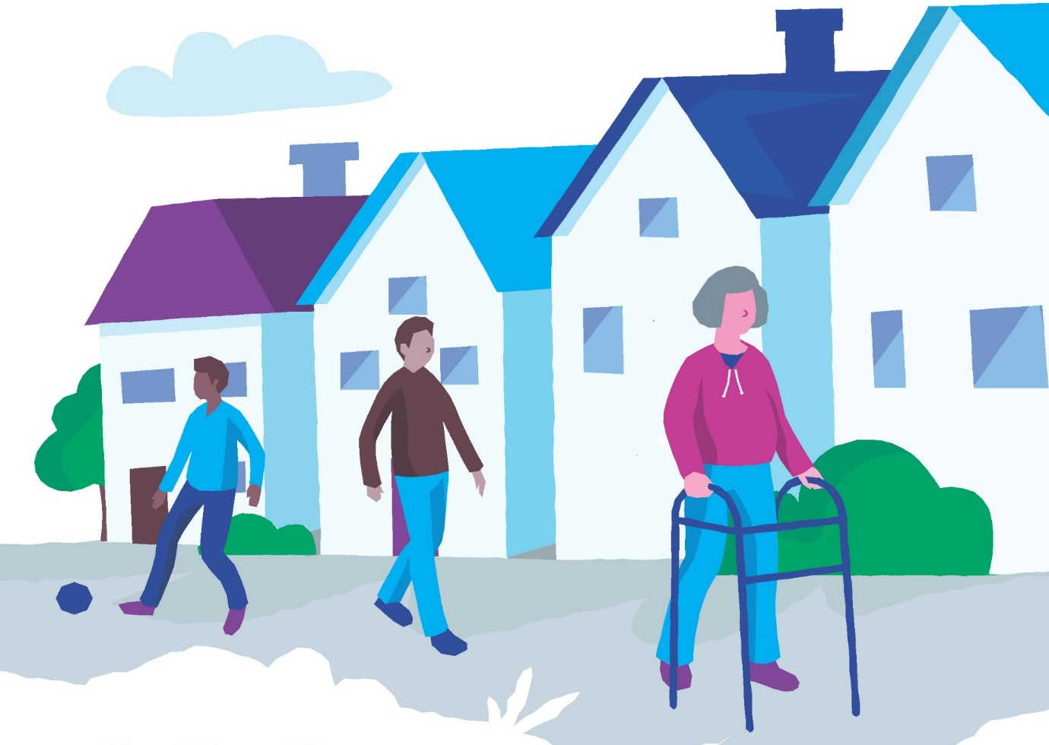

 December 2021

# Acknowledgements

The NDA would like to acknowledge and thank a number of people and organisations that made this project possible. First, we would like to thank the participants for their time, views and honesty. The participants were very generous with their life stories and support needs. The NDA hopes that the participants see themselves reflected in this report and the accompanying Easy-Read summary. Second, we would like to acknowledge the assistance of different agencies and service providers in the recruitment process. Third, we would like to thank the interviewers who assisted the staff of the National Disability Authority for their assistance, input and expertise throughout the project.

We would also like to thank the members of the HSE’s disability team and the Scientific Advisory Committee for their invaluable input and support.[1]

We would like to thank Suzanne Guerin (UCD) who acted as an ethical guide and advisor throughout the project.

# Funding

This study was commissioned and funded by the Health Service Executive.

 

# Contents

Abbreviations 4

Executive Summary 5

Background and Introduction 5

Methodology 6

Study findings 9

Conclusions and Recommendations 21

1. Chapter 1: Introduction 24

1.1 Evaluation aims and scope 25

1.2 Structure of the report 26

2. Chapter 2: Methodology 28

2.1 Sampling and recruitment strategy 28

2.1 Research tools 30

2.2 Ethical approval, consent and research protocols and procedures 31

2.3 Research team and supports 32

2.4 Costs 33

3. Chapter 3: Phase 1 findings 34

3.1 Description of the sample 34

3.2 Profile of Phase 1 participants pre transition 34

3.3 Findings from FACE 35

3.4 Quality of Life and Outcomes 37

3.5 Findings from reflective diaries 37

3.6 Changes in the lives of Phase 1 participants 42

3.7 Quality of Life 46

3.8 Findings from reflective diaries 50

3.9 Comparison between participants who did and did not transition 58

3.10 Case studies 60

3.11 Discussion of Phase 1 findings 61

Chapter 4: Phase 2 Findings 65

4.1 Primary supports received by Phase 2 participants 65

4.2 Findings from FACE 67

4.3 Quality of life and outcomes 73

4.4 Findings from reflective diaries 81

4.5 Case studies 82

4.6 Comparison of Phase 1 and Phase 2 participants 83

4.7 Discussion of Phase 2 findings 84

Chapter 5. Cost of disability services 87

5.1 Introduction 87

5.2 Costs in congregated settings 91

5.3 Costs in Community settings 95

5.4 Comparison of pay and non-pay costs in congregated settings and community housing 98

5.5 Cost of further decongregation 105

5.6 Discussion of costs 109

Chapter 6. Limitations 114

6.1 Limitations in participant selection 114

6.2 Limitations of FACE 114

6.3 Limitations related to measuring quality of life and outcomes 115

6.4 Limitations related to service costings 116

Chapter 7. Conclusions and Recommendations 117

7.1 Phase 1 participants 117

7.2 Phase 2 participants 118

7.3 Costs 120

7.3 Recommendations 121

References 123

Appendix 1: Original Terms of Reference for congregated settings project 127

Appendix 2: Scientific Advisory Committee Members 129

# Abbreviations

| ABI | Acquired brain injury |
| --- | --- |
| ADLs | Activities of daily living |
| ASCOT SC4 | Adult Social Care Outcomes Toolkit Self-Complete |
| ASD | Autism Spectrum Disorder |
| BMI | Body Mass Index |
| DSMAT | Disability Supports Management Application Tool |
| DPER | Department of Public Expenditure and Reform |
| DoH | Department of Health |
| ER | Easy Read |
| FACE | Functional Assessment of Care Environment v7 Recording and Measurement Systems Toolset |
| HIQA | Health Information and Quality Authority |
| HSE | Health Service Executive |
| HRCDC | Health Research Consent Declaration Committee |
| IADLs | Instrumental Activities of Daily Living |
| ID | Intellectual Disability |
| MDT | Multi-disciplinary therapy |
| NASS | National Ability Support System |
| NDA | National Disability Authority |
| PA | Personal Assistant |
| UK | United Kingdom |
| UNCRPD | United Nations Convention on the Rights of Persons with Disabilities |
| VFM | Value for Money |

# Executive Summary

This report sets out the findings of an extensive study on the costs and benefits of new models of disability service provision in Ireland. The National Disability Authority (NDA) conducted and managed the study on behalf of, and was funded by, the Health Service Executive (HSE).

## Background and Introduction

National policy regarding residential disability services is set out in the Time to Move On from Congregated Settings report (HSE 2011). This policy commits to providing residential disability support services in settings where no more than four individuals would live together in an ordinary home within the community. The policy was developed based on evidence indicating that the best quality of life outcomes for persons with disabilities requiring residential care and support were to be found in smaller settings. Traditionally in Ireland, in common with many countries, residential supports for persons with disabilities were provided in large institutional settings.

The Time to Move On policy committed to closure of all these settings, and to transitioning residents to smaller, community-based residences. Initially, a target was set for transitioning 4,099 residents to the community by 2019, although this deadline was subsequently moved to the end of 2021. As of the end of 2019, HSE figures indicate that approximately 1,953 individuals remained within congregated settings (HSE 2020). The HSE’s 2020 National Service Plan projected that 132 individuals would be transitioned to community settings, bringing to total number of people remaining in congregated settings at the end of 2020 to 1,821; once mortality is accounted for, this figure is estimated to be 1,739 (HSE 2019).

Historically it was felt that the institutional models of care offered economies of scale in terms of staffing and centralised services which would be negated by staffing smaller and dispersed community units and by the costs of the acquisition and adaptation of housing within the community. However, the decongregation agenda has not been pursued with a view to achieving a more cost effective service model. The commitment to pursue deinstitutionalisation stems from fundamental human rights considerations, including the obligation to ensure that individuals can choose who they live with in community settings in line with Article 19 of the UNCRPD (United Nations, 2006). The expectations of greater costs of being supported to live in the community are balanced with corresponding expectations of improved quality of life outcomes for the individuals in receipt of this support. It was this hypothesis that the NDA set out to test through the Moving In, Moving On study, while also gathering learning that would be beneficial to the on-going decongregation process.

## Methodology

The study was designed in two phases. In Phase 1, a total of 146 persons in 11 residential disability congregated sites scheduled for accelerated decongregation (also referred to as ‘priority sites’) were interviewed before transitioning to the community. A total of 91 of these participants were re-interviewed a minimum of 6 months post their transition to the community. Throughout the study these are referred to as ‘Phase 1’ participants.

In the original terms of reference, the purpose of Phase 2 was to conduct an evaluation of a cohort of people who have already experienced ‘new’ models of service against a matched sample of people in traditional models of services. However, it proved impossible to identify whether ‘new’ or ‘traditional’ models of service were in practice because of the continuum from traditional to newer models of support. Therefore, in consultation with the scientific advisory group, it was decided that Phase 2 would document the profile, characteristics, and support needs and measure the social care related quality of life of the diverse population that use specialist disability supports.

In Phase 2, 280 persons with a wide range of disabilities and support needs were interviewed. This group of participants used a range of service types, both community-based and residential. While the number of Phase 2 participants recruited was significantly less than the original target sample it was decided that the sample achieved was sufficiently representative of the population of adults with disabilities and the time and resources required to recruit further participants would not be repaid with significant new information. These participants are referred to in this report as ‘Phase 2’ participants

The information gathered throughout the project was collected using a variety of tools, each designed to gather specific data:

### Quantification of support needs

The Functional Assessment of Care Environments (FACE v7) tool was used for all those interviewed in Phase 1 and Phase 2 in order to establish a standardised measure of support needs for each individual. The FACE v7 allowed the research team to assign participants to a ‘Global Need Band’ that was broadly descriptive of their support needs, while also scoring their capacity with regard to carrying out Activities of Daily Living (ADLS) and Instrumental Activities of Daily Living (IADLS). ADLs are personal care activities in which people engage daily that are fundamental to caring for oneself and maintaining independence. ADLs include dressing, bathing, toileting, eating, transferring from bed to chair, walking, and climbing stairs. IADLs are activities that are not as fundamental to self-care as ADLs but are indicative of the ability to live independently. Activities such as shopping, cooking, doing housework, using the telephone, managing medications and managing finances are examples of IADLs.

### Assessment of quality of life

The Adult Social Care Outcomes Toolkit (ASCOT SC4) is designed to assign a quantitative measure to self-assessed, social care related quality of life for persons in receipt of disability services. The easy-read version of the toolkit specifically designed for use with people with intellectual disabilities was used in this study. However, persons with severe or profound intellectual disabilities often cannot provide a self-assessment of their quality of life, meaning that many Phase 1 participants could not engage with this tool.

### Outcomes Framework

An outcomes framework developed by the NDA (2016), through extensive engagement with service providers and service users, and adopted throughout disability services, was used to assess the extent to which the decongregation process, and newer models of service, were succeeding in supporting persons with disabilities to achieve quality of life outcomes. The nine outcomes identified in this framework set out quality of life goals or objectives that disability services should be able to support individuals with disabilities to achieve (Table 1). In order to facilitate this analysis, a number of supplementary questions were added to the ASCOT tool to ensure all outcome areas were considered during the research.

### Reflective Diaries

In light of the limitations of the ASCOT tool, the study team used semi-structured reflective diaries to provide a subjective assessment of the social care related quality of life of individuals, including descriptions of their surroundings and daily lives. The research team underwent training to optimise the extent to which similar topics would be covered within the diaries, and similar approaches taken. The diaries are therefore a source of rich qualitative data, particularly in relation to the comparative experiences of Phase 1 participants both before and after their transition to the community.

### Costs

The budget for disability residential care services stood at €1.25bn in 2020, accounting for 61% of the total disability services budget. Given the significant levels of public monies directed towards providing disability residential care services it is essential to carefully examine and consider the implications of major policy changes in the sector for the public finances. The general concern with comparative costings pre and post decongregation stems from the fact that diseconomies of scale arise in the transition from congregated settings to community housing settings. As congregated settings are, by definition, high density facilities, these institutional settings can generally operate with lower staff-to-resident ratios as compared to community housing units.

The main concern of the cost component of this research is to ascertain the costs associated with delivering the Time to Move On policy objective and CRPD Article 19 obligation around deinstitutionalisation, and to ensure adequate funding and appropriate budgetary planning are in place to implement the deinstitutionalisation agenda on an appropriately ambitious timeline. The study addresses these issues by comprehensively measuring the cost of service delivery in both congregated and community settings so as to assess the implications of the ongoing process of deinstitutionalisation for the Exchequer.

In terms of the approach to costing service delivery in congregated and community settings, this was achieved through the development of representative rosters for each respective setting which were then converted into unit cost estimates. Pay costs were calculated using mid-point salary scales. Non-core pay costs and premia payments[2] were also captured using current HSE rates and arrangements. Non-pay costs were calculated using findings from observational field research and data from service provider managers and finance officers.[3]

In congregated settings the data on representative rosters were obtained through a survey that purposively selected a sample of non-priority congregated settings that were asked to fill-in a representative roster template for facilities capturing variation in staffing arrangements across day and night times, as well as weekdays and weekends. In community settings researchers gathered information on representative rosters from service managers, finance officers and through observation in the houses where Phase 1 and Phase 2 participants resided, with a house of four residents serving as the main comparator for congregated setting cost data.

For both the congregated settings and community housing the rostering arrangements were directly reflective of the profile of need of the residents, with greater support need requiring a greater allocation of staffing resources. While the community housing rostering data allowed for the disaggregation and comparison of running costs for housing units on the basis of residents’ level of support need, this was not achievable for the survey of congregated settings. However, the comparative cost analysis does compare the simple average unit costs for congregated with the weighted average unit costs for community housing while profiling the support need of those who have yet to decongregate using available HSE data. This approach takes account of the level of support need among those clients that have yet to decongregate, a majority of which have support needs described as High (66%) or Intensive (7.7%).[4] This results in a directly comparable estimation of the cost of service provision per client per annum for those clients that have yet to decongregate in both the congregated and community housing settings, while also taking account of residents’ level of support need.

### Ethics and Consent

Ethical approval was sought and received from all the service providers from which participants were recruited, and who had ethics committees in place. Service providers identified potential participants within their services, and disseminated information and consent documentation for the study. Written informed consent was obtained from participants at two time points prior to participation. Where individuals did not have capacity to provide consent to participate, proxy consent was initially sought from either a relative or key worker. This approach changed following the introduction of the Health Research Regulations 2018 and the commencement of the Health Research Consent Declaration Committee (HRCDC). The NDA applied to the HRCDC for permission to interview people who were unable to give their explicit consent and this was granted in the public interest.

## Study findings

A summary of the findings are presented below for Phase 1, Phase 2 and costs. The full report and associated Technical Annex set out the detailed findings in relation to the two groups of participants. A literature review is provided as a separate document. Data analysis is balanced with case study vignettes of some of the pseudonymised participants, and extracts from the reflective diaries prepared by the research team.

### Phase 1 findings

#### Pre transition findings

Of the 146 Phase 1 participants interviewed, 98.6% (n=144) had a Global Need Band of six, meaning they had high support needs. The sample consisted of 42.5% (n=62) women and 57.5% (n=84) men. The average age of participants was 51 years and six months. The primary disability of all participants was intellectual disability, and a majority (79.5%; n=116) had two or more disabilities. No participant was engaged in employment and only 5% (n=7) were engaged in education. The majority of participants (93.8%; n=137) had communication difficulties and 31.5% (n=46) had behaviours of concern[5] with a history of harm.

The mean ADL[6] score was 14.1 and the median score was 13 (range of 0-31). Almost four in ten (39.7%; n=58) participants had an ADL score of less than 10, indicating that they required relatively low levels of support. A further 32.2% (n=47) had an ADL score in the 10-19 range, indicating they required moderate levels of support. Almost three in ten (28.1%, n=41) participants had ADL scores of 20 or greater and required high or intensive support. The mean IADL score was 12.7 and the median was 14 (range: 6-14).[7] Just 11% (n=16) of participants indicated they experienced ongoing family support.

Only a very small proportion of participants, from just a few priority sites, were able to provide an evaluation of their quality of life (using the ASCOT tool) and therefore the Outcomes Framework (NDA 2016) was used to assess quality of life for these participants.

#### Post transition findings

The transition process was slower than anticipated and some participants remained in the priority congregated settings at the end of the study. For the 91 participants who had transitioned during the life time of the study, before and after comparisons indicated improved quality of life outcomes for individuals following the transition. Where, prior to transition, individuals could not be deemed to be achieving any of the nine quality of life outcomes, there was evidence that some outcomes were being fully or partially achieved following transition. Table 1 presents the outcomes pre and post transition. Outcomes that are being successfully achieved are coloured green, those being partially achieved are coloured orange and those not achieved at all are coloured red.

**Table 1: Outcomes for Phase 1 participants, pre and post transition to the community.**

**Outcome1: Are living in their own home in the community**

| Sub-domains | Pre transition | Post transition |
| --- | --- | --- |
| Ordinary housing | No | Yes |
| Suitable housing (e.g. adapted) | Most necessary adaptations provided | All necessary adaptations provided |
| Choice of who lives with you | None | Limited |
| The run of your own home | No – certain areas restricted | Yes |
| Privacy | Almost none | Yes – own bedrooms and more living space |

**Outcome 2: Are experiencing choice and control in their everyday lives**

| Sub-domains | | Pre transition | Post transition |
| --- | --- | --- | --- |
| Choice | Almost none | Yes – choice with regard to clothes/bedtimes. Consulted about weekly menu plans | |
| Control | No | Limited – control still largely rested with staff | |
| Everyday routines | Some ability to opt out of activities | Some ability to opt out of activities. Same range of activities normally offered to all residents but some personalised activities | |
| Major life decisions | No control | No control | |

**Outcome 3: Are participating in social and civic life**

| Sub-domains | | Pre transition | Post transition |
| --- | --- | --- | --- |
| Social life | Minimal engagement with mainstream community activities | Increased engagement with mainstream community activities | |
| Socially connected/not lonely | Rarely socially connected outside of service | No change | |
| Community/civic activities including accessibility/ transport/mobility) | Dependent on availability of transport and staff to access community | Two thirds were living within walking distance of local amenities. Remaining one third were dependent on availability of transport and staff to access community | |
| Attends church if so wishes | In some sites the church was on campus | Now attended local churches | |

**Outcome 4: Have meaningful personal relationships**

| Sub-domains | | Pre transition | Post transition |
| --- | --- | --- | --- |
| Family | Contact with family encouraged | Contact with family enabled and supported – increased family contact for more than a quarter of those who moved to community settings | |
| Friends | Friendship circle of most limited to within service | Friendship circles remained limited | |
| Intimate relationships | No intimate relationships | No intimate relationships | |

**Outcome 5: Have opportunities for personal development and fulfilment**

| Sub-domains | | Pre transition | Post transition |
| --- | --- | --- | --- |
| Education/training/ outcomes | Almost no orientation towards training/education | Slight increase in orientation towards education/training | |
| Realisation of personal goals, both long-term and short-term | Absence of goals/ambition with regard to progression/skills | Increased orientation towards possibility of progression – but continued lack of ambition. Difficulty in determining personal goals | |

**Outcome 6: Have a job or other valued social roles**

| Sub-domains | | Pre transition | Post transition |
| --- | --- | --- | --- |
| Employment | None | None – but some efforts to find work experience | |
| Other valued social roles | Not promoted | Actively promoted in a minority of houses | |
| Doing things for others | Not promoted | Actively promoted in a minority of houses | |

**Outcome 7: Are enjoying a good quality of life and well being**

| Sub-domains | | Pre transition | Post transition |
| --- | --- | --- | --- |
| Satisfaction with life | Participants unable to provide self-assessment of their quality of life | Participants unable to provide self-assessment of their quality of life | |

**Outcome 8: Are achieving best possible health**

| Sub-domains | | Pre transition | Post transition |
| --- | --- | --- | --- |
| Physical health | Many aspects of health subject to regular/ongoing monitoring and screening | Many aspects of health subject to regular/ongoing monitoring and screening. Some evidence of reductions in medication. | |
| Mental health | Environmental conditions (noisy, lack of privacy) not consistent with good mental health | Participants were now living in quieter, less crowded environments – this is likely to promote better mental health | |
| Healthy lifestyle | Some aspects of lifestyle not consistent with good health – e.g. not enough physical activity or variation in diet. Many examples of polypharmacy | More varied diets and increased physical activity likely to result in health benefits | |

**Outcome 9: Are safe, secure and free from abuse**

| Sub-domains | | Pre transition | Post transition |
| --- | --- | --- | --- |
| Safety | Emphasis on safety through confinement | Emphasis on safety through avoiding risk | |
| Security and continuity | Environment generates safeguarding risks | Environments were now safer | |
| Being respected/listened to | Paternalistic attitudes not respectful of residents autonomy | Paternalism less explicit but had not disappeared | |
| Freedom from abuse | Risk of abuse | Risk of abuse remained | |

The case studies and reflective diaries showed examples of individuals taking an interest in activities that they would not previously have been exposed to, such as household tasks and cooking. Participants now routinely intermingled with the general population in all sorts of spaces that they rarely or never ventured into previously. After moving to the community, they attended local GPs, hairdressers and barbers, walked in local parks and beaches, went to the same church or chapel as their neighbours, and sometimes had a pint in the local pub. Their lives were now more like those of people without disabilities than they were when they lived in congregated settings. Although full integration in the community, and the taking on of roles such as volunteering or employment was infrequent, there is scope for this to grow. There were several examples given of participants enjoying their life in the community and exceeding expectations, for example:

Richard[8] enjoys physical activity. He goes horse-riding and goes to local football matches. He did surfing with day services in the summer and loved it. He has membership in a local leisure centre and has gone to the cinema twice in the last couple of months- this is something that would not have been thought possible in the past (FACE profile, reported by interviewer)

There was also some evidence to suggest that as individuals transitioned to smaller settings, the likelihood of displaying behaviours that challenge and the requirement for high levels of medication was reduced. In many instances the participants continued to attend on-campus day centres following decongregation. The findings also highlighted the importance of staff attitudes and outlook on the success of the transition process.

Following their move to homes in the community, participants’ living environments vastly improved. Their new homes were quieter, safer and more comfortable and bore little resemblance to the institutions they have left behind. There was little evidence of the use of assistive technology and it seems opportunities had not been fully explored.

In many ways, the findings in this research report set out the improvements in quality of life that are evident at the very outset of the decongregation process. However, all stakeholders agreed that the process will be on-going rather than a single event and that, over time, individuals might move again, to another residence with other housemates, or even to live alone with relevant supports. While beyond the scope of this research, it would be interesting to review the progress of individuals at regular intervals to establish the extent to which independence, choice and control could be strengthened through increased exposure and use. Similarly, reviewing the extent of behaviours that challenge or the degree of polypharmacy, may show further evidence of improvement as more time elapses.

### Phase 2 findings

Overall the heterogeneity of the Phase 2 sample, and the range of living circumstances encountered, precluded a similar tracking of outcomes between old and new models of service. However, the information from Phase 2 was very valuable in relation to measurement of quality of life as it was not possible to use the quality of life tool with Phase 1 participants.

In Phase 2, 280 people were recruited from across 43 locations and 33 service providers. A range of support services were provided to participants including residential support (55.7%; n=156), supported living (20%; n=56); day services (21.8%; n=61) and ancillary support (2.5%; n=7). Ancillary services include services such as advocacy, counselling, community outreach and facilitated networks. Services included both those general to all persons with disabilities and those who were targeted to specific cohorts of persons with disabilities.

The majority of Phase 2 participants (59.7%; n=167) had a Global Need Band score of six, indicating that they had high support needs. The sample consisted of 47.7% (n=134) women, and 52.3% (n=146) men. The average age of participants was 47 years. The primary disability of participants was intellectual disability (76.4%; n=214), and a majority (71.8%; n=201) had two or more disabilities. Just over one in five (22.9%; n=64) participants were engaged in employment and another 22.9% (n=64) were engaged in part-time education. More than half of the participants (56.1%; n=157) had communication difficulties and 15% (n=42) had behaviours of concern.

The mean ADL score was 6.6 (range 0-31). Almost half (48.6%; n=136) of participants had a score of 0 or 1, indicating that they had relatively low support needs. Participants with moderate support needs (ADL score 10-19) had the highest incidence of behaviours of concern. On average, participants with supported living arrangements and those living in their family homes required lower support to undertake ADLs than participants with other living arrangements. The mean IADL score was 8.7 (range 0-14; median score=9). Almost one in five (18.6%) participants required maximum assistance with all IADLs.

Although it was less feasible than anticipated to compare old and new models of service for Phase 2 participants, it is nevertheless clear that positive outcomes are more likely to be achieved where supports are delivered in a tailored and person-centred way, which is not generally compatible with institutional or congregated living. Lower quality of life scores measured through the ASCOT tool were more likely for Phase 2 participants who lived in congregated residential settings. The Phase 2 findings also showed other factors that can impede an individual’s capacity to achieve positive outcomes, including experiencing pain, not being able to choose the people one lives with, or not liking the people one lives with.

Almost half (45.7%) of Phase 2 participants received ongoing support from family and/or friends. The support provided by families ranged considerably and was a function of need, the availability of formal services and the ability/desire of families to support their relative. The average age of participants living in their family home was over 36 years, suggesting that many had elderly parents. We encountered very little evidence of planned or phased transitions into residential care for those who may have been reliant on family supports to live within the community.

### Comparison of Phase 1 and Phase 2 findings

Phase 2 participants differed from Phase 1 participants in a number of ways. Phase 2 participants reported lower levels of communication difficulties, mental ill health, behaviours of concern, pain/distress and epilepsy. The functional ability of Phase 2 participants was higher than that of Phase1 participants. Phase 2 participants were heterogeneous, reflecting the varying levels of support needs, different types of disabilities and living arrangements and the array of disability services that were being accessed. This allowed a good insight into the range of services being used and the levels of need among Phase 2 participants. Phase 1 participants were more homogenous; all had intellectual disabilities, lived in congregated settings, and most had high support needs.

### Costs

The findings of the comparative analysis of service delivery costs pre and post decongregation indicate that there will be increased costs post decongregation for those residents that have yet to decongregate. This is mainly due to diseconomies of scale where staff-to-resident ratios are higher in the community, leading to higher pay costs in community housing.[9] Figure 1.1 displays the average annual per resident running costs of congregated settings as compared to the running costs of four bedded community houses which have been costed according to the level of support need of residents along a five band scale of need. Community housing facilities that house residents with ‘Minimum’ or ‘Low’ support needs are found to be cheaper than the current average unit costs at congregated settings. However, when the support needs of residents at community housing facilities are ‘High’ or ‘Intensive’ the unit costs at these facilities are found to be significantly higher than the average unit costs that currently prevail at congregated settings.

Figure 1.1: AVG annual cost[10] per resident in congregated settings and community housing

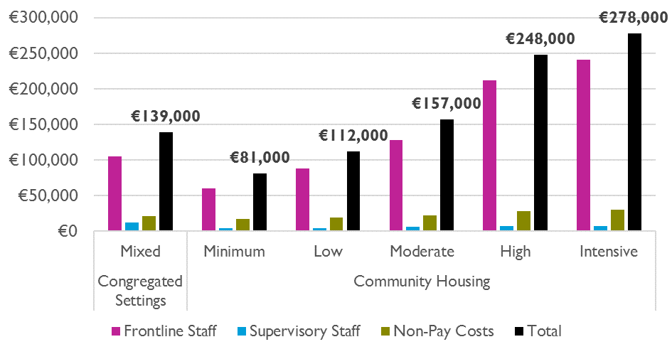

In order to arrive at a directly comparable unit cost metric the analysis utilised a weighted cost of service delivery in the community housing setting which took account of the level of support need among those clients that have yet to decongregate, a majority of which have support needs described as ‘High’ (66%) or ‘Intensive’ (7.7%).[11] This approach arrives at a directly comparable estimation of the cost of service provision per client per annum in both the congregated and community housing settings. Once the level of support need among residents has been accounted for, the average cost of service delivery increases from €139,000 per resident per annum in congregated settings to €223,000 per annum in the community housing context. The cost uplift associated with transfer from congregated settings to community housing averages €84,000 per resident per annum for those residents that have yet to decongregate – a cost uplift of 60.2%. The main driver of this cost uplift are diseconomies of scale stemming from the higher staff-to-resident ratios in the community, as is evidenced by the higher pay costs per resident observed in the community housing context. (See Figure 1.2)

**Figure 1.2: Weighted Comparison of Per Resident Annual Costs in Congregated Settings and Community Housing**

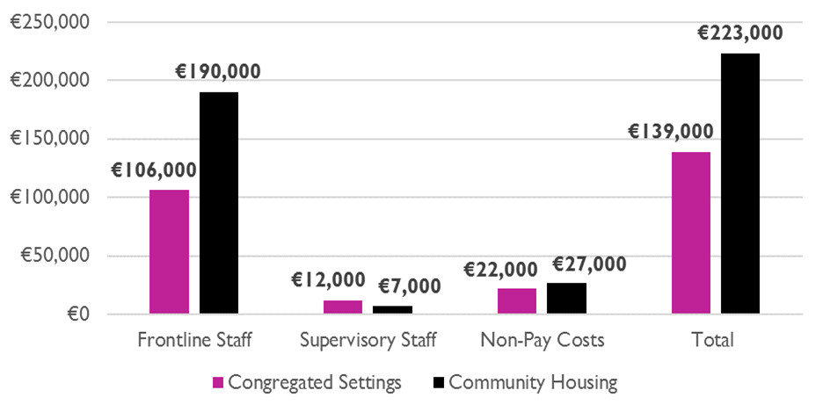

It is important to clarify that these results express the average cost uplift associated with the future transfer of those individuals that have yet to decongregate to community housing. The generally high levels of support need among these individuals and resultant higher staff resident ratios means that the cost of providing services are higher for this particular cohort as compared to the approximately 6,200 that already reside in disability residential care community housing.[12] It is hoped that these higher staff to resident ratios would result in more individualised and personalised models of support.

Considering both congregated and community housing contexts, the average annual unit cost of a placement nationally stood at approximately €144,000 per resident in 2018 (Department of Health, 2021). This is in fact comparable to the unit costs of service provision for those individuals that currently remain in congregated settings (€139,000 p.a.). The implication of this observation is that, while the forward-looking cost to the Exchequer of decongregation will be an additional €84,000 per annum per individual for the approximately 1,800[13] clients that have yet to decongregate, the historical cost uplift for those individuals who already reside in community housing has actually been significantly less. Figure 1.3 compares the findings with respect to service delivery unit cost estimates across settings, data resources and support need.

In addition to calculating the unit costs of service delivery pre and post decongregation, the analysis also modelled the practical and fiscal implications for the full achievement of decongregation. This was done while considering three potential timelines for the completion of decongregation – 2030, 2027 and 2025. Completion of decongregation in 2030 (Scenario 1), 2027 (Scenario 2), and 2025 (Scenario 3) would require an average of 134 (Scenario 1), 215 (Scenario 2) and 337 (Scenario 3) individuals to transfer to the community per annum from 2022.

When modelled at scale to reflect the forward-looking cost of transferring all individuals that have yet to decongregate to the community, the implications for the Exchequer are significant. Once mortality and inflation have been accounted for, the annual cost uplift for disability residential care services that is attributable to the transfer of additional individuals to the community reaches €140.1million (m) per annum (p.a.) by 2030 in Scenario 1. However, a comparable level of expenditure of €139.2m p.a. is reached in 2027 under scenario 2 before rising to €147.7m p.a. by 2030. Under scenario 3, expenditure of €138.8m p.a. is reached in 2025 before reaching €153.2m p.a. by 2030.

Figure 1.3: Comparison of AVG annual per resident unit costs across findings

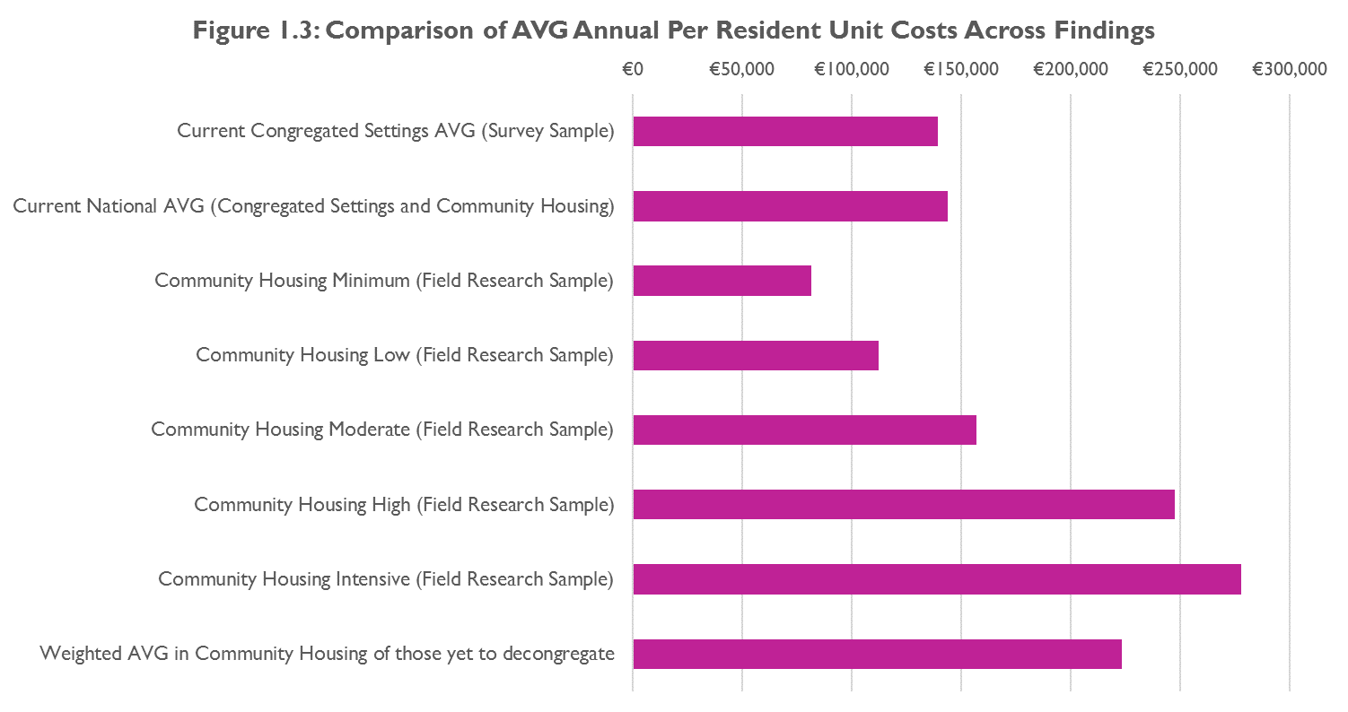

## Conclusions and Recommendations

The Moving In, Moving On study offers a mixed methods approach to considering the costs and benefits of newer models of disability service provision, and much like the decongregation process itself, underwent a number of adaptations over the course of the three years of fieldwork and subsequent analysis. It provides detailed information on the support needs, profiles and outcomes achieved by 426 individuals – including those who moved directly from a congregated setting to a home within the community. The findings show the extent of positive outcomes associated with person-centred and tailored models of support – which can be described as ‘newer’ models, as well as the potential for further improvements over time as individuals have greater opportunity to exercise choice and control, and build independence and associated life skills.

The overall findings of Phase 1 show that the decongregation process, and the shift of disability services to a more person-centred model, by and large, delivers more positive outcomes for individuals than were achieved in congregated settings. The decongregation process is also important in realising the goals of the UNCRPD as well as several national policies and strategies. The findings indicate that decongregation should continue, and continue to be appropriately resourced in order to build on the progress already made.

Phase 2 participants were a heterogeneous group, most of whom lived in the community. This group tended to have higher capacity than Phase 1 participants and many were able to complete the social care related quality of life assessment. Regression analysis indicated that, for this group, being in pain or great pain, disliking the people one lives with, living in any type of community residential facility or sharing with 10 or more people were all significantly associated with poorer quality of life.

The cost of providing disability residential care services has been steadily increasing in recent years due to improvements in the regulatory environment leading to increased staffing levels at facilities. Pay costs have also increased in all settings due to the ongoing process of public sector pay restoration. While the transition of individuals from congregated settings to the community is costly, the improvements in quality of life outcomes for residents are also substantial and cannot be achieved through continued residence in congregated settings. The high costs are also driven by the high support needs of the majority of those who are still resident in congregated settings. It is also possible that improvements in well-being and increased independence among residents will result in reductions in staffing levels in the long-term, resulting in additional savings for the Exchequer. Disability residential care staff have frequently reported a reduction in behaviours of concern following a move to the community and there may be a decrease in the amount of medication required that could also impact on costs. Parallel policies that support ageing in place in the family home with input from respite and day services, and increased planning to avoid emergency placements will be important to reduce transfers into residential care. The study also found limited use of assistive technology (AT) to increase independence of residents and there is scope for further exploration of the potential for AT to reduce overall costs of community supports.

A key budgetary implication of this analysis is that the faster decongregation is achieved, the more costly it is. It is critically important that adequate funding is provided so as to realise the goal of deinstitutionalisation on an appropriately ambitious timeline, so as to achieve the quality of life improvements that living in the community brings as soon as is practicable.

### Recommendations

The findings from this study have allowed for a number of recommendations to be made relating to the ongoing decongregation process and to providing person-centred supports more generally. Below, summary recommendations specific to the HSE, service providers, the Department of Health, and relating to future research are outlined. More detailed recommendations are included in the main report. For each recommendation the corresponding results or discussion section pertaining to it in the main report is indicated in brackets.

#### Recommendations for HSE

* Continue to prioritise the process of decongregation to improve the lives of those living in congregated settings. In addition, continue to minimise any new or re-admissions into congregated settings (Section3.11).
* Continue to support residents, both newly resident in the community and newly transitioned, to meet their goals and objectives in a person-centred way (Section 3.11.2).
* Enhance the support provided to promote ageing in place in the family home through respite and day services, and increase forward planning for this cohort to minimise emergency placements in residential care (Section 4.2.2).
* Keep the current process surrounding the determination of funding under review to ensure that the process serves the interests and quality of life concerns of clients. Consider the use of a standardised assessment tool (Section 5.6).
* Continue to improve data collection and management standards in the disability residential care sector, both in relation to data on service delivery costs and data on service outcomes more broadly (Section 5.6).

#### Recommendations for service providers

* Continue to prioritise staff training and support, particularly in the area of person-centred support and a rights-based approach to support (Section 7.2).
* Consider implementing a structured but person-centred day activation programme for community residents who do not currently have one (Section 3.6.1.4).
* Implement systems to ensure that, in keeping with a rights-based approach to care, the supports provided to clients are appropriately aligned with the ability and capacity of individuals (HIQA 2019a) and provide them with more independence and opportunities for self-determination (Section 7.2).

#### Recommendation for Department of Health

* Provide leadership, guidance, support and resources so that the HSE can effectively and fully implement the TTMO strategy (Section 3.9.1).
* Accelerate the setting up of a National Research Ethics Committee for social care related research (Sections 2.2 and 6.1).

#### Recommendations for further research

* Conduct further research on quality of life tools and alternative methods of assessing quality of life including extensive structured observation (Section 6.3).
* Consider ongoing research among people who have transitioned to the community from congregated settings to track their quality of life and level of community integration over time and changes in staffing requirements (Section 3.8.2 & 4.7).
* Conduct further research on the benefits of mainstream and assistive technology to promote independence of people with intellectual disabilities living in the community and to explore possibilities of reducing staff costs (Section 5.6).

# 1. Chapter 1: Introduction

For some years a major programme of reform has been underway in the Irish disability sector. Several factors coalesced to provide the impetus for reform. These included the publication of two seminal reports: Time to Move on from Congregated Settings - A Strategy for Community Inclusion (HSE 2011); and Value for Money and Policy Review of Disability Services in Ireland (Department of Health 2012). These reports highlighted the need for systemic reform in the disability sector. Other factors were the introduction of a statutory regulatory and inspection system for residential care settings and a series of domestic legislative and policy changes[14] to achieve alignment with the United Nations Convention on the Rights of People with Disabilities (UNCRPD) which Ireland ratified in 2018. These policies and strategies collectively set out a framework for realising the rights and promoting the independence and autonomy of persons with disabilities. Their central aim was to ensure that persons with disabilities have the same opportunities as all others to live in the community and exercise choice and control.

The evaluation of public service reforms is essential to ensure that strategic changes deliver better services. The National Disability Authority (NDA), is the independent statutory body that provides information and advice to the Government on policy and practice relevant to the lives of persons with disabilities. The NDA undertakes and commissions research in relation to disability, in particular to guide and underpin policy and practice.

This study, Moving In, Moving On, set out to evaluate the outcomes and cost of new or emerging models of service in order to assess the effectiveness and financial sustainability of the changes emerging and envisioned in the disability sector. It aligns with the wider government commitment to outcomes-driven reform evaluation. This independent study, undertaken by the NDA, was commissioned and funded by the HSE under the Transforming Lives programme. The Department of Public Expenditure and Reform (DPER) and the Department of Health both had an interest in this study, particularly in relation to the costs of different models of residential support.

This chapter outlines the aims and scope of the evaluation and the structure of the report.

## 1.1 Evaluation aims and scope

The study was conducted in two phases. The original terms of reference for the study is included in Appendix 1. These, and the objectives, were adapted and refined in conjunction with the HSE and the Scientific Advisory Committee as the study evolved. This proved necessary due to the difficulties in defining ‘traditional’ and ‘new’ models of service and due to the need to undertake new survey work to inform the comparative analysis of service delivery unit costs.

The final overall aim of the study was to;

* Estimate the costs and evaluate the benefits (mainly in the form of quality of life outcomes) of ‘new’ models of service, or models of service congruent with government policy and compare these costs and benefits to those associated with models of service not in accordance with government policy.

### 1.1.1 Phase 1 objectives:

To conduct an evaluation of persons with disabilities currently living in congregated settings at two stages: before their transition and again at least 6 months after their transition to community models of service to allow for:

* An examination of the profile, characteristics and support needs of the population residing in congregated settings deemed a priority for decongregation.
* A comparison of the costs of care for residents of priority congregated settings before and after their move to the community.
* A comparison of the quality of life of residents before and after their move to the community.
* An examination of experiences of people who transitioned to the community using outcomes measures, case studies and reflective diaries.
* A comparison of the profile of residents of priority sites for decongregation who did and did not transition to the community during the study period with those who did.

### 1.1.2 Phase 2 objectives:

To conduct an evaluation of people with disabilities currently living in a variety of settings that use specialist disability supports to allow for:

* An examination of the profile, characteristics and support needs of the diverse population that use specialist disability supports.
* Measurement of the social care related quality of life of participants using both subjective and objective measures.

### 1.1.3 Additional objectives

* Compare and contrast the profiles and quality of life of participants from Phase 1 and Phase 2.
* Evaluate the cost of the main models of service pre and post decongregation.
* Evaluate the financial implications of the shift to models of service that provide person-centred supports and assess the financial sustainability of these which are envisioned to be the primary model of care in the disability sector.
* Develop a series of recommendations to inform both decongregation specifically and the transfer into alternative models of service generally through the identification of good practice to inform and promote change in the sector.

### 1.1.4 Scope

The evaluation was limited to specialist disability services provided to adults. The research did not focus on respite and multi-disciplinary services although some participants were in receipt of these services. Services provided to children were outside the scope of this research.

The outcomes delivered were evaluated by reference to the overall objective of the Transforming Lives programme (to ensure full inclusion and self-determination for people with disabilities) and the Outcomes Framework (NDA 2016).

## 1.2 Structure of the report

In Chapter 2, the research methodology is described including the process of securing ethical approval. Chapter 3 describes the findings from Phase 1 of the study which included persons with disabilities living in congregated settings which had been prioritised for decongregation. The chapter concludes with a sample case study that serves as a reminder of the individuals whose life course has been fundamentally shaped by their placement in institutional care and their recent move to homes in the community. Further case studies can be found in Technical Annex 11. Chapter 4 describes the findings from Phase 2 of the study. Chapter 4 also concludes with a sample case study. Further case studies, which demonstrate the diversity in the lives, needs and supports of Phase 2 participants, are available in Technical Annex 11. Chapter 4 also presents a comparison between Phase 1 and Phase 2 participants. Chapter 5 presents the findings of a model developed to compare the costs pre and post decongregation. There is a discussion section at the end of each of the chapters 3, 4 and 5. Chapter 6 presents the study limitations. Chapter 7 provides a conclusion and presents a number of recommendations. These are disaggregated by recommendations for the HSE, for service providers, for the Department of Health and for further research.

A Technical Annex has also been developed. This contains more detailed information than is contained in this report. In particular, it has more detailed analysis of the findings of the study and more information on the costing components. References are made throughout this report to relevant sections in the Technical Annex.

# 2. Chapter 2: Methodology

In this chapter the research methodology is described, including brief descriptions of the tools used and the process of receiving ethical approval. Further details can be found in Technical Annex 1.

## 2.1 Sampling and recruitment strategy

At the initial stages of the study design, it was agreed that 165 individuals, across 14 service provider sites, would be interviewed. We planned to evaluate the costs and social care related quality of life for these participants at two points in time: before the person moved from the congregated setting and after their move to the community, when a minimum period of 6 months had elapsed. This ‘before and after’ evaluation would, therefore, provide a basis for comparing the cost of care in both settings and assessing the benefit of the transition in terms of improved outcomes for individual participants. The study findings would also provide learning to inform the on-going decongregation process. The sites were identified in collaboration with the HSE. Those chosen had poor HIQA inspection findings including being designated by HIQA as requiring closure. Choosing priority sites for decongregation meant that it was likely that most study participants would have transitioned to the community by the end of the study. This part of the study was deemed Phase 1.

In discussions with the Department of Public Expenditure and Reform (DPER) regarding the disability services budget, it was agreed to expand the parameters of the research to offer a larger sample size on which to base future expenditure decisions. It was therefore agreed that a research sample of 600 people would be recruited, to include the original group of 165 individuals. The remainder of the larger sample would seek to include matched groups of participants between traditional and new models of service to allow some comparison of experience and costs across models. This part of the study was deemed Phase 2.

For Phase 2, we were constrained in the choice of our sampling strategy by the absence of a sampling frame[15] and by the availability and willingness of individual service providers and those using services to participate in the study. Participants were, therefore, selected using purposive sampling, based on their characteristics and/or the objectives of the study. This sampling technique ensured that the sample included participants supported by a wide selection of service providers that adopt a variety of service models. This also ensured that our sample included participants with different types of disability and varying levels of support needs. This also ensured a wide geographical spread and a good age and gender balance. All adults in receipt of disability services were potential participants for the study. Phase 2 participants were made up of new entrants[16] to day services for whom a specific budget has been allocated, people living in community-based residential care settings, people with a physical/sensory disability, people with acquired disabilities of various forms, people living in various community settings including family homes, sheltered housing and independently. This approach was considered to be consistent with the ethos and body of the CRPD.

We also sought to base our sample selection on the model of service adopted by service providers so as to compare ‘old’ and ‘new’ service models. However, in practice, the service models ranged on a continuum from old to new and often resisted classification. Therefore, it was not possible to draw a meaningful distinction between old and new models of service in advance of our fieldwork. Consequently, various lists and registers of service providers were used to identify the service providers we approached to recruit participants. In recognition of the high proportion of funding directed to large service providers, these were initially targeted for inclusion. It proved unfeasible to include matched groups of participants and to reach the target of 600 due to the voluntary nature of the study and the dependency on service providers to facilitate access to potential study participants. Therefore, data collection ceased at 426 participants (146 from Phase 1 and 280 from Phase 2). While the number of Phase 2 participants recruited was significantly less than the original target sample, it was decided, due to the purposive nature of sampling used, that the sample achieved was sufficiently representative of the population of adults with disabilities. In addition, the time and resources required to recruit further participants were unlikely to be repaid with significant new information.

It was intended that costs would be collected from the Phase 1 study pre and post transition. However, it proved difficult to obtain accurate costs from services for congregated settings. Therefore, after initial data collection a separate data collection exercise was conducted to collect data from a number of congregated settings that were purposively selected to obtain costs that mostly centred on staffing rosters. These were then compared to the costs for community residential support obtained through Phase 1 and Phase 2 interviews in the community.

Data were collected between December 2016 and January 2020 with a delay of several months following the introduction of the Health Research Regulations and to allow for an application to the Health Research Consent Declaration Committee (HRCDC) to provide a consent declaration to allow processing of personal data, with appropriate safeguards, in the light of the public interest of the research (see further section 2.3 below).

## 2.1 Research tools

Four tools used in the research are outlined briefly below. More detailed descriptions of each tool are available in Technical Annex 3.

### 2.1.1 FACE Toolset

The Functional Assessment of Care Environment Recording and Measurement Systems Toolset (UK; FACE v7) was used to assess the support needs of participants around activities of daily living, instrumental activities of daily living, and participation in work, education and social activities. The FACE Toolset is a comprehensive, integrated toolset for use across health and social care settings.

### 2.1.2 ASCOT-SC4-ER

The easy-read version of the Adult Social Care Outcomes Toolkit (ASCOT-SC4-ER (Netten et al. 2012) was used to assess social care related quality of life. This version was specifically designed for use with people with intellectual disabilities. ASCOT was used in conjunction with an acquiescence test (Cummins 2005) which provided a means of screening participants to ensure that they had the cognitive capacity to engage with the tool. The acquiescence test was most useful when participants had moderate intellectual disability and their ability to engage with the tool was uncertain. The ASCOT tool was administered after the completion of FACE profiles.

### 2.1.3 NDA Outcomes Framework

The use of the NDA Outcomes Framework (NDA 2016) for quality of life for specialist disability services allowed for quality of life domains not sufficiently considered through the FACE or ASCOT tools to be considered. The ASCOT-SC4-ER was therefore supplemented by a number of questions designed to capture the nine outcomes set out in the NDA framework.

### 2.1.4 Semi-structured reflective diaries

Following each site visit, interviewers recorded their observations in a semi-structured reflective diary. The reflective diaries included observations regarding the service location and the environment, the demeanour and personal appearance of participants, evidence of person-centred practice, the activities that participants were engaged in and their integration in the community.

### 2.1.5 Additional information

Additionally, details of staffing numbers, rotas and skill mix were recorded for the majority of sites. Sometimes this was from staff on the day of the interview and sometimes it was through follow up emails. The FACE tool also provided some information about levels of staffing in the relevant site.

## 2.2 Ethical approval, consent and research protocols and procedures

As there is no national or co-ordinated system of ethical approval for social research in Ireland, individual ethical approval applications were submitted to all relevant research ethics committees. The recruitment of participants did not commence until ethical approval had been granted. Many participants in our study were unable to provide informed consent due to the extent of their intellectual disability. For such participants, we relied on proxy assent from a family member or a member of staff with a long-standing relationship with the participant. This process was approved by multiple research ethics committees. After the 2018 Health Research Regulations introduced additional safeguards to protect the data privacy of participants in health research, the process of securing consent was reviewed to ensure compliance with the regulations.[17],[18] An application was made to the Health Research Consent Declaration Committee (HRCDC) which subsequently issued a consent declaration which provided the authority to process the data gathered from participants who were unable to provide explicit consent. More details relating to these processes are outlined in Technical Annex 2.

### 2.2.1 Participant information sheets and consent forms

The NDA commissioned Easy Read and Plain English versions of information sheets and consent forms (copies of which are included in Technical Annex 4). These were revised and updated to ensure compliance with data protection regulations. The information sheet explained the purpose of the research, that participation was voluntary, and set out how the research data would be collected, managed, stored and retained. It also included contact details for the Data Protection Officer, the Project Manager and the Lead Investigator. The consent form asked participants to confirm that they had read and understood the information sheet and reminded them of the voluntary nature of their participation and their ability to opt out of the process at any time. Project documentation was circulated among service providers who were asked to disseminate and discuss it with their clients.

### 2.2.2 Research Protocols and Procedures

Research protocols were devised which ensured that all data protection regulations were complied with. All sites, interviewers and participants were assigned a code. Data were recorded using the assigned codes. Master code sheets were stored securely in the NDA during the data collection period. Data were collected on encrypted laptops and transferred electronically to the NDA. Completed consent forms were returned to the NDA offices and stored in a locked filing cabinet in the NDA offices. Access to data files was limited to the NDA project team. On publication of this report, the FACE profiles have been deleted and all remaining data has been anonymised. Data and consent forms will be stored for 10 years; after this time the data will be permanently destroyed.

A procedure to manage the disclosure of past or ongoing experiences of harm, abuse or neglect was drafted and an independent ethical advisor was appointed. All interviewers were provided with the contact details of the independent ethical advisor. Participants are referred to by pseudonyms throughout the report.[19]

## 2.3 Research team and supports

The NDA project team was supported by a Scientific Advisory Committee that included representatives from a number of government departments including DPER and the Department of Health, the HSE, a service provider, a disability advocacy organisation and academics and researchers with expert knowledge of disability and health economics (Appendix 2). An external ethics advisor (Dr Suzanne Guerin- University College Dublin) was also available to the research team.

Service providers assisted in the recruitment of interviewers from within their services to assist in fieldwork. Non-NDA interviewers conducted 35% of the fieldwork with NDA staff completing the remainder. Their involvement was particularly concentrated on the pre transition interviews of participants from priority sites. All interviewers were provided with training which ensured their familiarity with the research tools and the research protocols. All interviewers were subject to Garda vetting.

## 2.4 Costs

The development of estimates of unit costs for disability residential care service pre and post decongregation relied upon a combination of observational field research data and survey work to determine representative rostering arrangements and associated pay costs for facilities. The rostering template utilised in the survey of congregated settings was based upon a roster template provided to the NDA by the HSE. The estimates of unit costs were calculated taking account of a range of factors including clients’ level of support need, HSE pay scales, regulatory staffing requirements, variability in supervisory arrangements, day care costs, variability in rostering arrangements at night and weekends, non-core pay costs and premia payments[20]. The data model used to forecast service costs based upon the roster inputs was developed by the NDA. In the final comparative analysis, the unit costs of service delivery pre and post decongregation were expressed in directly comparable unit costs while taking account of clients’ level of support need. Additional detail on the methodology is provided in the costs section below in Chapter 5.

# 3. Chapter 3: Phase 1 findings

The decongregation process has been underway for several years and a review of progress and outcomes is both timely and pertinent at this juncture. The context of the progress to decongregation in Ireland and internationally is important and is considered in more detail in the Literature Review, which is available as a separate document.

In this chapter we set out our findings with regard to Phase 1 participants. We first present the profile of the 146 study participants living in congregated settings. We then present the differences in the lives of the 91 persons who moved out of a congregated setting into homes in the community. Finally we present a comparison between the 91 persons who moved and the 55 persons who did not move, only recently moved, or who had died before the transition process was completed.

## 3.1 Description of the sample

A total of 146 participants were recruited in Phase 1 of the study from 11 priority sites for decongregation. The HSE directly managed four of the eleven priority sites with the remainder operated by voluntary providers.

Of the participants recruited, 91 were re-assessed after their move to the community across 34 residential settings. The death of ten participants (eight before and two after their move to the community) prevented their re-assessment. A further two participants were moved to medical facilities and so could not be re-assessed. The remaining 43 participants either had not transitioned to the community (26.7%; n=39) or had only recently transitioned (2.8%; n=4) when the field work concluded, and therefore had not been living in the community for the period of time required to allow post transition interviews.

## 3.2 Profile of Phase 1 participants pre transition

Five priority sites were located in Munster (62 participants; 42.5%); four in Leinster (52 participants; 35.6%); two in Connacht (32 participants; 21.9%).

A more detailed description of the findings from the FACE toolset is presented in Technical Annex 5. The main points are summarised below. As all Phase 1 participants had intellectual disabilities, the FACE profiles were completed either in full, or with assistance by, a member of staff.

## 3.3 Findings from FACE

* Global Need Band - FACE analyses the support needs of those profiled into seven bands that range from 0 to 6, with 6 indicating high support needs. The majority (98.6%; n=144) of participants from the priority sites were classified as Global Need Band 6. The remaining two participants were classified as Global Need Band 4. Participants in one site (Site B) had significantly less complex needs, as reflected in their lower ADL and IADL scores, than any other site.
* Gender - gender mix reflected the composition of the priority sites; the overall sample comprised 62 (42.5%) women and 84 (57.5%) men.
* Age - the average age of the participants recruited from priority congregated settings was 51 years and six months (range 18-84 years).
* Primary disability - all participants recruited within priority sites had a primary disability of intellectual disability.
* Multiple disabilities - many participants had multiple disabilities including mental ill health (52.7%; n=77) and physical disabilities (38.4%; n=56). The majority of participants (79.5%; n=116) had two or more disabilities.
* Employment - none of the participants were in employment; although 21(14.4%) participants were aged over 65 years and therefore would be expected to be retired.
* Education - almost all (95%; n=139) of the participants were not in education. Most were attending a day centre on campus. Seven (5%) were in part time education.
* Communication difficulties - the majority of participants (93.8%; n=137) had communication difficulties. Similar numbers of female (22.6%; n=33) and male (20.3%; n=30) participants were reported to have none/mild communication difficulties. The combined severe/profound category was indicated for 51.6% (n=75) of female participants and 54.7% (n=80) of male participants.
* Safeguarding concerns - safeguarding concerns were noted in respect of 15 (10.3%) participants. Behaviours of concern were reported in respect of 12 of these 15 participants. In light of the level of non-compliance with regard to safeguarding and safety revealed by HIQA inspection reports relating to several of the priority sites the level of safeguarding concerns reported by staff informants appears low.
* Mental health - sixty-three (43.2%) participants had a history of serious mental ill health. This was more common for male participants (51.2%) compared to female participants (32.3%; n=47). Almost three quarters (74.0%; n=108) of participants had had contact with mental health services in the previous year.
* Emotional wellbeing - more than one third (37.0%; n=54) of participants were reported to have no difficulty with their emotional wellbeing. Almost a quarter (24.7%; n=36) were reported as feeling low or anxious most days. Daily severe mood disturbance was indicated for 6.8% (n=10) of participants. Continuous and severe difficulties were noted for two (1.4%) male participants. Female participants (41.9%; n=61) were more likely to be described as feeling low or anxious once or twice a week than males (21.4%; n=31). Males were 1.9 times more likely to feel low or anxious most days and three times more likely to have daily severe mood disturbances than females.
* Behaviours of concern - almost one third of participants in priority sites did not have any behaviours which affected themselves or others. However, 31.5% (n=46) had behaviours of concern with a history of harm. The behaviour of three participants (2.1%) was considered to present a constant severe risk of harm. Male participants (35.7%; n=52) were more likely to report behaviours of concern with a history of harm to oneself or others than female participants (21.0%; n=30).
* Physical health - just over one in five (21.2%; n=31) participants reported any pain. However, the assessment of pain was provided by a member of staff. A history of epilepsy was indicated for 45.9% (n=67) of participants. One third (33.6%; n=49) of participants required support to manage or prevent skin conditions. Two participants reported skin ulcers.
* Activities of Daily Living (ADL) – ADLs are activities in which people engage daily. They are everyday personal care activities that are fundamental to caring for oneself and maintaining independence. ADLs include dressing, bathing, toileting, eating, transferring from bed to chair, walking, and climbing stairs. The mean ADL score was 14.1 and the median score was 13 (range of 0-31[21]). Almost four in ten (39.7%; n=58) participants had an ADL score of less than 10 indicating that they required relatively low levels of support. A further 32.2% (n=47) had an ADL score in the 10-19 range, indicating that they required moderate levels of support. Almost three in ten (28.1%; n=41) participants had ADL scores of 20 or greater and required high or intensive support.
* Instrumental Activities of Daily Living (IADL) - IADLs are activities that are not as fundamental to self-care as ADLs but are indicative of the ability to live independently. Activities such as shopping, cooking, doing housework, using the telephone, managing medications and managing finances are IADLs. The mean IADL score was 12.7 and the median was 14 (range: 6-14).[22] The mean and median score indicate that most participants required high support to undertake ADLs. Three quarters of participants indicated they would need someone else to undertake household shopping. Three quarters of participants required another person to undertake the preparation of snacks and drinks. Most participants (93.8%; n=137) required assistance maintaining their home. None of the participants in the priority sites were able to manage paperwork or their own finances. Almost all (98.6%; n=144) participants were reported to be using medication for a physical or mental health issue. None of the participants taking medication were administering it independently.
* Family support - just 11% (n=17) of participants were described as having ongoing family support. Ongoing family support was strongest in the youngest cohort of participants and completely absent for participants aged 65 and over. Three of the four participants aged under 25 had no ongoing family support. All of these young adults had multiple and severe disabilities and complex support needs.

## 3.4 Quality of Life and Outcomes

Despite the fact that the version of the ASCOT tool used was developed for people with an intellectual disability only a very small proportion of participants, from just a few priority sites, were able to provide a self-evaluation of their quality of life. Therefore, it was not considered appropriate to present the data from this small sub-group.

We used the supplementary questions based on the NDA’s Outcome Framework to assess the model of care in the priority sites. In Table 2 (pages 47-50), we present a pre and post transition comparison in relation to the NDA Outcomes Framework. Outcomes successfully achieved are coloured green. Those who are partially achieved are coloured orange. Those who are not achieved at all are coloured red. Table 2 highlights that while living in congregated settings, the eight outcomes that were assessed (participants were not able to provide a self-assessment of their quality of life) were not being achieved.

## 3.5 Findings from reflective diaries

Researchers were asked to complete a structured reflective diary to record their observations regarding each site they visited. The observations noted have been analysed thematically and are presented below. Quotes are taken directly from the reflective diaries.

### 3.5.1 Staff attitudes to decongregation

The priority status for decongregation attributed to each of these sites indicated major regulatory compliance failures and impending closure of the site. It was anticipated that residents would be transitioned from these sites within a relatively short timeframe. The process of transition has been much slower than anticipated and in some sites very little progress had been made by the end of this study.

The impending closure of the sites and the consequent major transition process for both staff and residents, featured prominently in researchers’ discussions with staff and is further explored in other NDA work (NDA, 2021). The diaries recorded a range of views towards the decongregation process. In some sites, staff expressed generally positive attitudes towards the decongregation process:

Manager very engaged with decongregation policy and saw the benefits of community living/smaller homes (Reflective diary, interviewer).

But in other sites, staff were noted as being fearful and resistant to change:

All the staff I met struggled with visualising what life might look like for the residents in their care even with the right supports in place. None spoke of the residents forming relationships outside their families/staff (Reflective diary, interviewer).

One researcher noted that many staff had spent most, if not all, of their career in an institutional setting. It is easy to understand that staff members may have felt threatened or concerned by the impending decongregation process.

Though not universally apparent across sites, several diaries questioned the adequacy of the person-centred training provided to staff at some sites and pointed to the need for further training. Others, however, pointed to the positive effects of training:

Some staff had a noticeable difference in outlook after Genio training - they were able to clearly identify faults in the site and see potential quality of life improvements for residents if they moved to the community and had more one-on-one support (Reflective diary, interviewer).

### 3.5.2. Location and physical environment

In general, the priority sites were in locations that contributed to them being separate from local communities. This sense of communities on the fringe of society was captured in the observational diaries by terms such as ‘isolated’, ‘not easily accessible’ and ‘hidden away’. The remoteness of the sites meant that residents were dependent on transport to access local amenities. Some of the sites were located in areas of great natural beauty, described as ‘picturesque’, ‘scenic’ and even ‘idyllic’. The buildings on the sites were often surrounded by large green areas. Researchers noted that the campus grounds were not utilised or were under-utilised even though they offered opportunities for activities:

...surrounded by green land. No garden, plants or benches visible (Reflective diary, interviewer).

The residential centres were often large institutional buildings that several researchers compared to hospitals and, in one instance, to an army barracks. The interiors were also often institutional rather than homely and it was observed that the living areas, or parts thereof, were sometimes locked or inaccessible to residents. The reported rationale for locked areas was to prevent residents from injuring themselves:

Staff canteen situated behind locked coded door (Reflective diary, interviewer).

Long narrow corridors, no windows, artificial light” (Reflective diary, interviewer).

However, it would be a mistake to assume that the level of dilapidation of buildings was correlated to the quality of care. For example, the care provided in a building that was described as ‘appalling’ was considered to be:

Very person-centred, responsive and of a very high quality (Reflective diary, interviewer).

### 3.5.3 Institutional model of care

Researchers reported a culture of paternalism in some sites and a belief that staff knew best. Some observations suggested that the paternalism reflects an authoritative stance that privileged the views and interests of staff over those of the residents. In many instances the staff were reported to be “speaking for residents”. Staff were comfortable doing things for residents and felt they were best placed to make decisions on their behalf. It was difficult for them to adopt a mind-set that placed residents’ preferences centre stage. Many of the staff encountered were caring but overly protective:

A culture of residents ‘not able’, ‘not safe on their own’ is portrayed at times. One resident told me ‘nurse said I wouldn’t be able, wouldn’t be capable, might burn myself’, when asked if she could make tea herself – (Reflective diary, interviewer).

Impression portrayed by a large no. of staff: Confines of [name of site] safe, outside [name of site] not safe. The message given to residents is ‘Staff keep us safe’ (Reflective diary, interviewer).

In some priority sites the supports observed were not person-centred. In some cases, researchers pointed to deficiencies in the person-centred plans made available to them and suggested that not all staff members understood the purpose of person centred plans:

Good deal of person centred plan goals appear to be more like activities and regular events such as ‘going out more’, ‘going to mass’. (Reflective diary, interviewer).

Not person centred. Decisions based on what staff could and could not do. Not on what was best for resident, what resident needed (Reflective diary, interviewer).

A medical model of service prevailed in many priority sites. However, it is recognised that many residents in priority sites had very complex support needs and some were very physically frail. Cooking and laundry were generally done at a central location which meant that residents did not have any opportunity to assist in these tasks. One staff member described the service model as ‘de-skilling’ residents as many had the ability to carry out everyday tasks when they came into the service but were not able to engage with these tasks anymore. The central provision of food also largely removed food choice from residents.

The diaries painted a picture of the almost complete absence of engagement of residents in purposeful, meaningful activities. As noted in the participant profiles, none of the residents were in employment and a very small minority were accessing part-time education:

Options for going out in the community would appear to be limited. Staff attribute this to the absence of sufficient resources to support residents. Very few people had aims of getting a job as their goals. Little evidence of training being accessed in the community (Reflective diary, interviewer).

I didn’t hear or see any evidence of individuals undertaking daily living chores or playing a meaningful role in their home, such as taking care of their laundry, cleaning their room, making meals (Reflective diary, interviewer).

Inactivity was encouraged in some sites by the presence of multiple televisions that contributed to what were often noisy environments. Staff acknowledged that excessive noise had a detrimental effect on residents’ behaviours but it seems that they did not make the link between the televisions and the noise level:

The staff themselves stated that the noise level in the large rooms were a catalyst for certain people’s behaviour…But in this site there were several televisions in one room (Reflective diary, interviewer).

There was very little evidence of residents being encouraged to engage in physical exercise or spend time outdoors:

Lack of fresh air/exercise. No outdoor activities except some mentioned in summer months. No organised walks (Reflective diary, interviewer).

One diary noted that even when physical activity was stipulated in the positive behaviour plans of residents, this was not being implemented. This was explained by staff as being due to a lack of resources:

Clinical approach to medicating for everything. One staff member mentioned that it was more resource effective to medicate/sedate as opposed to provide residents with opportunities to exercise (Reflective diary, interviewer).

Staff had an attitude that walking around grounds was ‘institutional behaviour’, therefore better to go out in the community. However, it seemed that most of the time spent on trips into town are spent on the bus (Reflective diary, interviewer).

### 3.5.4 Personal appearance of residents

The reported personal appearance of residents varied considerably. In some sites researchers commented that residents were well groomed and dressed according to their personal preferences/style:

Residents themselves presented very well, showed a good interest in their own appearance etc. Evidence of staff taking good care of residents in supporting them in their personal appearance (Reflective diary, interviewer).

In other sites the appearance of residents suggested that they were not being sufficiently supported in their personal care and that they were heavily medicated:

One resident with a dirty jumper, ripped trousers. Staff mentioned he would not change. Some clothes ill fitting. Some residents unwashed looking - generally those with more challenging behaviours (Reflective diary, interviewer).

### 3.5.5 Opportunities to exercise choice

The diaries indicated that researchers observed very little evidence of residents being provided with opportunities to exercise choice in their daily lives:

Lack of choice and ownership with regard to money/financial management, e.g. ‘Ask staff for money and they give it to you (Reflective diary, interviewer).

Little choice re activities bar ‘going for a spin’ to the shops (Reflective diary, interviewer).

However, one diary noted efforts by staff to accommodate a resident’s love of animals:

One resident loves dogs but pets are not allowed. Staff have arranged regular visits of a therapy dog. Staff noted that the resident’s humour and mood was noticeably improved after these visits (Reflective diary, interviewer).

In two sites, researchers considered that the principles of the New Directions policy[23] were reflected in staff practices:

From discussion with staff and my own observations, it was very evident that dignity was provided, choices were being encouraged, independence was being promoted, and the people supported are being listened to (Reflective diary, interviewer).

## 3.6 Changes in the lives of Phase 1 participants

In the next section of this chapter we present our findings regarding changes in participants’ lives following their move to the community. All participants who moved to the community moved to HIQA registered residential care settings. We begin by considering changes in key elements of pre and post transition FACE profiles to track any changes in supports required. All reported changes in FACE profile scores were statistically significant at a minimum of a 0.05 significance level. This is followed by relevant extracts from observation diaries and a review of post transition outcomes based on the evidence from the profiles, observations at sites and discussions with staff.

### 3.6.1 FACE findings

FACE profiles were completed for all 91 residents of priority sites, usually 6-12 months after their transition to the community. The profiles provide the basis for the comparison of pre and post transition adaptive behaviours and behaviours of concern set out below. Full details and illustrative examples are provided in Technical Annex 6. The main points are summarised below.

* Changes in wellbeing and quality of life - the majority of participants were unable to conceptualise changes that would improve wellbeing and quality of life. The information compiled is mostly based on potential changes suggested by members of staff. The pattern of changes suggested as having potential to be beneficial were markedly different pre and post transition. Key changes identified by staff pre transition included the participants’ living environment (n=33; 22.6%), the people they were living with (n=35; 24.0%), additional support (n=24; 16.5%) and getting out and about more (n=18; 12.3%). Fewer, but more diverse, hoped for changes were identified by staff post transition. These included getting out about more (n=10; 9.1%), the living environment (n=8; 7.3%), training/employment (n=6; 6.6%). No changes were identified for 42.9% of participants post transition.
* Global Need Band – there was very little change in the Global Need Band. Pre transition, 89 of the 91 people who moved had a Global Need Band of 6, indicating the highest level of support and two had a Global Need Band of 4. Post transition the Global Need Band of 88 participants remained the same, one reduced to 4 and two increased to 5.
* Emotional wellbeing – on the basis that pre and post transition scores were static if they are within + or -1, the FACE profiles indicated that emotional wellbeing improved for ten participants and dis-improved for five participants.
* Behaviours of concerns – on the basis that pre and post transition scores were static if they are within + or – 1, the FACE profiles indicated that behaviours of concern improved for 11 participants. The seriousness of behaviours of concern reduced by two levels for six participants and by three levels for a further five participants. The comparison of pre and post transition behaviours of concern of those who moved suggests that post transition environments and management of behaviours of concern may contribute to sustainable reductions in the incidence and severity of behaviours of concern. It must be noted that the FACE v7 is not designed to capture changes in behaviour, and indeed, there were several participants for whom the FACE v7 indicated no change despite a substantive reduction in the frequency and or severity of their behaviours reported by staff post transition:

Margaret[24] has a serious history of behaviours that challenge. She injured staff previously and there were also safeguarding issues with other residents. This behaviour has not manifested at all - no incidents! - since the move. She now has a 'little blow out' every couple of weeks- this used to happen every day (FACE profile, interviewer).

* Activities of Daily Living (ADL) - a comparison of pre and post transition ADLs scores reveals a mixed pattern. The mean post transition ADLs score (11.6) was lower than the mean pre transition ADLs score (13.0) indicating that, on average, support needs had decreased.[25] However, informants’ (i.e. family members/support workers who completed the forms) perspectives may have impacted scores. Half (49.4%) of those who moved had static ADL scores. ADLs scores indicated the need for additional support for 15.4% of those who moved and a reduced need for support for 35.2%.
* Instrumental activities of daily living (IADL) – those who moved required slightly lower levels of support to undertake IADLs following transition to the community. The pre and post transition IADL score remained static for 85.7%, dis-improved (indicating a need for additional support) for 4.4% and improved (indicating a reduced need for support) for 9.9%.[26] The transition to more enabling environments allowed some participants to participate more fully in IADLs.

#### 3.6.1.1 Family contact and support

In completing post transition FACE profiles, participants were asked to indicate current levels of family contact and changes in family contact since their move to the community.

Ongoing family support is defined as support received from family in a typical week. Pre transition, just eight (8.8%) participants received ongoing family support. After moving to homes in the community, ongoing family support increased significantly with 18 (19.8%) participants noting that they received ongoing family support.

While most of those who moved to the community did not enjoy ongoing support from family before or after transition, the majority (90.1%; n=132) did enjoy some family contact. Following transition, family contact remained unchanged for 58 (63.7%) participants, increased for 24 (26.4%) participants and reduced for nine (9.9%) participants. Staff efforts to promote and maintain family contacts with residents increased after the transition process. For example, one resident was accompanied by two staff members to enable him to attend a family wedding. However, the efforts of staff to promote family contact are not always successful:

The last visit to Brenda’s sister’s home went badly. Her sister is currently unwilling to have Brenda come to her home (FACE profile, interviewer).

Reasons for reductions in family contact included death, ill health or increased fragility of relatives. Staff also considered relatives’ opposition to the decongregation process, or relatives being more satisfied with the care provided post transition, as additional potential reasons for reductions in family contact.

Reasons for improvements in family contact included participants living nearer to family members, family members feeling more at ease visiting their relatives in smaller, quieter, more homely settings, siblings organising visiting rotas, and staff efforts.

#### 3.6.1.2 Social integration

Most participants had opportunities to engage in a wider range of community based activities following their move from the congregated settings. The additional profile extracts presented in Technical Annex 6 illustrate the range of activities participants are enjoying:

Anthony enjoys social interactions - he likes to play bingo in the local community centre and likes to go bowling. He also likes to go for a drink. He enjoys aromatherapy and reflexology (FACE profile, interviewer).

While the frequency of community based activities increased, the social networks of most participants continued to be very limited post transition, and consisted almost entirely of family and service provider staff. Contacts with the wider community were largely activity based rather than relational. Six participants had roles as volunteers in their new communities. One participant had also completed work experience. Staff were seeking to secure volunteer roles/work experience for several other participants. Volunteer opportunities were difficult to secure and not always successful, however.

Participants were sometimes facilitated to maintain links with friends within their service living in other houses. A small number visited friends or were visited by friends in the same service. Just one participant was supported by regular visits from a volunteer.

Community interactions were not always positive. In a few instances neighbours had complained about the parking of staff cars and the noise made by residents. In other houses it was noted that neighbours had not accepted invitations to house-warming parties or responded to Christmas cards. Staff also reported that difficulties finding groups/courses that would or could accommodate residents:

Imelda now has more opportunity to do art which she likes. She goes to the local pub and shops but staff are still trying to find community based activities that suit her (FACE profile, interviewer).

For some participants, social interactions were not enjoyable, were tiring or could trigger behaviours of concern. Therefore, for a cohort of participants, community interactions continue to be limited and carefully managed.

#### 3.6.1.3 Attendance at day centres and day activation

The majority of participants did not attend a day centre post transition. Some services provided day activation schedules in community homes as an alternative. Many participants, particularly older participants, were content with this situation. Some did not want to go to ‘work’, others were described as tiring easily. A few were not considered medically fit to travel to and from a day centre. One participant received daily one-to-one activation from a personal assistant. Staff indicated that some of those who did not have a place in a day centre would benefit from a structured activity programme. Many participants only attended a day centre part-time due to limited day centre places, difficulties sourcing and arranging transport and individual preference.

## 3.7 Quality of Life

Due to the inability of participants to engage with the ASCOT tool, this self-assessed measurement of quality of life was not used and instead the supplementary questions based on the NDA Outcomes Framework were used. Table 2 below, presents a comparison of domains of the Outcomes Framework pre and post transition. Outcomes that were being successfully achieved are coloured green. Those who were partially achieved are coloured orange. Those who were not achieved at all are coloured red. Pre transition, none of the outcomes were being fully achieved, whereas, post transition, two of the outcomes were considered to be wholly or substantially achieved for this group of participants. While progress was made in relation to six outcomes, they were not considered to be fully realised. It is recognised that those with severe or profound disabilities may not be able to fully realise certain outcomes. This compares to only three of the outcomes being partially achieved pre transition.

The relative importance of each of the nine outcomes can be expected to vary over the individual’s life-course. Post transition, the outcome of living in homes in the community was achieved and other outcomes may now have featured more prominently. Individual characteristics will also influence how this outcome framework should be applied to individuals. Those who enjoy social interactions may welcome support to initiate and maintain friendships that may result in wider social networks. But others find social interactions challenging and stressful and may not benefit from a greater number of relationships.

Table 2: Outcomes before and after transition to the community

**Outcome1: Are living in their own home in the community**

| Sub-domains | Pre transition | Post transition |
| --- | --- | --- |
| Ordinary housing | No | Yes |
| Suitable housing (e.g. adapted) | Most necessary adaptations provided | All necessary adaptations provided |
| Choice of who lives with you | None | Limited |
| The run of your own home | No – certain areas restricted | Yes |
| Privacy | Almost none | Yes – Own bedrooms and more living space |

**Outcome 2: Are exercising choice and control in their everyday lives**

| Sub-domains | | Pre transition | Post transition |
| --- | --- | --- | --- |
| Choice | Almost none | Yes – choice with regard to clothes/bedtimes. Consulted about weekly menu plans | |
| Control | No | Limited – control still largely rested with staff | |
| Everyday routines | Some ability to opt out of activities | Some ability to opt out of activities. Same range of activities normally offered to all residents but some personalised activities | |
| Major life decisions | No control | No control | |

**Outcome 3: Are participating in social and civic life**

| Sub-domains | | Pre transition | Post transition |
| --- | --- | --- | --- |
| Social life | Minimal engagement with mainstream community activities | Increased engagement with mainstream community activities | |
| Socially connected/not lonely | Rarely socially connected outside of service | No change | |
| Community/civic activities including accessibility/ transport/mobility) | Dependent on availability of transport and staff to access community | Two thirds were living within walking distance of local amenities. Remaining one third were dependent on availability of transport and staff to access community | |
| Attends church if so wishes | In some sites the church was on campus | Now attended local churches | |

**Outcome 4: Have meaningful personal relationships**

| Sub-domains | | Pre transition | Post transition |
| --- | --- | --- | --- |
| Family | Contact with family encouraged | Contact with family enabled and supported – increased family contact for more than a quarter of those who moved to community settings | |
| Friends | Friendship circle of most limited to within service | Friendship circles remained limited | |
| Intimate relationships | No intimate relationships | No intimate relationships | |

**Outcome 5: Have opportunities for personal development and fulfilment**

| Sub-domains | | Pre transition | Post transition |
| --- | --- | --- | --- |
| Education/training/ outcomes | Almost no orientation towards training/education | Slight increase in orientation towards education/training | |
| Realisation of personal goals, both long-term and short-term | Absence of goals/ambition with regard to progression/skills | Increased orientation towards possibility of progression – but continued lack of ambition. Difficulty in determining personal goals | |

**Outcome 6: Have a job or other valued social roles**

| Sub-domains | | Pre transition | Post transition |
| --- | --- | --- | --- |
| Employment | None | None – but some efforts to find work experience | |
| Other valued social roles | Not promoted | Actively promoted in a minority of houses | |
| Doing things for others | Not promoted | Actively promoted in a minority of houses | |

**Outcome 7: Are enjoying a good quality of life and well being**

| Sub-domains | | Pre transition | Post transition |
| --- | --- | --- | --- |
| Satisfaction with life | Participants unable to provide self-assessment of their quality of life | Participants unable to provide self-assessment of their quality of life | |

**Outcome 8: Are achieving best possible health**

| Sub-domains | | Pre transition | Post transition |
| --- | --- | --- | --- |
| Physical health | Many aspects of health subject to regular/ongoing monitoring and screening | Many aspects of health subject to regular/ongoing monitoring and screening. Some evidence of reductions in medication. | |
| Mental health | Environmental conditions (noisy, lack of privacy) not consistent with good mental health | Participants were now living in quieter, less crowded environments – this is likely to promote better mental health | |
| Healthy lifestyle | Some aspects of lifestyle not consistent with good health – e.g. not enough physical activity or variation in diet. Many examples of polypharmacy | More varied diets and increased physical activity likely to result in health benefits | |

**Outcome 9: Are safe, secure and free from abuse**

| Sub-domains | | Pre transition | Post transition |
| --- | --- | --- | --- |
| Safety | Emphasis on safety through confinement | Emphasis on safety through avoiding risk | |
| Security and continuity | Environment generates safeguarding risks | Environments were now safer | |
| Being respected/listened to | Paternalistic attitudes not respectful of residents autonomy | Paternalism less explicit but had not disappeared | |
| Freedom from abuse | Risk of abuse | Risk of abuse remained | |

## 3.8 Findings from reflective diaries

### 3.8.1 New homes

A total of 34 homes were visited during post transition interviews, of which 21 were located within walking distance of local amenities. The remaining 13 were in locations where residents were wholly dependent on transport to access amenities.

The community homes visited bore little resemblance to the institutional surroundings participants previously called home. They were all spacious, comfortable and nicely decorated and furnished. Residents could enjoy privacy in their own bedrooms and some also had en-suite bathrooms. All had suitable adaptations to meet the needs of residents. All bedrooms and living areas typically had televisions. These were all ‘Smart’ televisions but the potential of these devices to improve accessibility, such as the use of screen reading or voice command technology, had not been fully explored.

Most of the houses had generously sized gardens with ample car-parking. A few houses had a feature such as raised beds planted with vegetables, a poly-tunnel or a hen-house in the garden. However, the diaries suggested that greater use could be made of the gardens which provide residents with safe outdoor spaces. One researcher who asked why the residents were inside on a lovely sunny afternoon, was told the residents did not go out in the sun for health and safety reasons. However, there was some evidence that gardens were being used. One diary noted:

I was told that Johanna’s mother commented on hearing her laugh recently when she was sitting outside in the garden enjoying the sunshine - her mother said she couldn’t remember when she had last heard her laughing (Reflective diary, interviewer).

However, some aspects of the new homes were criticised. One researcher described a large house that had hoists in most rooms as feeling clinical rather than homely. However, other interviewers queried the absence of hoists in houses where elderly residents live. One diary commented that the living rooms in a large house were overly big and did not feel cosy but another diary noted that the size of the house meant that residents had plenty of space for different activities. Interviewers also questioned the appropriateness of two storey properties and a house with steps at the entrance for elderly residents. Most of the houses had required adaptations to provide suitable accommodation for the residents. The adaptations noted included hoists, ramps, stair and bathroom grips, bathroom extensions and modifications, fire-doors, fire-alarms, security alarms, flooring, and safety lighting.

### 3.8.2 Staffing levels

The report of the Working Group on congregated settings indicated that average day-time staffing ratios was one staff member for every 2.3 residents. Average night-time staffing ratios was one staff member for every 5.9 residents (HSE 2011, p.45). Following transition, staffing ratios within four-bed community homes were usually a minimum of three staff during the day and two (one sleeping) at night. This equates to a day-time staffing ratio of 1:1.3 and a night-time ratio of 1:2. Researchers commented on what were perceived as generous staffing levels in the community homes:

The high staff ratio to residents was striking and provided opportunities for the best possible quality of life for residents (Reflective diary, interviewer).

Staffing levels of community homes were determined in advance of the transition process on the basis of risk assessments that took account of the needs and behaviours of the residents. In some centres, staffing was influenced by concerns raised through the industrial relations process. Almost all those who moved from the priority sites lived in houses with waking night staff. Waking night staff may be necessary to ensure medically frail residents are appropriately monitored and to respond to behaviours that might disturb the sleep of other residents in the house. However, it must also be acknowledged that the presence of waking night staff can have unintended consequences and contribute to sleep disruptions. Staffing levels were reviewed in one community house with four residents that was allocated one waking and one sleeping staff member at night. A log was kept that revealed that the waking staff member was not being called upon and after consultation within the service the night-time staffing level was adjusted. A review of staffing levels in other houses may be warranted, noting that it may take time for the potential for adjustments to emerge.

### 3.8.3 Attitudes and work practices of staff

The Phase 1 research also highlighted the importance of staff attitudes and outlook on the success of the transition process. Where staff were unconvinced about the benefits of the transition, the process could be much delayed. In some cases, staff also brought previous ways of working to homes in the community, resulting in ‘mini-institutions’ in homes for four people, rather than the goal of achieving ‘ordinary lives in ordinary places’. However, the research also highlighted the extent to which some staff re-interrogated their previous attitudes on seeing the transformative effects of the move to the community for the residents they supported. This is similar to findings from other NDA research that examined staff transitions to the community (NDA 2021). Though not universally apparent across sties, several diaries questioned the adequacy of the training regarding person-centred care provided to staff at some sites and pointed to the need for further training. Others, however, pointed to the positive effects of training.

The staff members encountered during the post transition visits were positive about the decongregation process and all felt that residents’ lives had improved since their move. The positive post transition outcomes for residents may well have influenced the attitudes of staff throughout the services as the diaries noted that in some services, campus based staff members, aware of the successful transitions of residents, had sought to transition from the institution.[27] However, the diaries suggested that some staff members continued to be unduly oriented towards doing things for people rather than supporting them to do things for themselves. The following extract from an observational diary highlighted this:

The nurse manager told me that Ciaran, a healthy and mobile young man with severe/profound ID, is able to get himself a snack like a biscuit or a packet of crisps but can’t pour himself a drink or a bowl of cereal. I asked if this is because Ciaran lacks the required motor control. The reply was ‘no, he probably doesn’t …but I’ve never seen him…he probably would if he was let…I’ve never seen him… (Reflective Diary, interviewer).

However, others were seeking to promote the independence of residents and focused on their ability rather than their disabilities. The diary extract below provides an example of how independence/choice and control can be promoted:

Life skills are being actively promoted - and although residents have very significant levels of ID they are responding very positively. Staff are also seeking to improve communication (residents are non-verbal) through the use of Lámh, objects of reference and visual prompts. Daily routines are dictated by the residents as they can opt in or out of attending the day centre. The manager encourages staff to organise activities that are based on their own interests. Feels this will ensure staff will be enthusiastic and this will help to engage residents (Reflective Diary, interviewer).

While evidence of good practice was noted, researchers also reflected on a lack of interaction between staff and residents in some sites:

My visit lasted almost three hours. I was introduced to three residents and met two members of staff. One staff member sat with me and the other was engaged in laundry and housework. Each of the residents were in different rooms in the house. Apart from the brief introductions staff did not engage or interact with the residents. When I asked about communication passports, I was told that each resident had one but the staff member could not find them in the files. The two staff members brought one of the residents to the bathroom to attend to her toileting needs. They spoke to one another but not to the resident (Reflective diary, interviewer).

The work undertaken by staff had changed as a result of the decongregation process. In congregated settings, catering and domestic staff were employed and shopping was generally done centrally. In community homes, staff were required to do domestic chores and shopping in addition to supporting the personal care and activation of residents. They also had to manage a budget for household shopping. The observations of researchers suggested that, at times, the primary focus of staff was on completing these ‘domestic’ tasks, which resulted in reduced interactions with residents.

Cooking was noted as being particularly challenging. Many staff noted that they had little or very basic cooking skills and faced a steep learning curve. When residents attended a day centre they sometimes ate their main meal during the day and thus reduced the amount of cooking undertaken in the community home. Takeaways were routine in almost all houses. One manager noted that staff usually eat the same food as residents. This was seen as breaking down any potential divisions between staff and residents. This was not universal, however, and staff were observed eating food from lunch boxes in a number of houses.

The diaries referred to what had sometimes been very tentative efforts to engage participants in activities and promote social integration. They note that activities were planned rather than commenced. The cautious approach adopted may derive from previous working practices rather than a balanced risk assessment. As one diary noted:

…there is a sense that staff are themselves still going through a transition process and learning to leave behind the institutional framework that guided their work previously (Reflective diary, interviewer).

In another house

The nurse in charge … seemed to be very focused on maximising the life changes and interactions of people. When asked what would improve their lives she thought for a long time and then said ‘more money’ she felt that, especially in the winter, they could do more and go more if they had more money. In summer it was easier because you could go to beach/parks etc. (Reflective diary, interviewer).

The move from congregated to community settings provided more opportunities for autonomous working practices. Some staff members welcomed this but others found the absence of on-site support and direction a challenge.

### 3.8.4 Community activities

Participants now routinely intermingle with the general population in all sorts of spaces that they rarely or never ventured into previously. Since moving to the community they attended local GPs, hairdressers and barbers, walked in local parks and beaches, went to the same church or chapel as their neighbours, and sometimes had a pint in the local pub. Their lives were now more like those of people without disabilities than they were when they lived in congregated settings. However, around one third of participants had moved to new homes that were in rural locations without footpaths and with very limited access to public transport. Thus, these participants had to be driven to all social activities.

### 3.8.5 Choice and autonomy

The diaries pointed to a number of ways in which participants were able to exercise greater choice and autonomy since their move from congregated settings. Participants now had free access to all living areas including the kitchen, an area that in the past they had limited, or no access to. Most could decide when they wanted to get up and when they wanted to go to bed. Some participants with low support needs now had keys to their house; this added greatly to their sense of autonomy even though having a key to the door may have little real significance as they were still subject to supervision by staff and were not free to come and go as and when they pleased.

Residents were involved in the choice of food purchased for the household and in deciding the weekly menu. They contributed to decisions regarding weekly activity schedules and had the choice of opting out of activities if they wished. These were very ordinary choices that most did not previously enjoy. Participants with more complex support needs continued to have fewer opportunities to exercise choice.

However, some restrictive practices remained. One observation diary noted that the window in the bedroom of a participant was alarmed due to a perceived risk of absconding. The risk of absconding was linked to behaviour that occurred some considerable time previously. In another house kitchen cupboards were locked to control residents’ problematic eating patterns. Access to several houses was controlled by electronic gates due to safety concerns.

### 3.8.6 Daily activity programme

At the time of our research, less than four in ten of those who transitioned to the community were attending a day centre. Some of the day centres were in the campus where they used to live. A number of participants opted not to attend on-campus day centres or to attend irregularly. While participants’ ability to exercise choice regarding day centre attendance is welcome, those who opted not to attend on-campus day centres were not usually offered any alternative day service place. Staff in residential services acknowledged that participants who were not attending day services would likely benefit from a structured programme of activities. Younger residents who lack appropriate day service places are likely to be most affected. Older residents may consider themselves to be retired and assert that they do not want to go to ‘work’ anymore. These residents would probably still benefit from activities that help to maintain their mobility. In several houses staff talked about plans to expand the range of activities but it was suggested in some reflective diary entries that the options under consideration had yet to be implemented.

### 3.8.7 Involvement in household chores

The move away from congregated settings has meant that residents had opportunities to be involved in daily household chores, whereas in the past household tasks such as laundry and cooking were done centrally and without their involvement. As the extract below illustrates, even when residents cannot participate directly, they may enjoy observing staff undertake tasks:

Previously all meals were prepared in the service kitchen and delivered to the house, so apart from snacks there were no opportunities to develop these skills. Staff report that the residents all enjoy the rituals associated with preparing and cooking meals, they enjoy spending time in the kitchen while the meals are cooked and watch the staff preparing the meals (Reflective diary, interviewer).

In one house, a resident demonstrated his cooking skills for the interviewer.

At the end of the interviews, Paddy stood up and said ‘soup’ the staff got a packet soup out of the cupboard and helped Paddy make the soup. Several times as he stirred the soup Paddy glanced at me to make sure I was watching. He was clearly very proud to be making soup for all the residents (Reflective diary, interviewer).

### 3.8.8 Management of behaviours of concern

With few exceptions, residents settled in their new homes immediately. Usually, difficulties with the transition process were short-lived but two participants returned to the congregated setting following an unsuccessful transition.

Bernard found the transition alarming and engaged in property destruction on the morning of the move. Since then he has not displayed any physical aggression (Reflective diary, interviewer).

In one house, animosity between two residents resulted in an escalation of aggressive behaviours requiring an increase in staff presence. The animosity was long-standing and staff considered that proper planning would have ensured that these two residents were not moved to the same house.

The behaviours of concern of a small number of participants increased for several months post transition. This was attributed to the presence of a lot of unfamiliar and agency staff. Regular staffing arrangements resulted in a de-escalation of behaviours.

In certain houses, all of the residents had serious behaviours of concern. The staff to resident ratio in these houses was high. This could result in a somewhat oppressive atmosphere in the house especially if most interactions with staff were in response to, or in anticipation of, behaviours of concern rather than in engaging residents in activities. Interviewers reflected increased physical activity had contributed to a reduction in behaviours of concern for some participants.

### 3.8.9 Valued social roles

The main valued social roles promoted for participants related to their roles within families as sons/daughters; sisters/brothers; aunts/uncles. When possible, links with family and participants’ family role were emphasised.

In one house each of the four residents has been assigned a specific role. Kenneth has been designated the spiritual advocate. Kenneth brings anything of interest in the parish newsletter to the attention of the other residents and is a volunteer cleaner in the church. Niall is the healthy eating advocate. Niall encourages healthy food choices. Colm is the house gardener. Colm selects and waters bedding plants. Daniel is the entertainment officer. Daniel reads the local weekly paper and brings details of any events of interest to the attention of the other residents (Reflective diary, interviewer).

Six residents in other locations had volunteer roles in the community. These volunteer roles had been attained as a result of efforts on the part of staff or family members. In two houses the residents enjoyed caring for pets (cats and a guinea pig). Offering residents an opportunity to care for pets is a means of providing them with a valued social role and promoting functional skills.

### 3.8.10 Health and therapeutic input

Many of the staff working in community homes previously worked in the priority sites and many were nurses. Their professional training and past experience helped them to monitor and maintain the health of the persons they supported. However, while some residents required careful monitoring due to poor or unstable health, many were healthy and fit and did not need, and perhaps did not want, their health to be closely monitored. In some houses, night-time staff checked on residents every 30 minutes and routinely recorded their respiration rate as part of this process. Such practices should only be in place if medically necessary. In most houses it was noted that the weight of residents was regularly monitored and the input of dieticians had been sought to promote healthy diets. However, a balance has to be struck between providing residents with healthy eating options and allowing them autonomy and choice. Staff cannot assume that their goals are aligned with residents’ preferences. One researcher reflected in a diary on whether staff understood the difference between personal care plans and person-centred plans after being told by a nurse that a participant had a personal goal of reducing their “BMI”.

In several houses staff members commented on residents eating bigger portions and a wider range of foods since their transition from the congregated setting. In other houses staff reported that overweight residents had achieved a significant reduction in weight. This was attributed to input from dieticians and staff efforts to provide a healthy and varied diet.

The more varied and expanded diet was attributed to having opportunities to be in the kitchen when food was being prepared, quieter calmer mealtimes and having the freedom to touch, smell and taste new foods. It was noted that in one service, staff received training from occupational and speech and language therapists to support residents to explore tastes and textures of food.

When participants lived in congregated settings they accessed multi-disciplinary therapy (MDT) within their service and often on campus. The transition to the community meant that accessing MDT could be more difficult than it was in the past and residents could experience delays in getting treatment. Several diaries referred to MDT being accessed through the private health system. Many diaries noted that since their transition to the community, participants regularly accessed alternative therapies such as reflexology and massage. Staff reported that participants enjoyed these therapies and that they appeared to reduce anxiety and agitation.

## 3.9 Comparison between participants who did and did not transition

### 3.9.1 Status of Phase 1 participants at the end of the study

The transition process was slower than anticipated and some participants remained in the priority congregated settings at the end of the study. By 31st January 2020, when data collection ended, 95 of the 146 participants had transitioned to the community. However, four (2.8%) of these had only recently transitioned and were not re-interviewed. Ten (6.8%) Phase 1 participants died during the period of the field work. Two (1.4%) participants had transitioned to a specialist medical facility due to ill health and 39 (26.7%) remained in congregated settings. By 31st January 2020, no participants in two of the 11 priority sites had transitioned to homes in the community. The reasons for the delays in transition included difficulties finding and funding suitable properties for persons with profound and multiple disabilities.

It does not appear that the uneven observed distribution pattern of those who moved and those who did not move is attributable to geographic factors, but rather to factors at individual site level.

It is notable that the transition process has progressed to a greater extent in HSE sites compared to other sites. Just 16.4% of participants in HSE priority sites had not moved compared to 40.5% in non-HSE priority sites.

Participants who died or transferred to specialist medical facilities differed in some key respects from other phase one participants (See Technical Annex 7 for more details). There are also some key differences between those who moved and those who did not move.

As deaths and transfers to specialist facilities were unevenly spread among our sites, the analysis below compares those who transitioned to the community with those who remained in congregated settings. Information relating to those who died or transferred to a medical facility are noted where relevant under the various headings from the FACE profiles. The comparisons between these different groups are outlined below. All changes in FACE profile scores reported below were significant at a minimum of a 0.05 significance level.

* Global Need Band – there were no differences in the Global Need Band as the majority in both groups were in Global Need Band 6, indicating high support needs.
* Gender - female participants accounted for 42.5% (n=62) of all participants in priority sites. The group that transitioned comprised fewer female participants (34.1%; n=31) compared to male participants (65.9%; n=60).
* Age - the average age of those who moved was 53.2 years compared to an average 51.0 years for those who did not move.
* Communication difficulties - those who moved were more likely to have no communication difficulties and less likely to have serious communication difficulties than those who did not move. The proportion reporting mild difficulties were very similar for those who moved (16.5%; n=15) and those who did not move (16.3%; n=6).The proportion reporting consistent difficulties were also very similar for those who moved (26.4%; n=24) and those who did not move (25.6%; n=10). However, those who did not move (55.8%; n=22) were more likely to be described as ‘severe’ or ‘unable’ in relation to communication difficulties compared to 49.5% (n=42) of those who did move.
* Mental health - the proportion of those who moved who were described as having a history of serious mental ill health (44.0%) prior to their transition was slightly higher than the proportion of those who did not move (41.9%). The slightly higher proportion of those who moved reporting a history of serious mental ill health is partially attributable to the smaller proportion of females who moved (34%) compared to females who did not move (60.5%). The different gender spilt in these groups is due to the uneven pattern of transitions from priority sites and the skewed gender distribution within sites. In determining the number of participants with mental ill health we included those who indicated a serious mental health issue and all others that listed a mental health issue as a condition that impacted their health and wellbeing. This definition of mental health indicates that those who moved had a higher incidence of mental ill health (58.2%) than those who did not move (44.2%).
* Emotional wellbeing and mood - those who moved were described as having no difficulties in emotional wellbeing more commonly than those who did not move (39.6% v 27.9). Those who did not move (9.3%) were more likely be described as having the most serious difficulties with emotional wellbeing compared to those who moved (5.5%).
* Behaviours of concern - those who moved were more likely to be described as having no behaviours of concern compared to those who did not move (35.2% v 23.3). However, if we combine the categories of ‘none’ and ‘occasional behaviours of concern’, the proportion of both groups is almost identical. Similarly combining the two categories that indicated the most serious behaviours of concern reveals that, although those who moved were reported to have the lowest levels, there were only marginal differences between the groups.
* Physical health – participants who moved (45.9%) were less likely to have Epilepsy compared to and those who did not move (48.4%).
* Functional ability - The mean ADL score was significantly lower for those who moved compared to those who did not move (13.0 v 14.7) indicating that those who moved had lower support needs than those who did not move. The mean IADL score was very similar for those who moved and those who did not move, with both groups indicating moderate support needs (12.7 v 12.5). The median for both groups was 14.
* Ongoing family support - none of those who died or moved to specialist facilities had ongoing family support. This compares to 11% of all priority site participants and 8.8% of those who moved.

## 3.10 Case studies

Two case studies were conducted of participants describing their lives pre and post transition. One is presented here with the other available in Technical Annex 11.

### 3.10.1 Case study- Vincent

#### Pre transition

Vincent is in his late 50s. He is non-verbal and has a severe/profound intellectual disability. He has been in residential care since he was a young child. Vincent’s parents are deceased. He gets occasional visits from his brother. He attends the day service on campus. He has obsessive compulsive disorder and can spend a lot of time turning off lights and moving furniture. He also regularly strips all the bedding off his bed and sleeps with no covers. He has a history of behaviours of concern. Vincent likes to listen to music, and also enjoys being around animals. He enjoys going out and about in the community for short periods.

#### Post transition

Since moving to his new home, Vincent has increased family contact. He now has visits from one of his sisters in addition to visits from his brother. He was invited to a family celebration but on the day he refused to attend. Staff are hopeful that he may agree to attend similar celebrations in the future. Vincent has opted not to attend the day centre. Initially, he accompanied other residents when they travelled to the day centre but would then refuse to leave the bus. He no longer goes on the bus. Vincent loves any activity with animals. He is brought regularly to feed apples to horses that graze in a field nearby and occasionally a staff member brings their dog to the house. He likes to help staff when they are cleaning. He is offered activities at home and can choose if he wants to participate. He usually likes being involved in gardening and woodwork. Vincent can make himself a cup of tea using a single cup kettle. He can put cereal into a bowl at breakfast time. He enjoys pushing the trolley when the shopping is being done and, while he does not participate in food preparation, he tends to wander in and out of the kitchen when meals are prepared. Staff think he may enjoy the smells of cooking and enjoy observing the food preparation. Vincent continues to have behaviours of concern and to present with anxiety. Due to Vincent’s obsessional behaviour and insistence on routines staff were concerned that his transition would not be successful. They now consider him the poster boy for transition.

## 3.11 Discussion of Phase 1 findings

### 3.11.1 Pre transition

The picture that emerged of phase 1 participants who lived in priority sites for decongregation was of a group of people whom almost all had have severe or profound disabilities and extensive or pervasive support needs. Most had been living in a congregated setting for many years, often since childhood or infancy. As a group, they had very high support needs in relation to all aspects of their lives and presented with high levels of communication difficulties, mental illness, behaviours that challenge, epilepsy and very limited ability with regard to undertaking ADLs and IADLs. High rates of multiple disability were reported.

The reflective diaries described institutional settings that were largely cut off from mainstream society and which seemed to foster dependency rather than independence. In many cases, the practices were inconsistent with the promotion of person centred care, personal choice and self-determination. Many practices spoken about by staff or participants or observed in the congregated settings did not tend to be supportive of positive risk taking. Institutional practices and, in some cases, a prevailing paternalistic attitude, made it challenging for residents to achieve autonomy or self-determination as reflected in the overall lack of achievement of any of the nine quality of life outcome domains.

### 3.11.2 Post transition

The experience of participants post transition was largely positive. On average those who moved to the community required slightly less support to undertake ADLs and IADLs after transitioning compared to before their transition. Half (49.4%) of those who moved had static ADL scores. Post transition, 15.4% of participants who moved required more support[28] to undertake ADLs however, 35.2% of those who moved required less support post transition[29]. Decreased capacity to undertake ADLs was often attributed to age-related reductions in mobility. Although for the majority of participants (85.7%), the IADL scores remained static post transition, an improvement in ability[30] to undertake IADL scores was observed for 9.9% of participants. Given the age, extent of disability and the history of lengthy institutionalisation among this group it is not surprising that major changes in functional ability did not flow immediately from the transition process. It is recommended that ADLs and IADLs are monitored over time, however, as there may be scope for modest changes to occur over a longer period of time post transition,

Participant profiles indicated minor pre and post transition changes in behaviours of concern and emotional wellbeing. Recent improvements in behaviours of concern may not have been reflected in participant profiles as the FACE tool focuses on the history of behaviours of concern, rather than changes.

The pre and post transition changes suggested by staff to improve the wellbeing of participants were strikingly different. The changes most commonly referenced pre transition related to the living environment, housemates and additional support. Additional support did not feature in suggested changes post transition and changes to living environment and people sharing featured less prominently. Increased references to improved family engagement post transition may reflect an increased emphasis on promoting and sustaining family relationships.

Observations indicated that the living environment of those who moved had improved immeasurably. The post transition reflection diaries contrasted with those of the pre transition diaries with regard to the living environment and atmosphere. The new homes of participants were quieter, safer and more comfortable than the institutions that had been left behind. Families’ experiences of visiting their relatives were reported as being more pleasant than in the past.

The outcomes measured also improved, with only three outcomes being partially achieved pre transition, but six being partially achieved and two being fully achieved post transition. Residents now had more opportunities to exercise choice and control than in the past but a greater willingness by staff to embrace positive risk-taking was still required to achieve the goal of maximising self-determination. Progress had been made in promoting community participation but further work in this area is also required.

However, it should not be assumed that major improvements in the living environments of participants had naturally resulted in improvements in their subjective wellbeing. While major life changes may result in immediate improvements or dis-improvements in self-assessed wellbeing, over time these are not usually sustained (Cummins 2013; Cummins 2016). Despite it being developed for use with persons with an intellectual disability, the version of the ASCOT tool used was not accessible to most of the participants and, therefore, wellbeing and quality of life was not measured. The lack of a suitable tool for this cohort of people is an area that requires further research.

Generally, transitions went very smoothly. The attitude of staff to the transition process also changed. Prior to the commencement of the decongregation process, staff expressed a great deal of trepidation. They were fearful of the change and anticipated largely negative outcomes for the residents they supported. However, residents proved to be more adaptable than expected and most embraced the changes that flowed from their transition to the community. Staff report that moving to the community resulted in improvements in the lives of the people that they support. The institutional culture and mind-set that was evident before the transition process began had lessened but had not wholly disappeared.

A great deal of commonality was evident in the management of the transition process in all of the priority sites. The houses, staffing levels, and range of activities were, in general, very similar. Differences were observed in the orientation of staff towards the promotion of independence and activation. These differences were not service based but rather seemed to stem from the attitudes of individual staff members. It is acknowledged that staff often struggle to see possibilities for progression when the people they support have severe/profound intellectual disabilities or profound/multiple disabilities. However, some staff members displayed ambition and imagination in designing activities and saw possibilities when perhaps others only saw limitations. Innovation and energy were not service specific. A continued focus on active supports and enablement is required to achieve the best possible outcomes for residents.

### 3.11.3 Those who moved compared to those who did not move

Those who moved were slightly older and, on average, were more likely to have none or less severe communication difficulties than those who did not move. There were only minor differences in terms of mental health, emotional wellbeing, levels of behaviours of concern and IADLs. Those who moved reported lower rates of pain but higher rates of epilepsy. On average, those who moved required less support to undertake ADLs than those who did not move. The pattern of transitions suggests that the transitions were influenced by site rather than geographical location. Participants supported by the HSE were more likely than those in other services to transition to the community.

# Chapter 4: Phase 2 Findings

In this section we turn our attention to participants recruited for the second phase of the study. The aim of this phase was to: 1) examine the profile, characteristics and support needs of the diverse population that use specialist disability supports; and 2) to measure the social care related quality of life of participants using both subjective and objective measures. Phase two was undertaken in order to expand the parameters of the research to offer a larger sample size on which to base future policy and expenditure decisions. This chapter begins with a summary of the support received, followed by a profile of participants based on FACE, then looks at outcomes and quality of life. This is followed by an analysis of diary reflections and ends with a case study example.

Two hundred and eighty participants were recruited via 43 local/regional centres supported by 33 service providers. Some service providers embraced the project and were very active in disseminating information about the project to their staff and clients. However, others were reluctant to assist in recruiting participants and it was often necessary to send repeated requests to get a response. Some service providers indicated that they were unable to be involved in the study because of the potential resource implications for facilitating the study.

The 280 Phase 2 participants are notable for diversity rather than similarity. Participants included individuals with a primary physical, sensory, or intellectual disability of varying severity. Phase 2 participants also included individuals with acquired brain injuries (ABI) and individuals with autism and no intellectual disability.

The majority of participants in Phase 2 had the capacity to engage directly with the research process. This contrasts markedly with participants recruited for Phase 1 of the study, almost of all of whom had limited capacity to engage with the research process due to significant levels of intellectual disability.

## 4.1 Primary supports received by Phase 2 participants

Service providers included Section 38, and Section 39 agencies. Section 39 agencies included not-for-profit and for-profit organisations. Geographically participants were well spread throughout the country. Participants had a range of disabilities and differing levels of support need. Adults in receipt of day, residential or personal assistant (PA) supports from a disability service were eligible for inclusion in the study. It is acknowledged that the support needs of many adults with disabilities are met informally and that some adults may have unmet needs. It is also noteworthy that older adults with disabilities who acquire a disability may receive supports from older people’s services. These adults were not included in this study. Participants included people who received minimal levels of support and those who received very high levels of support. Some participants only accessed one type of support while others used a variety of supports.

For the purposes of Phase 2 analysis, residential support services have been defined as services provided in disability designated centres monitored and regulated by HIQA or in any 24-hour supervised community residences that support individuals with intellectual disability and mental ill health and are inspected by the Office of the Inspector of Mental Health. Personal support services are considered to be a supported living support and include personal assistant (PA) support and home support services. Adult day services are non-residential support services. They can vary considerably in size, location and orientation and can cater for anything from one person upwards. Depending on the support needs of attendee, services may be oriented towards care or medical support or may prioritise life-skill training and social activation. Ancillary services include services such as advocacy, counselling, community outreach and facilitated networks. Services may be universal or targeted at specific cohorts of individuals with disabilities. The majority of participants were receiving full-time residential supports in settings with staff on hand 24/7. However, others were receiving very minimal levels of support. Based on participants’ primary support service, the four main areas of support were: residential (55.7%; n=156); supported living (20%; n=56); day services (21.8%; n=61) and ancillary support (2.5%; n=7). The four main areas of support, are outlined in more detail below.

Participants receiving a primary shared care service (i.e. spend part of the week in the family home and part of the week in a residential setting) and those receiving intensive supported living assistance had lower functional ability, evidenced by higher average ADL and IADL scores, compared to those receiving other primary services. Those receiving ancillary or minimal supported living supports had the lowest average ADL and IADL scores (indicating lower support needs), which suggests that the supports provided were aligned with their needs (more details are presented in Technical Annex 8).

### 4.1.1 Residential supports

More than half (51.8%; n=145) of Phase 2 participants were receiving residential supports in either a community residence (38.6%) or a congregated setting (13.2%). A quarter (26.8%) of participants lived with their families and a further 14.6% of participants had a supported living arrangement. Only a small minority of participants had other living arrangements including a live-in-carer (2.9%), shared care (1.8%), specialist unit (1.4%) and nursing homes (0.7%).

### 4.1.2 Supported living

Fifty-six (20%) Phase 2 participants were in receipt of supported living services as their primary means of support. These are frequently provided in a person’s home through a variety of supported or assisted living models that usually provide intermittent rather than constant access to support staff. They include personal support services such as a personal assistant.

The majority of recipients in receipt of supported living were receiving either low (32.1%; n=18) or minimal support (32.1%; n=18). A quarter of participants (25%; n=14) were receiving high support, while 10.7% (n=6) were receiving intensive support. Table 8.4 in Technical Annex 8 outlines the level of support provided by primary disability.

### 4.1.3 Day Services

Sixty-one (21.8%) Phase 2 participants were receiving day services as their primary support. Day services were mainly used by individuals with intellectual disabilities (80%; n=49). A small number of day services were also used by individuals with physical (9.8%; n=6) or sensory disabilities (3.3%; n=2) or ABIs (6.6%; n=4). People using day services include individuals receiving residential support services and those with other living arrangements.

### 4.1.4 Ancillary services

Seven Phase 2 participants used ancillary services as their primary support. These were mainly people with an ABI (42.5%; n=3) and autism spectrum disorder (42.5%; n=3).

## 4.2 Findings from FACE

Full details of the Findings from the FACE analysis are presented in Technical Annex 8. The main points are summarised below.

### 4.1.1 Findings from FACE Summarised

* Global Need Band - the majority of Phase 2 participants (59.7%; n=167) had the highest Global Need Band score of 6, indicating high support needs. A fifth (19.9%; n=26) had a score of between 1 and 3, while 4.7% (n=13) had a score of 0 (indicating low support needs).
* Gender - Phase 2 participants included slightly more males (52.3%; n=146) than females (47.7%; n=134.).
* Age - the average age of Phase 2 participants was 46.9 years (range: 19-87 years). The median age band was 45-54. Thirty (10.7%) Phase 2 participants were aged 65 or over.
* Primary disability - the primary disability for the majority of participants was intellectual disability (76.4%; n=214). This was followed by people with physical disabilities (23.6%; n=38) and people with ABI (4.3%; n=12).
* Multiple disabilities - a total of 71.8% (n=201) of participants had two or more disabilities and 21.8% (n=61) participants had three or more disabilities.
* Employment - a total of 64 (22.9%) participants were in employment. However, just nine (3.2%) worked 20 or more hours per week. Many participants who engaged in part-time employment worked fewer than five hours per week. If employment rates are re-calculated after excluding participants aged over 65 (n=30), the full-time (20 hours or more) employment rate increases to 3.6% and the part-time employment rate to 22% or a total of 25.6%. Seven in ten participants (70.7%; n=198) were not undertaking any form of paid or voluntary work.
* Education - three-quarters (76.1%; n=213) of participants were not in education. Over one in five participants (22.9%; n=64) were considered to be in part-time education. Participation in education was especially low amongst participants who had a primary disability of an ABI or a mental illness.
* Communication difficulties - more than half (56.1%; n=157) of Phase 2 participants had no communication difficulties, while 18.3% (n=51) had serious communication difficulties (i.e. ‘severe’ and ‘unable’ combined). Female participants had significantly fewer and less serious communication difficulties than their male counterparts. Consistent and severe communication difficulties were reported by male participants more often than females.
* Safeguarding concerns - forty-four (15.7%) participants identified concerns regarding how they were treated by others. Many of these concerns were minor and mostly concerned interactions with other clients or, less frequently, family members. Some concerns were more serious and included references to verbal, physical and sexual abuse, and bullying.
* Mental health - more than a third (35%; n=98) of Phase 2 participants had a mental health condition, with over a quarter (27.1%; n=76) having a serious mental health condition. There was no difference in the rates of mental illness of male and female participants. Mental ill health was especially common in participants with autism (100%; n=4) and ABI (58.3%; n=7). Participants living in community residences (40.7%; n=44) and in shared care (40%; n=2) had the highest rate of mental ill health.
* Emotional wellbeing - one-third (33.9%; n=95) of Phase 2 participants indicated some level of emotional difficulties. Male participants (72.1%) were more likely than females (60.5%) to report no emotional difficulties.
* Behaviours of concern - two-thirds (67.9%; n=190) of participants reported no behaviours of concern and 15% (n=42) reported one of the two most serious categories of behaviours of concern. Participants with intellectual disability accounted for 84.4% (n=76) of those who reported behaviours of concern and 85.7% (n=77) of those who reported the two most serious categories of behaviours. Female participants (27%; n=24.3) were less likely to report behaviours of concern than male participants (39%; n=35.1) and reported fewer serious behaviours of concern than male participants
* Physical health - one in eight (12.5%; n=35) Phase 2 participants indicated that they experience pain or distress as a result of a physical condition or medication. This was most common for participants with a primary physical disability. More than one in five (22.5%; n=63) Phase 2 participants had epilepsy. More than one in five (22.1%; n=62) participants required support to manage skin conditions or to prevent skin conditions developing
* ADL - the mean ADL score was 6.6 (range 0-31).[31] More than four in ten (43.2%; n=121) had an ADL score of 0 and almost half (48.6%; n=136) of participants had a score of 0 or 1, indicating relatively low support needs. Participants with moderate support needs (ADL score 10-19) had the highest incidence of behaviours of concern. On average, participants with supported living arrangements and those living in their family homes required lower support to undertake ADLs than participants with other living arrangements.
* Instrumental Activities on Daily Living (IADL) - the mean IADL score was 8.7 (range 0-14; median score=9)[32]. Almost one in five (18.6%; n=52) participants required maximum assistance with all IADLs. On average participants with a physical disability required higher levels of support with IADLs (indicated by higher IADL scores) than participants with other types of disabilities. Participants with autism and no intellectual disability had lowest support needs in relation to IADLs (indicated by lower IADL scores). All of those with a shared care service or with intensive supported living assistance had higher IADL support needs (indicated by higher IADL scores). All participants with minimal supported living assistance had relatively low IADL support needs (all scoring in the lower 0-7 range). Participants with low IADL needs (i.e. scores in the 0-7 band) were more likely than those with higher IADL support needs to report no behaviours of concern (92.8% versus 74.0%).
* Devices and aids - one in five (19.6%; n=55) participants indicated that they were using aids/technology to assist them at home. Most aids indicated were ‘low-tech’ equipment such as special shower chairs, ceiling hoists and air mattresses, but also included iPads, voice activated software to operate computers, and the House-Mate system.

### 4.2.2 Formal, informal and natural supports

Participants’ attitudes towards formal and natural supports are discussed briefly below.[33] The review draws on evidence recorded in the FACE profiles completed in respect of each participant. More examples can be found in Technical Annex 8.

Almost half (45.7%; n=128) of Phase 2 participants received ongoing support from family and/or friends. The support provided by families ranged considerably and was a function of need based on the availability of formal services and the ability/desire of families to support their relative. Parents were usually the principal providers of day-to-day supports and, in the main, participants reported positive, loving relationships within their homes. The average age of participants living in their family home was over 36 years, suggesting that many had elderly parents who were continuing to support their adult children. We encountered very little evidence of planned or phased transitions into residential care by the HSE or service providers, however. Parents were generally expected to carry on until such time as death or illness resulted in an emergency placement. The extracts from the FACE profiles below and in the Technical Annex give a sense of the degree to which the lives of some parents are affected by the support needs of their disabled adult child:

Mark is a young man with a severe intellectual disability. His mother gave up her job when Mark was born and has never felt able to return to work because of his extensive support needs. Mark attends a day service Monday-Friday. The family receives 3 hours respite a month. The family has never been able to have a holiday (FACE profile, interviewer).

Participants living in residential care settings frequently described very positive contact with both immediate and extended family members.

Claire is included in all family celebrations. The regular contact she has with family members provides her with a great deal of emotional support (FACE profile, interviewer).

### 4.2.3 Participants with a preference for formal supports

Some of those with physical and or neuro-degenerative disabilities did not want to receive support or only wanted to receive certain types of support from family members. Laura, a young woman with a physical disability commented:

Your Dad shouldn’t be lifting you in and out of the shower when you are 26 (FACE profile, participant).

Other participants with physical and or neuro-degenerative disabilities felt that the number of PA hours provided should not be based on the assumption of continuing family support. They were unhappy that their family members were expected to take on the role of a personal assistant and felt their relationship with family members was altered because family members felt obliged to provide them with support. Occasionally participants with intellectual disabilities expressed disappointment and frustration that their lives had not progressed in line with their expectations and articulated a desire to shed natural supports and in so doing assert their independence:

Elaine has a mild intellectual disability. She lives with her elderly parents in her family home. She has completed several further education courses and undertaken work experience in a child care facility. Her 40th birthday is approaching and she is keen to move into a house with a couple of housemates. She would also like to have a job. Elaine pointed out that her siblings have all moved out of the family home and all have jobs. The goals of securing employment and moving out of the family home do not feature in the personal plan made for Elaine by her service provider. She has recently been treated for depression and anxiety (FACE profile, interviewer).

### 4.2.4 Negative family relationships and contact

Although most participants enjoyed positive and supportive family relationships, families were not always a source of support. For some they were a source of distress due to intra-familial abuse, conflict or disengagement. A few participants recounted details of very serious abuse experienced within the family home which included reference to sexual and physical abuse. Occasionally, participants and/or staff members were concerned with regard to the control exercised by family members over participants’ personal finances.

Conflict within families sometimes arose when participants sought to exercise greater independence and control in their lives:

Aileen’s brother and his wife were very unsupportive [about participant living independently] at first. Brother didn't believe she was capable of living alone in an apartment. He kept telling Aileen 'you are thick, you are stupid'. Aileen’s sister-in-law also thought the move would not work out and said 'let’s see how long you last in an apartment'. They have come around now and there is a better relationship (FACE profile, interviewer).

The families of some participants had disengaged and distanced themselves from their relative with a disability.

### 4.2.5 Mutual supports

We encountered a small number of participants who lived with a housemate(s) with a disability in an arrangement of mutual support. These arrangements drew on the strengths and abilities of each resident and allowed them opportunities to maximise their independence. The extract from FACE profiles set out below highlights an example of mutual support:

Mary has an intellectual disability and lives with two housemates. Mary was very unhappy when she lived in her family home. She moved initially to a congregated setting and now lives in a supported tenancy with two other adults with an intellectual disability. She is very happy: ‘look at me now girl’. She manages her own money and the money of her two housemates. One of her housemates drives and does the household shopping. They have a PA who helps with household chores (FACE profile, interviewer).

### 4.2.6 Caring responsibilities

The vast majority of our participants did not have caring responsibilities. Few participants had long-standing intimate relationships or were parents. However, four phase two participants had dependent children at the time of the study. Some of those who were parents were not able to care for their children now or in the past. This was usually due to a confluence of factors such as the absence of, or a fractured relationship with, the other parent; the special needs of the children; mental illness and/or substance abuse. However, we did encounter a small number of participants who were successfully supported to parent their children and others who were supporting their elderly parents:

Catherine has an intellectual disability and lives in a council house. Her sister lives nearby. Her adult daughter lives with her. Her daughter has a job and does not have an intellectual disability. Catherine goes to a day centre four days a week. She receives help with household chores and managing her money. She has the support of her family, disability service provider and district nurse. This has allowed her to raise her daughter successfully (FACE profile, interviewer).

## 4.3 Quality of life and outcomes

Findings in relation to participants’ social care related quality of life, wellbeing and the areas of their life that they most value and enjoy are presented below with more details in Technical Annex 9. The findings draw on the results from the tools used to assess quality of life (ASCOT SC4-ER and supplementary questions) and relevant extracts from the individual FACE profiles of Phase 2 participants. The ASCOT was administered after the FACE profiles and, although participants were offered opportunities to take breaks, it may be that tiredness resulted in some participants failing the acquiescence test. A small number of participants also opted not to engage with the tool. Four participants with a physical disability and one with a sensory disability opted not to complete the ASCOT. These participants might have been more willing to engage with the tool if it had not been preceded by the FACE profiling process. Overall two-thirds (190; 67.9%) of the 280 Phase 2 participants were able and opted to engage with ASCOT with 186 (66.4%) completing all questions.

### 4.3.1 Quality of life using ASCOT

* The mean quality of life score for Phase 2 participants was 20.0. The range was 4-24 and the standard deviation was 3.9.[34] Higher scores on the ASCOT tool are indicative of lower levels of need and, therefore, better social care related quality of life.
* Respondents with autism or an intellectual disability were more likely to have maximum quality of life scores than respondents with other types of disabilities.
* Participants with live in carers reported the highest quality of life scores. However, due to the small number of participants in this category these results must be interpreted with caution. Participants with supported living arrangements and those living in their family home reported significantly better quality of life scores than those living in community residences and congregated settings. The lowest quality of life scores were reported by those living in congregated settings.
* The domain with the highest proportion of maximum scores in relation to quality of life was food & drink (76.3%). Three-quarters of respondents indicated ‘I get all the food and drink I like when I want’. The domain with the lowest proportion of maximum quality of life scores was personal safety (outside the home).
* High-level need (i.e. low quality of life) was identified in all areas, apart from food and drink, and ranged from 0.5% of participants indicating high need to 5.3%. The highest rate of high-level need was identified in respect of social participation and involvement (5.3% of participants indicated high need) and personal safety outside the home (4.8% of participants indicated high need).

### 4.3.2 Supplementary questions

After completion of the ASCOT, respondents were asked a small number of supplementary questions based on the NDA Outcomes Framework. Technical Annex 9 provides a more detailed breakdown of responses to these questions.

#### Do you have a key to the house?

Most (69.8%; n=132) of the 189 participants who answered this question indicated that they had a key to their house. All of those with a live-in-carer, and a supported living arrangement and most (73.1%) of those living in their family home, indicated that they had a key to the door. In contrast, none of those with a shared care arrangement had a key to the door. Two-thirds (67.3%) of those living in community residences and almost a quarter (23.1%) of those living congregated settings indicated that they had a key to the door. Participants with sensory and intellectual disabilities were less likely than others to have a key to their homes.

#### In the past month, has anyone come to have a cup of tea at your house?

Most (78.8%) participants responded positively to this question. Respondents with a live-in-carer and those living in their family homes were especially likely to respond positively to this question (100% and 83.6% respectively).

#### Did you choose the staff who support you?

Almost six in ten (57.5%) respondents indicated that they chose the staff that supported them. This is an unexpected finding and the reason is unclear but may reflect that participants felt they had a say in choosing the staff who supported them if they were involved in conversations about staffing. It is also worth noting that the participants who were able to complete the ASCOT had, in general, higher capacity than those who could not. Having a choice with regard to support staff was associated with better quality of life scores.

#### Do you take regular exercise?

Almost three-quarters (73.3%) of respondents indicated that they take regular exercise. Respondents with physical disabilities reported the lowest (33.3%) rates of regular exercise. Most respondents with either an intellectual disability (82.3%) or mental ill health (80.0%) reported taking regular exercise. There was no association between taking exercise and quality of life.

#### How do you spend your time most days?

Attending the day centre and housework were the activities that respondents were most likely to undertake most days. A high proportion of respondents never engaged in education/training (75.0%), volunteering (71.1%) or paid work (67.9%). High quality of life scores were found for those who: had paid work, exercised sometimes or most days, were involved in training, were involved in volunteering, attended a day centre or were involved in housework.

Lower quality of life scores were noted for those who never went to the cinema/concerts/daytrips/going to shops/ going to cafe/pub. However, as this was just seven people, this could either be a random finding or an indication that those who were able to exercise control and reject cultural activities had a higher quality of life. This result would need to be reproduced.

#### Relationships

The final supplementary question asked respondents to rate their relationship with support staff, the place where they lived, the people they lived with and the control they had in their life.

One hundred and forty people answered this question. Higher quality of life scores were observed for participants who said the relationship was great.

Most participants reported that their relationship with their support staff was ‘great’ (72%) or okay (23%). Higher quality of life scores were observed for those who said the relationship was great.[35]

### 4.3.3 FACE questions relating to quality of life and wellbeing

As part of the FACE profile participants were asked to identify changes that would improve their well-being or quality of life. This question was answered by 225 participants.

#### No change

Forty-two (18.7%) participants answered that they were happy and didn’t think any changes would improve their lives. Participants who identified changes that would improve their wellbeing also sometimes indicated they were content. One noted ‘I am living in a happy environment’. Participants who identified changes are not included in the 42 participants who indicated they were happy. Participants who had higher quality of life scores were more likely to indicate that they were happy. Two (0.9%) young adult participants indicated that they would like to change everything in their lives. The changes suggested by participants ranged from the very aspirational (being the President of Ireland) to the very specific (a bigger bedroom).

#### More outings

The frequency with which increased outings/activities were mentioned as a means of improving wellbeing is consistent with the findings from the analysis of ASCOT scores which indicated that the two domains with the highest proportion of some and high level need (i.e. lower quality of life) were social participation and involvement (24.2%) and occupation (21.6%). Most of the 33 participants who wanted more outings referred to getting out more or having more opportunities to socialise. Two participants living in the same congregated setting suggested additional day-centre sessions would improve their lives. Others mentioned more opportunities to do specific activities (such as art, swimming and going to shows) and five people mentioned going on trips and holidays.

Wanting more outings is related to the issue of transport. Eleven (4.9%) participants felt that greater access to transport would be a positive change in their lives. Nine of these were wheelchair users and six had a primary intellectual disability. Three participants living in community residential settings or congregated settings wanted improved transport from their service provider, whereas others referenced access to public transport or being able to drive their own vehicle.

#### Changes to housing

With respect to changes to housing, 13 (5.8%) people indicated that they would like to move to their own home/apartment and a further three people wanted to live with fewer or different people. One person wanted to move back to their family home. Three people wanted to move from a congregated setting to a setting in the community. One of these, a person (age 45-54) living in a nursing home, described himself as totally devastated and depressed by his living arrangements and likened his situation to serving a prison sentence. He considered his involuntary institutionalisation to be an infringement of his basic human rights.

Of the 33 housing related changes suggested, twelve (36.4%) related to improvements or adaptations such as a stair lift or a ramp. Five (41.7%) of the twelve participants who sought housing improvements were tenants and four lived in houses owned by themselves or their family.

A number of participants who wanted to move from their present homes identified barriers such as affordability and wanting to be near family members. Analysis indicated that people who wanted to change their housing situation were more likely to indicate lower quality of life[36]

#### Relationships

Fourteen (6.2%) participants thought that their lives would be improved by more family contact. Two of these participants lived in their family home and wanted increased contact with a relative living abroad. The remaining twelve participants were living in community (71.4%) or congregated (14.3%) residential care settings. Two (14.3%) participants wanted increased contact with their children.

Six participants expressed the desire for more contact with existing friends or thought their lives would be better if they had more friends. Seven participants, including a participant who also wanted more friends, indicated that they wanted to have an intimate partner and/or children.

#### Better support

Fourteen (6.2%) participants indicated that additional or improved support would promote their wellbeing. Almost two thirds (64.3%; n=9) of these participants had a primary physical disability. These nine participants were receiving personal support services and seven were also attending a day centre. Six of those who had a day service only had a part-time service and all of these wanted to be able to attend day-services more often. They were also seeking additional PA hours. Similarly, a participant with a sensory disability and another with an ABI indicated that they would benefit from additional support. Although three-quarters (76.4%; n=214) of Phase 2 participants had a primary intellectual disability, they accounted for just one in five (21.4%; n=3) of those who thought additional support would boost their wellbeing. This may indicate that accessing disability supports is more difficult for those who do not have a primary intellectual disability.

Six participants identified specific health interventions that they felt would improve their wellbeing. Improved access to physiotherapy, speech and language therapy and occupational therapy. While some of the larger agencies provide a range of multidisciplinary services, most services do not. Staff in some services pointed out that there are often considerable waiting times to access services. Even when agencies do provide multidisciplinary services, they may only provide a limited range of services. One parent noted her frustration at having to make physiotherapy and orthotic appointments with different agencies. This parent also felt that linkages and the sharing of information between services could be improved.

#### Greater independence

Six participants considered that their lives would be improved if they had greater independence. One young participant expressed a great deal of frustration at the extent to which his independence was constrained and said:

I want more freedom- I’m made to go to the day service whether I like it or not, the staff decide and I have to go…. I want to make my own choices. I have to go to bed at 11pm, I don’t want to go to bed at 11, I want to stay up later, I want to do things on my own… I don’t want the staff around me (FACE profile, participant aged 18-24: Lives in a residential care setting in the community- 5 sharing)

Another participant also wanted greater independence but recognised that he might need the support of staff. He said:

I want to go on a trip to Dublin on my own- I would have enough credit on my phone to make sure I can contact the staff (FACE profile, participant aged 35-44: Lives in a residential care setting in the community- 4 sharing)

#### Work and education

Nine (4%) participants felt that their wellbeing would be improved by new skills or training. The skills/training identified reflected the range of educational attainment among our participants including learning how to read and write, improve cooking skills, get a driver’s licence, engage in Rehabilitative Training or a further education course or get another degree.

Eleven (4.9%) people identified work as an area where change would improve their wellbeing. Ten participants wanted to secure work or work more hours and one participant wanted to work less. Six participants who were not in employment wanted to get a job. No association was found between attitudes to work and quality of life scores.

#### Other changes

Other changes identified included not having a disability, changing own behaviour, different housemates, losing weight, eating more healthily, having more opportunities to be outside and winning the Lotto. One participant noted that they would like to pay their PA more. Another also displayed an altruistic orientation and said: ‘I would like people to be happy’. Finally, one participant simply wanted others to see them first and foremost as a person:

I would like to be treated as a person rather than a person who is blind and in a wheelchair (FACE profile, participant aged 45-54: Lives in family home).

#### Most enjoyable/valued areas of life

Participants were asked to indicate the activities they most enjoyed, their main interests, and aspects of their life where they contributed most. Respondents most commonly expressed enjoyment from listening to music/dancing (19.6%), watching or being involved in sports (15.1%), going out and meeting people (15.1%), going to the cinema, attending concerts and going to the pub (12.4%), eating out/ takeaways (10.2%), spending time outdoors (9.8%), arts and crafts (8.4%) and shopping (6.7%).

While relationships were important to some participants (family -10.2%; friends - 5.8%; partner - 3.1%), it was also notable that many participants did not mention relationships. This may reflect the limited social networks of the participants. Those who were in a relationship spoke warmly about partners. Few respondents identified aspects of their lives where they felt they made a contribution. Eighteen (8.0%) people noted that they enjoyed working in either a paid or voluntary capacity, and a further seven (3.1%) mentioned their involvement in advocacy.

### 4.3.4 Multivariate analysis

So far the analysis has shown that quality of life – as measured by the total ASCOT score – varies by service provision and by disability. However we know that many different variables and elements affect quality of life. Bringing these variables together to form a coherent narrative about how services affect quality of life is challenging, not least because the data is both clustered and nested. This means that people who are in the same group or setting (i.e. context) tend to be more similar to each other than those chosen at random due to shared characteristics, experiences and/or environmental influences.

Therefore, analysing quality of life without taking into account the clustered nature of the data risks overstating or understating the importance of some variables. The standard Ordinary Least Squares regressions demonstrate omitted variable bias – we therefore finish by modelling a Two-Stage least squares regression analysis. This technique controls for feedback loops and allows us to see the true correlation between the explanatory variables and total quality of life scores. The details of this analysis are included in Technical Annex 9. Only the stepwise regression analysis is presented below. [37]

The adjusted r squared of the final model was 0.382 meaning that 38.2% of all variance in ASCOT (i.e. quality of life) scores was explained by the variables included and 61.8% was unexplained. This level of explanation is relatively high for a regression on quality of life. Six variables were significant. The stepwise regression (Table 3) indicated that being in pain or great pain, disliking the people you live with, living in any type of community residential facility or sharing with 10 or more people all significantly decreased quality of life scores.

Table 3: Stepwise regression of variables on variables on total ASCOT score.

| **Variable** | **B** | **Sig.** |
| --- | --- | --- |
| (Constant) | 21.212 | .000 |
| In great pain | -8.214 | .000 |
| Dislike people live with | -4.258 | .000 |
| No changes - happy | 1.877 | .002 |
| Lives in community residence | -1.542 | .002 |
| In pain | -1.333 | .009 |
| Lives with 10 or more people | -1.725 | .012 |

Source: NDA analysis

## 4.4 Findings from reflective diaries

The diversity of the living arrangements of Phase 2 participants made meaningful thematic analysis difficult. Accordingly, a series of observation diaries from different settings were developed. One is presented here based on a community residence and others based on a congregated setting and a specialist unit are available in Technical Annex 10. To protect the privacy of participants no observation diaries are presented of family homes.

### 4.4.1 Researcher Diary 1: Community Residence

This house is located in an urban housing estate in the suburbs of a provincial city. The house looks exactly like the neighbouring houses. The five residents attend three different day centres. They are all fully mobile, have good communication skills and have mild to moderate intellectual disability. One staff member is present in the house from 4 pm – 9.30 am. At weekends one staff member is on duty from 4 pm on Friday until 9.30 am on Monday. A mini-bus is available for the house from 4 pm daily.

All residents have a key to the house and a key to their bedrooms. The residents are all able to go out and about in the local community for short periods without being accompanied. The house is about a 10 minute walk to a shopping centre with a cinema and restaurants. Residents are encouraged to participate in household chores and to clean their own bedroom.

The residents were clearly comfortable in their surroundings and there was a lot of chat between them. The atmosphere in the house was very pleasant. During the visit, the evening meal was being prepared. The food looked and smelt delicious.

The house is clean and organized and not at all clinical. The house has five bedrooms. As one bedroom is reserved for staff two residents share a bedroom. The residents that share a bedroom each spend every alternate weekend with a family member. In this way they always have the bedroom to themselves during the weekend they are at home.

As there is only one member of staff on duty at the weekend, many activities are done in a group. They regularly go to the cinema and usually go out for lunch on Sundays. Activities are largely organised by the day centres the residents attend. Their friends all appear to be from within the service. However, as they go to different day centres this widens the collective circle of their acquaintances.

## 4.5 Case studies

To illustrate the range of support services and the diversity of participants a series of case studies describing participants in receipt of each type of service is presented in Technical Annex 11. One example of a person attending a day services is presented below. The case studies also serve to remind us of the varied circumstances and life histories of the individuals and their families that rely on specialist disability services.

### 4.5.1 Case Study: Paula: Day Service

Paula has Spina Bifida and related medical conditions. She lives with her elderly mother in the family home. Paula receives support from a PA every day. The PA helps her to dress and undertakes her personal hygiene and toileting. The extent and timing of the support varies. Three days a week it is scheduled to take place from 8am-9am. On the other four days it is scheduled for 11am-12.30pm. Paula finds that the early morning support is often late and sometimes she has to ring to check if someone is coming. She does not get any support in the evening.

Paula attends a day centre four days a week. She would attend five days if she could. She is brought by bus to and from the day service. She rarely leaves home except to go to the day centre or on outings organised by the day service. The size of her wheelchair makes it difficult to even get wheelchair accessible taxis. She has never travelled on public transport but is receiving training to use Dublin buses. Paula loves coming to the day centre. She loves arts and crafts and drama. She is an active member of the local advocacy group and enjoys attending meetings about different campaigns. Being involved makes her feel more powerful.

Paula gets a hot meal when she attends the day centre. Her mother no longer cooks so, on the days she does not attend the day service she either has a takeaway or a packet of biscuits for her main meal. Paula does not want to think about the possibility of a further decline in her mother’s health and the implications that might have for her.

## 4.6 Comparison of Phase 1 and Phase 2 participants

There were a number of differences between Phase 1 and Phase 2 participants. As Phase 1 participants all came from congregated settings that were prioritised for decongregation, they were a much more homogenous group. All had a primary intellectual disability. The Phase 2 participants, on the other hand, were more heterogeneous and had a number of different disability types, needs and used different services.

Phase 2 participants’ were, on average, younger than Phase 1 participants. More than half (56.1%) of Phase 2 participants had no communication difficulties compared to 93.8% of Phase 1 participants who had communication difficulties. Similarly, the proportion of serious communication difficulties among Phase 2 participants was markedly lower (18.3%) than that reported by Phase 1 participants (53.4%).

One-third (33.9%) of Phase 2 participants indicated some level of emotional difficulties compared to the two-thirds of Phase 1 participants. Two-thirds (67.9%) of Phase 2 participants reported no behaviours of concern compared to 32.2% of Phase 1 participants.

One in eight (12.5%) Phase 2 participants indicated that they experienced pain or distress as a result of a physical condition or medication. This compares to more than one in five (21.2%) Phase 1 participants.

The prevalence of epilepsy reported by Phase 2 participants was significantly lower than the prevalence rate among Phase 1 participants. Eight (2.9%) Phase 2 participants reported pressure ulcers. Interestingly, this is a higher rate than that reported by Phase 1 participants (1.4%). Compared to Phase 1 participants (79.5%), Phase 2 participants (71.8%) were less likely to have multiple disabilities.

Phase 2 participants reported significantly lower (mean=6.6; range 0-31) ADL scores than Phase 1 participants (mean=14; range 0-31), which meant that Phase 2 participants required less support with ADLs than Phase 1 participants. .

Phase 1 participants also reported higher IADL scores (mean=12.7; range: 6-14), than Phase 2 participants (means=8.7; range 0-14), meaning that Phase 1 participants had higher support needs with IADLs than Phase 2 participants. Almost half (45.7%) of Phase 2 participants received ongoing support from family and or friends. This compares to just over one in ten (11%) Phase 1 participants.

Phase 2 participants were more likely than Phase 1 (5%) participants to be in employment or in education, although rates were low even among phase 2 participants (47%).

## 4.7 Discussion of Phase 2 findings

Phase 2 participants comprised a group with varying levels of support needs, different types of disabilities and living arrangements, whom accessed an array of disability services. The participants reflect the heterogeneity of the population supported by specialist disability services.

Participants with a primary physical disability required more support with regard to both ADLs and IADLs, and were more likely to indicate that they would like additional support than those with other types of disabilities. Several participants also noted that the process of negotiating supports felt adversarial. Participants with a primary disability of mental ill health or autism and no intellectual disability scored highest on functional ability.

Just a quarter of Phase 2 participants aged under 65 were engaged in some form of employment; the majority of whom were in part-time employment. Most of those not in employment were not seeking work. Locating services within or adjacent to a town or urban area helps to embed the service and clients in the community. A community presence and having a designated job coach appeared to be vital factors in achieving job placements (see some examples in the case studies in Technical Annex 11).

### 4.7.1 Natural supports

Participants’ support needs were positively correlated with the severity of their disability. However, the presence or absence of familial or other ‘natural’ supports was a mediating factor in determining participants’ reliance on or requirement for disability services. A decline in natural supports often ensues after parents die. The study also points out that not all adults with disabilities wish to access natural supports, particularly for personal or intimate care. Although most of the case studies described individuals with strong and enduring family support, the findings also highlight that the family can be a source of abuse and in such circumstances safeguarding concerns may dictate that ‘natural’ supports are displaced by formal supports. Families can also repress their relatives with a disability from exercising autonomy and realising independence. Importantly, this study also notes that adults with disabilities may also be care providers. Further research on barriers and facilitators of natural and other supports may contribute to knowledge regarding best practice in sustaining and developing natural supports.

### 4.7.2 Living arrangements and choice

The living arrangements of Phase 2 participants included family homes, rented apartments/houses, shared care, staffed community residences and various forms of congregated settings. Those living in their family homes or with supported living arrangements required the least support to undertake ADLs and IADLs.

It is of concern that 23 of the participants with low support needs and no or little behaviours of concern were living in residential care settings. Several of these participants had been in residential care since they were children. Early admission to residential care often results in a lifetime of care as residential placements create a presumption of support needs which is rarely displaced or challenged. Spending long periods of time in residential care may promote dependency and erase the possibility of independent living arrangements. Community placements had been tried but failed for some.

### 4.7.3 Quality of life and outcomes

The mean ASCOT score for Phase 2 participants was significantly lower than mean scores reported in previous research reported in the UK (Rand and Malley, 2017; Rand et al. 2020). In our study researchers assisted participants to complete the questionnaire whereas in the UK studies respondents were assisted by care staff or family members. The lower scores reported in this study may reflect reduced bias as respondents may have been more willing to provide negative assessments to researchers than to support staff or family members.

Respondents with autism or an intellectual disability were the most likely to have maximum ASCOT scores indicating a good quality of life. Respondents with an intellectual disability were four times more likely to report a maximum quality of life score compared to those with a physical disability. It is unclear if this reflects more critical and discriminating attitudes among respondents with physical disabilities compared to those with intellectual disabilities or other factors.

The lowest scores were reported by those living in congregated settings. These results are consistent with previous research that has indicated that higher quality of life is associated with living arrangements that provide more opportunities for control and self-determination (Fisher et al. 2007; McConkey et al. 2018).

Multivariate analysis highlighted that experiencing pain, disliking people one lived with, and living in a congregated setting were detrimental to a good quality of life.

### 4.7.4 Comparison of Phase 1 and Phase 2 Participants

Phase 2 participants differed in many respects from Phase 1 participants. They reported lower levels of communication difficulties, mental ill health, challenging behaviours, pain/distress and epilepsy. The functional ability of Phase 2 participants was also markedly higher than that of Phase1 participants. Phase 1 participants were largely homogeneous, with all having an intellectual disability and relatively high support needs. Phase 2 participants were heterogeneous reflecting the varying levels of support needs, different types of disabilities and living arrangements and the array of disability services that were being accessed.

Although Phase 1 participants were unable to engage with the ASCOT, some of the Phase 2 participants receiving residential supports did. Findings showed that residential care, especially living in congregated settings, was associated with lower quality of life scores. Smaller settings and compatibility between people living together facilitated better quality of life scores. These findings suggest that service providers can ameliorate potential negative effects of residential accommodation if they work to ensure that the residents’ choices and preferences are recognised and supported.

# 

# Chapter 5. Cost of disability services

## 5.1 Introduction

### Public spending on Disability services

In Ireland, specialist disability services are almost wholly funded by public monies. Spending on specialist disability services accounts for the third largest category of HSE expenditure, exceeded only by spending on acute hospitals and the primary care reimbursement scheme (Campbell et al. 2017). In 2020, the budgeted spend on disability services was just over €2bn – 11.2% of the total HSE non-capital budget. Moreover, the actual spend on disability services has frequently exceeded the amount budgeted for in recent years (Bruton et al. 2020) (See Figure 5.1). Cost pressures in the disability sector have been attributed to increases in staffing costs in residential service settings in order to ensure compliance with HIQA regulatory standards, the ongoing process of public sector pay restoration and the fact of an increasingly higher proportion of residents with intensive support needs (Bruton et al. 2020, p. 35).

**Figure 5.1: Disability services annual budget vs actual expenditure (€m)**

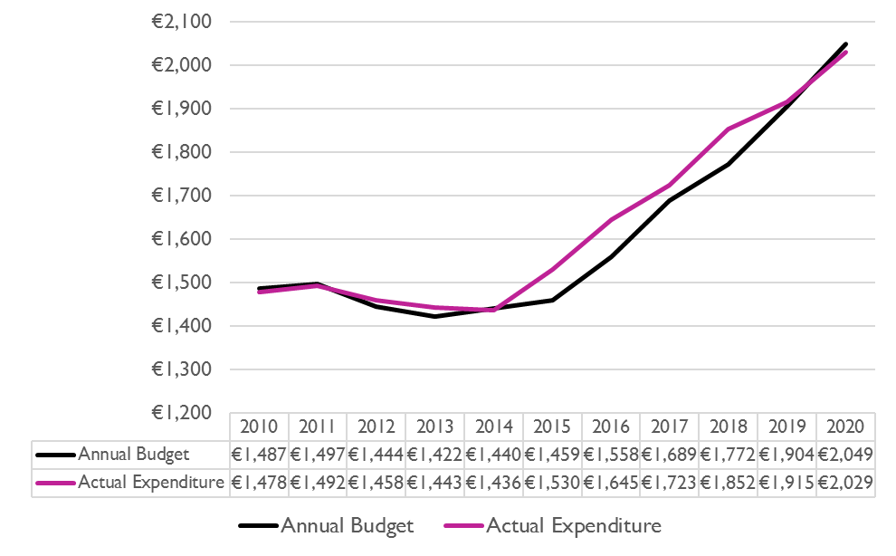

Source: HSE

Despite the scale of the monies spent on disability services, current service provision does not provide all the specialist disability services needed (Hourigan et al. 2018). The numbers requiring disability services and the cost of those services is also projected to increase in the future (Department of Health 2021). For example, the number of adults with intellectual disability needing specialist disability services has been projected to increase by 25% over the 2018-2032 period. Concern has been expressed regarding the financial sustainability of funding. Pike, O’Nolan and Farragher have asserted that:

To be economically sustainable into the future, and to fulfil the expectation that care in the future will be honoured and that the taxpayer will be happy to subscribe, governments need to coordinate care resources and set eligibility criteria to deliver the appropriate level of service to a variety of different categories of people (2016, p.6).

Around three-quarters of HSE disability spending is absorbed by supports for persons with an intellectual disability. One tenth of spending relates to persons with a physical or sensory disability and the remaining 15% is spent on ‘individuals who have some form of mixed disability’ (Campbell et al. 2017, p.28). Residential supports account for almost two-thirds of monies allocated to disability services. It is estimated that around 90% of those receiving residential supports are persons with intellectual disabilities (Bruton et al. 2020; HSE 2018). Based on the premise that 65% of total funding for disability supports is absorbed by residential services for 8,400 individuals (HSE, 2020), this indicates that, in 2020, average annual funding per recipient is €148,185 which equates to a weekly amount of €2,842.

### Value for Money and Policy Review

The Department of Health’s Value for Money (VFM) and Policy Review of Disability Services in Ireland highlighted significant variation in cost outcomes within the sector (Department of Health 2012). The VFM review found that cost variations were not consistently linked to agency status or size. However, on average the cost per person was found to reduce as the size of service units increased. The highest support costs were most commonly associated with individuals with autism and behaviours of concern or mental health issues. Staff pay and conditions, rostering practices, staff-to-client ratios and staff skill mix were all identified as important contributors to unit costs. The report pointed to the absence of national guidelines regarding staff-to-client ratios and rostering practices (p.117).

The VFM review also noted that data deficits were a significant barrier to reaching conclusive findings and recommended that:

A reconfigured governance framework is put in place which will encompass the standardised assessment of individual need; allocation of resources; procurement and commissioning; quality assurance; risk management; performance management, review and accountability; information systems; and management structures (Department of Health 2012, p. xxv)

The recommendations within the VFM report regarding the allocation of individual budgets have not yet been fully implemented, although a scheme is underway to pilot personal budgets.

Despite the publication of the VFM review almost a decade ago, many of the key issues raised in the report have not been addressed. A review of available data resources of disability residential services was undertaken as a component of the current research. There was limited data available with the notable exception being from the HSE’s service improvement team (See Technical Annex 12). The significant data deficits in relation to services referenced in the VFM review have not yet been fully addressed. While there has been a notable, but as yet incomplete, re-orientation of services towards person-centred supports, this change has not been accompanied by the full range of improvements in the management of information and governance envisioned by the VFM review. Recommendations with regard to commissioning and procurement, resource allocation and information infrastructure are not yet fully implemented. Funding allocations continue to be primarily driven by historic allocations and incremental budgeting. Although the VFM review characterised “client-level costing” as fundamental to an assessment of the efficiency with which services or supports are provided (p.90), a sector wide system of unit costing is not yet in place. Consequently, funding of services and the allocation of resources to individual disability residential services clients has not developed to the point of being a fully rationalised and transparent process. The delay in the implementation of the VFM recommendations and the consequent lack of appropriate service costings data has continued to restrict robust evaluation procedures within the sector.

### Capital costs

Another important cost element for consideration in the context of decongregation is the capital costs associated with constructing new housing units for individuals that transfer to the community. Housing solutions for individuals that transfer to the community generally involve a mix of new and pre-existing properties. A share of these housing solutions are funded by the HSE, while others may be funded by alternative funding streams such as those under the Department of Housing.

Table 5.1: Housing solutions for those who transitioned in 2019

| Type of Housing Arrangement | No. of People | % of those who transitioned |
| --- | --- | --- |
| New HSE Funded Community Housing | 28 | 24.1 |
| Existing Service Provider House | 28 | 24.1 |
| Local Authority Housing | 11 | 9.5 |
| Nursing Home | 10 | 8.6 |
| Existing Approved Housing Body | 9 | 7.8 |
| New Approved Housing Body Home | 9 | 7.8 |
| Other & Not Specified | 8 | 6.9 |
| Private Rental Arrangements | 7 | 6 |
| Family Home | 3 | 2.6 |
| Palliative Care Setting | 2 | 1.7 |
| Private Provider | 1 | 0.9 |
| Total | 116 | 100 |

Source: HSE[38]

The Department of Health’s Capacity Review of Disability Services estimates that the capital costs of providing housing solutions for individuals that have yet to decongregate may be as high as €280m. As this analysis is a comparison between two models of service delivery in two distinct settings, whereby residents transfer from congregated settings to community housing units with a mix of housing solutions, costs arising from the need for additional housing units are taken to be beyond the scope of this service model cost assessment. Capital costs associated with providing housing solutions for individuals that do decongregate are additional to the current costs examined in this study.

### Purpose of the costing element

Given the significant levels of public monies directed towards providing disability services, it is essential to carefully examine and consider the implications of the ongoing process of reform in the sector for the public finances. Most importantly, it is necessary to ensure that any unanticipated emerging service cost pressures do not result in budget re-profiling, which may result in impaired service standards or reduced quality of care. This chapter seeks to address these issues by comprehensively measuring the cost of service delivery pre and post decongregation in order to assess the implications of the ongoing process of deinstitutionalisation for the Exchequer.

This research has been preceded by the 2011 report ‘Time to Move On from Congregated Settings’, which was published by the HSE’s Working Group on Congregated Settings.[39] While the Time to Move On report includes many findings of interest in relation to service costings, the relevant 2006 field research data is now too dated to inform a cost assessment seeking to compare the current cost of service provision pre and post decongregation.

We have estimated the costs based upon the staffing mix and roster arrangements observed in both the congregated and community housing settings in recent years, that is after the introduction of increased regulatory oversight and associated pay cost increases (See Technical Annex 13). Pay cost estimates are based upon current HSE pay scales and estimated overheads.[40]

Further work was done as part of this study around estimating the cost of day services for persons with disabilities. These estimates are outlined in Annex 14.

The remainder of this chapter looks separately at the costings of congregated settings (5.2) or community settings (5.3) and then compares the two (5.4). It then forecasts the further costs of decongregation and finishes with a discussion of the cost findings.

## 5.2 Costs in congregated settings

### Calculating pay costs for congregated settings

A survey of staffing and operational arrangements at congregated settings was undertaken in early 2021 to determine the likely current running costs of congregated settings. A 24-hour roster template, designed by the HSE and modified for the purposes of this survey, was distributed to five different service providers, one of which was the HSE. The survey distribution encompassed 12 residential units within congregated settings at 7 different locations, resulting in returned sample rosters for 11 residential units. The congregated settings were purposefully chosen in conjunction with the HSE to reflect a range of settings. This approach was considered preferable to using data collected in Phase 1 of the survey as those 11 congregated settings were all deemed priority sites meaning they had not met HIQA standards and were therefore prioritised for decongregation. Therefore, the potential costs related to these 146 individuals may not be reflective of all congregated settings.

Respondents were asked to fill in the roster template to reflect 24-hour staffing arrangements at facilities covering all staff types and grades. This approach allowed for the accurate calculation of premia payments associated with unsociable working hours, such as the twilight payment and night allowance payments. The roster template also differentiated weekday and weekend roster arrangements in order to take account of likely differences in resourcing across different stages of the week and to calculate premia payments associated with weekend work. The specification of weekly resource allocations for various staffing grades also allowed for the calculation of additional staffing cost elements such as relief hours, annual leave and public holidays on a facility-by-facility basis.[41] All but one of the congregated settings provided day services on site.

In terms of the substantive findings of the survey of congregated settings, the results showed a considerable degree of variation in the staffing arrangements across the congregated settings that participated in the survey. This finding was to be expected, as the profile of need among residents at the facilities which participated in the survey varied considerably.[42] Average weekly staffing hours per resident at congregated settings ranged from 46.9 hours up to 106.5 hours. Half (50%) of all staffing hours at congregated settings were allotted to Care Assistants, with an additional 31.1% of all hours allotted to Staff Nurses. The remaining roster hours were staffed by Catering and Support Staff (8%), Supervisory Staff[43] (7.1%) and Administrative Staff (3.8%).

Using the weekly roster template inputs from the survey of congregated settings, pay costs were calculated for all facilities using the mid-point of HSE pay scales while taking account of non-core pay costs such as cover hours, relief hours, annual leave and salary premia payments. Average pay costs per resident at congregated settings ranged from €77,000 p.a. at the lowest cost unit up to €163,000 p.a. at the highest cost unit, again reflecting the considerable range of support need amongst the residents at different facilities.[44] Care Assistants constitute the largest share of pay costs (43.7%), followed by Staff Nurses (35.7%), Clinical Nurse Managers (9.1%), Catering and Support Services (6%), Clerical Officers (3.1%) and Directors of Nursing (1%), as shown in Figure 5.2.

**Figure 5.2: Share (%) of pay costs and AVG hours in congregated settings by staff category**

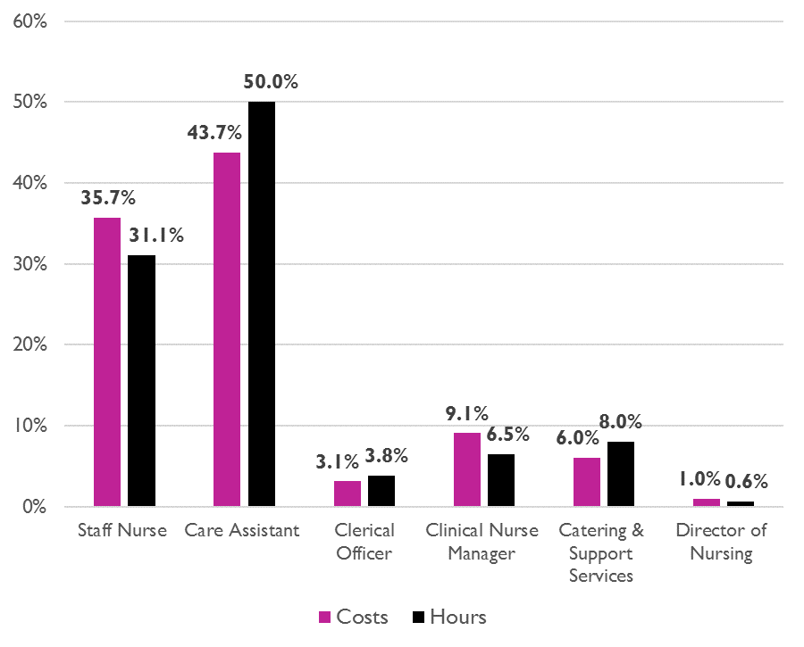

### Calculating non-pay costs for congregated settings

Advice from the HSE was that it could be very challenging and a lengthy process to get non-pay costs using the same method as for pay costs described above. Therefore, non-pay cost for congregated settings were calculated from the information that had previously been gathered from the 11 Phase 1 priority sites. This information was obtained from residential care managers and service provider finance officers. The unit costs calculation methodology was guided by pre-existing research by LaingBuisson (2013) and by social care costing work from the UK Personal Social Services Research Unit (PSSRU) report on unit costs of health and social care[45] A breakdown of the components of the annual per-resident non-pay costs at congregated settings and their estimated values is provided in Table 5.2.

Table 5.2: Annual per resident non-pay costs[46] at congregated settings

| Living Expenses | €5,451 |
| --- | --- |
| Other Accommodation Costs | €3,832 |
| Support Overheads | €555 |
| Service User Expenses | €2,104 |
| Central Overheads | €9,739 |
| Total Per Resident Non-Pay Costs | **€21,680** |

### Total congregated settings costs

Once non-pay costs are included, average total (i.e. pay and non-pay) costs per resident at the congregated settings which participated in the survey ranged from €98,000 p.a. up to €185,000 p.a. The overall average cost per resident for the full sample of congregated settings which participated in the survey exercise was €139,000 p.a. as shown in Figure 5.3.

**Figure 5.3: AVG annual per resident pay and non-pay running costs in congregated settings**

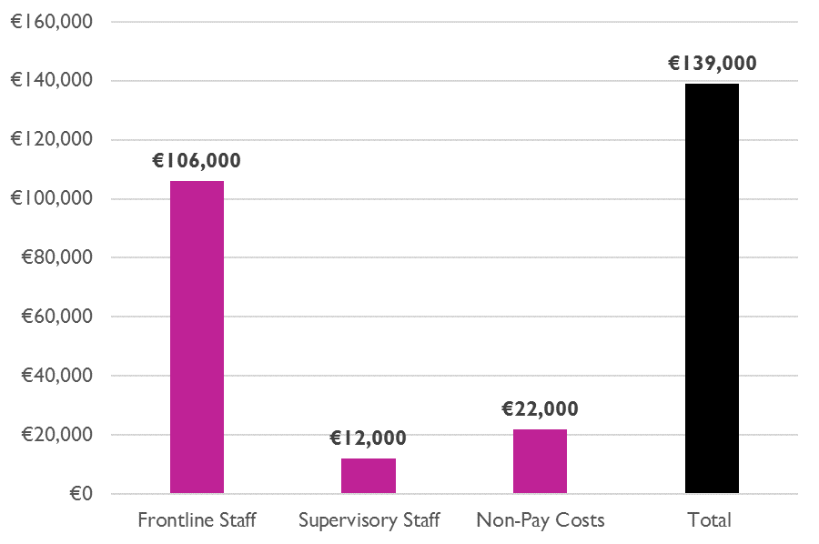

## 5.3 Costs in Community settings

In terms of calculating costs in the community housing setting, all costs for community residential houses are based upon houses with four residents, as this is most representative of the housing arrangement for people currently decongregating.

### Calculating non-pay costs for community housing

The approach to calculating non-pay costs are the same for community housing as those utilised for congregated settings. These are based upon a combination of observational field research, information from residential care managers and service provider finance officers. While basic living expenses and service user expenses do not vary significantly according to residents’ level of support, support overheads and central overheads in the community housing setting rise in tandem with levels of support need (Figure 5.4).

**Figure 5.4: AVG annual per resident non-pay costs at community housing by level of support need**

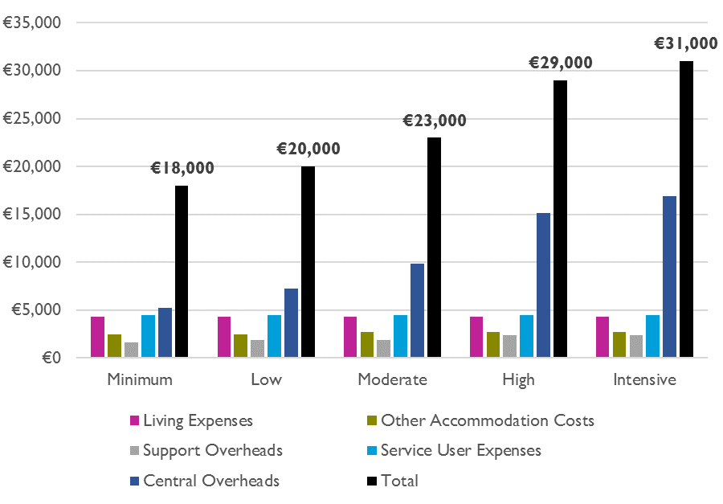

### Calculating pay costs for community housing

While the approach to obtaining representative rosters in congregated settings involved a survey exercise, whereby managers completed a spreadsheet to provide details on staffing hours, staff types and staffing grades, in the community setting, NDA research staff compiled the same information through discussions with and follow up information from residential care managers and service provider finance officers. Another difference in the approach to examining each respective setting is that for community housing the representative rosters were drawn up on the basis of the level of support need of residents, with four residents living in each unit. By contrast, the survey of congregated settings did not request such details from facilities which participated in the survey.

While the approach to obtaining representative rosters for each respective service setting are distinct in these respects, each applies a mutually consistent methodology to calculate staffing costs and arrives at mutually consistent unit cost metrics for comparative purposes in the subsequent final analysis. Staffing costs were calculated using mid-point salary scales while taking account of non-core pay costs such as cover hours, relief hours, annual leave and salary premia payments.[47]

### Total community costs

In common with past research in this area, our findings point to significant variation in staffing costs that is mainly driven by widely varying levels of support needs among residents. Assumptions regarding the skill mix of staff and the provision of sleeping or waking night cover are informed by our engagements with service providers and observational field research, as well as knowledge of staffing practices and regulatory requirements.

Figure 5.5 highlights the strong positive correlation between residents’ level of support need and service delivery unit costs. Total annual per resident running costs for those with low levels of support need average €81,000 per annum in the community housing context. These costs increase according to residents’ level of support need, reaching €278,000 per annum for those residents with ‘Intensive’ support needs.

**Figure 5.5: Annual per resident community housing residential care service cost elements by level of support need**

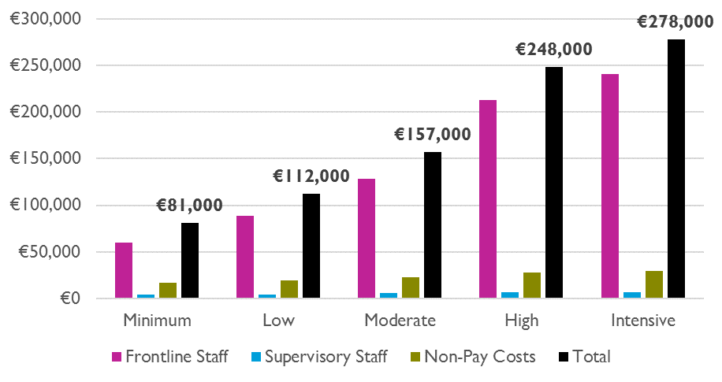

## 5.4 Comparison of pay and non-pay costs in congregated settings and community housing

The final phase of the analysis consist of a comparison of the cost of service delivery in congregated settings and community housing. Figures 5.5 and 5.6 compare the pay and non-pay costs for those congregated settings which participated in the survey with the community housing facilities examined delineated by residents’ level of support need. As previously observed, there is a positive correlation between residents’ level of need and the cost of service delivery, though this is significantly more pronounced for pay costs than for non-pay costs.

**Figure 5.5: Comparison of AVG annual pay costs in congregated settings and community housing by level of support need**

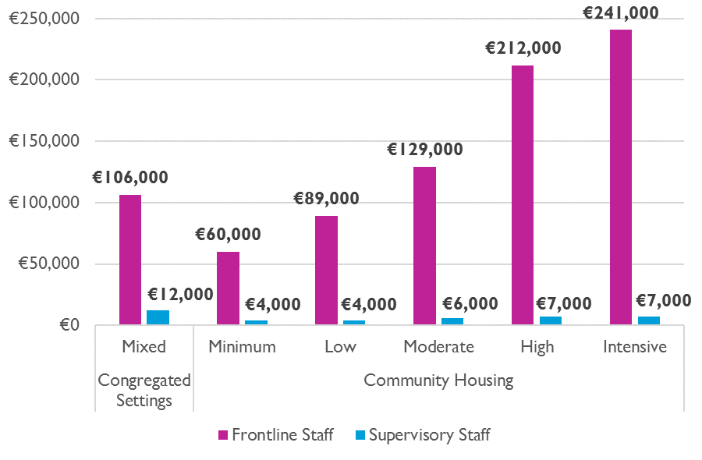

**Figure 5.6: Comparison of AVG non-pay costs in congregated settings and community housing by level of support need**

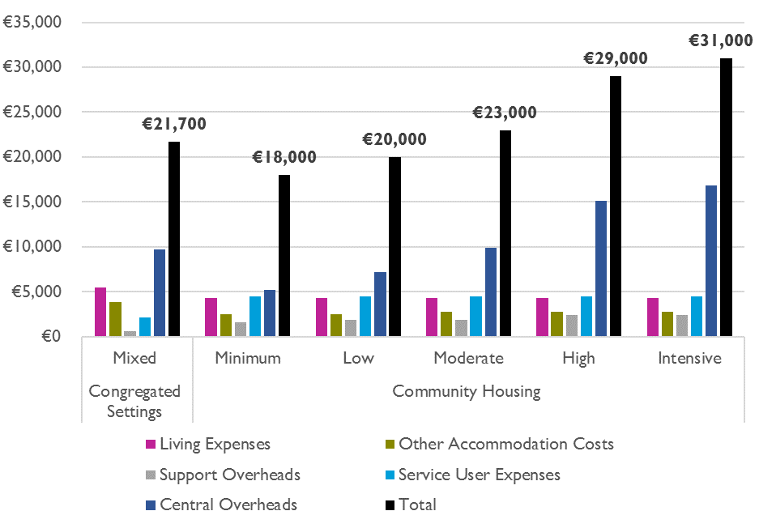

Figure 5.7 presents the average annual per resident pay and non-pay costs for the congregated settings that participated in the survey exercise alongside the same measure for each of the four bed community housing units costed according to residents’ level of support need. Again, the strong positive correlation between residents’ level of support need and running costs is clearly observable for the community housing setting. As the cost of service delivery for congregated settings presented below is a simple average for all residents across all congregated settings which participated in the survey, it is reflective of the mean level of support needed and mean unit costs at these facilities. It is therefore unsurprising to observe that the average annual per resident running costs for all congregated settings is higher than that for community housing units with residents that have low or moderate levels of support need, while also being significantly lower than the running costs of facilities with residents with intensive or very intensive levels of support need.

**Figure 5.7: AVG annual per resident pay and non-pay costs in congregated settings and community housing by level of support need**

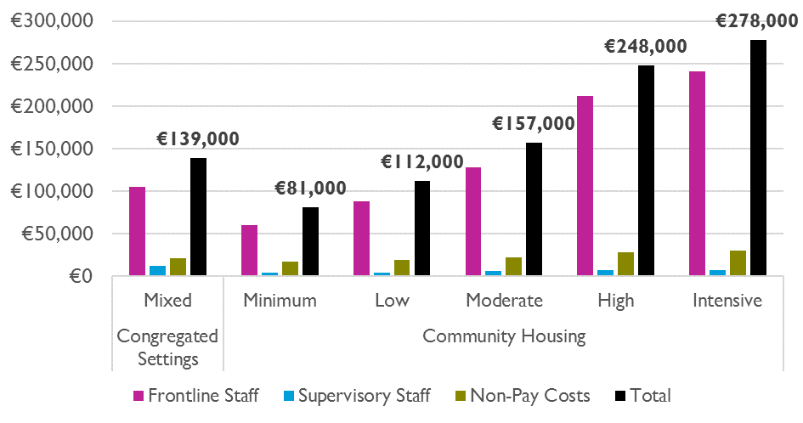

While it is interesting to observe and compare the average cost of service delivery at congregated settings with costs as they arise across a range of support needs in community housing units as modelled above, this does not yet constitute a directly comparable measure of service delivery costs pre and post decongregation. The comparative unit costings analysis above does not yet show the full cost implications of providing services in community housing for those individuals currently in congregated settings. In order to assess the full cost of transferring those individuals that have yet to decongregate to community housing it is necessary to apply a weighted average[48] cost which reflects the distribution of support needs among residents that currently reside in congregated settings. This was achieved using available data on support needs for individuals who have yet to decongregate as reported by the HSE in its “Time to Move On from Congregated Settings” Annual Progress Report for 2019 (HSE 2020 p19). The majority of individuals (66%) still living in congregated settings have a level of support need described as ‘High’. The next largest group is those designated as having ‘Moderate’ levels of support need (20.6%) while a further 7.7% are ‘Intensive’. Just 4.1% of those who have yet to decongregate have ‘Low’ levels of support need while a further 1.5% have ‘Minimum’ levels of support need (See Figure 5.8).

**Figure 5.8: Support needs of individuals who have yet to decongregate**

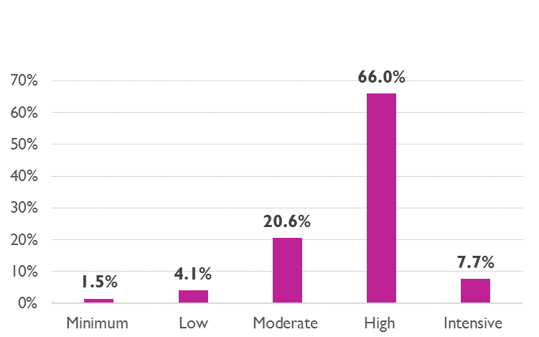

Source: HSE

In order to arrive at a directly comparable unit cost metric we calculate a weighted cost of service delivery in the community housing context using the four bed housing unit costings data as inputs. The resulting weighted average unit cost is expressed below as cost per person per annum for community housing and compared to the average cost per person for service delivery for the same cohort in congregated settings.[49] Once the level of support need among residents has been accounted for, the average cost of service delivery increases from €139,000 p.a. in congregated settings to €223,000 per annum in community housing (See Figure 5.9). The average cost uplift associated with transfer from congregated settings to community housing for those who have yet to decongregate is €84,000 per resident p.a. – a cost uplift of 60.2%. The main drivers of this cost uplift are diseconomies of scale stemming from the higher staff-to-resident ratios in the community housing setting as evidenced by the higher per resident frontline staff costs observed in the community housing context.

**Figure 5.9: Weighted AVG comparison of per resident annual service delivery costs in congregated settings and community housing**



It is important to clarify that these results express the average cost uplift associated with transferring those individuals that have yet to decongregate to community housing. The generally high levels of support need among these individuals means that the cost of providing services are higher for this particular cohort as compared to the approx. 6,200[50] people with disabilities that already reside in disability residential community housing.[51] Considering both congregated and community housing contexts, the average annual unit cost of a placement nationally stood at approx. €144,000 per resident in 2018 (Department of Health, 2021 p.19 & 141). This is in fact comparable to the unit costs of service provision for those individuals that currently remain in congregated settings (€139,000 p.a.). While the forward-looking cost to the Exchequer of decongregation will be an additional €84,000 p.a. per individual for the approx. 1,800[52] clients that have yet to decongregate, the historical cost uplift for the approx. 6,200 individuals who already reside in community housing has actually been significantly less. Figure 5.9 compares the unit cost estimate findings across settings, data resources and support need.

**Figure 5.10: Comparison of AVG annual per resident unit costs**

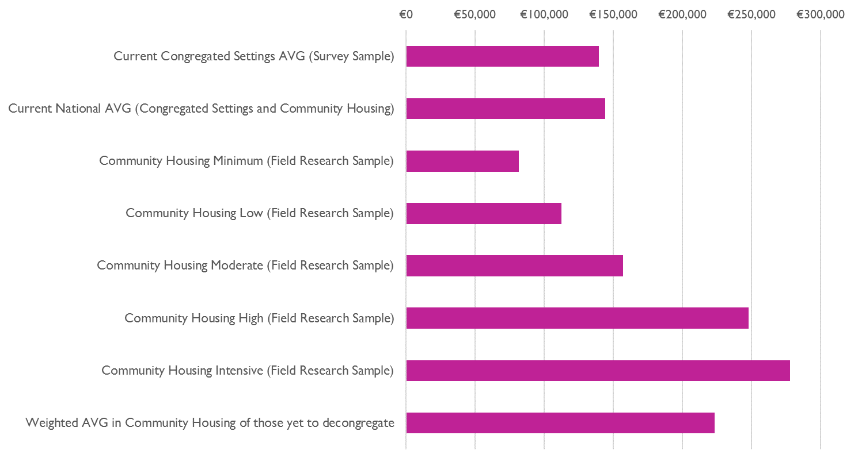

## 5.5 Cost of further decongregation

Progress in the ongoing process of decongregation has been gradual. The Time to Move On policy initially committed to closure of all congregated settings by 2019, before this target was subsequently moved to the end of 2021. While there were 4,099 people residing in congregated settings in 2009, this stood at approx. 1,950 at the end of 2019 (HSE, 2020). A total of 789 people passed away in congregated settings over the 2012-2019 period, while 278 were either admitted or re-admitted to congregated settings over the same period[53]. The reduction in the number of individuals in congregated settings has averaged 191 individuals per annum since 2012.[54] A subset of these have been successful transitions to the community averaging 117 per annum.

**Figure 5.11: Individuals remaining in congregate settings at year end and annual reductions**

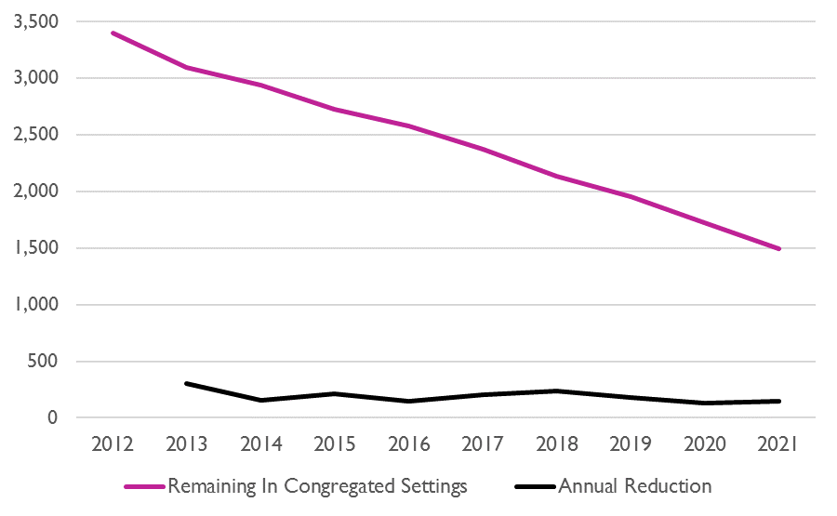

While the number of individuals remaining at congregated settings stood at approx. 1,950 at the end of 2019, HSE National Service Plans indicate planned transfers to the community of 132 in 2020 and 144 in 2021 (HSE 2019; HSE 2021). Once additional annual mortalities[55] have been accounted for, the number of individuals remaining in congregated settings at the end of 2021 will stand at approx. 1,500. The HSE’s most recent projections suggest that “completion of decongregation by 2030 would require around 150 people a year to transition to the community from 2020 onward, assuming the current mortality rate of 4% among those remaining in the institutional settings” (Department of Health 2021, p69). We model the practical and fiscal implications of this timeline for the completion of decongregation, as well as two additional, more ambitious, timelines – completion in 2025 and completion in 2027 (Figure 5.12 and Figure 5.13).

**Figure 5.12: Scenario analysis of decline in the number of individuals remaining in congregated settings.**

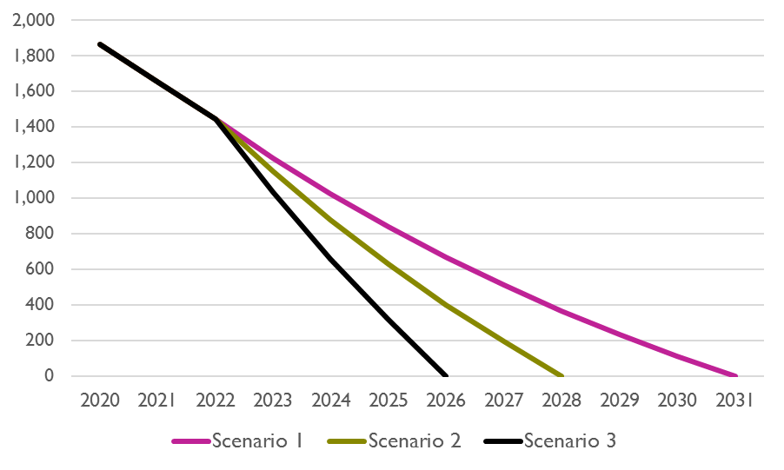

**Figure 5.13: Scenario analysis of annual transfers from congregated settings to the community**

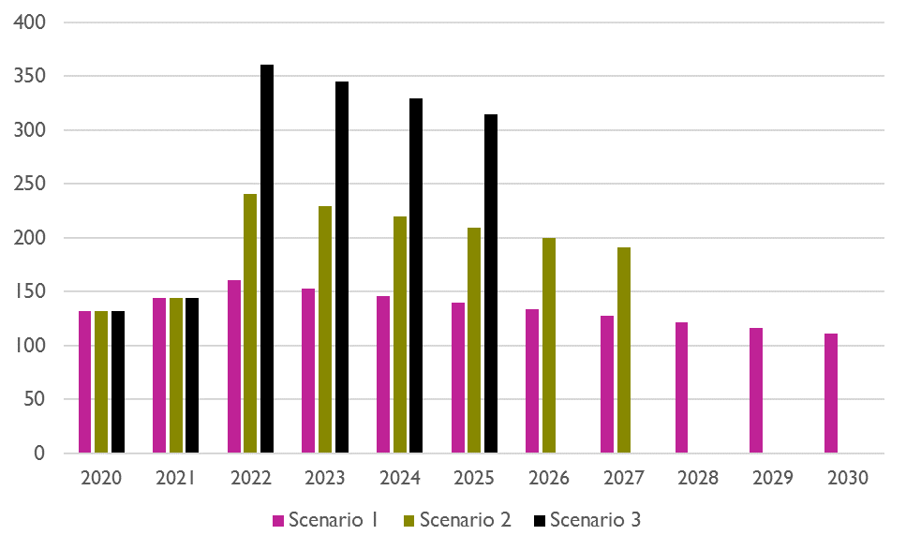

Completion of decongregation in 2030 (Scenario 1) would require an average of 134 individuals to transfer to the community per annum over the 2022-2030 period. Completion of decongregation in 2027 (Scenario 2) would require an average of 215 individuals per annum to transfer to community housing over the 2022 to 2027 period. Completion of decongregation in 2025 (Scenario 3) would require an average of 337 individuals to transfer per annum over the 2022-2025 period.

The timeline on which decongregation is eventually achieved has significant implications in terms of budgetary management and the cost of providing services, since the cost uplift associated with providing services in the community housing setting for a given individual is then carried over into subsequent years. When modelled at scale to reflect the forward-looking cost of transferring all individuals that have yet to decongregate to the community the implications for the Exchequer are substantial. Once mortality and inflation[56] have been accounted for the annual cost uplift for disability residential care services that is attributable to the transfer of additional individuals to the community reaches €140.1m p.a. by 2030 in Scenario 1. However, a comparable level of expenditure of €139.2m p.a. is reached in 2027 under scenario 2 before rising to €147.7m p.a. by 2030. Under scenario 3 expenditure of €138.8m p.a. is reached in 2025 before reaching €153.2m p.a. by 2030 (See Figure 5.14).

**Figure 5.14: Scenario analysis of cost uplift due to additional decongregation**

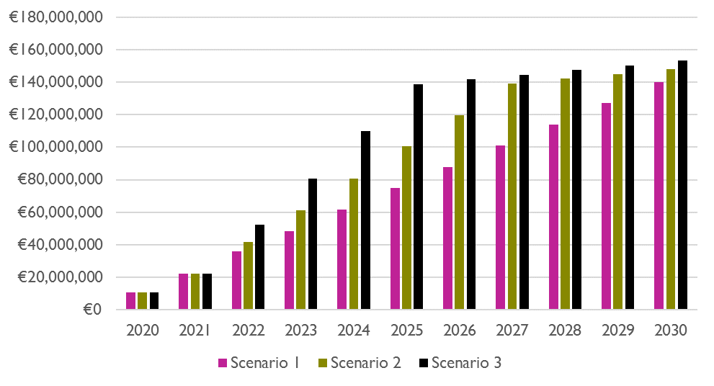

As it is more costly to provide residential care in the community housing setting, a key budgetary implication of this analysis is that the faster decongregation is achieved, the more costly it is to implement. It is critically important that adequate funding is provided so as to realise the goal of deinstitutionalisation on an appropriately ambitious timeline, so as to achieve the quality of life improvements that living in the community brings as soon as is practicable.

## 5.6 Discussion of costs

The system in place in Ireland for the allocation of funds to disability residential care service providers has generally not been underpinned by a standardised unit costing approach or assessment of need for disability residential care service clients. A comprehensive register of persons in receipt of residential and day services is currently not available, and there has been little progress in moving away from the system of incremental budgeting as recommended in the VFM review of disability services. Low levels of service evaluation standardisation and centralisation stem from a combination of factors, including the very high levels of reliance upon the voluntary sector in Ireland, with just 12.3% of places in designated centres being provided directly by the HSE. There is a need to continue to significantly improve data collection in relation to both costs and outcomes across disability services.

Service delivery costs have increased over time in recent years, stemming from factors such as increased rates of pay under the public sector pay agreements and changes to the regulatory environment for disability residential care services in Ireland. Increases in staffing levels in both the congregated and community housing settings are attributable to improvements in the external regulation and monitoring of services as well as a sector-wide commitment to delivering higher-quality person-centred supports. These cost increases are captured in both the congregated setting and community housing contexts compared in this service costings assessment, allowing for direct comparison of the cost of service delivery pre and post decongregation.

Once residents’ level of support need has been accounted for, the comparative analysis of service delivery costs in congregated and community housing settings showed an average cost uplift of €84,000 p.a., representing an increase of 60.2% in service delivery costs as a result of decongregation. The cost uplift of service delivery associated with decongregation is largely attributable to diseconomies of scale associated with higher staff-to-resident ratios in community housing.

To capture the full cost of decongregation at scale, the analysis modelled the forward-looking practical and cost implications of decongregation examining three scenarios – completion in 2030, 2027 and 2025. The analysis suggests that the cost implications of completing the process of decongregation are significant, and necessitate the provision of adequate funding to achieve the aims of the deinstitutionalisation agenda. The cost increases associated with decongregation are in addition to the regulatory and public sector pay-based drivers of cost increases in the sector, and so must be adequately budgeted for in the years ahead in order to deliver on the aims of the deinstitutionalisation agenda.[57]

The methodological approach to costing services was somewhat distinct for the congregated settings and community housing elements. While representative rosters were attained for congregated settings through the distribution of a survey, such data were captured for community housing through a combination of observational field research and data from service provider managers and finance officers. Additionally, while the work to attain representative rosters for community housing captured data on residents’ level of support need, this was not achievable for congregated settings.[58] While residents’ level of support need was not recorded in the survey of congregated settings, available data from the HSE allowed for a representative profiling of the support needs of residents in congregated settings that have yet to decongregate.[59] Using these data on the support need, a weighted average of service delivery unit costs in the community housing context was then estimated for this same cohort, thereby coming to a directly comparable average per resident unit cost for comparative purposes. While these approaches are somewhat distinct for each respective setting, the analysis ultimately arrives at a mutually consistent and directly comparable service delivery unit cost estimate, i.e. average cost per resident annum.[60]

Costs arising from the delivery of housing solutions for individuals that decongregate are taken to be beyond the scope of the service model cost assessment. A share of these housing solutions are funded by the HSE, while others may be funded by alternative funding streams such as those under the Dept. of Housing. While the cost of delivering community housing solutions and the adaptation of homes are beyond the scope of the service delivery unit cost analysis, such costs are additional to those examined in this report. The Department of Health’s Capacity Review of Disability Services estimates that the capital costs of providing housing solutions for individuals that have yet to decongregate may be as high as €280m. These capital costs are additional to the service delivery running costs examined in this study.

Finally, the service costings results reflect the economic cost implications of the provision of disability residential care services in community housing, i.e. the full cost implications without regard for budgetary considerations stemming from non-commercial income. Recipients of residential support services are required to make a statutory contribution towards maintenance costs in the form of the Residential Support Services Maintenance and Accommodation Contribution (RSSMAC) (See Technical Annex 15). While deduction of the RSSMAC would be appropriate to a corporate financial analysis or a budgetary forecasting exercise, it would not be appropriate to a service cost assessment analysis, as doing so would understate the full service costs under examination.[61]

In terms of potential cost savings, it is possible that there could be some reductions in costs over time and the NDA recommends that these are actively explored. One possibility is that there would be a reduction in the client to staff ratio as clients become more independent and as staff and managers become more comfortable with working in the community. Some examples were given by service providers of adjusting staffing levels by, for example, moving from a waking night cover to a sleeping night cover. The move away from nursing staff to more care staff and social care workers is likely to continue and this may reduce staff costs somewhat. A resource allocation tool may help in ensuring consistency in staffing levels between services for clients with similar needs. Staff have also frequently reported a reduction in behaviours that challenge following a move to the community and there may be a decrease in the amount of medication required that could also impact on costs. Parallel policies that support ageing in place in the family home through respite and day services, and increased planning to avoid emergency placements, will be important to reduce transfers into residential care.

The study also found that the use of technology to increase independence of clients was limited. There are a number of technological solutions such as self-monitoring tools for service users of their health, telehealth, falls detection technology, safety related technology such as personal alarms and voice activated or timed technologies for routine home activities such as turning on lights. These could all potentially reduce staff support requirements and could ultimately reduce overall costs of community supports in future.

Another issue worth noting is the costs associated with transitions. These costs might include the additional staffing costs relating to planning and preparation of both the resident and in terms of sourcing and preparing a house. Measuring the costs stemming from this additional work was outside of the scope of this study. It is also worth noting that many services had increased expenditure during the period when transitions to the community were underway. These were not related to the transition but were often associated with the costs of upgrading the congregated setting or increasing staffing to meet HIQA regulations. Therefore, while the cost modelling set out above indicates substantial costs associated with the decongregation process, these costs are derived within the current regulatory contexts and based on the higher support needs of those remaining in congregated settings. It does not purport to model the longer term costs of providing individualised supports within the community for the heterogeneous population in receipt of residential supports.

# Chapter 6. Limitations

## 6.1 Limitations in participant selection

Due to the nature of how disability services are structured and due to the lack of a comprehensive sampling frame it was not possible to randomly select participants for this study. Therefore the study was reliant on gatekeepers in services to recruit participants for the study.

Phase 1 of the study was restricted to people resident in the congregated priority sites for decongregation, all of which provided care to people with intellectual disabilities. Therefore, this sample may not be representative of all people living in congregated settings.

Similarly the Phase 2 participants, who were selected based on their use of disability services, were not recruited randomly and may not be representative of the total population of persons receiving disability support. However, given the high number recruited for this study it is likely that at least some of the findings are generally applicable.

Not all service providers contacted were willing to assist in the recruitment of participants. Where services did engage in the research, the researchers had limited control over who the service provider invited to participate. It is not clear if all service providers used the same criteria to select participants. Similarly, it is not known if those chosen are representative of the population resident in each site.

To ensure full transparency and accountability and promote best practice in relation to participation in relevant research, the HSE, within service level and grant agreements with providers, may wish to explore the possibility of mandating services to participate in certain research projects. It is hoped that the establishment of a National Research Ethics Committee for social care related research will flow from the National Research Ethics Committees Bill 2019 which may improve direct access to service providers to invite them to take part in research.

## 6.2 Limitations of FACE

FACE has limitations in that it does not provide a clinical assessment of need and does not indicate the type and quantity of therapy supports an individual may require (e.g. speech and language therapy, physiotherapy or occupational therapy), nor the need for specific assistive technologies. It does not collect information specifically regarding the use of psychotropic or anti-psychotic medication, which could facilitate the monitoring of prescribing practices within disability services. This information would have been useful in this study in measuring the level of unmet need which would have an impact on quality of life and wellbeing.

FACE calculates a Global Need Band. However, the weight given to the Global Need Band may overstate the support needs of those who are living in settings with a constant staff presence as responses may be influenced by staffing levels rather than with the safety needs of each individual participant. There may also be an overly conservative approach to assessing the safety needs of individuals with disabilities by family carers. The assessment of the presence of staff required for safety often seemed to be heavily influenced by risk averse practices that stemmed from paternalistic attitudes rather than each individual’s capacity and ability. Therefore, the Global Need Bands indicated should be interpreted with caution.

Some of the assumptions that underpin the costing algorithm for the FACE tool do not reflect the model of service in the Irish context. For example, the algorithm assumes that no more than one person will ever provide waking night cover, which is not a valid assumption in the Irish context. Another shortcoming of the FACE algorithm is that, while it takes account of the number of people sharing, it does not factor in the support needs of the other residents when assessing a given individual. Staffing in residential care settings are generally significantly influenced by the needs of the resident that requires the highest level of support. Individual support needs may alter depending on the abilities or impairments of other residents. More information on these limitations is provided in Technical Annex 12

## 6.3 Limitations related to measuring quality of life and outcomes

There is no easy reliable means of assessing the subjective wellbeing or quality of life of persons with severe/profound intellectual disability (Nieuwenhuijse et al. 2019) and the use of proxy assessments is controversial. None of the Phase 1 participants could engage with the ASCOT-SC-ER, the tool used to measure subjective social care related quality of life despite it being a tool specifically designed for people with an intellectual disability. One-third of Phase 2 participants were unable, or opted not, to engage the tool. Some participants with other primary disabilities such as visual impairments, limited literacy skills, or physical disabilities that affected their ability to write, also required assistance.

Our research indicates that, while the use of ‘smiley face’ images in the ASCOT-SC4-ER tool did assist many participants to understand each domain, they also frequently distracted participants and in several cases, the images associated with the safety outside the home question caused participants to become distressed. They may also have introduced bias to the responses to this question. It may, therefore, be preferable to display images on a separate page from the answer options so that participants can more easily focus on selecting a response option.

The ASCOT tool was administered after the completion of FACE profiles and although participants were offered opportunities to take breaks it may be that tiredness resulted in some participants failing the acquiescence test.

As part of the FACE profile, participants were asked to identify changes that would improve their well-being or quality of life. This question was not answered by all participants. Some participants lacked the capacity to respond while others struggled to think of any changes and might have been better able to answer this question if they had had more time to reflect and consider possible changes.

As Phase one participants were not able to engage with the ASCOT tool the nine outcome domains previously developed by the NDA were used. While some information on the outcomes could be obtained from the FACE tool and the participant some subjective assessments were also made which could be influenced by interviewer bias.

It is not possible to link the quality of life or outcomes of participants to costs. Both assessments were done independently so one cannot say that the increased spend required for an individual who is decongregating will automatically lead to a better quality of life or better outcomes for that individual.

## 6.4 Limitations related to service costings

While every effort has been made to accurately estimate service delivery unit, costs for both the congregated settings and community housing contexts, a general lack of reliable data and other practical considerations including lack of access to data, resulted in some limitations in the approach to estimating service costs. While data on representative rostering arrangements was attained through a survey exercise for congregated settings, representative rostering data for community housing was obtained through observational field research and the utilisation of data resources provided by service provider managers and finance officers. Additionally, data on residents’ level of support need was not captured during the survey of congregated settings, but was obtained during the estimates work for community housing. Despite these differences in the approach to obtaining representative rosters for each respective setting, the final comparative analysis examined directly comparable unit cost metrics. Finally, the costings work relating to congregated settings was undertaken during a later phase of the research project than that for community housing in light of the recognition of the need to reflect the current pay and regulatory conditions in the sector.

# Chapter 7. Conclusions and Recommendations

## 7.1 Phase 1 participants

Phase 1 participants, who lived in priority sites for decongregation, constituted a group of people whom almost all have extensive or pervasive support needs. As a group they presented with high levels of communication difficulties, mental illness, behaviours that challenge and epilepsy. These difficulties, combined with very limited competency with regard to ADLs and IADLs suggest that many had an intellectual disability in the severe to profound range.

The transition process has progressed at a slower than anticipated rate. More than three years have elapsed since this study commenced and almost three in ten participants remain in the priority sites. Sadly, ten participants have died. Two have transferred to other facilities due to increased medical needs.

On average those who moved to the community required slightly less support to undertake ADLs and IADLs after transitioning from priority sites than before their transition. Given the age, extent of disability and the history of lengthy institutionalisation among this group it is not surprising that major changes in functional ability did not flow from the transition process.

Similar to findings observed by HIQA (2019b) in their report entitled ‘Five years of regulation in designated enters for people with disabilities’, observations in this study indicate that, for those who moved, the living environment and other quality of life domains had improved immeasurably post transition even though not all outcomes had yet been fully achieved.

A great deal of commonality was evident in the management of the transition process across the priority sites. The houses, staffing levels, and range of activities were in general very similar. Differences were observed in the orientation of staff towards the promotion of independence and activation. These differences were not service based but rather seemed to stem from the attitudes of individual staff members. It is acknowledged that staff often struggle to see possibilities for progression when the people they support have severe/profound intellectual disabilities or profound/multiple disabilities. However, some staff members displayed ambition and imagination in designing activities and saw possibilities when perhaps others only saw limitations. Innovation and energy were not service specific. A continued focus on active supports and enablement is required to achieve the best possible outcomes for residents.

Those who moved differ in some minor respects from participants who did not move. Those who moved were slightly older, more likely to have none or less severe communication difficulties, and on average, required less support to undertake ADLs than those who did not move. There were only minor differences in the mental health, emotional wellbeing and levels of behaviours that challenge of those who moved and those who did not move. Those who moved reported lower rates of pain but higher rates of epilepsy than those who did not move. Both groups required similar levels of support to undertake IADLs.

Capital and revenue funding to support transitions has been generous. New homes are spacious and fitted out to a high standard. The ratio of staff to residents is high. However, the pace of the transition process has slowed. This is potentially reflective of a number of factors that may reflect a downward shift in the priority afforded to decongregation, a lack of resources, and the more time-consuming nature of supporting transition in a person-centred manner.

The study identified some areas which might merit further consideration as the decongregation process continues. In many instances, the participants continued to attend on-campus day centres following decongregation. This raises questions whether this approach precludes full integration into the community. However, Sheerin et al. have pointed out that former residents of congregated settings may not be able to easily or completely “dissociate from the congregated setting” and a continuing link may provide them with a sense of security (2015, p. 278). This issue may warrant further investigation over a longer period of time and guidance for staff to be mindful of the need to move away from the congregated setting over time.

Some services grouped together participants with similar difficulties when decongregating them. This is possibly due to service provider attempts to manage staffing ratios and rosters. However, previous research has highlighted the negative consequences, in terms of both costs and outcomes, which can result from grouping people with behaviours of concern together (Robertson et al. 2004). It may be preferable if persons with serious behaviours of concern were not housed together.

## 7.2 Phase 2 participants

Phase 2 participants comprise a group with varying levels of support needs, different types of disabilities and living arrangements, whom access an array of disability services. This reflects the heterogeneity of the population supported by specialist disability services.

Participants with a primary physical disability required more support with regard to both ADLs and IADLs than those with other types of disability and were more likely to indicate that they would like additional support. Just a quarter of Phase 2 participants aged under 65 were engaged in some form of employment and the majority of those in employment were in part-time employment.

The research suggests that there is further scope for services to promote independent life skills. Our study indicates considerable variation in the interpretation of ‘New Directions’ and in determining the appropriate role of services with regard to training and job search/job placements. There is also a need for greater coordination between day and residential services and between services and families to ensure that training provided is incorporated and promoted in all areas of a person’s life. There is also a need for ongoing training and development of staff through mentoring and supportive supervision to ensure that staff are providing support in a person-centred way that maximises the opportunities for independence of those they support.

Participants’ support needs were positively correlated with the severity of their disability. However, the presence or absence of ‘natural’ or informal supports was a mediating factor in determining participants’ reliance on or requirement for disability services. Many families provide extensive and enduring support to relatives with disabilities. A decline in natural supports often ensues after parents die. In recognising the importance of natural supports the study also identifies that not all adults with disabilities wish to access natural supports, particularly for personal or intimate care.

The study highlighted the extent to which, at times, the level of support some people were receiving seemed to constrain, rather than support, self-determination and independence. These findings highlight the necessity of evaluating the support needs of individuals with disabilities prior to admission to residential settings to avoid inappropriate placements. In keeping with a rights based approach to care, the supports provided should be appropriately aligned with the ability and capacity of individuals (HIQA 2019a). It is worthy of reflection that the transition of a resident from a registered designated centre to a living arrangement other than another designated centre is subject to statutory regulation (HIQA 2015), but admission into designated centres are not the subject of regulation.

Multivariate analysis of the data highlighted several important aspects for a high quality of life (ASCOT) score. Any pain, especially a high level of pain, was detrimental to quality of life. Disliking the people an individual lives with, or living in a congregated setting was also detrimental. The variable about liking or disliking the people lived with may seem to be beyond public policy but as the cluster analysis demonstrated, it is associated with other variables such as picking staff, having family support and having the key to the door. Where service providers work to ensure that the individual has choices and actually likes the people they live with (or don’t actively dislike them) the negative effect of being in a residential setting can be offset. It is, therefore, wrong to focus on a single variable – such as the key to the door, or picking staff. Rather, what seems to be important is working with residents to give them as much choice over as many variables as possible regarding the life they want to lead.

It must be borne in mind that quality of life assessments will be influenced by individual, environmental and survey related factors. UK research points to an association between poor self-reported health, poor ratings for home design, higher levels of anxiety and depression and lower quality of life (Rand and Malley 2017).

## 7.3 Costs

The service delivery unit costs comparative analysis indicates a significant cost increase stemming from the transfer of individuals from congregated settings to community housing. This is largely driven by the high need level of those who have yet to decongregate and the therefore relatively high staffing level they will require. The analysis suggests that the cost implications of completing the process of decongregation are significant, and necessitate the provision of adequate funding to achieve the aims of the deinstitutionalisation agenda. The cost of providing disability residential care services has been steadily increasing in recent years due to improvements in the regulatory environment leading to increased staffing levels at facilities. Pay costs have also increased in all settings due to the ongoing process of pay restoration. The cost increases associated with decongregation are in addition to these established drivers of inflation in the sector, and so must be adequately budgeted for in the years ahead in order to deliver on the aims of the deinstitutionalisation agenda on an appropriately ambitious timeline. The long-term budgetary outlook for the sector highlights the need to ensure value for money and appropriate budgetary oversight in the funding of services in the years ahead.

While providing services in the community housing context is generally more costly, the decision to do so does not stem from budgetary considerations or the aim of achieving a more cost effective model of service delivery. The commitment to pursue deinstitutionalisation stems from fundamental human rights considerations, including the obligation to ensure that individuals can choose who they live with in community settings in line with Article 19 of the UNCRPD (Sections 4.3.4). The justification for decongregation is the substantial improvements in their quality of life which residents experience when living in the community.

## 7.3 Recommendations

The findings from this study have allowed for a number of recommendations to be made relating to the ongoing decongregation process and to providing person-centred supports more generally. Below, recommendations specific to the HSE, service providers, the Department of Health, and relating to future research are presented. For each recommendation the corresponding results or discussion section pertaining to it in the main report is indicated in brackets.

### 7.3.1 Recommendations for the HSE

* Continue to prioritise the process of decongregation to improve the lives of those living in congregated settings. In addition, continue to minimise new or re-admissions into congregated settings (Section 3.11).
* Continue to support residents, both newly resident in the community and newly transitioned people, to meet their goals and objectives in a person-centred way (Section 3.11.2).
* Enhance the support provided to promote ageing in place in the family home through respite and day services, and increase forward planning for this cohort to minimise emergency placements in residential care (Section 4.2.2).
* Keep the current process surrounding the determination of funding under review to ensure that the process serves the interests and quality of life concerns of clients. Consider the use of a standardised assessment tool that can be one factor in informing resource allocation for clients. An assessment tool, however, should not be the only tool used for resource allocation and should be linked with the person’s person-centred plan (Section 5.6).
* Continue to improve data collection and management standards in the disability residential care sector, both in relation to data on service delivery costs and data on service outcomes more broadly. Such improvements are needed at all levels, including the HSE, CHOs, voluntary sector organisations and other government agencies (Section 5.6).
* Consider providing guidance to service providers on the merits, or otherwise, of residents continuing to attend the institutional setting to access day and other services following decongregation, particularly regarding the barrier this may be to community integration (Section 7.1).
* Consider providing guidance to service providers on the merits, or otherwise, of grouping together residents with similar needs in community houses (Section 7.1).
* Standardise the interpretation of ‘New Directions’ among services to combat the variation in interpretation observed in this study (Section 7.2).
* Support services to improve opportunities to innovate and enhance the lives of disability support users through technological solutions. As evidenced in this study, these are not being fully explored (Section 5.6).

### 7.3.2 Recommendations for service providers

* Continue to prioritise staff training, particularly in the area of person-centred support and a rights-based approach to support (Section 7.2).
* Consider implementing a structured but person-centred day activation programme for community residents who do not currently have one. A continued focus on active supports and enablement is required to achieve the best possible outcomes for residents (Section 3.6.1.4).
* Implement systems to ensure that, in keeping with a rights-based approach to care, the supports provided to clients are appropriately aligned with the ability and capacity of individuals (HIQA 2019a) and provide them with more independence and opportunities for self-determination. This should include regular reviews of the levels of support needed and provided. It will also require that staff are developed and provided with supportive supervision to ensure they are providing a person-centred approach and avoiding institutional practices in community settings (Section 7.2).
* Work to ensure that clients can choose who they live with in community settings, in line with Article 19 of the UNCRPD (Section 4.3.4).
* Improve coordination between day and residential services and between services and families to ensure that training provided is incorporated and promoted in all areas of a person’s life (Section 7.2).

### 7.3.3 Recommendation for Department of Health

* Provide leadership, guidance, support and resources so that the HSE can effectively and fully implement the TTMO strategy (Section 3.9.1).
* Accelerate the setting up of a National Research Ethics Committee for social care related research (Sections 2.2 and 6.1).

### 7.3.4 Further research

* Conduct further research on quality of life tools and alternative methods, including extensive structured observation. Although the quality of life tool used in the study was designed for use by people with intellectual disabilities, many participants, particularly those with a moderate or severe intellectual disability, could not engage with the tool (Section 6.3).
* Consider ongoing research among people who have transitioned to the community from congregated settings to track their quality of life and level of community integration over time as well as changes in staffing requirements (Section 3.8.2 and 4.7).

# References

Bigby, C. (2008) ‘Known well by no-one: Trends in the informal social networks of

middle-aged and older people with intellectual disability five years after moving to

the community’, **Journal of Intellectual and Developmental Disability** 33, 2 148-157. <https://doi.org/10.1080/13668250802094141>

Bruton, L., Gibney, S. and Collins, D. (2020) Social Impact Assessment Series: Specialist Disability Services for People with Intellectual Disabilities. Irish Government Economic and Evaluation Service. Available from: <https://igees.gov.ie/wp-content/uploads/2020/01/Intellectual-Disabilities-SIA.pdf> (Last accessed December 2021)

Campbell, T., de Barra, S., Duffy, R., Newman, F. and Reilly, D. (2017) ‘Spending Review 2017 Disability and Special Education Related Expenditure’, Dublin: Department of Public Expenditure and Reform. Available from: <http://www.budget.gov.ie/Budgets/2018/Documents/5.Disability%20and%20Special%20Education%20Related%20Expenditure%20-%20Part%20of%20the%20Spending%20Review%202017.pdf> Available from: (Last accessed December 2021)

Cummins, RA (2005) ‘Moving from the quality of life concept to a theory’, **Journal of Intellectual Disability Research**, 49(1)’, pp.699-706. <https://doi.org/10.1111/j.1365-2788.2005.00738.x>

Cummins, RA. (2013), ‘Fostering quality of life.’ **InPsych,** 35(1). Available from: <https://www.psychology.org.au/publications/inpsych/2013/february/cummins> (Last accessed December 2021)

Cummins, RA. (2016) ‘The theory of subjective wellbeing homeostatis: A contribution to understanding life quality.’ In F.Maggino (Ed.) **A Life Devoted to Quality of Life-Festchrift in Honor of Alex C. Michalos** (Vol.60 pp.61-79). Dordrecht, Netherlands: Springer.

Department of Health (2012) ‘Value for money and policy review of disability services in Ireland’, Available from: <https://www.gov.ie/en/publication/ed3564-value-for-money-and-policy-review-of-disability-services-in-ireland/> (Last accessed December 2021)

Department of Health (2021) ‘Disability Capacity Review to 2032 - A Review of Social Care Demand and Capacity Requirements to 2032’, Available from: <https://www.gov.ie/en/publication/d3b2c-disability-capacity-review-to-2032-a-review-of-social-care-demand-and-capacity-requirements-to-2032/> (Last Accessed December 2021)

Fisher, KR., Parker, S. and Purcal, C. (2007),’ Effectiveness of Supported Living in Relation to Shared Accommodation’, Report prepared for the Disability Policy and Research Working Group. Sydney: University of New South Wales. Available from: <https://www.arts.unsw.edu.au/sites/default/files/documents/Report18_08_Effectiveness_of_SuppLiving.pdf> (Last Accessed November 2021)

Health Information and Quality Authority (HIQA) (2015), ‘What constitutes a designated centre for people with disabilities? Guidance for provider organisations’ (Revised Date: 22 June 2015). Available from: <https://www.hiqa.ie/sites/default/files/2017-01/What-constitutes-a-designated-centre.pdf> (Last Accessed December 2021)

Health Information and Quality Authority (HIQA) (2019a) ‘Guidance on a Human Rights-based Approach in Health and Social Care Services’, Available from: <https://www.hiqa.ie/sites/default/files/2019-11/Human-Rights-Based-Approach-Guide.PDF> (Last Accessed December 2021)

Health Information and Quality Authority (HIQA) (2019b) Five years of regulation of designated centres for people with a disability. Available from: <https://www.hiqa.ie/sites/default/files/2019-08/HIQA-DCD-5-Year-Regulation-Report-2019.pdf> (Last accessed December 2021)

Health Service Executive (2011) ‘Time to Move on from Congregated Settings: A Strategy for Community Inclusion’. Report of the Working Group on Congregated Settings. Available from: <https://www.hse.ie/eng/services/list/4/disability/congregatedsettings/time-to-move-on-from-congregated-settings-%E2%80%93-a-strategy-for-community-inclusion.pdf> (Last Accessed December 2021)

Health Service Executive (2012) ‘New Directions. Report of the National Working Group for the review of HSE Funded Adult Day Services’, Available from: [new directions report.pdf (hse.ie)](https://www.hse.ie/eng/services/list/4/disability/newdirections/new%20directions%20report.pdf) (Last Accessed December 2021)

Health Service Executive (2018) ‘Transforming Lives Working Group 1 Report on Future Needs for Disability Services, April 2018’, Available from: <http://nda.ie/Publications/Disability-Supports/Transforming-Lives.pdf> (Last Accessed December 2021)

Health Service Executive (2019) ‘National Service Plan 2020’, Available from: <https://www.hse.ie/eng/services/publications/national-service-plan-2020.pdf> (Last accessed December 2021)

Health Service Executive (2020) ‘Time to Move on From Congregated Settings: A Strategy for Community Inclusion, Annual Progress Report 2019’, Available from: <https://www.hse.ie/eng/services/list/4/disability/congregatedsettings/time-to-move-on-annual-progress-report-2019.pdf> (Last Accessed December 2021)

Health Service Executive (2021) ‘National Service Plan 2021’, Available from: <https://www.hse.ie/eng/services/publications/serviceplans/national-service-plan-2021.pdf> (Last Accessed December 2021)

Hourigan S., Fanagan S. and Kelly C. (2018) ‘HRB Statistics Series 37 Annual Report of the National Intellectual Disability Database Committee 2017 Main Findings’, Dublin: Health Research Board. Available from: <https://www.hrb.ie/fileadmin/2._Plugin_related_files/Publications/2018_pubs/Disability/NIDD/NIDD_Annual_Report_2017.pdf> (Last Accessed December 2021)

LaingBuisson (2013). Surrey Learning disabilities costing survey. Cost analysis report. LaingBuisson, London.

McConkey, R., Keogh, F., Bunting, B., & Iriarte, E. G. (2018) ‘Changes in the self-rated well-being of people who move from congregated settings to personalized arrangements and group home placements’, **Journal of Intellectual Disabilities**, 22(1), pp.49–60. <https://journals.sagepub.com/doi/10.1177/1744629516674086>

National Disability Authority (2016) ‘Outcomes for Disability Services’, Dublin: National Disability Authority. Available from: [NDA paper on outcomes for disability services | The National Disability Authority](https://nda.ie/Publications/Disability-Supports/NDA-paper-on-outcomes-for-disability-services.html) (Last Accessed December 2021)

National Disability Authority (2021) ‘Staff and Change Management: Good Practice in the Transition to Community Residential Disability Services’, Available from: <http://nda.ie/news-and-events/news/staff-and-change-management-report.html> (Last accessed December 2021)

Netten, A., Burge, P., Malley, J., Potoglou, D., Towers, A.M., Brazier, J., Flynn, T. and Forder, J., (2012) ‘Outcomes of social care for adults: developing a preference-weighted measure’, **Health Technology Assessment**, 16(16), pp.1-166. <http://doi.org/10.3310/hta16160>

Nieuwenhuijse, A.M., Willems, D.L., van Goudoever, J.B., Echteld, M.A. and Olsman, E., (2019) ‘Quality of life of persons with profound intellectual and multiple disabilities: a narrative literature review of concepts, assessment methods and assessors’, **Journal of Intellectual & Developmental Disability***, 44(3*), pp.261-271. <https://doi.org/10.3109/13668250.2017.1388913>

Pike, B., O’Nolan, G. and Farragher, L. (2016) ‘Individualised budgeting for social care services for people with a disability: International approaches and evidence on financial sustainability’, Dublin: Health Research Board. Available from: <https://www.hrb.ie/fileadmin/publications_files/Individualised_budgeting_for_social_care_2016.pdf> (Last Accessed December 2021)

Rand, S., and Malley, J. (2017) ‘The factors associated with care-related quality of life of adults with intellectual disabilities in England: implications for policy and practice’, **Health and Social Care in the Community**, 25(5), pp.1607-1619. <https://www.doi.org/10.1111/hsc.12354>

Rand, S., Towers, A.M., Razik, K., Turnpenny, A., Bradshaw, J., Caiels, J. and Smith, N. (2020) ‘Feasibility, factor structure and construct validity of the easy-read Adult Social Care Outcomes Toolkit (ASCOT-ER)’, **Journal of Intellectual and Developmental Disability**, 45(2), pp.119-132. <https://www.doi.org/10.3109/13668250.2019.1592126>

Robertson, J., Emerson, E., Pinkney, L., Caesar, E., Felce, D., Meek, A., Carr, D., Lowe, K., Knapp, M. and Hallam, A. (2004). ‘Quality and costs of community-based residential supports for people with mental retardation and challenging behavior’, **American Journal on Mental Retardation**, 109(4), pp.332-344. <https://pubmed.ncbi.nlm.nih.gov/15176914/>

Sheerin F., Griffiths, C., de Vries, J., Keenan, P. (2015). ‘An evaluation of a community living initiative in Ireland’. **Journal of Intellectual Disabilities**, 19(3), pp.266-81. <https://doi.org/10.1177/1744629515573679> .

United Nations (UN) (2006) Convention on the rights of persons with disabilities. Geneva: United Nations. Available from: <https://www.un.org/development/desa/disabilities/convention-on-the-rights-of-persons-with-disabilities/convention-on-the-rights-of-persons-with-disabilities-2.html> (Last Accessed December 2021)

# Appendix 1: Original Terms of Reference for congregated settings project

Below are the original terms of reference for the project. These were adapted through the life of the project as required and when difficulties accessing required data were encountered.

**Introduction:**

This project is being undertaken by the NDA at the request of the HSE in order to measure and evaluate changes in quality of life for individuals who move from congregated settings to community settings, as well as analysing the costs of the new models through measurement tools for consistency and an equitable approach. The project will have specific reference to the 14 accelerated decongregation sites. The project complies with the requirements of the Department of Public Expenditure and Reform with regard to an appropriate approach for analysis of costs and benefits and an acceptable sample size to ensure the reliability of the research findings.

The evaluations proposed in the project plan will be conducted using FACE (v7) profiling tool and will be augmented by an accompanying ‘quality of life’ tool, a summary observation tool and collection of cost data.

**The Terms of Reference for the project can be summarised as follows:**

To conduct an evaluation of people currently living in congregated settings at two stages: before their move and again after their move to community models of service. This will allow a comparison of ‘before’ and ‘after’ in terms of cost and quality of life.

To conduct an evaluation of a cohort of people who have already experienced ‘new’ models of service in either Genio or Next Steps demonstration projects against a matched sample of people in traditional models of services.

To ensure the evaluations are conducted according to the highest ethical standards and under rigorous data protection protocols.

To use the results of the above evaluations to conduct a cost-benefit analysis of the various models of service: congregated settings, new models and traditional service models. This will inform HSE and DPER decision making for future service-provision.

To use the results of the above evaluations to develop a ‘measure’ of quality of life under the various models of service.

To ensure the experiences of people in new models of service, and the progress of those who decongregate, is captured under new Outcome measures.

To develop a series of recommendations to inform both decongregation specifically and the transfer into alternative models of service generally.

# Appendix 2: Scientific Advisory Committee Members

These members served at various times through the project

* Anne McGrane (Department of Health)
* Claire Collins (Department of Health)
* Alison Harnett (The National Federation of Voluntary Bodies)
* Eithne Fitzgerald (NDA, Independent consultant and Department of Health)
* Suzanne Moloney (HSE)
* Maev-Ann Wren (ESRI)
* Mary-Ann O’Donovan (TCD)
* Laura Watts (Department of Public Expenditure and Reform)
* Noel Howard (Department of Public Expenditure and Reform)
* Jane McEvoy (Saint John of Gods)
* Anna Cunniffe (NDA)
* Caroline O’Nolan (NDA)
* Grainne Collins (NDA)
* Aideen Hartney (NDA)
* David Hallinan (NDA)
* Rosalyn Tamming (NDA)

1. Members of the Scientific Advisory Group are listed in the appendix
2. Premia payments refers to various allowances that are additional to basic pay. These mainly arise when staff work overtime, on standby or unsocial hours.
3. The calculation of non-pay costs for both congregated settings and community housing are based upon a combination of observational field research, information from residential care managers and service provider finance officers. The same methodology was applied to calculate non-pay costs for both congregated settings and community housing, and took account of potential variability in non-pay costs arising due to the level of support need among residents.
4. This was achieved using the data for individuals who have yet to decongregate as reported by the HSE in its “Time to Move On from Congregated Settings” Annual Progress Report for 2019 (HSE 2020 p19). The majority of individuals (66%) still living in congregated settings have a level of support need described as ‘High’. The next largest group is those designated as having ‘Moderate’ levels of support need (20.6%) while a further 7.7% are ‘Intensive’. Just 4.1% of those who have yet to decongregate have ‘Low’ levels of support need while a further 1.5% have ‘Minimum’ levels of support need
5. Behaviours of concern or behaviours that challenge include self-injurious behaviours, aggression and destruction of property.
6. Range 0-32 with 0 indicating no assistance needed with any of the 8 ADLs and 32 indicating participants were unable to undertake any of the 8 ADLs and needed two others to undertake each task.
7. The composite IADL score for each participant could range from a minimum of 0 (indicating little or no assistance required with any of the six IADLs) to a maximum of 14 (indicating no capacity to undertake any of the six IADLs).
8. All participants have been assigned a pseudonym. Pseudonyms were chosen from https://www.cso.ie/en/interactivezone/visualisationtools/babynamesofireland/ with the reference year of 1965.
9. Pay costs make up 84% of total running costs in congregated settings and 88% of pay costs in community housing.
10. Unit costs rounded to nearest €1,000.
11. This was achieved using the data for individuals who have yet to decongregate as reported by the HSE in its “Time to Move On from Congregated Settings” Annual Progress Report for 2019 (HSE 2020 p19). The majority of individuals (66%) still living in congregated have a level of support need described as ‘High’. The next largest group is those designated as having ‘Moderate’ levels of support need (20.6%) while a further 7.7% are ‘Intensive’. Just 4.1% of those who have yet to decongregate have ‘Low’ levels of support need while a further 1.5% have ‘Minimum’ levels of support need
12. Based upon DoH figures for 2018 showing the total number of individuals in residential care services at 8,300, with 2,100 in congregated settings at end of 2018. (Dept. of Health, 2021)
13. Approx. number at end of 2020. Calculated as 1,953 at end of 2019 (HSE 2020), less approx. 132 transitions in 2020 (HSE 2019).
14. For example, New Directions - Personal Support Services for Adults with Disabilities (HSE, 2012)
15. A sampling frame is the population from which a sample is taken. At the time when this study was being conducted, there was no accessible bed register or register of day centre attendees. The new National Ability Supports System is likely to provide a sampling frame in time.
16. Most new entrants to day services are young adults transitioning from school. New entrants to day services are commonly referred to as school-leavers.
17. Data Protection Act 2018 (Section 36(2); Health Research) Regulations 2018 (SI 314/2018).
18. For the purposes of the Health Research Regulations, social care research is included within the definition of health research.
19. All participants have been assigned a pseudonym. Pseudonyms were chosen from <https://www.cso.ie/en/interactivezone/visualisationtools/babynamesofireland/> with the reference year of 1965 for Phase 1 participants based on their average age.
20. Premia payments refers to various allowances that are additional to basic pay. These mainly arise when staff work overtime, on standby or unsocial hours.
21. Range 0-32, with 0 indicating no assistance needed with any of the 8 ADLs and 32 indicating participants were unable to undertake any of the 8 ADLs and needed two other to undertake each task.
22. The composite IADL score for each participant could range from a minimum of 0 (indicating little or no assistance required with any of the six IADLs) to a maximum of 14 (indicating no capacity to undertake any of the six IADLs).
23. A Working Group report on Day Services and an implementation plan for reform is set out in New Directions (HSE 2012).
24. All participants have been assigned a pseudonym. Pseudonyms were chosen from https://www.cso.ie/en/interactivezone/visualisationtools/babynamesofireland/ with the reference year of 1975.
25. Range 0-32 with 0 indicating no assistance needed with any of the 8 ADLs and 32 indicating participants were unable to undertake any of the 8 ADLs and needed two other to undertake each task.
26. The composite IADL score for each participant could range from a minimum of 0 (indicating little or no assistance required with any of the six IADLs) to a maximum of 14 (indicating no capacity to undertake any of the six IADLs).
27. A recently published NDA report had the same finding which is explored in more depth (NDA 2021).
28. Indicated by an increase in ADL scores
29. Indicated by a decrease in ADL scores
30. Indicated by a decrease in IADL scores
31. Range 0-32 with 0 indicating no assistance needed with any of the 8 ADLs and 32 indicating participants were unable to take any of the 8 ADLs and needed two other to undertake each task.
32. The composite IADL score for each participant could range from a minimum of 0 (indicating little or no assistance required with any of the six IADLs) to a maximum of 14 (indicating no capacity to undertake any of the six IADLs).
33. Natural supports are supports provided from with a person’s social network. They include supports provided by family and extended family, friends, colleagues and neighbours. Informal supports are community based supports often provided in an unstructured or voluntary basis (Bigby, 2008).
34. The unweighted maximum total ASCOT score is 24 indicating that the ‘ideal state’ is present in all domains. The minimum score of 0 indicates high-level needs in all eight domains.
35. Ascot asked a similar question “How do you feel about the way your paid support treat you?” with four possible answers:

    I am very happy with the way my paid support treat me.

    I am quite happy with the way my paid support treat me.

    I am a bit unhappy with the way my paid support treat me.

    I am very unhappy with the way my paid support treat me. The responses to the two variables are significantly correlated.
36. A desire for a change to housing was significantly negatively correlated with total ASCOT scores,
37. The subsequent two-stage least squares regression used when the dependent variable’s error terms are correlated with the independent variables confirms all the variables that the stepwise regression had highlighted as important are indeed important– they are all significant and in the same direction as the previous regressions.
38. https://www.hse.ie/eng/services/list/4/disability/congregatedsettings/time-to-move-on-annual-progress-report-2019.pdf
39. https://www.hse.ie/eng/services/list/4/disability/congregatedsettings/time-to-move-on-from-congregated-settings-%E2%80%93-a-strategy-for-community-inclusion.pdf
40. See: https://healthservice.hse.ie/staff/benefits-services/pay/pay-scales.html

    On-costs or overheads are employment related costs that are incurred by employers in addition to basic pay rates. These include payroll tax, workers' compensation and various salary premium payments.
41. Some of the congregated settings were campus-based facilities, resulting in a degree of overlap and resource pooling in areas such as catering services, rostering and senior managerial responsibilities. Such transfer effects are neutralised in the final comparative unit cost analysis.
42. By this it is meant that the wide range of outcomes in terms of rostering arrangement and associated labour costs is indicative of a wide range of support need. The scope of this part of the study did not allow for collection of data on the precise level of need of residents at specific facilities as part of the survey exercise.
43. Clinical Nurse Managers and Directors of Nursing.
44. As these figures express an average cost at each facility they do not reflect the likely full range of support needs and costs as may arise if comparing individual residents.
45. The PSSRU and the work done by LaingBuisson provided a template for categorising and organising various costs headings and for ensuring that as far as possible the cost estimates represented all relevant costs. The PSSRU estimates also provided a comparator for the cost estimates arrived at in this analysis.

    The method utilised for calculating the non-pay running costs for congregated settings is wholly consistent with that employed for community housing facilities in the subsequent comparative costings analysis. The calculation of non-pay costs took account of potential variability in non-pay costs arising due to the level of support need among residents.
46. These include groceries, light and heating, laundry, telephone, Wi-Fi, TV, security, furniture and fittings, repairs and renewals, appliances, property insurance, property maintenance, gardening, local admin, training, cost of HIQA registration, activities, clinical activity and other central overheads.
47. The methodological approach to calculating pay costs for community housing was also informed by the social care unit costs template from the UK Personal Social Services Research Unit (PSSRU) report on unit costs of health and social care.
48. Weighted average implies an average resulting from the multiplication of each component by a factor reflecting its relative importance, which in this case is based upon the proportion of individuals in congregated settings within each respective service support need band.
49. As the cost of service delivery for congregated settings presented previously is a simple average for all residents across all congregated settings which participated in the survey, it is reflective of the mean level of support need at these facilities.
50. Based upon DoH figures for 2018 showing the total number of individuals in residential care services at 8,300, with 2,100 in congregated settings at end of 2018. (Dept. of Health, 2021)
51. This higher level of support need among residents that have yet to decongregate, as compared to those individuals that already reside in community housing, is evident within the HSE’s Disability Supports Management Application Tool (DSMAT). Within this data 51.4% of the residents in community housing are categorised as the lowest or second lowest level of support need along a five point scale, while 25.9% of residents are categorised as having the highest or second highest level of support need along the same five point scale. By contrast, just 13.7% of residents in congregated settings are categorised as having the lowest or second lowest level of support need along the same five point scale, while 60.1% of residents in congregated settings have the highest or second highest level of support need along the same five point scale of need.

    Similarly, National Ability Support System (NASS) data on the support needs of clients living in residential care also suggests that the national average level of support need is lower than that for those individuals that remain in congregated settings. https://www.hrb.ie/data-collections-evidence/disability-service-use-and-need/
52. Approx. number at end of 2020. Calculated as 1,953 at end of 2019 (HSE 2020), less approx. 132 transitions in 2020 (HSE, 2019).
53. https://www.hse.ie/eng/services/list/4/disability/congregatedsettings/infographic-time-to-move-on-2012-2019.pdf
54. Tracking of the decongregation process began in 2012. Some of these individuals died or transitioned to nursing home care.
55. Based upon 2019 annual progress report that reported a mortality rate of 4.5% for those remaining in congregated settings (HSE, 2020).
56. Mortality is based upon the HSE’s 2019 annual progress report that reported a mortality rate of 4.5% for those remaining in congregated settings (HSE, 2020). All figures are inflation adjusted using the European Central Bank’s target rate of inflation of 2%.
57. These issues have also been noted in the recently published Disability Capacity Review report (Department of Health, 2021)
58. This outcome is partly due to the fact that the congregated settings rostering data collection work was undertaken during the Covid-19 pandemic, while the rostering data for community housing predates the pandemic.
59. This was achieved using the data for individuals who have yet to decongregate as reported by the HSE in its “Time to Move On from Congregated Settings” Annual Progress Report for 2019 (HSE 2020 p19). The majority of individuals (66%) still living in congregated have a level of support need described as ‘High’. The next largest group is those designated as having ‘Moderate’ levels of support need (20.6%) while a further 7.7% are ‘Intensive’. Just 4.1% of those who have yet to decongregate have ‘Low’ levels of support need while a further 1.5% have ‘Minimum’ levels of support need
60. The approach to calculating non-pay costs was the same for each respective setting, and was based upon a combination of observational field research and data from service provider managers and finance officers.
61. Any effort to deduct the RSSMAC contributions of clients in a fiscal impact analysis would largely be redundant given the fact that the payment of this contribution is often through the disability allowance payment, which is in turn funded by the Exchequer.