# Annual Conference 2021 Logo of the National Disability Authority

**Meet the Speakers**

## Plenary Session

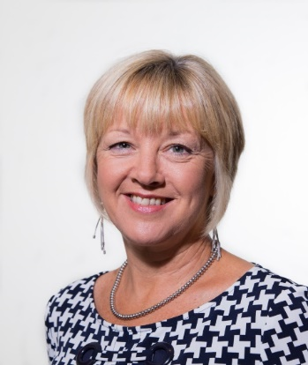 **Helen Guinan, Chairperson, National Disability Authority**

Helen Guinan spent most of her career working with, or on behalf of, children and young adults with intellectual, physical and sensory disabilities. She has been Chairperson of the National Disability Authority (NDA) since July 2014 and started her second four-year term in August 2018. She has been closely involved over many years in policy development and implementation at national level with a number of organisations, statutory and non-statutory, including the National Council for Curriculum and Assessment, the National Council for Special Education, and the National Federation of Voluntary Bodies. In this work, she gained a national and international perspective on advancements and improvements for persons with disabilities. She spent ten years as Principal in St. Paul’s School, Cork; a school for students with complex needs. As Chairperson of the National Disability Authority, Helen is committed to ensuring that this statutory body continues to provide independent, evidence-informed advice and information to Government about current matters influencing the lives of persons with disabilities in Ireland.

Roderic O’Gorman, T.D.
Minister for Children, Equality, Disability, Integration and Youth 
 **Roderic O’Gorman, T.D.**

**Minister for Children, Equality, Disability, Integration and Youth**

Roderic O'Gorman TD is the Minister for Children, Equality, Disability, Integration and Youth. He was appointed to this role in June 2020, having been elected as a member of the Dáil (Irish Parliament) in February 2020. He is a member of the Green Party/Comhaontas Glas. Prior to being elected, he was a lecturer on EU law. He worked with the Brexit Institute at Dublin City University, focusing on how to manage the challenge facing Ireland as a result of the UK’s decision to leave the European Union.

Rosemary Kayess, Chair of the UN Committee on the Rights of Persons with Disabilities 
 **Rosemary Kayess**

**Chair of the UN Committee on the Rights of Persons with Disabilities**

Rosemary Kayess is an internationally recognised and well-respected human rights lawyer in the area of disability. She is Chairperson of the United Nations Committee on the Rights of Persons with Disabilities. Rosemary teaches international human rights law at the Faculty of Law, University of New South Wales. Rosemary was a designated expert on the Australian Government delegation to the United Nations negotiations for the Convention on the Rights of Persons with Disabilities and facilitated the drafting of Article 24 on the Right to Education.

**Alberto Vásquez Encalada, Disability Rights Advocate and Lawyer, and Senior Advisor at Centre for Inclusive Policy  
 Alberto Vásquez Encalada, Disability Rights Advocate and Lawyer, Senior Advisor at Centre for Inclusive Policy**

Alberto Vásquez Encalada is a Peruvian lawyer and disability rights advocate. He holds an LL.M in International and Comparative Disability Law and Policy from the National University of Ireland, Galway. He works as Senior Advisor at the Center for Inclusive Policy (CIP). Previously, he worked as Research Coordinator at the Office of the UN Special Rapporteur on the Rights of Persons with Disabilities and as a consultant for different United Nations agencies, including UNICEF, the World Health Organization, the Office of the UN High Commissioner for Human Rights, and the Office of the UN Secretary-General. As the president of the Peruvian NGO Sociedad y Discapacidad - SODIS, he was actively involved in the drafting and advocacy related to the adoption of Peruvian legal capacity reform.

Dr Aideen Hartney
Director, National Disability Authority 
**Dr Aideen Hartney, Director, National Disability Authority**

Dr Aideen Hartney became Director (Chief Executive) of the National Disability Authority (NDA) in mid-2020, having joined the organisation in 2016 as its Head of Policy, Research and Public Affairs. The NDA is the independent statutory body, which provides evidence-based advice and research to Government on disability policy and practice and promotes Universal Design. (Universal Design involves the design of the built environment, products, services and information and communications technology (ICT) so that they can be accessed, understood and used by all, regardless of age, size, ability or disability).

Aideen has had a long career in overseeing research for the public good, having managed several major funded research programmes in University College Dublin, before coming to the NDA. She also has private sector experience following 7 years as a market research consultant. Aideen holds a doctorate in Ancient History, and lectured for a time at the University of Bristol.

## Session 1: The Assisted Decision-Making (Capacity) Act 2015

Áine Flynn, Director, Decision Support Service 
 **Áine Flynn, Director, Decision Support Service**

Áine Flynn graduated from Trinity College Dublin with a law degree and M.Litt. in criminal justice policy. She was admitted as a solicitor in 1999 and from 2012-2017 was a senior partner in KOD Lyons, a firm specialising in criminal defence and public interest law. She was on the panel of legal representatives of the Mental Health Commission and the Mental Health (Criminal Law) Review Board from their inception in 2006 and represented wards of court instructed by the General Solicitor. She has written and lectured on human rights and has been a member of the Human Rights Committee of the Law Society since 2012. Prior to her present appointment, she was a member of the Law Society’s Mental Health and Decision-Making Capacity Task Force.

In October 2017, Áine commenced her current post as Director of the Decision Support Service under the Assisted Decision-Making (Capacity) Act 2015.

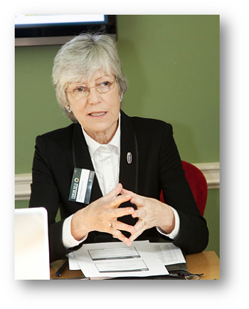 **Patricia Rickard-Clarke, Chairperson, Safeguarding Ireland**

Patricia Rickard-Clarke is a solicitor and former Commissioner of the Law Reform Commission. She is the Independent Chair of Safeguarding Ireland clg and Chair of SAGE Advocacy clg. She was a member of the HSE’s National Assisted Decision-Making (Capacity) Act Steering Group preparing for the implementation of the *Assisted Decision-Making (Capacity) Act 2015,* a member of the Multi-Disciplinary Group appointed by the Minister for Health to draft a code of practice for Advance Healthcare Directives and was also a member of the National Disability Authority’s Expert Group that developed the non-health care codes of practice for the 2015 Act. She is author of the Irish section on the *International Protection of Adults* published by Oxford University Press and has contributed to a number of publications on topics related to decision-making capacity and rights of older and vulnerable adults, the latest being Changing Horizons in the 21st Century – Perspectives on *Ageing* published by Cambridge Scholars Publishing in 2020.

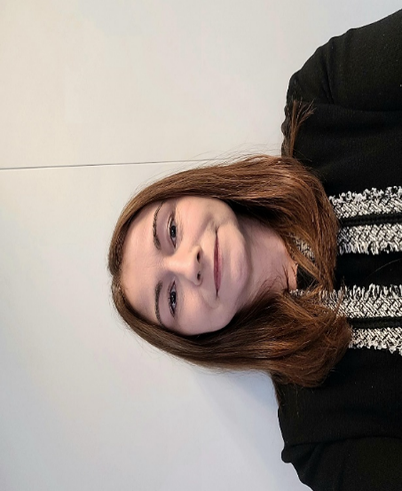 **Alice White, Registrar of Wards of Court**

Alice White is the Registrar of Wards of Court and has 19 years’ experience in the Courts Service. She has worked in a number of front line court offices and support areas in the Service. She has had senior roles in the Wards of Court Office and the High Court and was the Central Office Registrar before being appointed Registrar of Wards of Court in October 2019. Alice has a Bachelor of Business degree and post graduate certificate in corporate governance.

 **Patricia Hickey**

**General Solicitor for Minors and Wards of Court**

Patricia Hickey is the General Solicitor for Minors and Wards of Court and was appointed to this role in 2015. Prior to this appointment, she worked for 10 years as a Senior Solicitor in the Office of the General Solicitor. Before specialising in the areas of Elder Law, Vulnerable Adults and Minors and Wardship and Mental Health law she worked as a solicitor, in general practice. She is a member of Law Society Mental Health & Capacity Task Force, the DSBA Mental Health and Capacity Committee, DSBA Probate and Taxation Committee, Mentor with the Law Society Mentoring Programme and a member of Peru Children's Charity Committee.

 **Bernice Evoy**, **Head of Legal and Regulation**, **Banking and Payments Federation of Ireland**

Bernice Evoy joined the Banking & Payments Federation Ireland in late 2014 as Head of Legal and Regulation. Bernice has responsibility for working with members on a wide range of domestic and EU legal affairs which impact on the financial services industry. Bernice also advises her BPFI colleagues on many issues including safeguarding and vulnerable customers. Bernice is working with members on the Assisted Decision Making (Capacity) Act, through the established BPFI Assisted Decision Making Capacity Act working group.

Bernice is a qualified solicitor, she trained with McCann FitzGerald Solicitors and worked with the firm’s real estate and banking teams for over fifteen years. Bernice left McCann FitzGerald to join the legal department of Danske Bank, where she worked for five years before joining the BPFI.

Caoimhe Gleeson, National Programme Manager, HSE National Office for Human Rights and Equality Policy
 **Caoimhe Gleeson**, **National Programme Manager**

**HSE National Office for Human Rights and Equality Policy**

Caoimhe Gleeson is National Programme Manager for the National Office for Human Rights and Equality Policy at the Health Service Executive (HSE). Caoimhe is the HSE representative on the Inter-departmental Steering Board for the commencement of the Assisted Decision Making (Capacity) Act 2015and has overseen the drafting of the Healthcare Codes of Practice on the Assisted Decision Making (Capacity) Act (2015) on behalf of the Minister for Health. As a member of the National Disability Authority Technical Group, Caoimhe participated in the drafting of the non-healthcare Codes of Practice on the 2015 Act on behalf of the Department of Justice. Caoimhe has responsibility for the oversight of HSE National Consent Policy, the implementation of the Assisted Decision Making (Capacity) Act 2015 when it is commenced and works to progress equality, human rights advocacy and policy issues for people with disabilities and other diverse groups in Ireland.

Prior to joining the HSE, Caoimhe worked in Community Development at NUI Galway across the border counties and in Northern Ireland.

Caoimhe holds a master’s degree in Community Development from NUI-Galway, a professional diploma in Equality and Human Rights from University College Dublin, qualified as a mediator from University College Dublin and is currently studying for an LLB..

Caoimhe was a ministerial appointee to the National Research Ethics Committee for COVID-19 during its tenure from April to August 2020 and is a current member of the National Research Ethics Committees for Clinical Trials. Caoimhe has contributed to a number of publications on equality and human rights issues and is co-editor of a forthcoming publication on the Assisted Decision Making (Capacity) Act 2015.

Louise Loughlin, National Manager
National Advocacy Service
 **Louise Loughlin, National Manager**

**National Advocacy Service**

Louise Loughlin is the National Manager of National Advocacy Service and also oversee the development and delivery of the Patient Advocacy Service. Louise has worked with NAS since 2011, and has been national manager since 2016. Louise is a Qualified Solicitor in Scots law and has expertise in the areas of advocacy and the rights of people with disabilities across three jurisdictions. Louise has a particular interest in capacity issues and safeguarding.

Louise is a member of the Nursing Home Expert Report Reference Group, the National Care Experience Programme Steering Board, an Observer on the National Screening Advisory Group, the HSE National Disability Consultative Forum.

The National Advocacy Service for People with Disabilities (NAS) is an independent, free and confidential service, funded and supported by the Citizens Information Board. NAS provides representative advocacy to people with disabilities, to ensure that their will and preferences are heard in decisions that affect their lives, in areas that include social services, health, accommodation, personal finances, legal issues and family and relationships.

NAS has a particular remit to work with people with disabilities who; live in residential services, live in inappropriate accommodation, attend day services, have communication differences, have limited natural supports or are isolated from their communities.

NAS also developed and hosts the Patient Advocacy Service, which was commissioned by the Department of Health. The Patient Advocacy Service is an independent, free and confidential service that provides information and support to people who want to make a complaint about an experience they have had in a HSE-funded public acute hospital.

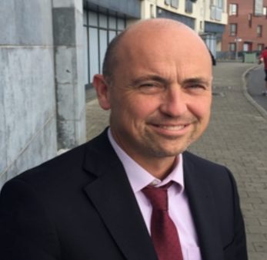 **Gary Lee**, **Solicitor**, **Ballymun Community Law Centre**

Gary Lee is managing solicitor of the Ballymun Community Law Centre, a charity providing free legal advice, information, education, and representation. He is an elected member of the Council of the Law Society of Ireland, is Vice-Chair of its Human Rights & Equality committee and served on its Taskforce on Mental Health Law and Capacity.

Gary has chaired Mental Health Tribunals since 2006 and is the immediate past Chairperson of the Disability Federation of Ireland. He has been appointed by successive Ministers for Disability to a number of bodies including the National Disability Strategy Implementation Group, The Disability Stakeholders Group, the Government Value for Money review of Disability Services working group and the Government Taskforce on Personalised Budgets.

## Session 2: Lessons from other jurisdictions

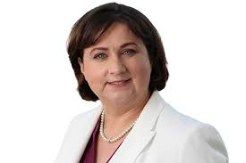 **Minister Anne Rabbitte, T.D.**

**Minister of State with responsibility for Disability, Department of Children, Equality, Disability, Integration and Youth**

Hailing from Portumna, Co. Galway, Anne Rabbitte entered politics in 2014 when she was elected to Galway County Council for Fianna Fáil. Two years later, in 2016, she was elected to Dáil Éireann and was then appointed to the Fianna Fáil front bench as Spokesperson for Children & Youth Affairs.

Re-elected to the 33rd Dáil in 2020, Deputy Rabbitte was subsequently appointed Minister of State with Special Responsibility for Disabilities by An Taoiseach Micheál Martin in July 2020.

Before entering the political arena, Anne worked for a financial institution for 25 years and is a qualified financial adviser. For 3 years, Anne also ran a community childcare facility.

Professor Eilionóir Flynn, Director 
Centre for Disability Law and Policy, National University of Ireland Galway
 **Professor Eilionóir Flynn, Director**

**Centre for Disability Law and Policy, National University of Ireland Galway**

Eilionóir Flynn is an Established Chair in Law and Director of the Centre for Disability Law and Policy, National University of Ireland Galway. Her research focuses on disability and social justice, with a particular emphasis on legal capacity, advocacy and reproductive justice. Her first book, “From Rhetoric to Action: Implementing the UN Convention on the Rights of Persons with Disabilities” was published by Cambridge University Press in 2011) and since then she has gone on to publish extensively in the domain of disability rights. Eilionóir is the Scientific Co-ordinator of the Disability Advocacy Research in Europe (DARE) Marie Curie Training Network, made up of 15 PhD researchers across seven European countries. Her work has attracted significant research funding, including a Starting Grant from the European Research Council, and an Investigator Award from Wellcome Trust. She has acted as a board member and advisor in a range of local, national and international bodies working on the rights of disabled people, and regularly advises policy-makers at national and international levels, including providing support to the Secretariat of the UN Committee on the Rights of Persons with Disabilities, and in particular the working group which developed General Comment 1.

 **Alex Ruck Keane, Barrister, Writer and Educator**

Alex Ruck Keene is an experienced barrister, writer and educator. His practice at 39 Essex Chambers in London is focused on mental capacity and mental health law, providing specialist advice and representation, as well as delivering expert training for front line professionals. He also writes extensively in the field, editing and contributing to leading textbooks and (amongst many other publications) the 39 Essex Chambers Mental Capacity Law Report, the ‘bible’ for solicitors (and others) working in the area. He is the creator of the website <http://www.mentalcapacitylawandpolicy.org.uk/>, providing resources and expert commentary on some of the most difficult mental capacity issues. Alex is a Wellcome Research Fellow and Visiting Professor at King’s College London, a Visiting Senior Lecturer at the Institute of Psychiatry, Psychology and Neuroscience, King’s College London and a Research Affiliate at the Essex Autonomy Project, University of Essex. He spent 2016 on secondment to the Law Commission of England & Wales as a consultant to their Mental Capacity and Deprivation of Liberty Project and throughout 2018 was legal adviser to the Independent Review of the Mental Health Act 1983. In 2020-1, he was a special adviser to the Joint Committee on Human Rights of the Westminster Parliament for their inquiry into the human rights implications of the Government’s response to COVID-19.

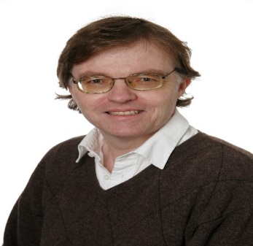 **Maths Jesperson, Founder and Board member, PO-Skåne**

Maths Jesperson was born in 1954. He was an inmate of an old mental hospital from 1980 to 1981. From 1982 to 1988 he was a producer at a travelling theatre company, as well as local politician of the Green Party in Lund, Sweden. In 1984 he converted to Catholicism. 1988-2020 he worked fulltime as a regional officer of RSMH(the Swedish National Organization for Social and Mental Health), meanwhile doing parallel research at the University of Lund (faculty of theatre). He was a founding member of ENUSP (the European Network of Users and Survivors of Psychiatry) in 1991. He was the editor of its newsletter 1994-2000. He has published articles in a huge number of books in Austria, Belgium, Germany, Greece, Sweden, United Kingdom and USA. Since 2000, he is an actor in the *Stumpen-Ensemble*, a theatre group with psychiatric survivors, drug addicts and homeless people as actors.

He was the initiator, the leader and later a board member of PO-Skåne, a professional service with personal ombudsmen for people with severe psychosocial disabilities. In January 2006 he presented PO-Skåne at a seminar in the UN-building in New York, as an example of supported decision-making. The seminar was connected to the UN committee working on the CRPD.

 **Jonathan Martinis, Senior Director for Law and Policy Burton Blatt Institute of Syracuse University**

Jonathan Martinis is the Senior Director for Law and Policy for the Burton Blatt Institute at Syracuse University, leading it's efforts to ensure that older adults and people with disabilities have access to the services and supports they need to lead independent, inclusive lives.

In 2013, Jonathan represented Margaret “Jenny” Hatch in the “Justice for Jenny” case – the first trial to hold that a person has the right to use Supported Decision-Making to make her own life choices instead of being subjected to a permanent, plenary guardianship. Since then, Jonathan has led SDM projects in New York, Ohio, California, Virginia, Vermont, Missouri, and Kansas. He has also educated and trained tens of thousands of older adults, people with disabilities, families, and professionals across the country on SDM theory and practice. Jonathan has written or co-written over 40 publications on SDM, including the first textbook and first theory-to-practice guidebook on the subject.

## Session 3: Hopes for the legislation from individuals whose lives will be impacted

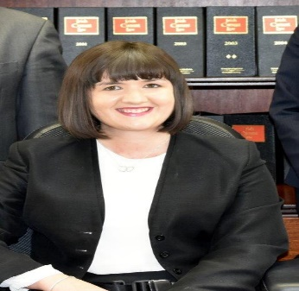 **Aisling Glynn, Solicitor and NDA Board Member**

Aisling Glynn is a solicitor practising in McMahon & Williams Solicitors in Kilrush Co. Clare in a variety of areas of law. As a wheelchair user Aisling brings her lived experience to her work and other roles. Shortly after qualifying, Aisling completed an LL.M in International and Comparative Disability Law & Policy at NUI, Galway. Aisling has a particular interest in disability law and capacity law and she works in the areas of disability discrimination, enduring powers of attorney and Will drafting. Aisling completed a [Law Society Certificate Course in Decision-Making Capacity & Support](https://www.mcmws.ie/index.php/gearoid-williams-and-aisling-glynn-complete-certificate-in-decision-making-capacity-support-2016/) following the signing into law of the Assisted Decision-Making (Capacity) Act 2015. Aisling was appointed to the Board of the National Disability authority in 2017. She is current Chairperson of West Clare Mental Health Association. Aisling has volunteered as a Solicitor at the Disability [Legal Information](https://www.mcmws.ie/) Clinic at the Centre for Disability Law & Policy at NUI Galway. Aisling was a contributor to the Irish Times ‘Platform” series where she and others shared their lived experience in order to raise awareness and to highlight barriers that impact the lives of disabled people in Ireland.

Joe McGrath, Steering Group member,
National Platform for Self-Advocates
 **Joe McGrath**, **Steering Group member**

**National Platform for Self-Advocates**

Joe McGrath is the Vice Chair of the National Platform of Self-Advocates, Ireland’s first DPO run for and by people with an intellectual disability. Joe has over 25 years’ experience as an advocate, researcher and trainer. He has served on the steering committee of the Clare Self-Advocates Platform and the Inclusive Research Network, among others. Joe is a member of the course team that delivers training on Assisted Decision-Making at the Centre for Disability Law and Policy in NUI Galway. Joe represented the National Platform of Self Advocates on the 30th September 2021 at the Oireachtas Joint Committee on Disability Matters speaking about 'Participation in political, cultural, community and public life'. He combines his campaigning and advocacy work with his day job at Seed Savers in County Clare. He is particularly interested in employment and assisted decision making for people with an intellectual disability.

Helen Rochford-Brennan, Former Chair Irish Dementia Working Group, Member of the European Working Group of People with Dementia
 **Helen Rochford-Brennan**

**Former Chair Irish Dementia Working Group, Member of the European Working Group of People with Dementia**

Helen Rochford-Brennan is a Global Dementia Ambassador, she is former Chair of the Irish Dementia Working Group and former Chair of the European Working Group of People with Dementia and was the group’s nominee to the Board of Alzheimer Europe; Helen is on the Monitoring Committee of Ireland’s first National Dementia Strategy and is a panel member of WHO Global Dementia Observatory Knowledge Exchange. Helen supports various research projects with the Global Brain Health Institute.   
Helen is a co-trainer on the NUIG Centre for Disability Law and Policy's biannual programme called "Implementing the Assisted Decision-Making (Capacity) Act: Making it Work in Practice". Helen co-delivers the training's session on capacity and older people with researchers from the Centre for Disability Law and Policy.

Throughout Helen’s time with these organisations, she has campaigned to raise awareness of dementia through a Rights based approach, to the media, speaking at international conference’s, engaging with pharma, scientists, clinicians, educators, students and many research projects from developing evidence –based diagnosis to palliative care to rural isolation and more recently living during the Covid lockdown. Helen strongly believes in Public Patient Involvement.

Helen is a former businessperson working at Senior Executive level in the USA and UK before returning to open her own business in Ireland; she has been very involved in community development wherever she has lived.

Helen was diagnosed after a five year struggle with the brain disorder of Early Onset Alzheimer’s in 2012 and has since written very personally about living with the illness. She hopes her participation in research will one day help find a cure; she wants her legacy to be that she has made the world a better place for people living with dementia.

Helen has received several awards for her advocacy work and has been awarded an Honorary Doctor of Laws degree from the National University of Ireland Galway for her work on the Rights of People with Dementia she also received an award as one of Irelands Most Inspiring people.

She contributed to various books and participated in several documentaries, the most recent with Global Brain Health Institute Trinity College Dublin and University of California San Francisco and WHO.

Michael Ryan, National Head of Mental Health Engagement and Recovery, HSE
 **Michael Ryan**

**National Head of Mental Health Engagement and Recovery, HSE**

Michael Ryan is National Head of Mental Health Engagement and Recovery with the HSE. Michael brings his own lived experience of mental health challenges and now enjoys a full life in recovery.

Michael has a strong track record in recovery practice and innovation having worked as an Advocate, as a Peer Support Worker, before being appointed as Director of Advancing Recovery in Ireland. His most recent role prior to taking up his current appointment was as a Service Improvement Lead with the HSE where he worked on a number of innovative project including being the lead author on the ‘Framework for Recovery in mental Health 2018 – 2021’.

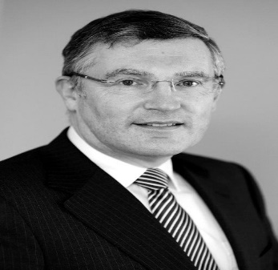 **John Dunne, Chief Executive, Family Carers Ireland**

John was appointed Chief Executive of Family Carers Ireland on 1st January, 2016 when it formed from the merger of The Carers Association and Caring for Carers Ireland. He had worked with The Carers Association since 2010. The early part of his career was spent in a variety of civil service roles including private secretary to the Minister for Foreign Affairs. His subsequent career included terms as Chief Executive of Ireland’s national Chamber of Commerce and of the National Youth Federation (now Youthwork Ireland). Over the past thirty years he has served as non-executive Chairman and/or Director of several public and charitable agencies. John was a member of the National Economic and Social Council from 2001 to 2010 and served as President of *Eurocarers*, the European organisation working for family carers, from 2014 to 2018.

## Closing Address

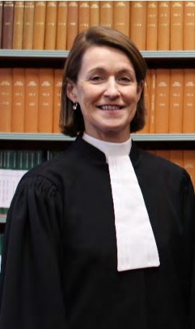 **Ms Justice Mary Irvine, President, High Court**

Ms. Justice Irvine was appointed President of the High Court in June 2020. Ms. Justice Irvine was born in Dublin and educated at the convent of the Sacred Heart, Mount Anville, University College Dublin and the Honourable Society of King's Inns. She was called to the Bar of Ireland in 1978 and to the Inner Bar in 1996. As a member of the Inner Bar, she specialised in medical law and was the legal assessor to the Fitness to Practice Committees of both the Medical Council and An Bord Altranais.

While in practise at the Bar Ms. Justice Irvine was elected to the Bar Council and served as Secretary to the Council. In 2004 she was elected a Bencher of the Honourable Society of King's Inns.

Ms. Justice Irvine was appointed a judge of the High Court in 2007. As a judge of the High Court, she was in charge of the Personal Injuries list from 2009 to 2014 and was responsible for the management and determination of all Garda Compensation claims. Following the retirement of Mr. Justice John Quirke, she chaired the Working Group on Medical Negligence and Periodic Payments established by the President of the High Court in 2010 to examine the system within the courts for the managements of claims for damages arising out of alleged medical negligence and to identify shortcomings in that system.

On its establishment in 2014, Ms. Justice Irvine was appointed a judge of the Court of Appeal. In 2018 she was appointed to chair the CervicalCheck Tribunal established by the Government to hear and determine claims made outside of the court process arising from acts of negligence on the part of CervicalCheck as provided for in the Cervical Tribunal Act 2019. Ms. Justice Irvine was appointed a judge of the Supreme Court in 2019.