NDA Factsheet 3: NEET
September 2019
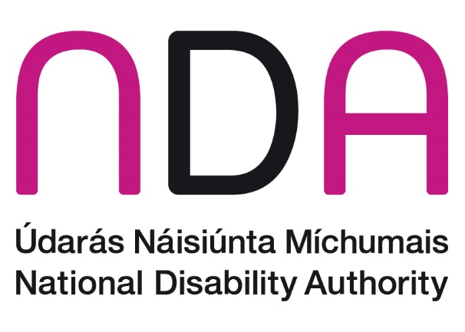

Introduction
This factsheet looks at disability and employment of young people. In particular it looks at young people with a disability who are Not in Employment, Education or Training (NEET).

Definitions
A NEET is the term used to describe a young person usually aged 16 to 24 who is "Not in Education, Employment, or Training". Employment is defined according to the International Labour Organisation (ILO) Guidelines and covers all those who have been in paid work for at least one hour in the reference week of the survey or were temporarily absent from such work. Therefore a person who is NEET can be either unemployed or inactive and not involved in education or training. Young people who are neither in employment nor in education or training are at risk of becoming socially excluded, poor and without the skills to improve their economic situation.
The definition of a ‘young’ person’ can vary depending on the study or country. Usually a young person, for the purpose of NEET, is defined as someone between the ages of 15 and 24 and this is the definition used for most of this document. Occasionally the paper uses a broader definition of young to include people under 30 – this is to make comparison purposes and to illustrate the dynamics of the NEET category. Further analysis (not shown) has highlighted that changes in the age category do not change the conclusions outlined below.
The final definition is ‘disability’. For all the Irish analysis we follow the Central Statistics Office’s (CSO) definition of disability and define disability as anyone who ticked yes to either of the Census disability questions. However to allow for international comparison a more restrictive definition of disability is used. Therefore it is not possible to read across the Irish rate of NEET to the international definition of NEET.

Consequences of being NEET
Studies have shown that time spent NEET can have a detrimental effect on physical and mental health, and increase the likelihood of unemployment, low wages, or low quality of work later on in life. By age 21, young people who have been NEET for six months or more are more likely than their peers to be unemployed, earn less, receive no training, have a criminal record, suffer from poor health and depression (UK Social Exclusion Unit, 1999, Gardner et al 2017, Sissons & Jones, 2012).
NEET, is therefore a serious social problem, with major implications both for the individual (e.g. poorer well-being/self-confidence, increased involvement in crime, reduced employability) and society (e.g. increased benefit and healthcare costs, lost tax revenues).

Policy context
Gardner et al (2017) quote a Eurofound (2012) report that found that those with a disability or health issue are 40% more likely to be NEET than those in good health. Additional research found that at the individual level disability is a strong predictor of NEET status, especially among males (OECD, 2016).
The OECD, in its 2011 Country Report on Ireland, noted that no effective national programme of pre-activation exists in Ireland, a critical gap in terms of encouraging and supporting people with disabilities to find work.
The OECD report on Ireland 2013 said the people with disabilities ‘require specific, targeted early intervention that incorporates a step by step approach to assist them to bridge educational and other gaps and progress into employment’.
A report by Judge et al (2017) for the Department of Social Protection on the recipients of Disability Allowance highlighted that many unemployed people with a disability wanted to work part time.
Gardner et al (2017) noted that of those identified as ‘inactive’ NEET, 20% describe themselves as disabled. Furthermore in 2014, Ireland had the highest rate of young unemployment and disability benefit recipients among the OECD.
Ireland’s rate of youth disability benefit recipients was approximately 5% - well above the OECD average of 2% and was the highest of the OECD countries.
Similarly a report by the– Academic Network of European Disability Experts produced a report in May 2017 that looked at how employment, skills varied across EU counties, they make the point that Ireland is one of the countries with the highest percentage of recipients of disability benefits (aged 16-64)
The Irish government’s policy for job creation and employment is framed by two key documents, the Action Plan for Jobs and Pathways to Work, overseen by the Department of Jobs, Enterprise and Innovation (DJEI). The Action Plan for Jobs is directed at stimulating employment growth. The DJEI has developed programmes, such as Springboard, which provides courses for qualifications needed in growing enterprise sectors, or Momentum, which helps the long-term unemployed to gain skills in occupational sectors.
Pathways to Work, overseen by the Department of Employment Affairs and Social Protection (DEASP), includes measures to move individuals who are long-term unemployed, inactive or are young unemployed into work. Priority is given to upskilling young people to move them away from NEET status (Irish Government, 2015). This included the creation of Intreo, a ‘one stop shop’ for support payments, job assistance and referrals, including to Social Inclusion and Community Activation Programme (SICAP) providers. Other programmes include JobPath (replacing JobBridge), which is directed at long term unemployed (more than 12 months unemployed), and the JobSeekers benefit and allowance.
The Department of Employment Affairs and Social Protection (DEASP) has allocated €16 million under the Ability Programme to 27 projects to test innovative approaches for pre-activation for young people with disabilities. This represents an increase of €6 million on the initial budget for a programme that aims to promote employment prospects and meaningful social roles for young people with disabilities and particularly those who are distant from the labour market. These demonstration projects provide an opportunity to develop services and approaches that can be scaled up for national implementation and therefore address the unique circumstances about disability and NEET.
The Department of Employment Affairs and Social Protection introduced a new Youth Employment Support Scheme (YESS). The scheme opened for applications in October 2018 and is specifically targeted at young jobseekers including people with disabilities aged 18-24 years of age who are long-term unemployed or who face barriers to employment. This scheme aims to give a person the opportunity to learn basic work and social skills in a supportive environment, while on a work placement in a host organisation. Participation on the YESS programme is wholly voluntary and participants will receive a weekly payment of €229.20 for 24 hours work per week.
EmployAbility is a programme of supported employed funded by the Department of Social Protection. Job coaches access mainstream employment, both part-time and full-time, for people with disabilities, based on their choice, needs and abilities. Importantly EmployAbility it targeted at people who are ‘job ready’ and willing to work a minimum number of hours. This in effect excludes those that wish to work very limited hours and those that have limited ability and limited skill level. In essence, a large population of people with a disability are excluded from participation in the programme.
In 2015 the Government launched the ten-year ‘Comprehensive Employment Strategy for People with Disabilities’ often shortened to CES. This is a cross-government approach to bring together actions by different government Departments and state agencies to address the barriers and challenges to employment of people with disabilities. The six strategic priorities are
- Build skills, capacity and independence
- Provide bridges and supports into work
- Make work pay
- Promote job retention and re-entry to work
- Provide co-ordinated and seamless support
- Engage employers
The Comprehensive Employment Strategy highlighted that for those who are out of work, and would wish to work, the main perceived barriers are, in order of importance
- Flexible work arrangements (45%)
- Modified tasks (29%)
- Wage subsidy (24%)
- Transport/parking (17%)
- Accessible building (13%)
- Human support (7%)
- Assistive technology or physical adjustments (4%).
An important part of the CES is to work with employers to discover how, with flexible work arrangements or modified tasks, many people with disabilities could be accommodated to work at little or no cost; and to ensure that other supports or accommodations can also be made available through a mix of public and employer support. Universal design of workplaces could play an important role in ensuring disability-friendly work environments without further modification.

NEET facts and figurers
The not in employment, education, or training (NEET) rate for young people with a disability at 23 percent is over twice the rate of youth people without a disability at 10 percent (table 1). The rate of study is relatively similar between the two groups (62% and 65%) and the difference in NEET rate is driven by the differences in employment (15% against 25%).
Table 1: NEET by disability
 | people with a disability | people without a disability
Total aged 15-24 | 53,465 | 522,987
Employment | 8,247 | 131,128
Student or pupil | 32,930 | 341,858
NEET | 12,288 | 50,001
NEET | 23% | 10%
Employment rate | 15% | 25%
Study rate | 62% | 65%
Source: Census 2016
The percentage of the population aged 15-24 with a disability is 9.3 per cent or 53,465 people. However, one in five people who are NEET have a disability (20%). This means people with a disability are twice as likely to be NEET as people without a disability (see graph 1).
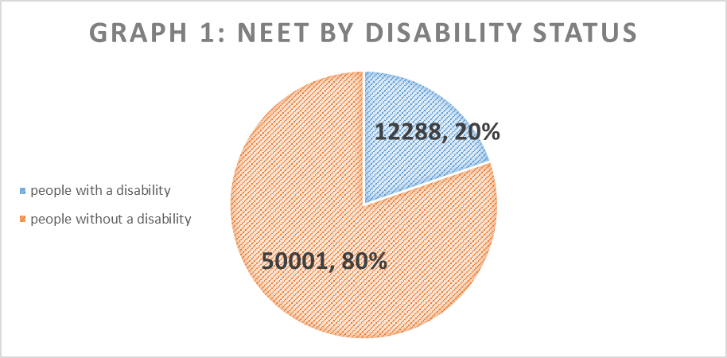
Source: Census 2016

Source: Census 2016. Note an individual can have multiple disabilities.
Every person with a disability has twice the risk of being NEET compared to a person without a disability. Apart for a condition that substantially limits one or more basic physical limits – (42%) high rates of NEET are associated with functional limitations:
- Difficulty in going outside home alone 44%
- Difficulty in dressing, bathing or getting around inside the home 43%
- Difficulty in working or attending school/college 37%
- Difficulty in participating in other activities 36%
Only difficulty in learning, remembering or concentrating has a relatively low level of NEET (24%).
If we look at NEET by age we see an important turning point at about the age of 18. At the age of 18, 17%, or one in six people with disabilities of this age (table 2), is NEET, and this jumps to 27%, or over a quarter, by age 19. There remains a steady rise to reach almost 40% by age 23.

Table 2: Proportion of NEET for people with and without disabilities
Age | People with a disability | Others | Difference
15 | 2% | 1% | 1%
16 | 6% | 2% | 4%
17 | 9% | 4% | 5%
18 | 17% | 10% | 7%
19 | 27% | 15% | 12%
20 | 30% | 16% | 15%
21 | 32% | 16% | 16%
22 | 35% | 18% | 17%
23 | 39% | 20% | 20%
24 | 41% | 21% | 20%
25 | 43% | 21% | 21%
26 | 44% | 22% | 22%
27 | 45% | 22% | 23%
28 | 45% | 22% | 23%
29 | 45% | 22% | 24%
Source: Census 2016 – special tabulation
Table 3 looks at economic status by single year of age to explore this difference further. The table directly compares people with and without a disability by taking away the rate for people without a disability from the rate for people with a disability. For example 1 percent more of 15 year olds with a disability are unable to work because of illness or disability compared to people without a disability and so on.

Table 3: Difference between people with disabilities and others in percentage rates of the different components of principal economic status
Age | Unable to work illness/  disability | At work | Unemployed | Student | Home/  family duties | Other (incl retired)
15 | 1% | 0% | 0% | -1% | 0% | 0%
16 | 3% | 0% | 1% | -4% | 0% | 0%
17 | 4% | -1% | 1% | -5% | 0% | 1%
18 | 6% | -4% | 1% | -4% | 0% | 1%
19 | 10% | -6% | 3% | -8% | 0% | 1%
20 | 12% | -10% | 4% | -8% | 0% | 1%
21 | 13% | -11% | 4% | -8% | 0% | 1%
22 | 14% | -16% | 4% | -5% | 0% | 1%
23 | 14% | -23% | 6% | -1% | 1% | 1%
24 | 15% | -26% | 6% | 2% | 0% | 1%
25 | 15% | -28% | 7% | 2% | 0% | 2%
26 | 15% | -28% | 7% | 2% | 1% | 1%
27 | 17% | -30% | 7% | 3% | 0% | 1%
28 | 17% | -28% | 7% | 1% | 1% | 1%
29 | 18% | -29% | 5% | 2% | 1% | 1%
Source: Census 2016 – special tabulation
Again we see that there is not much difference between people with and without a disability until about 18. At 18 we start to see a big increase in the numbers who are ‘unable to work due to illness/disability’, and a concomitant fall in the relative numbers at work. Education numbers diverge and then converge again. Indicating the people with a disability leave education earlier than people without a disability.
There were negligible differences in the proportions engaged in caring for a family, or in the ‘other‘subcategory (table 3).

NEET by gender and disability
Men are slightly more likely to be NEET than women. For people without a disability this is 9.9 percent and 9.3 percent respectfully (table 4).This gender difference follows through to people with a disability where it is 24.7 percent compared to 21.1 percent (table 4).
Table 4: Gender and disability by NEET status0-1
Disability status | Male | Female
Disability | 24.7% | 21.1%
Non disability | 9.9% | 9.3%
Source: Census 2016
The gender difference can also be seen for most disabilities (graph 4). Graph 4 plots the differences between men and women on NEET status – a positive number means men with that disability are more likely to be NEET than women with that disability. A negative number means women with that disability are more likely to be NEET than men with that disability. For all disabilities except two, men are more likely to be NEET than women with the same disability. And in the case of people with mental health issues the difference is substantial. The two disabilities where the gender trend is reversed are:
- Difficulty in dressing, bathing or getting around inside the home
- Difficulty in going outside home alone
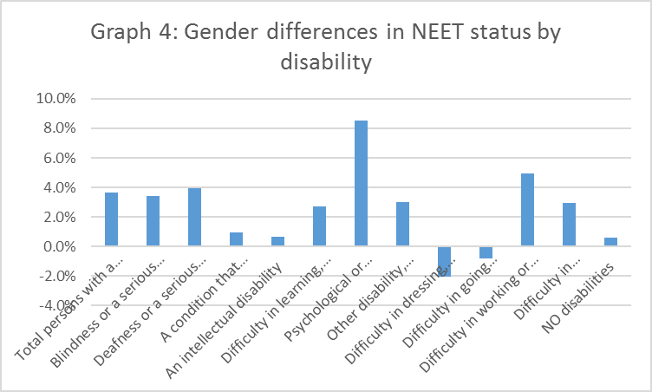
Source: Census 2016

Change over time in NEET status
While the NEET level for young people with a disability has declined between 2011 and 2016 it is still higher than for the level of people without a disability (graph 5).
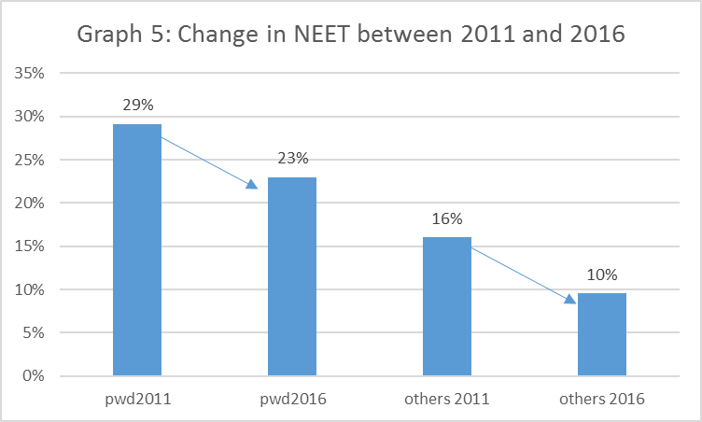
Source: Census 2016 and Census 2011
The level of NEET for people with a disability went from 29% to 23% a six percentage point drop. The rate of NEET for people without a disability dropped also by six percentage points from 16% to 10%. Given that 20% of all people who are NEET have a disability (see above) this indicates that if Ireland is to tackle the problem of young people who are not in education, training or work they will have to focus on people with a disability.

Table 5: NEET 2011 and 2016 by disability
 | All people aged 15 years and over 2016 | NEET 2011 % | NEET 2016 %
Blindness or a serious vision impairment | 3374 | 29.4% | 24.0%
Deafness or a serious hearing impairment | 2629 | 31.0% | 25.4%
A condition that substantially limits one or more basic physical activities | 6158 | 48.0% | 42.3%
An intellectual disability | 12556 | 37.1% | 32.8%
Difficulty in learning, remembering or concentrating | 23848 | 29.1% | 24.3%
Psychological or emotional condition | 15669 | 43.6% | 30.7%
Other disability, including chronic illness | 15029 | 28.6% | 22.3%
Difficulty in dressing, bathing or getting around inside the home | 4949 | 48.4% | 43.4%
Difficulty in going outside home alone | 9688 | 47.9% | 44.0%
Difficulty in working or attending school/college | 16498 | 43.5% | 37.2%
Difficulty in participating in other activities | 13145 | 40.6% | 36.0%
without a disability | 85789 | 16% | 10%
Source census 2011 and 2016
If we look at the NEET rates in 2016 and compare them to 2011 (table 5 and chart 6) we see that for all disability groups the numbers have improved. Fewer young people with a disability can be counted as a NEET in 2016 compared to 2011. This is partly because of the economy recovering. For instance, the NEET rate for people without a disability fell from 16% in 2011 to 10% in 2016. If we look at the percentage change, (graph 6) we see that for those without a disability the rate of NEET fell by six percentage points. Several disability groups matched this improvement or bettered it – particularly those with a psychological or emotional condition who went from 43.6 percent to 30.7 percent. However overall the change was similar for people with and without a disability – meaning that as people with a disability started with a much higher rate of NEET they were relatively disadvantaged by the change.
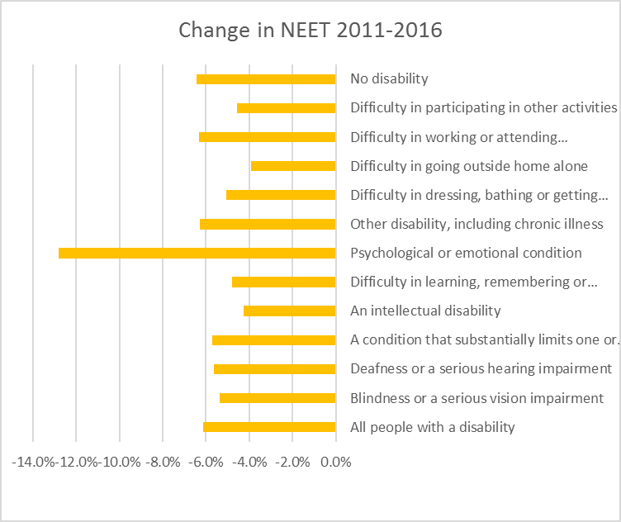
Source Census 2011 and 2016 Note the categories are not mutually exclusive – an individual can fall under multiple categories.

NEET International comparisons
The OECD looks at the education, training and unpaid work experience of people with and without limitations and people than with and without disabilities (so a different definition of disability than used above) (table 6).
Table 6: International comparisons percentage
 | people with limitations in education * | people without limitations in education * | people with disabilities in education ~ | People with a disability who are pupils, students, further training & unpaid work experience.* | People without a disability who are pupils, students, further training & unpaid work experience.*
AT | 28.1 | 36.3 | 25.4 | 17.4 | 26.4
BE | 29.2 | 41.2 | 35.2 | 32.2 | 37.8
BG | 16.4 | 29.5 | 10.7 | 11.4 | 24.4
CY | 18.6 | 31.6 | 15.3 | 18.8 | 28.7
CZ | 31 | 31.9 | 16.4 | 24.3 | 27
DE | 40 | 51.9 | 42.1 | 29 | 37.4
DK | 53.6 | 63 | 38 | 42.3 | 49.5
EE | 36.7 | 39.2 | 32.6 | 23.3 | 26.2
EL | 31 | 39.8 | 22.4 | 27 | 34.6
ES | 32.9 | 43.9 | 30.4 | 31.1 | 37.8
FI | 44.1 | 49 | 41 | 31.1 | 30.9
FR | 28.5 | 36.4 | 27.9 | 26.1 | 31.3
HR | 18.3 | 34.5 | 24.7 | 12.8 | 30.7
HU | 29.1 | 40.8 | 33.1 | 26.4 | 38.2
IE | 37.1 | 43.7 | 36.9 | 25.4 | 32
IT | 36.1 | 33.9 | 21.8 | 37.9 | 40.2
LT | 16 | 40.3 | 34.2 | 14.9 | 31.8
LU | 39.3 | 41.8 | 36.9 | 26.9 | 35.6
LV | 28.4 | 35.9 | 29.3 | 21.9 | 27.1
MT | 20.1 | 31.4 | 10.4 | 20.3 | 23.7
NL | 43.7 | 45 | 39.5 | 33.7 | 38.2
PL | 29.5 | 36.9 | 28.8 | 21.5 | 28
PT | 29.6 | 34 | 34.1 | 26.1 | 32.1
RO | 14.1 | 35.5 | 27.8 | 12.7 | 34.8
SE | 30.6 | 42 | 32.1 | 17 | 36.4
SI | 58.5 | 56.8 | 59.5 | 48.1 | 45.4
SK | 30.6 | 34.2 | 38.5 | 28.8 | 32.2
UK | 23.4 | 25.5 | 31.8 | 15.4 | 17.4
EU | 32.8 | 38.3 | 33.1 | 26.4 | 32.2
Source: https://data.oecd.org/youthinac/youth-not-in-employment-education-or-training-NEET.htm. Note *=2014, ~=2010. Table refers to people aged 18-29.
The above table 6 shows that Ireland is above average for people with a limitation or with a disability aged 18-29 at being in education. However when we look at the percent of people declaring themselves as ‘pupils, students, further training & unpaid work experience’ we slip below the EU average. This means that while we are good at keeping people with a disability in education we are worse at giving them work experience than other OECD countries.
Another table produced by Eurostat looks NEET (table 7) shows that Ireland has some of the highest level of NEET for people with a disability in Europe.

Table 7: Young people neither in employment nor in education and training by type of disability, sex and age 15-24
 | Difficulty in basic activities | No difficulty in basic activities | Limitation in work caused by a health condition or difficulty in a basic activity | No limitation in work caused by a health condition or difficulty in basic activities
Belgium | 20.6 | 9.6 | 37.1 | 9.2
Bulgaria | 77.2 | 21.4 | 81.2 | 21.5
Czechia | 34.9 | 7.7 | 35.0 | 7.4
Denmark | 15.4 | 5.4 | 17.1 | 5.2
Germany | 14.8 | 8.0 | 31.7 | 7.9
Estonia | 23.3 | 10.3 | : | 10.5
Ireland | 40.3 | 17.8 | 49.5 | 17.5
Greece | 44.6 | 15.9 | 52.3 | 15.8
Spain | 26.7 | 19.4 | 32.7 | 19.1
France | 19.8 | 10.7 | 24 | 10.7
Italy | 45.9 | 18.0 | 45.1 | 18.0
Cyprus | 41.6 | 10.6 | 46.3 | 10.6
Latvia | : | 16.6 | : | 16.8
Lithuania | 43.4 | 10.4 | 53.4 | 10.4
Luxembourg | 15.1 | 4.2 | : | 4.5
Hungary | 48.5 | 11.3 | 48.3 | 11.3
Netherlands | 17.3 | 2.7 | 22 | 2.6
Austria | 12.7 | 6.5 | : | 6.7
Poland | 31.8 | 10.0 | 35.1 | 10.0
Portugal | 23.5 | 11.0 | 26.5 | 10.7
Romania | 61.9 | 15.9 | 78.1 | 15.8
Slovenia | 23.5 | 5.6 | 16.4 | 5.5
Slovakia | 37.4 | 12.7 | 44.3 | 12.5
Finland | 18.1 | 6.4 | 19.7 | 6.4
Sweden | 10.6 | 6.4 | 10.4 | 6.5
United Kingdom | 28.6 | 15.9 | 39.5 | 15.2
Iceland | : | 7.3 | 12.3 | 6.8
Switzerland | 7.7 | 6.8 | 8.7 | 6.8
Turkey | 41.5 | 26.7 | 44.9 | 26.6
Source: http://appsso.eurostat.ec.europa.eu/nui/show.do?dataset=hlth_de030&lang=en

Conclusion
There are no advantages to being NEET. It leads to lower wages (often called wage scarring), reduced employability, increased risk behaviour and overall poorer well-being. NEET is a particular risk factor for people with a disability and one in five people who are NEET have a disability. Not only is this high but it seems to be high by OECD and European standards. Ireland’s rate of youth disability benefit recipients at approximately 5% is well above the OECD average of 2% and was the highest of the OECD countries. The rates of young people in NEET have fallen for both people with and without a disability. However, they are still higher for people with a disability and are falling at a slower pace compared to people without a disability. If NEET rates are to fall further then the lack of employment opportunities for people with a disability must be addressed.
The responses needed to reduce the numbers in NEET status are multifaceted. The age breakdown of people with a disability who are NEET showed a turning point at the age of 18 – this emphasises the importance of early intervention to support school leavers with disabilities to continue with education or training, and to maximise their potential, and to provide bridging into suitable employment opportunities, as envisaged under the Comprehensive Employment Strategy for People with Disabilities.
Elements of the Comprehensive Employment Strategy, including the plans developed by the Department of Employment and Social Affairs around positive engagement with school leavers, could have a potential to lower the proportion of young people with disabilities who see themselves as incapable of work, and to increase the proportion who have a job.
Mawn et al (2017), in a systematic review, highlighted that multi-component (e.g. education, training and work placements, advice, support, and incentives) interventions effectively decrease unemployment amongst those who are NEET. Therefore standalone apprenticeships are not enough and vulnerable young people need a range of interventions and supports. A review of the Disability Allowance highlighted the importance of ensuring early intervention on the part of activation services if the risk of longer-term welfare dependency is to be addressed effectively (Judge et al, 2017). The review also highlighted the need to shift to focussing on actual capacity to engage in work, training or education. Also a need to ensure that appropriate supports are directed to all those who need them and to identify a level of capacity to engage in education, training or employment. The report highlighted that such interventions are likely to be multi-agency interventions if they are to be effective.
Apprenticeships are one element of giving people with a disability an opportunity for employment.
Ireland continues to expand its apprenticeship system to higher qualification levels and to new sectors. This action is part of the 2025 national skills strategy, published in 2016, and aims to significantly increase work-based learning opportunities for school graduates who choose not to go to general higher education, as well as for employees (DES, 2016).
The National Skills Council is continuing its work to identify and prioritise skills demands and pinpoint how the education and training sector and other relevant stakeholders can best respond to this challenge. A disability focus is essential.
At the same time it must be remembered that some people who are NEET neither want to, or can, work or engage in training. Rather a range of choices must be afforded to people so they engage at the level and to the extent they desire. That said the level of NEET among people with a disability is far in excess of those without a disability and indicates that many are being deterred and excluded unnecessarily.

References
Academic Network of European Disability Experts (2017) https://www.disability-europe.net/theme/statistical-indicators
Irish Government. (2013). Pathways to Work: The implementation of the EU Council Recommendation for a Youth Guarantee. Retrieved from https://www.welfare.ie/en/downloads/Youth-Guarantee-Implementation-Plan.pdf
Irish Government. (2015). Pathways to Work. Dublin: Irish Government. Retrieved from http://www.welfare.ie/en/downloads/pathways-to-work-2015.pdf
Irish Government. (n.d.). Action Plan for Jobs 2017. Dublin: Irish Government. Retrieved from https://www.djei.ie/en/Publications/Publication-files/Action-Plan-for-Jobs-2017.pdf
Mawn L, Oliver EJ, Akhter N, Bambra C, Torgerson C, Bridle C and Stain H (2017) - Are we failing young people not in employment, education or training (NEETs)? A systematic review and meta-analysis of re-engagement Systematic Reviews20176:16
UK Social Exclusion Unit (1999) Bridging the Gap: New Opportunities for 16 –18 Year Olds Not in Education, Employment or Training http://www.cabinetoffice.gov.uk/media/cabinetoffice/social_exclusion_task_force/assets/publications_1997_to_2006/bridging_gap.pdf
Gardner, C., Dermody, A., O’Donoghue, R., Davis, S., Isard, P. (2017) Kickboxing, kindness and going the extra mile: Good practice for working with NEETs under SICAP. Pobal. Ireland
Judge, Rossi, Hardiman and Oman et al (2017) Department of Social Protection Report on Disability Allowance Survey 2015 https://www.welfare.ie/en/downloads/Value-for-Money-Review-of-the-Disability-Allowance-Scheme.pdf

For instance see O’Dea et al (2014) ‘A cross-sectional exploration of the clinical characteristics of disengaged (NEET) young people in primary mental healthcare’ https://bmjopen.bmj.com/content/4/12/e006378

