Moving In, Moving On Report

Plain English Version
December 2021
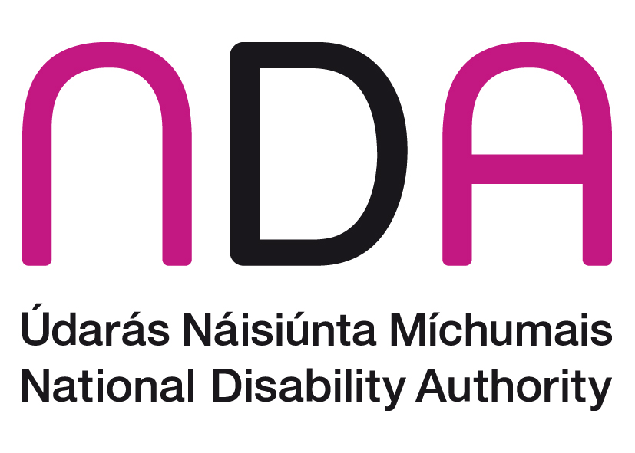

Table of Contents
What is this report about? 2
Who wrote this report? 2
Introduction 3
How did the NDA do the research? 5
Phase 1 6
Who was in phase 1? 6
What happened in Phase 1? 6
Quality of Life 7
Diaries 13
Phase 2 14
Who was in Phase 2? 14
What happened in phase 2? 14
Quality of Life 15
Differences between people in phase 1 and phase 2 15
Costs 17
Conclusion 17
Recommendations 18
Ideas for future research 19

What is this report about?
This report is about the results of a big piece of research.
The research is about new ways to provide residential disability services in Ireland.
The results of the research talk about the costs and benefits of these new ways to provide residential disability services in Ireland.

Who wrote this report?
The National Disability Authority (NDA) did the research for the Health Service Executive (HSE).
The NDA is an organisation that gives information and advice about disability issues to the Government of Ireland.
The HSE paid for the research.

Introduction
The Time to Move on from Congregated Settings report was written in 2011. The report talks about the national policy on residential disability services.
Residential disability services are places that people with disabilities live together.
The policy says that a maximum of 4 people with disabilities can live together in residential disability services.
The policy comes from research from around the world.
The research says that people with disabilities have a better quality of life when they live in smaller groups.
In the past, Ireland and many other countries provided services to people with disabilities in large institutional settings.
An institutional setting is a big place that provides a service for a large amount of people.
Institutional settings in this report are services for people with disabilities.
A congregated setting is a place where 10 or more people with disabilities live.
The Time to Move On policy was a plan to close all of the large institutional settings in Ireland.
There was a plan to move about 4,000 people out of large institutions and into smaller homes in the community by 2021.
About 2,200 people have now moved out of congregated settings.
About 1,800 people are still in congregated settings.
It is cheaper for people with disabilities to live in large institutional settings.
It costs the government more money for people with disabilities to live in smaller homes in the community.
It costs more money to pay staff and provide services in lots of smaller homes than it does in one large congregated setting.
The NDA did this research called ‘Moving In, Moving On’.
‘Moving In, Moving On’ looked at the cost of living in smaller homes in the community compared to institutions.
It also looked at the quality of life of people living in different places.
‘Moving In, Moving On’ also collected information that may help the ways people move out of congregated settings in the future.

How did the NDA do the research?
The NDA did interviews with people about moving out of congregated settings and about living in the community.
The NDA used different types of interview tools suitable for people with disabilities.
There were 2 phases in the research.
In the first phase, the NDA did interviews with people with disabilities before and after moving out of congregated settings.
In the second phase the NDA did interviews with people living in different settings and using many different types of disability services.
People working in disability services were asked to put forward residents to take part in the research.
Written information about the research was sent out to these residents.
Most people gave written consent to take part in the research.
Some residents were not able to give consent to take part in the research.
The NDA contacted the Health Research Consent Declaration Committee (HRCDC) to ask if they could still interview people who were not able to give consent to take part.
The HRCDC agreed to this.
The HRCDC said it was in the best interest of the public for these residents to have their say about moving out of congregated settings.
A lot of public money is spent on residential services for people with disabilities.
This research looks carefully at the cost of disability services in large institutions.
This research looks carefully at the new cost of disability services in smaller homes in the community.

Phase 1
The NDA did interviews with 146 people with disabilities in Phase 1.

Who was in phase 1?
There were 11 congregated settings in phase 1.
There were 84 men in phase 1.
There were 62 women in phase 1.
The average age of people in phase 1 was 51 years old.
All people in phase 1 had an intellectual disability.
Most had high support needs
Most had 2 or more disabilities.
Most had communication difficulties.
About one third had behaviours that challenge.
None had jobs.
7 were in part-time education.
17 had ongoing help from family.

What happened in Phase 1?
In phase 1, the NDA did interviews with 146 people before they moved out of congregated settings.
The NDA did interviews with 91 of the same people after they moved out of congregated settings to the community.
Some people were not interviewed again because they did not move out of the congregated setting, they died or they moved to a nursing home.
The NDA collected information about activities of daily living with an interview tool called FACE v7.

Activities of daily living are the basic life tasks that people need to do to be independent.
Activities of daily living are called ADLs for short.
ADLs are things like feeding and dressing yourself.
The people in phase 1 had a lot of care needs.
The people in phase 1 had different skills in activities of daily living.
58 people could do ADLs with a little support.
47 people could do ADLs with a medium amount of support.
41 people needed a lot of support to do ADLs.
The NDA also collected information about instrumental activities of daily living with an interview tool called FACE v7.
Instrumental activities of daily living are called IADLs for short.
IADLs are things like taking medicine and making meals.
People in phase 1 needed a lot of support with IADLs.

Quality of Life
The NDA tried to do interviews about quality of life with an interview tool called the ASCOT SC4.
It was too difficult for most people in phase 1 to do this interview.
The NDA used tool called an ‘outcomes framework’ to look at a person’s quality of life.
The NDA did interviews with 91 of the people in phase 1 after they moved out of congregated settings.
None of the people were fully achieving the quality of life outcomes before moving out of their congregated setting.
After moving, all of the 91 people interviewed were achieving some quality of life outcomes.
These quality of life outcomes are explained in the table below.
Red means the quality of life outcomes were not achieved at all.
Yellow means the quality of life outcomes were nearly achieved.
Green means the quality of life outcomes were fully achieved.
Quality of Life Outcome | Before Moving | After Moving
Living in their own home | People lived in congregated settings.  People did not choose who they lived with.  People had very little privacy. | People were living in homes in the community.  People had some choice about who they lived with.  People had their own bedrooms and more living space.
Choice and control in their everyday lives | People had few opportunities to make day-to-day choices.  People had very little control of their everyday lives.  There were some options to say no to activities. | People made choices about things like the clothes they wear and bedtimes.  People were involved in choices about weekly food menu plans.  Staff still had most of the control.  The same activities were offered to all residents but some of the activities were organised for individuals.  There were options to say no to activities.
Taking part in social and civic life | People did not have a social life.  People only took part in community activities if staff and transport were available.  There was a church at some of the residential sites.  This meant that when people did go to church, they did not get the chance to mix with their community. | More engagement with activities in the community.  Most people were living within walking distance of local amenities. A small group were dependent on the availability of transport and staff to access the community.  People could attend local churches now.
Meaningful personal relationships | Contact with family was encouraged.  Friendship circles were limited to people they lived with.  People did not have intimate relationships. | Contact with family was encouraged and supported.  Many people now had more contact with their families.  Friendship circles were limited to people they lived with.  People did not have intimate relationships.
Personal Development | There were almost no chances to take part in education and training.  People did not get the chance to set life goals. | Small increase in supporting people to think about training/education opportunities.  Small increase in supporting people to think about setting life goals.
Jobs and Other Valued Social Roles | People did not have jobs.  People did not have the chance to find ways to help others in the community. | Some effort made to find work experience.  Staff encouraged people to find ways to help others.
Well-Being | People were unable to give this information about their quality of life. | People were unable to give this information about their quality of life.
Health | Regular monitoring of health issues.  Many people were taking too many medications.  Some environmental issues like noise and a lack of privacy were not good for mental health.  Not enough physical activity or variety in diet. | Regular monitoring of health issues.  Some people were taking less medication.  People now lived in quieter and smaller places. This was better for mental health.  More varied diets and more physical activity.
Safety | In congregated settings, residents were kept safe by keeping them confined.  Large congregated settings could have safeguarding risks.  Some staff felt like the residents did not have the same right to independence as other adults.  Staff felt it was their role to look after residents in the same way parents look after children.  There could be some risk of abuse in congregated settings. | Now the focus on safety was more about avoiding risk.  The smaller houses in the community were safer.  Residents were more respected and listened to.  Some staff still felt that it was their role to look after residents in the same way as parents look after children.  There could still be some risk of abuse in smaller settings.

Diaries
The researchers also collected information in diaries about the daily lives of people in phase 1.
They also wrote down information about the places that people lived in and information about the staff.
The diaries showed examples of people taking a new interest in activities such as cooking and household tasks after they moved to the community.
People in phase 1 did not experience these activities in congregated settings.
The diaries showed that more work is needed to help people in phase 1 to get jobs and to volunteer in their community.
The diaries showed how the homes in the community were quieter, safer and more comfortable than the institutions.
Residents all had their own decorated bedrooms.
Some staff wanted to work in the community houses in the same way that they did when they were working in the institution.
This meant that the people with disabilities living in the house had less say about what they did and when they did it.
Some staff did not want to work in the community houses in the same way that they did when they were working in the institution.
They worked in a different way that gave the people with disabilities living in the house more choice about what to do and when to do it.
The report found that some staff needed more training to work in a person-centred way.
Person-centred means that disability services are focused on what is important to the person with a disability using the service.

Phase 2
The NDA did interviews with 280 people with disabilities in phase 2.

Who was in Phase 2?
The people in phase 2 came from lots of different settings.
All were receiving some sort of disability service.
There were 146 men and 134 women in phase 2.
156 people in phase 2 were receiving residential supports.
Most of these were living in community houses and a few were living in congregated settings.
56 people in phase 2 received supported living services, for example, a personal assistant.
61 people in phase 2 attended disability day services.
7 people in phase 2 had some different supports.
Most people in phase 2 had an intellectual disability.
Most people had more than one disability.
Some people had communication difficulties.
90 people in phase 2 had behaviours that challenge.
64 people were in employment.
64 people were in part-time education.
Many people in phase 2 had a lot of care needs.

What happened in phase 2?
People in phase 2 came from lots of different settings.
This meant it was difficult to compare old ways of delivering disability services to new ways.
The NDA collected information about ADLs and IADLs with an interview tool called FACE v7.
Most people living at home or in supported living needed less help with ADLs and IADLs than people with other types of support.

Quality of Life
The NDA did interviews with people in phase 2 about quality of life with an interview tool called the ASCOT SC4.
People in phase 2 who lived in congregated settings had lower quality of life scores.
The phase 2 interviews also showed that people had a lower quality of life when:
- they could not choose who they lived with
- they did not like the people they lived with
- they were experiencing pain
Nearly half of the people in phase 2 were getting ongoing help from family and friends.
Most people in phase 2 who lived at home were older than 36 years of age.
Many people in phase 2 living at home had elderly parents.
There were no plans for people living at home to move to residential care.

Differences between people in phase 1 and phase 2
People in phase 1 and phase 2 were different for many reasons.
People in phase 1:
- all had intellectual disabilities
- all lived in congregated settings
- most had a high support needs
People in phase 2 had:
- fewer communication difficulties
- fewer mental health problems
- fewer behaviours that challenge
- less epilepsy
- less pain and distress

Costs
The research says that it costs the government a lot more money for people with disabilities who have a high level of need to live in smaller homes in the community.
The average increase in cost is just over €80,000 per resident per year.
Most of the extra cost is to pay for more staff.
It costs more money for staff to work with a small number of residents in lots of smaller places than it does to pay staff to work in a congregated setting.
Most of the people living in congregated settings have higher needs than people living in the community.
The higher needs of these residents leads to increased costs in the community.
The Irish government must make sure there is enough money given in the budget for people with disabilities to live in smaller homes in the community.

Conclusion
The research showed us that people with disabilities have more positive outcomes when they move out of congregated settings.
The research showed that it costs a lot more money for a person with a disability to live in a smaller home in the community.
Some of this higher cost is because people still living in congregated settings have higher needs.
More work is needed to provide opportunities for better outcomes in the areas of:
- choice and control
- independence
- developing life skills.

Recommendations
This report talked about many things for the HSE, service providers and the government to work on.
The HSE should:
- keep supporting people to move out of congregated settings as a priority.
- continue to support people who have moved out of congregated settings.
- ensure that people cannot return to a congregated setting.
- help people still living in congregated settings to take part in the community.
- make an assessment that will help organise resources for people with different needs.
- promote ‘ageing in place’ in the family home through supports such as respite and day services.
Ageing in place means a person can continue to live in their own home and community when they get older.
- give training to disability services about how to best support people in small groups.
- make sure there are more opportunities for people with disabilities to use technology as a tool to improve their quality of life.
Disability service providers should:
- give more training to staff about human rights and person-centred planning.
- provide support and supervision to staff to help them avoid old institutional ways of working.
- improve the ways residential services, day services and families work together and communicate.
- develop day activation programmes for community residents who do not have one.
The Department of Health in the government should:
- set up a national committee that makes sure research is done in an honest and fair way. This will make research quicker and easier to do.
- make sure the HSE has enough resources to continue moving people out of congregated settings and into the community.

Ideas for future research
It is important that the views of all people with disabilities are gathered.
Some people with intellectual disabilities have communication difficulties that make it too difficult for them to do interviews with researchers.
The NDA says that it is important to figure out new ways to collect information from people with intellectual disabilities.
It is important that people of all levels of ability can have their say.

This study was funded by the Health Service Executive (HSE) as part of the Transforming Lives programme.

