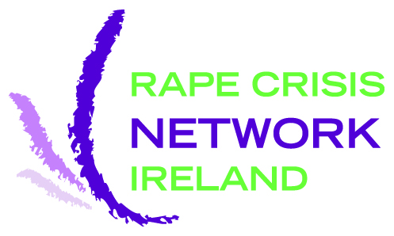

Sexual Violence Against People with Disabilities:
Data collection and barriers to disclosure

October 2011

Table of Contents
Acknowledgements 3
Authors 4
List of abbreviations and acronyms 5
List of tables and graphs 6
Executive summary 9
1. Introduction 14
1.1. Context - Cost of sexual violence to society 15
1.2. Aims of research 15
1.3. Scope of research 15
2. Methodology 17
2.1. RCNI analysis of sexual abuse survivors with disabilities 17
2.2. Stakeholder survey and workshop 17
2.3. Review of sexual violence database systems 18
3. Quantitative analysis of RCNI data 2008 – 2010: People with disabilities attending Rape Crisis Centres for counselling and support 20
3.1. Counselling and Support 22
3.2. Single incident (SI) – survivor information 30
3.3. Single Incident - Perpetrator Information 34
3.4. Multiple incidents (MI) – Survivor information 40
3.5. Multiple incidents - Perpetrator information 42
3.6. Reporting the sexual violence 44
3.7. Client Demographics 46
3.8. Conclusion 48
4. Quantitative analysis of online survey for people with disabilities – What stops us talking about sexual violence? 49
5. Qualitative findings from online survey – What stops us talking about sexual violence? 63
5.1. Fear of, and experience of, not being believed 64
5.2. Need for informed, trained and trusted support 65
5.3. Culture of blame and stigmatisation 65
5.4. Long term impact of sexual violence 66
5.5. Isolation and secrecy 67
5.6. Dissatisfaction with professional services following disclosure 68
5.7. Insufficient disability awareness 69
5.8. Lack of information and education 70
5.9. Fear of personal consequences 71
5.10. Confidentiality 72

6. Data Collection 74
6.1. Legal Framework 74
6.2. Discussion 79
7. Review of database systems used to record experience of sexual violence of people with disabilities 80
7.1. GBVIMS Gender-based Violence Information Management System 80
7.2. Modus SARC – Paloma Systems UK, Sexual Assault Referral Centres 83
7.3. RCNI Database – Rape Crisis Network Ireland Database 84
7.4. SATU Database – Sexual Assault Treatment Unit Database 86
7.5. ViCLAS: Violent Crime Linkage Analysis System 87
7.6. Comparative review 89
8. Discussion: Analysis of key reporting issues 114
8.1. Recommendations for policy 120
8.2. Recommendations for data collection practice 121
8.3. Recommendations for further research 121
9. Bibliography 123
Books and Journals 123
Legislation and key policy documents 129
10. Appendices 131
Appendix 1: Glossary of terms and definitions 131
Appendix 2: Multi-disciplinary Steering Committee Members 137
Appendix 3: Working Group Members 137
Appendix 4: Survey for people with disabilities 138
Appendix 5: RCNI Database disability indicators (2004-2011) 143

Acknowledgements
We would like to take this opportunity to thank the large number of people without whom this report would not have been possible.
The Steering Committee for this research included Eithne Fitzgerald (National Disability Authority), Lillian Buchanan (Disability Federation of Ireland), Eilionóir Flynn (NUIG Centre for Disability Law and Policy) and Fiona Neary (Rape Crisis Network Ireland).
The research required responses from many practitioners and academics in the field of sexual violence against people with disabilities. The following people contributed information on data collection methodologies in many countries: Birgitt Haller, Institut für Konfliktforschung Wien, Austria; Blanca Cedeno, Rehabilitation International; Caroline Gooding, Disability Rights Consultant UK; Catriona Gleeson, Safe Ireland; Declan Daly, An Garda Síochána; Doris Pant and Stephan Klaus, Austrian Federal Ministry for Justice; Dr. Maeve Eogan, Consultant Obstetrician and Gynaecologist, Rotunda Hospital; Dragana Ciric Milanovic, Disability Rights International –Serbia; Gert-Jan Brinkie; Netherlands Police; Hilary McCollum; Liz Kelly; Marianne Hester, Professor of Gender, Violence and International Policy, University of Bristol, UK; Michaela Krenn, Domestic Abuse Intervention Centre Vienna, WAVE Network; Monika Mitra, Center for Health Policy and Research, University of Massachusetts Medical School; Monika Schroettle, Universität Bielefeld; Paloma Systems Ltd; Renée Römkens, Professor of Interpersonal Violence, Tilburg University; Richard Curen, Respond UK; Sharon O’Halloran, Safe Ireland; Silvia Walby, UNESCO Chair in Gender Research, University of Lancaster; Stephanie A Condon, Institut National d'Etudes Demographiques, France; and Therese Evers, Netherlands Police Academy.
Research on RCNI Database was made possible only with the help of Emma Calvert, Independent Statistics Expert; Elaine Mears and Fiona Neary at Rape Crisis Network Ireland; and all the countless volunteers and counsellors at the participating Rape Crisis Centres who have developed and maintained the RCNI Database over the years.
The research on barriers to disclosure would have been impossible to complete without the help of: Safe Ireland; Claire O’Riordain and all at NALA; Eilionóir Flynn and all at NUIG Centre for Disability Law and Policy for hosting the workshop; and finally the many people who completed the survey.
Very special thanks go to: Catherine Ormond and Maria McGreal for data checking and for editing the draft report; to Priya Varaprath and Kathy Tu for legal analysis; and to Caroline Counihan, Clíona Saidléar, Mary D’Arcy and Susan Miner.

Authors
Helen Bartlett is a researcher and consultant for the non-governmental and community development sectors. Helen has worked in Africa, Asia and Europe as a legal advocate for forced migrants, trafficked persons and refugees. She holds a first class honours LL.M in International Human Rights Law from NUI Galway. As the primary researcher, Helen researched and wrote this report, with the exception of chapter 3.

Elaine Mears is the Statistics and Information Officer for Rape Crisis Network Ireland. Elaine provides ongoing support and up-skilling to all frontline services using the RCNI Database. Elaine also organises and delivers database training; coordinates national data cleaning; carries out data analysis using SPSS; produces RCNI Statistics reports; tests database software updates; and coordinates the ongoing development and expansion of the RCNI Database. She holds a BA in English, Media and Cultural Studies and an LL.M in International Human Rights Law. Elaine carried out the RCNI statistical analysis and wrote chapter 3 of this report.

The National Disability Authority has funded this research. Responsibility for the research (including any errors or omissions) rests with the authors. The views and opinions in this report are those of the authors and do not necessarily reflect the view of or opinions of the NDA.

List of abbreviations and acronyms
CARI  CoE | Children at Risk Ireland  Council of Europe
Cosc | National Office for the Prevention of Domestic, Sexual and Gender-based Violence
CSO | Central Statistics Office
DRCC  DPP  EDS | Dublin Rape Crisis Centre  Department of Public Prosecution  European Union Disability Strategy
0FRA | Fundamental Rights Agency
NALA  NDA | National Adult Literacy Agency  National Disability Authority
NGO | Non-Governmental Organisation
NNWRSS | National Network of Women’s Refuges and Support Services (Safe Ireland)
NSC | National Steering Committee on Violence Against Women
NSDA | National Study of Domestic Abuse
ODPC | Office of the Data Protection Commissioner
ODPP | Office of the Director of Public Prosecutions
OMCYA | Office of the Minister for Children and Youth Affairs
OOP | Office for Older People
RAJI | Rape and Justice in Ireland (Hanly et al 2009)
RCC | Rape Crisis Centre
RCNE | Rape Crisis Network Europe
RCNI | Rape Crisis Network Ireland
SARA | Spousal Assault Risk Assessment
SARC | Sexual Assault Referral Centre
SATU | Sexual Assault Treatment Unit
SAVI | Sexual Abuse and Violence in Ireland (McGee et al 2002)
SVRI | Sexual Violence Resource Initiative
UNCEDAW | United Nations Convention on the Elimination of Discrimination Against Women
UNCRPD | UN Convention on the Rights of Persons with Disabilities
UNCRC | United Nations Convention on the Rights of the Child
WAVE | Women Against Violence Europe
WHO | World Health Organisation

List of tables and graphs
Number | Title | Page
Graph 1 | Rape Crisis Network Ireland (RCNI) Data graph: Survivor’s type of disability | 22
Graph 2 | RCNI Data graph: When the sexual violence took place | 23
Graph 3 | RCNI Data graph: When the sexual violence took place by survivor disability type | 23
Graph 4 | RCNI Data graph: When the sexual violence took place comparison between survivors with a disability and those with no disability | 25
Graph 5 | RCNI Data graph: Gender of survivors with disabilities | 26
Graph 6 | RCNI Data graph: When the sexual violence took place by gender of survivor | 26
Graph 7 | RCNI Data graph: Females only – Type of sexual violence comparison between survivors with a disability and those with no disability | 27
Graph 8 | RCNI Data graph: Number of incidents of sexual violence survivors were subjected to | 29
Graph 9 | RCNI Data graph: Single incident – When the sexual violence was perpetrated | 30
Graph 10 | RCNI Data graph: Single incident – Type of sexual violence by when the sexual violence was perpetrated | 31
Graph 11 | RCNI Data graph: Single incident – Type of other violence | 32
Graph 12 | RCNI Data graph: Single incident – Duration of sexual violence | 33
Graph 13 | RCNI Data graph: Single incident – Perpetrators acting alone or in groups | 34
Graph 14 | RCNI Data graph: Single incident – Perpetrators acting alone or in groups by when the sexual violence took place | 35
Graph 15 | RCNI Data graph: Single incident – Gender of perpetrators | 36
Graph 16 | RCNI Data graph: Single incident – Relationship of survivor to perpetrator by when the sexual violence took place | 37
Graph 17 | RCNI Data graph: Single incident – Relationship of survivor to perpetrator by type of disability | 39
Graph 18 | RCNI Data graph: Multiple incidents – When the sexual violence took place | 40
Graph 19 | RCNI Data graph: Multiple incidents – Number of multiple incidents of sexual violence perpetrated against survivors | 41
Graph 20 | RCNI Data graph: Multiple incidents – Perpetrators acting alone or in groups | 42
Graph 21 | RCNI Data graph: Multiple incidents – Gender of perpetrators | 43
Graph 22 | RCNI Data graph: Reporting the sexual violence | 44
Graph 23 | RCNI Data graph: Reported to a formal authority by when the sexual violence was perpetrated | 45
Graph 24 | RCNI Data graph: Age of survivors accessing RCC services | 46
Graph 25 | RCNI Data graph: Survivor’s country of origin | 47
Graph 26 | Survey Results graph: All respondents | 50
Graph 27 | Survey Results graph: Have you suffered sexual violence? | 51
Graph 28 | Survey Results graph: If yes, did you tell anyone? | 51
Graph 29 | Survey Results graph: Gender of Survivors | 52
Graph 30 | Survey Results graph: Age groups of survivors | 53
Graph 31 | Survey Results graph: Sexual violence by disability | 54
Graph 32 | Survey Results graph: Has anyone ever given you any information about where to go for support surrounding sexual violence? | 55
Graph 33 | Survey Results graph: Has anyone ever given you any information about where to go for support surrounding sexual violence? Gender breakdown | 55
Graph 34 | Survey Results graph: Has anyone ever asked you if you have suffered sexual violence? All respondents | 56
Graph 35 | Survey Results graph: Has anyone ever asked you if you have suffered sexual violence? Survivors only | 56
Graph 36 | Survey Results graph: Has anyone ever asked you if you have suffered sexual violence? Gender breakdown | 56
Graph 37 | Survey Results graph: Who would you tell? | 57
Graph 38 | Survey Results graph: How many people would you tell? | 58
Graph 39 | Survey Results graph: Who would you tell? Survivors who would disclose at one place only | 59
Graph 40 | Survey Results graph: Who would you tell? Survivors who would disclose at two or more places | 60
Graph 41 | Survey Results graph: What would stop you telling someone? | 61
Table 1 | Summary of databases | 80
Table 2 | Primary purpose of databases | 89
Table 3 | Standardisation and shared definitions | 93
Table 4 | Additional contextual information | 95
Table 5 | Sample breadth | 96
Table 6 | Time span | 97
Table 7 | Quality and accuracy of data | 98
Table 8 | Training and support | 98
Table 9 | Protocols and security | 99
Table 10 | Accessibility | 102
Table 11 | Timeliness | 103
Table 12 | Cost and general availability | 104
Table 13 | Types of sexual violence | 108
Table 14 | Patterns of sexual violence | 110
Table 15 | Consequences of sexual violence | 112
Table 16 | Responses to sexual violence | 113

Executive summary
There is a fundamental and universal need to build a national knowledge base on the nature of sexual violence perpetrated against people with disabilities. International human rights law, European Community law, and national equality legislation endorse this need. Legislation, local and national policy, programming, and protection services must all be informed by reliable and objective data. Sexual violence is a global problem and cannot be solved in isolation in one country and ideally, information should be comparable across services and across borders.
Systematic collection and analysis of service-based data can vastly increase understanding of sexual violence. This report examines 5 service-based data collection models. As service-based data can only reflect the users of any particular service, barriers to disclosure of sexual violence among people with disabilities are also examined.
Basing protection of people with disabilities from sexual violence on reliable and comparable data
The first section of this report concentrates solely on quantitative data collected in Ireland. Sexual violence data for the years 2008-2010, as collected by Rape Crisis Centres and contained in the Rape Crisis Network Ireland (RCNI) Database, was analysed. Unfortunately it is not possible to compare specific findings from the RCNI data with international data due to the global dearth of service-based sources of data that are comparable to the RCNI dataset. In addition to the general lack of comparable service-based data, only a few population-based quantitative or prevalence studies focusing on or including sexual violence against people with and without disabilities in other countries exist (for example, Mitra et al 2011, Stoltenborgh et al 2011, Lin et al 2009, Martin et al 2006, Sullivan and Knutson 2000, Finney 2004). Due to inconsistencies and incompatibilities between different definitions of disability and sexual violence, comparisons between the limited existing data and statistics are problematic. Good data collection practices that are consistent with national, regional and international policies, such as the RCNI Database, need to be supported and continued to be developed.
Analysis of the RCNI Database produced several significant findings. The data relating to people with disabilities was compared to a sample group of people without disabilities. Overall few marked differences were displayed between the two cohorts. However, data analysis showed that survivors with disabilities disclosed more multiple incidents of sexual violence than those with no disabilities. Multiple incidents refer to a change in the perpetrator(s) and do not include repeated violence by the same perpetrator(s). A single incident of sexual violence may last years, but the same perpetrator(s) are always responsible. Multiple incidents are violence by successive perpetrators as opposed to successive attacks by the same perpetrator(s).
Female survivors with a disability also disclosed an increase in sexual violence as they age compared with female survivors with no disability who disclosed a decrease as they age. This finding is consistent with recent research (Nannini 2006, Nosek et al 2001). Survivors with a disability disclosed a lower incidence of sexual violence solely as children and a higher incidence of sexual violence solely as adults than people with no disabilities in annual RCNI National Rape Crisis Statistics.
Addressing barriers to disclosure
Under-reporting of sexual violence and all forms of abuse is an important issue, and considered to be a particular problem for people with disabilities. A culture of blame and disbelief leaves the survivor without support or validation. Abuse perpetrated by a carer or person in authority is particularly hard to disclose, as a double vulnerability is in play. The survivor often remains dependent upon or in the control of the abuser after the incident and may be reluctant to complain or be unable to access a complaints mechanism. Accessibility to an independent complaints mechanism must be available for all people.
The second part of the research is based on findings of an online survey of September 2011. Barriers to disclosure of sexual violence among a small sample of people with disabilities were analysed. Qualitative research to date generally indicates that people with disabilities are more likely to experience abuse than people without disabilities, and are less likely to report the abuse and less likely to achieve a satisfactory legal outcome (NDA 2011). While directly comparable research on barriers to disclosure was not found, some of the findings can be compared with existing studies of sexual violence against people with and without disabilities (McGee et al 2002, Nannini 2006, Hague et al 2008).
Almost half of respondents to the survey were survivors of sexual violence (45%) and 30% of these had never told anybody about the violence. Nine in ten of those who reported being subjected to sexual violence were female and one in ten was male (90% and 10% respectively). Seven in ten of all respondents said that nobody had ever asked whether they had suffered sexual violence (71%). Just under half of all respondents had never been given any information on where to go for support surrounding sexual violence (48%), with seven in ten of the male respondents never receiving any information (71.4%).
Respondents often did not tell anyone until years later, citing periods of up to 50 years before disclosure. Respondents were sometimes not believed when they disclosed the violence and some suffered further violence as a consequence. When respondents were subjected to multiple incidents of sexual violence, they did not always tell about every incident. Respondents sometimes tried to tell but were not able to fully disclose the extent of their experiences. The highest percentage of sexual violence was disclosed by people with sensory and mental health disabilities. Two in three respondents who identified with sensory and mental health disabilities disclosed sexual violence (67% and 65%, respectively).
Survivors reported that the top three fears that would prevent disclosure of sexual violence were fear of being blamed for the violence (54%), fear of not being believed (52%), and an ongoing fear of the abuser (48%). Almost six in ten survivors of sexual violence would only talk to one person or place about the violence (56%). Approximately one in four of this group would tell a friend (28%).
Establishing best practice on data collection
The third part of the research examines best practice in the collection of service-based data on sexual violence. It is extremely challenging to devise a single, multi-use data collection solution with multiple collection and entry point capability. The data system must maintain reliability and objectivity and adopt standardised definitions and classification standards. It must be robust enough and secure enough to protect personal information and adhere to legal standards of privacy and data collection. RCNI has developed one such database, which is currently in use by 14 autonomous organisations in Ireland. This research compares RCNI Database with four other models in use in Ireland and in other jurisdictions and makes recommendations for the development of a national database or data collection system to capture the details of sexual abuse among people with disabilities. Best practice must simultaneously aim to reduce barriers to reporting and increase data security.
Data must be recorded consistently and accurately, in a standardised way that protects individual privacy. The most secure information management systems do not record personal identification data. All systems require a checking system to minimise human error and improve consistency. Advances in software and technology present the possibility of live, electronic, national level data. Data can and should be collected in a way that makes it possible to disaggregate for comparison with data collected in other services and other jurisdictions. Databases developed primarily for case management, law enforcement and crime prevention purposes are rarely suitable for, or used for, the purposes of monitoring, policy development, public awareness, research or calculating the wider impact and cost of sexual violence.
Identifying disability for data collection
A data collection system that collects data on disability over a long time series needs to accommodate ongoing changes in definition, labelling and categorisation. The data collection systems analysed in this research primarily collect data on sexual violence, from survivors. Service-based data is collected in the context of the survivor seeking specific supports following sexual violence, and long-term health conditions and disabilities are not always disclosed by survivors. Furthermore, information on disability is not always consistently sought by frontline services, or defined in the data collection system. Disability may be recorded on the basis of subjective observation rather than reflecting the survivor’s personal identification of their health status. For these reasons, profound disability is more likely to be picked up and recorded in the existing systems. Recommendations are made for better practice in recording disability in the sexual and domestic violence sectors in Ireland.
Recommendations
The findings from this research will be a useful addition to public knowledge and provide valuable information and food for thought to policy makers and service providers. It is recommended that the national bodies that represent the sexual and domestic violence sectors (RCNI and Safe Ireland), partner with the relevant statutory bodies (Cosc, the National Disability Authority and HSE), in order to apply a joint approach towards the production of a disability strategy for the sexual and domestic violence sectors.
Policies on disclosure of abuse in the disability sector, including provisions on whistle-blowing, need to be updated. Information and access to supports that are independent of disability service providers must be available to all. Referral links and sign-posting to sexual and domestic violence services must be established and all public awareness materials on sexual violence disability-proofed. Training and employment opportunities for people with disabilities in sexual and domestic violence sectors must be promoted.
Much of the groundwork for the collection of accurate, reliable national statistics has already been developed, field tested and proven by RCNI. The RCNI Database, with some modification, may prove suitable for a far wider range of interested agencies, or a new disability-specific database could be developed in tandem. Agreed disability indicators must be standardised and recorded in all data collection systems across the sexual and domestic violence sectors. The RCNI Database needs to be revisited in future for further data-mining and research. Future RCNI annual statistics will include updated disability indicators and data from Dublin Rape Crisis Centre and CARI, significantly increasing the scope of the dataset.
Gathering and analysing data is a vital piece of uncovering and speaking about the truth. National and international policy recognises that publishing and disseminating evidence-based data is important to achieving lasting positive societal change. Although sexual violence data collection is in its infancy globally, the pioneering work that has been achieved to date in Ireland should be supported and extended to ensure it reflects the full extent of sexual violence against people with disabilities.
- Introduction
This research was funded by the National Disability Authority under its Research Promotion Grants scheme, which in 2011 had the theme 'Promoting Safety and Freedom from Abuse for People with Disabilities'. The report focuses on analysing data on experience of sexual violence by people with disabilities collected in the RCNI Database over 2008-2010; understanding barriers to disclosure for people with disabilities; and reviewing and analysing relevant database models used to record incidents of sexual violence as experienced by people with disabilities.
The report analyses data from the Rape Crisis Network Ireland Database. Incidents of sexual violence reported by people with disabilities in the Republic of Ireland in the three years from 2008 to 2010 were analysed from this dataset. Findings from this analysis will inform broader policy on providing appropriate and accessible disclosure support and abuse monitoring structures for people with disabilities.
We elicited input from people with disabilities through an anonymous online survey. People with disabilities are best placed to contribute to policy development by identifying barriers that limit their access to information and supports concerning sexual violence. Their insights will progress policy on how sensitive data is captured, while protecting privacy and ensuring easy access to people with any form of disability. Barriers were identified and solutions to challenges proposed by the survey respondents. The analysis of the survey will be of interest to a wide range of stakeholders including those who support people with disabilities and those who support survivors of sexual violence.
The research also reviews existing data collection mechanisms in order to identify international models of good practice and makes practical recommendations for nationally coordinated data collection on sexual violence experienced by people with disabilities. The recommendations also have relevance for monitoring other forms of abuse against people with disabilities.
Rape Crisis Network Ireland (RCNI) is an information and resource centre on all aspects of sexual violence, with a proven capacity in strategic leadership including contributing and advising on the necessary infrastructure for the national response to all aspects of sexual violence. RCNI is the representative body for Rape Crisis Centres in Ireland. RCNI’s role includes the development and coordination of national projects, supporting Rape Crisis Centres to reach quality assurance standards, and using expertise to influence national policy and social change.

  - Context - Cost of sexual violence to society
The cost of sexual violence to society is both direct and indirect. Costs occur in a wide variety of settings including health care provision, social services and welfare, emergency services, law enforcement and criminal justice, housing and refuge, economic productivity and community development. The negative costs go far beyond the tangible to include the far-reaching and long-term effects of trauma, human pain, and family or marital breakdown. Significant emotional and psychological effects, forced displacement, fear, and reduced education, employment, and social network are part of the costs of violence. These costs are difficult to estimate or quantify, especially where prevalence and incidence is unknown (Hagemann-White 2006). Capturing the data of those survivors who do access services and disclose violence cannot provide prevalence or incidence figures for sexual violence, but will significantly improve understanding of the direct and indirect costs.
  - Aims of research
The research has the following aims:
      - To analyse existing RCNI data on incidents of sexual abuse disclosed by people with disabilities between 2008 and 2010 to further understanding of the personal, social and relationship context of abuse
      - To identify key reporting issues and barriers to disclosure for people with disabilities
      - To provide a review and analysis of five key database models that are used to record levels and experience of sexual violence
      - To develop recommendations for national best practice for collecting sexual violence and abuse data of people with disabilities.
  - Scope of research
RCNI Analysis of Sexual Abuse of Survivors with Disabilities
The first section of the report is primary research, analysing the sole available dataset relating to sexual violence in Ireland for people with disabilities. The RCNI Database for the period 2008-2010 is the subject of the analysis. The findings of this analysis were compared to survivors of sexual abuse without disabilities to understand any differences in the experiences of the two groups. This work was conducted from July to September 2011.
Stakeholder Survey
A survey for people with disabilities was designed and implemented between July and September 2011. Over 100 respondents identified key barriers to disclosing sexual violence and provided their views on the subject. This group included 50 people who disclosed in the survey that they were survivors of sexual violence.
Review of Sexual Violence Database Systems
There is currently no overall study of the national or international use of electronic databases to record or monitor incidents of sexual violence or abuse. This paper includes a literature and policy review of existing databases that record sexual violence perpetrated against people with disabilities.
This research identifies and reviews currently used electronic databases with the capacity for simultaneous recording by multiple agencies. These databases have specific functions to record, monitor and produce comparable, time series datasets and live data. The Review of Sexual Violence Database Systems was conducted in June and July 2011.
Recommendations
The report makes recommendations for monitoring and recording sexual violence against people with disabilities through service-based data collection. Recommendations also highlight broader policy implications and identify further research to inform this endeavour.

- Methodology
A multi-disciplinary steering committee and a separate working group were formed to provide strategic planning, advice and guidance to the research at all stages. Please see Appendices 2 and 3 for membership.
  - RCNI analysis of sexual abuse survivors with disabilities
A time series study of RCNI Database, between the years 2008 and 2010, was conducted analysing data entered by 14 Rape Crisis Centres (RCCs) in Ireland. The data represents all survivors of sexual violence using RCCs for counselling, support, accompaniment and helpline services between 2008 and 2010. It represents only these people and cannot be used to make assumptions about the overall incidence or nature of sexual violence in Ireland. Records of survivors with a disability were subset and compared with survivors without a disability to determine significant variations, differences in patterns of abuse or vulnerabilities to abuse.
Demographic information and incident data (single and multiple) are included in the report. ‘Incident-related’ data relates to each incident or episode of sexual violence. Some survivors using RCC services have experienced more than one incident of sexual violence. An incident is not necessarily a once-off act of sexual violence. It instead identifies if the sexual violence was connected by the same perpetrator acting alone or a specific group of perpetrators acting together. An incident of sexual violence may last hours, days, weeks, months or years. The RCNI Database collects data on survivors’ abuse details by incident because it is the internationally recognised best practice method of doing so (Department of Health and Human Services, USA, 2009).
For each service user, data is input about each incident of sexual violence and the perpetrators of that sexual violence. It is clearly indicated where any tables and analysis in this report specifically refer to single or multiple incidents of sexual violence. SPSS software was used to carry out the analysis. All of the analysis used in this report is verified by an independent statistics expert.
  - Stakeholder survey and workshop
We conducted an online survey for people with disabilities, entitled ‘What stops us talking about sexual violence?’ Research findings informed the survey questions, which were available in both a paper survey and an online survey. National and local disability service providers, support groups, advocacy organisations, personal contacts, and the RCNI website were utilised to distribute the survey. The respondents were self-selecting.
The survey was approved by the steering committee, edited in plain English, approved by NALA, and administered using the Survey Monkey™ online survey tool. Paper copies of the survey were available by direct mail or by printing copies from the RCNI website. Given the scale of the project, no attempt was made to include, exclude or balance representation from specific disability sectors. As with any online survey, the identity of the respondents is not verifiable and it is possible for people without disabilities to have responded. This may be a limitation of this research.
Participants were provided with the national rape crisis helpline number and the link to the RCNI website if they wished to access help for themselves or for somebody else. Survey respondents were also invited to attend a one-day workshop to follow up issues in greater depth. However, the workshop was not held due to the very limited response, possibly indicating that face-to-face discussion of this subject is too confidential and sensitive to be conducted in a group setting.
We present the quantitative and qualitative results from the survey in sections four and five, respectively, in this report. The 137 total survey respondents are an unscientific sample of persons with disabilities who use online services and who accessed the survey during the six week period it was available. The detailed analysis is only representative of this sample, and cannot be generalised to the entire population of people with disabilities. Despite this limitation, the survey results provide a useful snapshot of this cohort and a basis for further study.
  - Review of sexual violence database systems
The methodology for this review included internet and email research leading to a systematic literature review and investigation of existing, relevant databases. An initial email query to professional peers in the sexual violence, violence against women and disability sectors identified a number of data collection models and a basis for further research.
To focus this research, the following criteria for inclusion were specified:
- The database should be web-based and capable of analysing real-time data
- The database should be capable of capturing specific incidents of reported abuse, as well as additional contextual information for each individual, in an anonymised fashion
- The database should include both sexual violence and disability identifiers
- The database can either explicitly focus on sexual violence and include other forms of abuse or not focus on any one form of abuse
- The database can either explicitly focus on persons with disabilities or include the general population, but should include identifiers for disability
- Data collection should be ongoing, with capacity for annual or regular anonymous and disaggregated reporting at local and national level
Online searches
We searched for empirical literature and research articles using a variety of search engines. Bibliographies and references of all articles found were examined for further research. We looked for databases and published research in the English language, using only English key words. During the short research period it would have been impractical to conduct research in other languages and this is an obvious limitation of this work.
Expert advice
We compiled a list of international scholars and experts from around the world in the fields of sexual violence, disability, statistics and monitoring. The steering committee and working group provided professional contacts and the names of renowned scholars whom we contacted to seek information on databases, national policies and unpublished work. We hoped that through their professional networks we would learn about the existence and use of relevant databases in their jurisdictions. The short time-frame of this research is a limitation in identifying all relevant databases.
We reviewed published work on all the data systems we investigated, which aided in providing a fuller understanding of the five systems. We contacted key personnel, database software developers or providers and asked them to complete a short questionnaire about their databases. In this report we used their own terms to describe similar variables. For example, some databases use the term ‘abuser’, others use ‘perpetrator’ or ‘assailant’. We asked the key personnel to provide information about the structure and function of their database systems. The database comparisons are based on descriptions from designers and administrators. We did not access any of the databases or independently analyse them for system security, usability or quality control. The key technical personnel reported that not all users use the database or the information captured in each database to full potential. Some users are aware of this and others are not. Therefore, the relative functionality of a database could only be compared on the basis of information provided and not on the full capability of the database.

- Quantitative analysis of RCNI data 2008 – 2010: People with disabilities attending Rape Crisis Centres for counselling and support
Rape Crisis Network Ireland Database contains anonymised data for every client attending any one of 14 Rape Crisis Centres in Ireland. This report analyses three years data relating to almost 200 clients with disabilities from 2008 to 2010 at 14 locations. The Rape Crisis Centres contributing data to the database during these years are mapped below.
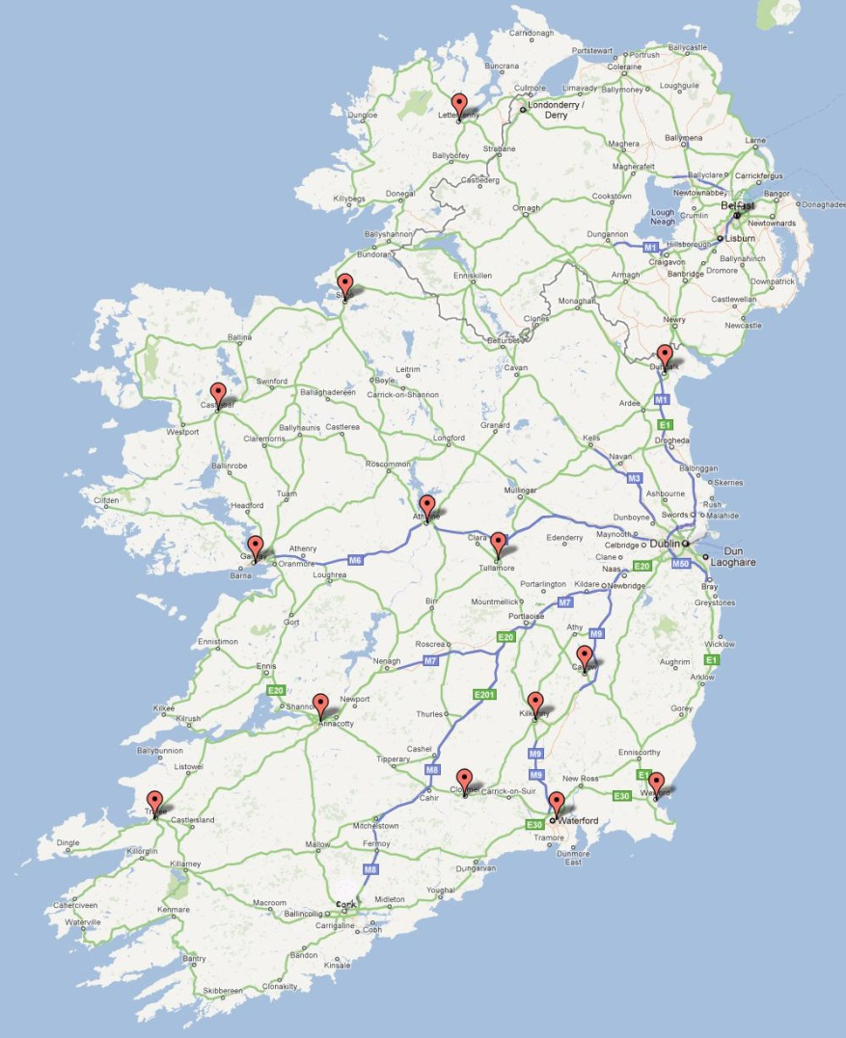
A quantitative study over three years has never been conducted before on RCNI data. We compared findings from the cohort of survivors with disabilities to a sample of 1,359 survivors without disabilities from RCNI 2010 data to understand any differences that may exist. One of the key findings is that there were few notable differences between data for clients with and without disabilities. Where there are notable differences between experiences of survivors with disabilities and those with no disability, these differences are highlighted.

Key Findings
- Survivors with a disability disclosed a lower incidence of sexual violence solely as children and a higher incidence of sexual violence solely as adults than people with no disabilities in annual RCNI National Rape Crisis Statistics.
- Female survivors with a disability disclosed an increase in sexual violence as they age compared with female survivors with no disability who are disclosing a decrease as they age. This finding is consistent with recent research (Nannini 2006, Nosek et al 2001).
- Survivors with disabilities who attended RCC services in 2010 were more likely to have been subjected to three or more incidents of sexual violence, than those with no disabilities (39% compared with 25%).
RCNI provides all data entry staff with regular training and a detailed user guide to help prevent inconsistencies in data entry. The guidance provided to data entry staff around different categories of disability that were in use in the RCNI Database during the relevant period are provided in Appendix 5. It is important to note that survivors may not self-identify as having a disability and the counsellor may not probe into detail of a disability where not relevant to the healing process. Survivors and supporters of survivors attend rape crisis services for support and counselling; data collection is secondary to this purpose.

  - Counselling and Support
Between 2008 and 2010, 197 people with disabilities attended Rape Crisis Centres (RCCs) for counselling and support. More than nine in ten of these were survivors of sexual violence (93%) and fewer than one in ten were supporting someone who had been subjected to sexual violence (7%).
Type of disability
Graph 1: Survivors type of disability (%)
n=184
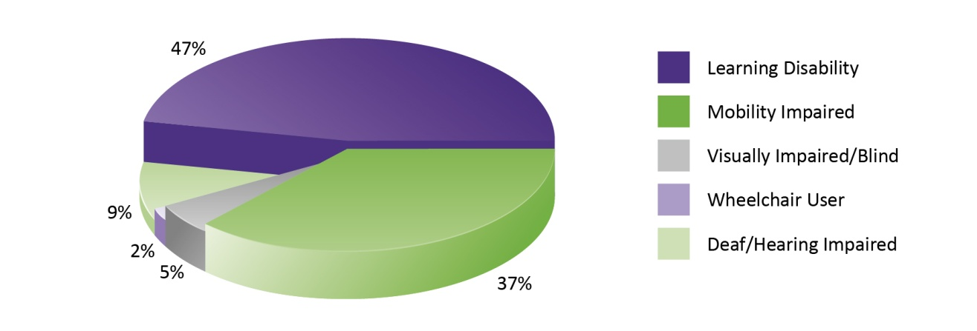
Of the 184 survivors of sexual violence with disabilities who attended RCCs in these three years:
- Almost half had a learning disability (47%). International research has found evidence to suggest that people with learning disabilities are more vulnerable to sexual violence and exploitation than those with other types of disabilities.
- Almost four in ten survivors with a disability had a mobility impairment (37%)
- Fewer than one in ten survivors with a disability was deaf or hearing impaired (9%)
- Fewer than one in ten survivors with a disability were visually impaired or blind (5%)
- A small number of survivors with disabilities were wheelchair users (2%).
In order to examine the data in as much detail as possible and to avoid any unintentional breaches of client confidentiality, it is necessary to merge a number of the disability types together. This allows us to examine the sexual violence details of survivors more accurately and overcome analytical barriers faced due to the relatively small number people with disabilities attending RCCs. It is important to note that the RCNI Database was established in 2004 and the disability indicators have changed since that time. As a result of this research these categories will be reviewed and updated by RCNI in conjunction with the NDA.

When the sexual violence took place
Graph 2: When the sexual violence took place (%)
n = 168
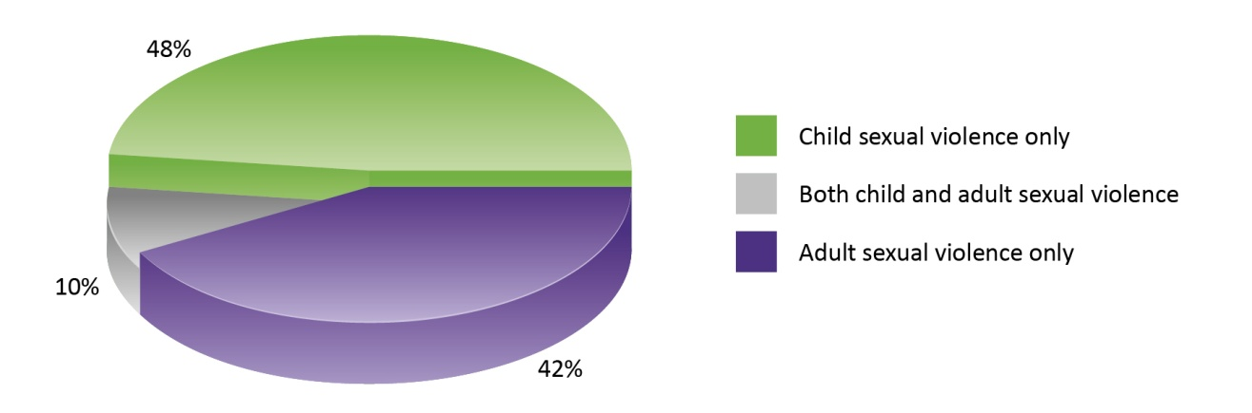
- Almost half of survivors with a disability disclosed that they were subjected to sexual violence solely in childhood, under age 18 (48%)
- More than four in ten survivors disclosed that they were subjected to sexual violence solely in adulthood, age 18 and older (42%)
- One in ten disclosed that they were subjected to sexual violence both as adults and children (10%)

Graph 3: When the sexual violence took place by survivor disability type (%)
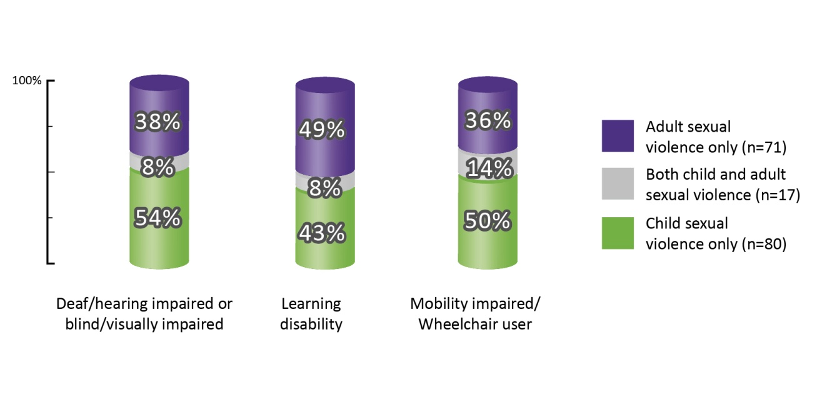

If we examine when the sexual violence took place in the lives of survivors with disabilities we see differences emerge between survivors with different types of disabilities.
- More than half of those who were deaf/hearing impaired or blind/visually impaired were subjected to the violence solely in childhood (54%)

- More than four in ten survivors with a learning disability were subjected to the violence solely in childhood (43%)

- Half of mobility impaired/wheelchair user survivors were subjected to the violence solely in childhood (50%).

When we look at survivors subjected to the sexual violence solely as adults:
- Fewer than four in ten deaf/hearing impaired or blind/visually impaired survivors were subjected to sexual violence solely as adults (38%)

- 36% of mobility impaired/wheelchair users were subjected to the violence solely as adults

- Just under half of survivors with a learning disability were subjected to the violence solely as adults (49%).

Looking at survivors with disabilities who were subjected to violence in both childhood and adulthood:
- Fewer than one in ten survivors who were deaf/hearing impaired or blind/visually impaired, or had a learning disability were subjected to the sexual violence in both childhood and adulthood (8% each)

- Over one in ten survivors who were mobility impaired/wheelchair users were subjected to the violence in both childhood and adulthood (14%).

Graph 4: When the sexual violence took place comparison between survivors with a disability and those with no disability (%)
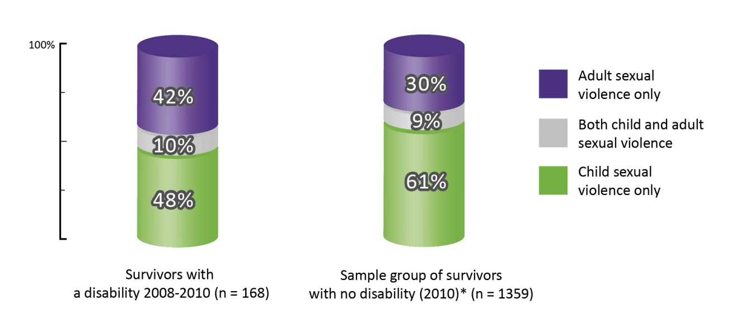
*This sample group of survivors accessing services is comprised of the number of survivors of sexual violence with no disability who attended RCCs in 2010 taken from RCNI National Rape Crisis Statistics 2010. This figure remains consistent every year.
Survivors with a disability disclosed a lower incidence of sexual violence solely as children and a higher incidence of sexual violence solely as adults compared to survivors with no disabilities in annual RCNI National Rape Crisis Statistics.
- Approximately half of survivors with a disability disclosed they were subjected to the sexual violence solely in childhood (48%)
- This contrasts with survivors with no disability, where six in ten disclosed they were subjected to sexual violence solely in childhood (61%)
- Approximately four in ten survivors with a disability disclosed they were subjected to sexual violence solely in adulthood (42%), compared with three in ten survivors with no disability (30%)
- One in ten survivors with a disability disclosed they were subjected to sexual violence both as adults and children (10%). This figure is approximately the same for survivors with no disability (9%) (RCNI, 2011).

Gender of survivors
Graph 5: Gender of survivors with disabilities (%)
n = 184
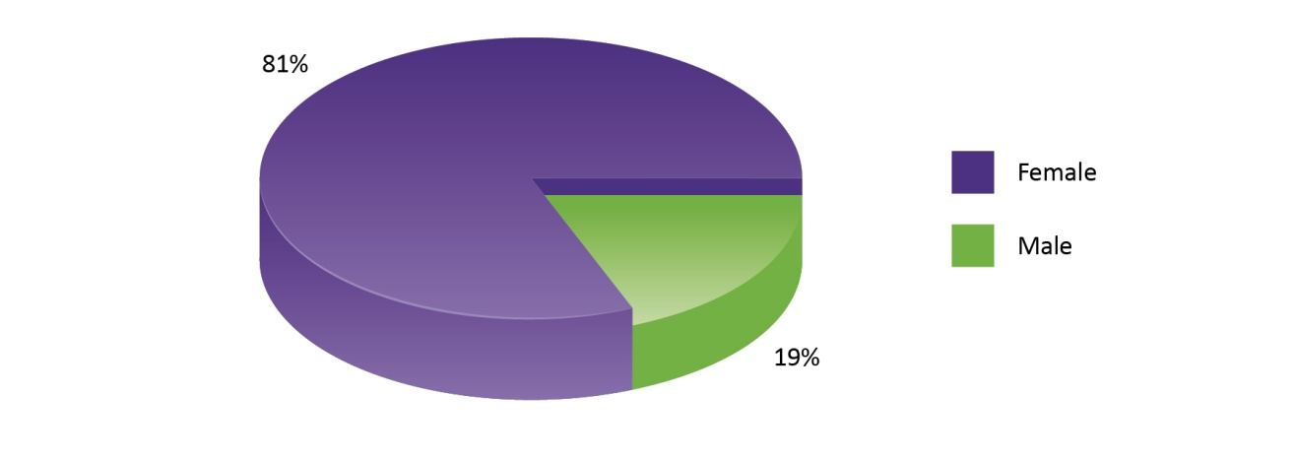
Of the 184 survivors with disabilities that attended RCCs between 2008 and 2010 eight in ten were female (81%) and two in ten were male (19%). There are no notable differences between survivors with disabilities and those with no disability (RCNI, 2011).

Graph 6: When the sexual violence took place by gender of survivor (%)
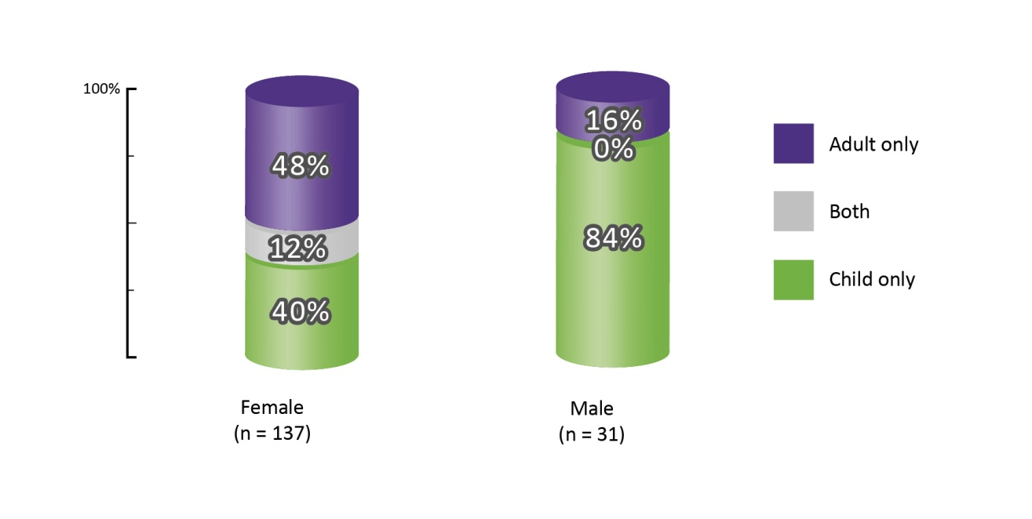
- The majority of male survivors with disabilities were subjected to sexual violence solely in childhood (84%)
- This contrasts with female survivors with disabilities, where four in ten disclosed that the violence took place solely in childhood (40%)
- Almost half of females with disabilities disclosed that the sexual violence took place solely as adults (48%)
- This contrasts with male survivors with disabilities, where less than two in ten were subjected to sexual violence solely as adults (16%)
- Just over one in ten female survivors with a disability were subjected to sexual violence in both their childhood and their adulthood (12%)
- No male survivors with a disability disclosed being subjected to sexual violence in both childhood and adulthood.
The SAVI study of prevalence rates of sexual violence, which does not identify people with disabilities, finds that male vulnerability to sexual violence decreases as they age, whereas female vulnerability to sexual violence does not decrease with age to the same extent (McGee et al, 2002: 280). When we examine female survivors with a disability who attended RCCs between 2008 and 2010, we can see that their vulnerability to sexual violence does not decrease with age at all, it instead increases.

Graph 7: Females only - Type of sexual violence comparison between survivors with a disability and those with no disability (%)
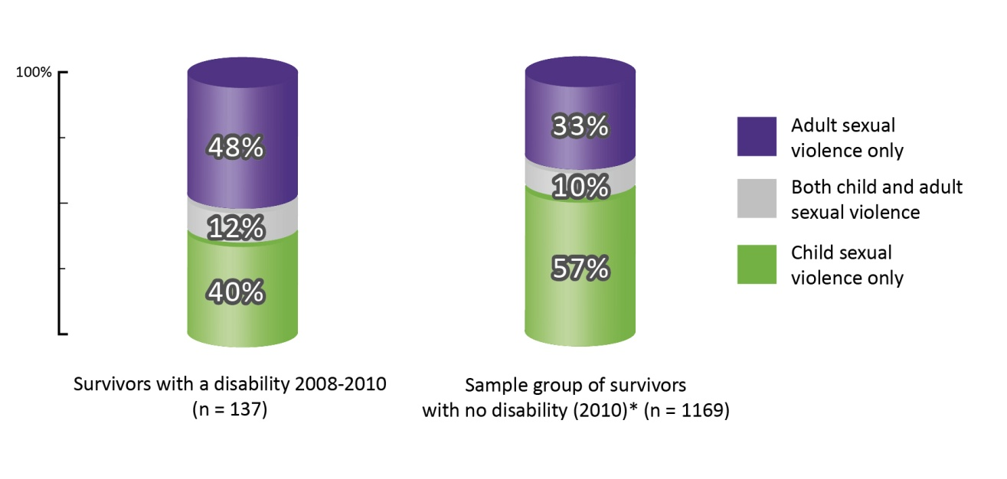
If we examine female survivors with a disability compared with female survivors with no disability, we see differences emerge:
- Almost half of female survivors with a disability disclosed being subjected to sexual violence solely as adults (48%), compared with one third of female survivors with no disability (33%)
- Four in ten female survivors with a disability disclosed sexual violence solely as children (40%), compared with almost six in ten females with no disability (57%)
- There were no notable differences between female survivors who had a disability and those that did not who were subjected to sexual violence in both their childhood and adulthood (12% and 10% respectively).
We can clearly see here that female survivors with a disability are disclosing an increase in sexual violence as they age, compared with female survivors with no disability who are disclosing a decrease as they age. As the number of male survivors with a disability who attended RCC services between 2008 and 2010 is quite low, we will confine this particular analysis to females.

Incidents of sexual violence
Graph 8: Number of incidents of sexual violence survivors were subjected to
n=179

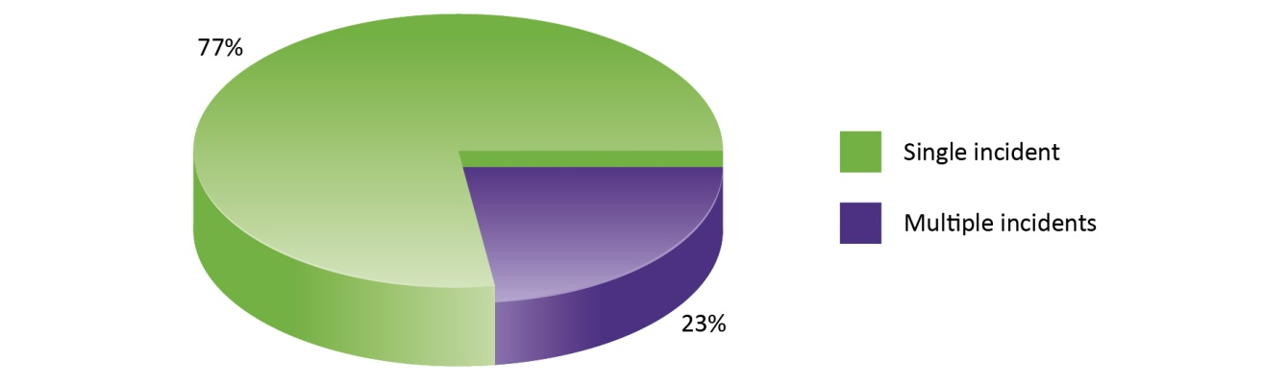
The majority of survivors with a disability disclosed they had been subjected to one incident of sexual violence (77%). Less than one quarter of survivors were subjected to more than one incident of sexual violence (23%). There are no notable differences between survivors with disabilities and those with no disability (RCNI, 2011).

An incident is not necessarily a once-off act of sexual violence. It instead identifies if the sexual violence was connected by the same perpetrator acting alone or a specific group of perpetrators acting together. An incident of sexual violence may last hours, days, weeks, months or years. The RCNI Database collects data on survivor’s abuse details by incident because it is the internationally recognised best practice method of doing so (Department of Health and Human Services, USA, 2009).

In order to examine the data in as much detail as possible, the analysis of the sexual violence will examine those who were subjected to one incident of sexual violence (single incident) and those who were subjected to more than one incident (multiple incidents) of sexual violence separately.

  - Single incident (SI) – survivor information
The following analysis examines sexual violence disclosed by survivors with disabilities who were subjected to one incident of sexual violence.
Clients who were subjected to a single incident of sexual violence were abused by either one perpetrator who acted alone each time they abused, or a specific group of perpetrators who acted together. For example; Mary was raped repeatedly by her uncle and his friend when she was between the ages of 10 to 14. This is one incident of sexual violence because it is the same group of perpetrators acting together all the time

Number of incidents
Graph 9: Single incident – When the sexual violence was perpetrated
Number of incidents of sexual violence survivors were subjected to  n=179 | Single incident - When the sexual violence was perpetrated (%)  n = 128
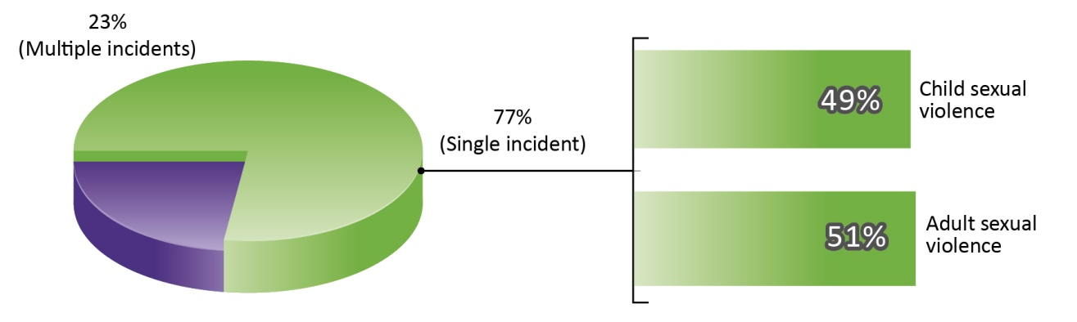

Over three quarters of survivors with a disability who attended RCCs between 2008 and 2010 were subjected to one incident of sexual violence (77%). Approximately half of these survivors were subjected to the sexual violence as children (49%) and half were subjected to the sexual violence as adults (51%).
Type of sexual violence
Graph 10: SI - Type of sexual violence by when the sexual violence was perpetrated (%)
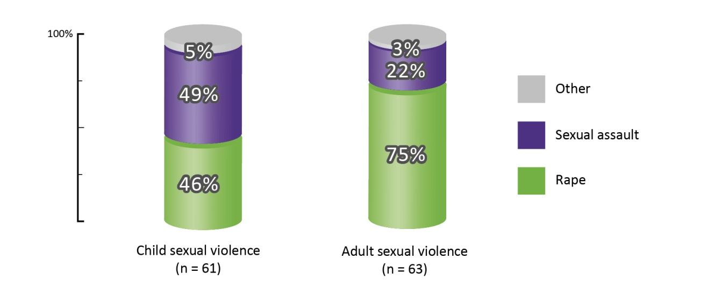
Survivors with disabilities who were subjected to sexual violence when they were children disclosed different types of sexual violence to those who were abused as adults.
Survivors of sexual violence as children:
- Most commonly disclosed type of violence perpetrated against children was sexual assault (49%), followed by rape (46%).
Survivors who were subjected to sexual violence when they were adults disclosed that:
- Three quarters of them were raped (75%)
- Over two in ten disclosed that sexual assault was the type of violence perpetrated against them (22%).
Other forms of sexual violence were disclosed by:
- 3% of survivors who were adults at the time of violence, and
- 5% of survivors who were children at the time of the violence.
There are no notable differences between survivors with disabilities and those with no disability (RCNI, 2011).
Types of other violence
Graph 11: SI - Type of other violence (%)
n = 76
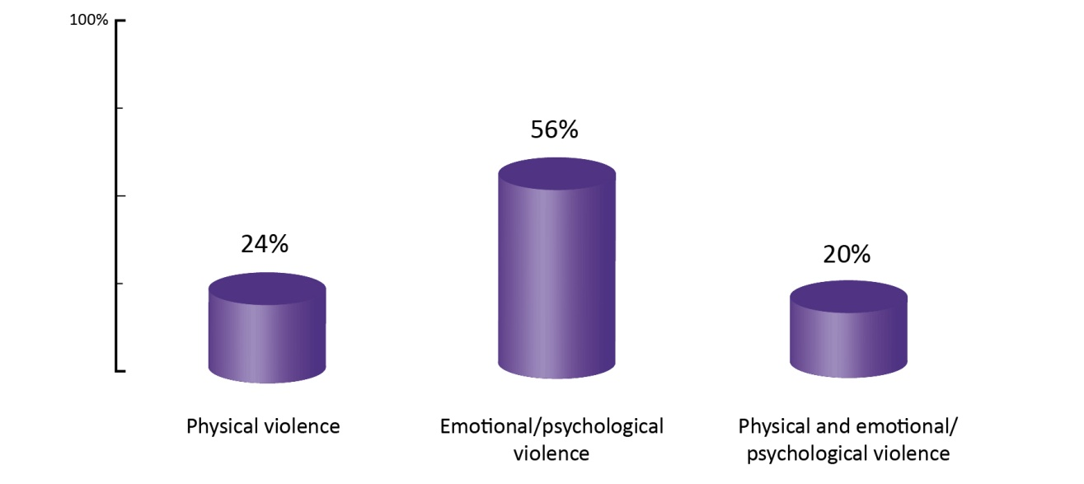
Research tells us that sexual violence usually does not happen in isolation. It is usually combined with other types of violence (McGee et al, 2002: 94). RCNI data analysis supports these findings. Almost nine in ten survivors with disabilities disclosed they were subjected to other forms of violence along with the sexual violence (87%). Other violence includes, amongst others, harassment/intimidation, threats to kill, stalking, imprisonment and attempts to kill.
- More than half of those with disabilities who were subjected to other forms of violence, disclosed that it was emotional/psychological in nature (56%)
- Approximately one quarter disclosed that the other violence was physical in nature (24%)
- Two in ten survivors, subjected to other forms of violence, disclosed that it was both physical and emotional/psychological in nature (20%).
There are no notable differences between survivors with disabilities and those with no disability (RCNI, 2011).
Duration of violence
Graph 12: SI - Duration of sexual violence (%)
n = 122
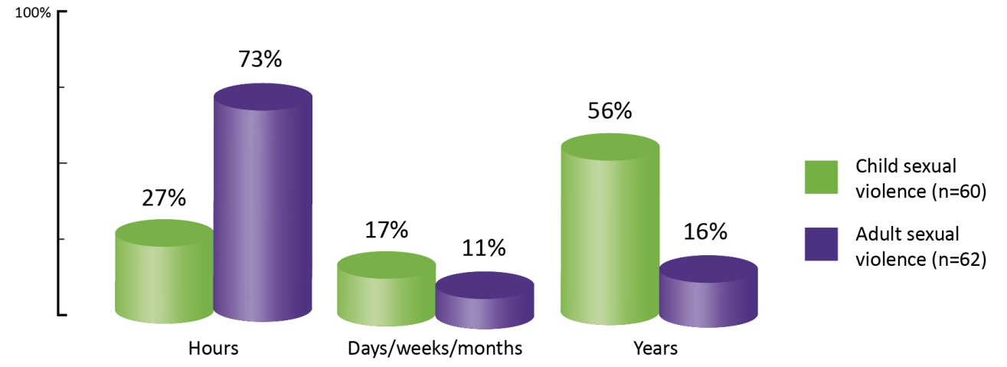

When we examine sexual violence disclosed by survivors of one incident of sexual violence with disabilities, we see clear differences in the duration of the violence of those subjected to violence as children and those subjected to sexual violence as adults.
- The majority of survivors of sexual violence as children with disabilities disclosed being subjected to abuse over years (56%)
- This is in contrast with survivors of sexual violence as adults who disclosed that in seven in ten incidents, the violence was perpetrated over hours (73%) and in fewer than two in ten incidents, the violence was perpetrated over years (16%)
- Over one quarter of survivors who were subjected to sexual violence as children disclosed that the violence was perpetrated over hours (27%).
There are no notable differences between those with disabilities and those with no disability (RCNI, 2011).
Location of violence
Survivors of single incidents of sexual violence with disabilities disclosed that the violence most commonly took place in the perpetrator’s home or in their own home.

  - Single Incident - Perpetrator Information
Number of perpetrators
Graph 13: SI - Perpetrators acting alone or in groups (%)
n = 138

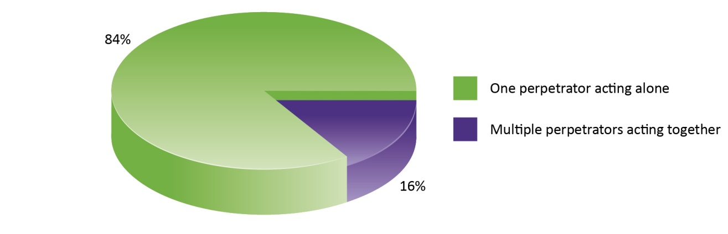

- The majority of survivors with disabilities disclosing one incident of sexual violence were subjected to the violence by one perpetrator acting alone (84%)
- Fewer than two in ten survivors disclosed that the sexual violence was perpetrated by more than one perpetrator (16%)
There are no significant differences in the number of perpetrators between female and male survivors, or between those subjected to sexual violence as children and those subjected to sexual violence as adults. There are also no notable differences between those with disabilities and those with no disability (RCNI, 2011).

Graph 14: Single incident - Perpetrators acting alone or in groups by when the sexual violence took place (%)
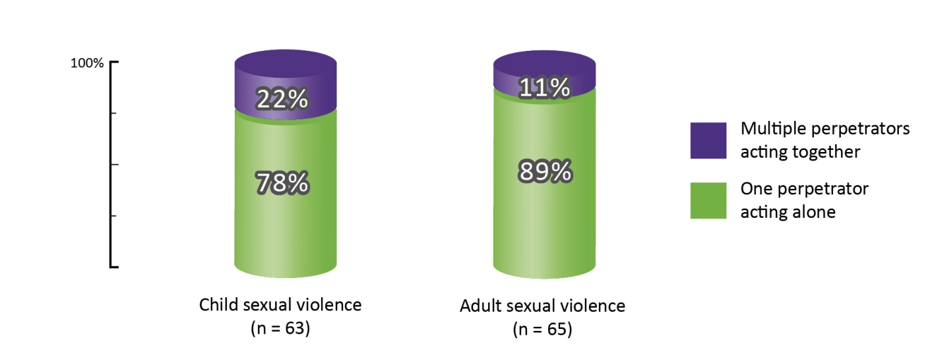

- Two in ten survivors of child sexual violence with a disability disclosed being subjected to the violence by multiple perpetrators who acted together (22%)
- This is twice the proportion of survivors of adult sexual violence (11%) who reported perpetrators acting together
- Nine in ten survivors of sexual violence as adults were subjected to the violence by one perpetrator (89%)
- Compared with fewer than eight in ten survivors of sexual violence as children (78%).
When we examine survivors with no disabilities who attended RCC services in 2010, there were no significant differences in perpetrator behaviour between survivors subjected to child sexual violence and those subjected to adult sexual violence (RCNI, 2011).
Gender of perpetrators
Graph 15: Single incident - Gender of perpetrators (%)
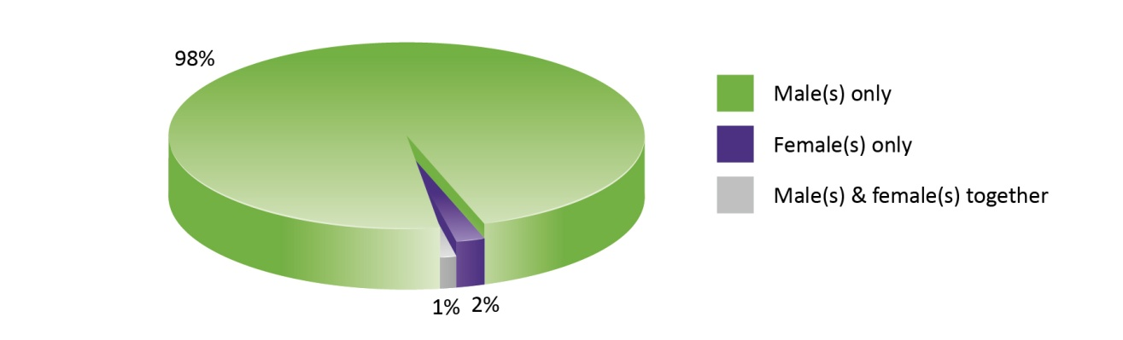

Looking at all single incidents of sexual violence:
- The majority of survivors disclosed they were subjected to sexual violence by male perpetrators only (98%)
- A minority disclosed that the violence was perpetrated by solely female perpetrators (2%), and
- Both male and female perpetrators acting together (1%).
There are no notable differences between those with disabilities and those with no disability (RCNI, 2011).

Relationship to perpetrator
More than eight in ten perpetrators are known to the survivor (84%). Survivors with a disability disclosed that:
- One third of perpetrators were friends, acquaintances or neighbours (33%)
- Over one quarter disclosed that the perpetrators were family members (27%)
- Partners and ex-partners were named as the perpetrators in more than one in ten single incidents of sexual violence (14%)
- Strangers were reported as the perpetrators in one in ten incidents (10%).
A stranger is defined as someone the survivor has never met before, in contrast with an acquaintance who is someone the survivor may have known to say hello to, or have chatted to in a nightclub, for example. The category of friends, acquaintances and neighbours used in this report offers a wider catch-all, which allows for any subjective differences that may arise in defining these types of relationships. Fewer than one in ten survivors disclosed that authority figures and other combinations of perpetrators were responsible for the sexual violence (8% each).
There are no notable differences between survivors with disabilities and those with no disability (RCNI, 2011).

Acquaintance: Somebody that the survivor may know to say hello to or have chatted to in a nightclub
Authority figure: Clergy, Doctor or Medical or Caring profession, Gardaí or PSNI or Other national police force, Security forces, Sports coach or Youth worker, Teacher (clergy), Teacher (lay), Babysitter or childminder, Employer, Landlord
Stranger: Somebody that the survivor has never met before

Graph 16: SI- Relationship of survivor to perpetrator by when the sexual violence took place (%)
n = 120
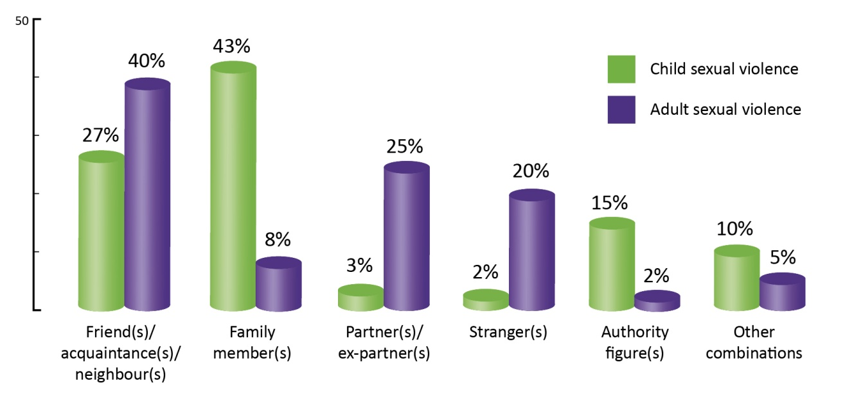
Clear differences emerge between survivors’ relationships to the perpetrators when we examine abuse that took place when survivors were children and that which took place when survivors were adults.
- Four in ten survivors who were children when subjected to the violence, reported that family members were the perpetrators responsible for the violence (43%)
- One in four reported that friends, acquaintances and neighbours (27%) were responsible
- Authority figures were perpetrators in fewer than two in ten cases by survivors of sexual violence as children (15%).
Survivors who were adults when the sexual violence took place disclosed that:
- Friends, acquaintances and neighbours were most commonly the perpetrators (40%)
- Followed by partners and ex-partners (25%)
- Strangers were disclosed as the perpetrators by two in ten survivors of sexual violence as adults (20%)
- Fewer than one in ten survivors of sexual violence as adults named family members as the perpetrators (8%).
There are no notable differences between survivors with disabilities and those with no disability (RCNI, 2011).

Graph 17: SI- Relationship of survivor to perpetrator by type of disability (%)
n = 108
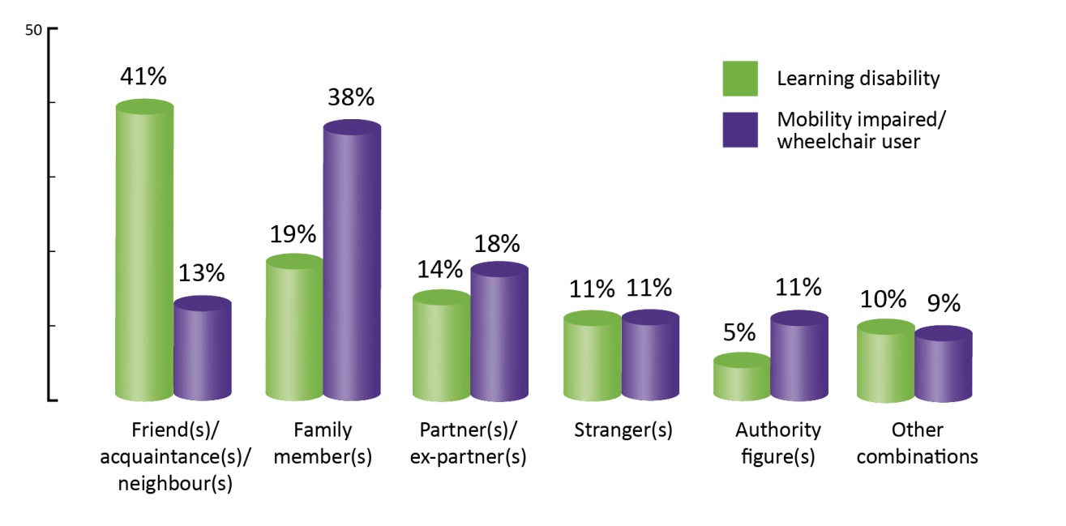
Some notable differences can be seen when we examine survivors’ relationship to perpetrators according to survivor’s disabilities. As the figures for survivors who are deaf/hearing impaired or blind/visually impaired are quite low, we will confine this analysis to those with a learning disability and those who are mobility impaired/wheelchair users.
- Four in ten survivors with a learning disability disclosed that friends, acquaintances or neighbours perpetrated the sexual violence against them (41%)
- Compared with over one in ten survivors who are mobility impaired/wheelchair users (13%)
- Four in ten survivors with a mobility impairment/wheelchair user disclosed the sexual violence was perpetrated by a family member (38%)
- Compared with two in ten survivors with a learning disability (19%).

  - Multiple incidents (MI) – Survivor information
The following analysis examines all incidents of sexual violence disclosed by survivors with a disability who were subjected to more than one incident of sexual violence.
Clients who were subjected to multiple incidents of sexual violence were abused by different perpetrators either acting alone or in groups. For example; Mary was raped repeatedly by her uncle when she was between the ages of 10 to 14. This is one incident of sexual violence because it is the same perpetrator acting alone all the time. The same uncle and his friend acting together raped her once when she was 13. This is a different incident of sexual violence because it involves a different combination of perpetrators.
Incidents of sexual violence may last hours, days, weeks, months or years. The RCNI Database collects data on survivor’s abuse details by incidents because it is the internationally recognised best practice method of recording sexual violence (Department of Health and Human Services, USA, 2009).
Number of incidents
Graph 18: Multiple incidents – When the sexual violence took place
Number of incidents of sexual violence survivors were subjected to  n=179 | Multiple incidents - When the sexual violence took place (%)  n = 41
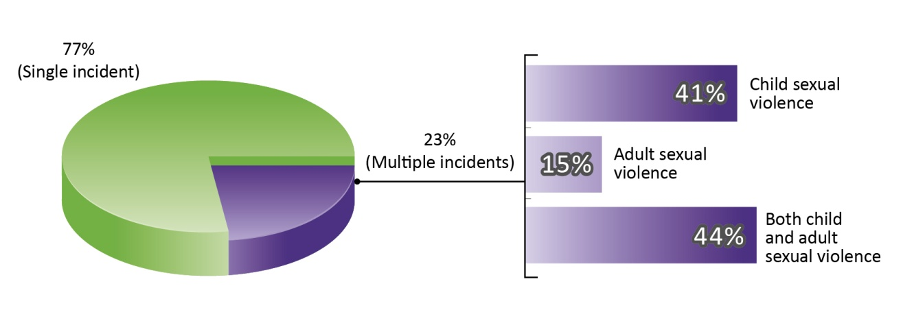
Two in ten survivors attending RCCs in 2010 were subjected to more than one incident of sexual violence (23%).
- Over four in ten of these survivors were subjected to the sexual violence in both their childhood and adulthood (44%)
- Or solely in their childhood (41%)
- Under two in ten were subjected to sexual violence solely as adults (15%).
Number of incidents of sexual violence
Graph 19: MI - Number of multiple incidents of sexual violence perpetrated against survivors (%)
n = 41
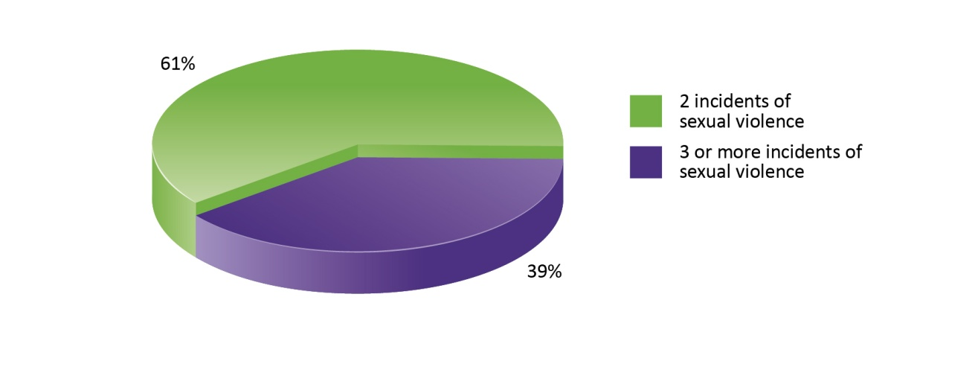
- Six in ten survivors, who disclosed they were subjected to multiple incidents of sexual violence, were subjected to two incidents (61%)
- Four in ten survivors, who disclosed they were subjected to multiple incidents of sexual violence, were subjected to more than two incidents (39%).
Survivors with no disabilities, who attended RCC services in 2010, showed a lower incidence of being subjected to three or more incidents of sexual violence than those with disabilities (25% compared with 39%). This means that survivors with disabilities were subjected to a greater number of multiple incidents of sexual violence than those with no disabilities.
Type of sexual violence
Survivors who experience multiple incidents of sexual violence are often subjected to different types of sexual violence or the same type of sexual violence multiple times in each incident.
Almost nine in ten survivors with disabilities were raped and/or sexually assaulted in the different incidents of sexual violence they were subjected to (88%). More than one in ten were subjected to different combinations of sexual violence (13%).
Other violence
Three quarters of survivors with a disability disclosing multiple incidents of sexual violence were also subjected to other violence alongside the sexual violence (76%). This is approximately the same for survivors who were subjected to a single incident of sexual violence (RCNI, 2011). There were also no significant differences in the types of other violence perpetrated against those subjected to a single incident and those subjected to multiple incidents (RCNI, 2011).
Duration of violence
Survivors with a disability who were re-victimised by different perpetrators acting separately disclosed that the violence was perpetrated over a range of different lengths of time. There are no notable differences between survivors with disabilities and those with no disability (RCNI, 2011).
  - Multiple incidents - Perpetrator information
Number of perpetrators
Graph 20: MI - Perpetrators acting alone or in groups (%)
n = 41

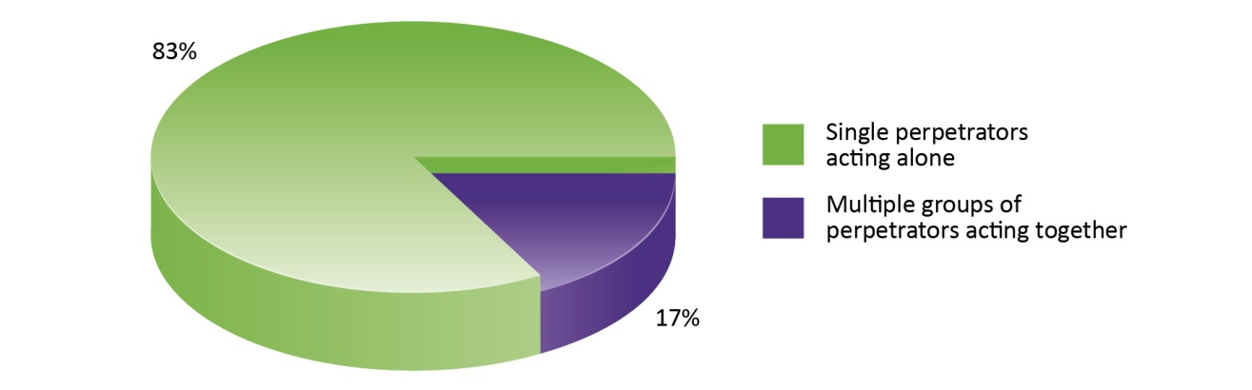

Approximately eight in ten survivors, subjected to more than one incident of sexual violence, disclosed that the violence was by a perpetrator who acted alone each time (83%). Fewer than two in ten survivors, subjected to multiple incidents of sexual violence, said they were subjected to the violence by perpetrators who acted in groups (17%). There are no notable differences between survivors with disabilities and those with no disability (RCNI, 2011).
Gender of perpetrators
Graph 21: MI - Gender of perpetrators (%)
n = 41

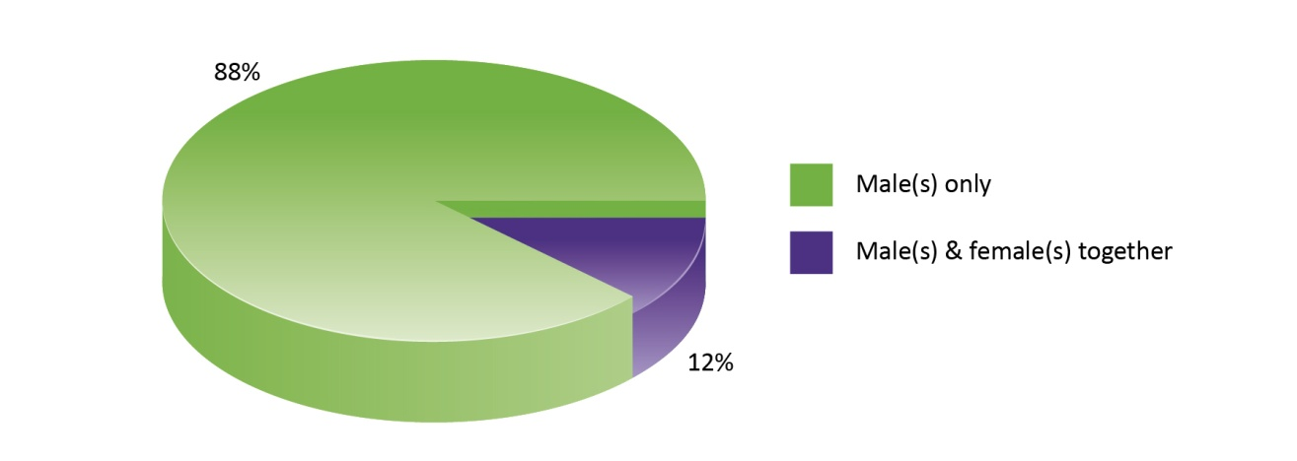
Survivors of multiple incidents of sexual violence disclosed that:
- The majority of perpetrators were males either acting alone or acting with other males (88%).
- Over one in ten perpetrators were combinations of males and females, either acting alone or together (12%).
There are no notable differences between survivors with disabilities and those with no disability (RCNI, 2011).
Relationship of survivor to perpetrators
As survivors of multiple incidents of sexual violence are subjected to different incidents of sexual violence by different perpetrators either acting alone or acting together, the relationships between the survivor and perpetrators are often complex. The majority of these survivors had the violence perpetrated against them by people who were within their circle of trust. This includes different combinations of family members, friends, acquaintances, neighbours, partners or ex-partners, either acting alone or acting together in different incidents (90%). There are no notable differences between survivors with disabilities and those with no disability (RCNI, 2011).
  - Reporting the sexual violence
Graph 22: Reporting the sexual violence to a formal authority (%)
n = 179

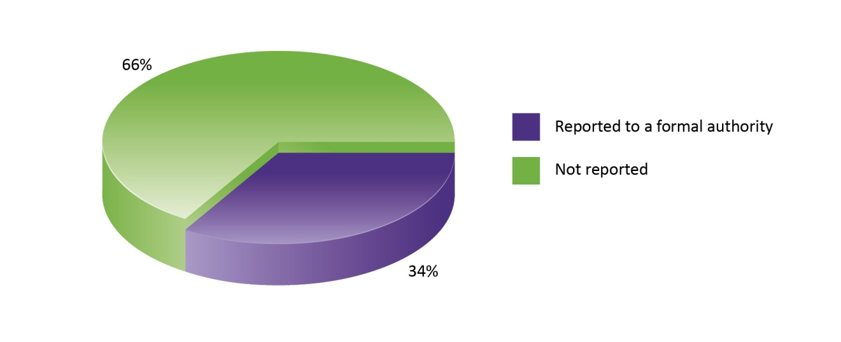
This analysis refers to all survivors with disabilities. Graph 22 illustrates that approximately one third of survivors with disabilities who attended RCCs between 2008 and 2010 reported the violence to the police and/or other formal authority (34%). Almost all of these survivors disclosed to the police (30%). Formal authorities include An Garda Síochána, the HSE, Redress Board, education authority, and church authority. The number of survivors attending RCCs who reported the violence to the police is four to six times higher than the overall rate of reporting of sexual violence in Ireland according to SAVI figures, where 8% of survivors of sexual violence as children and 6% of survivors of sexual violence as adults, reported to the police (McGee et al, 2002: 128).

As Hanly et al point out, non-reporting of sexual violence has a number of consequences for the survivor and society; survivors may not be able to access the support services they need, offenders are not held to account, and information about the violence and its impact on the survivor is not collected (Hanly et al, 2009: 35). The RCNI Database, therefore, fills a gap in the gathering of accurate and reliable information from survivors of sexual violence who have not reported to any formal authority. It allows us to examine in detail the nature of the violence and the impact on the survivor. The 66% of RCC survivors with disabilities who did not report to any formal authority are therefore not included in any other formal statistics or records. This unique and essential part of the story, and the only place where these survivors have their experiences documented publicly to support and influence national policy, is in the RCNI National Statistics and this report. The high level of self referral and referral from other agencies to RCCs demonstrates that RCCs are highly regarded and trusted. The finding that there are no notable differences in recording between survivors with disabilities and those with no disability is consistent with recent research (Nannini 2006).

Graph 23: Reported to a formal authority by when the sexual violence was perpetrated (%)
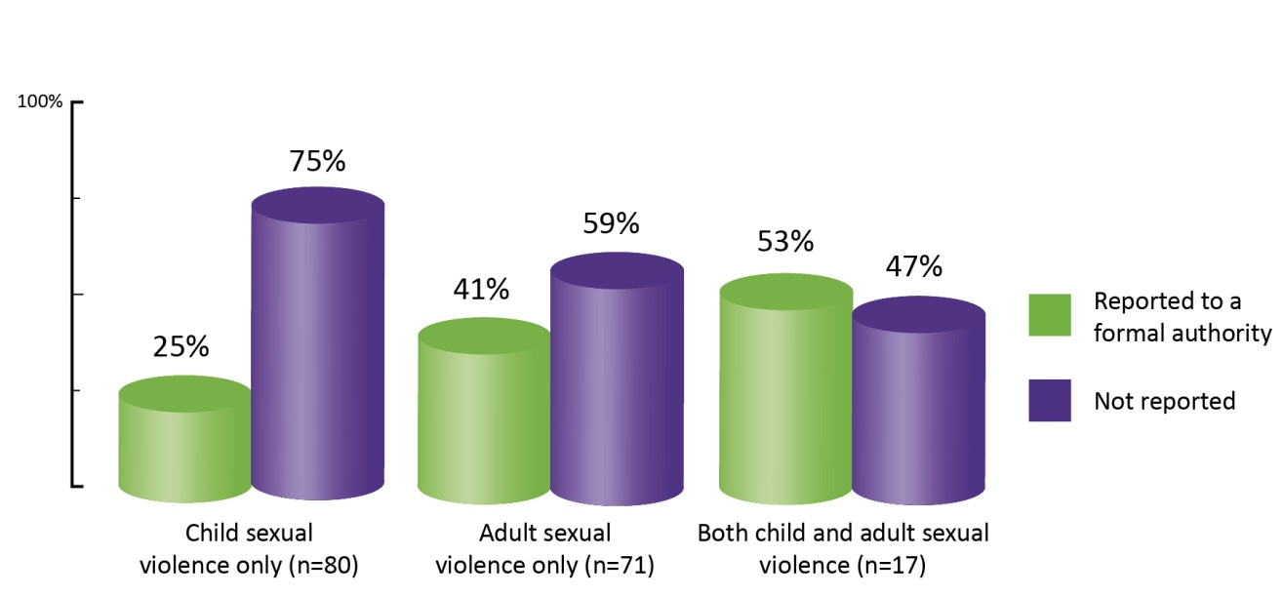

As Graph 23 illustrates:
- Four in ten survivors of sexual violence solely as adults reported the violence to a formal authority (41%)
- One quarter of survivors of sexual violence solely as children reported the violence to a formal authority (25%)
- Over half of survivors of sexual violence in both childhood and adulthood reported the violence to a formal authority (53%).
There are no notable differences between survivors with disabilities and those with no disability (RCNI, 2011).

  - Client Demographics
Age of survivors
Graph 24: Age of survivors accessing RCC services (%)
n = 183
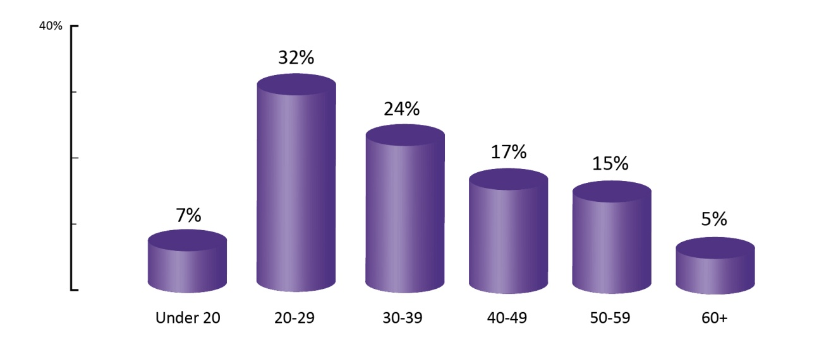

- More than seven in ten survivors with a disability who attended RCC services between 2008 and 2010 were aged between 20 and 49 (73%)
- The largest age category were those between the ages 20 and 29 (32%)
- One quarter of survivors were aged 30 to 39 when accessing services (24%)
- Fewer than two in ten were aged 40 to 49 (17%)
- Under two in ten were aged 50 to 59 (15%)
- One in twenty survivors with a disability were under the age of 18 when accessing RCC services (6%).
RCCs provide more counselling and support services to child survivors of sexual violence than any other non-statutory organisation in Ireland. There are no notable differences between survivors with disabilities and those with no disability (RCNI, 2011).

Country of origin
Graph 25: Survivor's country of origin (%)
n=182
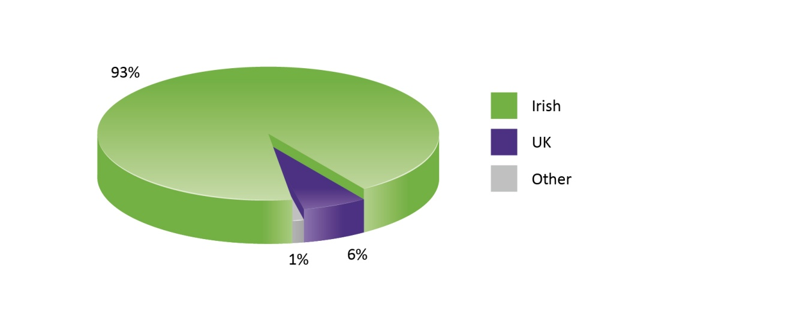
- The majority of survivors with disabilities were Irish (93%)
- Fewer than one in ten were from the UK (6%) and
- 1% were from other countries.
Supporters
Supporters are invaluable in helping survivors rebuild their lives. Receiving compassionate and validating responses from friends and family can make a substantial difference. A supporter may want to help but not know what to do or say. In addition, a supporter may feel overwhelmed and struggle with her or his own feelings of helplessness. It is natural and normal for supporters to experience shock, anger and devastation as well. It is a clear indication of the impact of sexual violence that those around the survivor can also suffer consequences. To provide support to survivors and for supporters to deal with the impact of the sexual violence upon themselves, it is vital that supporters also have access to the expert counselling and support that RCCs provide.
Of the 197 people with disabilities who attended RCCs in the three year study period, 7% did so because they were supporting someone who had been subjected to sexual violence. Supporters were most commonly partners or parents of the survivor. There are no notable differences between supporters with disabilities and those with no disability (RCNI, 2011).

  - Conclusion
This quantitative study of RCNI data, focusing on people with disabilities who attended RCC services from 2008 to 2010, has found three notable differences between survivors with disabilities and those with no disabilities.
Survivors with a disability, who attended RCC services between 2008 and 2010, disclosed a lower incidence of sexual violence solely as children and a higher incidence of sexual violence solely as adults than those with no disability. It is important to remember that 81% of survivors with disabilities who attended services between 2008 and 2010 were female, so female survivors are driving this trend.
Female survivors with a disability disclosed an increase in sexual violence as they aged compared with female survivors with no disability who disclosed a decrease in sexual violence as they age. From this, we can say that female survivors with a disability who attended RCC services between 2008 and 2010 displayed an increase in vulnerability to sexual violence as they aged.
Survivors with disabilities were subjected to more multiple incidents of sexual violence than those with no disabilities. From this we can say that survivors with a disability who attended RCC services between 2008 and 2010 disclosed a higher vulnerability to sexual violence perpetrated by more different groups of perpetrators, acting together or perpetrators acting alone, than survivors with no disability.
The information in this report is compiled from the data entered by all 13 RCNI Republic of Ireland member Rape Crisis Centres and one non-member Rape Crisis Centre (Athlone Midlands Rape Crisis Centre) around Ireland. The data represents all people using these RCCs for counselling and support between 2008 and 2010. It represents only these people and cannot be used to make assumptions about the overall incidence or nature of sexual violence in Ireland. In order to determine the scale of sexual violence against people with disabilities a prevalence study is needed. This would allow an assessment of the level of sexual violence perpetrated against people with disabilities throughout Ireland, and indicate where to target resources effectively to challenge this violence, how to protect people with disabilities from the violence, and help those who have already been subjected to the violence.

- Quantitative analysis of online survey for people with disabilities – What stops us talking about sexual violence?
RCNI, in conjunction with the Centre for Disability, Law and Policy, NUIG and NALA, designed a survey for people with disabilities. The survey was disseminated widely through disability support organisations in the Republic of Ireland and on the RCNI website. The survey used Survey MonkeyTM online software tool and was available online from 22 August 2011 to 30th September 2011. A printed version of the survey was also available to potential respondents.
Respondents were invited to answer nine questions aimed at increasing understanding of the barriers and challenges for people with disabilities to disclosing sexual violence (see Appendix 4 for full survey).
The survey was introduced with the following definition of sexual violence, approved by NALA:
Sexual violence or abuse is when anyone does something to you in a sexual way that you do not want them to do. You can experience sexual violence from anyone, including people you are related to. Sexual violence can happen anywhere, including at home or at work.
Examples of sexual violence are:
- Someone making you do sexual things that make you sad, angry, afraid or ashamed
- Someone touching you in a sexual way where you do not want to be touched
- Someone making you touch them on their private parts
- Someone making you take your clothes off or have sex when you do not want to
- Someone taking photographs of you with no clothes on.
Respondents to this survey are not a representative sample and these findings cannot be used to indicate prevalence of sexual violence. As noted above, respondents were self-selecting and participated using online technology. It is not known if any of the respondents were assisted to complete the survey. The data includes those able to access the internet and use a computer.

Graph 26: All respondents %
n=137

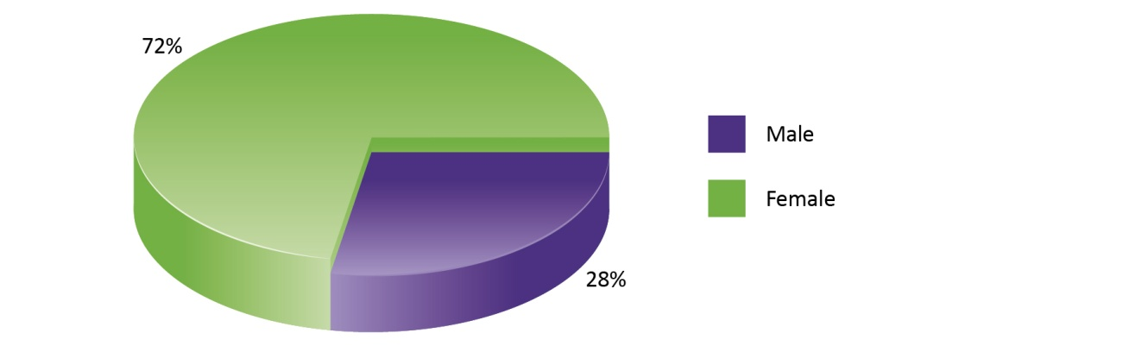

137 people with disabilities participated in the nine question survey comprised of binary choice, multiple choice and open-ended questions.
- Seven in ten respondents were female (72%), three in ten were male (28%)
- Eight in ten respondents fully completed the survey (111 people or 81%)
- Of the 26 people who did not complete the survey, 9 were male and 17 female
- Ten respondents (all female) dropped out at the eighth question, ‘Has anyone ever asked you if you have experienced sexual violence?’
- Five (all male) dropped out at question seven, requiring a free-text response, ‘What would help you to tell someone?’
- The last question, (‘Have you suffered sexual violence?’), did not cause any respondents to drop out of the survey, although three females who answered yes to this question, did not answer the follow up question, ‘If yes, did you tell anyone?’
- Five respondents dropped out within the first three questions (gender, age, disability).
Graph 27: Have you suffered sexual violence?
n = 111

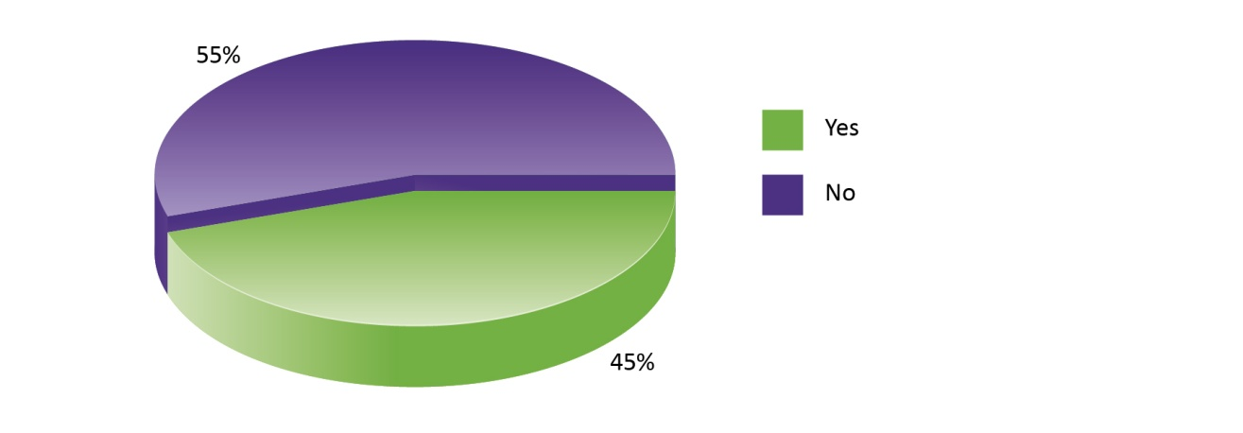

- Fifty people, or 45% of respondents who answered this question, said that they were survivors of sexual violence
- Over half (55%) were not survivors of sexual violence or did not disclose sexual violence.

Graph 28: If yes, did you tell anyone?
n = 50

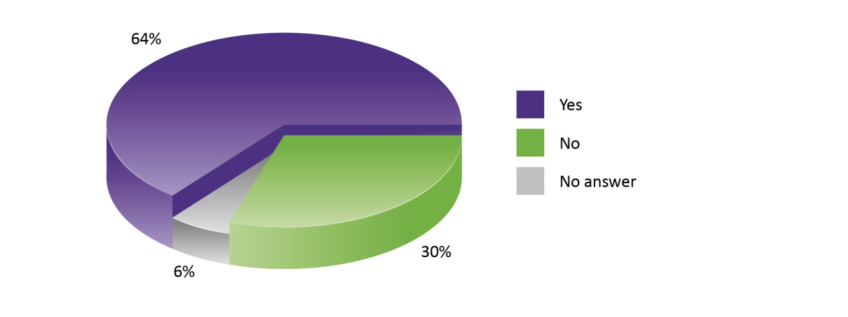

- Three in ten respondents who disclosed in the survey that they had been subjected to sexual violence were disclosing this violence for the first time (30%)
- Six in ten had previously disclosed the violence to someone else (64%).
A comment box was provided for this question and the 32 survivors (64%) who had previously disclosed sexual violence revealed that:
- Respondents often did not tell anyone until years later, citing periods of up to 50 years before disclosure
- Respondents were not believed when they disclosed the violence and some suffered further violence as a consequence
- If respondents had been subjected to multiple incidents of sexual violence, they did not always tell about every incident
- Respondents sometimes tried to tell but were not able to fully disclose the extent of their experiences.

Graph 29: Gender of Survivors
n = 50

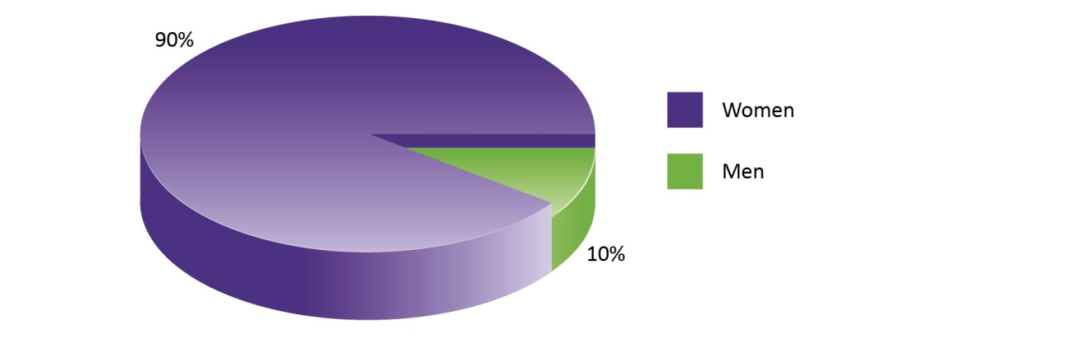

- Nine in ten of those who reported being subjected to sexual violence were female and one in ten was male (90% and 10% respectively)
- Of the 30 men who answered the question, ‘Have you suffered sexual violence?’, fewer than one in five was a survivor of sexual violence (17%)
- Over half of the 82 women who answered this question identified themselves as survivors of sexual violence (55%).

Graph 30: Age groups of survivors
n = 50
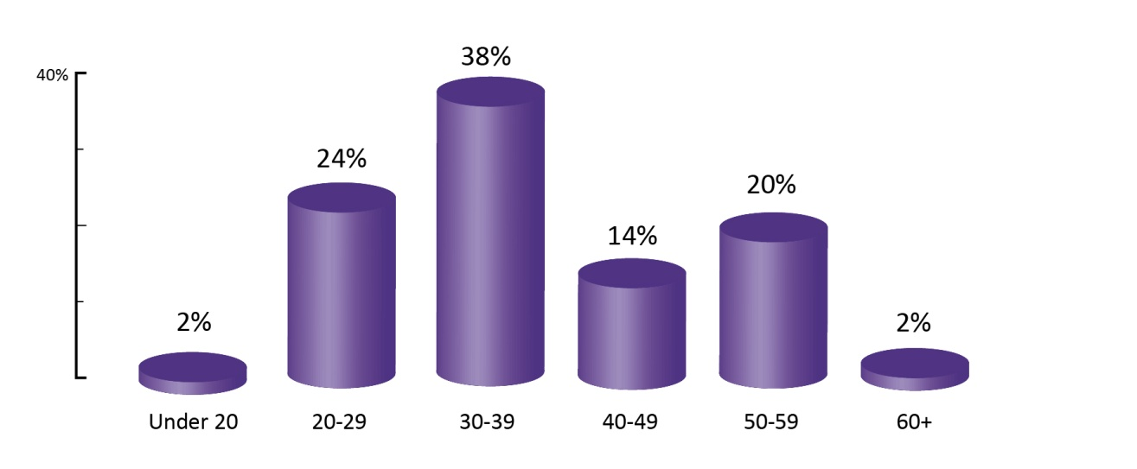

- Four in ten of those respondents who disclosed sexual violence were between 30 and 39 years of age (38%)
- This chart reflects the current age of the survivor, not the age when the violence was experienced.

Graph 31: Sexual violence by disability
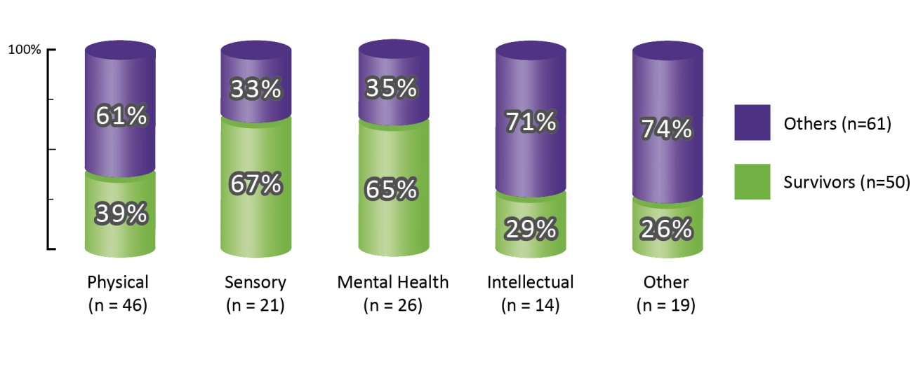
The response choices of disability was limited to five categories in the survey Respondents self-selected one or more categories of disability.
Those who selected the category ‘Other’ provided further detail in a comment box. ‘Other’ was not defined in the survey and some respondents identified with conditions that might also be described under the first four categories. However, as the respondents had self-identified, we report the findings in the categories where the respondents placed themselves. ‘Other’ disability responses include Asperger Syndrome, acquired brain injury, cancer, dyslexia, epilepsy, chronic pain and membership of the Deaf Community.
The highest percentage of sexual violence was disclosed by people with sensory and mental health disabilities.
- Two in three respondents who identified with sensory and mental health disabilities disclosed sexual violence (67% and 65%, respectively)
- Four in ten respondents who identified with physical disabilities disclosed sexual violence (39%)

- Fewer than three in ten respondents who identified with intellectual or other disabilities disclosed sexual violence (29%).
Graph 32: Has anyone ever given you any information about where to go for support surrounding sexual violence?
n = 132

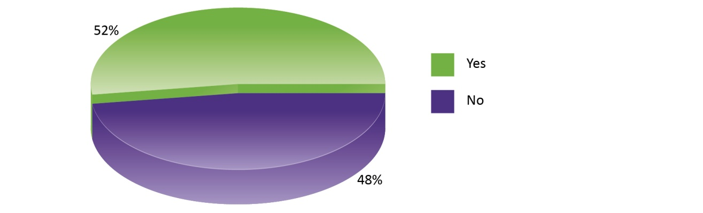

There was no difference between survivors and those who did not disclose sexual violence with regard to being provided with information about support surrounding sexual violence. Just under half of all respondents had never been given any information (48%).

Graph 33: Has anyone ever given you any information about where to go for support surrounding sexual violence?
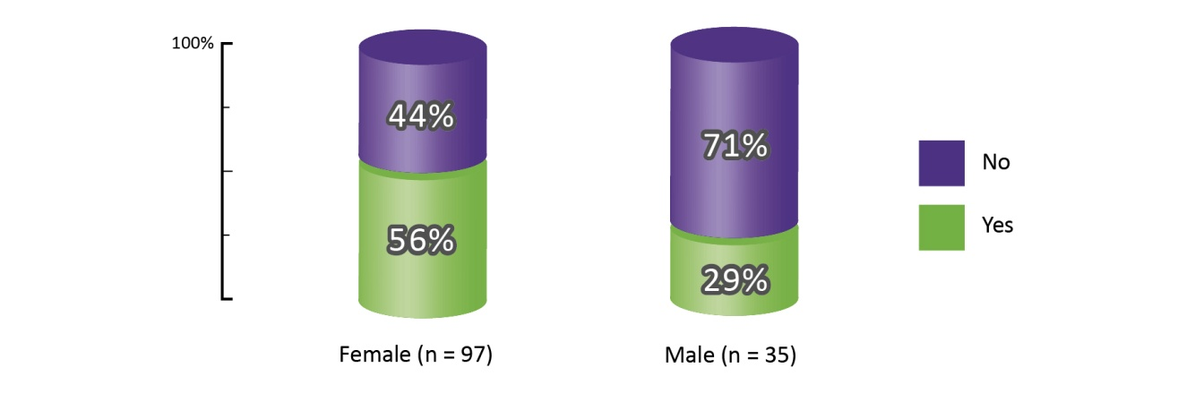

When this data was analysed for gender difference, only 29% of the men report having received information, compared to 56% of the women
- Seven in ten men had never received any information (71%).
Graphs 34, 35 and 36: Has anyone ever asked you if you have suffered sexual violence?
Graph 34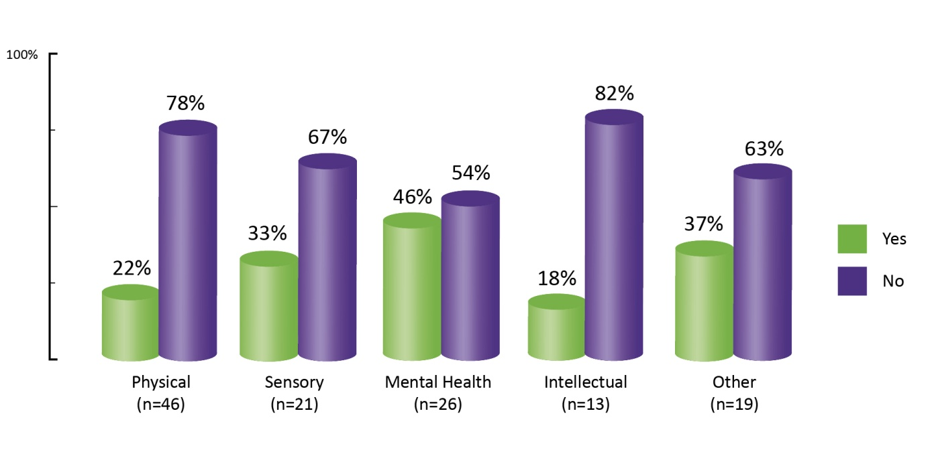
- Seven in ten of all respondents said that nobody had ever asked whether they had suffered sexual violence (71%)
- Two in ten people with intellectual disabilities and people with physical disabilities reported ever being asked if they had suffered sexual violence (18% and 22% respectively).

Graph 35 | Graph 36
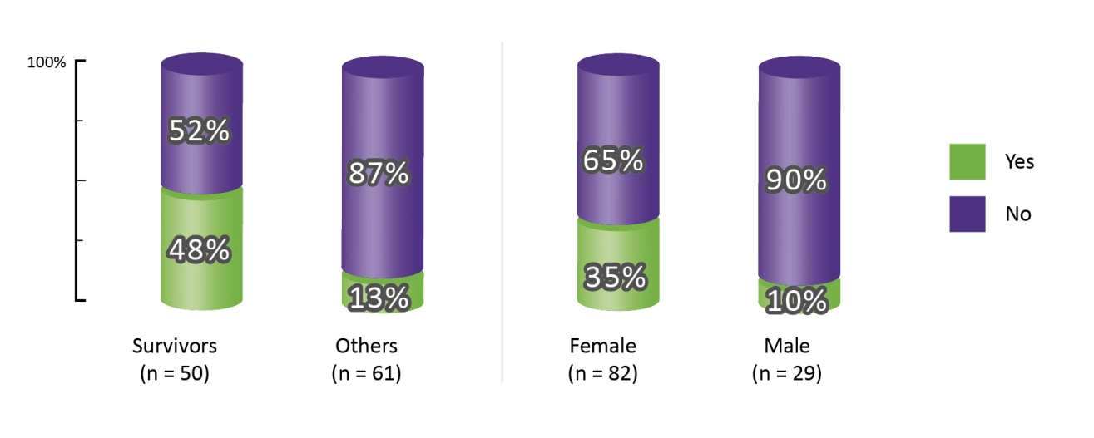
- Survivors were more likely to be asked about sexual violence. Nearly half of all survivors, (48%) said that someone had asked them if they had suffered sexual violence, compared with only 13% of respondents who had not been subjected to sexual violence
- One in ten males reported being asked about sexual violence (10%), compared with 35% of the female respondents.
Graph 37: Who would you tell if you were worried about sexual violence?
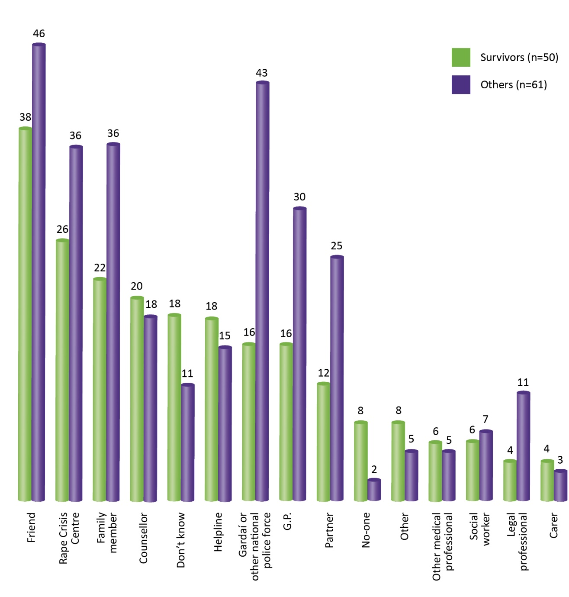

This chart demonstrates that those who disclosed sexual violence (Survivors) and those who did not disclose sexual violence (Others) have different views on who they would tell if they were worried about sexual violence.
Respondents could choose as many selections as appropriate to this question.
- Almost one in ten survivors would tell no-one if they were worried about sexual violence (8%)
- Almost one in five survivors of sexual violence (18%) do not know who they would tell
- Survivors are less likely to tell anyone and those who do disclose are less likely to tell as many people
- Survivors selected Friend, Rape Crisis Centre, Family Member, Counsellor, and Helpline as the top five choices
- Others selected Friend, Garda, Rape Crisis Centre, Family Member and GP as the first five choices
- Others were twice as likely as Survivors to tell Gardai, GP, Partner or a Legal Professional and more likely to tell Friends, Family and Rape Crisis Centres
- There are seven categories that Survivors are more likely to choose than Others: Counsellor, Don’t know, Helpline, No-one, Other, Other medical professional and Carer.

Graph 38: Who would you tell if you were worried about sexual violence?
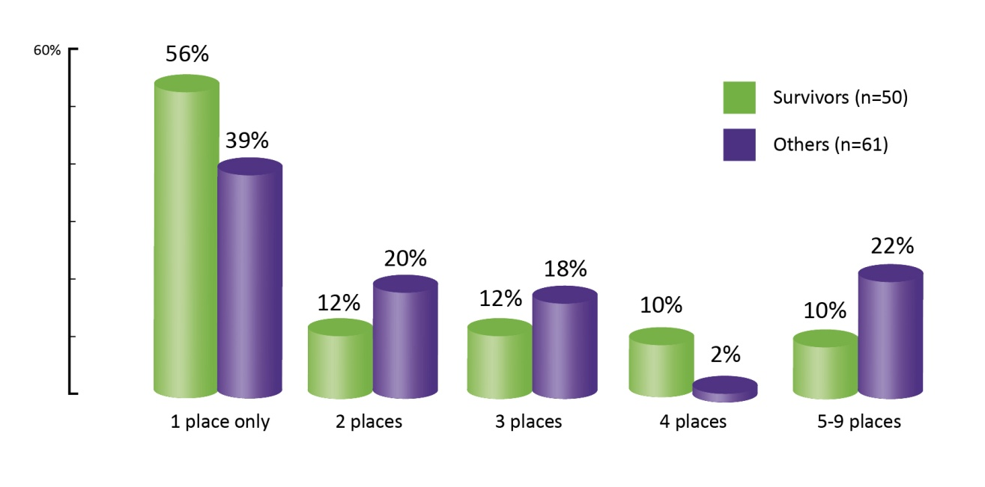
Further analysis of this question revealed that survivors tend to talk to fewer people about sexual violence than people who have not suffered sexual violence.
- Almost six in ten survivors of sexual violence would only talk to one person or place about the violence (56%)
- Six in ten of those who have not been subjected to sexual violence would tell between 2 and 9 people or places.
Graph 39: Who would you tell? Survivors who would disclose at one place only
n = 28
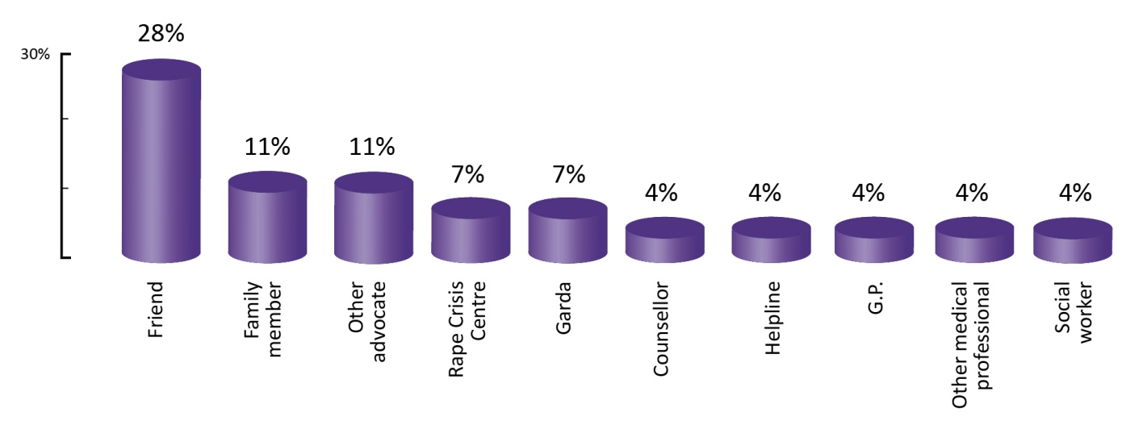

- The graph above shows the distribution of places where survivors, who would contact only one person or place, would go if they were worried about sexual violence. Twenty-eight of the 50 survivors, or 56%, would only discuss sexual violence with one person or place. Approximately one in four of this group would tell a friend (28%)
- One in ten would tell a family member (11%)
- Fewer than half of this group would seek out any professional such as a Rape Crisis Centre, Garda, Counsellor, Helpline, GP, other medical professional, social worker, disability or other advocate (45%)
- None of this group would tell their partner.
Graph 40: Who would you tell? Survivors who would disclose at two or more places
n = 22

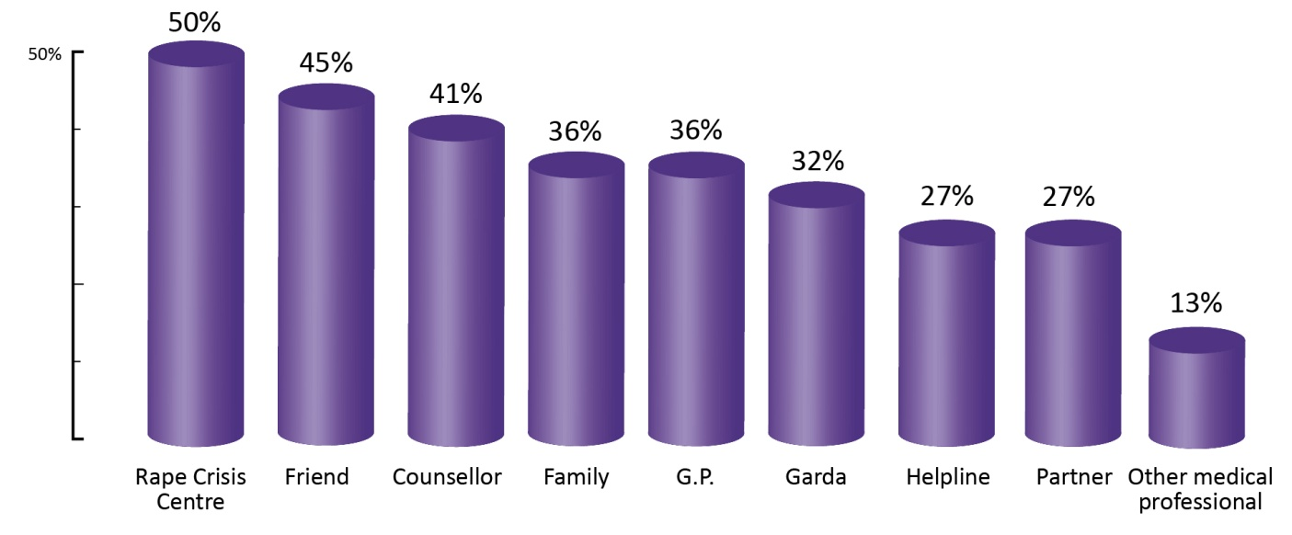

Of the 50 survivors of sexual violence in the survey, 22, or 44%, would tell more than one person if they were worried about sexual violence.
- Of these, half would go to a Rape Crisis Centre (50%)
- Fewer than half would tell a friend (45%)
- Four in ten would tell a Counsellor (41%)
- One in three would tell a family member (36%)
- One in four would tell a Helpline (27%)
- One in four would tell their partner (27%).

Graph 41: What would stop you telling someone?
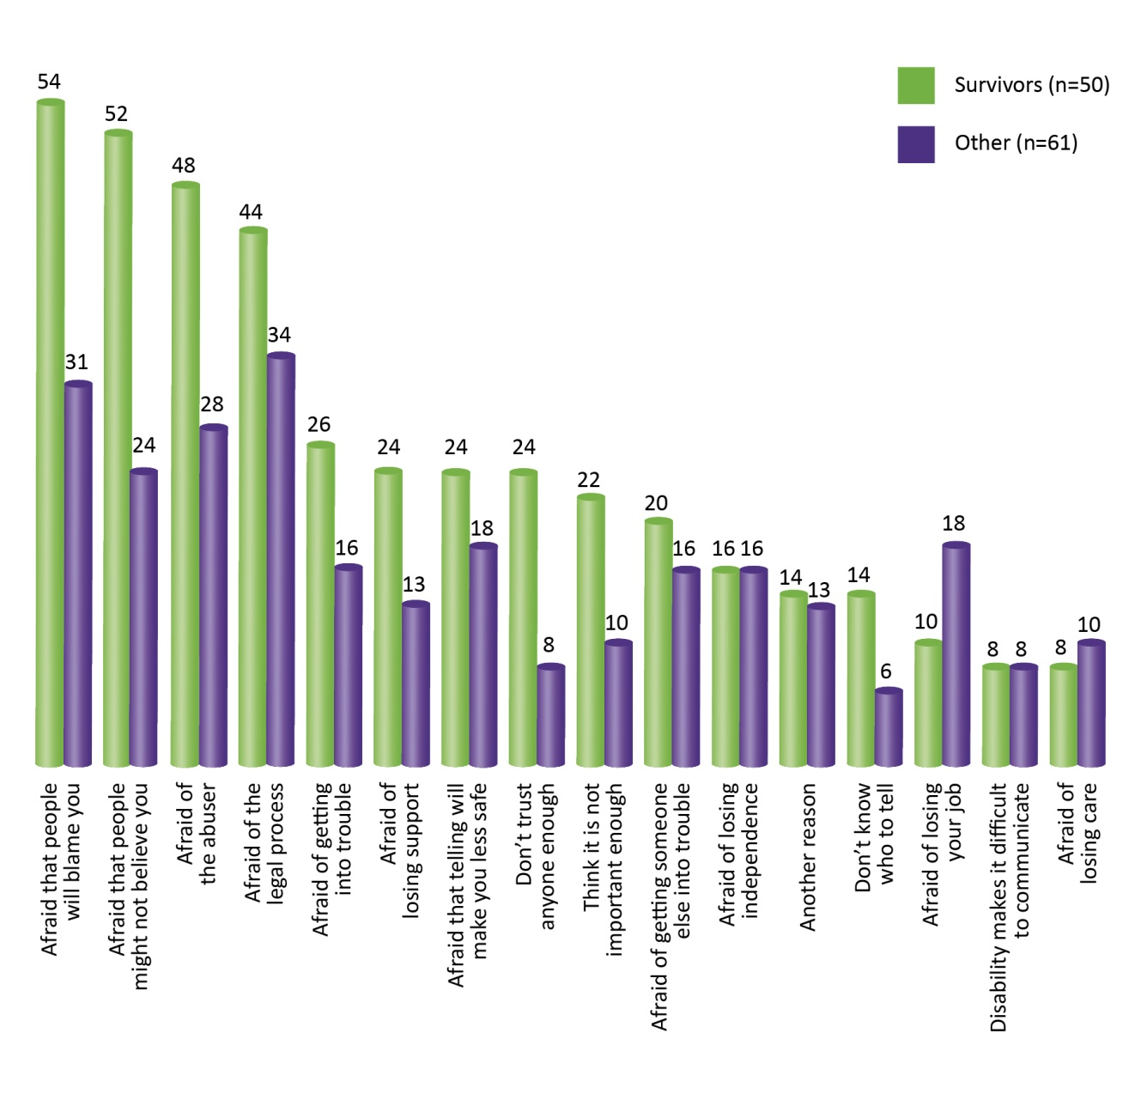
Survivors reported more barriers and fears related to disclosing sexual violence than those who did not disclose sexual violence. The 50 survivors who completed this question gave 206 responses or an average of four fears each. The 61 other respondents (those who did not disclose an experience of sexual violence in this survey) gave a total of 165 responses or an average of 2.7 reasons each.
The top five barriers or fears that would prevent survivors from disclosing sexual violence were fear of blame, fear of non-belief, fear of abuser, fear of the legal process and fear of getting into trouble. The top five reasons for ‘others’ were fear of legal process, fear of blame, fear of abuser, fear of non-belief and fear of losing employment.
- Fear of being blamed for the violence would prevent more than half of all survivors from reporting sexual violence (54%), compared with 31% of other respondents

- Fear that they will not be believed would prevent more than half of all survivors from reporting sexual violence (52%); this is more than double the reporting of other respondents (24%)

- Almost half of all survivors cite fear of the abuser as a potential barrier to disclosure of sexual violence (48%), compared to 28% of other respondents

- Survivors were more than twice as likely as other respondents not to know who to tell, to think that the violence was not important enough to report and that they would not be believed

- Fear of losing support was almost twice as likely to prevent survivors from reporting sexual violence (24% and 13% respectively)

- Survivors were three times as likely as those who did not disclose sexual violence not to trust anyone enough to report sexual violence (24% and 8% respectively).
In addition to the nine multiple-choice questions, respondents were also provided with further opportunities to provide free-text feedback in comment boxes. The contents of these comment boxes reveal additional qualitative information. A filter was applied in order to divide the respondents into those who had suffered sexual violence and those who had not. As would be expected, survivors had a different perspective on certain issues and comments were analysed thematically. Survivors also had, on average, more to say than respondents who did not disclose sexual violence, with some survivors thanking the survey for the opportunity to ‘get all that off my chest’.

- Qualitative findings from online survey – What stops us talking about sexual violence?
Sexual violence is a crime which has significant long term impacts on survivors. It is also true that considerable silence around sexual violence remains. This means that support is not being sought by many who will go on to develop long term and complex effects of trauma such as depression and self-harming behaviour.
This silence tells us that there are consequences to disclosure for survivors. Survivors assess these consequences and many choose not to seek support and not to seek justice rather than face those consequences. Those consequences arise from issues such as shame, the relationship of the survivor to the abuser, and a culture of blaming the survivor. For survivors of sexual violence who also experience disability, with added levels of vulnerability, these consequences of disclosing can be heightened and potentially more severe.
Some indicators that show the impact of the culture of blame can be found in recent research. In a decade old prevalence study of the general population, 50% of the respondents found to have experienced sexual violence had not told anyone (McGee et al, 2002). In the extensive Rape & Justice in Ireland (RAJI) research, 100 survivors of recent rape (between 2000 and 2004) were interviewed (Hanly et al 2009). Of these, 42% who had made a report seriously considered withdrawing their complaint and the primary reason for this was poor treatment by the Gardaí. One third of those who made a report were encouraged to withdraw, almost half of those after dissuasion by Gardaí. RAJI also found that the pressure to stay silent and to withdraw complaints was heightened when the victim had a disability.
- RAJI found that after gender, disability is the second most common risk factor for rape.
- Where a complainant had a psychiatric illness the DPP only prosecuted two of the 78 cases compared to approximately 30% of all cases.
- 38% of complainants with a psychiatric illness withdrew their statements. This represents a disproportionate 16% of all complainant withdrawal.
Examination of the RCNI National Statistics and the qualitative research undertaken for this report supports these findings.
In the following sections (5.1 - 5.10) we have captured the comments and views of the survey respondents who generously shared their thoughts in the free text sections of the survey. We have grouped their comments into the section themes; their words are verbatim. Respondents expressed their vulnerabilities, fears and experiences and made many recommendations. The number of comments and the personal details of the comments suggest a need for sharing and communicating their concerns. However, it is instructive to note that all survey respondents were invited to attend a workshop to discuss the barriers to disclosure of sexual violence in more detail. No respondents volunteered for the workshop. This indicates a comfort in anonymity in discussing this topic and underscores the enormous difficulty in seeking support or even discussing barriers to disclosure of sexual violence in a small, focussed workshop.
  - Fear of, and experience of, not being believed
Survey respondents explained their fear of not being believed and their frustration of having the sexual violence minimized. When survivors disclose sexual violence and are not believed, negative consequences such as mental health issues, low self-esteem and further violence often emerge:
“At the time I was not believed and suffered further violence as a consequence.”
“Telling someone can have horrific consequences.”
“When it happened I told someone, but it was made out to be less serious than it actually was.”
“When sexual assault is reported in the case of a disabled person, people always point the finger at you and not the person who committed the crime.”
“Rape/abuse survivors are not taken at their word. The harm perpetrated on them is not seen as serious.”
In some cases the survivor was silenced by a perception that they would be disbelieved if they told anyone about the violence.
“I did not tell anyone as I would not have been believed at the time as the support was not like now.”
“They will tell me that it is my own fault...or that it wasn’t as bad as what I think.”
“As I suffer from mental health problems, triggered by abuse etc, I feel people automatically disbelieve everything you say anyway.”
“It would help if I knew that they would not say it was my own fault, because I should have acted differently.”
Survivors commented that their experiences of violence were not understood to be as serious as they actually were. In some cases disbelief was followed by further violence. Survivors also felt that they were accused of being in some way responsible for the violence. Belief and validation are core requirements of trust between people, and without trust secrets are unlikely to be shared. The situation where a victim of violence remains too afraid to report the violence is a societal problem indicating a culture of disbelief that fails to support survivors.

  - Need for informed, trained and trusted support
Some spoke of the need to have informed, trained and trusted support, both professional and informal, to turn to:
“What would help - the understanding that a family member would believe it happened.”
It would help if I felt I would be taken seriously, and if I knew who I could turn to.”
“I need support and validation.”
“People with disabilities need to know that they do count and that someone out there does actually care.”
“Feeling completely safe and not subject to the threat of danger afterwards or isolation or lack of support or understanding.”
“Finding someone to help in a practical sense is big problem.”
“Some things are left unsaid because of fear of the unknown in reactions and treatment by professionals who are now responsible.”
“I told a friend. I'm lucky that she is older than me and helped me to deal with it without telling anyone else. We eventually told my parents the basics together without freaking them out too much.”
  - Culture of blame and stigmatisation
Others spoke of feeling blamed and stigmatised:
“If you are physically disabled and a female, people generally point the finger at you when it comes to a case of sexual assault. You must have encouraged it. She was desperate for a man, after all, who would want her, a cripple.”
“A long time after it happened I told somebody. Telling someone nearly made it worse for a long time. I was so scared of what people thought.”
“I don't regret never having spoken of it at home. Years later, a young female cousin in a totally separate incident told her parents about having experienced sexual violence from a family member and although her parents supported her, it caused a huge rift in the wider family and left that young girl completely stigmatised - years later, she still feels this way, and since her teenage years has suffered from a variety of mental health problems.”
“That you will always be tarnished with the stigma of being a sexual abuse victim.”
“There is a culture of ‘blame the victim’. I’ve been called sick and told I need to be locked away for speaking out… whilst the perpetrator of the crime walks free.”
“I don't want family to be judged and break mum’s heart.”
“A lot of people have said that I am a psycho, etc, because of my mental health issues, but they do not understand that the sexual violence has contributed to it. They are unwilling to believe that these things happened and that is why I am too frightened to live a normal life.”
“Of course we are not 'normal'; how could you be after such an abnormal thing happening to you? People think we make it up 'because of the way we are', which is not true – disability or not, pain is pain, and you feel it no matter what your IQ, mental health status or 'other' as surveys are so fond of putting it.”
  - Long term impact of sexual violence
Others spoke of the impact the sexual violence has had on them:
“‘I’ve been raped’ is a short sentence for a very long scary movie.”
“My whole life destroyed as threat still very real and then further society to deal with.”
“Experiences such as this are soul-destroying; there is no respite - memories remain and in laying blame I look to myself, wondering what I did.”
“It took me years to admit it to myself.”
“I wish I had been given some help on how to handle further possibly dangerous situations as I can no longer find a balance between total paranoia that everyone is dangerous and overly trusting people.”
“Completing this limited survey has been difficult for me. People like me want to forget but memories remain and can be overwhelming. I know I've not dealt with it adequately and it has marred my life in too many ways. I feel so incredibly 'alone'. A child in many ways, unaware of what was happening.”
“I believe that rape will eventually be the cause of my death and I have fought so long and hard and know that I have to be violent or abusive to defend myself and that compromises my character and makes me one of them. I join their club to protect myself or risk being overpowered again. Not everyone lives in that place, to live there all the time without justice is soul destroying.”
“I think undisclosed sexual violence has a massive unspoken effect on the individual and can exasperate existing conditions.”
“I am close to breakdown again and have attempted suicide numerous times. So sad that services are there yet abuse of power by the people who can help but don’t. It’s worse than murder because we have to live with it, and mental abuse erodes all confidence and ability to operate or function as capable adults leaving us vulnerable to more attacks which is devastating. I want to be euthanized and now wish rape victims had this choice in this country. Need more proactive help.”
Research is required into the impact of sexual violence, ways to address the long-term consequences of previous sexual violence and ways to encourage disclosure of historic sexual violence (Powers et al 2009). Recent high-profile reports (e.g. Ryan Report) have gone some way to encourage disclosure and sexual violence services continue to report increased reporting as a result. Mediating, rehabilitating and providing redress for trauma and long term damage are societal responsibilities. Helping survivors to overcome historic abuse is no less important than current abuse.
  - Isolation and secrecy
Some spoke of isolation and secrecy:
“I know there are witnesses because one of them 'saved me' from continued abuse and I thank God for her intervention at a time when I didn't have anywhere to turn or anybody to trust.”
“Interestingly, my file in that hospital has been ‘lost’…. I’ve not got the strength or the courage to speak or challenge anyone about it.”
Fear of the abuser was the third highest barrier to disclosure. Fear of further violence or recriminations after disclosure prevented some survivors from telling anyone. Survivors mentioned isolation, fear, intimidation, and protecting family members as barriers to disclosure.
“I had three children and wanted to protect them. Not sure what would help me to tell anyone as there is still that fear.”
“Feeling completely safe and not subject to the threat of danger afterwards or isolation or lack of support or understanding.”
“People are too scared and intimidated to ask for help and afraid of being followed/attacked again.”
Information on how to read dangerous situations and self defence were identified as important, as was the importance of friends being protective of each other and being alert to dangers.
“Help on self defence and reading further abusive situations; there are a lot of dangerous people out there.”
  - Dissatisfaction with professional services following disclosure
Some expressed dissatisfaction with professional services following disclosure:
“The police let me down in some regards by not investigating more fully and the saddest thing is rape, mutilation and attempted murder is not exactly a grey area. There was a lack of information from the police and constant worry of being murdered.”
“I don’t know what it is like today, but in my day the Gardai were not disability aware, thus making the whole process very difficult and causing unnecessary stress.”
Lack of communication between responsible parties, and lack of training are also highlighted:
“Lack of communication by adults who are actually employed to deal with crime...”
“Many individuals who run or are involved in support services don’t appear to be appropriately educated in the area.”
The survey indicates that the many survivors do not disclose to more than one person or place. If a helpful and respectful response is not provided initially, the survivor may be less likely to tell anyone else.
“I went to a counselling session once, but it ended in disaster for me from a personal perspective.”
“Disclosure is awful, the one time I did disclose to the police I was treated like I was on trial.”
“The first people I told were my secondary school guidance counsellors who were useless, in fact, they were worse than useless, they made the situation worse.”
“I did tell, but I received no help.”
“After years of abuse I told my social worker but she didn’t do anything other than help me to plan leaving home.”
Unfortunately, some survivors did not receive the response that they needed at more than one place.
“I told health professionals, who didn’t really care, and social workers, who then used it as an excuse to have my suitability as a parent assessed.”
“I was sexually abused for seven years of my life. I did go to the Gardaí but they handled it very, very badly and I had to go to the papers so that they would take the situation I was in seriously. The Gardaí eventually put me in touch with the rape crisis centre in my area. They said I didn't have a case and I wasn't raped so they said they weren't the people to help me because they were dealing with people who had it worse than me. I was eventually raped in my own home at 20 years of age. I never legally pursued it because I didn't think there was any real support for me in Ireland.”
These survivors sought out certain professionals with the reasonable expectation that these professions would be equipped to deal appropriately with their disclosure. All professions need to have guidelines and policy surrounding disclosure; this is especially true of those named above.
  - Insufficient disability awareness
Many spoke about finding it difficult to access general services and the fear and experience that they would not have sufficient disability awareness to respond appropriately:
“What would help are counsellors trained in British Sign Language, who understand deaf issues.”
“It would make a huge difference if there were trained professional people with disabilities working within services. Them being visible would make it easier to use the service. Disabled people would know the history of discrimination, of segregation, but also of not being believed.”
“It would help if counsellors are disability aware.”
Survivors indicated that it would be easier and less embarrassing to disclose to a person with disabilities. They also noted that counsellors trained in sign language and with understanding of specific issues are not available. Sexual and domestic violence services may have limited capacity and training around disability, and disability-specific services have limited understanding of the dynamics of sexual violence, causing survivors to fall between the cracks (McClain 2011).
“Ultimately, I feel ashamed telling a non-disabled person that I may have been abused or raped by a disabled man. They don’t see it as a crime. They end up feeling sorry for him instead of me.”
“I went to the Rape Crisis Centre and they knew all about rape, but they did not understand about the disability element of the situation.”
“What would have helped me at the time was to understand what sexual violence was, and if I could have talked to another disabled woman.”
A proactive campaign is required to increase faith in professional services.
“Services don’t always say or have pictures of disabled or deaf people in their brochures or advertisements. It feels like the service is only for non-disabled people. There’s no clear message about welcoming disabled people to your service. Often it’s said in a silent but explicit way that we are problematic and this service can’t support us.”
  - Lack of information and education
For many, they felt a lack of information and education for themselves and others was a problem. Survivors commented that they had not received enough information around sexuality and sexual violence, prior to or after their experiences of sexual violence. An individual’s self-defence mechanisms include social awareness, the ability to distinguish behaviour, and knowledge and language around sex and sexuality (Hollomotz 2007). The survey results indicate that the increased exposure of this population to sexual violence is not accompanied by increased education and information that would support individual awareness and self protection.
“I was just a very trusting and affectionate child and I had no information about sexuality, so when things felt wrong, I had no idea what was happening, or why, or what to do about it.”
“I didn’t really understand it, I thought it didn’t happen to women like me.”
“What would have helped me at the time was to understand what sexual violence was.”
“I asked a psychiatrist the question is there such a thing as rape within marriage, who then directed me to my local Rape Crisis Centre.”
“Often we don’t have the language to talk about abuse and how it affects us.”
Education campaigns aimed at men were seen as necessary for men to understand violence and the limits of acceptable behaviour.
“Men need more awareness of what’s acceptable and unacceptable behaviour towards their partner, of her feelings, etc.”
Primary school children, parents and teachers were also noted as needing more information, both to combat stereotypes and to make talking about sexuality easier.
“I think the issue of sex abuse should be taught at primary schools! Children should be aware of the danger and they should be assured that there are people there just for this case, and 100% will follow the case in private. Some kids do not want that their family knows, because they are afraid to be blamed. Please do this.”
“Irish people are often uncomfortable and incapable of talking about sex in general, never mind violence and sexual assault. Sex education should be compulsory for all children in all schools, from primary school up. The real language of sex/sexuality is something we need to learn. It is naive to expect children/people to just pick it up from friends/media/society. Also, the media presents a warped language of sex that it is difficult to know what's right or wrong.”
“I think with the Stay Safe programs in schools, children were encouraged to tell parents and teachers about sexual violence, but perhaps those adults they told were not prepared for dealing with this.”
Information campaigns must be proactive and not only available to those who actively seek information.
“Appreciate your sources of information. It is too late for me but I know it’s not too late for everyone.”
“Information, education and awareness that I was not alone would help.”
“We need more education & information for children and young people. Women should not be blamed for sexual violence ‘She dressed/walked/deserved it’ used to excuse it. Sexualisation of children, our public spaces and advertising hoardings, etc. all promote an atmosphere where sex is not dealt with maturely. Instead, immature, inhuman and warped urges are encouraged and facilitated.”
“Keep the awareness campaigns going and continue with the really valuable work ye are doing to highlight all the issues in and around the area of sexual abuse/violence/rape against women, but do not forget the men who have suffered… and of course us…those who have a disability of one sort or another.”
“It would help to be told what can happen, how much evidence the DPP needs, do we have the opportunity to press charges, will I be granted the opportunity to do that, and how will I be kept safe while the process goes through.”
  - Fear of personal consequences
Other barriers to disclosure included a fear of consequences for their personal lives. Of the survivors who did disclose the sexual violence to someone, many revealed that it was not until many years later, in some cases over 50 years. Some survivors felt too ashamed or could not identify a person (or service) that they could trust enough to tell.
“I'm afraid of upsetting my parents and of them overreacting and stopping any freedom I have. I had a bad experience, but the risk of losing my freedom is scarier so I can't make it public.”
“Felt too ashamed to tell. I needed my husband's physical support and it seemed to be the expected pay-off.”
“I never told anybody as I was embarrassed.”
“A long time after it happened I told somebody. Telling someone nearly made it worse for a long time. I was so scared of what people thought.”
  - Confidentiality
Respondents made a number of new proposals in response to the question ‘What would help you to tell someone?’. Confidentiality was a clear concern, as was confidence in services. A wide number of fears were reflected by respondents in the survey, including getting into trouble, loss of independence, support or employment, and not knowing who to trust. Prior to disclosure, a survivor will need to feel trust and confidence in the person they select to tell, and this includes knowing that confidentiality will be respected. Some of the suggestions include:
- ‘Completely confidential service that is easy to access’
- ‘Confidential support’
- ‘Having total confidence in the person’
- ‘Feeling confident in the support services’
- ‘That what I reported was kept in the strictest confidence’
- ‘Being able to trust them to not tell anyone else unless I want them to’
- ‘I have paid a dear price by confiding my secret in someone who took advantage of that weakness in me’
- ‘Knowing I can trust the person might help’
- ‘Them being the right sort of person - someone who listens, believes you and is responsive to what you need.’
Respondents made specific proposals to overcome barriers to disclosure, including anonymous reporting and online communications:
“If there was someone where it would be off the record - that was easy or made easy to talk to - that was in complete confidence, where nothing that’s talked about is repeated. Someone that you can speak to at your own pace without pressure…who would maybe even come to your own home or even talk online.”

“If I could have an anonymous survey – like an Internet based version of the crime stoppers number, so that they could be investigated. And if other people are also reporting this person an article in the local newspaper could ask for those of us who are willing to prosecute to respond to a pre arranged word or number?”
“Textual online communication channel.”

- Data Collection
Systematic data collection can help to reduce barriers to disclosure and improve understanding of sexual violence. It is clear that complaints mechanisms and data collection systems need to improve for people with disabilities and that the responsible bodies need to ensure that proactive measures are taken. Sexual violence against people with disabilities is known to have occurred in residential institutions and perpetrated by carers in Ireland (and elsewhere). Abusive behaviour by members of staff and the existence of a culture of abuse can no longer be tolerated and must be eliminated. It is also clear that internal institutional regulation and oversight are insufficient to monitor abuse. External periodic monitoring visits or surveys employed in isolation may also fail to document the full extent and nature of abuse. A judicious combination of complaints mechanisms and data collection systems is necessary.
With the increase in independent living, new methods must be introduced to help witnesses and survivors to convey experiences and achieve reform. The barriers to disclosure that have been identified by people with disabilities in this research reflect societal issues that must be addressed and legislated for. Reluctance to disclose sexual violence is perceived to be based on a culture of blame and disbelief. This, combined with fear of the abuser and other barriers, hinders all data collection methodologies. Survivors of sexual violence appear to disclose to a very wide variety of places, and many will never speak to a person trained in disclosure. It is therefore also worth examining alternative data collection methodologies that are not institution based. Examples of these would include annual census type surveys, population-based surveys, and various technology assisted tools (Walby Myhill 2001, Basile Saltzman 2002, UNECE Task Force 2006).
  - Legal Framework
International human rights instruments support the collection of national quantitative data on sexual violence as experienced by people with disabilities. Current data collection in Ireland, as in other countries, is insufficient. States are obliged to take special measures to prevent exploitation, violence and discrimination and to uphold equality, freedom and dignity for all people. Measures include the provision of services, independent monitoring of services, and the effective identification, investigation and, if necessary, prosecution of abusers. Independent monitoring and effective investigation may require international cooperation and the use of new technologies to provide disaggregated data for general dissemination and to fulfil reporting requirements to various UN treaty bodies. Of particular relevance are the legal themes of access to justice, freedom from exploitation, violence and abuse, and freedom from torture or cruel, inhuman or degrading treatment or punishment.
Relevant international legislation is found in United Nations, European Union and Council of Europe Conventions and is binding on States that have signed and ratified the treaties.
- United Nations Convention on the Elimination of All Forms of Discrimination Against Women (CEDAW 1979) and its Optional Protocol (1999), Articles 2 (c) and 11 (c), (d) and (e)
- United Nations Convention on the Rights of the Child (CRC 1989) and its Optional Protocols (2000), Articles 19 (2) and 23 (4)
- United Nations Convention on the Rights of Persons with Disabilities (CRPD 2006), Articles 15, 16, 31, 32, 33
- Council of Europe Convention for the Protection of Individuals with regard to Automatic Processing of Personal Data (CETS No. 108, 1985)
- Council of Europe Convention on Action against Trafficking in Human Beings (CETS No. 197, 2005)
- Council of Europe Convention on the Protection of Children against Sexual Exploitation and Sexual Abuse (CETS No. 201, 2007), Article 10
- Council of Europe Convention on Preventing and Combating Violence against Women and Domestic Violence (CETS No. 210, 2011).
Further non-binding recommendations can be found in the EU Guidelines on violence against women and girls and Recommendations of the Committee of Ministers to member States of the Council of Europe. Recommendations include the identification of tools to build national capacity to collect accurate comparable quantitative data and relevant indicators so that States can frame their actions and strategies in full knowledge of the facts.
- EU Guidelines on violence against women and girls and combating all forms of discrimination against them (GAC 2008), Article 3.1.2
- Recommendation of the Committee of Ministers to member States of the Council of Europe: Rec(2002)5 on the protection of women against violence;
- Recommendation of the Committee of Ministers to member States of the Council of Europe: Rec(2007)17 on gender equality standards and mechanisms
- Council of Europe Resolution Res AP(2005)1 on safeguarding adults and children with disabilities against abuse
- Council of Europe Disability Action Plan 2006, Action Line No. 14: Research and development
- European Disability Strategy 2010-2020: A Renewed Commitment to a Barrier-Free Europe
The principles of universality and indivisibility mean that all international human rights law applies equally to all persons. These principles are reinforced by specific principles of equality and non-discrimination. The principle of anti-discrimination is enshrined in the Universal Declaration of Human Rights and has achieved customary international law status; therefore, it is binding in all States.

Convention on the Elimination of All Forms of Discrimination against Women (CEDAW)
CEDAW, adopted in 1979 by the UN General Assembly, obliges States to report compliance measures they have taken. Articles 2, 5, 11, 12 and 16 of the Convention require States to act to protect women against violence of any kind occurring within the family, at the work place or in any other area of social life. The Committee on the Elimination of All Forms of Discrimination against Women was founded to monitor the implementation of the Convention and make recommendations on issues that States should address.
General Recommendations 9, 12, 19 and 24 all require States to provide statistical data on the incidence of violence against women ‘considering that statistical information is absolutely necessary in order to understand the real situation of women’ (Gen. Rec . 9). Information provided should be disaggregated by gender and include absolute numbers and percentages. “States’ parties should encourage the compilation of statistics and research on the extent, causes and effects of violence, and on the effectiveness of measures to prevent and deal with violence” (Gen. Rec. 19(24c). States’ parties should include statistical data, in their periodic reports to the committee, on the incidence of all kinds of abuse against women and on women who are the victims of violence (Gen. Rec 12). Ireland’s most recent report to CEDAW was 10 June 2003 and the report did not contain statistical data on sexual violence. The Committee criticised this omission and recommended that the State closely monitor the incidence of all forms of violence against women.
The UN Convention on the Rights of Persons with Disabilities (CRPD) and the Optional Protocol to the Convention
CRPD was signed on behalf of the Irish State on 30 March 2007 and entered into force on 3 May 2008, but Ireland has not yet ratified the Convention. The European Union concluded the treaty with the effect of ratifying it to the extent that member States’ responsibilities are transferred to the Union. The Convention adopts the social model of disability, including “those who have long-term physical, mental, intellectual or sensory impairments which in interaction with various barriers may hinder their full and effective participation in society on an equal basis with others”.
The Convention recognises that women and girls with disabilities face greater risk of violence. Articles 6 and 7 relate specifically to women and girls with disabilities, recognising multiple discrimination, and reaffirming rights to equal enjoyment of fundamental rights and freedoms. Article 15 states that no-one shall be subjected to torture or to cruel, inhuman or degrading treatment or punishment. States must take all measures to equally prevent people with disabilities from being subjected to such treatment.
Article 16 deals with freedom from exploitation, violence and abuse and reminds States to take “all appropriate legislative, administrative, social, educational and other measures to protect persons with disabilities, both within and outside the home, from all forms of exploitation, violence and abuse, including their gender-based aspects”. Article 16.2 focuses on prevention, including through the provision of information on how to avoid, recognise and report instances. Article 16.3 requires that States ensure that all facilities and programmes serving persons with disabilities are “effectively monitored by independent authorities” in order to prevent the occurrence of all forms of exploitation, violence and abuse. Article 16.4 places an obligation on States to take all measures to promote recovery, rehabilitation and social reintegration of victims of all forms of abuse, including through the provision of protection services, in an environment that fosters dignity and autonomy and takes into account gender specific needs. Article 16.5 requires effective legislation and policies to ensure that instances of abuse are identified, investigated and where appropriate, prosecuted.
Article 31 deals with statistics and data collection and requires States to undertake to collect appropriate information and statistical data to enable them to formulate policies to give effect to the Convention. The data shall be disaggregated and disseminated to help to assess how the State is performing in achieving obligations under the Convention. Article 32 recognises the importance of international cooperation in sharing technologies and research in achieving the aims of the Convention. Article 33 obliges States to establish focal points and coordination mechanisms, through the involvement of people with disabilities and their organisations, responsible for monitoring implementation of the Convention. During the negotiation of the Convention, data collection was seen as a key factor in ensuring States’ commitment to implementing national policies to give effect to the Convention, without the need for Committee intervention (De Burca 2010). Reducing the reliance on Committee intervention is a distinctive and unique characteristic of CRPD, as is the emphasis on States’ requirements to collect data (Lord et al 2010).
The European Commission Disability Strategy 2010 – 2020 (EDS)
EDS specifically identifies constant data collection and monitoring as important, restating the goals of CRPD.
“EU action will support and supplement Member States’ efforts to collect statistics and data that reflect the barriers preventing people with disabilities from exercising their rights” (EDS 2010)
The Commission promises to “supplement the collection of periodic disability-related statistics with a view to monitoring the situation of persons with disabilities”. Furthermore, the Commission commits to a monitoring framework to promote, protect and monitor implementation of the UN Convention on the Rights of Persons with Disabilities. However, the strategy does not specifically mention violence or abuse, despite the issue being highlighted as very important in the consultative preparation process.

Council of Europe Convention on Preventing and Combating Violence against Women and Domestic Violence
The newest addition to the legislative framework was adopted April 2011. The Convention aims to promote international cooperation and an integrated approach to the elimination of both violence against women and domestic violence. It reaffirms the need to prioritise the collection of data beyond criminal justice data. Although named as a Convention protecting women, the provisions of the Convention, in particular measures to protect victims, are specifically stated to be secured without discrimination on any ground such as gender, disability or other status.
In Article 11, on data collection and research, States are required to support research and to collect disaggregated relevant statistical data. States must make the information public and available to the group of experts established by the Convention, for the purposes of international cooperation and benchmarking. The obligation on States to take the necessary measures to promote social change provides a strong basis for argument in favour of ongoing statistical data collection.
Cosc National Office for the Prevention of Domestic, Sexual and Gender-based Violence
In Ireland, the National Office for the Prevention of Domestic, Sexual and Gender-based Violence is Cosc, an executive body within the Department for Justice and Equality. Cosc national strategy for 2010-2014 is the expression of State policy and highlights research and data collection as critical to the success of the strategy.
“The first and most fundamental action required is the development of a systematic approach to data capture and collation. The lack of consistent information about the number of people affected by domestic and sexual violence limits our ability to respond to the problem. Improving data on domestic and sexual violence will involve working with the relevant organisations to develop and improve data, including realising the statistical potential of data collected for administrative and research/policy purposes. With an improved approach to data, Ireland will be in a better position to evaluate effectiveness. The aim is to develop an evidence-based approach to assessing effectiveness of activity and impact.” (Cosc National Strategy 2010-2014)
The national strategy aims to promote clear, high quality standards in service delivery for victims and perpetrators of domestic and sexual violence, including suitable specific responses for high-risk groups including people with disabilities. Cosc further aims to “improve the effectiveness of policy planning through improved data capture and data co-ordination”.
An Garda Síochána, Courts Service, Central Statistics Office, HSE and the Probation Service are represented on the Cosc Data Committee. According to the 3rd Progress Report, work has commenced to develop and improve domestic and sexual violence data (including data collected for administrative and research/policy purposes). Work to date includes preparing a data plan, seeking legal advice on data protection implications of sharing information across services, engaging with the European Union Fundamental Rights Association in relation to a proposed violence against women survey, and commissioning a data system analysis report (Cosc 2011). A Data System Analysis Project Report was prepared by Dr. M. Lyons and the data plan was finalised and circulated to Committee members in March 2011.
  - Discussion
The Irish State, under international and EU law, and in published national strategy, is committed to improving data collection on sexual violence. By building upon the methodology of existing data collection systems, such as that pioneered by RCNI, it would be possible and cost-effective to engineer a specialist database with as many data collection points as required, at a variety of appropriate agencies. This would significantly increase reporting and over time would produce a detailed time series dataset providing much insight into the nature of sexual violence against people with disabilities. However, for as long as people with disabilities perceive that the result of disclosure will be blame, disbelief and reduced personal safety, then disclosure will continue to be limited and delayed.
The reaction of the first person told about the abuse is inevitably significant to the decision to disclose elsewhere. If the first person has no information or education about how to support a survivor of sexual violence, then the experience for the survivor may be negative. Collection of data through service providers can only reflect the experiences of service users and not that of those who do not seek professional help. Disclosure to a professional service is essential to service based data collection. National policy must support sexual violence professionals, and must tackle the culture of blame, disbelief and fear in order to support disclosure.

- Review of database systems used to record experience of sexual violence of people with disabilities

Five databases were identified as suitable for comparative review in this study. All will be useful in future development of data collection indicators. Three are in use in the Republic of Ireland, three in the United Kingdom and two in a number of other jurisdictions.
Table 1: Summary of databases
Acronym | Organisation | Geographical application | General application
GBVIMS Gender-based Violence Information Management System | UNHCR, WHO, RESCUE, UNOCHA, and the IRC | Multiple countries, humanitarian, emergency and development settings | Information management system developed specifically to monitor gender-based violence reported in humanitarian settings
Modus SARC (Sexual Assault Referral Centre) | SARCs and MARACs (Multi Agency Risk Assessment Conference) | United Kingdom | Case management system developed specifically for inter-agency use by UK SARCs, police and other agencies
RCNI Database | Rape Crisis Network Ireland | Republic of Ireland Rape Crisis Centres and other participating organisations in UK and ROI | Statistical database developed specifically to provide statistics on sexual violence reported to Rape Crisis Centres
SATU Sexual Assault Treatment Unit Database | Sexual Assault Treatment Unit | Republic of Ireland Sexual Assault Treatment Units | Statistical database developed specifically to monitor forensic data collection following sexual violence and to collate local and national figures
ViCLAS Violent Crime Linkage Analysis System | Royal Canadian Mounted Police (RCMP) | Law enforcement agencies in at least 11 countries including Ireland | Case linkage system developed specifically to identify links between separate incidents of violent crime in order to catch serial perpetrators

All the databases in the study were developed to record incidents of sexual violence, although not all are solely dedicated to this purpose. Three of the databases were specifically developed for statistical and monitoring purposes. The remaining two were developed as inter- and intra-agency case management or case linkage tools, and have the additional capacity to produce anonymised statistical data on sexual violence and disability. Two are used by law enforcement agencies and include wider forms of violent crime. One was developed to record all forms of violence against women in emergency or humanitarian settings. All provide useful examples of parameters and indicators for monitoring sexual violence for people with disabilities.
  - GBVIMS Gender-based Violence Information Management System
The Gender-Based Violence Information Management System (GBVIMS) aims to improve information management and sharing of information relating to gender-based violence in humanitarian contexts. The system was developed collaboratively between the International Rescue Committee (IRC), United Nations Office for the Coordination of Humanitarian Affairs (OCHA), United Nations High Commission for Refugees (UNHCR) and United Nations Population Fund (UNFPA). GBVIMS was launched in 2006 and is currently in use or being introduced in a number of countries including Kenya, Uganda, Thailand, Sudan, Nepal, Chad, Yemen, Democratic Republic of the Congo, Liberia and Colombia (UN VAW Inventory 2011).
This data collection system is designed for use by caseworkers in emergency settings and front-line service provision. This allows for comparability between and within sectors, countries and regions. The system explicitly sets out to overcome some of the issues that are often cited as reasons for poor data collection and management in these settings. Aiming to be used in as many countries and cultures as possible, the database uses standardised definitions and terminology for violence that can be understood and accepted across cultures. The system was developed specifically for a wide range of non-governmental organisations (NGOs) to improve information management and service provision. The primary aim is to improve prevention, response and coordination of service providers. Ethical and safety concerns for collecting, analysing, storing and sharing sensitive information are identified and inter-agency protocols have been developed.
By setting out standardised terminology and classifications, the system increases comparability between and within sectors, countries and regions. The system offers a standardised management tool to improve and simplify data collection in a variety of settings. GBVIMS considers their automatically-generated incident statistics and reports to be of high quality.
GBVIMS emphasises that the primary purpose of service delivery is to help the client. Therefore, the only data collected is data that serves to offer appropriate services to clients. It does not attempt to capture prevalence data. Detailed information collected in intake forms and case notes that are crucial for individual care may not be relevant to inter-agency programming or compiled data for analysis. Intake forms and case notes are qualitative data and must be anonymised and aggregated as quantitative data. This new data is no longer actionable on an individual basis and is aimed at program management and statistics. Despite emphasis on safeguarding sensitive data, the system can only make recommendations for best practice in security. The non-web-based nature of the system which enables it to work in the field in humanitarian settings, means that encryption, user-passwords, anti-virus software, back-up files, and other security features cannot be centrally controlled. These features are applied, or not, by each agency or individual. This weakness increases the risk of human error and loss of stored electronic data. Procedures and sample protocols are offered for correct storage and sharing of data, and destroying or relocating files in emergencies as precautions for protecting client anonymity and safety. However, protocols are only as good as the agencies and individuals that implement them.
The system requires users to standardise their terminology for data related purposes to support the emergence of a common framework for the sector. Six universally-recognised and mutually-exclusive core forms of gender-based violence are used: Rape, Sexual Assault, Physical Assault, Forced Marriage, Denial of Resources Opportunities or Services, and Psychological / Emotional Abuse. These were chosen because they are defined only by the specific act of violence that occurred and not by the motivation or context within it occurred. The definitions of these terms can be found in the glossary of terms.
Other forms of violence are identified through additional case related detail. Domestic violence, intimate partner violence, sexual exploitation, sexual slavery, female genital mutilation, incest, and child sexual abuse are not core forms of violence. These forms of violence are recorded within the appropriate core form of violence and identified during data analysis by case context. For example, data analysis will pick up incidents of child sexual violence by the age of survivor. Incest and intimate partner violence will be picked up by contextual information on power relationships. This is possible because the database is not intended to record historical abuse. It is also possible to record historical core forms of violence but usually only the most recent event is reported as the aim is to reflect current service needs in the data.
Only one core form of gender-based violence is entered for each incident. A process of elimination is used to identify the correct form of violence. The six core forms of violence are ordered by specificity and the user eliminates them in turn, until the correct identification is found. This is designed to eliminate bias and subjectivity. All incidents reported at the same time by the same survivor are entered separately but may be linked during analysis by the unique identification number allocated to the client. This is important to evaluate connections between core forms of violence.
Designed for use in almost any setting, the system does not challenge local cultural or legal definitions. For example in some countries, sex before the age of 18 is always a crime; in other countries marriage is legal at 13 years of age. The age of consent is usually set by national statute. Local legal parameters do not apply to GBVIMS and the database provides clear definitions for all concepts. Local services and practices are not expected to change how or what services are provided to a client. The cultural and legal implications of case management are, therefore, kept distinct from classification and data collection.
GBVIMS uses the most accessible technology of all the databases examined in this report. Microsoft Excel™ formulas and tables are used to reduce the amount of technological capacity and the amount of staff time dedicated to data entry and manual calculation. The system offers a standardised management tool to improve and simplify data collection in a variety of settings. Users consider their automatically-generated incident statistics and reports to be of high quality. All data is kept together in one database and can be easily filtered, sorted and aggregated by various data fields. Statistical tables and charts are automatically produced in a variety of formats. Incident trends and referral pathway tracking is simple and comparable. The database can be easily customised for specific contexts and programming needs. However, Excel is unsuited to massive amounts of data. In large scale operations, it is recommended to construct a Microsoft Access™ database to import data at regular intervals. A further problem with Excel is that fields can only have a one-to-one relationship, making the database less suitable for tracking one-to-many relationships.
One strength of the database is the rigid separation of data from case management while using a single intake form from service provision. This means that the survivor must be present and incidents without a survivor cannot be recorded. Third party recording is permitted in the limited case of the survivor’s guardian reporting if the survivor is unable to report due to age or a disability. The survivor must also be present for the data to be entered. Cases cannot be followed over a period of time, for example cases in the criminal justice system or cases of repeated violence. This type of information is kept separately within a case management or case file system.
This is a user-friendly system for limited resource and technological capacity situations. The system takes into account a far broader spectrum of culturally situated violence and violent traditional practice than is accommodated in other systems currently in use in Ireland. It is not clear how sexual violence that is not defined as ‘gender-based’ can be captured on this system. This may be a limitation of this system.
  - Modus SARC – Paloma Systems UK, Sexual Assault Referral Centres
In the United Kingdom services for survivors of sexual violence are structured and funded differently to the Republic of Ireland. The Home Office funds specialist sexual assault referral centres known as SARCs in each police district. SARCs aim to provide one-stop services for medical care, counselling and forensic examination for survivors of sexual violence. SARCs usually only provide services to clients shortly after an incident. Long-term support and services for survivors who report assault long after the incident are provided by Rape Crisis Centres. SARCs offer services to people referred by the police or other agency, and to self-referrals, who may then be referred to other complementary services. For this reason, the database developed for SARCs is a multi-agency case management system (CMS), and not a statistical database. The CMS also has the capacity to produce detailed statistical reports showing live data, and therefore is included in this study.
Modus SARC case management system was developed by Paloma Systems specifically for the Home Office and SARCs. The software is licensed on a per user basis by Paloma Systems and the data belongs to the licensee. Full personal data including National Insurance number, name, date of birth, address and contact details, details of sexual violence, including photographs, forensics, appointments and full case notes can be recorded on the database. Police names, court proceedings and sentence details can also be recorded. High risk clients can be flagged and case details shared between agencies. Survivors may choose to withhold their personal information.
Three different user levels are defined with varying levels of access to data. A search function allows searches within fields, including a ‘sounds like’ function for names to overcome transliteration issues.
Paloma Systems offer to customise the CMS for new institutional users. Detailed user specific forms and templates can be integrated and tabs and fields can be adapted. Drop down menus allow for multiple choice questions to be included, increasing comparability of data. Minimising free form data entry fields reduces risk of human error. Online training and help is available for users and Paloma Systems also provide in-house training and train-the-trainer courses.
The highly sensitive nature of the data recorded requires an especially high level of data security. This CMS software was launched in 2009 and is independently security tested to check for system security weaknesses that could make the system vulnerable to compromise, abuse, hacking or other attack (NCC 2010). Testing revealed that, for the most part, the web server infrastructure is in line with industry standards. Various weaknesses were identified during testing that may have been corrected by now. Misuse or human error by users with legitimate access is less easily tested and is a generic weakness associated with including this level of personal data on a shared, electronic, hosted system.
  - RCNI Database – Rape Crisis Network Ireland Database
Since 2003, Rape Crisis Network Ireland has pioneered the development of a custom made database to record all disclosures of sexual violence to Rape Crisis Centres. In conjunction with independent software and statistics experts, the database has been significantly expanded and improved since 2003.
The database is adaptable to all sizes of organisations and is used as successfully by both the smallest volunteer-run centre and the largest. RCNI continuously supports participating Rape Crisis Centres in this national data collection. RCNI also provides support to non-member sexual violence services using the RCNI Database and those interested in exploring participation in it. The RCNI Database has been adopted by Scotland Rape Crisis Network and other national agencies providing services to survivors of sexual violence as a model for recording information on those subjected to sexual violence.
The RCNI Database allows users to enter anonymised data relating to each client and each separate incident of abuse into a national database. The database is entirely separate from case files and case notes. Each client is automatically allocated a unique identification number. Names, and other personal identifiers such as date of birth and personal identification numbers, are not recorded in the database. This is to provide the highest level of protection for individual clients and to avoid exposing sensitive individual data in case of hacking or compromise. This also adds a layer of protection against misuse and human error among authorised personnel. All data is also encrypted.
The system provides for three levels of user access. Data is currently entered by approximately 225 users in 14 locations, although these figures can both be expanded or reduced according to need. Users entering data are counsellors in Rape Crisis Centres and users at this level only have access to their own clients. This allows users to create new client records and access only the records of clients that have been assigned to them. Users can only view, edit or delete records they have entered, but cannot view, edit or delete any records that have been assigned to other personnel.
Each of the 14 Rape Crisis Centres appoints one trained member of staff (Data Collection Officer) with privileged access. At this second user level, the user can access data only from the relevant Rape Crisis Centre and can print anonymised up-to-date statistical reports containing only data relating to that Rape Crisis Centre. This access allows the Data Collection Officer to create new client records, view, edit or delete client records and generate reports for all records entered in that location.
The third and highest level of access is held by the Information & Statistics Officer, located in Rape Crisis Network Ireland. The Database Administrator can access, edit and delete data in all Rape Crisis Centres and can print statistical reports for combined or for individual centres. The administrator can also export data to EXCEL and SPSS software for further detailed analysis. RCNI conducts the statistical analysis of this database in-house and publishes an annual national statistics report.
Anonymous client data is recorded separately for three distinct Rape Crisis Centre services – counselling, accompaniment and helpline clients. The most detailed information is recorded for clients attending counselling; the system has the capacity to record several incidents of violence for one client over a period of time. Clients who are accompanied to court or to An Garda Síochána by a Rape Crisis Centre representative are always allocated a unique number. When the accompanied client is also attending counselling, the client will have two unique numbers that are not linked. RCNI will be making the function to link accompaniment and counselling records available in 2012. New accompaniment sessions can be recorded for the same client over time. Helpline clients are treated differently as it is not possible to link repeat callers with previous calls. Every caller to a helpline is recorded as a unique caller, even if they are also attending counselling and/or accompaniment. RCNI will be making the function to link helpline and counselling records available in 2012. Only where the client’s unique identification number is known can a user access records. The Data Collection Officer at each RCC is responsible for the separate and secure storage of client numbers.
A very significant and important aspect of the RCNI Database is the ability to record in detail the context surrounding the actual incident of abuse. Context includes and is not limited to age, gender, abuser details, relationship of abuser to survivor, time of complaint and other agencies involved. Crucially the RCNI Database is capable of recording many other forms of abuse and violence beyond the sexual violence. Examples of other information variables are:
- 20 options, including self-referral, are provided to describe the referral process to the RCC
- The number of days that each client is in contact with the RCC is recorded
- When counselling or contact with the client ends, the reason is recorded
- 12 housing types
- 41 relationship to abuser types
- The number of abusers
- The number of episodes of abuse
- 14 referral options
- 11 further types of violence
- Parameters for the duration of abuse
- 9 types of location for abuse
- Length of time since abuse
Survivors and supporters use sexual violence services because they need the services, not to provide a source of data. Counsellors collect data from clients in the course of providing crisis intervention, support, advocacy and counselling. This means that information emerges over time and every field may not always be complete for every client. Data is checked quarterly at each RCC which helps to ensure that missing data is entered. Significant quantities of missing data can reduce the quality of the entire dataset. For this reason, if 20% or more data in any field is missing or unknown, the remaining data is considered unrepresentative and will not be used for statistical analysis. The data entry system includes drop down menus with online definitions and requires most fields to be entered in order to proceed. This helps to ensure complete information is entered.
  - SATU Database – Sexual Assault Treatment Unit Database
There are eight SATU services in the Republic of Ireland and each one contributes to a central database. Data collection within the eight centres developed separately and until very recently has not been identical at each service. The first SATU Annual Clinical Report was published in April 2010 using data from 2009, including 526 patient records (Eogan 2010). This report shows a lack of standardisation in data collected by different SATUs, compromising comparability between services. This will be amended in the 2012 report for all data collected in 2011.
The new data collection system has been built using Microsoft Access™. The database is very user friendly and national implementation benefitted from the general familiarity that staff have with Microsoft software. The system is a double entry system, where clinical, personal and forensic data is entered onto a paper form. Data from this form is retrospectively copied to the new database by administrative staff.
Data is generally more limited in scope than the other databases. Although all the SATU premises are purpose built and accessible to people with disabilities, no standard definitions of disability are used. Indicators of disability are not collected either in the database or in the Confidential Forensic Clinical Examination Report. Definitions for sexual violence and guidelines for the examination of people with disabilities are to be found in the National Guidelines on Referral and Forensic Clinical Examination in Ireland (National SATU Guidelines Development Group 2010). Definitions are according to national statute.
The database is hosted on the internal system used by the individual SATU premises, often a regional or local hospital. The database resides on an internal server at each SATU and access to the system from outside the hospital premises is blocked by a firewall. All employees are HSE employees and subject to national security checks and clearances. All staff have received Garda Clearance. The database is password protected and access is based on staff access permissions to the folder.
  - ViCLAS: Violent Crime Linkage Analysis System
ViCLAS is a system developed to track perpetrators of violent crime and link the offenses that they commit. The system analyses detail relating to the survivor and the perpetrator of violent crimes, including forensic and behavioural data. The database was specifically designed to capture behavioural detail in order to be able to link cases within and between different police districts.
ViCLAS was developed in 1991 in Canada, adopted in Ireland 2005 and used by national police forces in at least eleven countries. Comparisons can be made on a provincial, national and international basis. Each case becomes searchable on a national basis immediately as it is entered into the database. New data is checked for quality control and encoded. It is then systematically and continually compared against all other cases in the database for potential linkages. This feature of continuous comparative analysis is unique to this database and significant for several reasons.
The database is particularly useful for predatory sexual violence. ViCLAS can automatically identify similar patterns, motivations and characteristics between cases to help in the identification of serial offenders. This database aims to reduce unsolved sexual violence, link perpetrators to crimes and can help to reduce attrition. Many survivors of sexual violence know the perpetrator, but are not aware of or able to provide evidence that may assist other victims. Many perpetrators of sexual violence are serial perpetrators. Case linkage may serve to increase understanding of victimization, increase evidence for criminal prosecution and prevent further sexual violence. It aims to apply a methodological approach to victimology and perpetrator behaviour to ultimately reduce sexual violence.
The ViCLAS unit in Canada also manages a program called ‘Anonymous Third Party Reports’ (Kitchener Waterloo Sexual Assault Support Centre 2005). Adult victims of sexual violence who do not wish to report to the police can be referred to the unit and provide details anonymously (Halton Regional Police Service 2008). Following counselling, medical attention and forensic examination, survivors have the opportunity to provide detailed information which may assist the police to link serial or predatory type offenders. Many survivors of sexual violence speak of wanting to prevent further violence and protecting other potential victims. The third party reporting feature can assist in this respect.
Much of the emphasis is on victimology, which is the scientific study of the victim, or survivor, of sexual violence. Victimology studies the relationship between the survivor and the perpetrator, vulnerabilities, precursors, events, abuse of power and other variables involved in the victimization that occurred. Victimology is a core part of criminal profiling. The majority of perpetrators know their victims and are friends, acquaintances, partners or ex-partners of their victims. The criminal justice system is a very difficult environment for survivors of sexual violence and attrition is high. A recent study of rape in the criminal justice system in Ireland shows that prosecutors are far less likely to prosecute where there is a history of mental illness (Hanly et al 2009). People with disabilities may feel unable to continue the prosecution process, be encouraged to withdraw complaints or be considered unreliable or lacking in credibility as witnesses. The continuous analysis aspect of ViCLAS means that information provided to the police during an investigation of sexual violence is still useful after the individual investigation is closed. Survivors and their families can take reassurance from the knowledge that information they provided will continue to help other people (Killmier 1997).
ViCLAS is used for many types of investigation, and is particularly focused on violent sexual crime. It is recommended that, at a minimum, the following be recorded:
- all sexual assaults and attempts, solved or unsolved, including false allegations
- all non-parental abduction or attempted non-parental abduction
- all solved, unsolved and attempted child luring
- all missing persons
- all unidentified human remains.
ViCLAS units in the UK, Germany, Netherlands and other Western European countries do not register all sexual offences. In these countries only crimes of a sexual nature with an unknown motive are registered. Crimes where the offender is known by the victim are not registered. In Canada, where the software was developed, the Royal Canadian Mounted Police (RCMP) store data on all sex crimes.
Research into childcare providers who commit sexual violence against children and young adults analysed ViCLAS data in order to understand the circumstances related to the sexual violence. Reports for 305 sexual offenders between 1995 and 2002 were selected to provide detail about the incidents, the survivors and the perpetrators (Moulden et al 2007). Adult and juvenile, male and female perpetrators were examined to provide unique information about childcare provision and sexual violence. Findings were in line with the hypothesis that some perpetrators deliberately seek out positions of authority with the aim of increasing access to opportunity for sexual violence. ViCLAS data was essential to this important piece of empirical research which aims to inform best practice in recruiting and monitoring people in trust and authority over children.
This system ultimately supports the integration of survivors’ experiences into protection of people with disabilities from sexual violence. The constant analysis of data from thousands of victims informs the training of criminal justice professionals and other professionals responsible for protection. Data collection and analysis has a huge role to play in the challenge to achieve consistent and equal protection from and reduction in sexual violence. This advanced piece of software relies on survivors’ voices to improve safety in society. ViCLAS demonstrates a very clearly thought out purpose for data collection and analysis that goes far beyond more general arguments based on human rights, equality or service provision monitoring. ViCLAS is a good example of how the voices of survivors in conjunction with an advanced, crime-tracking database can play a huge role in the education of society and in society’s responses to violence.

  - Comparative review
Table 2: Primary purpose of databases
Question | GBVIMS | MODUS SARC | RCNI Database | SATU | ViCLAS
What is the primary purpose of the organisations using the database? | To provide humanitarian and refugee assistance | To provide a variety of services including medical care, forensic testing and crisis counselling immediately after sexual violence | To provide ongoing counselling, accompaniment, helpline and support services to survivors of sexual abuse | To provide forensic testing of survivors of sexual violence | To conduct police investigation
What is the primary purpose of the database? | To improve information management and sharing of information relating to gender-based violence in humanitarian contexts | Multi-agency case management and sharing system capable of establishing common data collection system for the collation of anonymous aggregate data | To deliver comparable, national sexual violence data and to equip RCCs to extract, at any time, local data | To monitor service provision and to collate local and national attendance figures and specifics. To identify emerging trends and possible targets for intervention strategies | To identify and track serial violent criminals. To capture, collate and compare violent crimes
Is the database a single agency or multi-agency tool? | Multi | Multi | Multi | Single | Single
What forms of violence and abuse are recorded? | Rape, Sexual Assault, Physical Assault, Forced Marriage, Denial of Resources, opportunities or services, psychological/emotional abuse | Sexual assault offences | Rape, Sexual Assault, Physical Assault, Harassment, Grooming, Voyeurism, Endangerment, Ritual Abuse, Trafficking , other violence that happens as part of sexual violence; e.g. pornography | All SATU attendances, regardless of specifics of allegation or whether engaging with criminal justice system or not | All solved or unsolved sexual assaults or attempts except domestic unless there is unique or significant physical, sexual or verbal behaviour. All solved or unsolved or attempted child luring. All false allegations of sexual assault

The framework for database comparison is based on the strengths and weaknesses of the following factors:
  - Standardisation and shared definitions
  - Additional contextual information and gaps analysis
  - Sample breadth and size
  - Time span
  - Quality and accuracy of data
  - Training and support
  - Protocols and Security
  - Accessibility
  - Timeliness
  - Cost and general availability
Entries in the following charts are from published works and from responses to our data systems personnel questionnaire.
Standardisation, shared definitions and disability indicators
Comparable, reliable data across a multi-user database can only be achieved with standardised definitions and classifications. Using formatted questions and clear, non-subjective definitions increases the reliability of data across agencies, sectors and jurisdictions. Examples of database design that provide clear results include: simple concise questions, easily accessible definitions in drop down menus, closed ended questions, and multiple choice answers. Narrative-based or free text answers complicate or prevent encoding for data analysis. Broad definitions are not necessarily problematic in terms of comparability with other data systems, but subjectivity always is. Potential for subjectivity in data entry was, therefore, examined in terms of sexual violence detail and disability models.
In terms of disability, none of the databases entirely avoid subjectivity or use the UN Convention (CPRD) definition. The most limited databases in terms of disability are GBVIMS, SATU and ViCLAS. GBVIMS only provides multiple choice options for the following: none; mental disability; physical disability; both. SATU does not record any disability indicators. ViCLAS limits indicators to mental or physical disability. The most comprehensive disability indicators are provided by Modus SARC, but no definitions are provided to accompany the indicators and free-text is permitted. This opens the data to subjectivity and significantly complicates data analysis. None of the databases appear to encourage self-identification by client or identify specific functional limitations.
RCNI disability indicators are accompanied by definitions in the User Manual (Appendix 5) and are more detailed than those used by GBVIMS of ViCLAS, and not as comprehensive as Modus SARC. However they do not reflect either a strictly medical or social model and are not grounded in international convention. The RCNI Database was established in 2004 and the disability indicators now need to be updated to reflect changes in the disability sector. However, any change will inevitably impact on the possibility for future time series analysis. Consensus on indicators is usually reached prior to database development. Changes to definitions and indicators after that point reduce the possibility for time series studies or year-on-year comparisons. New indicators should be selected to keep open, as far as possible, the option for comparability with historical data and unforeseeable new data or research. Capturing how survivors would like to self-identify in terms of independence and ability is the primary aim. The possibility to retrospectively analyse the dataset in the future is then retained.
In the case of a relatively small dataset, such as RCNI, containing hundreds rather than thousands of disability-related records, it may not be possible to analyse indicators which identify too much detail, as confidentiality may be compromised. In this case the data analyst defines bands or groups of indicators in order to aggregate and analyse data in a safe way. The overall purpose of a database is paramount to decisions on the level of detail recorded. Monitoring policy implementation and improving support and service provision for survivors of sexual violence may not require a very fine level of detail relating to specific functional ability. Such data may be more appropriately included in large-scale surveys and population-based prevalence studies.
This analysis makes it clear that detailed information about disability is not always sought or captured in frontline sexual and domestic violence services. Increased disability awareness within the sexual and domestic violence sectors could contribute to disability disclosure and help staff to recognise and record indirect disclosure about mobility and function in relation to the violence. Subjectivity needs to be minimized and the situation where a member of staff makes a personal judgement about the disability needs to be eliminated. This practice distorts statistics in favour of more visible and profound disabilities. A procedure that allows survivors to self-identify needs to be put in place as best practice for all record keeping.
Out of the five databases, MODUS SARC comes closest to a good model for recording disability, although reliance on free text complicates analysis. Four options (Yes, No, Don't know, Can't answer) are provided for the following disability indicators: physical, hearing, mobility, visual, progressive chronic disease, any perceived difficulties in communication, carer, other, registered disabled. More than one indicator can be selected. Use of Braille and sign-language are recorded under language needs. Significantly, the option of ‘Other’ is included; and visual and hearing disabilities are separated. However, the use of four answer options allows this compulsory field to be completed without a conclusive answer. The severity of disability is not recorded, nor is the presence or absence of the disability at the time of violence (important for cases of historical abuse). Unfortunately data entry personnel are not provided with any guidance or definitions for these indicators. No analysis is available.
The MODUS SARC definitions may not be suitable for the pressured environment and relatively small dataset collected at Irish frontline sexual and domestic violence organisations. They are also not in line with the Irish Census data or National Disability Survey. The Irish Census 2011 provided for Yes/No answers to the question ‘Do you have any of the following long-lasting conditions or difficulties? (a) Blindness or a serious vision impairment (b) Deafness or a serious hearing impairment (c) A difficulty with basic physical activities such as walking, climbing stairs, reaching, lifting or carrying (d) An intellectual disability (e) A difficulty with learning, remembering or concentrating (f) A psychological or emotional condition (g) A difficulty with pain, breathing, or any other chronic illness or condition. For the purpose of this question a long-lasting condition or difficulty is one which has lasted or is expected to last 6 months or longer, or that regularly re-occurs. A follow-up associated question asked respondents who had provided a positive response to any category in the previous question to answer yes or no if they had any difficulty in doing any of the following: (a) Dressing, bathing or getting around inside the home (b) Going outside the home alone to visit a doctor’s surgery (c) Working at a job or business or attending school or college (d) Participating in other activities, for example leisure or using transport.
It is not practical to capture this level of detail at sexual violence counselling sessions and helplines. Survivors use sexual violence services because they need services and data is collected from clients in the course of providing crisis intervention, support, advocacy, and counselling. In the context of frontline services it is not possible to record in any great detail the health or functionality of the client. In addition to this, RCNI data for the Republic of Ireland shows that the cohort is too small to introduce so many variables. Less than 100 people with disabilities approach Rape Crisis Centres annually, and the introduction of seven or more variables may make the data unpublishable as high levels of detail compromise client anonymity. In terms of coding and analysis the possibility of recording more than one disability for any individual is too complicated for meaningful analysis. Local Rape Crisis Centres also use the data produced by each centre and use of too many variables within the disability indicator may make an individual identifiable locally.
Meaningful quantitative data cannot be collected without watertight definitions. The census does not provide definitions for the variables. For example, inclusion of ‘a psychological or emotional condition’ variable is particularly complex in the context of crisis intervention counselling and sexual and domestic violence, as the majority of, if not all, clients could be considered to have emotional or psychological conditions. It is therefore not recommended that a direct general question be immediately included in all sexual violence data collection, such as ‘Do you have a long-standing health condition or disability?’ as the inclusion of mental health conditions would record a majority disability finding in survivors of sexual violence. However if a tight definition of the level of mental health, emotional and psychological conditions amounting to disability can be agreed, this may be possible in the future.
RCNI Database is the lead data collection system in the Republic of Ireland and the best way forward is to work within this existing structure. It is recommended that indicators based closely on the Irish census replace existing RCNI disability indicators. These new indicators should be implemented as standard throughout all data collection within the sexual and domestic violence sectors. Clarification and definition of the new indicators must be done in conjunction with the NDA and Cosc Data Committee, with the aim of standardising application across the sexual and domestic violence sectors. It may be necessary to revisit the new indicators after 5 years as terminology is frequently revised within the disability sector. It is, however, recommended that new indicators should stand for at least five years.
Unfortunately, encouraging the survivor to name the condition or disability may not be viable. Free text is restricted in quantitative data collection, and it is not feasible for a database user manual to provide exhaustive guidance as to which category each named condition should be placed within. The inclusion of ‘Other’ as a variable is the best alternative. Quantitative data collection is not the best place to identify whether, and to what extent, the condition or disability was a factor in the sexual violence, or whether the condition or disability pre-existed the violence. Qualitative research or representative survey would be more appropriate.
Information pertaining to disability is not limited to the disability indicators in a database. The RCNI Database also provides indicators for housing type (including institution) and 41 variables for relationship to perpetrator. As a result of this research, RCNI will add carer and residential staff to the variables for relationship to perpetrator. However the low numbers for this cohort mean that, while the data may be available, it is unlikely to be included in national summary statistics annually. It is therefore worthwhile to undertake disability-specific analysis of the RCNI data at regular (3-5 year) intervals.
Table 3: Standardisation and shared definitions
Question | GBVIMS | MODUS SARC | RCNI Database | SATU | ViCLAS
Are standardised definitions of sexual violence clearly described in the user manual and training materials? | Yes | No | Yes | No | No. National legislation provides definitions
Are they internationally recognised definitions? | Yes | No | No. Definitions are currently based on Irish legislation and international best practice | None | No
Are standardised definitions or types of disability clearly described in the user manual and training materials? | Yes | No | Yes | No | No
What disability indicators are recorded? | The incident form provides the following multiple choice options: none, mental disability, physical disability, both | Free text option for disability. Yes/No/Don't know/Can't answer options available for the following: physical, hearing, mobility, visual, progressive chronic disease, any perceived difficulties in communication, disability - carer, other, registered disabled. Use of Braille and sign-language are recorded under language needs | Did the survivor have a disability and if so what kind? Drop down menu:  Deaf/hearing impaired; Learning disability; Mobility impaired; Visually impaired/blind; Wheelchair user; Unknown | None | Disability is noted under a question on vulnerability. Mental or physical disabilities are the options in this question
Is the disability related data potentially comparable across sectors and jurisdictions? | Limited | Limited | Limited | No | Limited
Is there potential for subjectivity in data entry? | Very low | Very low | Very low | N/A | Very low
Does the database contain only classified fields or does it allow for free text? | Only classified fields | Mainly classified fields | Mainly classified fields | No free text | Mainly classified fields. Allows for free text containing facts that do not have related fields in the database and will not be encoded.
Additional contextual information and gaps analysis
We examined the capacity of each database to record socio-demographic associations for survivors of sexual violence. We found variations in the extent to which survivor and perpetrator are profiled. Variables common to all databases include associated forms of abuse, survivor/perpetrator relationship, and equality grounds.
A wide range of additional variables are recorded, especially in the ViCLAS, Modus SARC and RCNI databases. For example, RCNI records information on who else the survivor has disclosed to and who knows that the survivor is attending the Rape Crisis Centre. This information may change while the survivor is still attending and this information is recorded for the first and most recent visit. This disclosure information is collected because disclosure is considered a way in which to gauge recovery. RCNI also records housing type, education and residence area of each survivor. SATU records a more limited dataset in terms of demographics, and places more focus on medical information such as contraception, sexually transmitted infection screening results and physical trauma. RCNI provides 40 options to describe the relationship between the survivor and the perpetrator, where GBVIMS provides 14 options and SATU seven options.
Information on impact, outcomes, referrals, interventions and repeat victimisation are recorded to varying degrees in the five databases. All the databases permit additional information to be added to an individual record at subsequent dates. A unique survivor code is provided for each survivor and it is possible to edit the records of incidents for each individual if this code is known to the data entry person. This code can also be used when a person re-enters or returns to the same service, reporting a fresh incident of sexual violence, reducing the risk of double counting.

Table 4: Additional contextual information
Question | GBVIMS | MODUS SARC | RCNI Database | SATU | ViCLAS
Does data record associations with other forms of abuse? | Yes | Yes | Yes | Yes | Yes
Does data profile survivor? | Yes | Yes | Yes | Yes | Yes
Does data profile survivor perpetrator relationship? | Yes | Yes | Yes | Yes | Yes
Does data provide further information on alleged perpetrator? | Yes | Yes | Yes | No | Yes
Does data include provision for recording impact, referrals, interventions and outcomes? | Referrals only | Referrals and interventions only | Referrals and interventions only | Referrals and interventions only | Unknown
Does data include the other equality grounds? (gender, marital status, family status, sexual orientation, religious belief, age, race, Traveller community)? | Yes to all except: sexual orientation, religion and membership of Traveller community | Yes to all except membership of Traveller community | Yes to all except: marital status, family status or religious belief. | Yes to all | Yes to all except: Religious belief, race, Traveller
Are other variables recorded? | Yes | Yes | Yes | Yes | Yes
Is it possible to return to an individual record and enter additional information at a later date? | Yes | Yes | Yes | Yes | Yes
Is it possible to attach additional documents, case files, legal notes or photos? | No | Yes | No | No | Yes
Is the database a case management system? | No | Yes | No | No | No

Sample breadth and size
All databases have an inherent capacity for sample bias. It is important to understand what sub-section of the general population are included and how the sample is selected. If reporting is not mandatory, how is the sample selected and is there a possibility of double counting?
Table 5: Sample breadth
Question | GBVIMS | MODUS SARC | RCNI Database | SATU | ViCLAS
What sub-section of the general population are included? | Displaced persons attending participating services | Survivors of sexual assault attending participating SARCs | Survivors of sexual violence attending participating Rape Crisis Centres | Survivors of sexual violence attending participating SATUs | Victims and perpetrators of reported violent crimes, including survivors and fatalities
How is the sample selected? | On basis of reporting recent gender-based violence to a participating service | On basis of reporting recent sexual violence to a participating service | On basis of reporting recent or historical sexual violence to a participating service | On basis of reporting recent sexual violence to a participating service (In 2009 87% reported less than 7 days after incident) | According to police policy
What potential for sample bias exists? | Sample reflects those attending services | Sample reflects those attending services | Sample reflects those attending services | Majority of clients are referred by external agencies (85.6% An Garda Síochána in 2009), small minority of self-referrals | Sample reflects reported crime
Is there possibility of double counting? | There is a provision to exclude local data from central database if it is known that the survivor has reported to another participating service. The data stays in the local database | There is a facility to check for duplicates within system based on multiple indicators | Survivors are unlikely to attend more than one RCC for geographical reasons. Survivors may enter and exit RCC services several times during lifespan and new records may or may not be opened according to the circumstances | A patient may be entered into the database twice if he/she attends twice (or more frequently) after separate incidences of sexual violence | No
Is reporting mandatory? | Yes, for participating services | Yes, for participating services | Voluntary, but no one has ever refused | Yes, for participating services | Not in every state, mandatory in Toronto since 1996
Time span
The length of time that data is consistently gathered according to an unchanging set of parameters within a given population provides scope for time series studies and trend analysis.
Table 6: Time span
Question | GBVIMS | MODUS SARC | RCNI Database | SATU | ViCLAS
When was the system launched? | The system was launched in 2006 and has been in use for shorter periods in some countries | Gradual adoption since 2007 in some UK councils | Since 2003 in most locations. Expanded significantly in 2007 and 2011 | Since Jan 2009 in 6 locations, more recently in 2 newer SATUs | The database has been used in Toronto since 1996 and since 2005 in Ireland

Quality and accuracy of data
Completeness, consistency and comparability are three key criteria for ensuring accurate data.
- Completeness refers the extent to which there are gaps or anomalies within individual data records. Data collection systems should have built in checks for gaps as missing or incomplete records diminish the integrity of data produced. Completeness can also refer to the range of indicators included in a database, but is not used in that context here.
- Consistency requires that data is always entered in the same way using the same definitions and indicators. Minimum use of free text comment boxes, maximum use of drop-down multiple choice answers, and dedicated trained data-entry personnel increase consistency.
- Comparability requires that definitions are standardised nationally and regionally for all agencies. Standardisation is a culturally sensitive action and concepts and terms may have different meanings in different cultural contexts. Unique approaches to data collection lead to fragmented data and uncoordinated policy and practice (CAHRV 2008). The greater the capacity for disaggregation of sub-categories, the greater the inter-agency or international comparability.
Table 7: Quality and accuracy of data
Question | GBVIMS | MODUS SARC | RCNI Database | SATU | ViCLAS
Is data complete? | Depends on user | Depends on user | Yes | Yes for 2009 and 2010, ongoing inputting for more recent cases | No
Is data consistent? | Yes | Yes | Yes | Yes | Yes
Is data comparable among the agencies using the data? | Yes | Yes | Yes | Yes | Yes
Training and support
Attention paid to the training, training development and support for the users and data entry personnel affects the quality of the results. If data is entered incorrectly or omitted and not corrected, the database integrity is compromised and the resulting reports will have little value. Planning must include long term skills and resource issues. Both inter- and intra-agency systems require a key person to manage the system, train new users, update security protocols, and address relevant policy issues. Relationships between users must also be managed, especially where users’ primary purpose and skill-set are not data-entry, for example, when counsellors perform data entry functions. The key person will also be responsible for managing limited resources in an environment where monitoring disability and sexual violence is not the sole or original purpose of data-entry personnel.
Table 8: Training and support
Question | GBVIMS | MODUS SARC | RCNI Database | SATU | ViCLAS
How is the data audited? | Unknown | Unknown | A system for checking data locally is described in the user manual. Central checks are performed during the semi-annual and annual data cleaning process | No defined schedule for auditing, informal checks | A quality assurance program is in place to monitor data accuracy
Is there ongoing training and support for data entry personnel and users? | Yes | Yes | Yes | Yes | Yes
Do only trained staff have access to the database? | Unknown | Yes | Yes | Yes | Yes
How long is the new user training period? | Seven days | As required | 2 days | As required | 3 weeks
Is there ongoing training development? | Unknown | Yes | Yes, two days per user per year | Yes | Yes
Is there an online help function? | Yes, Skype helpline | Yes | Yes | Windows Access 2003 help is available online but SATU specific help is not | Unknown
Is the database user friendly? | Yes | Yes | Yes, telephone help available 9-5pm, 5 days a week | Yes, runs in Microsoft Windows environment | Yes, runs in Microsoft Windows environment
Protocols and Security
Challenges to the management of sexual violence data occur at every level from database development to final analysis and data sharing. Human error cannot be eliminated at any stage.
Protocols for data entry, storage, maintenance, back-up, processing, web-hosting, confidentiality and consent must ensure that the data is secure and adheres to the highest international data protection standards. Storage of data must provide against electronic loss, error, failure, virus or hacking attempt. A number of restricted access user levels are required and editing rights should be minimised. User vetting, password protection, anonymised data, firewalls and encryption must be applied, and independent testing for security of IT software and personnel with access to data is recommended. Protocols for confidentiality and client consent must always be clearly established even where personal identification information is not held.
Consent to include a survivor’s information, personal or otherwise, must be fully informed and explicit. The consent protocol must include outcomes for sharing information without consent where that information relates to child or ongoing sexual violence, court cases and statutory requirements. Data sharing between agencies raises additional issues. The overall purpose of data collection should be defined at the outset and the survivor must be explicitly informed of the purpose and confidentiality of the data in every circumstance. The safety of the survivor is paramount and this will both reduce and extend data sharing in different circumstances. The anonymity of the survivor, the survivor’s community and the service providers may provide or hinder protection and very explicit and strict protocols are required for sharing, even where personal identification data is not disclosed. Protocols must also be included for destroying data when it is no longer required.
Table 9: Protocols and security
Question | GBVIMS | MODUS SARC | RCNI Database | SATU | ViCLAS
Does the database contain personal identification information? | No | Yes, however client may withhold personal data. A unique identifier record is created for every entry. Helpline entries can include name or not. | No | No, each record is identifiable by unique identifier (patient's chart number) only, ensuring anonymity of all patients. | Yes
Is there a fully informed and explicit protocol for survivor consent? | Yes | Yes | Yes | Yes | Unknown
Does the survivor consent protocol include provision for non-consensual sharing for at-risk survivors? | Not applicable as personal identification data is not recorded | Yes | Not applicable as personal identification data is not recorded | Not applicable as personal identification data is not recorded | Unknown
How many different user levels are there? | Two. One at local level and one at central level | Three user levels and two levels of security. Users are classified as User, Super and Report levels. | As many as required, currently three | Two. Read only and data entry | Unknown
Approximately how many people use the database at each level? | Infinite | Infinite. The service is costed on a per-user basis to license holder | Currently 2 people have administration rights,  approx 25-30 people have data collection officer rights,  approx 18-200 have counsellor rights, this can be extended infinitely | All clinical SATU staff have read-only access if required. Data entry is generally performed by a single person in each unit (6 units around country). | The data entered is owned by the agency responsible for investigating the offence. There are strict privacy conditions placed on who can view the data.
How many people can view, edit and delete data that was not entered by them? | Unknown | Users may only access their own records, anonymised records are available for reporting. | 25-32 people – This amounts to approx 2 people in each RCC. Each RCC can only access its own data. | Location dependent – usually only 1 person per location has data entry/edit/delete rights | It is up to the discretion of each investigator as to what is shared.
Is the data secure and in line with data protection standards? | Depends on capacity and implementing standards of organisation using the database | Yes. User agencies are responsible for their own security and must ensure that information is held in accordance with UK Data Protection Act 1998 | Yes | Yes | Yes
Is the system backed up? | The central database is backed up, but individual users have different capacities. Data entry is not live web-based | Yes | Yes | The system is backed up every week night as part of the user folder backup procedure | Yes
How is the system hosted? | Unknown | Unknown | Online secure shared hosting – https | It is on a network server, under a user folder. | Police hosting
What data security methods are used (e.g. encryption, firewalls, user passwords, user vetting, etc)? | Unknown | SSL based encryption, passwords, session timeout, user vetting, independent security audit, strict firewall rules | https, username and passwords, guidelines on encryption of all mobile devices, access only to RCC personnel, no identifying info included. | Password protected; Access through permissions hosted on internal server, a firewall blocks all external access. | Unknown
Has the system been independently tested for security? | Unknown | Yes | Yes | Hospital IT have tested restrictions, no independent testing has been carried out. | Unknown
Are users vetted by police? | Users are trained personnel of humanitarian and non-governmental agencies. Screening depends on individual organisational policy | According to agency policy | Yes | Yes, HSE employees all have received Garda Clearance. | Yes
Do only dedicated data entry staff have access to the database? | Yes | Yes | No | Yes | Yes
Is data entered locally or centrally? | Both | Locally | Locally | Locally | Centrally
Is it a direct or indirect entry system? | Indirect. Incident report forms are sent to central data entry | Direct | Direct | Direct | Indirect, moving to direct
Are all users password protected? | Impossible to ascertain | Yes | Yes | Yes | Yes
Are there regular on-site audits of all locations? | Unknown | Unknown | No | No | Yes
Is data exported to memory stick or carried on mobile devices or laptops? | Under protocol | Yes | Yes, encrypted | No | No

Accessibility
Services dealing with survivors of sexual violence, who will include people with disabilities, need to be accessible to people with disabilities. It is also important to let the public know that such services are geared to receive and to support survivors with disabilities. Training on disability awareness should be provided throughout the sexual and domestic violence sectors. It will not be necessary or feasible for all services to be permanently accessible, for example, by having sign language interpreters on staff. Specialist training on disclosure and sexual violence can be provided to a small number of interpreters nationwide, who will be available to the sexual and domestic violence sector as required. Equal opportunity policies, specifically including disability, should be in place and disability equality training provided.
Within the database, indicators which provide for self-classification of disability and for third party reporting of sexual violence against people with disabilities should also be identified. Detailed sub-categorisation of disability indicators including specific impairments, activity limitations, and scale of dependencies increase both the comparability of the data and understanding of sexual violence against people with disabilities. Clients using the service must be informed what data is recorded and for what purpose. Data reporting and publication should be transparent and available to the public, without compromising survivor confidentiality in small communities.
All of the databases include the possibility of third party reporting where the survivor attends the service. Third party reporting is the inclusion of information from a supporter of the survivor and should not be permitted unless the survivor is present.
Table 10: Accessibility
Question | GBVIMS | MODUS SARC | RCNI Database | SATU | ViCLAS
Is the service using the database accessible to people with disabilities? | Varies | Yes | Most RCCs are | Yes | Yes
Is self-classification of disability allowed? | Yes | Yes | Yes | No | No
Is third-party reporting of suspected abuse provided for? | Survivor’s guardian can report if the  survivor is unable to report due to age or a disability. The survivor must be present for the data to be entered. | Yes, but survivor must be present for the data to be entered. | Yes, but survivor must be present for the data to be entered. | Yes, but survivor must be present for the data to be entered. | Yes
Is data reporting transparent and made available to public? | Not to date | No | Annual report, time series studies and possibility of tailored data as relevant | Annual report | No
What are the overall purposes of data collection (client management and/or statistical data)? | Information management for program management | Client file management | Statistical data, public policy advocacy, service management and monitoring | Statistical data collection, assessment of trends etc | To capture, collate and link violent crimes
Timeliness
The frequency of data collection and data-entry is an important one for monitoring and reporting purposes. Single entry and double entry systems were examined for accessibility for live reporting across a number of parameters. The delay period for extracting accurate current statistics varies greatly between databases. Data must be capable of being analysed and presented in a meaningful way, in a timely fashion. Anonymous, disaggregated data for a single date or time series study should be as current as possible to reflect more than a historical picture of sexual violence.
Table 11: Timeliness
Question | GBVIMS | MODUS SARC | RCNI Database | SATU | ViCLAS
Is the data accessible for live reporting across a number of parameters? | Yes | Yes | Yes – data reports can be produced from live data, but data is not published until it has been cleaned. | Yes at local level, analysis of national statistics is difficult. The database was rolled out nationally in January 2010, with 2009 data input retrospectively. | Unknown
What is the delay period to gain accurate current statistics? | Unknown | Unknown | The cleaning process occurs annually and takes between 4-5 months | No delay locally, national stats take longer and currently require amalgamation of local results. | Approximately 2 months
Is it possible to extract anonymous, disaggregated data for research and reporting purposes? | Yes | Yes | Yes | Yes. Data can be extracted with ease using many of the pre-designed  queries or queries can be designed ad-hoc based on user requirements | Crime data is mined for police force analysis of sexual offences. ViCLAS data has been used for internal research programmes and external research.

Cost and general availability
The final analysis of the five databases relates to their global reach and availability to the non-governmental sector. Each database was examined for adaptability to include new capacities, categories, definitions or purpose. The database software has been developed by inter-governmental, state and commercial agencies. Commercial agencies have worked both on a pro-bono and a for-profit basis, with different limitations for change and for replication elsewhere. Database software may be licensed on a per-user or per-agency basis, making cost comparisons difficult. It is essential to build in safeguards in order to maintain data collection and secure hosting and to protect data in the event of a financial failure of a commercial agency or non-governmental agency.

Table 12: Cost and general availability
Question | GBVIMS | MODUS SARC | RCNI Database | SATU | ViCLAS
Is the database available to the non-governmental sector? | The database was designed for field work in the non-governmental sector | Yes, licenses sold on per-user basis | Yes | Database built using Microsoft Access – widely available on most business computers | No
Can the database be modified to include new capacities, categories, definitions or purpose? | Yes | Yes | Yes | Yes | Unknown
Applicability or potential of databases for replication elsewhere, global reach? | The database was specifically developed for global reach | Yes, but currently only used in UK | Yes (currently used by Rape Crisis Scotland) | Yes | National police forces can apply to use ViCLAS. Currently used in at least 11 countries including Ireland

Establishing shared indicators and categories of sexual violence for a potential national database
Standardisation of data is key to improving international knowledge on sexual violence against people with disabilities. In order to establish comparisons over time and place, a set of common indicators must be agreed. Shared indicators will enable standardised monitoring of sexual violence against people with disabilities and will incentivise the collection of data. Shared indicators and categories can be effectively, promptly, and economically incorporated into administrative data collection across the wide range of services accessed by people with disabilities.
Shared indicators, once established, can also be incorporated into current official national statistics collection methods, such as census or household surveys, and form the basis for future dedicated surveys on disability or sexual violence. Dedicated surveys are particularly appropriate for gathering detailed data on difficult subjects such as victimisation, violence and disability. However, national and international surveys are expensive, and unless regularly repeated do not provide information on trends. Household surveys may also have the disadvantage of excluding people in institutions, homeless people, people with communication difficulties in the majority language, or without land-line telephones.
To be of international or national significance, indicators must be agreed in common and the restraints and requirements of the participating agencies must be taken into account. An examination of indicators used in four of the five databases examined in this report revealed 22 main indicators all with numerous categories and variables. This level of detail is unlikely to be practicable for all agencies to collect, and it may be necessary to telescope or prioritise both categories and indicators to reach a more feasible and sustainable number. What is important is that indicators, categories and definitions are sufficiently standardised to produce comparable results, regardless of how many or how few a single agency has the capacity to collect.
Indicators can be developed to measure many aspects of sexual violence, and can be grouped as follows:
  - Types of violence
  - Patterns of violence
  - Consequences of violence
  - Responses to violence
Each indicator may be disaggregated by a large number of categories to provide a more complete and complex picture of the scope and incidence of the violence. A technical description must be defined for each indicator and category in a User Manual, and adopted by each agency using the database. (Prevalence of sexual violence cannot be estimated from administrative data as such data only reflects violence that has been reported.)
In most States, sexual violence is described in national statute. The definition of each type of sexual violence may differ from State to State and certain types of sexual violence are not acknowledged in some States. For example, rape within marriage is not a crime in some States. The use of national statute to define indicators for types of sexual violence will inevitably limit international comparability, while the use of international or UN definition may reduce the relevance of local data to national policy formulation or service provision. It is important to proceed with developing national data collection in the interests of policy and service development in the interim period than to wait for international indicators to be successfully agreed and established. It is also likely that time series datasets will always be more reliable within a single agency or country. A balance between achieving national and international aims must be achieved.
Language can also be a barrier to comparability in databases, especially where free text is permitted. ViCLAS was developed for bilingual use in Canada and has subsequently been adopted in many other countries. The mobility of perpetrators across legislative boundaries was also a motivation for the development of a system that could be comparable across languages.
“Each standardised answer to the ViCLAS questions has been assigned a value and when the analyst queries the system, it is actually the value assigned to the answer given, rather than the language used, that the computer searches on. So the language of data entry is irrelevant for all queries involving formatted field.” (Killmier 1997)
Shared definitions are an important feature of comparable data. If comparability between nations is paramount, and part of the purpose of the data collection, and definitions are absent, it is still possible to record detailed data and apply the appropriate definitions at the analysis stage. For example, by entering date of birth in a database, it is possible to subsequently analyse the data in as few or as many age-groupings as required. By entering the data in pre-defined age groupings, this detail and comparability is lost.
GBVIMS has made a concerted attempt to overcome culture-based definitions of gender-based violence, but it remains to be seen whether GBVIMS will have widespread adoption and whether the definitions will gain international acceptance. The imposition across cultures of new and distinct definitions that are not founded in international convention runs the risk of limiting comparability to agencies using the database. GBVIMS has also rejected the possibility of recording associated forms of violence for each incident and limits each record to one core form of violence. RCNI has internationally compatible definitions of sexual violence, based on Irish legislation and international best practice. ViCLAS indicators are also based on legislation, and are limited to national legislation, so may not be directly comparable between national police agencies. Modus SARC and SATU databases do not provide definitions.
Types of violence
There are many types of sexual violence, including traditional harmful practices such as female genital mutilation, forced and early marriage, and abduction. Trafficking, prostitution, pornography, voyeurism and forms of sexual exploitation using the internet are also types of sexual violence. All types of sexual violence are frequently associated with other forms of violence and abuse that are not necessarily sexually motivated, such as physical, psychological and economic abuse. It is important to record this associated violence as it may improve our understanding of patterns of violence. The choice of types of violence to include in a dataset will help to determine what we learn about scope and patterns of violence against people with disabilities. If only a subset of types of violence is represented, our understanding about less well understood types or patterns of violence will not improve. A single indicator can be used to record all types of violence , or a separate indicator can be used for each type of violence, again with different categories. The use of many separate indicators will provide more detail on the phenomenon of violence as experienced by people with disabilities, and will also demand more sophisticated software coding and analysis. None of the databases examined in this study attempt to record all the forms of violence experienced by each survivor at each incident. Instead they record the violence under the category that they perceive to be the most all encompassing or according to a system of prioritisation. This is a serious limitation to our understanding of the phenomenon of violence.
Patterns of violence
Sexual violence against people with disabilities may be due to power imbalances; be classified as a hate-crime; be a form of discrimination; or may occur without motive, regardless of disability or as part of generalised violence. The issue has not been well documented to date and new shared indicators for incidents of violence, duration and location of violence, survivor details, and perpetrator details should aim to improve understanding. Violence can be associated with social exclusion, gender, geographical location, poverty, and armed conflict and categories can be introduced to measure these associations.
All forms of violence are under-reported, and reporting can occur at varying lengths of time after it occurs. A single individual may experience an isolated incident by one perpetrator, frequent or repeated incidents by one or more connected or unconnected perpetrators. Violence may occur as a child only, as an adult only or repeatedly throughout a lifetime. Categories can be introduced to establish the exact time and date of each incident of violence or whether the incident was in the past week, year or during the lifetime, according to the data requirements of the agency.
Consequences of and responses to violence
Indicators have also been developed to collect data on the consequences or severity of violence and the response of the agency or State to the violence. Different agencies have very different requirements for data collection and the indicators used will reflect this. For example, SATU database includes indicators for medical consequences of sexual violence, including contraception requirements, sexually transmitted infection screening results and physical trauma. RCNI collects data on pregnancy as a consequence of sexual violence, court or SATU attendance, and future counselling appointments. Most of the databases record whether the survivor was referred to other services as part of the response. Only a client management system, such as Modus SARC, can permit a separate agency to record the outcome or response following referral.
Multi-agency data collection
Inter-agency or multi-agency data collection is fraught with methodological issues. Safe Ireland, the national network representing frontline domestic violence services and refuges in Ireland, used a non-web-based database for a number of years across approximately 40 services. Safe Ireland no longer uses the database for several reasons. They concluded that a web-based system was essential in order to monitor data quality and minimise missing data. Other challenges to be overcome included data protection for individual records, especially where violence was ongoing and/or the criminal justice system was involved; diversity in definitions across services; quantity of categories; lack of resources for required training and sustainability of database; and the possibility of double counting clients due to the wide range of services accessed by each client. Safe Ireland now collects data on services provided by more than 40 services using an annual one-day census and an annual mapping exercise. The one-day census uses specific indicators and categories to record anonymous data about all the women and children who attend services on the same day every year. The annual mapping exercise collects data on general service capacity and provision, including information on services provided for people with disabilities. This limited approach can provide an accurate snapshot of service use and capacity across a wide number of indicators, and is very economical and effective for raising awareness.
The development of new indicators to record sexual violence against people with disabilities must focus on the information requirements of the participating agencies, the State and the stakeholders. Global indicators for violence against women recommend disaggregation by gender; by time period (violence experienced within the previous year and within the lifetime); by survivor/perpetrator relationship; and by severity and repetition of violence (United Nations (2006) EGM report). The indicators in use in the databases studied in this report are outlined below. The decision as to how many shared indicators and categories to use can be determined by each collecting agency, according to their capacity and requirements, provided that related categories are capable of being summarised or telescoped for comparability with other lower capacity agencies. This will result in loss of detail, but will not compromise the integrity or confidentiality of the data and ensure that agencies without great capacity for data collection can still contribute to a national data collection program.
Experience shows that attempting to capture too many categories may result in large numbers of unknown or missing data entries. Any category missing more than 20% of data should not be used, as the captured 80% cannot be considered indicative of the whole. The level of detail that can be usefully captured in a database is often relative to the quantity of records. A small service with a low number of clients will not be able to collect or protect data that is broken down into too many categories. The data will not be useful in identifying trends, and it may also inadvertently reveal the identity of individuals with particular characteristics using the service. Related categories of data can be aggregated to provide summarised information at a broader level than that which it is collected at. Software permitting, categories can also be split or disaggregated when finer details are required.
Table 13: Types of sexual violence
Types of sexual violence indicators | GBVIMS | MODUS SARC | RCNI Database | SATU
Type of sexual violence perpetrated at each incident | Only gender-based violence is defined and recorded | No definitions provided | Definitions provided | No definitions provided
Rape | ✓ | ✓ | ✓ | ✓
Sexual assault | ✓ | indecent assault | ✓ and aggravated sexual assault | ✓
Sexual harassment | none | ✓and indecent exposure | ✓ | none
Reckless endangerment | none | none | ✓ | none
Observing/voyeurism | none | none | ✓ | none
Grooming | none | none | ✓ | none
Ritual abuse | none | none | ✓ | none
Forced marriage | ✓ | ✓ | ✓ | none
Child sexual abuse | ✓ | ✓ | ✓ | none
Intimate partner violence | ✓ | ✓ | ✓ | intra-familial assault
Long-term abuse | none | ✓ | ✓ | ✓
Sexual exploitation | sexual exploitation or transactional sex; sexual slavery | ✓ | ✓ | forced prostitution
Pornography | none | none | Used by abuser prior to assault; Used by abuser as part of assault; Survivor forced to act out role from pornography; Survivor filmed/ photographed as part of abuse; No pornography; Unknown | none
Trafficking | ✓ | ✓ | ✓ | none
Other violence | Harmful traditional practice. Each agency may specify up to 5 different types of HTP that are culturally appropriate for the area of operation. Examples include female genital mutilation; abduction for sexual violence; early marriage; forced sterilisation | Female Genital Mutilation | All other types of sexual violence are recorded appropriately under other categories | none
Children witnessing sexual violence | none | none | none | none
Sexual violence during pregnancy | none | none | ✓ | none
Other types of violence associated with incident, that are not sexual violence | Only gender-based violence is defined and recorded | No definitions provided | Definitions provided | No definitions provided
Attempts to kill | If gender-based | none | ✓ | none
Threats to kill | If gender-based | none | ✓ | none
Harassment/  intimidation | If gender-based | none | ✓ | none
Psychological/emotional abuse | If gender-based | none | ✓ | none
Economical abuse | If gender-based | none | none | none
Verbal abuse | If gender-based | none | Recorded as appropriate under intimidation or psychological/emotional abuse | none
Stalking | If gender-based | none | ✓ | none
Physical assault | If gender-based | none | ✓ | none
Denial of resources, opportunities or services | If gender-based | none | Recorded as appropriate under intimidation or psychological/emotional abuse | none
Other violence | Harmful traditional practices that are gender-based but not sexual violence; for example abandonment, denial of paternity, forced prenatal sex selection, infanticide, femicide, honour based violence | none | All other types of violence are recorded appropriately under other categories (e.g. psychological or physical abuse) | none
None | none | none | ✓ | none

Table 14: Patterns of sexual violence
Patterns of sexual violence indicators | GBVIMS | MODUS SARC | RCNI Database | SATU
Number of perpetrators involved at each incident of sexual violence | Number of alleged perpetrators. Secondary perpetrators (i.e. person who did not commit violence but aided in planning, preparation or perpetration) are not recorded. | Number of perpetrators | Number of perpetrators. Single episode, single abuser; single episode multiple abusers; multiple episodes, single abuser; multiple episodes, multiple abusers; multiple episodes, single and multiple abusers | Single or multiple assailant; unknown
Number of incidents of sexual violence for each individual over a given time period | A separate incident form is filled in for each incident, even where multiple incidents are reported by the same person at the same time. The use of a survivor code to link incidents is optional. Option to record whether client has experienced previous incidents of GBV (yes; no; brief description) | none | Database automatically calculates number of abuse incidents entered for each individual record | none
Age of survivor | DOB Unknown dates are recorded as 1 (e.g. 1/1/1970); | DOB | Approximate age of survivor; age of survivor when violence began, age when violence ended | age band (8 variables)
Socio-economic detail about survivor | none | none | none | none
Gender | Male/female | Male/female, sexual orientation | Gender (male, female, transgender/transsexual, unknown); sexual orientation | Male/female
Disability | none; mental; physical; both | learning difficulties, physical, hearing, mobility, visual, progressive or chronic illness; carer; | none; deaf/hearing impaired; learning disability; mobility impaired; visually impaired/blind; wheelchair user; unknown | none
Interpreter | none | language; ability to communicate in English | Yes/no | none
Marital status | civil/marital status (multiple variables) | marital status (11 variables) | Only in context of survivor/ perpetrator relationship | marital status (5 variables)
Ethnicity | clan or ethnicity; country of origin; nationality | Ethnicity; immigration status; nationality; | country of origin; legal status (9 variables) | ethnicity (5 variables)
Employment status | occupation | none | highest educational achievement (7 variables) | employment status (9 variables)
Additional information about child survivors | current number and age of children and other dependants; current unaccompanied minor, separated child; relationship between child and caretaker; caretaker’s marital status; caretaker’s primary occupation | none | none | none
Religion | religion | religion (16 variables) | none | none
Use of drugs/alcohol | none | use of drugs/alcohol; intoxicated | none | alcohol consumed; drugs consumed; suspected spiking of drink
Housing type | displacement status (multiple variables) | housing type (12 variables); postcode, area, emergency contact; addresses | housing type (12 variables); area of residence (36 variables); | none
Other | none | Forename, surname, NI number, contact number, registration date; risk level; red flag; use of vehicle; alternative names; | none | patient’s awareness of whether a sexual assault had occurred
Socio-economic detail about supporter | Same as survivor | n/a | Same as survivor (above); relationship to survivor (40 variables) | Support worker in attendance (yes/no)
Date of incident | Day, month, year. Unknown dates are recorded as 1 (e.g. 1/1/2011); time of day of incident | Date of offence, time of offence | none | Date of incident; time of day (2 variables). More than or less than 7 days since incident; notable day or event
Duration of abuse | none | none | Length of time in hours, days, weeks,  months or years that the abuse lasted | none
Location(s) of abuse | Bush/Forest; Garden/cultivated field; school; road; client’s home; perpetrator’s home; other (give details); area name, sub-area name; camp/town/site name | Scene type; Area of offence, postcode; police/geographical division; friends; known associate; other dwelling; other location; public area; parents; perpetrators home; public building; victims home | Survivors House; School; Abusers House; Prison; Friends House; Direct provision centre; Pub/Nightclub; Other; Outside | Name of city/county (or country if outside Ireland); car, taxi, home, assailants home, street, field/park, other indoors, other outdoors
Alleged perpetrator information | Female, male, both; nationality; clan or ethnicity; age group; main occupation (19 variables); weapon used | Offenders address, perpetrator age; perpetrator intoxicated; weapon used; domestic offence; ethnicity; suspected substance assisted; | Gender (male, female, transgender/transsexual, unknown) approximate age; | none
Perpetrator relationship to survivor | 14 variables (select one only) | Relationship of alleged perpetrator (21 variables) | 41 variables (select as many as apply) | 10 variables
Location of 1st disclosure | none | none | 8 variables | none
Length of time between incident and 1st disclosure | none | none | 6 variables | none

Table 15: Consequences of sexual violence
Consequences of sexual violence indicators | GBVIMS | MODUS SARC | RCNI Database | SATU
Consequences of violence | none | none | none | none
Emergency contraception | none | ✓ | none | ✓
Pregnancy | none | ✓ | Pregnancy before incident; after incident; outcome of pregnancy (7 variables) | none
Forensics | none | ✓ | Referral to SATU noted | ✓
Sexually Transmitted Infections (STIs) | none | ✓ | Referral to SATU noted | HIV and STI screening and results recorded
Physical trauma | none | none | none | Medical intervention requirement noted
Psychiatric disorder | none | none | Crisis support requirement noted | Crisis support requirement noted
Prophylactics against HIV | none | ✓ | none | ✓

Table 16: Responses to Sexual Violence
Responses to sexual violence indicators | GBVIMS | MODUS SARC | RCNI Database | SATU
Was complaint recorded elsewhere? | Select: No; health/medical services; psychosocial/counselling services; police/other security actor; legal assistance services; livelihoods program/NGO; safe house/shelter; other (specify) | none | Select: Gardai; HSE; Redress Board; Church Authority; Education Authority; Other; unknown; date/time of report; outcome; complaint filed before after contact with RCC; length of time between violence and complaint | Gardai
Client referred by other agency? | 12 variables | none | 20 variables | 5 variables
Client referred to other agency? | 7 variables | 38 variables | 14 variables | none
Client accompanied to other agency? | none | none | ✓ | none
Reason required for non-referral | ✓ | ✓ | none | none
Future appointments scheduled? | Yes/No, date, time, agency | First contact date; All appointments and activities recorded (e.g. home visit, email, text, outreach visit); final contact date, number of client contacts; type of contact (20 variables) | Number of days in contact; date of 1st contact; appointment dates; type of appointment; appointment location; interpreter required; date of last contact; reason for end of contact | Given SATU appointment for follow-up screening; other service follow-up; refused follow-up; appointment not given
Client future safety assessment | Free text entry | Risk assessment (5 variables); service plan produced; service plan implemented; reason for non-implementation; assessment of harm/ self-harm, vulnerability, sexual health, acute mental health follow-up, forensic services | Priority (2 variables) | none

- Discussion: Analysis of key reporting issues
In chapter 3 of this report, we presented data recorded by 14 local rape crisis services belonging to one national sexual violence network. The data reflects only the service users of these services and it should be noted that service uptake is never the same as service need. Systematic and repeated examination of time series patterns within the RCNI dataset will provide a solid foundation and will be instructive in informing service provision. Such data can also inform policy and help our understanding of social determinants and other associated violence. However, administrative data is limited as a critique of policy implementation, in that it only reflects the existing service users. Wider research is needed to supplement administrative data in order to tell us if policy is working for everyone. Systematic monitoring and a more comprehensive national database could fill in the blanks.
The RCNI administrative data is very useful and revealing, and may be unique in Europe, but non service user perspectives also need to be gathered. Therefore, qualitative feedback was gathered for this report through an online survey, which attempted to reach people who had not necessarily accessed services or previously disclosed sexual violence. The survey was very successful at this, and the outcome was that 45% of participants responded that they had suffered sexual violence and, of these, three in ten had not told anyone before. There were clear differences in the free-text responses of those who had, and had not, suffered sexual violence and for those who had, and had not, accessed services.
Importance of proactive approach
The online survey reached 137 people with disabilities in just over one month and included 50 survivors of sexual violence, somewhat fewer than the average number of survivors with disabilities who attend RCCs each year (61). Given the dearth of data on sexual violence and people with disabilities in Ireland, even such a small pilot study presents findings that are very disturbing, if the findings from this small sample are representative. More than half of all survivors with disabilities reported they are afraid they would be blamed or disbelieved. Half of all survivors reported that they would be too afraid of the abuser to disclose; nearly a quarter would be afraid of losing support. Unfortunately, comparable data does not exist for people without disabilities.
A collaboration of experts is required to tackle barriers to disclosure and to understand perspectives of people with disabilities and survivors of sexual violence. In the free text section of the survey respondents highlighted issues such as male victims, LGBT victims, untrained service providers, communication issues, physical access, isolation, stigmatisation and the need for confidentiality. Respondents made pleas to not forget certain disability groups. They also shared relief at finally being able to discuss the violence. Some of the societal issues, revealed by survey respondents, which need to be tackled proactively, include the culture of blame, concern of not being believed and fear of the abuser. Recommendations provided by respondents speak to all people with disabilities, as well as many without.
International research identifies this population as hugely vulnerable and one might have expected survey results to show a very high level of information about sexual violence and being regularly asked about sexual violence. Disturbingly, the opposite has come to light. Seven in ten males reported that they had never received any information and nine in ten males reported never having been asked about sexual violence.
Supporting disclosure at organisational level
Teachers, children, peer groups, families and faith-based groups all need help towards a more open and inclusive society where survivors of sexual violence can disclose without fear. Survivors need to be confident that any disclosure will be met with a positive, helpful, supportive response. All organisations and services need to establish a culture or environment for safe disclosure without negative consequences for survivors or witnesses. One approach might be to designate a member of staff to be trained in sexual violence issues, coupled with a wider training for all staff and service users. A broader knowledge base in this topic would discourage gate-keeping and denial. The designated sexual violence contact person could build relationships with local sexual and domestic violence support services and encourage trust and referral. All disability professionals, especially frontline service workers, would benefit from solid sexual violence and referral training.
Post-disclosure support is always required in terms of counselling and justice, especially where the alleged perpetrator and survivor must continue to share the same home, work, learning or care space until a conclusion is reached. Organisations can benefit from clear guidelines in terms of policy and practice in the event of disclosure. Guidelines respond to safety needs without causing alienation, unnecessary suffering, isolation or loss of independence to the survivor or alleged perpetrator. It is essential that such guidelines include appropriate responses for adults with limited capacity or consent and a multi-disciplinary team should review practice to assess where disability-specific responses are required.
Matching form to function
A clear vision of purpose for data collection will strengthen collaboration. New systems that are imposed on small agencies may incur unwelcome pressure on limited resources. Buy-in must be voluntary, and services must overcome professional differences and take joint responsibility to greater agreed aim. Clarity is required about use of data and on transparency and availability of data. Is one of the aims to create a shared resource of accessible data online?
Complaints based data is collected primarily to understand the issues, shape policy and practice, and not to count the victims. Victim counting surveys must be done separately and have their own limitations (Lalor McElvaney 2011). Complaints based data collection must always be complemented by further qualitative research, prevalence studies, and complex socio-demographic data. The difference between incidence and prevalence must be clearly understood. It is important to separate prevalence studies from the issue of data collection. By identifying and separating the functions of data collection, occasional occurrences of double counting within or between services cease to be so important.
Specialist skills are needed to capture, collate and analyse nationwide data. Data may be unusable if quality and skills investment is not made, or is insufficient from the beginning. Data quality controls built in from the outset are vital; poor data entry, left unchecked may render entire sequences of data unusable. It is also critical for quality control and standardisation guidelines to be agreed and implemented across agencies, especially where comparability is desired.
Best practice encourages choice
Survivors need a choice of agencies to support them, especially where they have multiple barriers to services. As survivors may disclose to a very diverse range of places, effective data collection requires buy-in by many organisations. In the short-term, the sexual and domestic violence sectors and disability sector need to collaborate in order to overcome disability-specific access issues and other barriers to disclosure. Outreach services to disability-specific services could be provided that build on the strengths of both services and can be realised in the absence of resources for physical and structural redevelopment of services. For survivors with multiple barriers, outreach, close collaboration and possible integration of sexual and domestic violence services into disability-specific services, may be the solution (Zweig et al 2002, McClaine 2011).
To date, best practice in data collection and innovation has been driven by the community and voluntary services sector. This sector has grasped the issues and worked hard with limited dedicated resources to achieve reliable statistics. This has been done through network collaboration, regular inter- and intra-agency liaison and feedback, updates by electronic newsletter, the establishment of standards of best practice, and ongoing training. This sector should be involved collaboratively in the implementation of any future data collection methodology.
For centralised national data to be collected, it is not essential for the same data to be collected at each agency. This means that disability advocacy agencies, or domestic violence services could contribute to the same national dataset while using a sector-specific interface. One or more levels of user interface would provide choices in levels of data collection for participating agencies. An appropriate range of indicators and fields would be included at each level, allowing services to control the parameters of information gathered by their own agency and by individual services within the agency.
Constant attention to quality
In order to achieve and maintain best practice, organisations should provide train-the-trainer sessions routinely. Constant attention to quality can be managed through online tutorials on database features, functions and definitions in order to get the most out of the database. Scrutinising the accuracy of reports and charts, and strictly adhering to guidelines will improve consistency across user organisations.
RCNI recommends frequent sessions to seek user feedback, improving and refreshing the database regularly, holding an annual launch and providing user networking opportunities. The aim is accountability and transparency and, to this end, research is encouraged. A high standard of communications must be established to challenge poor reporting and key reporting barriers such as blame, stigmatisation and disbelief.
Data protection is paramount
Electronic records can be the most reliable, accurate and secure form of recording and, therefore, most appropriate for sensitive information. However, the use of electronic records within and between different agencies needs to be matched with the highest data protection, security and privacy standards. Potential service users have the right to be confident that their confidential records will not be disclosed, accidentally or otherwise. Data protection standards must comply with international and national legal requirements and must be subject to regular updating as new technologies and new technological weaknesses emerge. Inter-agency protocols must be developed and adhered to. All service users must be made aware of and agree to the purpose of data collection, data sharing if appropriate, and storage of information. For example, if information may be used in future for research, or shared with another agency, this should be discussed with the service user at the time of collection.
A concerted effort to encourage trust in all professional services must be made in order to increase the percentage of survivors disclosing to professionals. This must include trust in security and proper use of data collected, so that service users can have complete trust in confidentiality and in the fact that their information is being appropriately used to help others. Trust established and developed with service users may encourage service uptake and ultimately reduce sexual violence. (UK Department of Health, Home Office and the Association of Chief Police Officers 2009)
Ongoing reporting versus periodic reporting
The community and voluntary sector in Ireland has spent considerable energy on data collection methodologies with mixed results. The development or abandonment of different data collection methodologies has been influenced by funder requirements for data collection. Where a funder makes an onerous periodic reporting requirement, for example on service provision, and provides a specific template for doing so, this can impact on or replace more holistic data collection methodologies. Given the pressure on resources, a single comprehensive and comparable data collection and reporting system on sexual and domestic violence, feeding into a national dataset, is recommended.
Performance indicators are important to funders and a balance must be found between encouraging data collection, research and monitoring and accurately reflecting performance. Existing service provision can be accurately mapped, and service mapping may be useful provided it is done on a comparative basis, either regionally or inter-regionally, and provided it is accompanied by sufficient complex socio-demographic data. A clear understanding of the aim of data collection will help here. Mapping usually aims to collect information on the service itself and not the service users. Therefore, it is less useful for service provision or service projection and, in that case, will not be useful for monitoring sexual violence and disability.
Externally imposed templates threaten to replace existing data collection in all domestic and sexual violence services in the Republic of Ireland, including the RCNI Database. Lyons identifies six specific data collection deficits in one proposed template, including the failure to provide definitions, use of ethnic identifiers that are not mutually exclusive, failure to collect data in the most disaggregated form and failure to record service exit and re-entry (Lyons 2011). These issues and others reverse progress in secure, web-based, empirical data on the nature of sexual violence pioneered by RCNI, and simply produce inaccurate service provision data that fails to meet stated national requirements.
Conclusion
The barriers to disclosure are neither new nor disputed (McGee et al 2002, Hanly et al 2009). A holistic strategy must be implemented to tackle cultural issues and help overcome fear of disclosure. The majority of all survey respondents, 58%, indicated they would contact a professional if they were worried about sexual violence. This may not be the first point of contact, but nearly six in ten indicated that they would tell one or more professional service providers including carers, counsellors, disability advocates, domestic violence services, Garda, helplines, legal professionals, other medical professionals, Rape Crisis Centres and social workers. A collaborative referral and data collection effort by these professionals would substantially increase learning about sexual violence against people with disabilities.
The data collected by RCNI currently only reflects the experiences of those people who attend Rape Crisis Centres. In the near future it will reflect data from a wider range of services, including Dublin Rape Crisis Centre (DRCC) and CARI. Developing a wider data collection system and strategy to monitor sexual and other forms of violence among people with disabilities will involve strategic collaboration. Much of the groundwork for the collection of accurate, reliable national statistics has already been developed, field tested and proven by RCNI. The RCNI Database, with some modification, may prove suitable for a far wider range of interested agencies, or a new disability-specific database could be developed in tandem.
Gathering data is a vital piece of uncovering and speaking about the truth. National and international policy recognises that publishing and disseminating evidence-based data is important to achieving lasting positive societal change. Although sexual violence data collection is in its infancy globally, the pioneering work that has been achieved to date in Ireland should be enhanced to ensure it reflects the full extent of sexual violence against people with disabilities.
Recommendations
If the findings from the small sample of survivors are representative, they would be very disturbing, and would suggest priorities for policy and services. It is well established internationally that people with disabilities are at higher than average risk of abuse. Yet up to one in four survivors (26%) with disabilities in our small sample either reported they would tell no-one of the violence (8%) or said they did not know whom to tell (18%). This suggests it is important to get information to people with disabilities that there are confidential services available to them where they can disclose abuse, and to let them know how to contact such services. It is also important to ensure that sexual violence services are accessible and skilled in delivering appropriate services and supports to people with disabilities who contact them.
Research has identified that people with disabilities need to be asked regularly and appropriately about sexual violence (Hague et al 2007). Survivors test the water for a safe environment prior to disclosure and clear signals of safety must be perceptible for them to feel confidentiality will be maintained. In order to create an environment that supports disclosure and subsequent support, the disability sector must be confident that any disclosure or attempted disclosure will be met with a positive and caring response. Disability support organisations should consider training key staff to address this issue, provide people with disabilities with information about sexual violence and ensure that the channels of communication, referrals and counselling supports are open and accessible to them.
This research cannot identify how many times more likely it is that a person with disabilities will be subjected to sexual violence compared with a person without disabilities. This information can only be established by a prevalence study that compares people with and without disabilities. The findings of this research go some way to establishing the baseline evidence required to inform decisions regarding the types of information and supports useful to people with disabilities and best practice in data collection.
Clear and agreed definitions around disability need to be established for all future data collections. This is a very important piece of collaborative work, which should be grounded in international statute, yet comparable with national census data. Self-identification of functional limitations and a high level of disaggregation will provide comparable data for detailed analysis.
The following recommendations were developed by RCNI prompted by reflection on the research findings. They do not necessarily represent the views of the NDA or research steering committee.

  - Recommendations for policy
    - It is recommended that focused awareness-raising on disability in the sexual and domestic violence sectors is funded within the Cosc 2012 and 2013 Awareness Raising Fund. Specifically attention should be paid to the following:

- Build on existing guidance on disclosure to provide information packs on best practice for disability service providers and diverse disability support organisations, including DVD materials. For example, best practice on disclosure for sign-language interpreters, including the use of remote interpreting and disclosure;

- Provide gender-appropriate, national public awareness information on safe places for disclosure and referral, to increase trust and awareness among people with disabilities;

- Design and provide targeted training and materials for individuals, youth groups, peer groups, teachers, parents, carers and disability advocates on responding to issues of sexual violence, to create an environment that supports disclosure and referral;

- Improve disability awareness and capacity within existing resources in domestic and sexual violence sectors, and in non-disability specific agencies including An Garda Síochána, SATUs, and among independent professional carers, counsellors, medical professionals and GPs;

- Promote awareness of existing disability-accessible sexual and domestic violence services, including text and technology assisted communication;

- Support the voluntary sector to include information on sexual and domestic violence in their literature, websites, communications and forums.

    - It is recommended that COSC lead a partnership with the national bodies that represent the sexual and domestic violence sectors (RCNI and Safe Ireland), the National Disability Authority and HSE, in order to apply a joint approach towards the production of a disability strategy for the sexual and domestic violence sectors. This would include:
- Consider how the sexual and domestic violence sectors could be up-skilled to provide more effectively for people with disabilities, drawing on available resources and on the learning from the accessible health services project;

- Develop a code of practice by the sexual and domestic violence sectors for accessibility to frontline sexual and domestic violence services based on existing resources;

- Work with disability service providers (building on HIQA residential standards) and support organisations to develop and update policies on disclosure of abuse (including provisions on whistle-blowing) and ensure vulnerable adults and children have access to supports external to their service provider;

- Consider dedicated personnel roles to respond to disclosure of abuse against people with disabilities;

- Support disability service providers and support organisations to establish referral links, and sign-posting to sexual and domestic violence services, in conjunction with Citizens’ Information Board and Personal Advocacy Service;

- Promote training, internship and employment opportunities for people with disabilities in sexual and domestic violence sectors.

    - It is recommended that Cosc ensure that Government policy, all national strategies, and all public awareness materials on sexual violence are disability proofed.

  - Recommendations for data collection practice
    - As lead agency in the collection of national data in the sexual and domestic violence sectors, RCNI should update the disability indicators, to bring them as far as possible in line with census questions.
    - Cosc Data Committee and HSE should ensure that the above agreed disability indicators are standardised and recorded in all data collection systems across the sexual and domestic violence sectors.
    - Cosc Data Committee should encourage ongoing national data development and buy-in from sexual and domestic violence sectors, through support for existing national data collection methodologies, and publication and research.

  - Recommendations for further research
    - As this is a small exploratory piece of research, RCNI strongly recommends that a larger piece of research around barriers to disclosure is undertaken by Cosc through academic partnership, to include qualitative research on functional limitations and include minority social and ethnic groups and survivors with multiple barriers.
    - It is recommended an expanded online survey over a longer period is considered under the Cosc Awareness Raising Fund.
    - Cosc Data Committee should also ensure that all future research and data collection commissioned or funded includes disability status.
    - RCNI Database needs to be revisited for future data-mining and research. Future annual statistics will include new disability indicators and data from Dublin Rape Crisis Centre and CARI, significantly increasing the scope of the dataset.

    - Establish an evidence base through data collection continuity, including but not limited to ensuring the continuity of the RCNI Database, and participating in periodic regional prevalence studies on all forms of abuse for people with and without disabilities.

- Bibliography

Books and Journals
Adderley RW (2007) The Use of Data Mining Techniques in Crime Trend Analysis and Offender Profiling, PhD Thesis, University of Wolverhampton, accessed 15/08/2011 at http://wlv.openrepository.com/wlv/handle/2436/15413
ANED/Van Oorschot W (March 2009) European Comparative Data on the Situation of Disabled People: an annotated review. Report prepared for Academic Network of European Disability experts (ANED)
Basile K and Saltzman L (2002) Sexual Violence Surveillance: Uniform Definitions and Recommended Data Elements, Atlanta, GA: National Center for Injury prevention and Control, Centers for Disease Control and Prevention
De Burca G (2010) “The EU in the Negotiation of the UN Disability Convention” European Law Review, Vol. 35, No. 2, 2010; Fordham Law Legal Studies Research Paper No. 1525611. Available at SSRN: http://ssrn.com/abstract=1525611
British Medical Association Board of Science (2007) Domestic Abuse: A report from the BMA Board of Science, accessed 19/08/2011 at http://www.bma.org.uk/images/Domestic%20Abuse_tcm41-183509.pdf
Brown H (2011) ‘Sexual Abuse of Children with Disabilities’ chapter 7 in Protecting children from sexual violence - A comprehensive approach, Strasbourg: Council of Europe Publishing, accessed 15/08/2011 at http://www.coe.int/t/dg3/children/1in5/WhatWeKnow/Publication_en.asp
Brownridge DA (2009) “Situating Research on safety promoting behaviours among disabled and deaf victims of interpersonal violence” Violence Against Women 15: 1075
CAHRV (2008) Gendering Human Rights Violations: The case of interpersonal violence, Final Report 2004-2007, Luxembourg: Office for Official Publications of the European Communities
Campbell R, Adams AE, et al (2009) “Training Interviewers for Research on Sexual Violence: A qualitative study of rape survivors’ recommendations for interview practice” Violence Against Women 15: 595
Campbell R, Adams AE, Wasco SM, Ahrens CE & Sefl T (2010) “What Has It Been Like for You to Talk With Me Today?: The Impact of Participating in Interview Research on Rape Survivors” Violence Against Women 16: 60-83
Curry MA, Hassouneh-Phillips D, Johnston-Silverberg A (2001) “Abuse of Women With Disabilities : An Ecological Model and Review” Violence Against Women 7:60
Curry MA, Renker P, et al (2009) “Development of measures of abuse among women with disabilities and the characteristics of their perpetrators” Violence Against Women 15: 1001
Cosc (2010) National Strategy on Domestic, Sexual and Gender-based Violence 2010-2014 Dublin: The National Office for the Prevention of Domestic, Sexual and Gender-based Violence, Department of Justice and Equality, Dublin
Cosc (June 2011) 3rd Report to Strategy Oversight Committee of Progress in Implementation of Strategy, The National Office for the Prevention of Domestic, Sexual and Gender-based Violence, Department of Justice and Equality, Dublin
Elman RA (2005) “Confronting the sexual abuse of women with disabilities” Harrisburg, PA: VAWnet, a project of the National Resource Center on Domestic Violence/Pennsylvania Coalition Against Domestic Violence. Accessed 15/08/2011 at http://new.vawnet.org/Assoc_Files_VAWnet/AR_SVDisability.pdf
Eogan M (April 2010) First National Sexual Assault Treatment Unit (SATU) Annual Clinical Report, Rotunda Hospital, Health Service Executive, available at http://lenus.ie/hse/handle/10147/96916
Fiduccia BW, Wolfe LR (1999) Women and girls with disabilities: Defining the issues, Center for Women Policy Studies, Washington DC
Finney A, (2004) Domestic Violence, sexual assault and stalking: findings from the 2004/05 British Crime Survey, Home Office Online Report 12/06 http://library.npia.police.uk/docs/hordsolr/rdsolr1206.pdf
GBVIMS.org (2011) The Gender-Based Violence Information Management System User Guide, gbvims.org accessed at http://gbvims.org/learn-more/gbvims-tools/user-guide/
Grassi C, Ceccacci L & D’Agostino A E (2011) “Gathering data on sexual violence against children” in Protecting children from sexual violence - A comprehensive approach, Strasbourg: Council of Europe Publishing, accessed online 15/08/2011 at http://www.coe.int/t/dg3/children/1in5/WhatWeKnow/Publication_en.asp
Hagemann-White C et al (Strasbourg 2006) ‘Combating Violence Against Women: Stocktaking Study on the measures and actions taken in Council of Europe member States’ pp 8-12, Council of Europe http://www.coe.int/equality/; accessed 4/07/2011 at http://www.wave-network.org/images/doku/stocktaking_study.pdf
Hague G, Thiara, RK, Magowan P (October 2007) Disabled Women and Domestic Violence: Making the Links, An Interim Report, Women’s Aid Federation of England
Hague G, Thiara RK, Magowan P, Mullender A (August 2008) Making the Links: Disabled Women and Domestic Violence, Final Report, Women’s Aid Federation of England
Halton Regional Police Service (2008) Anonymous Report for Sexual Assault, accessed 27/06/2011 at http://www.hrps.on.ca/SpecializedUnits/CriminalInvestigations/CASA/SexualAssault/Documents/Anonymous%20Report%20for%20Sexual%20Assault.pdf
Hanly C, Healy D, and Scriver S (2009) Rape & Justice in Ireland: A National Study of Survivor, Prosecutor and Court Responses to Rape, Rape Crisis Network Ireland, Liffey Press, Dublin
Hollomotz A (2007), “Beyond ‘vulnerability’: An ecological model approach to conceptualizing risk of sexual violence against people with learning disabilities” British Journal of Social Work 39 pp.99-112
Human Rights Monitoring Institute et al (Vilnius 2005) ‘Human Rights Monitoring in Residential Institutions for Mentally Disabled and Psychiatric Hospitals’ http://www.old.gip-vilnius.lt/leidiniai/human_rights_monitoring_report.pdf
International Network of Women with Disabilities (INWWD) (2011) “Violence Against Women with Disabilities” Barbara Faye Waxman Fiduccia Papers On Women and Girls With Disabilities, Boise State University Idaho, Center for Women Policy Studies
Jarosz E (2008) “Disability and child abuse: An introduction to study review” The New Educational Review 14(1) pp.15-28
Killmier B (1997) “Tracking Violent Crime” Paper presented to the Australian Institute of Criminology, 2nd National Outlook Symposium, Australian Bureau of Criminal Intelligence
Kitchener Waterloo Sexual Assault Support Centre (2005) ViCLAS is the Violent Crime Linkage System, accessed at http://www.sascwr.org/files/www/resources_pdfs/legal/ViCLAS_is_the_Violent_Crime_Linkage_Analysis_System.pdf
Kirke J and Spring P (2008) Public Health Report on Domestic Violence for Nottinghamshire County Teaching Primary Care Trust, National Health Service, UK accessed 15/08/2011 at http://www.notts-tpct.nhs.uk/content/showcontent.aspx?contentid=11194
Krug, EG (2002) World Report on Violence and Health, Vol 1, World Health Organisation, Geneva
Laffan, B, Information Standard No. 24 “Policies for the management of information within Government” Queensland Information Planning Branch (IPB)
Lalor K, McElvaney R (2011) “Overview of the nature and extent of child sexual abuse in Europe” chapter 1 in Protecting children from sexual violence - A comprehensive approach, Strasbourg: Council of Europe Publishing, accessed online 15/08/2011 at http://www.coe.int/t/dg3/children/1in5/WhatWeKnow/Publication_en.asp
Latvian Centre for Human Rights (2006) ‘Human Rights in Mental Health Care in Baltic Countries’ http://pdc.ceu.hu/archive/00003076/01/human_rights_in_mental_health.pdf
Lin J-D, Lin L-P, Lin P-Y, et al (2010) “Domestic violence against people with disabilities: Prevalence and trend analysis” Research in Developmental Disabilities 30 pp.969-975
Lin L-P, Yen C-F, Kuo F-Y et al (2009) “Sexual assault of people with disabilities: results of 2002-2007 national report in Taiwan” Research in Developmental Disabilities 31 (2010) 1264-1268
Lord JE, Suozzi D & Taylor AL (2010) “Lessons from the Experience of U.N. Convention on the Rights of Persons with Disabilities: Addressing the Democratic Deficit in Global Health Governance” Journal of Law, Medicine & Ethics 38, pp.564-574
Lyons M, 2011 ‘RCNI National Statistics Database Project’ http://www.rcni.ie/national-data.aspx
Martin SL, Ray N, Sotres-Alvarez D, Kupper LL, Moracco KE, Dickens PA, et al (2006) “Physical and sexual assault of women with disabilities” Violence Against Women 12, 823–837
McClaine L (2011) ‘Women, disability and violence: Strategies to increase physical and programmatic access to victims’ services for women with disabilities’ Barbara Faye Waxman Fiduccia Papers On Women and Girls With Disabilities, Boise State University Idaho, Center for Women Policy Studies
Mitra M, Mouradian V, Diamond M (November 2011) “Sexual violence victimization against men with disabilities” American Journal of Preventative Medicine 41(5) forthcoming publication
McCabe M, Wauchope M (2005) “Behavioural Characteristics of Rapists” Journal of Sexual Aggression (September 2005) 11(3) pp.235-247
McClain L (March 2011) “Women, Disability and Violence: Strategies to Increase Physical and Programmatic Access to Victims’ Services for Women with Disabilities” Barbara Waxman Fiduccia Papers On Women and Girls with Disabilities, Boise State University Idaho, Center for Women Policy Studies
McGee H, Garavan R, de Barra M, Byrne J, and Conroy R (2002) The SAVI Report, Sexual Abuse And Violence in Ireland: A National Study Of Irish Experiences, Beliefs And Attitudes Concerning Sexual Violence, Dublin: Liffey Press
Moulden H et al (2007) “Childcare Providers Who Commit Sexual Offences: A Description of Offender, Offence and Victim Characteristics” International Journal of Offender Therapy and Comparative Criminology 51(4) pp.384-406
Murphy N (2011) “Maltreatment of Children with Disabilities: The breaking point” Journal of Child Neurology 26 pp.1054-1056
Nannini A (2006) “Sexual Assault Patterns among Women with and without Disabilities Seeking Survivor Services” Women’s Health Issues 16, 372-379
National Disability Authority & Women's Aid (2002) Responding to Violence Against Women with Disabilities. Available from http://www.womensaid.ie/policy/publications/responding-to-violence-against-women-with-disabilities/
National Disability Authority (2004) Violence against People With Disabilities: Seminar Proceedings. Proceedings of a Seminar held on 29 November, 2004. Available from www.nda.ie/Website/NDA/CntMgmtNew.nsf/0/BE967D49F3E2CD488025707B004C4016?OpenDocument
National Disability Authority (2009) Abuse of People with Disabilities: Briefing Paper
National SATU Guidelines Development Group (2010) Recent Rape/Sexual Assault: National Guidelines on Referral and Forensic Clinical Examination in Ireland. 2nd edition. Accessed 26/08/2011 at http://www.lenus.ie/hse/bitstream/10147/119128/1/sexualassnatguidelines.pdf
NCC Group Secure Test Ltd (May 2010) Modus Web Application Security Retest (confidential document)
Nosek M, Howland C and Hughes R (2001) “The investigation of abuse and women with disabilities: Going beyond assumptions” Violence Against Women 7(4)
Powers LE, Hughes RB, Lund EM, Wambach M (2009) “Interpersonal violence and women with disabilities: A research update” Harrisburg, PA: VAWnet, a project of the National Resource Center on Domestic Violence/Pennsylvania Coalition Against Domestic Violence. Accessed 14/09/2011 at http://www.vawnet.org/summary.php?doc_id=2077&find_type=web_desc_AR
Powers LE, Oschwald M (2004) “Violence and abuse against people with disabilities: experiences, barriers and prevention strategies” at http://www.directcareclearinghouse.org/download/AbuseandViolenceBrief%203-7-04.pdf#search='powers%20oschwald%20disabilities%20abuse
Rape Crisis Network Ireland (2005) Exploring the Justice Gap in Rape Cases, Attrition Research Project Briefing paper, Rape Crisis Network Ireland
Rape Crisis Network Ireland (2005) What Survivors Told Us, National Rape Crisis Statistics 2004 http://www.rcni.ie/uploads/natstats2004.pdf
Rape Crisis Network Ireland (2007) National Rape Crisis Statistics 2006 http://www.rcni.ie/uploads/NationalRapeCrisisStatistics2006.pdf
Rape Crisis Network Ireland (2008) National Rape Crisis Statistics 2007 http://www.rcni.ie/uploads/RCNI_stats07_proof2.pdf
Rape Crisis Network Ireland (2009) National Rape Crisis Statistics and Annual Report 2008 http://www.rcni.ie/uploads/RCNI-Stats-AR-2008.pdf
Rape Crisis Network Ireland (2008) National Rape Crisis Statistics 2009 http://www.rcni.ie/uploads/RCNINationalStatistics2009.pdf
Rape Crisis Network Ireland (2011) National Rape Crisis Statistics and Annual Report 2010 http://www.rcni.ie/uploads/RCNINationalRapeCrisisStatisticsAndAnnualReport2010.pdf
Rogow SM (2002) “Silent Victims: Emotional Abuse and Neglect of Children with Disabilities” International Journal of Special Education, 17(1) pp.11
Royal Canadian Mounted Police RCMP Violent Crime Linkage Analysis System (ViCLAS) accessed 27/06/2011 at http://www.rcmp-grc.gc.ca/viclas-salvac/index-eng.htm
Ryan Report: Final Report of the Commission to Inquire into Child Abuse (20th May 2009) accessed at http://www.childabusecommission.com/rpt/pdfs/
Stoltenborgh M, van Ijzendoorn MH, et al (2011) “A global perspective on child sexual abuse: Meta-analysis of prevalence around the world” Child Maltreatment 16(2) 79-101
Sullivan PM & Knutson JF (2000) “Maltreatment and disabilities: A Population-Based Epidemiological Study” Child Abuse and Neglect 24(10) pp.1257-1273
United Kingdom Department of Health, Home Office and the Association of Chief Police Officers (2009) Revised National Service Guide: A Resource for Developing Sexual Assault Referral Centres (SARCs) http://www.dh.gov.uk/en/Publicationsandstatistics/Publications/PublicationsPolicyAndGuidance/DH_107570
United Nations (2006) Economic and Social Council “Analysis of national surveys carried out by the countries of the conference of European statisticians to measure violence against women” UNECE Task Force on Measurement of Violence Against Women ECE/CES/GE.30/2006/6, Geneva accessed online 12/07/2011 at http://unstats.un.org/unsd/demographic/meetings/egm/genderstats06/UNECE%201%20Violence%20against%20women.pdf
United Nations (Feb 2011) “Inventory of United Nations system activities to prevent and eliminate violence against women” Division for the Advancement of Women, accessed on 26/08/2011 at http://www.un.org/womenwatch/daw/vaw/inventory/Inventory-Feb-2011.pdf
United Nations High Commission for Refugees (2003) Sexual and Gender-Based Violence against Refugees, Returnees and Internally Displaced Persons: Guidelines for Prevention and Response, UNHCR Geneva http://www.unicef.org/violencestudy/pdf/UNHCR%20-%20SGBV.pdf
Walby S & Allen J (2004) Domestic violence, sexual assault and stalking. Findings from British Crime Survey, UK: Home Office Research, Development and Statistics Directorate
Walby S, Myhill A (2001) “New survey methodologies in researching violence against women” British Journal of Criminology 41 pp502-522
Walby S, Armstrong J, Humphreys L (2008) Review of Equality Statistics Research Report 1, Equality and Human Rights Commission Research Report Series, Lancaster University
Zweig JM, Schlichter KA and Burt MR (2002) “Assisting women victims of violence who experience multiple barriers to services” Violence Against Women 8(2) 162

Legislation and key policy documents
Cosc National Strategy on Domestic Sexual and Gender-based Violence 2010-2014, Dublin, accessed online 13 July 2011 http://www.cosc.ie/en/COSC/Final%20Electronic%20NS%20full%20doc%203%20March.pdf/Files/Final%20Electronic%20NS%20full%20doc%203%20March.pdf
Cosc (June 2011) 3rd Report to Strategy Oversight Committee of Progress in Implementation of Strategy, Dublin
Council of Europe Convention for the Protection of Individuals with regard to Automatic Processing of Personal Data (CETS No. 108, 1985)
Council of Europe Convention on Action against Trafficking in Human Beings (CETS No. 197, 2005)
Council of Europe Convention on Preventing and Combating Violence against Women and Domestic Violence, adopted by the Committee of Ministers on 7 April 2011 and opened for signature in Istanbul on 11 May 2011, (CETS No. 210, 2011) http://conventions.coe.int/Treaty/EN/Treaties/Html/210.htm
Council of Europe Convention on the Protection of Children against Sexual Exploitation and Sexual Abuse (CETS No. 201, 2007) http://conventions.coe.int/Treaty/EN/treaties/Html/201.htm
Council of Europe Disability Action Plan 2006, Action Line No. 14: Research and development http://www.coe.int/t/e/social_cohesion/soc-sp/Rec_2006_5%20Disability%20Action%20Plan.pdf
Council of Europe Resolution ResAP(2005)1 on safeguarding adults and children with disabilities against abuse https://wcd.coe.int/wcd/ViewDoc.jsp?id=817413&Site=CM
Data Protection (Amendment) Act 2003, No 6/2003, Irish Statute Book
Data Protection Act 1988, No 25/1988, Irish Statute Book
EU Guidelines on violence against women and girls and combating all forms of discrimination against them (GAC 2008), Article 3.1.2 http://www.consilium.europa.eu/uedocs/cmsUpload/16173cor.en08.pdf
European Commission (Brussels 15/11/2010) Communication from the Commission to the European Parliament, the Council, the European Economic and Social Committee and the Committee of the Regions, European Disability Strategy 2010-2020: A Renewed Commitment to a Barrier-Free Europe, at 10 COM(2010) 636 final [hereinafter EDS] http://eur-lex.europa.eu/LexUriServ/LexUriServ.do?uri=COM:2010:0636:FIN:EN:PDF
European Parliament and Council Directive 95/46/EC of 24 October 1995 on the protection of individuals with regard to the processing of personal data and on the free movement of such data [Official Journal L 281 of 23.11.1995]
Freedom of Information (Amendment) Act 2003, No 9/2003, Irish Statute Book
Freedom of Information Act 1997, No 13/1997, Irish Statute Book
General Recommendations of the CEDAW Committee on the Elimination of Discrimination against Women http://www.un.org/womenwatch/daw/cedaw/recommendations/recomm.htm
National SATU Guidelines Development Group. Recent Rape/Sexual Assault: National Guidelines on Referral and Forensic Clinical Examination in Ireland, 2nd edition 2010, accessed 26/08/2011 at http://www.lenus.ie/hse/bitstream/10147/119128/1/sexualassnatguidelines.pdf
Recommendation of the Committee of Ministers to member States of the Council of Europe: Rec(2002)5 on the protection of women against violence;
Recommendation of the Committee of Ministers to member States of the Council of Europe: Rec(2007)17 on gender equality standards and mechanisms;
United Nations Convention on the Elimination of All Forms of Discrimination Against Women (CEDAW 1979) and its Optional Protocol (1999)
United Nations Convention on the Rights of Persons with Disabilities (CPRD 2006) and the Optional Protocol to the Convention http://www.un.org/disabilities/convention/conventionfull.shtml
United Nations Convention on the Rights of the Child (CRC 1989) and its Optional Protocols (2000)

- Appendices

Appendix 1: Glossary of terms and definitions
The model of disability used is from the UN Convention on the Rights of Persons with Disabilities (CRPD) and the Optional Protocol to the Convention.
“Persons with disabilities include those who have long-term physical, mental, intellectual or sensory impairments which in interaction with various barriers may hinder their full and effective participation in society on an equal basis with others.” (CRPD)
Sexual violence (SV) is the use of sexual actions and words that are unsought or unwanted by and/or harmful to another person. All forms of sexual abuse are acts of violence involving the abuse of power and control. Sexual violence and domestic violence are both forms of gender-based violence and there are many similarities and differences between these forms of abuse. Sexual violence is most commonly perpetrated against women by men. Sexual violence can also be perpetrated against men and boys.
As this research identifies and compares the attributes of existing databases, it is necessary to acknowledge the different definitions attached to each database. Disparities in definition, and sometimes lack of definition, make datasets incomparable between agencies and states. This is an important issue that will be discussed in more detail. Definitions are identified by source and attention is drawn to variations between sources.
Aggravated Sexual Assault | Sexual assault that involves serious violence or the threat of serious violence or is such as to cause injury, humiliation or degradation of a grave nature to the person assaulted (RCNI)
 | Section 3, Criminal Law (Rape) (Amendment) Act 1990 “Aggravated sexual assault means a sexual assault that involves serious violence or the threat of serious violence or is such as to cause injury, humiliation or degradation of a grave nature to the person assaulted.” (Irish Statute Book)
Aggregation | Aggregation is the combination of related categories, usually within a common branch of a hierarchy, to provide information at a broader level to that at which detailed observations are taken.
Anonymised record | A record from which direct identifiers have been removed.
Case Management System (CMS) | The means by which organisations efficiently record, collaborate, plan and communicate the options and services required to meet an individual’s health, legal, social care or other service delivery needs.

Data cleaning | The activity through which the correctness of the data is verified and the error or the condition not met is specified
Denial of Resources, Opportunities or Services | Denial of rightful access to economic resources/assets or livelihood opportunities, education, health or other social services. Examples can include but are not limited to: a widow prevented from receiving an inheritance, earnings taken by an intimate partner or family member, a woman prevented from using contraceptives, a girl prevented from attending school, etc. This type of GBV does not include reports of general poverty (GBVIMS)
Disaggregation | The breakdown of observations, usually within a common category, to a more detailed level to that at which the detailed observations were taken.
Domestic Violence | All acts of physical, sexual, psychological or economic violence that occur within the family or domestic unit or between former or current spouses or partners, whether or not the perpetrator shares or has shared the same residence with the victim (Council of Europe Convention on Preventing and Combating Violence against Women and Domestic Violence)
Field | A column in a database table
Firewall | A hardware- and/or software-based system that is used as an interface between the internet and a computer system to monitor and filter incoming and outgoing communications.
Forced Marriage | The marriage of an individual against her or his will. Early marriage is a specific type of forced marriage where the individual is not old enough to make an informed choice (GBVIMS)
Gender-based violence*: | Violence that is directed against a person on the basis of gender or sex. It includes acts that inflict physical, mental, or sexual harm or suffering, threats of such acts, coercion, or other deprivations of liberty. While women, men, boys and girls can be victims of gender-based violence, because of their subordinate status, women and girls are the primary victims (GBVIMS)
 | For the purpose of the Convention ‘gender’ shall mean the socially constructed roles, behaviours, activities and attributes that a given society considers appropriate for women and men; ‘gender-based violence against women’ shall mean violence that is directed against a woman because she is a woman or that affects women disproportionately. (Council of Europe Convention on Preventing and Combating Violence against Women and Domestic Violence)
Grooming | Deliberate actions taken by an adult to form a trusting relationship with a child, with the intent of having sexual contact (RCNI)
Incidence | The number of incidents that occur for a given population during a given time frame.
Incident*: | Incident (‘violent episode’) is defined as an act or series of acts of violence or abuse by one perpetrator or group of perpetrators. May involve multiple types of violence (physical, sexual, emotional, economic, socio-cultural); and may involve repetition of violence over a period of minutes, hours, or days (GBVIMS)
 | An incident is not necessarily a once-off act of sexual violence. It instead identifies if the sexual violence was connected by the same perpetrator acting alone or a specific group of perpetrators acting together. An incident of sexual violence may last hours, days, weeks, months or years. (RCNI)
Indicator | An instrument that provides specific information
Information Management System (IMS) | “The means by which an organisation efficiently plans, collects, organises, uses, controls, disseminates and disposes of its information, and through which it ensures that the value of that information is identified and exploited to the fullest extent” (Laffan)
Live data | Web-based data where a time-lag does not exist between data entry and the possibility to automatically process the data
Observing/Voyeurism | For the purposes of obtaining sexual gratification, observing (or operating or installing equipment to enable any person to observe) someone doing a private act, and knowing that the other person does not consent to being observed. A private act is an act in circumstances which would reasonably be expected to be private, and the person’s genitals, buttocks or breasts are exposed or covered only with underwear, the person is using the lavatory, or the person is doing a sexual act that is not of a kind ordinarily done in public (RCNI)
Perpetrator | Person, group, or institution that directly inflicts or otherwise supports violence or other abuse inflicted on another against her/his will. Perpetrators are in a position of real or perceived power, decision-making and/or authority and can thus exert control over their victims (GBVIMS)
Person with disabilities | Persons with disabilities include those who have long-term physical, mental, intellectual or sensory impairments which in interaction with various barriers may hinder their full and effective participation in society on an equal basis with others. A short term disability, such as a broken leg, should not be considered a disability here (GBVIMS)
Physical Assault | Physical violence that is not sexual in nature. Examples can include but are not limited to: hitting, slapping, choking, cutting, shoving, burning, shooting or use of any weapons, acid attacks or any other act that results in physical pain, discomfort or injury. This type of GBV does not include female genital cutting / mutilation, or honour killing (GBVIMS)
Prevalence | The number of people affected in a given population during a specific time period

Psychological/Emotional Abuse | Infliction of mental or emotional pain or injury. Examples can include but are not limited to: threats of physical or sexual violence, intimidation, humiliation, forced isolation, stalking, verbal harassment, unwanted attention, remarks, gestures or written words of a sexual and/or menacing nature, destruction of cherished things, etc (GBVIMS)
Rape*: | Non-consensual penetration (however slight) of the vagina, anus or mouth with a penis or other body part. Also includes non-consensual penetration of the vagina or anus with an object. Examples can include but are not limited to: gang rape, marital rape, sodomy, forced oral sex. This type of GBV does not include attempted rape since no penetration has occurred (GBVIMS)
 | There are two UK Statutory definitions of rape according to the Sexual Offences Acts 1956 (for offences committed before 1 May 2004) and 2003 (for offences committed on or after 1 May 2004). The 2003 definition includes non-consensual penile penetration of male or female vagina, anus or mouth (UK Statute)
 | Penetration (however slight) of the mouth, vagina, or anus by the penis or penetration (however slight) of the vagina with an object or the penis without consent (RCNI)
 | The crime of rape may be charged under the Criminal Law (Rape) Act 1981 or Section 4 of the Criminal Law (Rape) (Amendment) Act 1990. Section 5 of the Criminal Law (Sexual Offences) Act 1993 provides for specific unlawful sexual offences perpetrated against people with disabilities (Irish Statute Book)
Reckless Endangerment | Wantonly or recklessly engaging in conduct that creates a substantial risk of bodily injury or sexual abuse to a child or wantonly or recklessly fails to take reasonable steps to alleviate such risk where there is a duty to act (RCNI). Definition derived from the Criminal Justice Act 2006 and the Criminal Justice (Miscellaneous Provisions) Act 2009, Section 48
Ritual Abuse | Prolonged, extreme, sadistic abuse within a group setting. The group’s ideology is used to justify the abuse and the abuse is used to reinforce the group’s ideology. The activities tend to be kept secret from society at large as they violate many norms and laws (RCNI)
Sexual Assault*: | Any form of non-consensual sexual contact that does not result in or include penetration. Examples can include but are not limited to: attempted rape, unwanted kissing, unwanted stroking, unwanted touching of breasts, genitalia and buttocks, and female genital cutting / mutilation. This type of GBV does not include rape since rape involves penetration (GBVIMS)
 | The UK Sexual Offences Act of 2003 created the offence of sexual assault. Section 3 makes it an offence for a person to intentionally and non-consensually sexually touch another person. The meaning of “touching” is explained at section 79(8); “sexual” is defined at section 78 (UK Statute)
 | An indecent assault means sexual abuse without any penetration of the mouth, vagina, or anus that DOES NOT involve serious violence (RCNI)
 | Section 2 of the Criminal Law (Rape)(Amendment) Act 1990 provides this definition of sexual assault “The offence of indecent assault upon any male person and the offence of indecent assault upon any female person shall be known as sexual assault.”(Irish Statute Book)
Sexual Exploitation | Any abuse of a position of vulnerability, differential power, or trust for sexual purposes; this includes profiting monetarily, socially or politically from the sexual exploitation of another (GBVIMS)
Sexual Harassment*: | Subjecting a person to an act of physical intimacy, requesting sexual favours, or subjecting to any act or conduct with sexual connotations when the act, request or conduct is unwelcome and could reasonably be regarded as sexually offensive, humiliating or intimidating, or someone is treated differently or could reasonably be expected to be treated differently by reason of her or his rejection or submission to the request or conduct (RCNI)
 | Defined in the Equality Act 2004. Sexual harassment is any form of “unwanted verbal, non-verbal or physical conduct of a sexual nature” which is related to any of the nine equality grounds (Irish Statute Book)
Sexual Violence*: | “Any sexual act, attempt to obtain a sexual act, unwanted sexual comments or advances, or acts to traffic, or otherwise directed, against a person’s sexuality using coercion, by any person regardless of their relationship to the victim, in any setting, including but not limited to home and work.” (Krug 2002)
 | “Sexual violence, gender-based violence and violence against women are terms that are commonly used interchangeably. All these terms refer to violations of fundamental human rights that perpetuate sex-stereotyped roles that deny human dignity and the self-determination of the individual and hamper human development. They refer to physical, sexual and psychological harm that reinforces female subordination and perpetuates male power and control.” (UNHCR 2003)
Survivor/Victim | Person who has experienced gender-based violence. The terms “victim” and “survivor” can be used interchangeably. “Victim” is a term often used in the legal and medical sectors. “Survivor” is the term generally preferred in the psychological and social support sectors because it implies resiliency (GBVIMS)

Trafficking in Persons | The recruitment, transportation, transfer, harboring or receipt of persons, by means of the threat or use of force or other forms of coercion, of abduction, of fraud, of deception, of the abuse of power or of a position of vulnerability or of the giving or receiving of payments or benefits to achieve the consent of a person having control over another person, for the purpose of exploitation. Exploitation includes, at a minimum, the exploitation of the prostitution of others or other forms of sexual exploitation, forced labor or services, slavery or practices similar to slavery, servitude or the removal of organs. Victims of trafficking have either never consented or their initial consent has been rendered meaningless by the coercive, deceptive or abusive actions of the traffickers. Trafficking can occur regardless of whether victims are taken to another country or only moved from one place to another within the same country (GBVIMS)
Variable | A characteristic of a unit being observed that may assume more than one of a set of values to which a numerical measure or a category from a classification can be assigned, e.g., 'sex' is a variable in this sense since any human individual may take one of two 'values', male or female.
Violence Against Women (VAW) | A violation of human rights and a form of discrimination against women and shall mean all acts of gender-based violence that result in, or are likely to result in, physical, sexual, psychological or economic harm or suffering to women, including threats of such acts, coercion or arbitrary deprivation of liberty, whether occurring in public or in private life. (CoE Convention on Preventing and Combating Violence against Women and Domestic Violence)
*A number of definitions are presented for comparison and to highlight the importance of using a single shared definition for data collection.

Appendix 2: Multi-disciplinary Steering Committee Members
Eithne Fitzgerald, Head of Policy & Public Affairs, National Disability Authority
Lillian Buchanan, Support Officer, Policy and Research, Disability Federation of Ireland
Eilionóir Flynn, Centre for Disability Law and Policy, NUI Galway
Fiona Neary, Executive Director, Rape Crisis Network Ireland

Appendix 3: Working Group Members
Fiona Neary, Executive Director, Rape Crisis Network Ireland
Elaine Mears, Statistics and Information Officer, Rape Crisis Network Ireland
Helen Bartlett, Researcher, Rape Crisis Network Ireland

Appendix 4: Survey for people with disabilities
The following survey was online from August 19th to September 30th 2011.
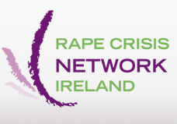
Online survey for people with disabilities
Rape Crisis Network Ireland and the Centre for Disability Law and Policy at NUI, Galway, are studying information that has been collected in Ireland and elsewhere about sexual violence experienced by people with disabilities. We are including information about people with mental health difficulties and people in the deaf community.
We invite people with disabilities to complete a short online survey about what stops you talking about experiences of sexual violence.
What is sexual violence?
Sexual violence or abuse is when anyone does something to you in a sexual way that you do not want them to do. You can experience sexual violence from anyone, including people you are related to. Sexual violence can happen anywhere, including at home or at work.
Examples of sexual violence are:
- Someone making you do sexual things that make you sad, angry, afraid or ashamed.
- Someone touching you in a sexual way where you do not want to be touched.
- Someone making you touch them on their private parts.
- Someone making you take your clothes off or have sex when you do not want to.
- Someone taking photographs of you with no clothes on.
Help us to improve society
Help us to improve public understanding, supports and protection for people with disabilities by completing the survey. There are only 9 questions to be answered. You may also want to take part in a one-day workshop to help us learn more after you have completed the survey.
The workshop will be a safe place for you and other people taking part to talk about what stops you, or people you know, from telling anyone if you have experienced sexual violence.
The workshop is important because it will help everyone to understand what stops people with disabilities who have experienced sexual violence from telling anyone about it. When we know the reasons, we can develop ways to help people tell someone if they have experienced sexual violence.
If you complete this survey you can apply to take part in the workshop
If you have a disability, whether physical, sensory, intellectual, mental health or other, and you complete this survey you can apply to take part in the workshop.
When: 29 September 2011
Where: NUI Galway, Galway City
Contact details are at the end of survey.

Q.1 Are you a man or a woman? Please tick one box.
A man A woman
Q2. What is your disability? Please tick any box that applies to you (you can tick more than one box).
Physical
Sensory
Mental health
Intellectual
Other – If you tick this box, please give us more information here
______________________________________________________________________________________________________________________________________________________________________
Q3. What age group are you in?
Please tick one box.
Under 12
12 - 14
15 - 17
18 - 19
20 - 29
30 - 39
40 - 49
50 - 59
60 - 69
70+
Q4. Has anyone ever given you any information about where to go for support surrounding sexual violence?
Please tick one box.
Yes No
Q5. Who would you tell if you were worried by sexual violence?
Please tick any box that applies to you (you can tick more than one box).
Carer
Counsellor
Don’t know
Family member
Friend
Gardaí or other national police force
GP
Helpline
Partner
Legal professional
No-one
Other medical professional
Rape Crisis Centre
Social worker
Other. If you ticked this box please tell us here who ‘other’ is _________________________________________________________________________________________________________________________________________________________________________________________________________________________________________________________

What would stop you telling someone?
Q6. Would any of the following stop you telling someone?
Please tick as many boxes as you need to.
You are afraid of getting into trouble.
You are afraid of getting someone else into trouble.
You are afraid of losing support.
You are afraid of losing care.
You are afraid of losing independence.
You are afraid of losing your job.
You are afraid of the person who is abusing you.
You are afraid that people will blame you.
You are afraid that telling will make you less safe.
You are afraid of what will happen after you tell someone – that you will not get enough support to help you to make a statement, be a witness, give evidence, or generally feel unwilling to through with it.
You don’t know who to tell.
You don’t trust anyone enough.
You think it is not important enough.
You think that people might not believe you.
Your disability makes it difficult to communicate or use tools, for example, a telephone.
You have another reason? If you ticked this box, please tell us what the other reason is ____________________________________________________________________________________________________________________________________________________________________________________________________________________________________________________
Q7. What would help you to tell someone?
Please tell us below.
_________________________________________________________________________________________________________________________________________________________________________________________________________________________________________________________
Q8. Has anyone ever asked you if you have been subjected to sexual violence?
Please tick one box.
Yes No
Q9. Have you suffered sexual violence?
Please tick one box.
Yes No
If ‘Yes’, did you tell anyone? Please tick one box.
Yes No
If you have any other comments or feedback, please tell us below.
__________________________________________________________________________________________________________________________________________________________________________________________________________________________________________________________________
Thank you for taking part.
If you would like to support this research project by coming to a one-day group discussion, please contact Helen by email helen@rcni.ie

If you want more information for yourself or someone else please click on this link http://www.rcni.ie/rape-crisis-centres.aspx or call the 24 hour helpline on 1800 77 88 88.
Please return the completed survey to helen@rcni.ie or by post to:
Rape Crisis Network Ireland, The Halls, Quay Street, Galway.

Appendix 5: RCNI Database disability indicators (2004-2011)
Excerpt from RCNI National Statistics Project User Manual
The user manual is a detailed guide of RCNI staff members and volunteers, member Rape Crisis Centre staff and volunteers, and other sexual violence services authorised by RCNI. The following disability indicators and guidance were in use for the period of this research.

Disability: Choose from a dropdown menu

- None
- Deaf/hearing impaired: Significant hearing difficulties or is deaf.
- Learning Disability: A substantial restriction in the capacity of the person to carry on a profession, business or occupation, or to participate in social or cultural life by reason of an enduring intellectual impairment.
- Mobility Impaired: Someone who is not very physically mobile but does not use a wheelchair.
- Visually Impaired/Blind: Significant sight difficulties or is blind.
- Wheelchair User
- Unknown

Data Protection Act 1988 & the Data Protection (Amendment) Act 2003, the Freedom of Information Act 1997 & Freedom of Information (Amendment) Act 2003 and the EU Data Protection Directive 95/46/EC.
For the purpose of the Convention “‘violence against women’ is understood as a violation of human rights and a form of discrimination against women and shall mean all acts of gender-based violence that result in, or are likely to result in, physical, sexual, psychological or economic harm or suffering to women, including threats of such acts, coercion or arbitrary deprivation of liberty, whether occurring in public or in private life”; “‘gender’ shall mean the socially constructed roles, behaviours, activities and attributes that a given society considers appropriate for women and men”; “‘gender-based violence against women’ shall mean violence that is directed against a woman because she is a woman or that affects women disproportionately”.
For the purpose of the Convention “‘domestic violence’ shall mean all acts of physical, sexual, psychological or economic violence that occur within the family or domestic unit or between former or current spouses or partners, whether or not the perpetrator shares or has shared the same residence with the victim”.
For example age: the more sub-categories the more comparable with wider fixed random categories such as infant, pre-teen, teen, adult. Subjective categories are incomparable.
http://stats.oecd.org/glossary/index.htm
http://stats.oecd.org/glossary/detail.asp?ID=6883
http://unstats.un.org/unsd/class/family/glossary_short.htm
http://stats.oecd.org/glossary/detail.asp?ID=5080
http://stats.oecd.org/glossary/detail.asp?ID=2857

