Moving In, Moving On: Technical Annex

An evaluation of the outcomes and costs of new or emerging models of service in the disability sector

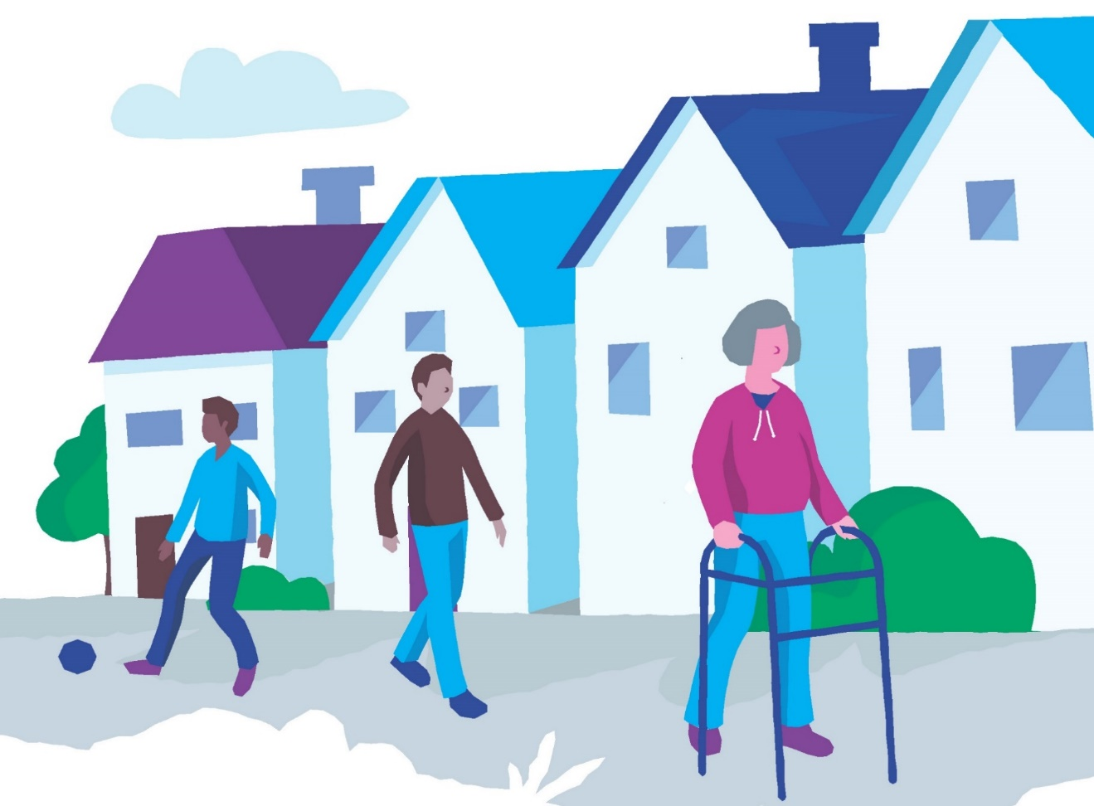

 December 2021

This Technical Annex accompanies the ‘Moving In, Moving On’ report. The study was commissioned and funded by the Health Service Executive (HSE) as part of the Transforming Lives programme.

 

# Contents

Abbreviations 3

Introduction 4

Annex 1 – Methodology 4

Sampling and recruitment strategy – additional information 4

Annex 2 - Ethical approval and Consent 10

Annex 3. Survey Tools 11

FACE Research Tool (Overview Assessment V7.2 NDA) 11

ASCOT Research Tool (Complete) 30

Supplementary questions 45

NDA outcomes 47

Reflective Diary 49

Annex 4. Participant information sheets and consent forms 51

Participant Information Sheet 51

Easy to Read Participant Information Sheet 58

Easy to Read Consent Form 65

Determination of lack of capacity form 72

Annex 5. Phase 1 Pre transition FACE findings 73

Findings from FACE 73

Annex 6 – Phase 1 Comparison of Pre and Post transition FACE findings 93

Findings from FACE 93

Annex 7: Phase 1 Comparison between participants who did and did not transition 103

Overview 103

Findings from FACE 104

Annex 8. Phase 2 Findings 110

Primary supports received by Phase 2 participants 110

Findings from FACE 115

Annex 9: Phase 2 quality of life findings 149

Quality of life using ASCOT 149

Supplementary questions 152

FACE questions relating to quality of life and wellbeing 157

Multivariate analysis 158

Annex 10. Additional examples of Phase 2 reflective diaries 171

Researcher Diary: Congregated setting 171

Researcher Diary: Specialist Unit 173

Annex 11. Case studies 174

Phase 1 Participants 174

Phase 2 participants 175

Annex 12: Data Resources relating to cost relevant to Disability Residential Services 181

UK FACE Assessment Tool 181

HSE Service Improvement Data 182

Annex 13: Staffing Levels and Regulatory Requirements 185

Annex 14: Day Service Costs 186

Estimates of Day Service costs 191

Annex 15: Residential Support Service Maintenance and Accommodation Contribution 195

References 199

# Abbreviations

|  |  |
| --- | --- |
| BI | Acquired brain injury |
| ADLs | Activities of daily living |
| AFS | Audited Financial Statements |
| ASCOT | Adult Social Care Outcomes Toolkit |
| ASD | Autism Spectrum Disorder |
| CHO | Community Health Organisations |
| COPD | Chronic Obstructive Pulmonary Disease |
| DA | Disability Allowance |
| FACE | Functional Analysis of Care Environments |
| GAA | Gaelic Athletics Association |
| GNB | Global Need Band |
| HIQA | Health Information and Quality Authority |
| HSE | Health Service Executive |
| HRDC | Health Research Consent Declaration |
| HRR | Health Research Regulations |
| IADLs | Instrumental Activities of Daily Living |
| ID | Intellectual Disability |
| KPI | Key Performance Indicators |
| MH | Mental Health |
| NDA | National Disability Authority |
| NIDD | National Intellectual Disability Database |
| OLS | Ordinary Least Squares |
| OT | Occupational Therapy |
| PA | Personal Assistant |
| PSSRU | Personal Social Services Research Unit |
| RSSMAC | Residential Support Maintenance and Accommodation Contribution |
| RT | Rehabilitative Trainees |
| SA | Service Arrangements |
| SIT | Service Improvement Team |
| SLS | Stage Least Squares |
| SLT | Speech and Language Therapy |
| UK | United Kingdom |
| UNCRPD | United Nations Convention on the Rights of People with Disabilities |
| VFM | Value for Money |
| WTE | Whole Time Equivalent |

# Introduction

The Moving In Moving on Report consists of a suite of three documents; the main report, a literature review document and a technical annex. This technical annex presents supplementary technical information for the Moving In, Moving On Study report. It is available to researchers who may wish to know about the study tools and methods used.

# Annex 1 – Methodology

## Sampling and recruitment strategy – additional information

Table 1.1 below sets out the variety of supports provided for persons with a disability and details of the anticipated number of recipients of each type of support in 2018, as indicated by the HSE (those receiving supports include children).

**Table 1.1: Disability services – Expected activity 2018**

| Type of service | Number of Recipients |
| --- | --- |
| Residential Places | 8,399 |
| Day services [1] | 24,856 |
| Respite Care | 6,320 |
| Personal assistant | 2,357 |
| Home Support | 7,447 |
| Respite Services | 6,320 |

Several different types of support may be provided to an individual. Most people receiving residential care also have access to day care. Some of those receiving home supports may also attend day services. While it is not possible to be definitive it is estimated that the total number of people supported by disability services is circa 30,000. We set out to recruit adults receiving either day, residential or personal support services or a combination of these. While many of our participants were in receipt of respite care almost all were also in receipt of some other form of support and therefore we did not extend the study to include respite services. We were constrained in the choice of our sampling strategy by the absence of a sampling frame and by the availability and willingness of individual service users to participate in the study. Participants were therefore selected using purposive sampling. Purposive sampling is a form of non-probability sampling which involves the selection of sample members based on their characteristics and/or the objectives of the study. This sampling technique allowed us to structure the sample to ensure that it included participants supported by a wide selection of service providers that adopt a variety of service models. We were also able to ensure that our sample included participants with different types of disability and with varying levels of support needs, provided a wide geographical spread and a good age and gender balance.

The planned sample size was decided in consultation with the Scientific Advisory Committee. The committee and The Department of Public Expenditure and Reform (DPER) agreed that a sample size of 600 would be sufficient to provide for the range of disability type, support needs and service models sought. It was decided that all adults in receipt of disability services were potential participants in the study. This approach was considered to be consistent with the ethos of the United Nations Convention on the Rights of Persons with Disabilities (UNCRPD). In adopting this inclusion criteria it was recognised that some persons with a significant intellectual disability would not have the capacity to give informed consent. Initially proxy assent was sought from persons supporting participants who lacked the capacity to provide informed consent. Support workers familiar with the participant and family members provided proxy assent. This approach was reviewed following the introduction of the Health Research Regulations in 2018 and a Consent Declaration was received from the Health Research Consent Declaration Committee (see more details in Annex 2 below)

In recognition of the significant challenges associated with the transition of people in congregated settings to homes and services in the community, and the uncertain costs and benefits associated with such transitions, it was decided that a segment of the total sample would comprise people in congregated settings who were expected to be among the first tranche of movers to the community. It was planned to include 165 people in sites with a priority designation for decongregation within this segment of the sample. We planned to evaluate the costs and social care related quality of life for these participants at two points in time; before the person moved from the congregated setting and after their move to the community was embedded and a minimum period of 6-9 months had elapsed. This ‘before and after’ evaluation would therefore provide a basis for comparing the cost of care in both settings and assessing the benefit of the transition in terms of improved outcomes for individual participants. This part of the study was deemed Phase 1.

Other sub-groups targeted were new entrants to day services for whom a specific budget has been allocated, people living in community-based residential care settings, people with a physical/sensory disability, people with acquired disabilities of various forms, people living in various community settings including family homes, sheltered housing and independently. This part of the study was deemed Phase 2.

We also sought to base our sample selection on the model of service adopted by service providers. Our aim was to have a roughly equivalent number of people receiving services from ‘old’ and ‘new’ service models. However, in practice the service models ranged on a continuum from old to new and often resisted classification. Some service providers who provided residential care in institutional settings also sought to promote community integration and provide opportunities for persons to exercise choice. Similarly, not all community based services were sufficiently oriented towards recognising and promoting the wishes and preferences of individuals. Therefore, we found that it was not possible to draw a meaningful distinction between old and new models of service in advance of our fieldwork. Consequently, various lists and registers of service providers were used to identify the service providers we approached to recruit participants. In recognition of the high proportion of funding directed to large service providers, these were initially targeted for inclusion.

### Phase 1 participants:

We sought to recruit a total of 165 participants from within priority sites for decongregation. The number of participants in priority sites recruited was somewhat smaller than that targeted. Reasons for this included a number of refusals by individual participants, the closure of one priority site prior to the commencement of fieldwork, the non-participation of two sites, and the selection of children from one site who could not be included.

### Phase 2 participants

The recruitment of the Phase 2 participants proved to be a resource intensive and slow process. The response of service providers to our request for assistance in recruiting participants was mixed. Some embraced the project and were very active in disseminating information about the project to their staff and service users. However, others were reluctant to respond to our request for assistance in recruiting participants and it was often necessary to send repeated requests to get a response. Some service providers indicated that they were unable to be involved in the study because of the potential resource implications.

A further 280 participants were recruited via 43 local/regional centres supported by 33 service providers. While the number of Phase 2 participants recruited was significantly less than the original target sample, it was decided that the sample achieved was sufficiently representative of the population of adults with disabilities and the time and resources required to recruit further participants would not be repaid with significant new information.

During the course of the fieldwork more than 80 different service settings were visited including day centres, residential care settings and private dwellings. In some local/regional centres participants were receiving a variety of supports in several different locations. Participants included adults with disabilities supported by statutory, voluntary and private service providers, as well as those who had self-directed support.

Our participants were dispersed throughout Ireland and include persons living in 22 different counties and one person receiving support outside the state.

For the purposes of Phase 2 analysis, residential support services have been defined as services provided in disability designated centres monitored and regulated by HIQA or in any 24-hour supervised community residences that support individuals with intellectual disability and mental ill health and are inspected by the Office of the Inspector of Mental Health.

Residential supports may also be provided via a variety of supported or assisted living models that usually provide intermittent rather than constant access to support staff. Care and housing may be provided by different agencies. This model of support is more aligned than other models of residential support with the promotion of the independence and autonomy of service users. For the most part these services are provided in living arrangements that are not designated centres and which may be family homes. In the absence of a legislative definition of residential services the different configurations of supported living can result in ‘a degree of uncertainty around whether these types of services fall within the definition of a designated centre, and thereby whether they are regulated by HIQA’ (HIQA 2017, p.13).[2]

For the purposes of this study personal support services are considered to be a supported living support.

Personal support services provided to individuals with disabilities include personal assistant (PA) support and home support services. The support provided by personal assistants includes, but is not limited to, assistance with personal care and activities of daily living. A home support service is a more restricted form of service than a PA service but the distinction between the two services is often blurred.

Adult disability day services are provided by 84 providers in over 900 locations.[3] There is considerable variety in the size, location and orientation of day services. Day service locations include home-like settings, spaces within congregated settings or health care facilities, purpose built centres and units within industrial parks. They can cater for anything from one person upwards. The primary orientation varies depending on the support needs of attendees. Services may be oriented towards care or medical support or may prioritise life-skill training and social activation.

The quantum of services provided to each person also varies. Services are generally provided Monday to Friday but individual service users may not always be offered a five day service. Service users may also opt not to attend on certain days. Day service hours may also vary. Transport arrangements may determine the times when service users arrive and leave. Services do not normally commence before 9.30am or end after 4 pm.

Ancillary services include services such as advocacy, counselling, community outreach and facilitated networks. Services may be universal or targeted at specific cohorts of individuals with disabilities. The National Advocacy Service for People with Disabilities is available to all individuals with a disability. Targeted services include support and outreach services for individuals with various disabilities.

### Required adaptations as study progressed

Throughout the progress of the study, the NDA worked closely with the HSE and the Scientific Advisory Committee for the research, to agree necessary adaptations to the project, including:

* Reduced sample size in the case of the priority sites (Phase 1), where some sites were not available to participate during the study timeline, and where fewer participants than initially planned were available in some of the remaining sites;
* Decision to conclude the fieldwork at the end of January 2020, in spite of the fact that not all of the 145 Phase 1 participants had transitioned to a new model of service. This meant that ‘after’ interviews were only conducted with 91individuals from this group.
* Reduced sample size in the case of Phase 2, where the purposive sampling approach allowed for a wide range of situations to be covered, but where recruitment took longer than anticipated, and the original sample planned for could not be achieved without considerable extension to the study timeline. It was agreed that such an extension would not lead to a corresponding increase in information or learning gathered, in light of the significant body of data gathered from the 280 people interviewed by end January 2020[4].
* Adjustments to the methodology used to identify and compare costs across different models of service, arising from challenges in obtaining and analysing data that is non-standardised. It was agreed that in the absence of the ability to directly compare costs for ‘traditional’ and ‘new’ models of service, a number of cost scenarios would be presented for information and analysis. While this does not provide a direct comparison of costs across models in every respect, it is nevertheless the first time that such a detailed breakdown of the financial variations in disability services has been presented for the Irish landscape. Additionally, the fundamental question of how the cost of service delivery compares pre and post decongregation has been comprehensively answered by this study.

# Annex 2 - Ethical approval and Consent

There is no national or co-ordinated system of ethical approval for social research in Ireland. The NDA sought, but was unable to agree, a single ethical approval process covering all of the member organisations of the National Federation of Voluntary Organisations. In the absence of any means of obtaining a ‘global’ ethical approval for this project, ethical approval for the research was obtained from all disability service providers with research ethics committees. This necessitated the completion and submission of multiple ethical approval applications and corresponding and liaising with all relevant research ethics committees. The recruitment of participants did not commence until ethical approval had been granted.

Many participants in our study were unable to provide informed consent due to their intellectual disability. For such participants we relied on proxy assent which was provided by a family member or a member of staff with a long-standing relationship with the participant. This process was approved by multiple research ethics committees. However, the 2018 Health Research Regulations (HRR) introduced additional safeguards to protect the data privacy of participants in health research and, in common with all other ongoing research projects that involved personal health data, the process of securing consent was reviewed to ensure compliance with the regulations.[5],[6] The HRR state that all processing of personal data for the purposes of health research requires the explicit consent of the data subjects. As assent provided by proxies does not constitute explicit consent, it was necessary to make an application to the newly formed Health Research Consent Declaration Committee (HRCDC). On foot of this application, the HRCDC issued a consent declaration which provided the authority to process the data gathered from participants who were unable to provide explicit consent. The process adopted has therefore been reviewed and endorsed.

# Annex 3. Survey Tools

This section describes the five survey tools used and provides the questionnaire where relevant. The tools are:

* FACE Research Tool (Overview Assessment V7.2 NDA)
* ASCOT Research Tool ( Self-complete)
* Supplementary questions
* NDA Outcomes Framework
* Reflective diary

## FACE Research Tool (Overview Assessment V7.2 NDA)

The tool used to assess the support needs of participants was FACE (Functional Assessment of Care Environment) v7 Recording and Measurement Systems Toolset (UK). The FACE Toolset is a comprehensive, integrated toolset for use across health and social care settings. It is designed to assess the level of support adults with a disability require.[7] It records information on a person’s capacity and personal support needs around activities of daily living, instrumental activities of daily living, and participation in work, education and social activities.

FACE also collects data on the informal support systems available to each person. Informal supports are incorporated into the costing model and reduce the estimated cost of support generated.[8] Qualitative data was also recorded in and harvested from the word version of the FACE profiles. The qualitative data helps to contextualise the participants and enables a more in-depth picture of the participants to emerge. The data were collated and analysed using a reflexive thematic analysis approach (Braun and Clarke 2006).

FACE was used under licence from Imosphere, the commercial organisation that developed the tool. FACE is also the assessment tool that was recommended for use in disability services by the NDA following an evaluation of four resource allocation systems (NDA 2015).

FACE provides a means of assessing a person’s ability to undertake activities of daily living by asking a series of questions about the assistance required while (1) eating/drinking; (2) dressing; (3) undressing; (4) toileting; (5) ensuring personal hygiene; (5) washing whole body; (7) transfers; and (8) staying comfortable at night. We calculated a composite score for the assistance required with ADLs by combining the scores for each of the eight activities. The level of assistance required was graded in five levels for each activity and ranged from ‘none’ (score of 0) to ‘unable to manage, needs two others to undertake’ (score of 4). The overall ADLs score for each participant could therefore range from 0 (indicating no assistance required with any of the eight ADLs) to 32 (indicating participants were unable to undertake any of the eight ADLs and needed the help of two others to undertake each task).

FACE provides a means of assessing a person’s ability to undertake Instrumental activities of daily living (IADLs) by asking a series of questions about the assistance required to (1) undertake household shopping; (2) prepare meals snacks and drinks; (3) maintain a clean and safe home; (4) manage paperwork; (5) manage finances; and (6) take medication. We calculated a composite score for the assistance required with IADLs by combining the scores for each of the six activities listed above. Assistance was graded in four levels for household shopping, preparing meals and snacks and maintaining a clean and safe home and ranged from ‘little or none’ (score of 0) to ‘unable to manage needs one or two others to undertake’ (score of 3). Support for medication was also graded into four levels: ‘none’ (score of 0); ‘reminders’ (score of 1); supervision (score of 2); and administration or trained administration (score of 3). The assistance required with paperwork and finances are dichotomous variables with a possible score of 0 (no assistance required) or 1 (assistance required).

The composite IADL score for each participant could range from a minimum of 0 (indicating little or no assistance required with any of the six IADLs) to a maximum of 14 (indicating no capacity to undertake any of the six IADLs).

Communication difficulties are difficulties expressing needs and or understanding others. Visual and hearing impairments often result in communication difficulties and are more common in adults with intellectual disabilities than in the general population. Individuals with certain physical and neurological conditions may also have communication difficulties. Participants described their communication difficulties as either: (1) none; (2) mild; (3) consistent; (4) severe; or (5) unable to express basic needs/understand others.

Participants were asked if they have any concerns about the way others treat them. They were prompted to think about whether they considered they were neglected or had experienced abuse or discrimination.

FACE profiles assess certain limited aspects of physical health but do not include an overall assessment of physical health. Participants are asked to indicate health conditions and disabilities that impact on their wellbeing but the descriptors provided (e.g. ‘other physical condition’, ‘other neurological condition’) do not facilitate the compilation of a detailed and accurate picture of participants’ health.

As part of the FACE profile participants were asked to indicate the support they receive on an ongoing basis from family friends and volunteers. Ongoing support was defined as support received in a typical week.

### FACE V7 Tool

| Main ID: | | | | | | | | | | | | | | | | | | | | | Main assessor: | | | | | | | | | | | | | | | | | | | | | | | | | | | | | | | | | | | | | | | | | | | | | | | | | |
| --- | --- | --- | --- | --- | --- | --- | --- | --- | --- | --- | --- | --- | --- | --- | --- | --- | --- | --- | --- | --- | --- | --- | --- | --- | --- | --- | --- | --- | --- | --- | --- | --- | --- | --- | --- | --- | --- | --- | --- | --- | --- | --- | --- | --- | --- | --- | --- | --- | --- | --- | --- | --- | --- | --- | --- | --- | --- | --- | --- | --- | --- | --- | --- | --- | --- | --- | --- | --- | --- | --- |
| **FACE Overview Assessment V7.2 (NDA) Confidential** | | | | | | | | | | | | | | | | | | | | | | | | | | | | | | | | | | | | | | | | | | | | | | | | | | | | | | | | | | | | | | | | | | | | | | |
| Gender: | |  | | | | | Date of birth: | | | | | | | | | | |  | | | | | | | | | | | | | | | | | | | | Your age band: | | | | | | | | | | | | | | | |  | | | | | | | | | | | | | | | | |
| **Supporting you in your assessment** | | | | | | | | | | | | | | | | | | | | | | | | | | | | | | | | | | | | | | | | | | | | | | | | | | | | | | | | | | | | | | | | | | | | | | |
| Preferred language: | | |  | | | | | | | | | | | | | | | | Do you need an interpreter? | | | | | | | | | | | | | | | | | | | | | | | | | | | Yes | | | | | | | | | |  | | | | | No | | | | |  | | | | |
| Do you consider yourself to be any of the following: | | | | | | | | | | | | | | | Hearing impaired | | | | | | | | | | | | | | |  | | | | Visually impaired | | | | | | | | | | | | | | | | | |  | | | | | | Deafblind | | | | | | | | | |  | | |
| Do you have communication difficulties? | | | | | | | | | | | | |  | | | | | | | | | | | | | | | | | | | | | | | | | | | | | | | | | | | | | | | | | | | | | | | | | | | | | | | | | |
| Do you have any difficulties with understanding and/or retaining information? | | | | | | | | | | | | | | | | | | | | | | | | | | | | | | | | | | | | | | | | | | | | | | Yes | | | | | | | | | |  | | | | | No | | | | |  | | | | |
| Do you have any difficulties making decisions and/or understanding their impact? | | | | | | | | | | | | | | | | | | | | | | | | | | | | | | | | | | | | | | | | | | | | | | Yes | | | | | | | | | |  | | | | | No | | | | |  | | | | |
| **If you have difficulties in communication, understanding or decision-making, you may need support for your involvement in your assessment, an advocate to represent you and help you explain your views, or a mental capacity assessment.** | | | | | | | | | | | | | | | | | | | | | | | | | | | | | | | | | | | | | | | | | | | | | | | | | | | | | | | | | | | | | | | | | | | | | | |
| Details of difficulties and what would help you communicate more easily during your assessment  For example, a family member or friend present, an independent advocate, specialist communication support. | | | | | | | | | | | | | | | | | | | | | | | | | | | | | | | | | | | | | | | | | | | | | | | | | | | | | | | | | | | | | | | | | | | | | | |
| Details: | | | | | | | | | | | | | | | | | | | | | | | | | | | | | | | | | | | | | | | | | | | | | | | | | | | | | | | | | | | | | | | | | | | | | | |
| Other people involved in your assessment  For example, advocate, carer, family, friend, other professionals. | | | | | | | | | | | | | | | | | | | | | | | | | | | | | | | | | | | | | | | | | | | | | | | | | | | | | | | | | | | | | | | | | | | | | | |
| Details: | | | | | | | | | | | | | | | | | | | | | | | | | | | | | | | | | | | | | | | | | | | | | | | | | | | | | | | | | | | | | | | | | | | | | | |
| **About you** | | | | | | | | | | | | | | | | | | | | | | | | | | | | | | | | | | | | | | | | | | | | | | | | | | | | | | | | | | | | | | | | | | | | | | |
| Your personal and family background  **Including important recent events or changes in your life.** | | | | | | | | | | | | | | | | | | | | | | | | | | | | | | | | | | | | | | | | | | | | | | | | | | | | | | | | | | | | | | | | | | | | | | |
| Details: | | | | | | | | | | | | | | | | | | | | | | | | | | | | | | | | | | | | | | | | | | | | | | | | | | | | | | | | | | | | | | | | | | | | | | |
| What areas of your life do you most enjoy or value?  **Including your main interests and where you can most contribute.** | | | | | | | | | | | | | | | | | | | | | | | | | | | | | | | | | | | | | | | | | | | | | | | | | | | | | | | | | | | | | | | | | | | | | | |
| Details: | | | | | | | | | | | | | | | | | | | | | | | | | | | | | | | | | | | | | | | | | | | | | | | | | | | | | | | | | | | | | | | | | | | | | | |
| What changes would most improve your well-being or quality of life? | | | | | | | | | | | | | | | | | | | | | | | | | | | | | | | | | | | | | | | | | | | | | | | | | | | | | | | | | | | | | | | | | | | | | | |
| Details: | | | | | | | | | | | | | | | | | | | | | | | | | | | | | | | | | | | | | | | | | | | | | | | | | | | | | | | | | | | | | | | | | | | | | | |
| *Your family, carer(s) or advocate’s views* | | | | | | | | | | | | | | | | | | | | | | | | | | | | | | | | | | | | | | | | | | | | | | | | | | | | | | | | | | | | | | | | | | | | | | |
| Details: | | | | | | | | | | | | | | | | | | | | | | | | | | | | | | | | | | | | | | | | | | | | | | | | | | | | | | | | | | | | | | | | | | | | | | |
| Do you have any concerns about how others treat you?  For example, neglect, abuse, discrimination. | | | | | | | | | | | | | | | | | | | | | | | | | | | | | | | | | | | | | | | | | | | | | | Yes | | | | | | | | | |  | | | | | No | | | | |  | | | | |
| Details: | | | | | | | | | | | | | | | | | | | | | | | | | | | | | | | | | | | | | | | | | | | | | | | | | | | | | | | | | | | | | | | | | | | | | | |
| **Your home and living situation**  Based on a typical week. | | | | | | | | | | | | | | | | | | | | | | | | | | | | | | | | | | | | | | | | | | | | | | | | | | | | | | | | | | | | | | | | | | | | | | |
| **Answer as if there is no support currently in place, but do consider the effect of existing equipment, adaptations or telecare.** | | | | | | | | | | | | | | | | | | | | | | | | | | | | | | | | | | | | | | | | | | | | | | | | | | | | | | | | | | | | | | | | | | | | | | |
| Are you currently staying in a hospital or step-down facility? | | | | | | | | | | | | | | | | | | | | | | | | | | | | | | | | | | | | | | | | | | | | | | Yes | | | | | | | | | |  | | | | | No | | | | |  | | | | |
| Your **current** living situation | | | | | | | | | |  | | | | | | | | | | | | | | | | | | | | | | | | | | | | | | | | | | | | | | | | | | | | | | | | | | | | | | | | | | | | |
| Your current tenure | | | | | | | | | |  | | | | | | | | | | | | | | | | | | | | | | | | | | | | | | | | | | | | | | | | | | | | | | | | | | | | | | | | | | | | |
| Maintaining your home in a sufficiently clean and safe condition | | | | | | | | | | Your situation: | | | | | | | | | | | | | | | | | | | | | | | | | | | | | | | | | | | | | | | | | | | | | | | | | | | | | | | | | | | | |
| Details of your needs and what you would like to achieve (maintaining your home in a sufficiently clean and safe condition): | | | | | | | | | | | | | | | | | | | | | | | | | | | | | | | | | | | | | | | | | | | | | | | | | | | | | | | | | | | | | | | | | | | | | | |
| Are you able to manage your own day-to-day paperwork? | | | | | | | | | | | | | | | | | | | | | | | | | | | | | | | | | | | | | | | | | | | | | | Yes | | | | | | | | | |  | | | | | No | | | | |  | | | | |
| Are you able to manage your own finances?  If no, please include detail of any power of attorney or wardship, decision-making representative, assistant to assist with in such matters, or a co-decision-maker to make decisions jointly with you. | | | | | | | | | | | | | | | | | | | | | | | | | | | | | | | | | | | | | | | | | | | | | | Yes | | | | | | | | | |  | | | | | No | | | | |  | | | | |
| Details of your needs and what you would like to achieve (managing paperwork, managing finances): | | | | | | | | | | | | | | | | | | | | | | | | | | | | | | | | | | | | | | | | | | | | | | | | | | | | | | | | | | | | | | | | | | | | | | |
| **If appropriate, you may wish to be referred for financial advice and/or maximising your benefits.** | | | | | | | | | | | | | | | | | | | | | | | | | | | | | | | | | | | | | | | | | | | | | | | | | | | | | | | | | | | | | | | | | | | | | | |
| Are you able to access and use the Internet? | | | | | | | | | | | | | | | | | | | | | | | | | | | | | | | | | | | | | | | | | | | | | | Yes | | | | | | | | | |  | | | | | No | | | | |  | | | | |
| Are you using specialist technology to help you manage at home?  For example, telecare. | | | | | | | | | | | | | | | | | | | | | | | | | | | | | | | | | | | | | | | | | | | | | | Yes | | | | | | | | | |  | | | | | No | | | | |  | | | | |
| Details: | | | | | | | | | | | | | | | | | | | | | | | | | | | | | | | | | | | | | | | | | | | | | | | | | | | | | | | | | | | | | | | | | | | | | | |
| Do you have any concerns about your current home and living situation?  For example, tenure, access and hazards, temperature, need for adaptations, smoke and carbon monoxide alarms. | | | | | | | | | | | | | | | | | | | | | | | | | | | | | | | | | | | | | | | | | | | | | | Yes | | | | | | | | | |  | | | | | No | | | | |  | | | | |
| Details: | | | | | | | | | | | | | | | | | | | | | | | | | | | | | | | | | | | | | | | | | | | | | | | | | | | | | | | | | | | | | | | | | | | | | | |
| **Eating healthily and safely**  Based on a typical week. | | | | | | | | | | | | | | | | | | | | | | | | | | | | | | | | | | | | | | | | | | | | | | | | | | | | | | | | | | | | | | | | | | | | | | |
| **Answer as if there is no support currently in place, but do consider the effect of existing equipment, adaptations or telecare.** | | | | | | | | | | | | | | | | | | | | | | | | | | | | | | | | | | | | | | | | | | | | | | | | | | | | | | | | | | | | | | | | | | | | | | |
| Shopping for food and essentials | | | | | | | | | Your situation: | | | | | | | | | | | | | | | | | | | | | | | | | | | | | | | | | | | | | | | | | | | | | | | | | | | | | | | | | | | | | |
| Preparing meals, snacks and drinks | | | | | | | | | Your situation: | | | | | | | | | | | | | | | | | | | | | | | | | | | | | | | | | | | | | | | | | | | | | | | | | | | | | | | | | | | | | |
| How often do you need support? | | | | | | | | | | | | | | | | | | | | | | | | | | | | | | | | | | | | | | | | | | | | | | | | | | | | | | | | | | | | | |
| Eating and drinking | | | | | | | | | Your situation: | | | | | | | | | | | | | | | | | | | | | | | | | | | | | | | | | | | | | | | | | | | | | | | | | | | | | | | | | | | | | |
| Details of your needs and what you would like to achieve (shopping, preparing meals, snacks and drinks, eating and drinking): | | | | | | | | | | | | | | | | | | | | | | | | | | | | | | | | | | | | | | | | | | | | | | | | | | | | | | | | | | | | | | | | | | | | | | |
| If you need someone else to feed you, are you able to have food and drink by mouth? | | | | | | | | | | | | | | | | | | | | | | | | | | | | | | | | | | | | | | | | | | | | | | Yes | | | | | | | | | |  | | | | | No | | | | |  | | | | |
| If you need someone else to feed you, how long does this usually take? | | | | | | | | | | | | | | | | | | | | | | | | | | | | | | | | | | | | | | | | | | | | | |  | | | | | | | | | | | | | | | | | | | | | | | | |
| Do you require specialist skilled support whilst eating and drinking?  For example, due to risk of aspiration. | | | | | | | | | | | | | | | | | | | | | | | | | | | | | | | | | | | | | | | | | | | | | | Yes | | | | | | | | | |  | | | | | No | | | | |  | | | | |
| Do you have a diagnosed eating disorder or other condition which is leading to significant concerns about your weight? | | | | | | | | | | | | | | | | | | | | | | | | | | | | | | | | | | | | | | | | | | | | | | Yes | | | | | | | | | |  | | | | | No | | | | |  | | | | |
| Details: | | | | | | | | | | | | | | | | | | | | | | | | | | | | | | | | | | | | | | | | | | | | | | | | | | | | | | | | | | | | | | | | | | | | | | |
| **Your personal care**  Based on a typical week. | | | | | | | | | | | | | | | | | | | | | | | | | | | | | | | | | | | | | | | | | | | | | | | | | | | | | | | | | | | | | | | | | | | | | | |
| **Answer as if there is no support currently in place, but do consider the effect of existing equipment, adaptations or telecare.** | | | | | | | | | | | | | | | | | | | | | | | | | | | | | | | | | | | | | | | | | | | | | | | | | | | | | | | | | | | | | | | | | | | | | | |
| Using the toilet and managing continence | | | | | | | | | Your situation: | | | | | | | | | | | | | | | | | | | | | | | | | | | | | | | | | | | | | | | | | | | | | | | | | | | | | | | | | | | | | |
| How often do you need support? | | | | | | | | | | | | | | | | | | | | | | | | | | | | | | | | | | | | | | | | | | | | | | | | | | | | | | | | | | | | | |
| Nature of support: | | | | | | | | | | | | | | | | | | | | | | | | | | | | | | | | | | | | | | | | | | | | | | | | | | | | | | | | | | | | | |
| Details of your needs and what you would like to achieve (using the toilet and managing continence): | | | | | | | | | | | | | | | | | | | | | | | | | | | | | | | | | | | | | | | | | | | | | | | | | | | | | | | | | | | | | | | | | | | | | | |
| Maintaining personal hygiene  For example, wash hands and face, hair, nails, shave. | | | | | | | | | Your situation: | | | | | | | | | | | | | | | | | | | | | | | | | | | | | | | | | | | | | | | | | | | | | | | | | | | | | | | | | | | | | |
| Washing whole body  For example, bath, shower, strip wash. | | | | | | | | | Your situation: | | | | | | | | | | | | | | | | | | | | | | | | | | | | | | | | | | | | | | | | | | | | | | | | | | | | | | | | | | | | | |
| How often do you need support? | | | | | | | | | | | | | | | | | | | | | | | | | | | | | | | | | | | | | | | | | | | | | | | | | | | | | | | | | | | | | |
| Details of your needs and what you would like to achieve (maintaining personal hygiene, washing whole body): | | | | | | | | | | | | | | | | | | | | | | | | | | | | | | | | | | | | | | | | | | | | | | | | | | | | | | | | | | | | | | | | | | | | | | |
| Getting dressed for the day | | | | | | | | | | | | Your situation: | | | | | | | | | | | | | | | | | | | | | | | | | | | | | | | | | | | | | | | | | | | | | | | | | | | | | | | | | | |
| Getting undressed at the end of the day | | | | | | | | | | | | Your situation: | | | | | | | | | | | | | | | | | | | | | | | | | | | | | | | | | | | | | | | | | | | | | | | | | | | | | | | | | | |
| Details of your needs and what you would like to achieve (dressing and undressing): | | | | | | | | | | | | | | | | | | | | | | | | | | | | | | | | | | | | | | | | | | | | | | | | | | | | | | | | | | | | | | | | | | | | | | |
| **Your mobility**  Based on a typical week. | | | | | | | | | | | | | | | | | | | | | | | | | | | | | | | | | | | | | | | | | | | | | | | | | | | | | | | | | | | | | | | | | | | | | | |
| **Answer as if there is no support currently in place, but do consider the effect of existing equipment, adaptations or telecare.** | | | | | | | | | | | | | | | | | | | | | | | | | | | | | | | | | | | | | | | | | | | | | | | | | | | | | | | | | | | | | | | | | | | | | | |
| Moving around the home | | | | | | | | | Your situation: | | | | | | | | | | | | | | | | | | | | | | | | | | | | | | | | | | | | | | | | | | | | | | | | | | | | | | | | | | | | | |
| Transfers | | | | | | | | | Your situation: | | | | | | | | | | | | | | | | | | | | | | | | | | | | | | | | | | | | | | | | | | | | | | | | | | | | | | | | | | | | | |
| Are you able to bear your own weight or assist with transfers? | | | | | | | | | | | | | | | | | | | | | | | | | | | | | | | | | | | | | | | | | | | | | | | | | Yes | | | | | | | |  | | | | | No | | | | |  | | | |
| To what extent does your weight impact on your mobility?  For example, if overweight or underweight or frail. | | | | | | | | | | | | | | | | | | | | | | | |  | | | | | | | | | | | | | | | | | | | | | | | | | | | | | | | | | | | | | | | | | | | | | | |
| Is there a high risk of harm to you or others when you are moving around? | | | | | | | | | | | | | | | | | | | | | | | | | | | | | | | | | | | | | | | | | | | | | | | | | Yes | | | | | | | |  | | | | | No | | | | |  | | | |
| Details of your needs (moving around the home, transfers): | | | | | | | | | | | | | | | | | | | | | | | | | | | | | | | | | | | | | | | | | | | | | | | | | | | | | | | | | | | | | | | | | | | | | | |
| Staying comfortable and repositioning | | | | | | | | | Your situation: | | | | | | | | | | | | | | | | | | | | | | | | | | | | | | | | | | | | | | | | | | | | | | | | | | | | | | | | | | | | | |
| Details of your needs (staying comfortable and repositioning): | | | | | | | | | | | | | | | | | | | | | | | | | | | | | | | | | | | | | | | | | | | | | | | | | | | | | | | | | | | | | | | | | | | | | | |
| Do you require regular support for a skin condition or to prevent one developing? | | | | | | | | | | | | | |  | | | | | | | | | | | | | | | | | | | | | | | | | | | | | | | | | | | | | | | | | | | | | | | | | | | | | | | | |
| Do you have any pressure ulcers? | | | | | | | | | | | | | |  | | | | | | | | | | | | | | | | | | | | | | | | | | | | | | | | | | | | | | | | | | | | | | | | | | | | | | | | |
| If pressure ulcer(s) are present, is treatment currently working? | | | | | | | | | | | | | | | | | | | | | | | | | | | | | | | Yes | | | | |  | | | | No | | |  | | | | | | | Does not apply | | | | | | | | | | | | | | | |  | | | | |
| Details of your needs (managing skin conditions): | | | | | | | | | | | | | | | | | | | | | | | | | | | | | | | | | | | | | | | | | | | | | | | | | | | | | | | | | | | | | | | | | | | | | | |
| Social relationships and activities  **Based on a typical week.** | | | | | | | | | | | | | | | | | | | | | | | | | | | | | | | | | | | | | | | | | | | | | | | | | | | | | | | | | | | | | | | | | | | | | | |
| **Answer as if there is no support currently in place, but do consider the effect of existing equipment, adaptations or telecare.** | | | | | | | | | | | | | | | | | | | | | | | | | | | | | | | | | | | | | | | | | | | | | | | | | | | | | | | | | | | | | | | | | | | | | | |
| The relationships that are most important to you and anything you would like to improve or change  For example, relationships with carers, family, friends, neighbours, volunteers. | | | | | | | | | | | | | | | | | | | | | | | | | | | | | | | | | | | | | | | | | | | | | | | | | | | | | | | | | | | | | | | | | | | | | | |
| Details of your needs and what you would like to achieve(maintaining relationships that are important to you): | | | | | | | | | | | | | | | | | | | | | | | | | | | | | | | | | | | | | | | | | | | | | | | | | | | | | | | | | | | | | | | | | | | | | | |
| Are you able to access the community? | | | | | | | | | | | Yes, independently | | | | | | | | | | | | | | | | | |  | | | | Yes, if accompanied | | | | | | | | | | | | | | | | | | | | | |  | | | | | No | | | |  | | | | | | |
| The support you need to stay safe out in the community | | | | | | | | | | | | | | | | | | | | | | | | | |  | | | | | | | | | | | | | | | | | | | | | | | | | | | | | | | | | | | | | | | | | | | | |
| Details of your needs(staying safe in the community): | | | | | | | | | | | | | | | | | | | | | | | | | | | | | | | | | | | | | | | | | | | | | | | | | | | | | | | | | | | | | | | | | | | | | | |
| The activities that are most important to you and anything you would like to improve or change  Including social, leisure, cultural and religious activities; making a meaningful contribution within society. | | | | | | | | | | | | | | | | | | | | | | | | | | | | | | | | | | | | | | | | | | | | | | | | | | | | | | | | | | | | | | | | | | | | | | |
| Details of your needs and what you would like to achieve (socialising, contributing to society): | | | | | | | | | | | | | | | | | | | | | | | | | | | | | | | | | | | | | | | | | | | | | | | | | | | | | | | | | | | | | | | | | | | | | | |
| The support you need to maintain personal relationships and engage in social activities Including leisure, cultural and religious activities. | | | | | | | | | | | | | | | |  | | | | | | | | | | | | | | | | | | | | | | | | | | | | | | | | | | | | | | | | | | | | | | | | | | | | | | |
| How often do you need support? | | | | | | | | | | | | | | | |  | | | | | | | | | | | | | | | | | | | | | | | | | | | | | | | | | | | | | | | | | | | | | | | | | | | | | | |
| Work, training, education and volunteering  **Based on a typical week.** | | | | | | | | | | | | | | | | | | | | | | | | | | | | | | | | | | | | | | | | | | | | | | | | | | | | | | | | | | | | | | | | | | | | | | |
| **Answer as if there is no support currently in place, but do consider the effect of existing equipment, adaptations or telecare.** | | | | | | | | | | | | | | | | | | | | | | | | | | | | | | | | | | | | | | | | | | | | | | | | | | | | | | | | | | | | | | | | | | | | | | |
| Current paid employment or voluntary work situation | | | | | | | | | | | | | | | | | | | | | | |  | | | | | | | | | | | | | | | | | | | | | | | | | | | | | | | | | | | | | | | | | | | | | | | |
| Current education or training situation | | | | | | | | | | | | | | | | | | | | | | |  | | | | | | | | | | | | | | | | | | | | | | | | | | | | | | | | | | | | | | | | | | | | | | | |
| What would you like to improve or change about your involvement in work, training, education or volunteering? | | | | | | | | | | | | | | | | | | | | | | | | | | | | | | | | | | | | | | | | | | | | | | | | | | | | | | | | | | | | | | | | | | | | | | |
| Details of your needs and what you would like to achieve (work, training, education or volunteering): | | | | | | | | | | | | | | | | | | | | | | | | | | | | | | | | | | | | | | | | | | | | | | | | | | | | | | | | | | | | | | | | | | | | | | |
| The support you need to participate in work, training, education and volunteering | | | | | | | | | | | | | | | | | | | | | | |  | | | | | | | | | | | | | | | | | | | | | | | | | | | | | | | | | | | | | | | | | | | | | | | |
| How often do you need support? | | | | | | | | | | | | | | | | | | | | | | |  | | | | | | | | | | | | | | | | | | | | | | | | | | | | | | | | | | | | | | | | | | | | | | | |
| Caring for others  Based on a typical week. | | | | | | | | | | | | | | | | | | | | | | | | | | | | | | | | | | | | | | | | | | | | | | | | | | | | | | | | | | | | | | | | | | | | | | |
| **Answer as if there is no support currently in place, but do consider the effect of existing equipment, adaptations or telecare.** | | | | | | | | | | | | | | | | | | | | | | | | | | | | | | | | | | | | | | | | | | | | | | | | | | | | | | | | | | | | | | | | | | | | | | |
| Do you have any children that are dependent on you? | | | | | | | | | | | | | | | | | | | | | | | | | | | | | | | | | | | | | | | | | | | | | | | | Yes | | | | | | | |  | | | | | No | | | | |  | | | | |
| If ‘Yes’, do you need support with your parenting or caring responsibilities? | | | | | | | | | | | | | | | | | | | | | | | | | | | | | | | Yes | | | |  | | | | No | | |  | | | | | | Does not apply | | | | | | | | | | | | | | | | | |  | | | | |
| Details of your needs and what you would like to achieve (caring for children): | | | | | | | | | | | | | | | | | | | | | | | | | | | | | | | | | | | | | | | | | | | | | | | | | | | | | | | | | | | | | | | | | | | | | | |
| Do you have any other caring responsibilities? | | | | | | | | | | | | | | | | | | | | | | | | | | | | | | | | | | | | | | | | | | | | | | Yes | | | | | | | | | |  | | | | | No | | | | |  | | | | |
| Details of your needs (caring for other adults): | | | | | | | | | | | | | | | | | | | | | | | | | | | | | | | | | | | | | | | | | | | | | | | | | | | | | | | | | | | | | | | | | | | | | | |
| **If you are providing care or support to other adults, you should be offered a carer’s assessment to discuss your caring role.** | | | | | | | | | | | | | | | | | | | | | | | | | | | | | | | | | | | | | | | | | | | | | | | | | | | | | | | | | | | | | | | | | | | | | | |
| **Staying safe at home**  Based on a typical week. | | | | | | | | | | | | | | | | | | | | | | | | | | | | | | | | | | | | | | | | | | | | | | | | | | | | | | | | | | | | | | | | | | | | | | |
| **Answer as if there is no support currently in place, but do consider the effect of existing equipment, adaptations or telecare.** | | | | | | | | | | | | | | | | | | | | | | | | | | | | | | | | | | | | | | | | | | | | | | | | | | | | | | | | | | | | | | | | | | | | | | |
| The support you need to stay safe at home during the day. Consider risk of falls and/or wandering, and responding to emergencies*.* | | | | | | | | | | | | | | | | | | | | | | | | | | |  | | | | | | | | | | | | | | | | | | | | | | | | | | | | | | | | | | | | | | | | | | | |
| The support you need to stay safe at home during the night.  Consider risk of falls and/or wandering, and responding to emergencies. | | | | | | | | | | | | | | | | | | | | | | | | | | |  | | | | | | | | | | | | | | | | | | | | | | | | | | | | | | | | | | | | | | | | | | | |
| Details of your needs and what you would like to achieve (making safe use of your home): | | | | | | | | | | | | | | | | | | | | | | | | | | | | | | | | | | | | | | | | | | | | | | | | | | | | | | | | | | | | | | | | | | | | | | |
| Your mental health and well-being  **Including mental well-being issues arising from physical conditions.** | | | | | | | | | | | | | | | | | | | | | | | | | | | | | | | | | | | | | | | | | | | | | | | | | | | | | | | | | | | | | | | | | | | | | | |
| **Answer as if there is no support currently in place, but do consider the effect of existing equipment, adaptations or telecare.** | | | | | | | | | | | | | | | | | | | | | | | | | | | | | | | | | | | | | | | | | | | | | | | | | | | | | | | | | | | | | | | | | | | | | | |
| Do you or have you ever suffered from a serious mental health issue? | | | | | | | | | | | | | | | | | | | | | | | | | | | | | | | | | | | | | | | | | | | | | | Yes | | | | | | | | | |  | | | | | No | | | | |  | | | | |
| Have you had contact with mental health services in the past year? | | | | | | | | | | | | | | | | | | | | | | | | | | | | | | | | | | | | | | | | | | | | | | Yes | | | | | | | | | |  | | | | | No | | | | |  | | | | |
| Details: | | | | | | | | | | | | | | | | | | | | | | | | | | | | | | | | | | | | | | | | | | | | | | | | | | | | | | | | | | | | | | | | | | | | | | |
| Emotional well-being | | | | | |  | | | | | | | | | | | | | | | | | | | | | | | | | | | | | | | | | | | | | | | | | | | | | | | | | | | | | | | | | | | | | | | | |
| Details of your needs (emotional well-being): | | | | | | | | | | | | | | | | | | | | | | | | | | | | | | | | | | | | | | | | | | | | | | | | | | | | | | | | | | | | | | | | | | | | | | |
| Memory and orientation | | | | | |  | | | | | | | | | | | | | | | | | | | | | | | | | | | | | | | | | | | | | | | | | | | | | | | | | | | | | | | | | | | | | | | | |
| Planning and decision-making | | | | | |  | | | | | | | | | | | | | | | | | | | | | | | | | | | | | | | | | | | | | | | | | | | | | | | | | | | | | | | | | | | | | | | | |
| Details of your needs(memory or orientation, planning and decision-making): | | | | | | | | | | | | | | | | | | | | | | | | | | | | | | | | | | | | | | | | | | | | | | | | | | | | | | | | | | | | | | | | | | | | | | |
| Behaviour affecting self or others  For example, aggression, self-harm. | | | | | |  | | | | | | | | | | | | | | | | | | | | | | | | | | | | | | | | | | | | | | | | | | | | | | | | | | | | | | | | | | | | | | | | |
| Is your behaviour severe, frequent or unpredictable to a level which requires availability of an immediate and skilled response? | | | | | | | | | | | | | | | | | | | | | | | | | | | | | | | | | | | | | | | | | | | | | | Yes | | | | | | | | | |  | | | | | No | | | | |  | | | | |
| Impact of your mood or well-being on your acceptance of support | | | | | |  | | | | | | | | | | | | | | | | | | | | | | | | | | | | | | | | | | | | | | | | | | | | | | | | | | | | | | | | | | | | | | | | |
| Details of your needs (behaviour affecting self or others, impact of mood or well-being on acceptance of support): | | | | | | | | | | | | | | | | | | | | | | | | | | | | | | | | | | | | | | | | | | | | | | | | | | | | | | | | | | | | | | | | | | | | | | |
| How effective is the support of others in minimising risks to you or others around you? | | | | | | | | | | | | | | | | | | | | | | | | | | | |  | | | | | | | | | | | | | | | | | | | | | | | | | | | | | | | | | | | | | | | | | | |
| Details: | | | | | | | | | | | | | | | | | | | | | | | | | | | | | | | | | | | | | | | | | | | | | | | | | | | | | | | | | | | | | | | | | | | | | | |
| **If you have mental health issues, you may need a specialist assessment or referral for e.g. a mental capacity assessment.** | | | | | | | | | | | | | | | | | | | | | | | | | | | | | | | | | | | | | | | | | | | | | | | | | | | | | | | | | | | | | | | | | | | | | | |
| **Health conditions and disabilities that impact your well-being** | | | | | | | | | | | | | | | | | | | | | | | | | | | | | | | | | | | | | | | | | | | | | | | | | | | | | | | | | | | | | | | | | | | | | | |
| **Please list your disabilities, impairments & health conditions in order of most to least impact on your daily life and well-being:** | | | | | | | | | | | | | | | | | | | | | | | | | | | | | | | | | | | | | | | | | | | | | | | | | | | | | | | | | | | | | | | | | | | | | | |
| 1 |  | | | | | | | | | | | | | | | | | | | | | | | | | | | | | | | | | | | | | | | | | | | | | | | | | | | | | | | | | | | | | | | | | | | | | |
| 2 |  | | | | | | | | | | | | | | | | | | | | | | | | | | | | | | | | | | | | | | | | | | | | | | | | | | | | | | | | | | | | | | | | | | | | | |
| 3 |  | | | | | | | | | | | | | | | | | | | | | | | | | | | | | | | | | | | | | | | | | | | | | | | | | | | | | | | | | | | | | | | | | | | | | |
| 4 |  | | | | | | | | | | | | | | | | | | | | | | | | | | | | | | | | | | | | | | | | | | | | | | | | | | | | | | | | | | | | | | | | | | | | | |
| Details, including relevant medical history: | | | | | | | | | | | | | | | | | | | | | | | | | | | | | | | | | | | | | | | | | | | | | | | | | | | | | | | | | | | | | | | | | | | | | | |
| How often do your needs significantly change or vary due to your condition(s)? | | | | | | | | | | | | | | | | | | | | | | | | | | | | | | | | | | | | | | | | |  | | | | | | | | | | | | | | | | | | | | | | | | | | | | | |
| Details: | | | | | | | | | | | | | | | | | | | | | | | | | | | | | | | | | | | | | | | | | | | | | | | | | | | | | | | | | | | | | | | | | | | | | | |
| **Details of any sensory impairment(s)**  Based on a typical week. | | | | | | | | | | | | | | | | | | | | | | | | | | | | | | | | | | | | | | | | | | | | | | | | | | | | | | | | | | | | | | | | | | | | | | |
| **Answer as if there is no support currently in place, but do consider the effect of existing equipment, adaptations or telecare.** | | | | | | | | | | | | | | | | | | | | | | | | | | | | | | | | | | | | | | | | | | | | | | | | | | | | | | | | | | | | | | | | | | | | | | |
| Impact of sensory impairment | | | | | | | |  | | | | | | | | | | | | | | | | | | | | | | | | | | | | | | | | | | | | | | | | | | | | | | | | | | | | | | | | | | | | | | |
| Details of your needs (sensory impairment): | | | | | | | | | | | | | | | | | | | | | | | | | | | | | | | | | | | | | | | | | | | | | | | | | | | | | | | | | | | | | | | | | | | | | | |
| **If you have a significant sensory impairment, you may need to be referred for a specialist sensory assessment.** | | | | | | | | | | | | | | | | | | | | | | | | | | | | | | | | | | | | | | | | | | | | | | | | | | | | | | | | | | | | | | | | | | | | | | |
| **Your medication and symptoms**  Based on a typical week. | | | | | | | | | | | | | | | | | | | | | | | | | | | | | | | | | | | | | | | | | | | | | | | | | | | | | | | | | | | | | | | | | | | | | | |
| **Answer as if there is no support currently in place, but do consider the effect of existing equipment, adaptations or telecare.** | | | | | | | | | | | | | | | | | | | | | | | | | | | | | | | | | | | | | | | | | | | | | | | | | | | | | | | | | | | | | | | | | | | | | | |
| Are you currently taking any prescribed medication? | | | | | | | | | | | | | | | | | | | | | | | | | | | | | | | | | | | | | | | | | | | | | | Yes | | | | | | | | | |  | | | | | No | | | | |  | | | | |
| If ‘Yes’, what support do you need with taking or applying medication? | | | | | | | | Support needed: | | | | | | | | | | | | | | | | | | | | | | | | | | | | | | | | | | | | | | | | | | | | | | | | | | | | | | | | | | | | | | |
| How often do you need support? | | | | | | | | | | | | | | | | | | | | | | | | | | | | | | | | | | | | | | | | | | | | | | | | | | | | | | | | | | | | | | |
| Details of your needs (medication): | | | | | | | | | | | | | | | | | | | | | | | | | | | | | | | | | | | | | | | | | | | | | | | | | | | | | | | | | | | | | | | | | | | | | | |
| Does your physical condition or any medication that you are taking cause you distress or pain? | | | | | | | | | | | | | | | | | | | | | | | | |  | | | | | | | | | | | | | | | | | | | | | | | | | | | | | | | | | | | | | | | | | | | | | |
| Are you getting adequate relief from pain or other distressing physical symptoms? | | | | | | | | | | | | | | | | | | | | | | | | | | | | | | | | | | | | | | | | | | | | | | Yes | | | | | | | | | |  | | | | | No | | | | |  | | | | |
| Details of your needs (managing distress or pain from health conditions): | | | | | | | | | | | | | | | | | | | | | | | | | | | | | | | | | | | | | | | | | | | | | | | | | | | | | | | | | | | | | | | | | | | | | | |
| **If you have needs in relation to medication, arrangements may need to be made for a review or an appropriate referral.** | | | | | | | | | | | | | | | | | | | | | | | | | | | | | | | | | | | | | | | | | | | | | | | | | | | | | | | | | | | | | | | | | | | | | | |
| Do you have any difficulties with breathing? | | | | | | | | | | | | | | | | | | | | | | | | |  | | | | | | | | | | | | | | | | | | | | | | | | | | | | | | | | | | | | | | | | | | | | | |
| Do you need equipment to help you to breathe? | | | | | | | | | | | | | | | | | | | | | | | | |  | | | | | | | | | | | | | | | | | | | | | | | | | | | | | | | | | | | | | | | | | | | | | |
| Is suctioning required? | | | | | | | | | | | | | | | | | | | | | | | | | | | | | | | | | | | | | | | | | | | | | | Yes | | | | | | | | | |  | | | | | No | | | | |  | | | | |
| Details of your needs (breathing): | | | | | | | | | | | | | | | | | | | | | | | | | | | | | | | | | | | | | | | | | | | | | | | | | | | | | | | | | | | | | | | | | | | | | | |
| Do you have any difficulties maintaining consciousness?  For example, due to epilepsy, seizures, blackouts. | | | | | | | | | | | | | | | | | | | | | | | | |  | | | | | | | | | | | | | | | | | | | | | | | | | | | | | | | | | | | | | | | | | | | | | |
| Details of your needs (maintaining consciousness): | | | | | | | | | | | | | | | | | | | | | | | | | | | | | | | | | | | | | | | | | | | | | | | | | | | | | | | | | | | | | | | | | | | | | | |
| Support you will receive on an ongoing basis from family, friends or volunteers  **Based on a typical week.** | | | | | | | | | | | | | | | | | | | | | | | | | | | | | | | | | | | | | | | | | | | | | | | | | | | | | | | | | | | | | | | | | | | | | | |
| Details of support you currently receive from family, friends or volunteers  Including what’s working well and not so well. | | | | | | | | | | | | | | | | | | | | | | | | | | | | | | | | | | | | | | | | | | | | | | | | | | | | | | | | | | | | | | | | | | | | | | |
|  | | | | | | | | | | | | | | | | | | | | | | | | | | | | | | | | | | | | | | | | | | | | | | | | | | | | | | | | | | | | | | | | | | | | | | |
| Will you receive **ongoing** support from family, friends or volunteers? | | | | | | | | | | | | | | | | | | | | | | | | | | | | | | | | | | | | | | | | | | | | | | Yes | | | | | | | | | |  | | | | | No | | | | |  | | | | |
| **If you will receive no support from family, friends or volunteers, the rest of this section does not need to be completed.** | | | | | | | | | | | | | | | | | | | | | | | | | | | | | | | | | | | | | | | | | | | | | | | | | | | | | | | | | | | | | | | | | | | | | | |
| **Mornings** | | | | | | | | | | | | | | | | | | | | | | | | | | | | | | | | | | | | | | | | | | | | | | | | | | | | | | | | | | | | | | | | | | | | | | |
| Preparing your meals, snacks and drinks and helping you to eat and drink | | | | | | | | | | | | | | | | |  | | | | | | | | | | | | | | | | | | | | | | | | | | | | | | | | | | | | | | | | | | | | | | | | | | | | | |
| Managing your personal care tasks For example, using toilet and managing continence, washing, dressing and undressing. | | | | | | | | | | | | | | | | |  | | | | | | | | | | | | | | | | | | | | | | | | | | | | | | | | | | | | | | | | | | | | | | | | | | | | | |
| Supporting your medication | | | | | | | | | | | | | | | | |  | | | | | | | | | | | | | | | | | | | | | | | | | | | | | | | | | | | | | | | | | | | | | | | | | | | | | |
| **Daytimes** | | | | | | | | | | | | | | | | | | | | | | | | | | | | | | | | | | | | | | | | | | | | | | | | | | | | | | | | | | | | | | | | | | | | | | |
| Preparing your meals, snacks and drinks and helping you to eat and drink | | | | | | | | | | | | | | | | |  | | | | | | | | | | | | | | | | | | | | | | | | | | | | | | | | | | | | | | | | | | | | | | | | | | | | | |
| Managing your personal care tasks For example, using toilet and managing continence, washing, dressing and undressing. | | | | | | | | | | | | | | | | |  | | | | | | | | | | | | | | | | | | | | | | | | | | | | | | | | | | | | | | | | | | | | | | | | | | | | | |
| Supporting your medication | | | | | | | | | | | | | | | | |  | | | | | | | | | | | | | | | | | | | | | | | | | | | | | | | | | | | | | | | | | | | | | | | | | | | | | |
| **Evenings** | | | | | | | | | | | | | | | | | | | | | | | | | | | | | | | | | | | | | | | | | | | | | | | | | | | | | | | | | | | | | | | | | | | | | | |
| Preparing your meals, snacks and drinks and helping you to eat and drink | | | | | | | | | | | | | | | | |  | | | | | | | | | | | | | | | | | | | | | | | | | | | | | | | | | | | | | | | | | | | | | | | | | | | | | |
| Managing your personal care tasks For example, using toilet and managing continence, washing, dressing and undressing. | | | | | | | | | | | | | | | | |  | | | | | | | | | | | | | | | | | | | | | | | | | | | | | | | | | | | | | | | | | | | | | | | | | | | | | |
| Supporting your medication | | | | | | | | | | | | | | | | |  | | | | | | | | | | | | | | | | | | | | | | | | | | | | | | | | | | | | | | | | | | | | | | | | | | | | | |
| **Day-to-day** | | | | | | | | | | | | | | | | | | | | | | | | | | | | | | | | | | | | | | | | | | | | | | | | | | | | | | | | | | | | | | | | | | | | | | |
| Keeping your home clean and safe | | | | | | | | | | | | | | | | |  | | | | | | | | | | | | | | | | | | | | | | | | | | | | | | | | | | | | | | | | | | | | | | | | | | | | | |
| Managing your paperwork and finances | | | | | | | | | | | | | | | | |  | | | | | | | | | | | | | | | | | | | | | | | | | | | | | | | | | | | | | | | | | | | | | | | | | | | | | |
| Shopping for your food and essential items | | | | | | | | | | | | | | | | |  | | | | | | | | | | | | | | | | | | | | | | | | | | | | | | | | | | | | | | | | | | | | | | | | | | | | | |
| Social, leisure, cultural and religious activities | | | | | | | | | | | | | | | | |  | | | | | | | | | | | | | | | | | | | | | | | | | | | | | | | | | | | | | | | | | | | | | | | | | | | | | |
| Work, training, education or volunteering | | | | | | | | | | | | | | | | |  | | | | | | | | | | | | | | | | | | | | | | | | | | | | | | | | | | | | | | | | | | | | | | | | | | | | | |
| Ensuring your safety during the day | | This does not apply as constant presence for safety is not required | | | | | | | | | | | | | | | | | | | | | | | | | | | | | | | | | | | | | | | | | | | | | | | | | | | | | | | | | | | | | | | | | |  | | |
| Family, friends or volunteers will be present to ensure safety at all times during waking hours | | | | | | | | | | | | | | | | | | | | | | | | | | | | | | | | | | | | | | | | | | | | | | | | | | | | | | | | | | | | | | | | | |  | | |
| Family, friends or volunteers will be present to ensure safety for almost all waking hours  For example, all but a few hours on one or two days each week. | | | | | | | | | | | | | | | | | | | | | | | | | | | | | | | | | | | | | | | | | | | | | | | | | | | | | | | | | | | | | | | | | |  | | |
| Family, friends or volunteers will be present to ensure safety for most waking hours  For example, all but a few hours on three or four days each week. | | | | | | | | | | | | | | | | | | | | | | | | | | | | | | | | | | | | | | | | | | | | | | | | | | | | | | | | | | | | | | | | | |  | | |
| Family, friends or volunteers will be present to ensure safety for about half of all waking hours  For example, at evenings and weekends but not weekday daytimes. | | | | | | | | | | | | | | | | | | | | | | | | | | | | | | | | | | | | | | | | | | | | | | | | | | | | | | | | | | | | | | | | | |  | | |
| Family, friends or volunteers will be present to ensure safety for about a quarter of all waking hours  For example, a few hours on most or all days each week. | | | | | | | | | | | | | | | | | | | | | | | | | | | | | | | | | | | | | | | | | | | | | | | | | | | | | | | | | | | | | | | | | |  | | |
| Family, friends or volunteers will be present to ensure safety for a small portion of all waking hours  For example, a few hours on two or three days each week. | | | | | | | | | | | | | | | | | | | | | | | | | | | | | | | | | | | | | | | | | | | | | | | | | | | | | | | | | | | | | | | | | |  | | |
| Family, friends or volunteers will not be present for any significant time to ensure safety during waking hours | | | | | | | | | | | | | | | | | | | | | | | | | | | | | | | | | | | | | | | | | | | | | | | | | | | | | | | | | | | | | | | | | |  | | |
| Supporting you during the night | | | | | | | | | | | | | | | | |  | | | | | | | | | | | | | | | | | | | | | | | | | | | | | | | | | | | | | | | | | | | | | | | | | | | | | |
| Providing company and emotional support | | | | | | | | | | | | | | | | |  | | | | | | | | | | | | | | | | | | | | | | | | | | | | | | | | | | | | | | | | | | | | | | | | | | | | | |
| Other ongoing support | | | | | | | | | | | | | | | | | Escorting you or providing transport | | | | | | | | | | | | | | | | | | | | | | | | | | | | | | | | | | | | | | | | | | | | | | | |  | | | | | |
| Helping you communicate with others | | | | | | | | | | | | | | | | | | | | | | | | | | | | | | | | | | | | | | | | | | | | | | | |  | | | | | |
| Helping you care for children | | | | | | | | | | | | | | | | | | | | | | | | | | | | | | | | | | | | | | | | | | | | | | | |  | | | | | |
| Details of all ongoing support to be provided by family, friends or volunteers  Where this is safe and can be sustained. | | | | | | | | | | | | | | | | | | | | | | | | | | | | | | | | | | | | | | | | | | | | | | | | | | | | | | | | | | | | | | | | | | | | | | |
|  | | | | | | | | | | | | | | | | | | | | | | | | | | | | | | | | | | | | | | | | | | | | | | | | | | | | | | | | | | | | | | | | | | | | | | |
| Are there any people in particular who provide you with a high level of support? | | | | | | | | | | | | | | | | | | | | | | | | | | | | | | | | | | | | | | | | | | | | | | | Yes | | | | | | | | |  | | | | | No | | | | |  | | | | |
| **If ‘Yes’, your carer(s) should be offered a joint or separate carer’s assessment to discuss their caring role(s).** | | | | | | | | | | | | | | | | | | | | | | | | | | | | | | | | | | | | | | | | | | | | | | | | | | | | | | | | | | | | | | | | | | | | | | |
| Impact of caring on your main carer’s independence | | | | | | | | | | | | | | | | | | | | | | | | | | | | | | | |  | | | | | | | | | | | | | | | | | | | | | | | | | | | | | | | | | | | | | | |
| Are arrangements in place to support you if your main carer(s) are ill or unavailable? | | | | | | | | | | | | | | | | | | | | | | | | | | | | | | | | | | | | | | | | | | | | | | | Yes | | | | | | | | |  | | | | | No | | | | |  | | | | |
| Details of impact and arrangements: | | | | | | | | | | | | | | | | | | | | | | | | | | | | | | | | | | | | | | | | | | | | | | | | | | | | | | | | | | | | | | | | | | | | | | |
| Further details  **To be filled in by a social care authorised person, where relevant.** | | | | | | | | | | | | | | | | | | | | | | | | | | | | | | | | | | | | | | | | | | | | | | | | | | | | | | | | | | | | | | | | | | | | | | |
| Are full breaks (through the year) required to sustain the ongoing caring situation? | | | | | | | | | | | | | | | | | | | | | | | | | | | | | | | Yes | | | |  | | | | No | | |  | | | | | | Does not apply | | | | | | | | | | | | | | | | | | | |  | | |
| Primary support reason | | | | | | | | | | | | | | | | | | | |  | | | | | | | | | | | | | | | | | | | | | | | | | | | | | | | | | | | | | | | | | | | | | | | | | | |
| Anticipated living situation | | | | | | | | | | | | | | | | | | | |  | | | | | | | | | | | | | | | | | | | | | | | | | | | | | | | | | | | | | | | | | | | | | | | | | | |
| Number sharing support in anticipated living situation | | | | | | | | | | | | | | | | | | | |  | | | | | | | | | | | | | | | | | | | | | | | | | | | | | | | | | | | | | | | | | | | | | | | | | | |
| ***Record of completion***  This section to be filled in by a social care authorised person. | | | | | | | | | | | | | | | | | | | | | | | | | | | | | | | | | | | | | | | | | | | | | | | | | | | | | | | | | | | | | | | | | | | | | | |
| Date of assessment: | | | |  | | | | | | | | | | | | | | Assessment type: | | | | | | | | | | | | | | | | | | | Initial | | | | | | |  | | | | | | | Reassessment | | | | | | | | | | | | | | | | | |  | |
| Location of assessment: | | | | |  | | | | | | | | | | | | | | | | | Is this a supported self-assessment? | | | | | | | | | | | | | | | | | | | | | | | | | | | | | | | Yes | | | | | |  | | | | No | | | | | | |  |
| If ‘No’, main assessor: | | | | |  | | | | | | | | | | | | | | | | | Assessor contact details: | | | | | | | | | | | | | | | | | | | | | | |  | | | | | | | | | | | | | | | | | | | | | | | | | |

## ASCOT Research Tool

An important measure of the quality of disability supports is the degree to which they contribute to the wellbeing and quality of life (QOL) of the persons who receive the supports. QOL has been variously defined and measured. It is also influenced by subjective and objective factors. It can be readily appreciated, therefore, that isolating and measuring the contribution of social care to QOL is a challenging process. It is especially challenging when service users have intellectual disabilities, as is the case for many participants in our study. Even tools that are specifically designed for individuals with intellectual disabilities impose a cognitive burden on respondents and this burden is too heavy for those with severe or profound intellectual disabilities and also for some of those with moderate intellectual disabilities. As yet, there is no generally accepted reliable means of measuring QOL for people with intellectual disabilities, particularly those with severe and profound disabilities. It is clear that the measurement of social care related quality of life may provide a means of promoting quality, accountability and transparency. However, it is also important to be mindful of the limitations of any such measurement.

A suite of measures collectively known as the Adult Social Care Outcome Framework (ASCOF) has been developed by the Personal Social Services Research Unit based in the University of Kent. ASCOF enables councils in the UK to track the quality of the services delivered. It also provides a basis for comparison of the quality of care delivered by councils and a means of promoting transparency and accountability. The suite of tools developed reflects the range of user groups accessing social care in England. The tools are designed to measure social care related QOL, that is, QOL of life in the domains most affected by social care. The ASCOT has been criticised for failing to incorporate service users’ perceptions of important influences on their quality of life (Bowling, 2014)[9]. This criticism applies equally to most other measures of quality of life.

One of the original measures, the Adult Social Care Outcomes Toolkit-Self Complete-Easy Read (ASCOT-SC4-ER), has been adapted for use by adults with intellectual disabilities and Autism. The ASCOT-SC4-ER seeks to retain the concepts and structure of the original instrument while incorporating easy read principles to make it accessible to persons with intellectual disabilities or other cognitive deficits.

This version of the tool (ASCOT-SC4-ER) was used in this study. Speed and ease of administration were important considerations in the choice of tool. The ASCOT provides these features and was also attractive as it provides a measurement of social care related quality of life (SCRQOL).

The ASCOT SC4-ER does not include a screening or filtering process to test the cognitive ability of respondents. As it was designed for use in a large-scale postal survey the design of a suitable screening process would be challenging. However, the developers of ASCOT-SC4-ER point to the potential usefulness of using a screening tool in conjunction with the questionnaire (Turnpenny et al. 2018). Therefore, in this study ASCOT was used in conjunction with an acquiescence test (Cummins 2005) which provided a means of screening participants to ensure that they had the cognitive capacity to engage with the tool.

The Easy Read format of the ASCOT-SC4 includes illustrations and a total of nine questions with four answer options for each question. The illustrations were developed in conjunction with people with learning disabilities (Turnpenny et al. 2018). Their purpose is to assist respondents to understand the meaning of each domain. To assist participants further, one of four different ‘smiley face’ images is placed beside each answer option. Illustrations and text relating to each domain are set out on a single page.

As preference weights[10] for the ASCOT-SC4-ER are not available, the unweighted Social Care Related Quality of Life (SCRQoL) score was calculated by summing the score of each item (Rand et al. 2020). The four response options were scored at the ideal state (3), no needs (2), some needs (1) or high-level needs (0) (Netten et al. 2012; Turnpenny et al. 2018). Although two questions in the ER questionnaire relate to safety, only one score is included in the overall total. When the scores of the two safety questions differ the lower score is included in the overall total. The unweighted maximum total ASCOT score is 24 indicating that the ‘ideal state’ is present in all domains. The minimum score of 0 indicates high-level needs in all eight domains.

In this study the process for completion (i.e. the selection of one of four answer options) was outlined before participants were provided with a copy of the questionnaire. Researchers then read the text of each question and the four answer options. Additional explanations were provided if required. Assistance was therefore provided proactively rather than in response to participants’ inability to engage independently with the tool.

The complete ACSOT tool is presented below as follows

* Cover sheet
* Acquiescence testing
* Answer sheet
* Easy Read version

**Cover sheet questions- COMPLETE BEFORE ASCOT**

**Participant ID Code - MIS/PC/T?/**

**Interviewer ID** **Code - MIS/IC/T?/**

**Site ID Code - MIS/SC/T?/**

Type of residence – (e.g. House/bungalow/apartment/residential centre/other)

How many people are living in the residence?

How many staff members?

**Acquiescent Testing- TO BE COMPLETED BEFORE ASCOT TOOL**

1. After checking that the respondent is comfortable and ready to respond, carefully and slowly proceed as follows:

2. Point to the respondent’s watch or to some item of clothing. Ask them:

a. Does that (for example, watch) belong to you?

b. Do you make all your own clothes and shoes?

c. Where you live, have you seen the people who live next door?

d. Where you live, did you choose who lives next door to you?

Scoring:

If the person gives a positive response to b and d, then it is apparent that the person is not able to complete the questionnaire. Hence, no further questioning should take place- INTERVIEWER SHOULD INSERT QOL SCORE BELOW.

**Acquiescent result**: Pass / Fail

If participant fails, Ascot can **NOT** be completed by proxy, i.e. with assistance from key worker/family member.

**ASCOT ANSWER SHEET**

To complete this questionnaire, please have a hard copy of the Easy Read Ascot on table to read through with participant.

1. **How do you feel about choice in your daily life?**

Please mark X beside correct statement

I have as much choice as I want. It is great.

I have enough choice. It is OK.

I have some choice. But I would like more.

I have no choice. It is bad.

1. **How presentable do you feel?**

Please mark X beside correct statement

I feel very presentable.

I feel quite presentable. It is OK.

I feel a bit presentable. It could be better.

I do not feel presentable at all. It is really bad

1. **What do you think about what you eat and drink?**

Please mark X beside correct statement

I get all the food and drink I like when I want.

I get enough of the food and drink I like when I want.

I get some of the food and drink I like when I want, but not enough.

I do not get any of the food and drink I like so I might get ill.

1. **How clean and comfortable is your home?**

Please mark X beside correct statement

My home is as clean and comfortable as I want.

My home is quite clean and comfortable.

My home is not clean and comfortable enough.

My home is not clean and comfortable at all

1. **How safe do you feel in your home?**

Please mark X beside correct statement

I feel very safe in my home.

I feel quite safe in my home.

I do not feel safe enough in my home.

I do not feel safe at all in my home.

1. **How safe do you feel when you go out?**

Please mark X beside correct statement

I feel very safe when I go out.

I feel quite safe when I go out.

I do not feel safe enough when I go out.

I do not feel safe at all when I go out.

1. **How do you feel about your social life?**

Please mark X beside correct statement

I see the people I like as much as I want. It is great.

I see the people I like sometimes. It is OK.

I see the people I like but not enough. It could be better.

I do not see the people I like at all. And I feel lonely

1. **How do you feel about the way you spend your time?**

Please mark X beside correct statement

I spend my time how I want. It is great.

I do enough of the things I like. It is OK.

I do some of the things I like. But I would like to do more.

I do not do the things I like. It is really bad.

1. **How do you feel about the way your paid support treat you?**

Please mark X beside correct statement

I am very happy with the way my paid support treat me.

I am quite happy with the way my paid support treat me.

I am a bit unhappy with the way my paid support treat me.

I am very unhappy with the way my paid support treat me.

### Easy Read version

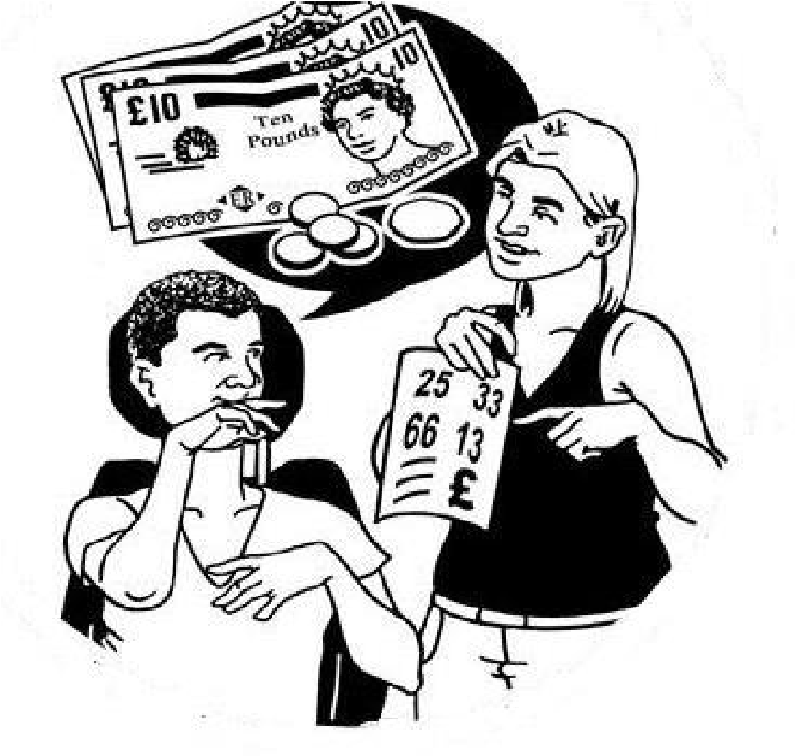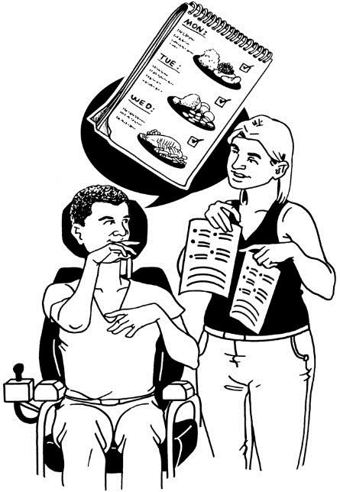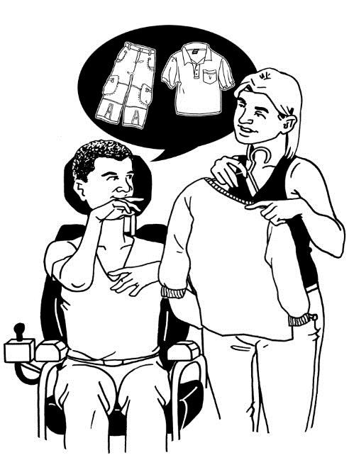

This question is about choice in your daily life.

Having choice means that you can decide what to do.

Think about the choices you have.

**How do you feel about choice in your daily life?**

Please tick (✓) 1 box

I have as much choice as I want. It is great.



I have enough choice. It is OK.

I have some choice. But I would like more.

I have no choice. It is bad.

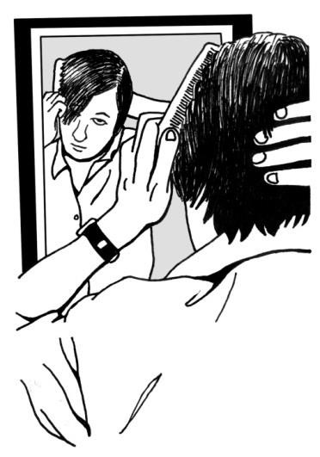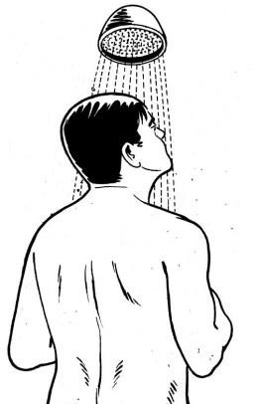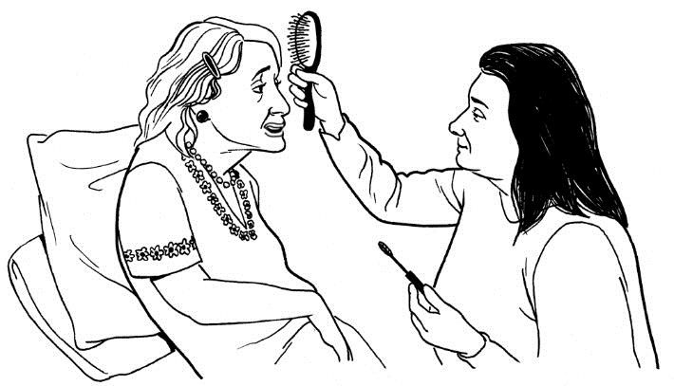

This question is about being presentable. Being presentable means being clean, having clean clothes and feeling comfortable in what you are wearing.

**How presentable do you feel?**

Please tick (✓) 1 box



I feel very presentable.

I feel quite presentable. It is OK.

I feel a bit presentable. It could be better.

I do not feel presentable at all. It is really bad.

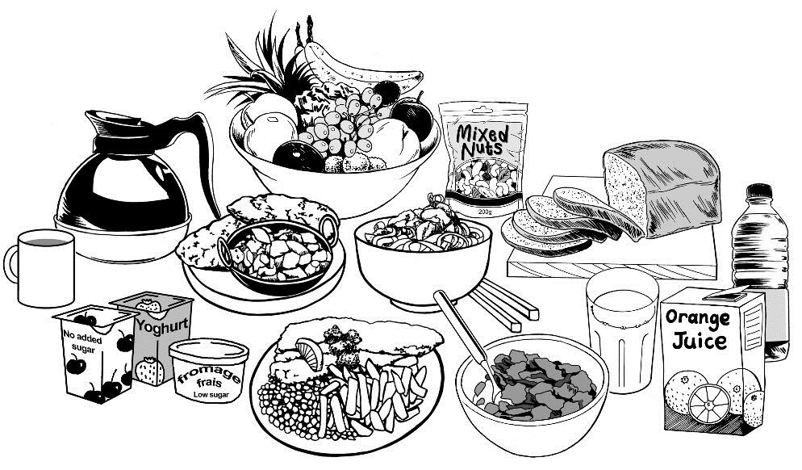

This question is about what you eat and drink. Think about if:

* You can have the food and drinks you like.
* You have enough food and drinks to keep you healthy.
* You can eat and drink as often as you need to.

**What do you think about what you eat and drink?** Please tick (✓) 1 box

I get all the food and drink I like when I want.



I get enough of the food and drink I like when I want.

I get some of the food and drink I like when I want, but not enough.

I do not get any of the food and drink I like so I might get ill.

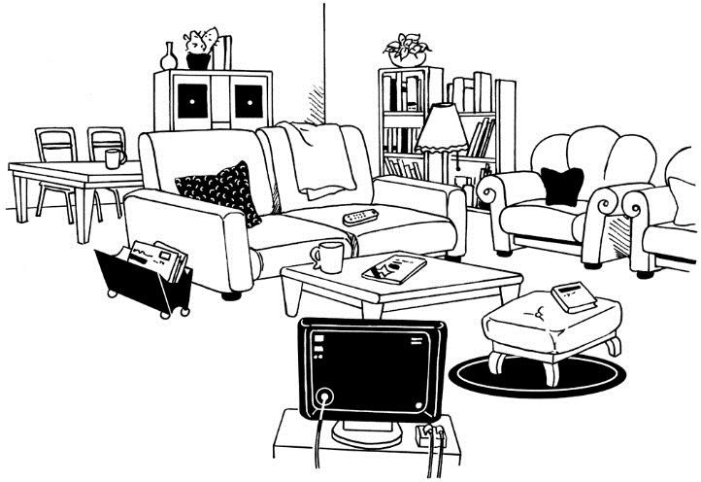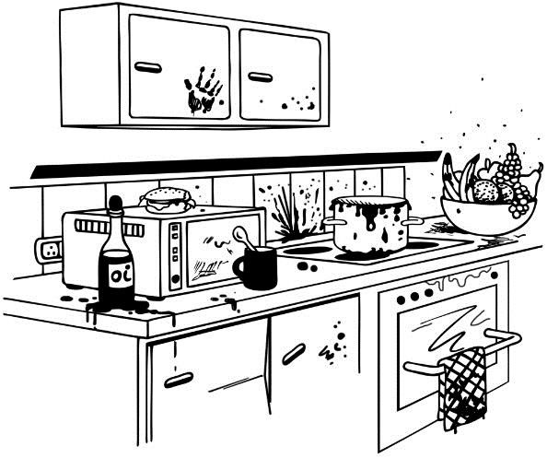

This question is about how clean and comfortable your home is.

Having a clean home means that the kitchen, bathroom, bedrooms and all other rooms are clean and tidy.

Having a comfortable home means that you like how your home looks and feels.

**How clean and comfortable is your home?**

Please tick (✓) 1 box

My home is as clean and comfortable as I want.



My home is quite clean and comfortable.

My home is not clean and comfortable enough.

My home is not clean and comfortable at all.

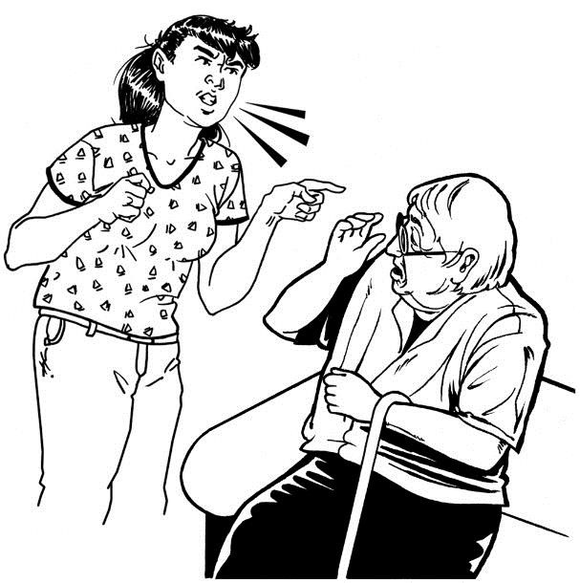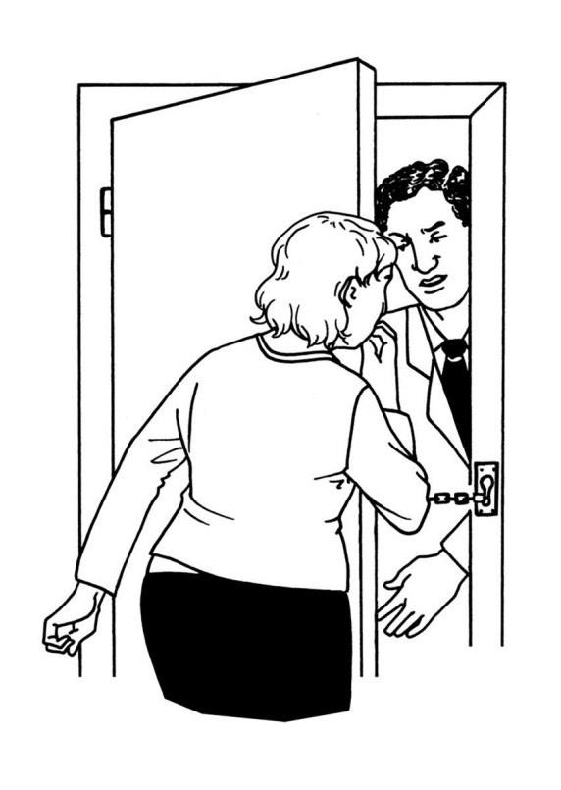

This question is about how safe you feel in your home.

Feeling safe means that you are not worried about:

* Being bullied or abused.
* Falling or getting hurt.
* Being attacked or robbed.

**How safe do you feel in your home?**

Please tick (✓) 1 box

I feel very safe in my home.



I feel quite safe in my home.

I do not feel safe enough in my home.

I do not feel safe at all in my home.

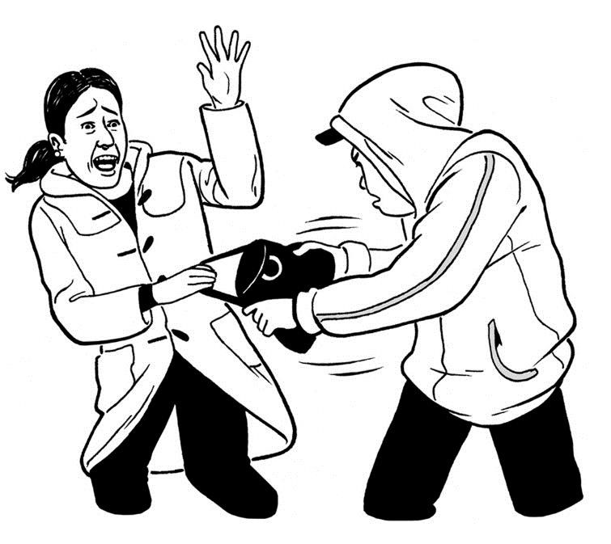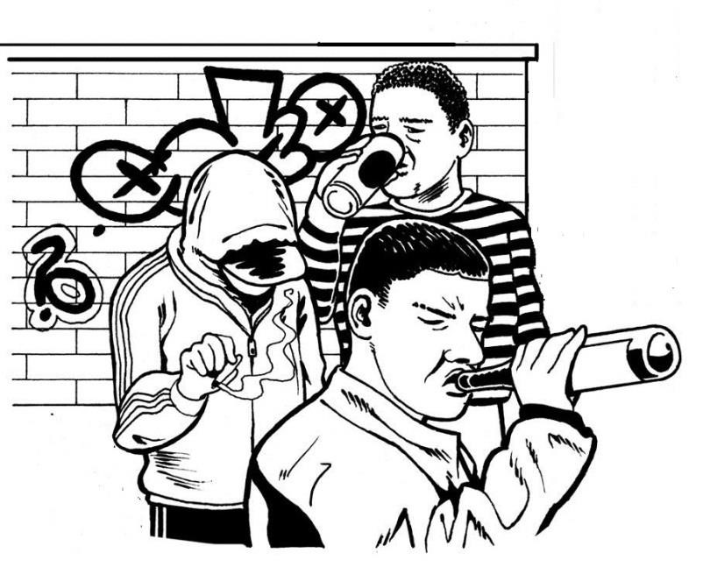

This question is about feeling safe when you go out in your local area.

Feeling safe means that you are not worried about:

* Being bullied or abused.
* Falling or getting hurt.
* Being attacked or robbed.

**How safe do you feel when you go out?**

Please tick (✓) 1 box

I feel very safe when I go out.



I feel quite safe when I go out.

I do not feel safe enough when I go out.

I do not feel safe at all when I go out.

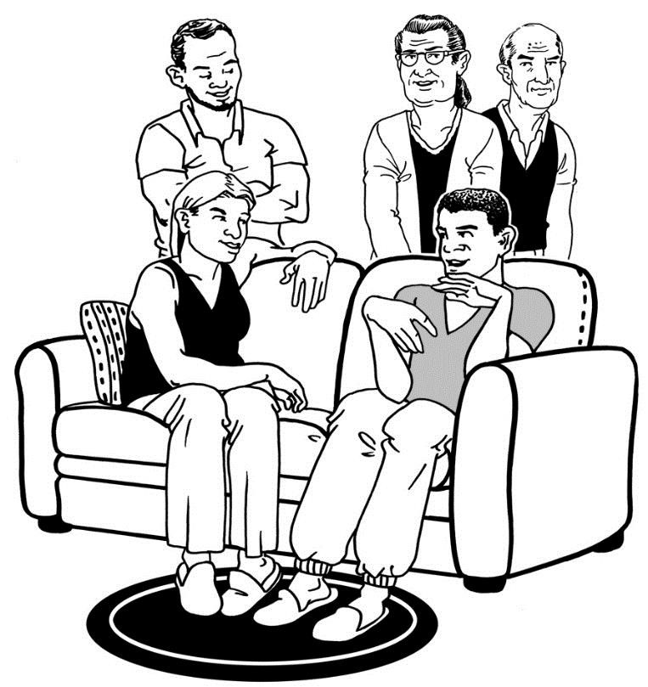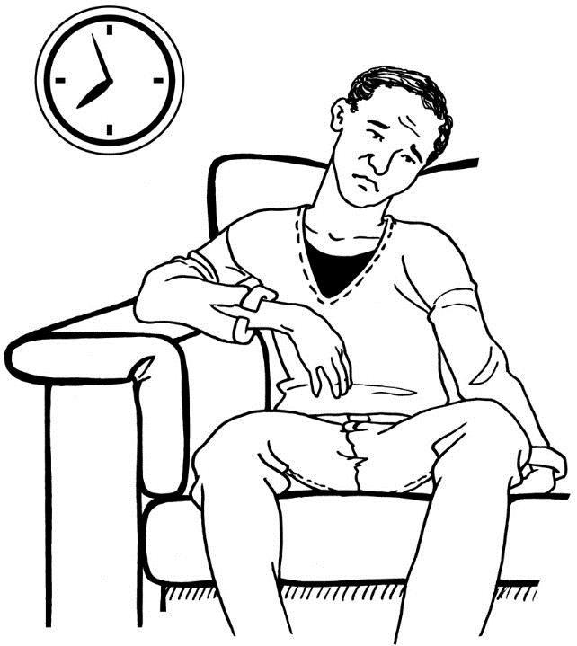

This question is about your social life.

Social life means spending time with people you like.

This could be friends, family or people in your community.

**How do you feel about your social life?**

Please tick (✓) 1 box



I see the people I like as much as I want. It is great.

I see the people I like sometimes. It is OK.

I see the people I like but not enough. It could be better.

I do not see the people I like at all. And I feel lonely.

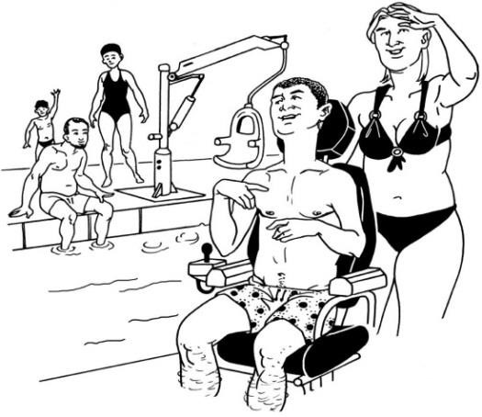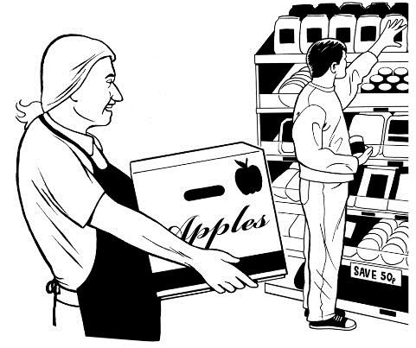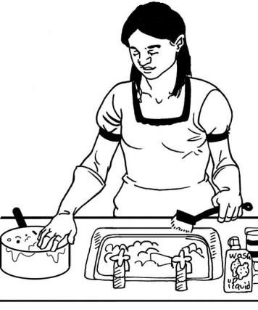

This question is about how you spend your time.

Think about all the things you do during the day. You could think about:

* Your free time.
* Going to work, college, or volunteering.
* Housework.

Think about if:

* You can choose the things you do.
* You enjoy the things you do.
* You have enough things to do.

**How do you feel about the way you spend your time?**

Please tick (✓) 1 box



I spend my time how I want. It is great.

I do enough of the things I like. It is OK.

I do some of the things I like. But I would like to do more.

I do not do the things I like. It is really bad.

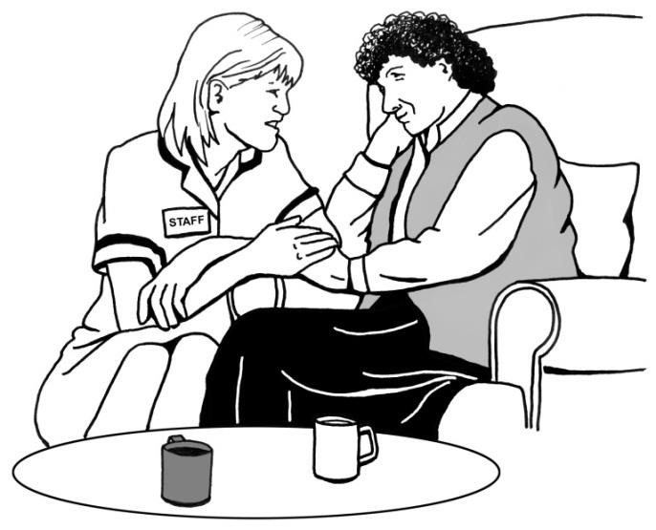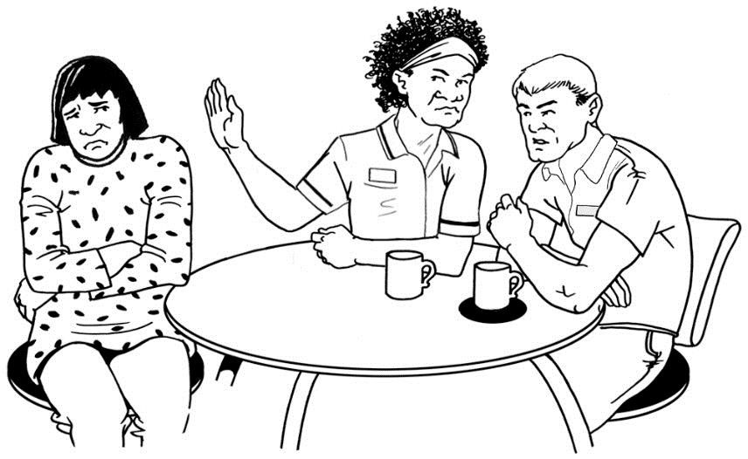

This question is about dignity.

Dignity means being treated nicely and kindly.

**How do you feel about the way your paid support treat you?**

Please tick (✓) 1 box



I am very happy with the way my paid support treat me.

I am quite happy with the way my paid support treat me.

I am a bit unhappy with the way my paid support treat me.

I am very unhappy with the way my paid support treat me.

© PSSRU at the University of Kent

**Supplementary questions following ASCOT quality of life.**

1. Do you have a key to the house? (yes/no/dk)
2. In the past month, has anyone come to have a cup of tea at your house? (yes/no/dk)
3. Can you tell me the three most important things that you want to do in the next 6 months? (probe - anything you are hoping to do/places to go etc., the plans you have in your personal plan?)

1.

2.

3.

1. Did you choose the staff who support you? (probe – did you ask for any particular staff member/carer to help you?)

(yes/no/dk)

1. Do you take regular exercise? (probe - do you go swimming, go for walks?) (yes/no/dk)
2. How do you spend your time most days? (probe - what kinds of things do you do most days?)

| **Activity** | **Most days (mark x)** | **Sometimes (mark x)** | **Never**  **(mark x)** |
| --- | --- | --- | --- |
| Paid work |  |  |  |
| Training/education/college |  |  |  |
| Volunteering/helping others |  |  |  |
| Day centre |  |  |  |
| House work/helping around the home |  |  |  |
| Going to sports club/sports centre/ swimming/training/special Olympics/walking |  |  |  |
| Cinema/concerts/daytrips/going to shops/going to cafe/pub |  |  |  |

1. I am going to ask some questions. For each question you have three choices. 1 – It’s Great 2 – OK 3 - Not Good (show page with smiley faces). Point to the one that describes best how you feel (If person is unsure or does not know, tick column DK column).

| **Overall how is …** | **1**  **(mark with x)** | **2 (mark with x)** | **3**  **mark**  **with x)** | **DK** |
| --- | --- | --- | --- | --- |
| Your relationship with support staff.  *(Probe: having people to help you to do the things that you want to do)* |  |  |  |  |
| The place where you live |  |  |  |  |
| The people you live with |  |  |  |  |
| The control you have in your life  *(Probe: making decisions for yourself rather than other people doing it for you.)* |  |  |  |  |

## Supplementary questions

This section looks at the literature that surrounds the supplementary questions that were used to determine wellbeing and outcomes and is followed by the questionnaire used. In general this was only administered to those who were able to complete the ASCOT tool.

### Do you have a key to the house?

This question is one of the suite of questions included in a survey of adults who receive supports from public developmental disability agencies in the United States. The survey data informs the National Core Indicators that are used to assess the outcomes of services provided to individuals and families both within and between states. The question was also used by McConkey and colleagues in their evaluation of personalised supports for people with intellectual disabilities and mental health difficulties. McConkey et al. found that having a key to the house was the best indicator of personalised accommodation (2013, p.36).

Seven in ten (69.8%) of the 189 participants who answered this question indicated that they have a key to their house. In 2018/19, 48% of respondents to the NCI survey indicated they had a key to their house[11]. In 2018/19, respondents to the NCI survey that did not have a key to their house were also asked if they wanted a key to their house. The results are somewhat surprising as seven in ten (71%) of those who did not have a key indicated that they did not want a key.

### In the past month, has anyone come to have a cup of tea at your house?

This question provides a measure of relationships with individuals other than paid staff and those who shared participants’ accommodation. It is an adaptation of a question found by McConkey et al. to be the best indicator of relationships with people not paid (2013, p.36).

### Did you choose the staff who support you?

A similar question also features in the survey administered to adult users of disability services in the United States[12]. Respondents of the US survey were asked if they chose staff or were aware they could request to change staff. In 2018/19, 68% of responses to this question were positive. It is noteworthy that proxy respondents were allowed for this question. This may have contributed to the high positive response rate.

McConkey et al. found that choosing own support staff was the best indicator of personalised supports (2013, p.36). Other indicators of personalised support were having had training in advocacy and having a personal plan.

### Do you take regular exercise?

Questions regarding physical activity are included in the ‘Wellness’ section of the survey of disability service users that informs the development of the National Core Indicators in the United States.[13] Respondents to the US survey were not only asked if they undertake exercise they were also asked how frequently they exercise and with what intensity. The results indicated that 74% of respondents exercised at least once a week for ten minutes or more, and 30% of respondents exercised for ten minutes or longer five or more times a week. However, 62% of respondents did not do any physical activity or exercise that makes their muscles work hard on a weekly basis

## NDA outcomes

Prior to commencing this study, the NDA had led on a piece of work to develop a framework for quality of life outcomes for specialist disability services. It was devised following extensive consultation with persons with disabilities and service providers. It was agreed with the Scientific Advisory Committee for the study that the 9 outcomes of the framework would offer a useful structure for analysis of the study findings, allowing alignment and cohesion between the study and implementation of policies across HSE-funded disability services, as well as to cover quality of life domains not sufficiently considered through the FACE or ASCOT tools. The ASCOT-SC4-ER was therefore supplemented by a number of questions designed to ensure the nine outcomes set out in the framework developed by the NDA are captured. The supplementary questions were piloted with a group of individuals with intellectual and physical/sensory disabilities. The objective measures included: engagement in meaningful occupation; control of access to living arrangements; choice of staff; family and social contact.

The NDA outcomes framework maps very closely on to other established outcome frameworks from international research and practice, on to the domains used in established quality frameworks for disability services, on to standards for residential and day services, and on to the UN Convention on the Rights of Persons with Disabilities (NDA 2016).

The outcome framework provides a holistic measure that can assist in monitoring and assessing outcomes for persons with disabilities. It should be noted that there are inherent tensions between certain outcomes within the framework. If positive risk-taking is achieved for example it may mean that safety has had to be compromised or at least not prioritised. Similarly an emphasis on a healthy life style may mean that constraints are placed on personal choice with regard to foods that are offered and health screening may be ubiquitous rather than optional.

The nine outcomes within the framework are nominal categories- but if an outcome framework was constructed on an individual basis, outcome domains could be assigned ordinal values which reflected the preferences, life circumstances and characteristics of each person. For some people certain outcome domains might be assigned no or very little value. Individual outcome frameworks might also be dynamic and vary temporally over the life-course and in response to intrinsic and extrinsic factors. So for example during periods of physical or mental ill health we would expect that achieving the best possible health would increase in importance. Similarly, people living in homes isolated from the community or living with too many people or people they do not like may be especially concerned that their housing situation improves.

Individual outcomes frameworks are also likely to vary depending on the nature and severity of their disability. The pervasive level of support required by persons with profound intellectual and multiple disabilities is likely to mean that their ability to exercise choice and control is very limited and their ability to attain outcomes in any domain will be dependent on the quality and quantum of support they receive (Nieuwenhuijse et al. 2020).

Quality of life and wellbeing is one of the nine outcomes in the outcomes framework. Quality of life is understood to include objective and subjective dimensions. Although it is a concept that has attracted a large body of research it remains nebulous having evaded consistent definition and measurement. Studies included within a recent evidence review of research regarding quality of life outcomes following deinstitutionalisation used a variety of objective measures to evaluate quality of life (McCarron et al. 2018). These measures include physical well-being, community access, routines, self-determination, residential well-being, and general life improvements. Other studies included in the review drew on observations and evaluations provided by proxies.

The outcome designated quality of life in the NDA outcome framework is best interpreted as subjective wellbeing. Not all persons with intellectual disability are able to communicate their assessment of their wellbeing. Instruments to measure subjective wellbeing will only be accessible to persons with mild and perhaps moderate intellectual disability. There is no easy reliable means of assessing the subjective wellbeing of persons with severe/profound intellectual disability (Nieuwenhuijse et al. 2019) and the use of proxy assessments is controversial. Observations by appropriately trained researchers may provide a means of interpreting wellbeing for this cohort. However, observational research of this nature is very resource intensive and did not form part of this study.

## Reflective Diary

The following were the headings and prompts used in the reflective diaries.

Centre code ____________

Interviewer code _____________

Dates and times _______________

**Initial impressions**

* Describe the area: Rural/urban? Safe?
* Is there access to public transport? Does the centre have its own transport (mini-bus)?
* What amenities/shops are within walking distance?
* Describe the outside of the building
* Are the staff welcoming?

**Environment**

* Is it safe? (Consider smoke alarms, fire extinguishers, space in kitchen)
* Is it clean?
* Is it homely?
* Are there any hazards?
* Are all areas accessible?

**Person Centred**

* Are timetables displayed/available?
* Are timetables individualised?
* Is progression promoted and monitored?

**Personal Appearance**

* Are the residents dressed in clothes of their choosing?
* Are the clothes in good condition?
* Have they had recent haircuts?
* Have they good teeth?
* Are their nails clean?

**Daily activities/living**

* Are service users supported to choose from and access a range of activities?
* Are service users offered opportunities to be involved in household activities/gain skills for ADL?

**New directions evidence**

* How is community inclusion supported?
* How are links with family supported?
* Is there evidence of support for the development of valued social roles?
* Is health and well-being promoted?
* How is mental health supported?

**Other**

* Did anything odd or unusual happen during the visit?
* Are there appropriate procedures around staff recruitment/training/ meetings/handovers.
* Is there a complaints register? Who reviews the register and follows up on the complaints?
* Who maintains service users’ personal files?
* How are service users personal files stored?

# Annex 4. Participant information sheets and consent forms

This section provides four documents as follows

* Participant information sheet
* Easy to Read participant information sheet
* Easy to read consent form
* Determination of lack of capacity form

## Participant Information Sheet

Study title: Moving In: Evaluating New Models of Service Provision

Key Project information

|  |  |
| --- | --- |
| Principal investigator | The principal investigator has overall responsibility for the study |
| Name | Dr Aideen Hartney |
| Job title | Head of Policy Research and Public Affairs, National Disability Authority |
| Contact details | amhartney@nda.ie  01 6080481 |
| Lead Investigator | The lead investigator manages the study on a daily basis |
| Name | Dr Caroline O’Nolan |
| Job title | Senior Research Officer |
| Contact details | cxonolan@nda.ie  01 6080430 |
| Data Controller | Responsible for determining the purposes, conditions and means of processing personal data |
| Name | National Disability Authority |
| Contact details | 25 Clyde Road, Ballsbridge Dublin 4.  nda@nda.ie  01 6080400 |
| Data Protection Officer | Provides advice and monitors compliance regarding data protection regulations |
| Name | Ms Elaine Monaghan |
| Contact details | emmonaghan@nda.ie  01 6080421 |

**Invitation to participate**

You are invited to take part in a research study conducted by the National Disability Authority. If you decide to take part the research will be carried out at a location that is convenient for you.

Before you decide whether or not you wish to take part, you should read the information provided below carefully and, if you wish, discuss it with your family, friends or support staff. Take time to make your decision and to consider the information provided. If you have any questions you can get in touch with us by phone or email.

You should clearly understand the risks and benefits of taking part in this study so that you can make a decision that is right for you. This process is known as ‘Informed Consent’.

You don't have to take part in this study. If you decide not to take part it won’t affect the support you receive in the future.

You can change your mind about taking part in the study any time you like. Even if the study has started, you can still opt out. You don't have to give us a reason. If you do opt out, the services you receive in the future will not be affected.

**What is this research project about?**

The National Disability Authority (NDA), as the independent statutory body provides information and advice to the Government on policy and practice relevant to the lives of persons with disabilities.

A programme of reform is underway in disability services. The reforms seek to put in place community based person-centred services and provide people with disabilities choice and control in their daily lives. The cost and benefits of the reforms are uncertain. The Health Service Executive (HSE) has asked the NDA to undertake this research project to evaluate new models of service delivery and compare the costs and benefits to those of traditional service models. The research will also identify practices that contribute to positive outcomes for people with disabilities.

**Who is organising and funding this study?**

The NDA is conducting the research on behalf of and at the request of the HSE.

The HSE funds the research.

**Why am I being asked to take part?**

You have been asked to take part because you are an adult receiving support from disability services.

The research is not limited to any particular disability or service type. We want to include adults with different types of disability who may be attending day services, living in residential care settings, or in receipt of other disability supports.

**How will the study be carried out?**

If you agree to take part in the study we will arrange to meet you on a date that suits you.

We will talk to you at a location of your choosing. Some of the places you might consider are a day centre, a residential care setting, your family home or the NDA offices. The location should not be too noisy and should provide you with privacy.

If you wish, you can ask a family member or a person who provides you with support to accompany you.

We are planning to recruit 600 participants for our study. Sometimes we may meet more than one participant at the same location.

We will ask you two sets of questions. The first set of questions will be about your everyday life, the place where you live and any support you need to undertake personal care and household tasks. You will also be asked about your physical and mental health, your mobility and your medication needs. This set of questions also asks about your family and personal life and the support, if any, you receive from your family.

The second set of questions asks you to consider how well your needs in various domains are met.

**What happens during the interviews?**

A trained researcher will conduct the interview. The researchers are all independent from your disability service.

Your answers will be recorded in a file stored on the researcher’s laptop computer. You will be assigned a code and your name will not be recorded in the data file.

We will only collect the information necessary to answer our research questions. The information you give will be stored securely.

The interviews will not be audio or video recorded.

You can choose to be interviewed on your own or, if you wish, you can choose to have a family member or support worker with you in the interview.

You can ask for a break at any point in the interview.

You can leave or ask for the interview to be stopped at any point.

It will usually take 60-90 minutes to complete the two sets of questions. Sometimes it may take a little longer.

Participants have the right, should they wish, to review and edit any transcripts to which they have contributed.

**What are the benefits of taking part in this study?**

You may not benefit directly by taking part in this study.

The research may benefit participants by promoting learning regarding the benefits of new service models. This may result in improvements in the services and supports provided to people with disabilities.

**What are the risks of taking part in this study?**

The risk of taking part in this study is assessed as being low to moderate.

Although data security is prioritised a data breach is possible. As personal data is pseudonymised, a data breach may not impact the privacy of participants. However, participants might find a data breach upsetting.

Participants may find it upsetting to talk about their personal history and in particular any experiences of abuse, bullying or neglect. Researchers will respond quickly to any signs of unease or upset. If necessary researchers will liaise with staff members to ensure that participants are appropriately supported.

**Is the study confidential?**

All information provided by you will be treated as confidential and will be stored securely. Only the NDA research team has access to the project files.

You will be assigned a code and your information will be filed using this code. Your name will not be included in the project data.

By replacing names of participants and locations with codes the data is pseudonymised. This means that it might still be possible to identify participants using the information in the files. When the final report is published the data will be annonymised. This will mean that it will not be possible to identify participants. Annonymised data will be stored for ten years.

If participants disclose information that raises concerns about their safety it may be necessary to share this information with other relevant persons. Information will only be shared after discussion with the participant.

**Results**

The results of the study will be published in a report. The report will be available on the website of the NDA.

The results may be presented at seminars and conferences.

The results may be published in journals.

There will be no information in the report that will identify you or any participant.

**Future Research Studies**

Annonymised data may be used for further research.

**Data Protection**

1. We will be using your personal information in our research to help us study models of disability services.
2. The National Disability Authority has a statutory remit to 'undertake, commission or collaborate in research projects and activities on issues relating to disability and to assist in the development of statistical information appropriate for the planning, delivery and monitoring of programmes and services for persons disabilities' (see NDA Act 1999 Part 2 Section 8). This study is in accordance with the legitimate interests of the NDA and Article 6 of the General Data Protection Regulation 2016 provides the legal basis for processing personal data. Legal authority to process personal data is also claimed under Article 9 of the General Data Protection Regulation 2016.
3. Access to research participants’ information will be restricted to the research team.
4. Personal data will be pseudonymised at the point of collection. Following the publication of the final report all personal data will be destroyed. Annonymised data will be retained for a period of ten years.
5. Although robust data security measures are in place data breaches/ theft are possible- however the likelihood of this is considered low. The consequence of a data breach could be a loss of privacy to the individual and a loss of reputational damage to the NDA and the Department of Justice and Equality.
6. You can withdraw your consent at any time. Please contact the Data Protection Officer of the NDA (for details see page 2) if you wish to withdraw your consent. Once data has been annonymised it will not be possible to identify personal data of any individual participant.
7. You have a right to lodge a complaint with the Data Protection Commissioner. The offices of the Data Protection Commissioner are at 21 Fitzwilliam Square South, Dublin 2.
8. You have the right to access your personal data. If you request access to your data you will be asked to verify your identity. You will be given access within one month of your request. No fee applies.
9. You have a right to restrict or object to the processing of your personal data. We will accommodate any request that does not make it impossible or very difficult to conduct the research.
10. You have a right to have any inaccurate information about you corrected or deleted, unless the correction would make it impossible or make it very difficult to conduct the research.
11. You have a right to have your personal data deleted, unless the deletion would make it impossible or very difficult to conduct the research.
12. You have a right to data portability. You have the right to a copy of your personal data in a readable format and a right to move your data to another data controller.
13. This project does not engage in automated processing or profiling.
14. You have a right to object to automated processing including profiling. This project does not engage in automated processing or profiling.
15. Your personal data will not be used for any other purpose.
16. Your data will not be transferred to a country outside of the EU or an international organisation.

**Where can I get further information?**

If you have any further questions about the study or if you want to opt out of the study, you can rest assured it won't affect the quality of support you get in the future.

If you need any further information now or at any time in the future, please contact Caroline O’Nolan (Lead Investigator) by email (cxonolan@nda.ie) or telephone (01 6080430).

## Easy to Read Participant Information Sheet



**Moving In: Evaluating New Models of Service Provision**

**Information Sheet**

|  | Information Sheet |
| --- | --- |
| A box with a question mark on it. | **What is this research project about?** |
| NDA logo | The National Disability Authority gives advice to the government and the Irish people on disability issues. |
| Four people. Two people are wheelchair users. One man is holding a White Cane. | The government has asked the National Disability Authority to look at new ways of providing disability services. |
| Money bags with Euro signs on the front | The National Disability Authority wants to find out how much these services cost |
| A a man holding a survey | They want to find out the good things about them. They want to know if they make the lives of people with disabilities better. |
| A magnifying glass. In the glass there is a group of people | We are looking for people to take part in this research.  You can help us find out how disability services can be improved.  You can help us find out what supports and money are needed. |
| Information Icon | **Important Information** |
| A woman  thinking | You can make a choice about taking part. The choice you make will not change the service you get now or in the future.  The answers you give will not change the service you get now or in the future.  By taking part in this research you may help to make services better in the future. |
| A man thinking | You should take time to look at the information.  You can take time to make up your mind about taking part.  You can change your mind about taking part at any time.  You do not have to give a reason. |
| A woman holding a sign with a red X on it. She is giving a thumbs down. | It is okay to say no and to decide not to take part in this research project. |
| A woman walking away. | You can leave the interview or ask for a break anytime you want. |
|  | **Looking after the information you give us** |
| A filing cabinate with a key in the drawer. | Information collected during research is called data.  All data must be kept safely and in line with the law. |
| The NDA logo | The National Disability Authority is the Data Controller for this research project.  This means they are responsible for collecting, studying and storing the data. |
| A laptop showing the Google homepage | Ms. Elaine Monaghan is the Data Protection Officer for the National Disability Authority. The Data Protection Officer gives advice to the Data Controller. |
| The NDA office in Dublin. It is a three story, red brick building. | The National Disability Authority has a website www.nda.ie  The National Disability Authority offices are at 25 Clyde Road, Dublin D04 E409, Ireland. |
| A laptop and a phone | They can be contacted by email nda@nda.ie or by telephone 016080400. |
|  | **Collecting data** |
| A magnifying glass. There are three people in the glass. They are discussing a plan and thinking. | Data will be collected and studied by a team of researchers. |
| A woman pointing at a whiteboard. | The researchers have all had training. The researchers are people who work in the National Disability Authority or in the disability sector. |
| A hand signing a consent form. | Consent forms will be stored in a locked cabinet in the National Disability Authority offices.  Only the researchers will be able to see the consent forms. |
| A laptop computer | Data will be stored safely on the National Disability Authority computer system.  Only National Disability Authority researchers will be able to see this data. |
| A sign wih the number 217 on it. | The people and organisations taking part in the study will be given a code or number.  This is so we can avoid using their names. |
| Two men woking together to fill out a form and a file | The codes will be used by the research team to manage the data. |
| A paper shredder | The people taking part can ask to see their data.  They can ask for their data to be removed or they can stop the research team from studying it |
| A  name that has been blocked out by a red X | No personal data will be shared. When the final report on this study is published, all personal data will be destroyed.  This means all names will be taken off the data.  This data, with the names taken off, will be stored for ten years. After ten years, it will be destroyed. |
| A phone | **Get in touch**  Contact: Dr. Caroline O’Nolan  Project Manager  Phone: 01 6080430  Email: [cxonolan@nda.ie](mailto:cxonolan@nda.ie) |
| A picture of Dr. Aideen Hartney, the Director of the NDA. A phone | Dr. Aideen Hartney Principal Investigator  Phone: 01 6080481  Email: amhartney@nda.ie |
| NDA logoACE communications logoPhoto Symbols logo | This information leaflet was made by the National Disability Authority and Ace Communication.  Experts by experience helped us to put this information together. |

## Easy to Read Consent Form

**Moving In: Evaluating New Models of Service Provision Consent Checklist**

**Moving In: Finding out about living in the community**

**Important**

|  |  |
| --- | --- |
| A picutre of the information leaflet Dr Aideen Hartney, Director of the NDA | Please read the information leaflet on the research project.  The Principal Investigator for this research project is Dr. Aideen Hartney. Contact on 01 6080481 or amhartney@nda.ie |
| A man filliing in a form on a clipboard | Answer the questions on pages 2, 3, 4 and 5 of this form. |
| A hand holding a pen | If you would like to take part in this study, sign your name and the date at the end of page 5. |
|  | Please give your form to: |

|  |  |  |  |  |  |
| --- | --- | --- | --- | --- | --- |
| A man with two thought bubbles. In one there is a thumbs up, in the other there is a thumbs down. | **Consent checklist – Moving In** | | A woman holding a clipboard with a tick for 'yes' on it. Yes | | A woman holding a clip board with an x for 'no' on it.No |
| The NDA logo | I know I am being asked to take part in research.  I know the National Disability Authority is doing this research. | |  | |  |
| Information icon | I have been given information about the research project. | |  | |  |
| A woman | I understand this information. | | A woman holding a clipboard with a tick for 'yes' on it. Yes | | A woman holding a clip board with an x for 'no' on it. No |
| A man standing in a doorway. | I understand that I will take part in two interviews. I know I will be asked to talk about where I live. | |  | |  |
| A woman thinking | I know I can make a choice about taking part.  I understand that my choice will not change the service I get. | |  | |  |
| A woman holding a clip board with an x for 'no' on it. | I know that it is okay to say ‘no’. | |  | |  |
| A man thinking | I have had time to make up my mind.  I know I can change my mind about taking part at any time. | | A woman holding a clipboard with a tick for 'yes' on it. Yes | | A woman holding a clip board with an x for 'no' on it.No |
| A woman walking | I know I can leave the interview at any time. | |  | |  |
| A question mark | I understand that I will be asked questions.  I know I can choose not to answer a question. | |  | |  |
|  | I know the researcher will type what I say into a computer.  I understand how the information I give will be collected, studied and stored. | |  | |  |
| A man holding holding one finger in front of his mouth to say 'shh' | I know that some of the things I say in the interview may be used in a report.  I know the report won’t say who said it. | | A woman holding a clipboard with a tick for 'yes' on it. Yes | | A woman holding a clip board with an x for 'no' on it.No |
| A report | I know my name will not be used in any report. | |  | |  |
| A man comfoting another man | I know if something upsets me I can ask for help from someone in my service. | |  | |  |
| A man and woman talking | I know that if something I say makes the researcher worried that I or others are not safe, they may have to tell someone who can help. |  | |  | | |
| **A woman with her hand up to ask a question** | Do you have any questions for the researcher? | A woman holding a clipboard with a tick for 'yes' on it. Yes | | A woman holding a clip board with an x for 'no' on it.No | | |
| **A woman pointing at a graph** | I want to take part in the research project. |  | |  | | |
| **A hand holding a pen** | **Name:** | A calendar | | **Date:** | | |
| **Two women sitting at a computer** | **Name of Witness:** | A calendar | | **Date:** | | |

## Determination of lack of capacity form

This form was used to record the determination of lack of capacity of research participant to provide informed consent

| **Information required** | **Answer** |
| --- | --- |
| Participant code |  |
| Researcher code |  |
| Site Code |  |
| Date of determination |  |
| Nature of cognitive impairment (ID/Acquired brain injury/dementia) |  |
| Details of communication difficulties |  |
| Current support needs of participant: ( PA /day care/residential care) |  |
| Interaction with participant (observation/conversation) |  |
| Name of staff/family member consulted |  |
| Staff member’s position |  |
| Relationship of family member |  |
| Staff/family member’s view regarding the capacity of the participant |  |
| Other relevant information |  |
| Proxy consent required: Yes/No |  |

# Annex 5. Phase 1 Pre transition FACE findings

## Findings from FACE

### Global Need Band

FACE analyses the support needs of those profiled into seven bands that range from 0 to 6 with 6 being the highest band. Global Need Band and support needs are positively related. All but two of the participants from the priority sites were classified as Global Need Band 6. The remaining two participants were classified as Global Need Band 4.

### Gender

There were more male than female participants in priority sites. Participants included 84 (57.5%) men and 62 (42.5%) women. The male: female ratio was 1.35:1. The gender mix of participants varied considerably between the priority sites. In the past, some religious orders provided gender specific disability services. This history of gender segregation in service provision was evident in our participants. As Figure 5.1 below highlights in four sites all our participants were either male or female and in a further three sites the gender mix was very skewed.

Figure 5.1: Gender mix in priority sites A-K

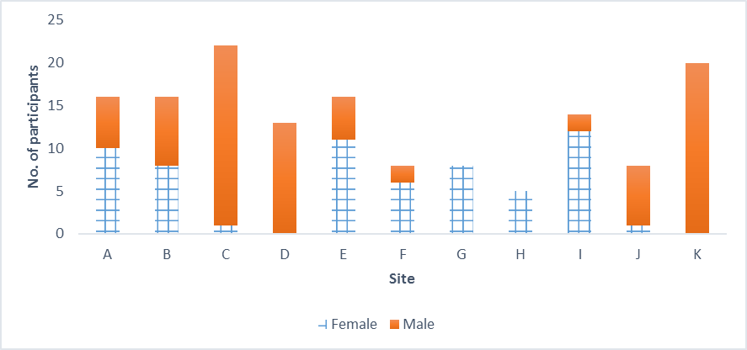Source: NDA Face profiles

### Age

The average age of the participants recruited from priority congregated settings was 51 years and six months. Table 5.1 presents age by province.

Table 5.1: Age band by province

| Province | Number of Participants | Age Band % | Age Band % | Age Band % | Age Band % | Age Band % | Age Band % |
| --- | --- | --- | --- | --- | --- | --- | --- |
|  |  | 18-34 | 35-44 | 45-54 | 55-64 | 65-74 | 75-84 |
| Connacht | 32 | 25.0 | 15.6 | 25.0 | 21.9 | 9.4 | 3.1 |
| Leinster | 52 | 3.8 | 19.2 | 38.5 | 30.8 | 7.7 | 0.0 |
| Munster | 62 | 12.9 | 9.7 | 35.5 | 21.0 | 16.1 | 4.8 |
| Total | 146 | 12.3 | 14.4 | 34.2 | 24.7 | 11.7 | 2.7 |

Source: NDA Face profiles

Six in ten (58.9%) participants were aged between 45 and 64 and 85% were aged between 35 and 74. It is notable that there were considerable inter-provincial variations in the age profile of participants. However, in each province the 45-54 age band was the median age band.

When we look at participants’ age band by gender a mixed picture emerges. Broadly similar proportions of male and female participants were aged under 45 (Males 28%; Females 25.8%). However, while almost half (48.4%) of female participants were aged 45-54 less than a quarter (23.8%) of male participants fell into this age band. In contrast half (48.9%) of male participants were aged 55 or over but just over a quarter (25.8%) of female participants were in the three older age bands. In the two oldest age bands (65-74 and 75-84) male participants predominated. One in five (21.5%) male participants were aged 65 or over. This compares to less than one in 20 (4.8%) female participants. There were no female participants aged 75-84. Figure 5.2 below illustrates the gender composition of the different age bands.

Figure 5.2: Age band by gender

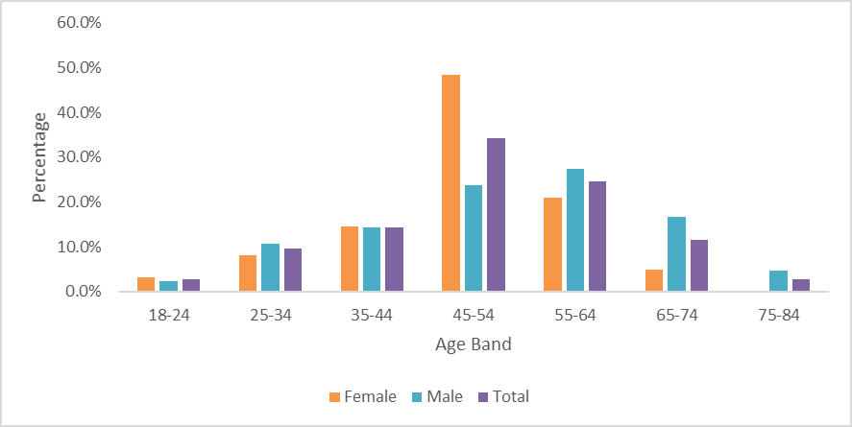Source: NDA FACE profiles

### Primary disability type

All participants recruited within priority sites had a primary disability of intellectual disability. This is consistent with the analysis of the population living in congregated settings at 31st December 2017 which revealed a population comprised almost wholly (94.3%) of persons with an intellectual disability (HSE 2018).

FACE profiles do not include information regarding the level of intellectual disability and indeed staff were often unaware of the diagnosis of participants’ level of intellectual disability. However, we can infer from the adaptive and intellectual function of participants along with other attributes (such as communication difficulties and the prevalence of epilepsy) that the majority of participants had severe/profound intellectual disability.

### Multiple disabilities

In addition to their primary disability many participants had other disabilities. Information regarding multiple disabilities was extracted from details of health conditions and disabilities recorded in FACE. Almost four in ten (38.4%) participants had a physical disability and over half (52.7%) had mental ill health.[14] Autism (17.1%), ABI (2%) and sensory disabilities (4.8%) were less commonly recorded. Table 5.2 illustrates the extent to which participants had multiple disabilities. Four in five (79.5%) participants had 2 or more disabilities and almost one in three (32.2%) had three or more disabilities.

Table 5.2: Presence of multiple disabilities

| **Number of disabilities** | **Number of participants** | **% of participants** | **Cumulative % of participants** |
| --- | --- | --- | --- |
| 4 | 5 | 3.4 | 3.4 |
| 3 | 42 | 28.8 | 32.2 |
| 2 | 69 | 47.3 | 79.5 |
| 1 | 30 | 20.5 | 100.0 |
| Total | 146 | 100.0 |  |

Source: NDA FACE profiles

### Employment and education

Only 17.3% of people with an intellectual disability aged 20-64 were in employment at the date of Census 2016.[15] Given the low employment rate of the population of working age adults with intellectual disabilities, the long periods of time spent in institutional care and the extent of the impairment of many participants, it is perhaps not surprising that none of the 146 participants in the priority sites were in employment. Twenty-one of the participants were aged 65 or over and therefore of retirement age.

Almost all (95%) of participants were not in education. Although most were attending a day centre on campus, just seven were in part-time education. The profiles note that two of the seven participants in part-time education would like to get a job.

### Communication Difficulties

Communication difficulties can be described as difficulties expressing needs and or understanding others. People with severe/profound intellectual disability may only have pre-symbolic communication, which means that they rely on others to interpret their vocalisations and body language. Participants described their communication difficulties as either: (1) none; (2) mild; (3) consistent; (4) severe; or (5) unable to express basic needs/understand others. Table 5.3 below sets out the communication difficulties indicated by the participants in priority congregated sites.

Table 5.3: Communication difficulties

| Gender | Level of Communication Difficulty % | Level of Communication Difficulty % | Level of Communication Difficulty % | Level of Communication Difficulty % | Level of Communication Difficulty % | Level of Communication Difficulty % |
| --- | --- | --- | --- | --- | --- | --- |
|  | None | Mild | Consistent | Severe | Unable | Total |
| Female | 9.7 | 12.9 | 25.8 | 43.5 | 8.1 | 100 (n=62) |
| Male | 3.6 | 16.7 | 25.0 | 28.5 | 26.2 | 100 (n=4) |
| Both Sexes | 6.2 | 15.1 | 25.3 | 34.9 | 18.5 | 100 (n=146) |

Source: NDA FACE profiles

As more than nine out of ten (93.8%) of participants had communication difficulties, most participants required assistance or were unable to provide the information required to complete the participant profiles on FACE. When required, staff members provided support to participants during the interview process or were proxy informants for participants who were either unable to understand the questions asked, or express a response, or both.

It should be borne in mind that as informants had no substantive metric to guide their assessment of communication difficulties the assessment of communication difficulties was somewhat subjective. Consequently, care must be exercised in interpreting the results and grouping responses may be more instructive than considering individual response categories. So while the results indicate that female participants were 2.7 times more likely than male participants to have no communication difficulties, when we look at responses for none/mild communication difficulties we see that there were only minor differences by gender (Male - 20.3%; Female - 22.6%). The pattern of consistent communication difficulties was very similar for both sexes. However, the pattern of severe/profound difficulties differs markedly by gender. The proportion of female participants with severe communication difficulties was 1.5 times that of male participants. Conversely, male participants were 3.5 times more likely than female participants to have profound communication difficulties. These disparities reduce if we combine the two categories with the greatest communication difficulties (severe/unable to express basic needs). The combined severe/profound category includes 51.6% of female participants and 54.7% of male participants.

### Safeguarding concerns

One of the eight themes set out in the National Standards for Residential Services for Children and Adults with disabilities is safe services (HIQA 2013). Outcomes in residential centres are assessed as compliant, substantially compliant or non-complaint based on HIQA inspection. HIQA inspection reports in respect of several of the priority sites point to non-compliance (both major and moderate) in the area of safeguarding and safety.

FACE seeks to assess safeguarding concerns by asking those profiled “do you have any concerns about how others treat you?” This only provides for a partial review of safe services. Safeguarding concerns were noted in respect of 15 (10.3%) participants. Behaviours of concern were reported in respect of 12 of these 15 participants.

For twelve participants the concerns noted related to the noise and behaviour of other residents. It is notable that six of these participants were resident in the same site. Two participants were concerned that staff were not appropriately respectful/attentive in their interactions with them. The final issue of concern related to the approach adopted by staff in supporting a participant. The approach was considered to be unduly fearful and risk averse.

In light of the level of non-compliance with regard to safeguarding and safety revealed by HIQA inspection reports relating to several of the priority sites, the level of safeguarding concerns reported by staff informants appears low.

### Mental health

The profiles collected information about the mental health of participants by compiling details regarding their history of diagnosed mental ill health; their moods and their behaviours. In assessing the presence of multiple disabilities among our participants mental ill health was treated as a disability.

We asked participants if they currently or previously had a **serious** mental health issue. The term ‘serious mental health condition’ was not defined. Figure 5.3 below illustrates that sixty-three (43.2%) participants indicated that they had a history of serious mental ill health. The incidence of serious mental ill health differed for male and female participants. Over half of the male participants (51.2%) reported a history of serious mental ill health. This compares to less than a third (32.3%) of female participants.

Figure 5.3: Participants with a history of serious mental ill health

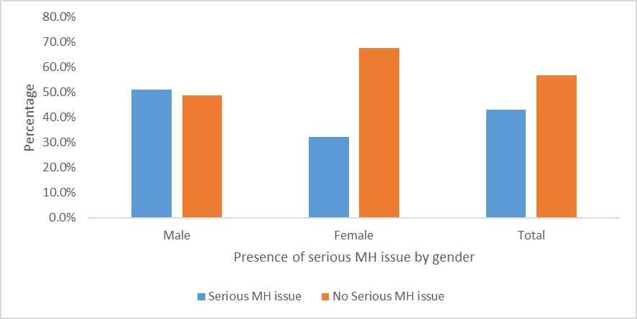

Source: NDA FACE profiles

Almost three quarters (74%) of participants indicated that they had contact with mental health services in the previous year. There was no significant difference between sexes in the reported contact with mental health services (Males: 72.6%; Females: 75.8%). It is interesting to note that although male participants reported serious mental ill health more frequently than female participants, they were somewhat less likely to have attended mental health services in the previous twelve months.

We were conscious that as regular psychiatric reviews were routinely provided in some sites, contact with mental health services was not necessarily a good barometer of the mental health of individual participants. Consequently, in determining the number of participants with mental ill health we included those who indicated a serious mental health issue (63) and all others that indicated that a mental health issue impacted their well-being (14). This process revealed that 77 (52.7%) participants had mental health difficulties.

### Behaviours of concern

Behaviours of concern or behaviours that challenge include self-injurious behaviours, aggression and destruction of property. The profiles include an assessment of behaviours of concern and categorise participants’ behaviours into five categories. The results are set out in Table 5.4 below.

Table 5.4: Behaviours of concern

| **Behaviours of Concern** | **Number of participants** | **% of participants** |
| --- | --- | --- |
| None | 47 | 32.2 |
| Occasional behaviour out of the ordinary | 36 | 24.7 |
| Behaviour of concern-no history of harm | 17 | 11.6 |
| Behaviour of concern-history of harm to self/others | 43 | 29.4 |
| Constant severe concern of harm to self/others | 3 | 2.1 |
| Total | 146 | 100.0 |

Source: NDA FACE profiles

Almost one third of participants in priority sites did not have any behaviours which affected themselves or others. However, more than three in ten (31.5%) had behaviours of concern with a history of harm. The behaviour of three participants (2.1%) was considered to present a constant severe risk of harm.

The proportion of male participants who reported behaviours of concern with a history of harm to self or others was 1.7 times that of female participants (21.0% v 35.7%). However, two of the three participants who reported the most serious level of behaviours of concern were female. The proportion of males with the two most serious categories of behaviours is higher than females (36.9% v 24.2%).

A total of 99 (67.8%) participants reported behaviours of concern. The supports in place to manage the risks associated with behaviours of concern were considered fully effective for 38 (26%) participants and partially effective for 61(41.2%) participants.

### Physical health

Participants were asked to provide a list of health conditions and disabilities that impact their wellbeing. However, some of the prelisted conditions do not lend themselves to meaningful analysis (e.g. other physical impairment/illness/injury; other mental health condition; other neurological condition). Health conditions named include Epilepsy (46%; n=67) COPD (5.2%; n=8), cancer (1.2%; n=2) stroke (2.1%; n=3) and arthritis (1.2%; n=2). Five participants indicated they had dementia. The FACE profile only provides space for four health conditions/disabilities. The conditions listed do not give a complete or accurate picture of the health of participants.

In completing the FACE profiles, participants were asked: ‘does your physical condition or any medication you are taking cause you distress or pain?’ Just over one in five (21.2%) participants reported any pain. Of these, less than one in five (19.4%) indicated that the pain was moderate or severe. However, for the majority of participants the assessment of pain was provided by a member of staff. Therefore, it is possible that these reports do not provide an accurate indication of the extent to which participants experience pain.

More than four out of ten participants (45.9%) in priority sites indicated a history of epilepsy. The high rate of epilepsy is consistent with the presence of a high proportion of persons with severe or profound intellectual disability among our participants.

One third (33.6%) of participants required support to manage skin conditions or to prevent skin conditions developing. Participants were asked to indicate if they had any pressure ulcers and the severity of any pressure ulcers. Two participants reported skin ulcers. In both instances the ulcers were Grade 1 (minor).

### Activities of Daily Living

Activities of Daily Living (ADLs) are activities in which people engage daily. They are everyday personal care activities that are fundamental to caring for oneself and maintaining independence. ADLs include dressing, bathing, toileting, eating, transferring from bed to chair, walking, and climbing stairs.

The mean ADL score was 14.1 and the median score was 13 with a range of 0-31[16]. Ten participants who scored 0 or 1 required almost no assistance with ADLs. Almost four in ten (39.7%) participants had a ADLs score of less than 10 indicating that they required relatively low levels of support. A further third (32.2%) of all participants had a ADLs score in the 10-19 range. These participants needed a moderate level of support to undertake ADLs. Almost three in ten (28.1%) participants had ADLs scores of 20 or greater and required high or intensive support. One in five (19.8%) had a ADLs score of 24 or higher indicating a requirement for pervasive support.

We also compared ADLs scores by site (see Table 5.5 below). This analysis revealed considerable variation between sites in the assistance required by participants to undertake ADLs. Site F is an outlier in that all participants from this site required high to intensive support. In contrast, 93.8% of participants in site B only required a low level of assistance to undertake these tasks. The mean ADLs scores for site B and site F differ significantly from the mean ADLs scores for all sites. Four sites had no participants requiring high or intensive support to undertake ADLs.

Just one in seven (14.9%) participants in HSE sites required high to intensive support to undertake ADLs. This compares to four out of ten (39.2%) participants in other sites.

Table 5.5: ADLs scores by site

| Site | ADLs<10 | ADLs 10-19 | ADLs 20+ |
| --- | --- | --- | --- |
|  | % | % | % |
| A | 56.3 | 31.2 | 12.5 |
| B | 93.8 | 0.0 | 6.2 |
| C | 31.8 | 36.4 | 31.8 |
| D | 76.9 | 23.1 | 0.0 |
| E | 0.0 | 31.2 | 68.8 |
| F | 0.0 | 0.0 | 100.0 |
| G | 50.0 | 50.0 | 0.0 |
| H | 60.0 | 40.0 | 0.0 |
| I | 7.1 | 57.2 | 35.7 |
| J | 50.0 | 50.0 | 0.0 |
| K | 25.0 | 40.0 | 35.0 |
| Total | 39.7 | 32.2 | 28.1 |

Source: NDA FACE profiles

#### Eating and drinking

The Eating and drinking assistance required is set out in Table 5.6 below.

Table 5.6: Support for eating and drinking

| **Level of assistance required** | **Total %** | **Male %** | **Female %** |
| --- | --- | --- | --- |
| Little/none | 44.5 | 45.2 | 43.5 |
| Sometimes needs help | 8.2 | 8.3 | 8.1 |
| Always needs help | 19.9 | 17.9 | 22.6 |
| Unable to undertake | 27.4 | 28.6 | 25.8 |
| Total | 100.0 | 100.0 | 100.0 |

Source: NDA FACE profiles

Just less than half (44.5%) of participants were able to eat independently. However, many of these required the texture of their food to be modified to minimise the risk of aspiration. Others used spoons and bowls that were adapted to suit their capabilities.

More than a quarter (27.4%) of participants were unable to assist in feeding themselves. Independence in eating was slightly more common in male participants compared to females but a higher proportion of male participants were also unable to undertake this task. Overall the pattern of assistance required for this activity was very similar for both men and women.

#### Dressing/undressing

Table 5.7 below sets out the level of assistance required by participants to dress and undress.

Just over a quarter (25.3%) of participants did not require any assistance dressing. A higher proportion of participants, three out of ten (31.5%), were able to undress independently.

Almost half of participants (46.6%) were not able to assist in dressing themselves and required one or two others to undertake this task. A slightly lower proportion (44.5%) also needed others to undress them.

Table 5.7: Assistance required dressing and undressing

| **Level of assistance required** | **Dressing %** | **Undressing %** |
| --- | --- | --- |
| Little /none | 25.3 | 31.5 |
| Sometimes needs help | 11.6 | 9.6 |
| Always needs help | 16.4 | 14.4 |
| Unable to manage- needs one other | 27.4 | 25.3 |
| Unable to manage- needs two others | 19.2 | 19.2 |
| Total | 100.0 | 100.0 |

Source: NDA FACE profiles

#### Assistance toileting

Almost three quarters of participants (72.6%) required assistance toileting (see Table 5.8 below). Female participants were 1.2 times more likely to require assistance with toileting than males. They were also 1.3 times more likely than males to have the highest level of difficulty toileting requiring the assistance of two persons.

Table 5.8: Assistance toileting

| **Level of assistance required** | **Total %** | **Female %** | **Male %** |
| --- | --- | --- | --- |
| Little or no difficulty | 27.4 | 19.4 | 33.3 |
| Sometimes needs help | 13.7 | 16.1 | 11.9 |
| Always needs help | 15.1 | 16.1 | 13.1 |
| Unable to manage - needs one other | 19.8 | 21.0 | 20.2 |
| Unable to manage -needs two others | 24.0 | 27.4 | 21.4 |
| Total | 100.0 | 100.0 | 100.0 |

Source: NDA FACE profiles

#### Assistance with personal hygiene and washing whole body

As Figures 5.4 illustrates, almost two thirds of participants (65.1%) were not able to assist in washing their own bodies and needed either one (37.7%) or two (27.4%) others to undertake the task. Half (50%) of the 140 participants who required assistance washing their whole bodies required daily assistance. Support was provided more frequently than daily to 21 (15%) participants and less frequently than daily to 49 (35%) participants.

One in eight participants (12.3%) did not require any assistance with personal hygiene but a much smaller proportion (4.1%) of participants were able to wash their whole bodies without assistance. More than half of the participants (55.4%) were unable to undertake personal hygiene activities. Some profiles noted particular aspects of personal hygiene such as shaving or hair washing that participants were unable to undertake.

Figure 5.4: Support to wash whole body

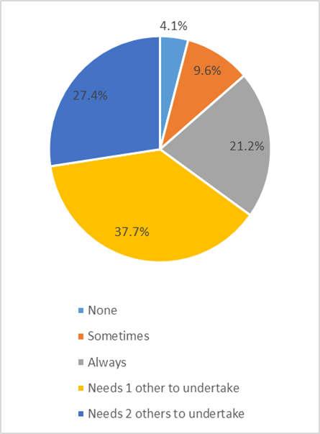

Figure 5.5: Support with personal hygiene

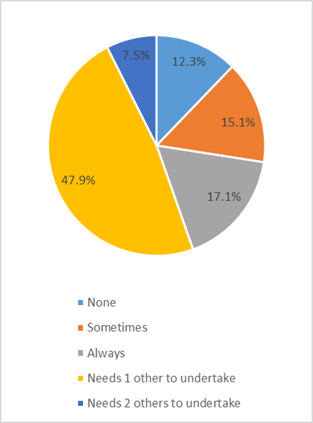

Source: NDA FACE profiles

#### Transfers

Transfers is the term used to describe the activity that occurs when an individual moves from one position to another (say from prone to sitting) or from one surface to another (say from chair to bed). Almost six in ten (58.9%) participants were able to undertake transfers independently. Almost three in ten (28%) participants were unable to manage and require one or two others to undertake transfers. Most of those who could not manage transfers require assistance from two others (see Figure 5.6 below). Females were more likely than males to require others to undertake transfers (30.7% v 26.2%).

More than one in five (22.6%) of participants were non-weight bearing. The primary reason for an inability to weight-bear is likely to be a physical disability. Obesity when combined with a physical disability can also result in a person being unable to weight-bear. Female participants were more likely to be non-weight bearing than males (27.4% v 19.0%). However, in our sample male participants were much more likely than female participants to indicate that weight affected their ability to undertake transfers (15.5% v 8.1%). Previous research has found higher levels of obesity in women with intellectual disability compared to men. However, the research also found that obesity was less common in more restrictive settings (Robertson et al. 2000).

**Figure 5.6: Assistance** **required with transfers** 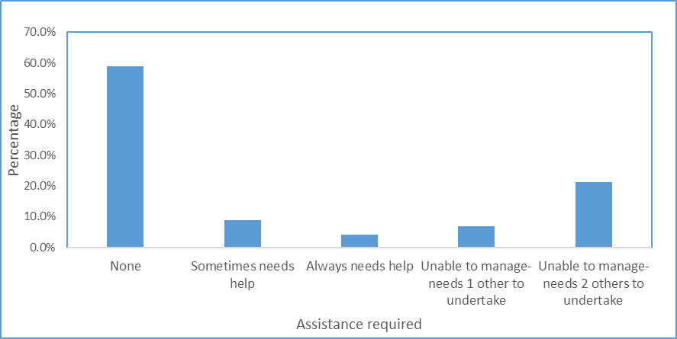

Source: NDA FACE profiles

#### Staying Comfortable and repositioning

More than three out of four (77.4%) participants were able to reposition themselves independently (see Figure 5.7). Participants required less assistance in this task than in any other ADLs. Most of those who are unable to undertake this task required the assistance of two people.

**Figure 5.7: Staying comfortable and repositioning**

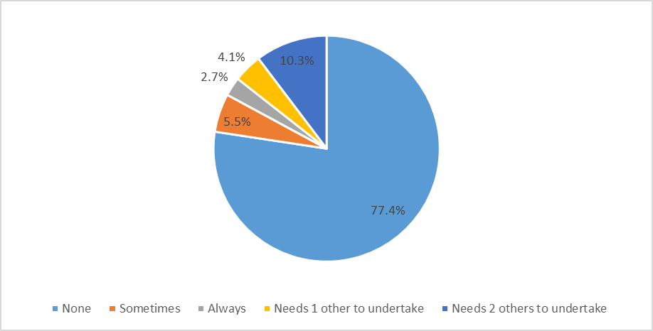Source: NDA FACE profiles

### Instrumental Activities of Daily Living

Instrumental activities of daily living (IADLs) are activities that are not as fundamental to self-care as ADLs but are indicative of the ability to live independently. Activities such as shopping, cooking, doing housework, using the telephone, managing medications and managing finances are IADLs.

The participant IADL scores ranged from 6 to 14.[17] The mean score was 12.7 and the median score was 14. The skewed distribution of the IADLs scores can be clearly seen in Figure 5.8. The distribution is consistent with the high proportion of participants with severe or profound intellectual disability already noted.

Figure 5.8: IADL scores

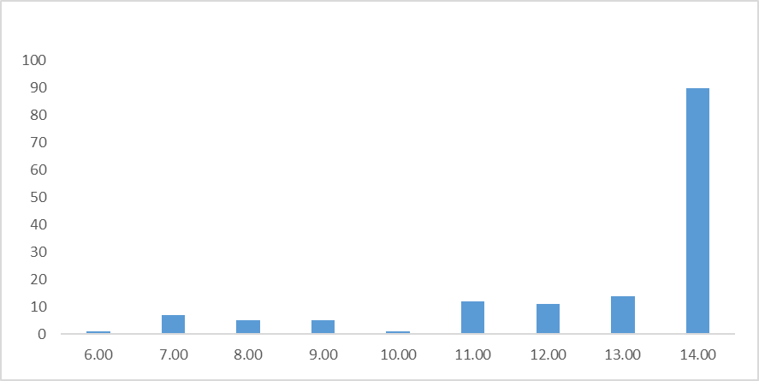Source: NDA calculations

There was considerable variation between sites in the IADLs scores. Participants in site B had on average the lowest IADLs scores at 8.1 and all participants with an IADL score below 8 were in this site. The difference between IADLs scores for participants in site B and IADLs scores for all other sites is statistically significant. This site is also of note because almost all (93.8%) participants from this site required a low level of assistance with ADLs. Participants in site A had the second lowest average IADLs score of 11.9. IADLs scores in this site were close to the mean. Participants from Site E had on average the highest IADLs scores (14). The average IADLs score in several other sites were proximate to the median (F: 13.9; I: 13.86; K: 13.85). Sites A and C included participants with the widest range of IADL scores (8-14).

#### Household shopping

Three quarters of participants indicated they would need someone else to undertake household shopping (see Table 5.9). With one exceptionthe remaining participants indicated that they would sometimes or always need assistance with household shopping.

The single participant who indicated that they needed little or no assistance with household shopping had lived with their family into adulthood and reported that they had previously been employed.

Table 5.9: Assistance required- household shopping

| **Level of assistance required** | **Number of participants** | **%** |
| --- | --- | --- |
| Little/none | 1 | 0.7 |
| Significant - sometimes needs help | 14 | 9.6 |
| Significant-always needs help | 21 | 14.4 |
| Needs one or two others to undertake | 110 | 75.3 |

Source: NDA FACE profiles

The high levels of dependency reported may be partially attributable to limited opportunities afforded to participants to participate in household shopping. Some profiles included comments pointing out the limited opportunities to undertake this task:

All shopping etc. is undertaken by staff in the house (Face profile, interviewer).

When he has the opportunity this man goes to the supermarket to assist with the weekly shopping (Face profile, interviewer).

#### Preparation of meals snacks and drinks

Participants displayed very high levels of dependency in this area. Just one participant indicated that they were independent as regards food and drink preparation. As Table 5.10 below illustrates, three quarters of participants were unable to assist in this task and required another person to undertake it. Female participants had especially high support needs in respect of this task.

Table 5.10: Assistance preparing meals/snacks/drinks

| **Level of assistance required** | **Total** | **Total %** | **Female** | **Female %** | **Male** | **Male %** |
| --- | --- | --- | --- | --- | --- | --- |
| Little/No difficulty | 1 | 0.7% | 1 | 1.6% | 0 | 0.0% |
| Sometimes needs help | 13 | 8.9% | 4 | 6.5% | 9 | 10.7% |
| Always needs help | 22 | 15.1% | 7 | 11.3% | 15 | 17.9% |
| Needs one or two others to undertake | 110 | 75.3% | 50 | 80.6% | 60 | 71.4% |
| Total | 146 | 100.0% | 62 | 100.0% | 84 | 100.0% |

Source: NDA FACE profiles

However, the profiles revealed that opportunities for participants to be involved in meal preparation were often limited. The comments below extracted from participant profiles highlight this:

…all meals are prepared in the service kitchen and are delivered to the house, so apart from snacks there does not appear to be an opportunity to develop these skills currently (FACE profile, interviewer).

Staff would like to see him have more opportunity within a home to choose food i.e. from a fridge (FACE profile, interviewer).

Prepares own breakfast and attends cookery classes, has good potential to be more involved in a smaller home, central kitchen now in place limits this at present (FACE profile, interviewer).

It may be that the paucity of opportunities to assist in food preparation and even in some instances to access snacks has contributed to the high levels of dependency found.

#### Assistance required maintaining a clean and safe home

More than nine out of ten participants (93.8%) required assistance maintaining their home. Two thirds of participants (67.8%) were unable to contribute to the maintenance of their home and needed one or more persons to undertake household tasks.

Many participants in congregated settings were not routinely provided with opportunities to engage in household tasks. Comments extracted from participant profiles illustrate this:

Currently staff undertake all the cleaning and maintaining the unit (FACE profile, interviewer).

The potential for increased involvement in household tasks was also commented on in some profiles:

Would like jobs around the house, ownership…rota of duties…would do well if provided with more opportunities (FACE profile, interviewer).

#### Managing paperwork/finances

None of the participants in the priority sites were able to manage paperwork or their own finances. Some profiles indicated that participants had an awareness of money that might be possible to develop further.

The profile extracts set out below illustrate this point:

….has his own wallet, pays for purchases. Needs staff to help with receipts, bank statements and budgeting (FACE profile, interviewer).

As with other activities many participants had limited opportunities to acquire the skills necessary to become proficient:

Participant noted that he can manage his money and gave examples of this, however, currently staff provide participant with money on request for going out. Participant noted that he has a bank account and bank card but never uses them and would like training in this (FACE profile, interviewer).

Independent with policies of unit in place. Can ask for own money anytime (FACE profile, interviewer).

#### Support for medication

Almost all (98.6%) participants reported using medication for a physical or mental health issue. This is largely consistent with a study of older Irish adults with intellectual disability which found that over 90% of participants reported using medication and that living in a residential institution was a predictor for polypharmacy and excessive polypharmacy. The authors note that higher rates of morbidity and multi-morbidity may account for the almost ubiquitous use of medication and high rates of polypharmacy (O’Dwyer et al. 2016).

None of the participants taking medication were administering it independently. A small proportion (3.4%) were able to take their medication with supervision but care workers administered medication to the vast majority (96.6%) of participants taking medication.

Some, but not all profiles include a list of the prescribed medications. The lists of medication that are available point to the common prescription of medication for constipation. As constipation is more common in people with intellectual disabilities than in the general population this was not unexpected. A study of a group of adults with moderate to severe intellectual disability and living in an institutional setting found that almost 70% of the group studied had constipation and that constipation was significantly correlated with non‐ambulancy, cerebral palsy, the use of certain medications, food refusal, and an IQ < 35 (Bohmer et al. 2001).

### Informal Support

The majority of participants moved from their family home to a congregate setting as young children. At the time of our research many participants had lived in these congregated settings for decades.

Participants were asked to indicate the support they receive on an ongoing basis from family friends and volunteers. Ongoing support was explained as the support received in a typical week. Just over one in ten (11%) participants indicated that they experienced ongoing family support (See Figure 5.9 below). Ongoing family support was strongest in the youngest cohort of participants and entirely absent for participants aged 65 and over. Although participants in the youngest age band (18-24) had a higher level (25%) of ongoing family support than other age groups, three of the four participants aged under 25 had no ongoing family support. All of these young adults had multiple and severe disabilities and complex support needs.

Figure 5.9: Ongoing family support

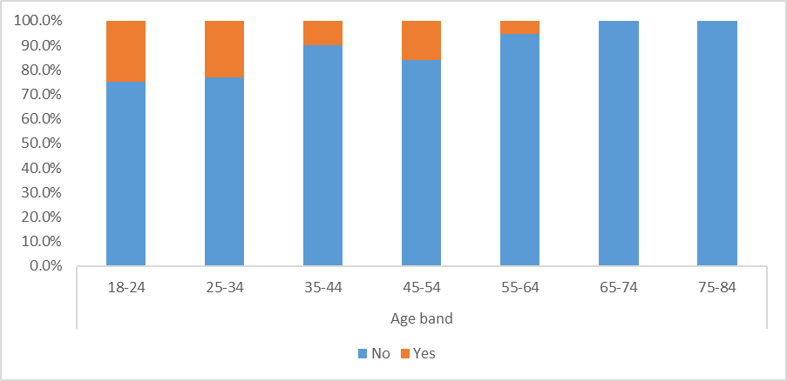Source: NDA calculations

# Annex 6 – Phase 1 Comparison of Pre and Post transition FACE findings

We conducted post transition interviews with 91 participants after they had lived in a community setting for at least six months. This was to allow a sufficient period for the transition process to be embedded and for benefits/challenges from the transition to emerge. Most participants had lived in the community for at least nine months and some for more than nine months at the time of re-interview. We concluded our fieldwork on 31st January 2020 and report here on all post transition interviews completed by that date. All differences in FACE scores reported below were significant at a minimum of a 0.05 significance level.

## Findings from FACE

### Changes that would improve wellbeing and quality of life

In completing FACE profiles participants were asked to identify changes that they considered would improve their wellbeing and quality of life. The vast majority of participants were unable to conceptualise changes and the information compiled is, for the most part, based on potential changes suggested by members of staff.

When the pre transition profiles were completed, the key changes identified as being required related to participants’ living environment (n=33; 22.6%) and the people they were living with (n=35; 24.0%) (Table 6.1). Staff felt that participants would benefit from moving to homes in the community and from living with fewer people. They mentioned the benefits of participants living in quieter environments and having more space and their own space. Staff also felt that twenty-four participants would benefit from more support and eighteen would like to get out and about more.

The pattern of the preferred changes mentioned post-transition are markedly different from the pre-transition pattern. Fewer but more diverse changes were identified following transition to the community. No changes were suggested by staff in respect of more than four in ten (42.9%) of those that moved. In contrast to the position when participants were living in congregated settings, very few suggested post-transition changes related to individuals’ living environment or the people they lived with. Staff felt that two participants would be happier if they lived with different people and that four participants would benefit from a quieter environment.

It was particularly notable that while ‘more support’ was identified in respect of twenty-four participants pre-transition, additional support did not feature at all in the changes identified post-transition. However, additional multi-disciplinary therapeutic input was identified as a change that would benefit six participants. Input from MDT did not feature pre-transition. It is possible that movement from congregated settings may make access to MDT less streamlined than in the past.

Getting out and about continued to feature as a change that would benefit participants after transition but to a lesser extent than previously. Increased family engagement featured more prominently as a change that would benefit participants post-transition compared to pre-transition.

Table 6.1: Changes that would improve wellbeing and quality of life

| Changes | Pre-transition | Post-transition |
| --- | --- | --- |
| Living environment | 33 | 8 |
| People who live with me | 35 | 6 |
| More support | 24 | 0 |
| Get out more and do more | 18 | 10 |
| Involvement in household tasks | 7 | 0 |
| Better transport | 4 | 5 |
| Training/employment | 3 | 6 |
| Greater independence | 5 | 0 |
| More choice | 1 | 0 |
| More family engagement | 4 | 11 |
| Better health | 1 | 2 |
| More community connections | 1 | 3 |
| Having a sense of purpose | 1 | 0 |
| MDT Input | 0 | 6 |
| More money for social activities | 0 | 3 |
| Equipment/appliances | 0 | 4 |
| Familiar staff | 0 | 2 |
| Day service place | 0 | 3 |
| Other | 3 | 4 |

### Global Need Band

The pre transition profiles indicated that 89 of the 91 Movers had a Global Need Band of 6 indicating that they needed the highest level of support. The remaining two participants had a Global Need Band of 4. The post transition profiles indicate that the Global Need Band of these two participants increased to 5. The pre transition profiles indicated that these participants did not require a staff presence at night to maintain their safety. However, they have transitioned to a house in the community that does have a constant staff presence. This has resulted in an increase in the Global Need Band indicated. These two participants are notable due to their high level of functional ability relative to most other participants from the priority sites. A reduction in the support offered would provide them with greater independence and control. Any reduction in support would have to be balanced against an assessment of risk.

### Emotional wellbeing and mood

In reviewing changes in the emotional wellbeing of participants pre and post transition and in recognition of the sensitivity of scores to informants’ bias, when emotional wellbeing pre and post transition was within + or – 1 it was considered unchanged. However, we recognise that minor changes in the scores in this area can reflect substantive changes. One participant who showed an improvement of one grade in emotional wellbeing was described as follows:

Noel used to be impacted by the behaviour of others while in the congregated setting, but this is no longer a feature of his life. As time goes on he gains in confidence and is not as nervous due to the calmer and less threatening environment. His level of anxiety has reduced significantly since moving from the congregated setting (FACE profile, interviewer).

On the basis that pre and post transition scores were static if they were within +1 or -1, the FACE profiles indicated that emotional wellbeing improved for ten participants and dis-improved in the case of five participants (Figure 6.1).

Figure 6.1: Changes in behaviours of concern and emotional wellbeing

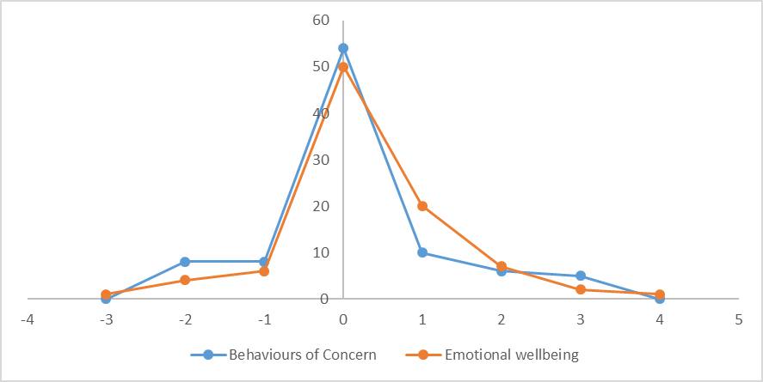

Source: NDA FACE profiles

### Behaviours of concern

Overall, the post transition FACE profiles indicated minor changes in behaviours of concern. A greater number of participants reported no behaviours of concern post transition compared to pre transition (41 versus 32; see Figure 6.2). But this trend was reversed among those reporting occasional behaviours of concern (10 versus 19). A similar pattern was evident in respect of participants reporting behaviours of concern with no history of harm and those reporting the more serious behaviours of concern with a history of harm.

Figure 6.2: Changes in behaviours of concern

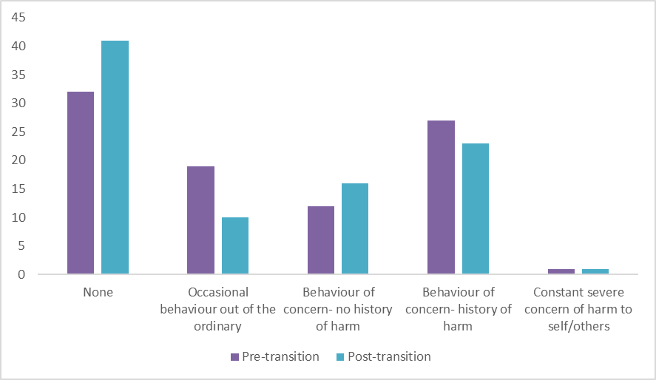

Source: NDA FACE profiles

As noted previously, FACE profiles are influenced by the perspectives of informants which are somewhat subjective. Therefore, in looking at changes in behaviours of concern it may be most instructive to condense the five grades of behaviours to three (none/occasional, more frequent than occasional, constant/severe). This indicated that for those who moved, behaviours of concern pre and post transition were static.

In assessing behavioural changes in individual participants pre and post transition, and in recognition of the sensitivity of scores to informants’ bias, behavioural grades within +1 or – 1 were considered unchanged. Using this definition, the FACE profiles indicated that behaviours of concern improved for eleven participants. The seriousness of behaviours of concern reduced by two levels for six participants and by three levels for a further five. The elimination or reduction in behaviours of concern were generally attributed to participants living in quieter environments and having their own space in their new homes. It was noted that one participant diagnosed with schizophrenia no longer displays evidence of psychosis. Peter’s behaviours of concern have reduced by two grades. This extract from his profile provides some insight into this change:

Peter can move delph to the sink and assists in cleaning down the table after meals. He can partly make his own bed. He would not have done these tasks before. He likes to see what is being cooked, which he couldn’t do in the campus. He would not be willing to wait for anything e.g. queue for his turn in the barber shop. However, the local barber understands this and gives him immediate attention. In the past Peter has inflicted serious injuries to self, but this no longer happens. Peter was restrained at times in the congregated setting. He has not been the subject of physical restraint in his new home (FACE profile, interviewer).

The profiles indicated dis-improvements in behaviours of concern for eight participants who moved (8.8%). Behaviours of concern increased in severity by two levels for each of these eight participants.

It should be borne in mind that the five-grade measurement scale included in FACE V.7 is not designed to capture changes in behaviours of concern over time. Improvements in behaviours of concern were noted for some participants but the seriousness of past behaviours meant that behaviours were still graded at the same level. Several examples are set out below of participants’ for whom the FACE profiles indicate no change in behaviours of concern despite a substantive reduction in the frequency and or severity of their behaviours of concern since their move to the community.

Margaret has a serious history of challenging behaviours. She injured staff previously and there were also safeguarding issues with other residents. This behaviour has not manifested at all- no incidents! - since the move. She now has a “'little blow out' every couple of weeks- this used to happen every day (FACE profile, interviewer).

Francis is more responsive now to verbal prompts and approaches. Frequency and intensity of behaviours has reduced since the transition (FACE profile, interviewer).

Denis has a history of causing harm to staff but has not displayed aggressive behaviour since the move. He engages in obsessive behaviour ripping and shredding clothes and bedding. Staff have adopted the approach of only intervening when Denis is outside the house. They attribute the improvement in his behaviour to their non-intervention within the house (FACE profile, interviewer).

Although the profiles revealed dis-improvements in behaviours of concern for a small group of participants, the transitions had not resulted in an escalation in challenging behaviours for most. Previous research has indicated that behaviours of concern can increase following transition to the community. The comparison of pre and post transition behaviours of concern of those who moved suggests that post transition environments and management of behaviours of concern may contribute to sustainable reductions in the incidence and severity of behaviours of concern.

### Activities of Daily Living

A comparison of the pre and post transition ADLs scores of those who moved revealed a mixed pattern. The mean post transition ADLs score of 11.6 is lower than the mean pre transition ADLs score of 13.0, indicating that, on average, those who moved required significantly lower levels of support following their transition to the community. However, while this overall change was positive, it masks the unevenness of the responses. Before considering the changes in more detail, it may be helpful to reflect on how the ADLs scores were arrived at. ADLs scores are a composite of the support needed to undertake eight different daily activities. The activities are (1) eating, (2) toileting, (3) personal hygiene, (4) washing whole body, (5) dressing,(6) undressing, (7) transfers and (8) staying comfortable/repositioning. For the majority of participants the support needed was based on information provided by a member of staff that knew the participant for a minimum period of six months and usually for several years. Informants,’ and indeed participants’, assessment of the support they require is somewhat subjective. In almost all cases, pre and post transition informants differed. Differences in the perspectives of informants may, therefore, have impacted scores. Care must be taken therefore in interpreting the recorded changes.

In light of the sensitivity of ADLs scores to informants’ bias and the eight different scores that make up the composite ADLs score, we have interpreted post transition ADLs scores to be static if they were within 2 (+ or -) of the pre transition score. This approach indicated that half (49.4%) of those who moved had static ADLs scores. ADLs scores dis-improved (indicating the need for additional support) for 15.4% of those who moved and improved (indicating a reduced need for support) for 35.2% of those who moved. The changes are illustrated in Figure 6.3 below.

Figure 6.3: Changes in pre and post transition ADLs scores

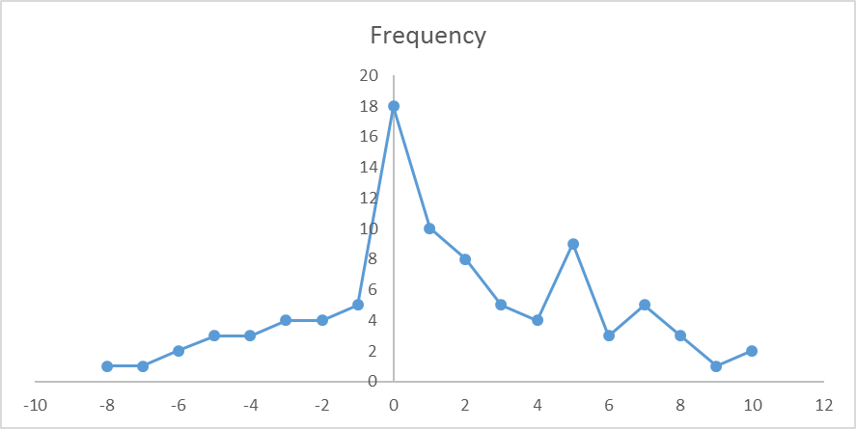

Source: NDA FACE Profiles

The median age-band of participants with improved capacity to undertake ADLs was 45-54. Participants who displayed increased ability to undertake ADLs post transition most commonly displayed increased ability in respect of several different tasks. So, over 70% of those with improved capacity to undertake ADLs recorded a reduction of 5 or more in their ADLs score. The FACE profile extract below illustrates how improvements can be achieved:

Staff are encouraging Thomas to become more and more independent. Thomas has to be encouraged to do things for himself. He will say that he needs to be lifted and assisted when he can do things independently. With reassurance and encouragement this issue has improved significantly since the move to the new house. He used to use a walking frame, but no longer needs this within the house (FACE profile, interviewer).

The median age-band of participants requiring additional support to undertake ADLs following their transition to the community was 55-64. Only two participants who required increased support to undertake ADLs following transition were aged under 45. For most of those with decreased capacity to undertake ADLs it was possible to attribute the requirement for increased support to age-related reductions in mobility.

### Instrumental Activities of Daily Living

A comparison of the pre and post transition IADLs scores for those who moved indicated some variation but more stablity than ADLs scores. For those who moved, the mean post transition IADLs score of 12.2 was lower than the mean pre transition IADLs score of 12.7 indicating that, on average, those who moved required slightly lower levels of support to undertake IADLs following their transition to the community. In common with ADLs scores, IADLs scores are a composite score and are impacted by the perspectives of informants. However, as IADLs scores are based on fewer individual scores (i.e. 6 items) and scores range over a much narrower band than ADLs scores (0-17 for IADLs versus 0-32 for ADLs). This will tend to result in more stability between pre and post transition scores. Due to the narrower range of IADLs scores compared to ADLs scores, static scores were defined as post transition scores within 1 (+ or -) of pre transition scores. This approach indicated that the pre and post transition IADL score of more than eight in ten (85.7%) participants who moved was static. IADLs scores dis-improved for 4.4% of those who moved and improved for 9.9% of those who moved. The changes in IADLs are illustrated in Figure 6.4 below.

Figure 6.4: Changes in pre and post transition IADLs scores

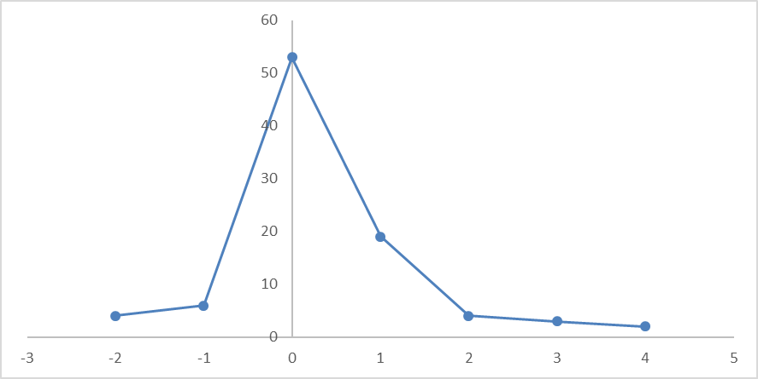

Source: NDA FACE profiles

When we take into account the level of intellectual disability of participants and also the extended period of time many had spent in institutional settings, it is easy to understand that the potential for improvements in this area was usually slight.

There is little participation by residents in household duties – in part due to mobility issues and in part probably because they had little opportunity to learn and develop such skills in the congregated setting (FACE profile, interviewer).

It should be remembered, however, that whereas participants previously lived in an environment where most IADLs were undertaken in a manner that was largely invisible to them – they did not see food being prepared, laundry being done, shopping being put away- they could now observe these tasks being undertaken even if their ability to participate was still constrained by their disabilities.

The transition to more enabling environments allowed some participants to participate more fully in IADLs. One participant achieved increased independence administering his medication following his transition which resulted in a reduction in his IADLs score. His pre transition profile noted:

Medication is provided to participant by staff. Participant noted that he would be capable of taking medication on his own with some initial guidance and checking from time to time (FACE profile, interviewer).

This participant was obviously keen to exercise independence in this area. When his post transition profile was completed he had gained this independence:

Participant noted that he takes his own medication, and doesn’t need reminders (FACE profile, interviewer).

### Family support – Additional information

In completing post transition FACE profiles participants were asked to indicate current levels of family contact and changes in family contact since their move to the community.

Reductions in family contact were often outside the control of the service provider. For six participants, reduced family contact resulted from the death, ill health or increased fragility of relatives and was therefore not directly linked to the transition process. The family of one participant had not visited since his transition. Staff linked this to the family’s opposition to the decongregation process. A participant who enjoyed very regular family visits whilst living in an institution and whose family was very involved in all decisions regarding his care receives regular but less frequent family visits since his transition. Staff considered that this family was now happier with the care their relative was receiving. Finally, family contact had ceased completely for one participant who only enjoyed irregular family contact prior to transition. Staff had provided a monthly update to family members but they indicated that they wanted no further contact.

Improvements in family contact stemmed from factors such as participants living nearer to family members, family members feeling more at ease visiting their relatives in smaller quieter homely settings, and siblings organising visiting rotas. The efforts of staff also contributed to improved family contact when contact had previously been intermittent and infrequent. Initiatives such as birthday and house-warming parties were noted as triggers that rekindled family contact. Family visits were also facilitated by staff bringing participants to visit family members.

### Social integration – Additional information

The profile extracts below illustrate the range of activities participants were enjoying post transition:

Noeleen goes to slimming world in a local hotel. She has weekly visits from a volunteer and weekly visits with a friend in another house. Noeleen likes to do her nails and get her hair done. She also enjoys going for walks. Staff are hoping she can join a walking group (FACE profile, interviewer).

Richard enjoys physical activity. He goes horse-riding and goes to local football matches. He did surfing with day services in the summer and loved it. He has membership in a local leisure centre and has gone to the cinema twice in the last couple of months- this is something that would not have been thought possible in the past. At the weekends Richard might go to the local market, shops, or to a football match…he has the option to go out on his own with his assigned staff member but often goes out with the other residents in the house. Family never thought Richard would be able to walk into town-they are thrilled with the change (FACE profile, interviewer).

The foundations for an expanded social network had been laid for some participants by securing them voluntary work or through contacts with local clubs or community organisations. Six participants had roles as volunteers in their new communities. Volunteer activities included helping with ‘Tidy Towns’, delivering local papers and cleaning the local church. One participant had also completed work experience. Staff were also seeking to secure volunteer roles/ work experience for several other participants. Staff in some houses had also sought to promote contact with local GAA and community organisations. Links had been forged with a community singing group, women’s sheds, and a group promoting accessibility in the local town.

Volunteer opportunities were difficult to secure, however, and efforts to secure volunteer roles were not always successful. This may be because there are limited volunteer opportunities or it may be because there is still a reluctance to embrace people with disabilities in all aspects of community life.

# Annex 7: Phase 1 Comparison between participants who did and did not transition

## Overview

Table 7.1 below outlines the status of Phase 1 participants at the end of the study.

Table 7.1: Status of Phase 1 participants at 31st January 2020

| **Status** | **Number of participants** | **% of participants** |
| --- | --- | --- |
| Interviews completed | 91 | 62.3 |
| Died | 10 | 6.8 |
| Moved to specialist medical facilities | 2 | 1.4 |
| Recent movers | 4 | 2.8 |
| Non-movers | 39 | 26.7 |
| Total | 146 | 100.0 |

Source: NDA FACE profiles

By 31st January 2020, in two of the 11 priority sites no participants had transitioned to homes in the community. The reasons for the delay in transition included difficulties finding and funding suitable properties for persons with profound and multiple disabilities.

While there was an uneven distribution of those who moved and those who did not move by geographical area, it does not appear that the uneven transition pattern observed is attributable to geographic factors, but rather to factors at individual site level.

It is notable that the transition process had progressed to a greater extent in HSE sites compared to other sites. Just one in six (16.4%) participants in HSE priority sites were Non-movers. In non-HSE priority sites, four in ten (40.5%) participants were Non-movers.

Participants who died or transferred to specialist medical facilities differed in some key respects from other phase one participants. There were also some key differences between those who moved and those who did not move. As deaths and transfers to specialist facilities were unevenly spread among our sites (Figure 7.1) comparing those who moved to those who did not move provides the best measure of the progression of the transition process from each of the eleven priority sites. Under the various headings from the FACE profiles the comparisons between these different groups are outlined below. For the purposes of clarity we refer to participants with whom post transition interviews have been completed as ‘Movers’ and participants remained in congregated settings as ‘Non-movers’. All reported differences in FACE scores between the two groups were significant at a minimum of a 0.05 significance level.

Figure 7.1: Non-movers by priority site

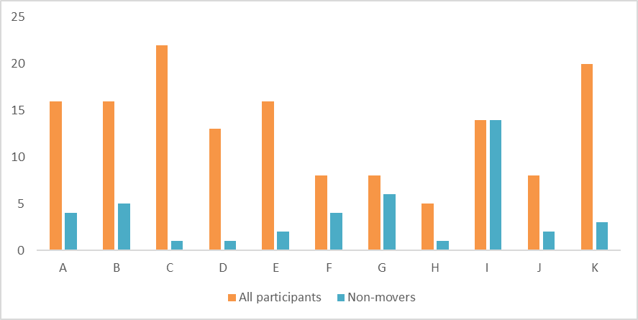

Source: NDA FACE profiles

## Findings from FACE

### Gender

Female participants accounted for 42.5% of all participants in priority sites. The number of females in the cohort who moved was considerably lower (34.1%) than in the total sample of participants from priority sites. The results indicate that female participants were less likely to have transitioned than male participants. Four (40%) of the ten participants who died were female.

### Age

The average age of Movers was 53.2 years, slightly older than the average age of all Phase 1 participants (51.5 years) in priority sites. To ensure consistency we based our analysis on the age of participants at the date of the first interview. Table 7.2 below compares the age profile of Movers, Non-movers and all Phase 1 participants. There were no major differences between the three groups.

Table 7.2: Participants by age band

| **Age band** | **No. of Movers** | **% of Movers** | **No. of Non-movers** | **% of Non-movers** | **No. of Phase 1 Participants** | **% of Phase1 Participants** |
| --- | --- | --- | --- | --- | --- | --- |
| 18-24 | 2 | 2.7% | 2 | 4.7 | 4 | 2.7% |
| 25-34 | 3 | 9.6% | 5 | 11.6 | 14 | 9.6% |
| 35-44 | 6 | 14.4% | 6 | 14.0 | 21 | 13.7% |
| 45-54 | 20 | 34.2% | 13 | 30.2 | 50 | 34.3% |
| 55-64 | 14 | 24.7% | 9 | 20.9 | 36 | 25.3% |
| 65-74 | 6 | 11.7% | 7 | 16.3 | 17 | 11.7% |
| 75-84 | 3 | 2.7% | 1 | 2.3 | 4 | 2.7% |
| Total | 91 | 100.0% | 43 | 100.0% | 146 | 100.0% |

Source: NDA FACE profiles

The average age of the participants who died was 48.2 years; four years younger than the average age of Phase 1 participants. The average age of those who moved to specialist facilities was 54.5 years; three years older than that of all Phase 1 participants.

### Communication difficulties

Movers were more likely to have no communication difficulties and less likely to have serious communication difficulties than participants who had not transitioned from priority sites. The proportion reporting mild and consistent difficulties are very similar for Movers, Non-movers and all priority site participants. However, there were considerable variations in the reported proportions in the two most serious categories of severe and unable. The combination of the responses in these two categories indicated that just less than half (49.5%) of all Movers reported communication difficulties prior to transition (Figure 7.2). This compares to 53.4% of all priority site participants and 55.8% of Non-movers.

Figure 7.2: Communication Difficulties- Movers, Non-movers and all priority site participants

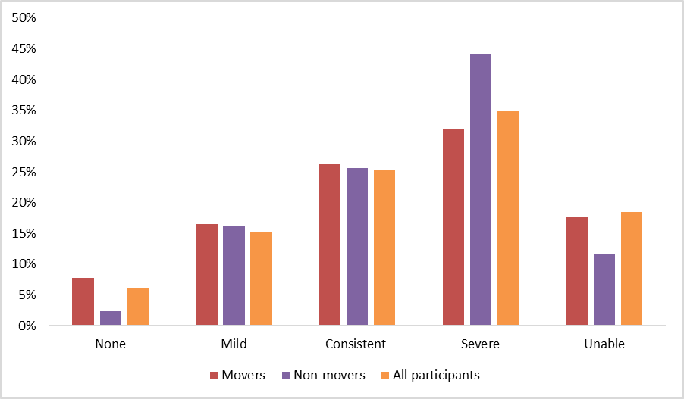

Source: NDA FACE profiles

### Mental health

Table 7.3 illustrates the presence of mental ill health for Movers, Non-movers and all Phase 1 participants.

Table 7.3: History of Serious Mental Ill Health

|  | **All Phase 1** | **All Phase 1 %** | **Movers** | **Movers**  **%** | **Non-movers** | **Non-movers %** |
| --- | --- | --- | --- | --- | --- | --- |
| Yes | 63 | 43.2 | 40 | 44.0 | 18 | 41.9 |
| No | 83 | 56.8 | 51 | 56.0 | 25 | 58.1 |
| Total | 146 | 100.0 | 91 | 100.0 | 43 | 100.0 |

Source: NDA FACE profiles

### Emotional wellbeing and mood

Those who moved reported no difficulties in emotional wellbeing more commonly than those who did not move (39.6% v 27.9%) and all Phase 1 participants (37.0%; Figure 7.3). However, the subjective nature of responses, and indeed the need to rely on proxy responses, should be borne in mind. If responses for ‘no difficulties’ and ‘low/anxious once or twice a week’ are combined we see that, while a higher proportion of those who moved (68.2%) reported no or low levels of difficulties compared to those who did not move (65.1%) and all Phase 1 participants (67.1%), the differences between the groups were minor. By combining the two categories that indicated the most serious difficulties with emotional wellbeing, we see that those who did not move had the biggest proportion (9.3%) of participants with the most serious level of emotional difficulties. This compares to 8.2% of all Phase 1 participants and 7.7% of those who moved.

Figure 7.3: Emotional wellbeing Movers, Non-movers and all participants

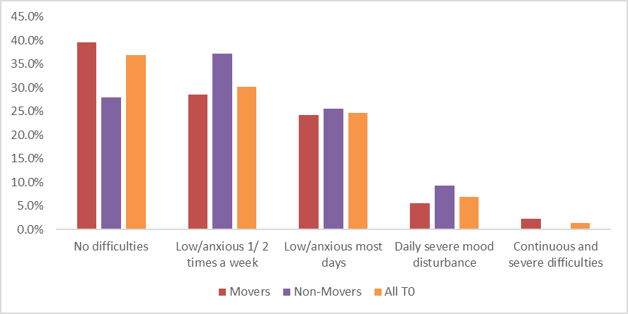

Source: NDA FACE profiles

### Behaviours of Concern

As Table 7.4 below illustrates, those who moved were less likely to report behaviours of concern compared to those who did not move and all Phase 1 participants. Less than a quarter of those who did not move reported no behaviours of concern compared to more than a third (35.2%) of those who moved. However, if we combine the first two categories of no or occasional behaviours of concern categories we see that the proportion of all three groups reporting no or occasional behaviours of concern is almost identical (56%; 55.8%; 56.8%). Similarly combining the two categories that indicate the most serious behaviours of concern revealed that, while Movers report lower levels (30.8%) of serious behaviours of concern than either Non-movers or all priority site participants, there are only marginal differences between the groups.

Table 7.4: Behaviours of Concern

| **Behaviours of concern** | **Movers** | **Non-movers** | **All Phase 1** |
| --- | --- | --- | --- |
| None | 35.2 | 23.3 | 32.2 |
| Occasional behaviour out of the ordinary | 20.9 | 32.6 | 24.7 |
| Behaviour of concern- no history of harm | 13.2 | 11.6 | 11.6 |
| Behaviour of concern- history of harm | 29.7 | 30.2 | 29.5 |
| Constant severe concern of harm to self/others | 1.1 | 2.3 | 2.1 |

Source: NDA FACE profiles

### Physical health

Compared to all Phase 1 participants, those who died or were transferred were more likely to be non-weight bearing and to have a physical disability (See Table 7.5). Those who died were also more likely to have three or more disabilities.

Two thirds (66.7%) of those who died or moved to specialist facilities reported epilepsy. This compared to 45.9% of all priority site participants, 48.4% of Movers and 34.9% of Non-movers.

A number of indicators highlight poorer physical health among the participants who died or were transferred to specialist facilities compared to all Phase 1 participants. They were statistically significantly more likely to report pain or distress than other priority site participants. Pain was reported by 58.3% of those who died or were transferred compared to the 21.2% of all participants. The percentage of those who moved who reported pain was lower again at 16.5%.

Table 7.5: Physical health and disabilities of Movers /Deceased/ Transferred

| **Physical health** | **All Phase 1 %** | **Movers %** | **Deceased %** | **Medical Transfers %** |
| --- | --- | --- | --- | --- |
| Mild or moderate pain/distress | 21.2 | 16.5 | 60.0 | 50.0 |
| Multi-disability: 3 or more | 32.2 | 33.0 | 60.0 | 0.0 |
| Physical disability | 38.4 | 35.2 | 70.0 | 50.0 |
| Non-weight bearing | 22.6 | 18.7 | 40.0 | 0.0 |
| Epilepsy | 45.9 | 48.4 | 60.0 | 100.0 |

Source: NDA FACE profiles

### Functional ability

The average ADLs and IADLs scores of those who died or were transferred to specialist facilities were higher than the average scores for all priority site participants and for Movers. It is especially notable that 60% of those who died had ADLs scores greater than or equal to 20. This compares to 28.1% of all priority site participants and 25.3% of Movers. As the range of IADLs scores is much narrower than ADLs scores the difference in the mean scores for this metric was much less marked. Table 7.6 below provides a comparison of the ADLs and IADLs scores of these different cohorts.

Table 7.6: Comparison of ADLs and IADLs scores

|  | **Phase 1** | **Movers** | **Non-movers** | **Deceased** |
| --- | --- | --- | --- | --- |
| ADLs -Mean | 14.1 | 13.0 | 14.7 | 20.5 |
| ADLs- Range | 0-31 | 0-31 | 0-31 | 4-31 |
| IADLs- Mean | 12.7 | 12.7 | 12.5 | 13.4 |
| IADLs-Range | 6-14 | 6-14 | 6-14 | 11-14 |

Source: NDA FACE profiles

The mean ADLs score for Movers was slightly lower at13.0 than for Non-movers at 14.7. The scores indicated that the functional ability of Movers was higher than the average for all Phase 1 participants while Non-movers had lower functional ability. The difference in mean ADLs score was statistically significant.

The mean IADL score for Movers at 12.7 was very similar to that of Non-movers at 12.5. The median for both groups was 14. These scores indicated that the ability to undertake IADLs was the same for Movers and Non-movers.

# Annex 8. Phase 2 Findings

## Primary supports received by Phase 2 participants

The disability supports provided to Phase 2 participants varied. While more than half (55.7%) were receiving full-time residential supports in settings with staff on hand 24/7, others were receiving very minimal levels of support. Although many participants were accessing several different supports, the analysis set out in Table 8.1 below is based on participants’ primary support service. The four main areas of support: residential, supported living, day services and ancillary supports are outlined in more detail below.

Table 8.1: Primary support service for Phase 2 participants

| Primary Support | Total | % |
| --- | --- | --- |
| Residential support | 156 | 55.7 |
| Supported living | 56 | 20 |
| Day services | 61 | 21.8 |
| Ancillary support | 7 | 2.5 |
| Total | 280 | 100 |

Source: NDA FACE profiles

Supported living supports that ranged from minimal to intensive were the primary services provided to one in five participants. Day services provided the primary support for a further one in five (21.8%) participants. A small (2.5%) proportion of participants relied on ancillary supports. Participants receiving a primary shared care service and those receiving intensive supported living assistance had lower function ability, evidenced by higher average ADLs and IADLs scores, compared to those receiving other primary services. Those receiving ancillary or minimal supported living supports had the lowest average ADLs and IADLs scores, which suggests that the supports provided were aligned with their needs.

### Residential supports

The living arrangements of participants in Phase 2 included campus based congregated sites, specialist units in campus settings, community residential homes, family homes, rented /owner-occupied apartments/houses and nursing homes. Eight participants had live-in-carers.

In further analysis individuals living in congregated settings include those living in nursing homes and specialist units.

Table 8.2 below presents an analysis of living arrangements by primary disability.

Table 8.2: Living arrangements by primary disability

| Living Arrangement | ABI | Autism-No ID | ID | MH | Physical | Sensory | Total | % |
| --- | --- | --- | --- | --- | --- | --- | --- | --- |
| Comm. Res | 1 | 0 | 98 | 5 | 3 | 1 | 108 | 38.6 |
| Congregated | 2 | 1 | 24 | 0 | 10 | 0 | 37 | 13.2 |
| Family | 8 | 2 | 53 | 0 | 10 | 2 | 75 | 26.8 |
| Live-In-Carer | 0 | 0 | 3 | 0 | 4 | 1 | 8 | 2.9 |
| Nursing  Home | 0 | 0 | 0 | 0 | 2 | 0 | 2 | 0.7 |
| Shared Care | 0 | 0 | 5 | 0 | 0 | 0 | 5 | 1.8 |
| Specialist Unit | 0 | 0 | 3 | 0 | 0 | 1 | 4 | 1.4 |
| Supp. Living | 1 | 1 | 28 | 0 | 9 | 2 | 41 | 14.6 |
| Total | 12 | 4 | 214 | 5 | 38 | 7 | 280 |  |

Source: NDA FACE Profiles

As shown in Table 8.3, more than nine in ten participants who lived in community residences were individuals with an intellectual disability. Those living in congregated settings were largely comprised of individuals with intellectual disability and physical disability. Participants with a physical disability accounted for more than a quarter (27%) of all those living in a congregated setting but only accounted for 13.6% of all Phase 2 participants.

Two-thirds of Phase 2 participants with Acquired Brain Injury (ABI; 66.7%) and half of those with Autism were living with their families. Around a quarter of participants with physical (26.3%), intellectual (24.8%) and sensory (28.6%) disabilities lived with their families. None of the participants with a primary mental health disorder lived with their family.

Five (1.8%) participants lived with their family for about half of all nights and spent the remainder of nights in a community residential setting. The residential support provided to these participants is described as shared care. It is interesting to note, however, that two of the three services that provided this support considered it to be respite care.

Table 8.3: Residential supports by primary disability

| Living arrangement | ABI | ASD | ID | MH | Physical | Sensory | Total | % |
| --- | --- | --- | --- | --- | --- | --- | --- | --- |
| Comm. Res | 1 | 0 | 98 | 5 | 3 | 1 | 108 | 38.6 |
| Congregated | 2 | 1 | 27 | 0 | 12 | 1 | 43 | 15.4 |
| Shared Care | 0 | 0 | 5 | 0 | 0 | 0 | 5 | 1.8 |

Source: NDA FACE Profiles

Residential supports are generally provided in a community based or campus based dwelling that is staffed 24 hours a day or at all times that residents are present. There are three different residential types for individuals with a disability: HIQA designated disability centres, centres that are inspected by the Officer of the Inspector of Mental Health and HIQA designated elder care facilities.

There are currently over 1,200 HIQA registered designated centres that provide residential services to people with disabilities.[18] Some of these only support children or only provide respite services so are outside the scope of this research. The HSE’s 2021 National Service Plan, indicated that around 8,130 residential places would be provided in 2021 (HSE 2021).

Community based residential services can accommodate up to nine residents.[19] A complement of staff is generally present in community homes at all times that residents are present. The combined presence of staff and residents mean that larger community houses can be crowded noisy places at times. Almost four in ten (38.6%) Phase 2 participants lived in community based residential services. Participants lived in community homes that accommodated from one to seven individuals. Around one in four of those who receive residential supports live in congregated settings. Forty-one Phase 2 participants lived in congregated settings. Of these, four were living in specialist units. The specialist units included in this study supported individuals with intellectual disability and very significant behaviours that challenge as well as older people with intellectual disability and dementia.

Adults with disabilities may also live in residences that are registered with and inspected by the Office of the Inspector of Mental Health. These residences are outside the remit of HIQA. Although the statutory scope of mental health regulation is limited to in-patient services, the Inspector of Mental Health has the power to visit and inspect any premises where a mental health service may be provided (Finnerty 2019a).

The available evidence suggests that individuals with intellectual disabilities are supported on a long-term basis in both mental health in-patient services and mental health community residences. A review of 100 patients in 10 in-patient continuing care centres found that 5% had a diagnosis of intellectual disability (Finnerty 2019b)[20]. In 2018 there were 118 residences that provided 24 hour supervision and care to approximately 1200 individuals with enduring mental illness. Those supported include individuals with intellectual disability. In 2018, the clinical team responsible for 10 of the 54 residences inspected was the Intellectual Disability team (Finnerty 2019c). Based on this, we estimate that the number of individuals with intellectual disability supported in community residences for individuals with mental illness is 200-250. Six Phase 2 participants were living in residential services monitored by the Inspector of Mental Health. These participants had an intellectual disability and comorbid mental illness.

Although we did not set out to recruit participants from within nursing homes, two participants, who were recruited via disability service providers, were living in nursing homes. Both of these participants attended a day service and one also received support from Personal Assistants (PAs).

### Supported living

Supported living assistance was divided into four categories to reflect the variation in the intensity of the supports provided. The categories of support are as follows:

* Minimal support: Less than 5 hours of regular weekly support
* Low support: 5-20 hours per week
* High Support: 21-60 hours per week
* Intensive support: 61 or more hours per week

Table 8.4 outlines the level of support provided by primary disability.

Table 8.4: Level of supported living service by primary disability

| Level of support | ABI | ASD | ID | MH | Physical | Sensory | Total | % |
| --- | --- | --- | --- | --- | --- | --- | --- | --- |
| Supp. Intensive | 0 | 0 | 1 | 0 | 5 | 0 | 6 | 10.7 |
| Supp. High | 1 | 0 | 2 | 0 | 9 | 2 | 14 | 25.0 |
| Supp. Low | 1 | 0 | 14 | 0 | 2 | 1 | 18 | 32.1 |
| Supp. Minimal | 0 | 0 | 18 | 0 | 0 | 0 | 18 | 32.1 |
| Total | 2 | 0 | 35 | 0 | 16 | 3 | 56 |  |

Source: NDA FACE Profiles

When supported living assistance is organised and provided by staff within a disability service provider, a flexible approach can be adopted that is better suited to person-centred care and ensuring that the support provided can respond to changes in the needs of service users.

Supported living services were provided most commonly to Phase 2 participants with an intellectual disability. However, this is reflective of the fact that the majority of Phase 2 participants were people with an intellectual disability. They were also provided to people with physical and sensory disabilities and acquired brain injuries.

As noted above, for the purposes of this study, personal support services are treated as a type of supported living assistance. However, it should be noted that PA and home support hours and any changes thereto must be negotiated with local disability managers, a process which can be lengthy and the outcome of which is often uncertain.

### Day Services

In recent years the support needs of all young adults transitioning from school to adult day services are profiled using a standard tool. The eligibility requirements for other adults seeking to access day services may vary within and between CHO areas. Some but not all day services provide a midday hot meal to service users. A small charge is usually but not always levied in respect of meals provided. Service providers may also levy a daily charge for day services. Table 8.5 illustrates the day services supports received by primary disability.

Table 8.5: Day service supports received by primary disability

|  | ABI | ASD | ID | MH | Physical | Sensory | Total |
| --- | --- | --- | --- | --- | --- | --- | --- |
| Day | 4 | 0 | 49 | 0 | 6 | 2 | 61 |

Source: NDA FACE Profiles

### Ancillary services

Ancillary services include services such as advocacy, counselling, community outreach and facilitated networks. Table 8.6 illustrates the day services supports received by primary disability

Table 8.6: Ancillary supports received service by primary disability

|  | ABI | ASD | ID | MH | Physical | Sensory | Total | % |
| --- | --- | --- | --- | --- | --- | --- | --- | --- |
| Ancillary | 3 | 3 | 0 | 0 | 1 | 0 | 7 | 2.5 |

Source: NDA FACE Profiles

## Findings from FACE

### Global Need Band

The FACE profile generated a metric called ‘Global Need Band’ which indicates the level of need. Global needs range from 6 (highest level of need) to 0 (lowest level of need). Table 8.7 sets out details of the Global Need Bands of Phase 2 participants. Six in ten (59.7%) participants had a Global Need Band of 6.

Table 8.7: Global Need Band Phase 2 participants

| **Global Need Band** | **Number of participants** | **% of participants** |
| --- | --- | --- |
| 0 | 13 | 4.7 |
| 1 | 16 | 5.7 |
| 2 | 6 | 2.1 |
| 3 | 34 | 12.1 |
| 4 | 11 | 3.9 |
| 5 | 33 | 11.8 |
| 6 | 167 | 59.7 |
| Total | 280 | 100 |

Source: NDA FACE Profiles

Almost one in twenty (4.7%) participants had a Global Need Band of zero. The primary disability of the thirteen participants with a Global Need Band of 0 was intellectual disability (10), Autism without ID (2) and physical (1). Four out of five participants with a primary disability of mental health had a Global Need Band of 6 and almost two-thirds (65.4%) of those with an intellectual disability were also assessed as having the highest level of need.

Global Need Band was further analysed by living arrangement (Table 8.8). Participants receiving supported living had, on average, the lowest level of global need compared to those with all other living arrangements. All of those in Special Units and more than three-quarters of those living in community homes had a Global Need Band of 6. The widest variation in need was observed among participants living with their families. This group included people in each of the seven Global Need Bands. More than half (52%) of participants living with their families had a Global Need Band of 6.

Table 8.8: Global Need Band by living arrangement

| **Living arrangement** | **Number of participants** | **Number of participants with GNB of 6** | **% of participants with GNB of 6** |
| --- | --- | --- | --- |
| Comm. Res | 108 | 85 | 78.7 |
| Congregated | 37 | 27 | 73.0 |
| Family | 75 | 39 | 52.0 |
| Live-In-Carer | 8 | 6 | 75.0 |
| Nursing home | 2 | 1 | 50.0 |
| Shared care | 5 | 4 | 80.0 |
| Special Unit | 4 | 4 | 100.0 |
| Supported Living | 41 | 1 | 2.4 |
| Total | 280 | 167 | 100.0 |

Source: NDA FACE Profiles

Further analysis showed that the Global Need Bands could be driven by questions relating to staying safe at home during the day and night. These can be influenced by the approach taken to risk by families or service providers. The Global Need Bands should, therefore, be interpreted with caution. This analysis is outlined below.

Global Need Bands are generated by an algorithm built into FACE which was not available to the NDA. FACE profiles collect information regarding the support needed to stay safe at home during the day and during the night. Our analysis suggested that the responses to these questions heavily influenced the determination of Global Need Band (see Table 8.9 and 8.10 below). All participants who required a constant or personal support presence during the day were assigned a Global Need Band of 5 or 6. No participants who required less intensive supports to ensure safety had a Global Need Band of 6. Similarly, when FACE profiles indicated that participants required sleeping or waking night cover, the minimum Global Need Band assigned was 5. Only 7 participants requiring less intensive support at night had a Global Need Band of 5 and none had a Global Need Band of 6

Table 8.9: Support needed to stay safe at home during the day

|  | Global Need Band | Global Need Band | Global Need Band | Global Need Band | Global Need Band | Global Need Band | Global Need Band | Global Need Band |
| --- | --- | --- | --- | --- | --- | --- | --- | --- |
| Support  Needed | 0 | 1 | 2 | 3 | 4 | 5 | 6 | Total |
| Safe alone | 7 | 8 | 3 | 11 | 2 | 8 | 0 | 39 |
| Alarm | 2 | 4 | 1 | 5 | 2 | 3 | 0 | 17 |
| Safety checks | 4 | 4 | 2 | 17 | 7 | 15 | 0 | 49 |
| Constant presence | 0 | 0 | 0 | 1 | 0 | 6 | 134 | 141 |
| 1-1 support | 0 | 0 | 0 | 0 | 0 | 1 | 28 | 29 |
| 2-1 support | 0 | 0 | 0 | 0 | 0 | 0 | 5 | 5 |
| Total | 13 | 16 | 6 | 34 | 11 | 33 | 167 | 280 |

Source: NDA FACE Profiles

Table 8.10: Support needed to stay safe at home during the night

|  | Global Need Band | Global Need Band | Global Need Band | Global Need Band | Global Need Band | Global Need Band | Global Need Band | Global Need Band |
| --- | --- | --- | --- | --- | --- | --- | --- | --- |
| Support  Needed | 0 | 1 | 2 | 3 | 4 | 5 | 6 | Total |
| None | 9 | 12 | 4 | 26 | 2 | 3 | 0 | 56 |
| Alarm | 4 | 4 | 2 | 7 | 3 | 3 | 0 | 23 |
| Safety checks | 0 | 0 | 0 | 0 | 6 | 1 | 0 | 7 |
| Sleeping | 0 | 0 | 0 | 1 | 0 | 26 | 125 | 152 |
| Waking | 0 | 0 | 0 | 0 | 0 | 0 | 42 | 42 |
| Total | 13 | 16 | 6 | 34 | 11 | 33 | 167 | 280 |

Source: NDA FACE Profiles

The weight given to the Global Need Band may have overstated the support needs of those who were living in settings with a constant staff presence, as responses may have been influenced by staffing levels rather than with the safety needs of each individual participant. There may have also been an overly conservative approach to assessing the safety needs of individuals with disabilities by family carers. FACE profiles indicated that more than half of participants living in the family home required a constant or more intensive presence in the home during the day to ensure safety and seven in ten required sleeping night support. However, the assessment of the presence required for safety often seemed to be heavily influenced by risk averse practices that stemmed from parental attitudes rather than each individual’s capacity and ability.

### Gender and age

Phase 2 participants included slightly more males than females (52.3% male versus 47.7% female). On average male participants were three years and one month younger than female participants.

Participants ranged in age from 19-87. The average age of Phase 2 participants was 46.9 years. As shown in Figure 8.1 below, the median age band was 45-54. Thirty (10.7%) Phase 2 participants were aged 65 or over. Within the wider population of individuals with a disability, one third (34.9%) are aged 65 years and over. The proportion of older individuals among Phase 2 participants was, therefore, less than one third of the proportion within the population of individuals with a disability. The criteria for inclusion in our sample was that participants were adults in receipt of disability services. People who acquire a disability when they are 65 years or older are likely to be supported by older people’s services rather than disability services.

Figure 8.1: Age-band of Phase 2 participants

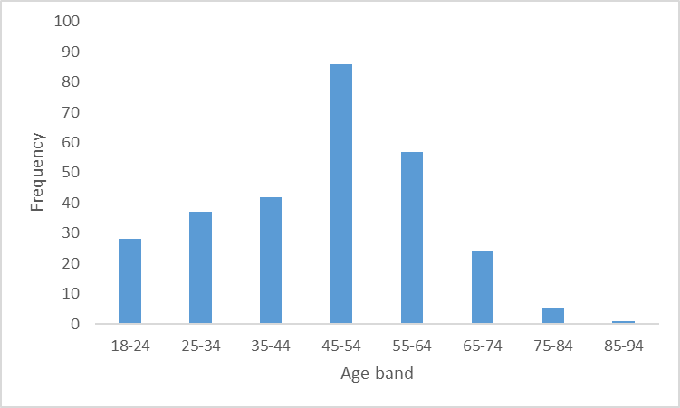

Source: NDA FACE Profiles

Table 8.11 below presents an analysis of participants by age-band and living arrangements. Younger participants were more likely to be living in the family home. Just over one in four (26.8%) Phase 2 participants lived in their family home but two-thirds (67.9%) of participants aged 18-24 and six in ten (61.5%) participants aged under 35 lived in their family home. In contrast, less than 10% of participants aged 55 or over lived in their family home. The five participants who had a shared-care living arrangement, and thus relied heavily on family support, had an average age that approximated to participants living with their families (37.8 years versus 36.6 years).

There were only minor differences in the average age of participants living in community residential homes, congregated settings, specialist units and with live-in-carers. Participants living in nursing homes had the highest average age but as only two participants had this living arrangement this must be interpreted with caution.

Table 8.11: Living arrangements by age

| Age-band | 18-24 | 25-34 | 35-44 | 45-54 | 55-64 | 65-74 | 75-84 | 85-94 | Total | Average age |
| --- | --- | --- | --- | --- | --- | --- | --- | --- | --- | --- |
| Comm. Res | 3 | 7 | 17 | 40 | 26 | 12 | 2 | 1 | 108 | 51.4 |
| Congregated | 4 | 1 | 3 | 12 | 12 | 3 | 2 | 0 | 37 | 51.6 |
| Family | 19 | 21 | 13 | 14 | 5 | 2 | 1 | 0 | 75 | 36.6 |
| Live-In-Carer | 0 | 0 | 1 | 5 | 2 | 0 | 0 | 0 | 8 | 50.8 |
| Nursing home | 0 | 0 | 0 | 1 | 0 | 1 | 0 | 0 | 2 | 59.5 |
| Shared care | 1 | 1 | 2 | 0 | 1 | 0 | 0 | 0 | 5 | 37.8 |
| Special Unit | 0 | 1 | 0 | 1 | 1 | 1 | 0 | 0 | 4 | 52 |
| Supp. Living | 1 | 6 | 6 | 13 | 10 | 5 | 0 | 0 | 41 | 49.3 |
| Total | 28 | 37 | 42 | 86 | 57 | 24 | 5 | 1 | 280 | 45.7 |

Source: NDA FACE Profiles

### Primary disabilities and multiple disabilities

Table 8.12 below provides a breakdown of the primary disability of Phase 2 participants. Participants with an intellectual disability included individuals with conditions such as Down Syndrome, Cerebral Palsy, and other congenital syndromes and developmental disorders. Participants with autism and an intellectual disability were also included within this category. Given this diversity it must be recognised that the support needs of individuals within this group were also likely to differ.

A small number of participants had profound intellectual and multiple disabilities. These were described as having a primary intellectual disability but their secondary physical and sensory impairments were often as serious as their intellectual disabilities.

Relative to the population of individuals with a disability, Phase 2 participants included a disproportionate number of individuals with intellectual disabilities. Individuals with intellectual disabilities are heavily reliant on disability services. The majority of individuals receiving residential supports are individuals with an intellectual disability. As only adults in receipt of disability services met the criteria for inclusion in this study, the presence of a high proportion of individuals with intellectual disability was anticipated.

Table 8.12: Primary disability of Phase 2 participants

| **Primary disability** | **Number of participants** | **% of participants** |
| --- | --- | --- |
| Intellectual | 214 | 76.4 |
| Physical | 38 | 13.6 |
| ABI | 12 | 4.3 |
| Sensory | 7 | 2.5 |
| Mental illness | 5 | 1.8 |
| Autism- No ID | 4 | 1.4 |
| Total | 280 | 100.0 |

Source: NDA FACE Profiles

Although participants were not recruited from within mental health facilities five participants had a primary disability of mental illness. Two of these participants also had an intellectual disability.

Table 8.13 below details the presence of multiple disabilities among Phase 2 participants. More than seven in ten (71.8%) participants had two or more disabilities and over one in five (21.8%) participants had three or more disabilities. Compared to participants from priority sites, Phase 2 participants were less likely to have multiple disabilities. Secondary sensory impairments are likely to be understated, as hearing and vision impairments recorded in the Word version of FACE are not exported to Excel. Our analysis only captured sensory impairments recorded as a condition/disability that impacts wellbeing.

Table 8.13: Number of disabilities - Phase 2 participants

| **Number of disabilities** | **Number of participants** | **% of participants** | **Cumulative % of participants** |
| --- | --- | --- | --- |
| 4 | 7 | 2.5 | 2.5 |
| 3 | 54 | 19.3 | 21.8 |
| 2 | 140 | 50 | 71.8 |
| 1 | 79 | 28.2 | 100 |
| Total | 280 | 100.0 |  |

Source: NDA FACE profiles

Participants with a primary physical disability were less likely than other participants to have two or more disabilities (See Figure 8.2). Just over four in ten participants with a physical disability (42.1%) had two or more disabilities. All four participants with Autism and no intellectual disability also reported mental health difficulties.

**Figure 8.2: Multiple disabilities by primary disability**

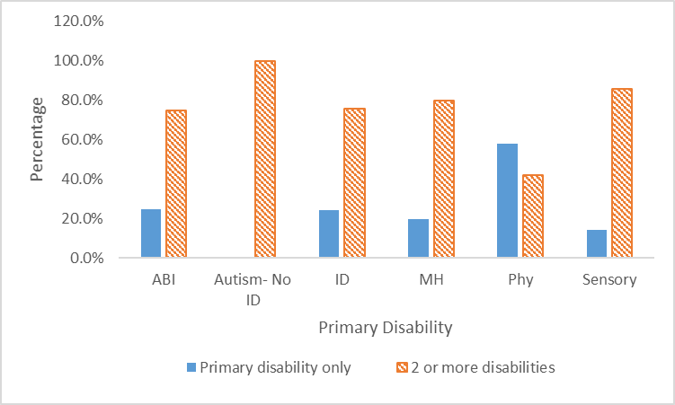

Source: NDA FACE Profiles

### Employment

As illustrated in Table 8.14, just nine Phase 2 (3.2%) participants indicated that they worked 20 or more hours per week while 55 (19.7%) participants worked less than 20 hours. Four of those employed for more than 20 hours a week had a primary physical disability. Four participants with an intellectual disability were also employed for 20 or more hours a week. Two of these participants were employed by a disability service provider. The remaining participant in full-time employment was an individual with Autism without an intellectual disability. Many participants engaged in part-time employment worked for fewer than five hours per week.

Table 8.14: Employment status of Phase 2 participants

| **Employment status** | **Number of participants** | **% of participants** |
| --- | --- | --- |
| Working 20 hours or more | 9 | 3.2 |
| Working less than 20 hours | 55 | 19.7 |
| Voluntary work | 18 | 6.4 |
| Not working-seeking employment | 30 | 10.7 |
| Not working-not seeking employment | 168 | 60.0 |
| Total | 280 | 100.0 |

Source: NDA FACE Profiles

Phase 2 participants include 30 participants aged 65 and over. If employment rates are re-calculated after excluding participants aged over 65, the full-time (20 hours or more) employment rate increases to 3.6% and the part-time employment rate to 22% or a total of 25.6%. Seven in ten participants were not undertaking any form of paid or voluntary work. Just 15% of unemployed participants were seeking employment. Participants with an acquired brain injury or a primary intellectual disability were especially likely to not be in paid or voluntary employment. Participants with autism but no intellectual disability were most likely to be in paid or voluntary employment. The high proportion of participants disengaged from the labour force and inactive is of concern.

### Education

Participation in education was especially low amongst participants who had a primary disability of an ABI or a mental illness. Participants who attended a day centre that provided educational modules (such as literacy and numeracy; computer skills; life-skills) were assessed as being in part-time education. Two of the three participants in full-time education were individuals with Autism without an intellectual disability. One participant with a physical disability was also in full-time education. Table 8.15 illustrates the educational status of Phase 2 participants.

Table 8.15: Educational status of Phase 2 participants

| **Educational status** | **No.** | **%** |
| --- | --- | --- |
| Not in education | 213 | 76.1 |
| Part-time | 64 | 22.9 |
| Full-time | 3 | 1.0 |
| Total | 280 | 100.0 |

Source: NDA FACE Profiles

### Communication Difficulties

Compared to males, female participants were 1.2 times more likely to have none/mild communication difficulties. Consistent communication difficulties were reported by male participants 3.3 times more often than females. The proportion of male participants unable to communicate or with severe communication difficulties was double (1.99) that of female participants. Table 8.16 presents the level of communication difficulty by gender.

Table 8.16: Communication difficulties by gender

|  | **None** | **Mild** | **Consistent** | **Severe** | **Unable** | **Total** |
| --- | --- | --- | --- | --- | --- | --- |
|  | % | % | % | % | % | % |
| Female | 71.0 | 16.1 | 2.4 | 4.8 | 5.7 | 100.0 |
| Male | 47.0 | 24.2 | 8.0 | 11.3 | 9.5 | 100.0 |
| Total | 56.1 | 20.4 | 5.4 | 10.4 | 7.9 | 100.0 |

Source: NDA FACE Profiles

### Safeguarding concerns

The living arrangement of participants with the highest proportion (50%) of concerns was nursing homes. However, given the small number of participants resident in nursing homes this should be interpreted with caution. Participants living in other congregated settings reported concerns regarding how others treated them more frequently (18%) than those living in community residences (16%) or in their family homes (15%) but this difference was not significant.

The two centres with the highest proportion of participants who reported concerns regarding how they are treated were operated by private service providers, but the research team note that the small number of participants within these centres prevents us from drawing any conclusions from this finding.

Many of the concerns noted were very minor. Most concerned interactions with other service users or, less frequently, with family members. However, other concerns were more serious:

Rachel said that the behaviour of her flatmate can distress her and she believes it contributes to her seizures (FACE profile, interviewer).

Gerard’s brother has been verbally abusive and the guards have been called on a couple of occasions! (FACE profile, interviewer).

Sometimes the children at the bus stop push and shove and Sandra is not able to get on the bus- she feels that the children do not behave respectfully (FACE profile, interviewer).

Denise said she gets bullied every day (by other service users) (FACE profile, interviewer).

A small proportion of the concerns related to the behaviour of staff. Keith reported that a staff member (Joe)[21] shouts sometimes but noted that Joe ‘doesn't put a hand on him’. Keith added that Joe wants everything done now. He said ‘he’s always on about stuff like tidying my room and going to day service.’ The staff member that accompanied Keith confirmed that there are tensions between him and the named staff member. Another service user, Anthony, was reported as thinking that some people are not very nice to him – he “feels that one of the staff members bullies him”.

Participants also sometimes recounted details of abuse experienced in the past. Two participants recounted details of sexual abuse. One of these participants had not previously disclosed the abuse she experienced. The disclosure of her abuse resulted in an investigation that was referred to An Garda Siochána.

### Mental Health

An analysis of mental ill health by primary disability is set out in Table 8.17 below and indicates that participants with a primary physical disability were the least likely to report mental ill health. Mental ill health was especially common in participants with Autism and ABI.

Table 8.17: Mental ill health by primary disability

| **Primary Disability** | **Number with a mental health disorder** | **% with a mental health disorder** |
| --- | --- | --- |
| ABI | 7 | 58.3 |
| Autism | 4 | 100.0 |
| Intellectual Disability | 70 | 32.7 |
| Mental Health | 5 | 100.0 |
| Physical | 9 | 23.7 |
| Sensory | 3 | 42.9 |
| Total | 98 | 35.0 |

Source: NDA FACE Profiles

An analysis of mental health difficulties by living arrangements indicated that participants living in community residences and in shared care had the highest rate of mental ill health (40.7% and 40% respectively). Those with a live-in-carer or living in their family homes reported the lowest rate of mental ill health (25% and 28% respectively).

### Emotional wellbeing

While only a small proportion of participants reported severe emotional difficulties, they were more common among male participants (see Figure 8.3).

Figure 8.3: Emotional difficulties-Phase 2

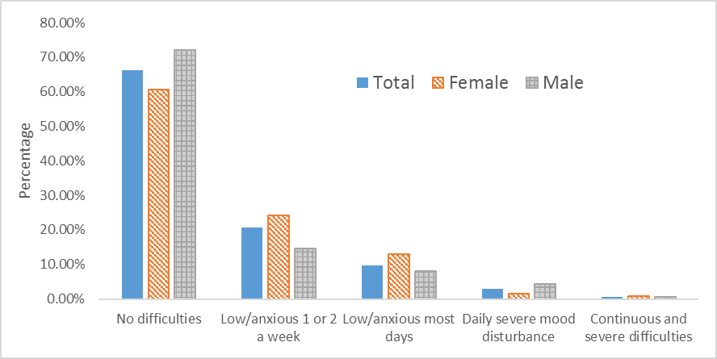

Source: NDA FACE Profiles

### Behaviours of concern

A comparison of behaviours of concern by primary disability indicated that those with a physical disability were least likely (7.9%) to report any behaviours of concern. No participant with a physical disability reported behaviours with a history of harm to self or others or behaviours that posed a constant or severe concern of harm.

Compared to female participants, male participants were 1.5 times more likely to report having either behaviours of concern with a history of harm to self or others, or behaviours that present a constant and severe concern of harm to self or others (See Table 8.18).

Table 8.18: Behaviours of concern-Phase 2

|  | **Total** | **Total %** | **Female %** | **Male %** |
| --- | --- | --- | --- | --- |
| None | 190 | 67.9 | 73.4 | 61.0 |
| Occasional behaviour out of the ordinary | 38 | 13.6 | 12.9 | 14.7 |
| Behaviour of concern-no history of harm | 10 | 3.6 | 1.6 | 5.9 |
| Behaviour of concern-history of harm to self or others | 35 | 12.5 | 11.3 | 14.0 |
| Constant severe concern of harm to self or others | 7 | 2.5 | 0.8 | 4.4 |
| Total | 280 | 100 | 100.0 | 100.0 |

Source: NDA FACE Profiles

### Physical Health

One in eight (12.5%) phase 2 participants indicated that they experience pain or distress as a result of a physical condition or medication (Table 19). Participants with a primary physical disability reported pain/distress more commonly than participants with other disabilities.

Table 8.19: Distress/pain by primary disability

| **Primary Disability** | **No significant distress or pain %** | **Mild distress or pain %** | **Moderate or severe distress or pain%** | **Total %** |
| --- | --- | --- | --- | --- |
| ABI | 91.7 | 8.3 | 0.0 | 100.0 |
| ASD | 100.0 | 0.0 | 0.0 | 100.0 |
| ID | 90.7 | 8.4 | 0.9 | 100.0 |
| MH | 80.0 | 20.0 | 0.0 | 100.0 |
| Physical | 65.8 | 21.0 | 13.2 | 100.0 |
| Sensory | 100.0 | 0.0 | 0.0 | 100.0 |
| Total % | 87.5 | 10.0 | 2.5 | 100.0 |
| Total N | 245 | 28 | 7 | 280 |

Source: NDA FACE Profiles

More than one in five (22.5%) Phase 2 participants had epilepsy. Participants with an ABI reported epilepsy more commonly than participants with all other primary disabilities. One third of participants with an ABI had epilepsy. This compares to a quarter of participants with intellectual disability and less than one in twelve (7.9%) of those with a primary physical disability. No participants in other disability categories reported epilepsy.

More than one in five (22.1%) participants required support to manage skin conditions or to prevent skin conditions developing. Eight participants reported pressure ulcers and all had reduced mobility due to a physical disability (six had a primary physical disability and two a primary intellectual disability). Four participants with a pressure ulcer lived in their family home, two lived in a congregated setting and one lived in a community residence. With one exception the pressure ulcers were considered minor. The participant with a severe pressure ulcer was morbidly obese and lived in a congregated setting.

### Activities of Daily Living

Figure 8.4 below provides a frequency table of ADLs scores. More than four in ten (43.2%) had a ADLs score of 0 and almost half (48.6%) of participants had a score of 0 or 1. Half of the participants with an ADL score of 0 had an indicative Global Need Band of 5 or 6. This apparent anomaly is attributed to the weight given to the need for a constant safety presence in assessing Global Need Band and tendencies towards risk averse practices on the part of both support staff and family members.

Figure 8.4: Distribution of ADL scores

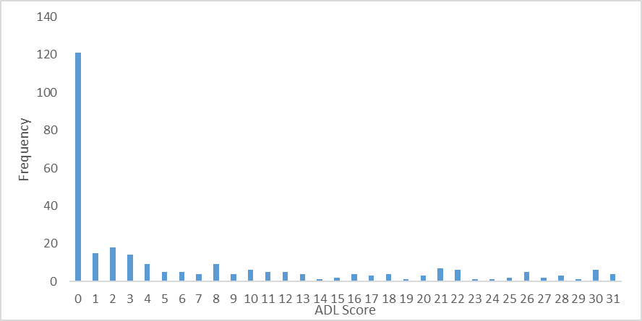

Source NDA FACE profiles

A cross-tabulation of ADL scores with behaviours of concerns indicated that participants with moderate support needs (ADL score 10-19) had the highest incidence of behaviours of concern (Figure 8.5). Compared to all other Phase 2 participants, those with very low ADLs scores (0-1) and those with high ADL scores (20+) were less likely to report behaviours of concern. As noted above, most participants who reported behaviours of concern had a primary intellectual disability.

**Figure 8.5: Comparison of behaviours of concern and ADL scores**

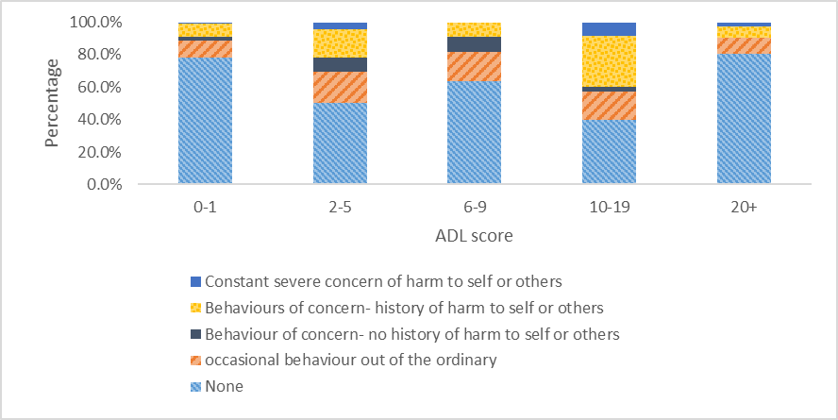

Source NDA FACE profiles

An analysis of ADL scores by primary disability highlighted a significant disparity in the support need to undertake ADLs by type of disability. The average ADL score of participants with a physical disability was 13.5 (see Figure 8.6). This compares to an average score of 5.9 for those with an intellectual disability. All participants with autism and no intellectual disability and those with a primary disability of mental health had an ADL score of 0.

**Figure 8.6: ADL score by primary disability**

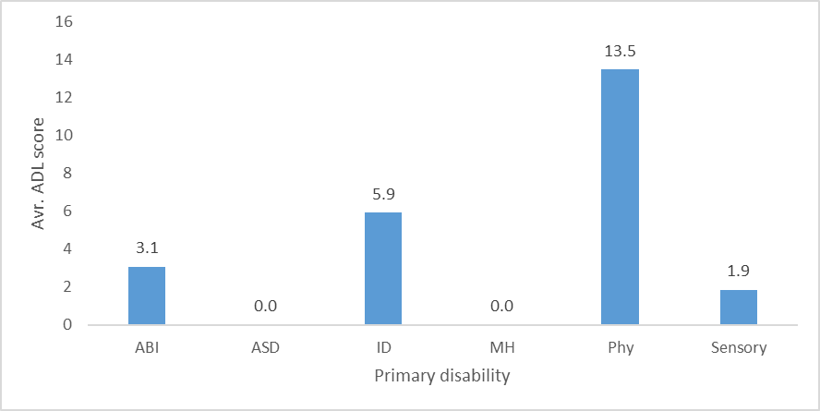Source: NDA calculations

Table 8.20 below sets out an analysis of ADLs scores by living arrangement. On average participants with supported living arrangements and those living in their family homes required lower support to undertake ADLs than participants with other living arrangements.

Table 8.20: ADLs by living arrangement

| **Living arrangement** | **Mean ADLs score** | **Median score** | **Range** |
| --- | --- | --- | --- |
| Comm. Res | 7.6 | 3 | 0-31 |
| Congregated | 10.6 | 5 | 0-30 |
| Shared Care | 19.0 |  | 0-30 |
| Live-in-carer | 10.6 |  | 0-24 |
| Supp. Living | 1.8 | 0 | 0-21 |
| Family | 3.8 | 0 | 0-25 |
| Total | 6.6 | 2 | 0-31 |

Source: NDA FACE Profile

ADL scores were also analysed based on the primary support service provided to participants. All participants receiving ancillary and minimal supported living assistance had an ADL score of 0 or 1 indicating they required little or no assistance to undertake ADLs. It is notable that one in five of those in shared care or living in congregated settings and almost four in ten of those living in community residences also had ADL scores of 0 or 1. No participant receiving intensive supported living assistance had an ADL score of 0 or 1.

Most of those with ADL scores of 20 or more were receiving residential supports or intensive supported living assistance (Figure 8.7). However, three participants with ADL scores of 20 or more were receiving lower levels of support (Day Centre: 1; Support Low: 1; Support High: 1). Two of these three participants were living in their family home.

Figure 8.7: ADL scores by primary support service

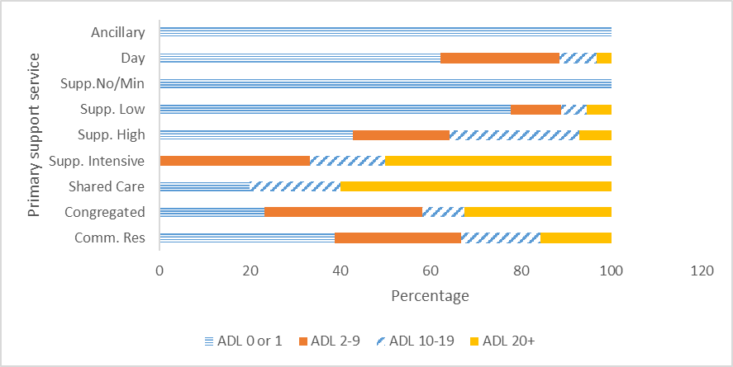

Source: NDA FACE Profile

#### Dressing/undressing

Table 8.21 below sets out the level of assistance required by participants to dress and undress. More than six in ten (63.5%) participants did not require any assistance dressing. A slightly higher proportion (65.0%) of participants, were able to undress independently. One in five participants were not able to assist in dressing or undressing themselves and required one or two others to undertake this task.

Table 8.21: Assistance required dressing and undressing

| **Level of assistance required** | **Dressing %** | **Undressing %** |
| --- | --- | --- |
| Little/none | 63.5 | 65.0 |
| Sometimes needs help | 5.4 | 6.1 |
| Always needs help | 11.1 | 8.9 |
| Unable to manage- needs one other | 11.4 | 11.8 |
| Unable to manage- needs two others | 8.6 | 8.2 |
| Total | 100.0 | 100.0 |

Source: NDA FACE profiles

#### Assistance toileting

A third of participants (33.2%) required assistance toileting (Table 8.22). Female participants were less likely to require assistance with toileting than males. Males were 2.6 times more likely than females to have the highest level of difficulty toileting requiring the assistance of two individuals.

One in five participants were not able to assist in toileting and required one or two others to undertake this task.

Table 8.22: Assistance toileting

| **Assistance required** | **Total** | **Total%** |
| --- | --- | --- |
| Little or no difficulty | 187 | 66.8 |
| Sometimes needs help | 25 | 8.9 |
| Always needs help | 13 | 4.6 |
| Unable to manage - needs one other | 32 | 11.4 |
| Unable to manage - needs two others | 23 | 8.2 |
| Total | 280 | 100.0 |

Source: NDA FACE profiles

#### Assistance with personal hygiene and washing whole body

As Figures 8.8 and 8.9 below illustrate almost six in ten (58.6%) did not require any assistance with personal hygiene and almost half (48.6%) of participants were able to wash their whole bodies without assistance. Compared to other ADL, washing whole body was the task that the smallest proportion of participants were able to undertake independently. It was noted that many participants with high functional ability were assisted in this task. A reason commonly cited for assistance with this task was the person’s difficulty rinsing shampoo or conditioner from their hair. This did not seem consistent with a personal care plan that promoted independence (HIQA 2014, p.5). The need for the temperature of the water to be checked was also cited by several participants as a reason for requiring assistance with this task. It would be preferable if modifications necessary to control water temperature were put in place rather than support staff or family members checking the water temperature.

More than one in five participants (22.2%) were unable to undertake personal hygiene activities. Some profiles noted particular aspects of personal hygiene such as shaving or hair washing that participants were unable to undertake.

Figure 8.8: Assistance with washing whole body

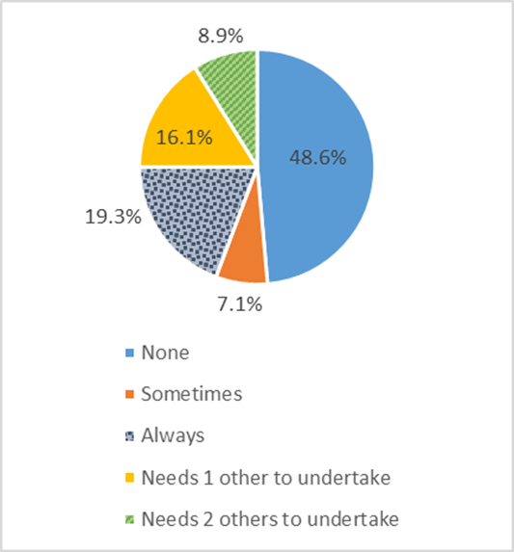

Figure 8.9: Assistance with personal hygiene

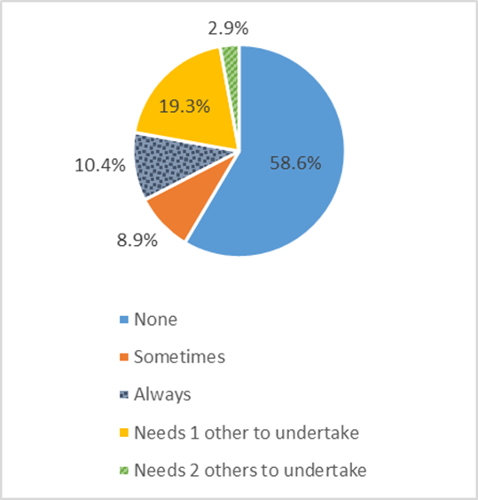

Source: NDA FACE profiles

One in four (25%) participants were not able to assist in washing their own bodies and needed either one (16.1%) or two (8.9%) others to undertake the task.

#### Transfers

Three-quarters (75.3%) of participants were able to undertake transfers independently. Forty-three (15.4%) participants were unable to manage and required one or two others to undertake transfers (see Figure 8.10 below).

Figure 8.10: Assistance required with transfers

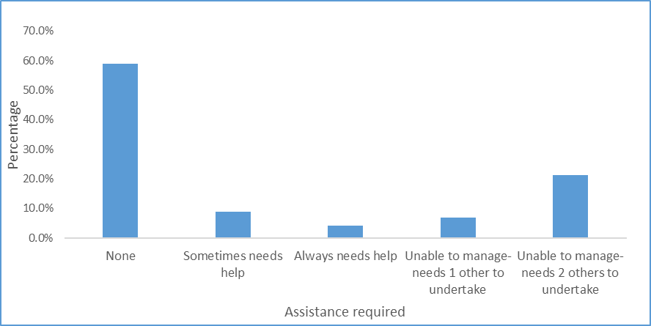Source: NDA FACE profiles

An analysis of the living arrangements of participants who were unable to transfer is set out in Table 8.23 below. The analysis indicated that 20 of the 24 participants who required 2 others to undertake were living in community residential or congregated settings. Three were in shared care and one was living in their family home. The living arrangements of those requiring one other to undertake transfers were more diverse and included participants with supported living arrangements and those with live-in-carers. Living arrangements may impact both the support offered and the perception of the support required for this task. Transfers undertaken by a single family member or PA might be undertaken by two members of staff in a community residence or congregated setting.

Table 8.23: Assistance with transfers by living arrangement

| **Living arrangement** | **Needs 2 others to undertake** | **Needs 1 other to undertake** |
| --- | --- | --- |
| Comm. Res | 10 | 6 |
| Congregated setting | 10 | 5 |
| Shared care | 3 | 0 |
| Live-in-carer | 0 | 3 |
| Family | 1 | 3 |
| Supp. living | 0 | 2 |
| Total | 24 | 19 |

Source: NDA FACE Profiles

Almost one in five (18.2%) participants were non-weight bearing. The primary reason for an inability to weight-bear is likely to be a physical disability. Obesity, when combined with a physical disability, can also result in a person being unable to weight-bear. Eighteen participants indicated that their weight impacted their mobility. Of these, eight were non-weight bearing and were unable to undertake transfers.

#### Staying comfortable and repositioning

Almost nine in ten (87.1%) participants were able to reposition themselves independently (See Figure 8.11 below). Participants required less assistance in this task than in any other ADLs. Only a small minority of participants (6.1%) were unable to undertake this task.

Figure 8.11: Staying comfortable and repositioning

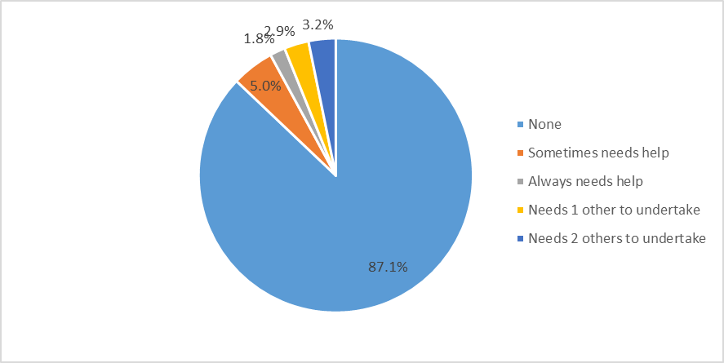

Source: NDA FACE profiles

#### Instrumental Activities of Daily Living

The IADL scores for Phase 2 participants ranged from 0 to 14 (Figure 8.12). The mean score was 8.7 and the median score was 9. The modal score was 14 with almost one in five (18.6%) participants requiring maximum assistance with all IADLs.

Figure 8.12: Distribution of IADLs scores

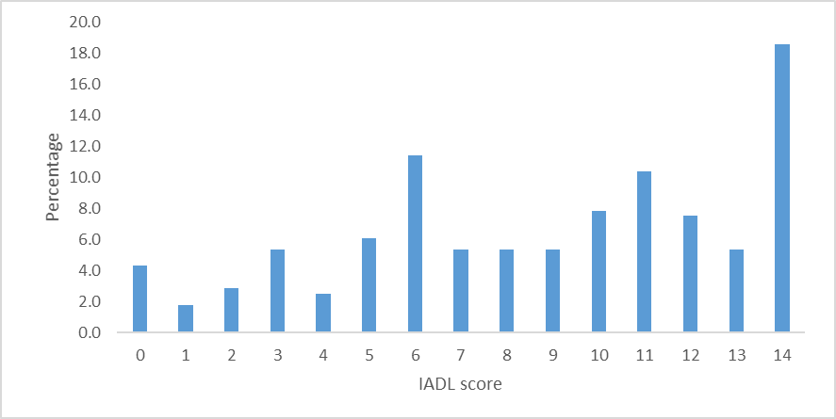

Source: NDA FACE profiles

An analysis of IADL scores by primary disability indicated that, on average, participants with a physical disability had higher IADL scores, and therefore required more assistance with IADLs, than participants with other types of disabilities (see Table 8.24 below). Participants with autism and no intellectual disability needed the lowest level of assistance with IADLs. Three of the four participants with autism only received ancillary support. The remaining participant with autism and no intellectual disability lived in a congregated setting.

Table 8.24: IADLs by primary disability

| **Living arrangement** | **Mean IADLs score** | **Median score** | **Range** |
| --- | --- | --- | --- |
| ABI | 8.4 | 8.5 | 2-14 |
| Autism | 2.0 | 2 | 1-4 |
| Intellectual disability | 8.9 | 10 | 0-14 |
| Mental health | 5.8 | 5 | 3-12 |
| Physical | 9.3 | 10 | 1-14 |
| Sensory | 7.6 | 6 | 3-14 |
| All Phase 2 participants | 8.7 | 9 | 0-14 |

Source: NDA FACE profiles

IADL scores were also analysed based on the primary support service provided to participants (see Figure 8.13). IADL scores were split into two bands; a lower band of 0-7 and a second, higher, band of 8-14. All of those with a shared care service or with intensive supported living assistance had IADL scores in the higher band. All participants with minimal supported living assistance had IADL scores in the lower 0-7 range. Participants whose primary support was a day service were almost equally divided between the two bands.

**Figure 8.13: IADL scores by primary support service**

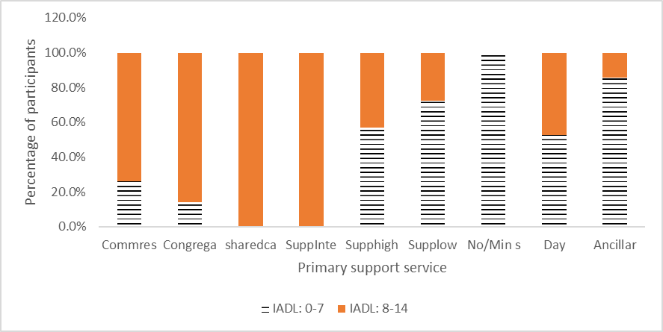

Source: NDA FACE profiles

An analysis of IADL scores by living arrangements revealed significant variation in scores (see Table 8.25). The average IADL score of participants with supported living arrangements was 3.7, significantly lower than the average score of participants in all other living arrangements. In contrast, participants with a shared care arrangement had an average IADL score of 13, significantly higher than the average IADL for all Phase 2 participants and higher than the average score for all other living arrangements. Participants living in their family home had an average IADL score of 7.8, slightly lower than the overall average score. The average IADL score for participants with a live-in carer was 8.8 and approximated to the mean of 8.7 for all Phase 2 participants. The average IADL score of participants in community residences and in congregated settings were both higher than average (10.2 and 10.9 respectively).

Table 8.25: Analysis of IADL score by living arrangement

| **Living arrangements** | **Average. IADL Score** |
| --- | --- |
| Supported living | 3.7 |
| Family | 7.8 |
| Live-in-carer | 8.8 |
| Shared care | 13 |
| Community res. | 10.2 |
| Congregated | 10.9 |
| All | 8.7 |

Source: NDA FACE profiles

Participants with IADL scores in the 0-7 band were more likely than those with higher IADL scores to report no behaviours of concern (92.8% versus 74.0%). Those with IADL scores in the lower range were also significantly less likely than those with IADL scores in the higher range to engage in the two most serious categories of behaviours of concern (behaviours of concern with a history of harm to self or others and constant severe risk of harm; 5.4% versus 21.4%).

#### Participants with low IADL and low ADL scores

A comparison of IADL and ADL scores indicated that 86.5% of participants with an IADL score in the lower band (0-7) also had an ADL score of 0 or 1. This indicated that 96 participants, one third of all Phase 2 participants, required little or no support with ADLs and low levels of support with IADLs.

Further analysis of this group revealed that more than nine in ten (91.7%) of this group, had either no behaviours of concern or only occasional behaviours out of the ordinary. The primary support service for this group of 88 participants who had high levels of adaptive behaviour and none or little behaviours of concern is detailed in Table 8.26 below.

Table 8.26: Primary support service of participants with high adaptive behaviour and no or little behaviour of concern

| **Living arrangement** | **No behaviours of concern** | **Occasional behaviours out of the ordinary** | **Total** |
| --- | --- | --- | --- |
| Comm. Res | 16 | 3 | 19 |
| Congregated setting | 2 | 2 | 4 |
| Shared Care | 0 | 0 | 0 |
| Supp. Intensive | 0 | 0 | 0 |
| Supp. High | 5 | 0 | 5 |
| Supp. Low | 11 | 1 | 12 |
| No/Minimal Support | 18 | 0 | 18 |
| Day | 21 | 4 | 25 |
| Ancillary | 5 | 0 | 5 |
| Total | 78 | 10 | 88 |

Source: NDA FACE profiles

The five participants receiving high supported living supports are also of concern. Three of these participants were persons that had recently moved from a congregated settings. Despite their high adaptive functioning it was considered that they needed the reassurance provided by a staff presence at night. Another participant in this category was elderly with no family contact and a very limited social network. The final participant was a person with a physical disability on the fringe of the high support category (21 hours support per week).

An analysis of the support required by participants for each of the IADLs is set out below.

#### Household shopping

One in eight participants indicated that they required little or no assistance to undertake household shopping (see Table 8.27). Six in ten participants needed some assistance to undertake this task and more than one third (36.8%) of participants indicated they would need someone else to undertake household shopping.

Table 8.27: Assistance required with household shopping

| **Assistance required** | **Number of participants** | **%** |
| --- | --- | --- |
| Little/none | 35 | 12.5 |
| Significant - sometimes needs help | 36 | 12.9 |
| Significant - always needs help | 106 | 37.8 |
| Needs one or two others to undertake | 103 | 36.8 |
| Total | 280 | 100.0 |

Source: NDA FACE profiles

Participants living in congregated settings and community residences reported low rates of independence in respect of this task (2.3% and 4.6% respectively). Those with supported living arrangements were most likely to be able to undertake this task independently (41.5%).

#### Preparation of meals snacks and drinks

More than one third (35.3%) of participants required another person to prepare meals/snacks and drinks. Half (49.0%) of participants require assistance sometimes or always. Almost one in six (15.7%) participants were able to undertake this task independently (See Table 8.25).

Table 8.28: Assistance preparing meals/snacks/drinks

| **Support required** | **Number of participants** | **% of participants** |
| --- | --- | --- |
| Little/None | 44 | 15.7 |
| Sometimes needs help | 85 | 30.4 |
| Always needs help | 52 | 18.6 |
| Needs one or two others to undertake | 99 | 35.3 |
| Total | 280 | 100.0 |

Source: NDA FACE profiles

Figure 8.14 below presents an analysis of support to prepare food and drinks by living arrangement. More than half (56.1%) of participants with supported living arrangements were able to prepare meals independently. In contrast none of the eight participants with a live-in-carer were able to undertake food preparation without assistance. Very low levels of independence was also reported by participants living in congregated settings (4.7%) and community residences (5.6%). Participants who lived in their family homes reported slightly higher than average (17.3%) independence in this task. Participants’ accounts suggested that training in food preparation and cooking provided in day centres was often not reinforced by practice in residential settings and family homes.

Figure 8.14: Support for preparation of food and drink by living arrangement

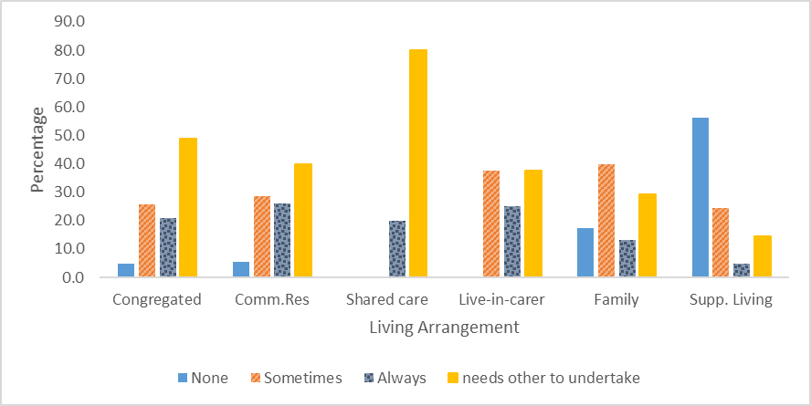

Source: NDA FACE profiles

#### Assistance required to maintain a clean and safe home

More than eight out of ten participants (82.5%) required assistance maintaining their home (see Table 8.29). One in three participants (35.0%) were unable to contribute to the maintenance of their home and needed another person to undertake household tasks.

Table 8.29: Assistance maintaining home

| **Support required** | **Number of participants** | **% of participants** |
| --- | --- | --- |
| Little/None | 49 | 17.5 |
| Sometimes needs help | 54 | 19.3 |
| Always needs help | 79 | 28.2 |
| Needs one or two others to undertake | 98 | 35.0 |
| Total | 280 | 100.0 |

Source: NDA FACE profiles

Participants with supported living arrangements had the highest level of competency with regard to this task. Half of those with supported living arrangements required no assistance to maintain their home. In contrast just 12% of those living in the family home, in community residences and in congregated settings were able to undertake this task independently.

#### Managing paperwork and finances

More than one in five participants indicated that they were able to manage their own paperwork (see Table 8.30). A third of participants indicated that they were able to manage their own finances. In contrast none of the participants in the prioritysites (Phase 1) were able to manage paperwork or their own finances.

Table 8.30: Assistance to manage paperwork and finances

| **Level of assistance required** | **Paperwork** | **Finances** |
| --- | --- | --- |
| Support required | % of participants | % of participants |
| Independent | 22.5 | 33.6 |
| Requires assistance | 77.5 | 66.4 |
| Total | 100.0 | 100.0 |

Source: NDA FACE profiles

#### Support for medication

More than eight in ten (82.5%) Phase 2 participants were taking medication for a physical or mental health condition. The rate of medication usage among Phase 1 participants was 93.8%.

An analysis of medication usage by living arrangements revealed that participants living in their family home had the lowest rate (58.7%) of medication usage. The highest medication usage was among participants with a shared-care arrangement (100.0%) and those living in congregated settings (97.7%). Figure 8.15 below illustrates medication usage by living arrangement.

Figure 8.15: Medication usage by living arrangement

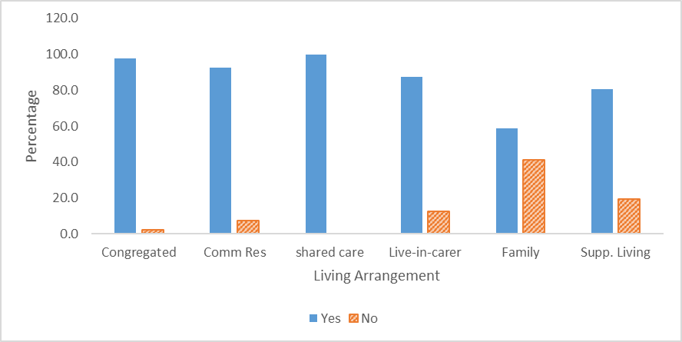

Source: NDA FACE Profiles

The support required by participants who were using medication also varied by living arrangement (see Figure 8.16 below). Almost three-quarters (72.7%) of participants with supported living arrangements required no assistance with the administration of medication but none of those with a shared care arrangement or a live-in-carer and only 2.3% of those in a congregated setting administered their medication independently. One in ten participants living in community residences and more than one in four (27.3%) of those living in their family home were able to administer their medications without support.

One in five participants administered their medication with the assistance of either reminders (6.9%) or supervision (13.9%). Participants living in family homes were especially likely to receive these forms of support to take their medication.

Figure 8.16: Support for medication by living arrangement

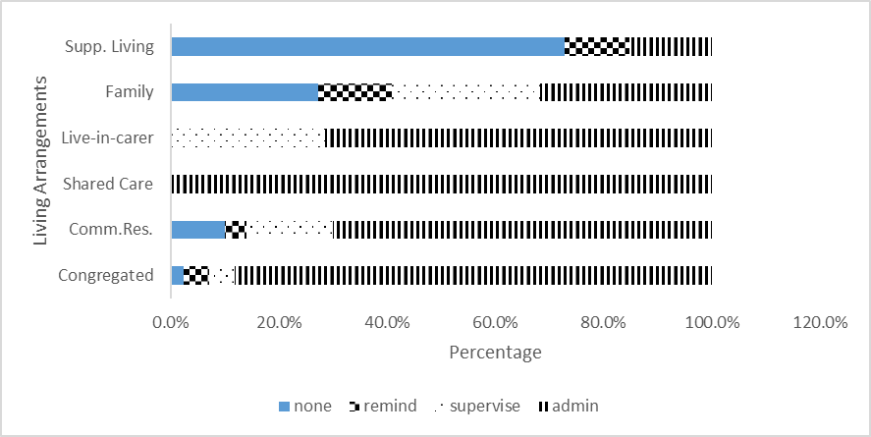

Source: NDA FACE profiles

#### Aids and Devices

Participants were also asked about their use of aids and devices. This is reported on here under ADLs, as aids and devices are often used to assist with ADLs. One in five (19.6%) participants indicated that they were using aids/ technology to assist them at home. Most aids indicated were ‘low-tech’ equipment such as special shower chairs, ceiling hoists and air mattresses. Personal iPads were also a feature in some residential services. Typically iPads were configured with a serious of icons that enabled the user to do tasks like activate their smart TV or connect to You-tube. While two participants used voice activated software to operate their computers, another participant had stopped using it and now preferred to get her PA to type for her. One participant used the HouseMate system that allowed him to do a variety of tasks such as pulling curtains and putting on lights through an app on his phone. None used a voice-controlled device capable of doing a similar range of tasks.

### Formal, informal and natural supports

It is impossible to capture the scale and extent of the supports provided by many parents. Considerable restrictions on parents’ life chances may be inevitable when adult children requiring extensive or pervasive support live in the family home. However, it must be recognised that many, and perhaps most, parents wished to continue to support their adult children. The extracts from the FACE profiles set out below give a sense of the degree to which the lives of some parents were affected by the support needs of their disabled adult child:

Someone is almost always with William. He would only ever be left on his own for a maximum of 15 minutes. William has a sleep system but often needs to be repositioned several times in the night. One parent sleeps in the same room as him- his parents swop places at 3 am each night. William’s father has an upcoming operation and his mother is seeking respite for most of the month of [X]. The family usually gets 12-16 nights respite care a month (FACE profile, interviewer).

Jason can be very restless and agitated. His father sometimes drives for hours with him in the evenings in an effort to calm him (FACE profile, interviewer).

Parents were sometimes grappling with the needs of their adult child with a disability and other caring responsibilities:

Suzanne attends a day centre five days a week. She is in her late 20s and has multiple and profound disabilities. She is peg fed and only has involuntary movements. She lives in the family home with her parents, three siblings and her nephew. Her youngest sibling is in primary school. She attends a day centre Monday to Friday and receives 12 PA hours a week and 6 respite nights a month (FACE profile, interviewer).

Siblings often provided important ancillary support but were rarely primary carers. One participant who lived with their sibling described a situation in which support was mutual:

Geraldine lives with her (unmarried) brother. Their sister visits them regularly. Her brother cooks dinners- he often cooks a large quantity of food and freezes four or five dinners. They share the housework between them. Her brother looks after the bills- she looks after her own money. Geraldine thinks they are safer living together as “we wouldn’t let anyone in (FACE profile, interviewer).

While it was unusual for participants to live with their siblings they often visited their homes and sometimes stayed for short periods at Christmas or during the summer. Even when participants had been in residential care for decades, sibling contact and support often endured.

Orla has been in residential care for most of her life. She stays with her brother at Christmas and Easter and for summer breaks (FACE profile, interviewer).

Teresa spends every second weekend in her sister’s home and also goes there for Christmas and family celebrations (FACE profile, interviewer).

Participants living in residential care settings frequently described very positive contact with both immediate and extended family members.

Nora has lots of contact with her nieces and nephews- she recently celebrated her 70th birthday and got loads of gifts from her family (FACE profile, interviewer).

#### Participants with a preference for formal supports

Some of those with physical and or neuro-degenerative disabilities did not want to receive support or only wanted to receive certain types of support from family members. Laura, a young woman with a physical disability commented:

Your Dad shouldn’t be lifting you in and out of the shower when you are 26 (FACE profile, interviewer).

Laura preferred to accept assistance for personal care from someone outside her family. She also felt that her parents resented having to provide her with support. Her desire for independence and the strained relationships within the family resulted in her moving from the family home to temporary accommodation.

For some participants, not only were they unhappy that their family members were expected to take on the role of a personal assistant, they were also unhappy because they felt their relationship with family members was altered because family members felt obliged to provide them with support. Andrew, a participant with a degenerative neurological condition noted that he received no PA hours at the weekend. His wife worked Monday-Friday and was at home at the weekends. He concluded that the absence of PA hours at the weekend was based on the assumption that his wife, who was approaching retirement age, was willing and able to provide him with the assistance he needed. Andrew felt that the absence of PA support at the weekend placed an undue burden on his wife and on their relationship. Similar sentiments were expressed by Ciara, a young woman with a physical disability who lived alone. She required support during the night but only received PA support one night a week. Consequently, a family member stayed with her six nights a week. Ciara considered that her family should not have to provide this support and particularly resented the fact that her young niece was sometimes called upon to stay with her.

#### Mutual supports

A further extract from FACE profiles which highlights another example of mutual support:

Patrick is a wheelchair user and shares a house with a person with a sensory disability. He helps his housemate by making phone calls on his behalf. His housemate does most of the cooking for them both and has assisted him on a couple of occasions when he fell out of bed. They do a weekly shopping list together and get help with some household chores (FACE profile, interviewer).

#### Negative family relationships and contact

Families were not always a source of support. For some they were a source of distress due to intra-familial abuse, conflict or disengagement. A few participants recounted details of very serious abuse experienced within the family home.

Occasionally, participants and or staff members were concerned with regard to the control exercised by family members over participants’ personal finances. A situation where this arose is described below:

[Staff member] noted that Angela’s brother manages her money and staff have to ask him to provide money for outings/clothes. Staff feel that Angela should have more access to her funds and would get pleasure from buying clothes or having other treats (FACE profile, interviewer).

Paul receives a disability allowance of €203 per week. His mother recently limited him to an allowance of €20 a week. This has cut down the things he can do. Paul uses his money for the lunch out [with the day service] on Friday, and to pay for a weekly fitness class and swimming session. He would like more money to hang out and do stuff (FACE profile, interviewer).

Conflict within families sometimes arose when participants sought to exercise greater independence and control in their lives:

Robert wants to move out of the family home. His parents and siblings are resistant to Robert’s efforts to become more independent. His relationship with his family has become fraught and fractious as a result (FACE profile, interviewer).

The families of some participants had disengaged and distanced themselves from their relative with a disability.

Kathleen used to go for visits to her parents’ house and on the bus to her brother’s house. Her parents recently passed away. Her family has asked not to be contacted (FACE profile, interviewer).

Usually family engagement continued during the lifetime of parents and declined following their death. Occasionally, however, parents chose not to have ongoing contact with their adult child with a disability:

Father has never accepted Pauline. At the request of Pauline’s mother her service provider has agreed that she will not attend local religious services to avoid her father seeing her. Pauline’s mother visits her when she can (FACE profile, interviewer).

#### Caring responsibilities

Some participants who were parents were not able to care for their children now or in the past:

Lorraine lives with her son who has an intellectual disability and autism. Her older daughter has mental health difficulties and is cared for outside the home. Lorraine’s physical disability makes it difficult for her to support her son. She is currently estranged from her daughter (FACE profile, interviewer).

However, we did encounter a small number of participants who were successfully supported to parent their children and others who were supporting their elderly parents:

Amanda has a physical disability and lives with her mother in their family home. Her mother is elderly and in poor health. Amanda reminds her mother to take her medication and helps her to look up things on the internet. She comments: “there’s only two of us so we look after each other (FACE profile, interviewer).

### Summary

Table 8.31 below presents a summary of the key characteristics of both groups.

Table 8.31: Comparison of Phase 1 and Phase 2 participants

|  | **Phase 1 participants** | **Phase 2 participants** |
| --- | --- | --- |
| Global Need Band | 98.6% Global Need Band 6 (highest score) | 59.7% Global Need Band 6 (highest score) |
| Primary disability | Intellectual- 100% | Intellectual-76%  Physical-14%  ABI- 4%  Other-6% |
| Multiple disabilities | 79%- 2 or more  32%- 3 or more | 50%- 2 or more  19%- 3 or more |
| Mental ill health  Serious mental ill health | 53%  43% | 35%  27% |
| Epilepsy | 46% | 23% |
| Behaviours of concern | None-32%  History of harm to self/severe risk of harm-32% | None-61%  History of harm to self/severe risk of harm-18% |
| Communication difficulties | None-6.2%  Severe difficulties/unable to express needs-53% | None- 56%  Severe difficulties/unable to express needs-18% |
| Employment | None | 20 hours or more: 3%  Less than 20 hours: 20% |
| ADL scores | Mean:14.1  Range: 0-31 | Mean: 6.6  Range: 0-31 |
| IADL score | Mean: 12.7  Range: 6-14 | Mean: 8.7  Range: 0-14 |

Source: NDA analysis

# Annex 9: Phase 2 quality of life findings

## Quality of life using ASCOT

An important measure of the quality of disability supports is the degree to which they contribute to the wellbeing and quality of life of the individuals who receive the supports. It should be borne in mind that four in five (80.7%) of Phase 2 participants had a cognitive deficit either due to an intellectual disability (76.4%) or an acquired brain injury (4.3%) thus making it more challenging for them to communicate their assessment of their wellbeing and needs.

As the ER version of ASCOT-SC4 aligns closely to the standard version it was used for all Phase 2 participants regardless of their primary disability. This was considered preferable than using different versions of ASCOT with different cohorts of participants. While most participants without a primary intellectual disability could read and understand ASCOT, some required assistance due to a co-existing intellectual disability, poor/absent literacy skills or visual impairments.

ASCOT was used in conjunction with an acquiescence test (Cummins 2005) which provided a means of screening participants to ensure that they had the cognitive capacity to engage with the tool. The acquiescence test was most useful when participants had moderate intellectual disability and their ability to engage with the tool was uncertain. The screening process determined that eighty-three, or three in ten (29.6%) participants with an intellectual disability, and two, or one in six (16.7%) participants with an ABI, were unable to engage with the tool. The ASCOT tool was administered after the completion of FACE profiles and although participants were offered opportunities to take breaks, it may be that tiredness resulted in some participants failing the acquiescence test. A small number of participants also opted not to engage with the tool. Four participants with a physical disability and one with a sensory disability opted not to complete the ASCOT. These participants might have been more willing to engage with the tool if it had not been preceded by the FACE profiling process. Overall two- thirds (67.9%; n=190) of the 280 Phase 2 participants were able and opted to engage with ASCOT with 186 (97.9%) completing all questions.

The mean ASCOT score for Phase 2 participants was 19.96. The range was 4-24 and the standard deviation was 3.88.[22]

Table 9.1 below sets out an analysis of ASCOT scores based on participants’ primary disability. The average mean scores for participants with a sensory disability, Autism or Mental Ill Health should be treated with some caution as they are based on a small number of participants. The differences between the mean ASCOT scores of those with an intellectual disability and a physical disability were statistically significant.

Table 9.1: ASCOT Scores by primary disability

| **Primary disability** | **Mean ASCOT Score** | **Range** | **Number of participants** |
| --- | --- | --- | --- |
| ABI | 18.9 | 10-24 | 10 |
| Autism (no ID) | 21.0 | 18-24 | 4 |
| Intellectual Disability | 20.6 | 4-24 | 127 |
| Mental Ill Health | 17.2 | 13-23 | 5 |
| Physical | 18.6 | 7-24 | 34 |
| Sensory | 18.3 | 8-23 | 6 |
| Total | 19.96 | 4-24 | 186 |

Source: NDA ASCOT Files

ASCOT scores were also analysed based on the living arrangements of participants. The results are set out in Table 9.2 below.

Table 9.2: ASCOT Scores by living arrangement

| **Living arrangement** | **Mean ASCOT score** | **Range** | **Number of participants** |
| --- | --- | --- | --- |
| Comm. Res | 19.2 | 7-24 | 53 |
| Congregated setting | 18.5 | 4-24 | 22 |
| Shared Care | 19.0 | n/a | 1 |
| Live-in-carer | 21.5 | 18-24 | 8 |
| Family | 20.3 | 8-24 | 63 |
| Supp. Living | 21.1 | 9-24 | 39 |
| Total | 19.96 | 4-24 | 186 |

Source: NDA ASCOT Files

The highest ASCOT scores were reported by participants with live-in-carers. However, due to the small number of participants in this category these results must be interpreted with caution. Only one participant with a Shared Care arrangement completed ASCOT. Hence, the indicated score is an individual rather than composite score. The ASCOT scores reported by participants with supported living arrangements and those living in their family home were significantly higher than the scores of those living in community residences and congregated Settings. The lowest scores were reported by those living in congregated settings.

In this study the maximum score of 24 was reported by 18.3% of respondents. An analysis of participants with a maximum score of 24 revealed that respondents with Autism or an intellectual disability were much more likely to have maximum ASCOT scores than respondents with other types of disabilities (Table 9.3). The proportion of those with an intellectual disability reporting a maximum score was four times that of those with a physical disability. It is not clear if this difference is reflective of more critical and discriminating attitudes among respondents with physical disabilities compared to those with intellectual disabilities or other factors.

Table 9.3: Max. ASCOT score by primary disability

|  | **ABI** | **ASD** | **ID** | **MH** | **Physical** | **Sensory** |
| --- | --- | --- | --- | --- | --- | --- |
| % with max. ASCOT score | 10.0% | 25.0% | 23.6% | 0.0% | 5.9% | 0.0 |

Source: NDA ASCOT Files

The domain with the highest proportion of maximum scores was food & drink (76.3%). Three-quarters of respondents indicated ‘I get all the food and drink I like when I want’. The domain with the lowest proportion of maximum scores was personal safety (outside the home). In response to the question ‘how safe do you feel when you go out?’ just over half (55.0%) of respondents answered ‘I feel very safe when I go out’. All the domains are presented in Figure 9.1.

No respondent indicated a high-level need in relation to one domain: food and drink (I do not get any of the food and drink I like so I might get ill). High-level need was identified in all other areas and ranged from 0.5% to 5.3%. Low rates of high-level need were identified in respect of personal comfort & cleanliness (0.5%) and control over daily life (1.1%). The highest rate of high-level need was identified in respect of social participation and involvement (5.3%) and personal safety outside the home (4.8%).

Figure 9.1: Response to each ASCOT domain

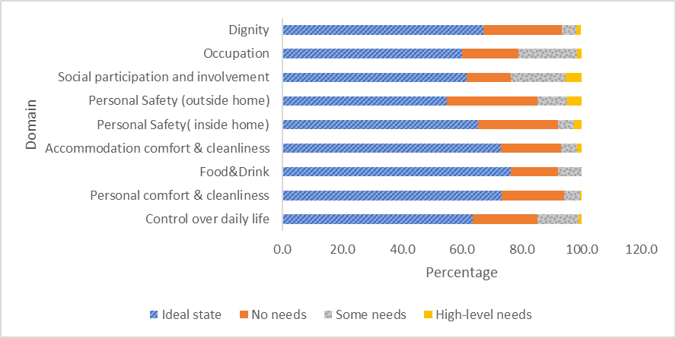

Source: NDA ASCOT files

## Supplementary questions

After completion of the ASCOT, respondents were asked a small number of supplementary questions based on the NDA outcomes framework. Responses to the supplementary questions provide subjective and objective measures of wellbeing. If respondents were judged to lack the capacity to engage with ASCOT they were not asked the supplementary questions. The supplementary questions and the responses are set out below.

### Do you have a key to your door?

Figures 9.2 and 9.3 present data on whether participants had a key to their house by living arrangement and by disability type respectively. Participants living in congregated settings were least likely (23.1%) to have a key to their door, while those with a live in carer (100%) or supported living arrangement (100%) were most likely to have a key. Participants with sensory and intellectual disabilities were less likely than others to have a key to their homes.

Figure 9.2: Key to the door by living arrangement

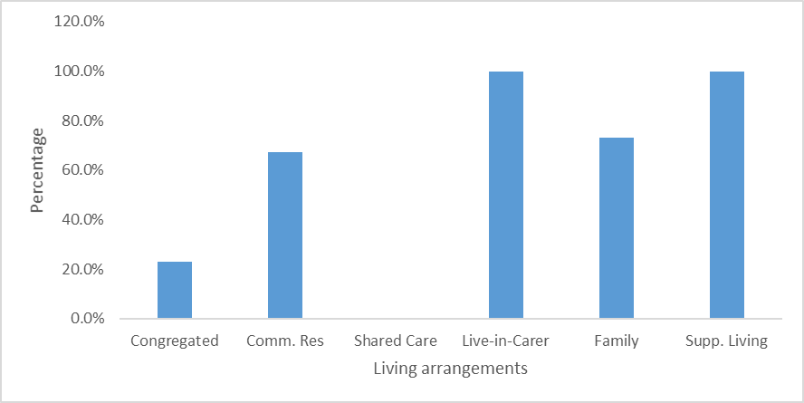

Source: NDA files

**Figure 9.3: Key to the door by primary disability**

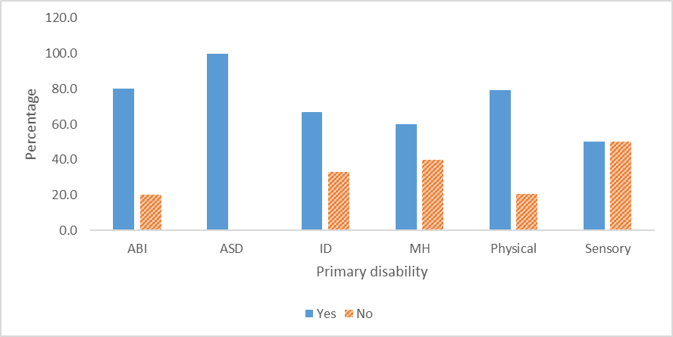

Source: NDA

### Have you had a visitor to your home who has stayed for a cup of tea?

Respondents with a live-in-carer and those living in their family homes were especially likely to respond positively to the question of ‘in the past month has anyone come to have a cup of tea at your house’ (100% and 83.6% respectively). The rate of positive responses in other living arrangements were very similar. Respondents with a primary mental health and sensory disability were least likely to report having a visitor to their home who had a cup of tea (60.0% and 66.7% respectively). However, as the numbers in both these categories were very small, the results may not be generalisable. Respondents with a primary physical or intellectual disability were equally likely to report having a visitor to their home for a cup of tea (20.6% and 20.0%).

### Do you take regular exercise?

As Figure 9.4 below highlights, the proportion of those with a physical disability that reported taking regular exercise was only half that of those with a sensory disability who had the second lowest rate of exercise.

Figure 9.4: Primary disability by exercise

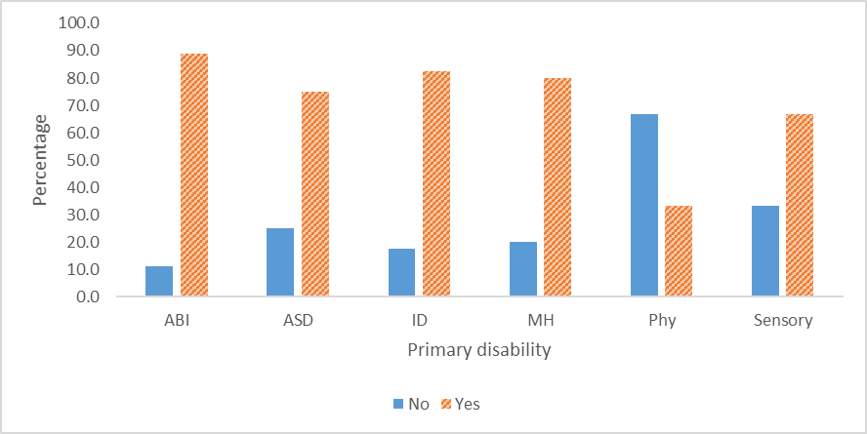

### How do you spend your time most days?

Respondents were asked to indicate how often they undertake seven different activities in order to determine how they spent their time most days. Answer options provided were ‘most days’, ‘some days’ and ‘never’. The activity that respondents were least likely to undertake most days, as outlined in Table 9.4, was volunteering. Attending the day centre and housework were the activities that respondents were most likely to undertake most days.

Table 9.4: Frequency that activities are undertaken

| **Activity** | **Most days**  **%** | **Sometimes**  **%** | **Never**  **%** |
| --- | --- | --- | --- |
| Paid work | 12.3 | 19.8 | 67.9 |
| Training/education/  college | 13.3 | 11.7 | 75.0 |
| Volunteering/ helping others | 2.1 | 26.7 | 71.1 |
| Day centre | 47.9 | 22.9 | 29.2 |
| House work/ helping around the home | 42.5 | 38.7 | 18.8 |
| Going to sports club/sports centre/ swimming/training/  Special Olympics/  walking | 25.0 | 40.4 | 34.6 |
| Cinema/concerts/ daytrips/going to shops/ going to cafe/pub | 17.6 | 77.0 | 5.4 |

High ASCOT scores, indicating a higher quality of life, were found for those who:

* Had paid work
* Exercised sometimes or most days
* Were involved in training
* Were involved in volunteering
* Attended a day centre
* Were involved in housework.

Lower ASCOT scores, indicating a lower quality of life, were noted for those who:

* Never went to cinema/concerts/daytrips/going to shops/ going to cafe/pub

### Relationships

The final supplementary question asked respondents to rate their relationship with support staff, the place where they lived, the people they lived with and the control they had in their life. Respondents had to choose between three answer options: ‘it’s great’, ‘it’s ok’ and ‘not good’. Responses are summarised in Figure 9.5 below.

Figure 9.5: Rating of relationship with support staff, place, people and control

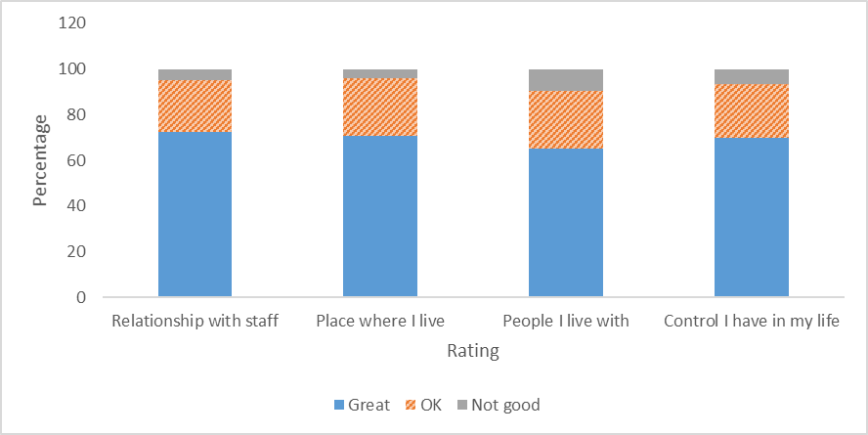

The eight people who said their relationship with their support staff was not good had an average ASCOT total score of 14, down from 20.9 for those who said the relationship was great and 17.2 for those who said it was OK (Table 9.5).[23]

Table 9.5: Total ASCOT score by relationship with support staff

| **Support staff** | **Mean Ascot score** | **N** | **%** | **Std. Deviation** |
| --- | --- | --- | --- | --- |
| Its Great | 20.9 | 118 | 72 | 3.09 |
| OK | 17.2 | 37 | 23 | 3.96 |
| Not Good | 14.0 | 8 | 5 | 5.70 |
| Total | 19.7 | 163 | 100 | 3.98 |

One hundred and forty people answered this question about how the relationship was with people they lived with. The 92 people who said the relationship was great had an average total ASCOT score of 21.1, this fell to 18 for those who said their relationship was OK (Table 9.6). It fell further (and significantly) to 14.5 for those who said their relationship with the people they live with was not good. This average score of 14.5 was one of the lowest total ASCOT scores of any group.

Table 9.6: Total ASCOT score by relationship with the people you live with

| **Relationship** | **Mean** | **N** | **Std. Deviation** |
| --- | --- | --- | --- |
| Its Great | 21.1 | 92 | 3.1 |
| OK | 18.0 | 35 | 3.4 |
| Not Good | 14.5 | 13 | 4.8 |
| Total | 19.7 | 140 | 3.9 |

Source: NDA

## FACE questions relating to quality of life and wellbeing

Figure 9.6 below shows the changes that participants reported would improve their life and wellbeing.

Figure 9.6: Changes that would improve my wellbeing: Phase 2 participants

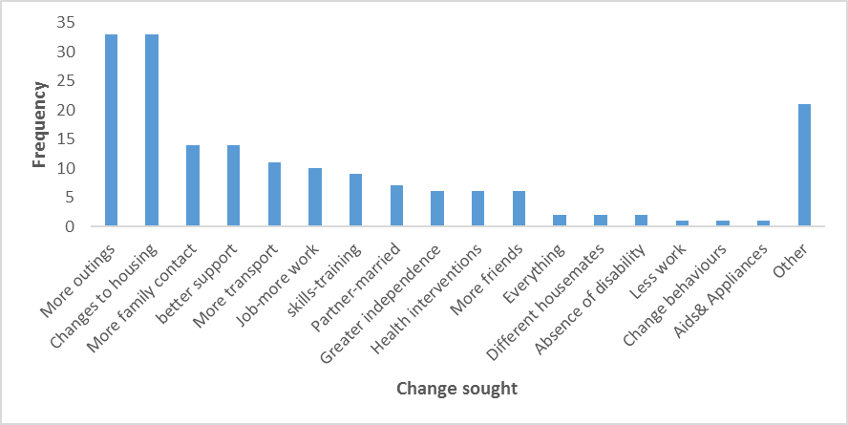

Source: NDA FACE Profiles

Six participants expressed the desire for more contact with existing friends or thought their lives would be better if they had more friends. Of these, three were living alone and two were sharing with one house-mate. Seven participants, including a participant who also wanted more friends, indicated that they wanted to have an intimate partner and/or children. One said:

I want a husband and kids –I’m nearly 30 and it’s time (Participant aged 25-34: Lives in family home).

There were also a lot of uncommon/individual responses which are not represented in Figure 9.6. These included smoking (3), betting (2), statistics (1) and playing on slot machines (1).

Participants were asked about the areas of life that were the most enjoyable / valued (Figure 9.7). Few respondents identified aspects of their lives where they felt they made a contribution. Eighteen people noted that they enjoyed working in either a paid or voluntary capacity and a further seven mentioned their involvement in advocacy as an area of their life that they enjoyed and where they made a contribution.

Figure 9.7: Most enjoyable/valued areas of life number

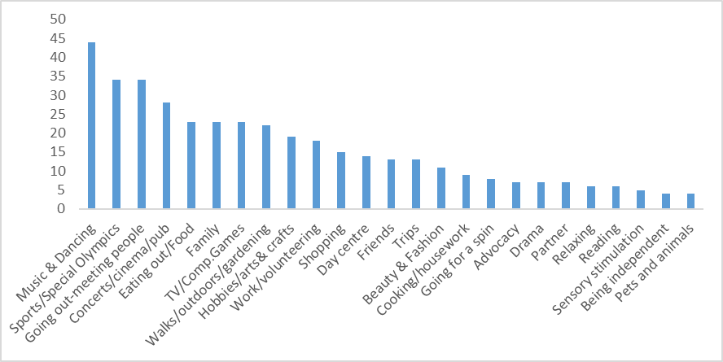

Source: NDA FACE Profiles

## Multivariate analysis

So far the analysis has showed that quality of life – as measured by the total ASCOT score – varies by the service provided and by disability. However, we know that many different variables and elements affect quality of life. Bringing these variables together to form a coherent narrative about how services affect quality of life is challenging, not least because the data is both clustered and nested.

People who attend the same service provider have common characteristics, capacities, experiences, and environmental influences. For instance, people with similar disabilities are likely to score similarly on IADLs and ADLs and will be more alike than people with different disabilities. In turn, people with similar disabilities and capacities are likely to have similar services. This is most likely to be true for people with profound and multiple disabilities that require 24 hour care. This study shows that people with very similar care needs have a variety of living arrangements but statistically they are more alike that people with dissimilar care needs.

This does not mean that all the individuals within a service are identical – just that statistically they are more similar than would be expected from the random allocation of people to services. In turn, these services are likely to have similar – clustered – outcomes. Further, all four levels (disability, capacity, services received, outcomes) affect quality of life (see Figure 9.8). Finally, there may be important feedback loops. For instance pain affects capacity, which might affect the services someone receives which in turn might affect pain level. At the same time pain affects quality of life.

**Figure 9.8: Clustering of characteristics**

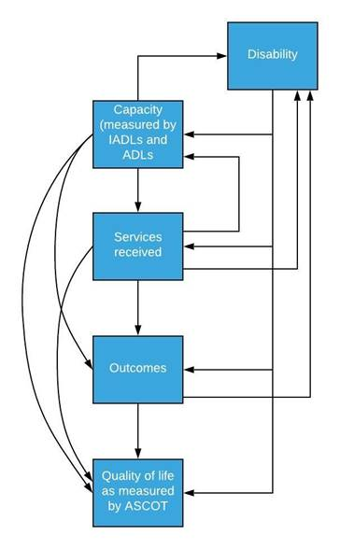

Therefore, analysing quality of life without taking into account the clustered nature of the data risks overstating or understating the importance of some variables. To get some traction on the complexity of the data collected we first explored clusters at each level, we then explored different regression techniques. Unfortunately, the standard Ordinary Least Squares (OLS) regressions demonstrated omitted variable bias – we therefore finished by modelling a Two-Stage least squares (2SLS) regression analysis. A 2SLS is a technique to control for feedback loops and allows us to see the true correlation between the explanatory variables and total ASCOT scores. All clustering methods identified three clusters.

### Capacity cluster

We start with a clustering of functional capacities measured by IADLs and ADLs. IADLs and ADLs are not independent, if you lack capacity to manage your own finances and paperwork it is probable that you also lack the capacity to cook. However the two are not perfectly correlated and understanding how they are related is important to understanding what services a person receives and how that affects their quality of life. [24] Analysis with SPSS shows that IADLs and ADLs were, as expected, clustered. A two-stage analysis divided participants into three clusters (Table 9.7):

Table 9.7: Clusters of IADLs and ADLs

|  | **Cluster 1** | **Cluster 2** | **Cluster 3** |
| --- | --- | --- | --- |
| Inputs IADLS z scores | -0.66 | -0.19 | 1.84 |
| Inputs ADLs z scores | -1.03 | 0.53 | 1.10 |

Source: NDA ASCOT scores

* Cluster 1 had 53 people with above average ADL and IADL scores. The ASCOT scores (for the 14 who completed the ASCOT) was 19.64 – slightly lower than average.
* Cluster 2 had 113 people with below average ADL scores but above average IADL scores The ASCOT scores (for the 63 who completed the ASCOT) was 19.29 – slightly lower than average.
* Cluster 3 had 114 people who had both below average ADL and IADL scores. The ASCOT scores (for the 109 who completed the ASCOT) was 20.39 – slightly above average.

Table 9.8 breaks down clusters by primary disability and Table 9.9 puts these into percentage terms.

Table 9.8: ADL/IADL clusters by primary disability

| **Primary disability** | **1** | **2** | **3** | **Total** |
| --- | --- | --- | --- | --- |
| Acquired Brain Injury | 1 | 5 | 6 | 12 |
| Autism Spectrum Disorder | 0 | 0 | 4 | 4 |
| Intellectual Disability | 37 | 91 | 86 | 214 |
| Mental health | 0 | 1 | 4 | 5 |
| Physical | 15 | 13 | 10 | 38 |
| Sensory | 0 | 3 | 4 | 7 |
| Total | 53 | 113 | 114 | 280 |

Source: NDA analysis

Table 9.9: ADL/IADL clusters by disability %

| **Primary disability** | **Two-step Cluster Number 1** | **Two-step Cluster Number 2** | **Two-step Cluster Number 3** | **Total** |
| --- | --- | --- | --- | --- |
| ABI | 8 | 42 | 50 | 100% |
| ASD | 0 | 0 | 100 | 100% |
| ID | 17 | 43 | 40 | 100% |
| MH | 0 | 20 | 80 | 100% |
| Physical | 39 | 34 | 26 | 100% |
| Sensory | 0 | 43 | 57 | 100% |
| Total | 19 | 40 | 41 | 100% |

Source: NDA analysis

### Services cluster

Services were found to be clustered into three groups.

* Cluster 1 had 107 members who lived in a community residence and lived with six or less people.
* Cluster 2 had 127 people who did not live in a designated centre and tended to live at home and attend day services
* Cluster 3 had 46 people who lived in congregated settings of 10 or more.

While it is gratifying to see services clustering as we expected them to cluster, we did not use this cluster further as we wanted to model the individual effects of services.

### Outcomes cluster

Outcomes were found to be clustered into two groups.

* Cluster 1 had 176 people where someone visited them for a cup of tea, they did regular exercise, they owned the key of their own door, they liked the people who they lived with and they picked their own staff[25], they maintained family contact and received support from their family.
* Cluster 2 had 104 people who were unlikely to have had someone for a cup of tea, they didn’t tend to exercise, they were unlikely to have the key to the door, they were likely to dislike the people they lived with, they were unlikely to have chosen their paid support and were less likely to have family support.

Of interest was the variable for behaviours of concern – this variable was not particularly associated with either cluster. In the first cluster, of the 160 who answered the ASCOT, the average score was 19.85, which is below average. In the second cluster, of the 26 who answered the ASCOT the average score was 20.61, which is above average. This is, at first glance, paradoxical. Those who reported more of the attributes of a good life had a lower ASCOT score. However, this could be explained by the different disability in each cluster (Table 9.10) and other confounding factors.

Table 9.10: Primary disability by outcomes cluster

| **Primary disability** | **Cluster Number of Case 1** | **Cluster Number of Case 2** | **Total** |
| --- | --- | --- | --- |
| ABI | 10 | 2 | 12 |
| ASD | 4 | 0 | 4 |
| ID | 122 | 92 | 214 |
| MH | 4 | 1 | 5 |
| Physical | 30 | 8 | 38 |
| Sensory | 6 | 1 | 7 |
| Total | 176 | 104 | 280 |

Source: NDA analysis

### Regression analysis

The cluster analysis highlighted that individuals grouped together along expected lines. While this was interesting, it did not allow us to explore the role of service provision in contributing to quality of life. This section first does an OLS regression on all the variables of interest, this was followed by a stepwise regression to narrow down the variables of interest and finally we ran a Two-Stage Least Squares (2SLS) regression analysis to account for the feedback loops between the layers of analysis and the correlations between the explanatory variables.

A regression (OLS) of variables on total ASCOT score (Table 9.11) resulted in an adjusted r squared of 0.389. This means that 38.9% of all variance in ASCOT scores was explained by the variables and 61.1% was unexplained. The overall model was significant (*p*<0.001; Table 9.12). This level of explanation is relatively high for a regression on quality of life. Only ten variables are significant at the 10% level.[26]

Table 9.11: OLS regression on total ASCOT score

|  | **Unstandardized Coefficients:**  **B** | **Unstandardized Coefficients:**  **Std. Error** | **Standardized Coefficients: Beta** | **t** | **sig** |
| --- | --- | --- | --- | --- | --- |
| (Constant) | 23.7 | 1.1 |  | 22.0 | 0.0 |
| In pain[27] | -0.9 | 0.6 | -0.1 | -1.7 | 0.1 |
| In great pain | -7.7 | 1.4 | -0.4 | -5.4 | 0.0 |
| Dislikes people they live with[28] | -4.2 | 1.0 | -0.3 | -4.0 | 0.0 |
| Likes people they live with | 1.4 | 0.6 | 0.2 | 2.4 | 0.0 |
| Receives ancillary support | -1.5 | 1.6 | -0.1 | -0.9 | 0.3 |
| Lives in community residence | -2.5 | 0.9 | -0.3 | -2.9 | 0.0 |
| Primary support day service | -2.2 | 0.9 | -0.3 | -2.4 | 0.0 |
| Receives shared care | -3.6 | 4.0 | -0.1 | -0.9 | 0.4 |
| High support needs | -2.6 | 1.2 | -0.2 | -2.2 | 0.0 |
| Intermediate support needs | -0.6 | 1.7 | 0.0 | -0.4 | 0.7 |
| Low support needs | -0.8 | 1.1 | -0.1 | -0.7 | 0.5 |
| No changes - happy[29] | 1.5 | 0.6 | 0.2 | 2.5 | 0.0 |
| Physical disability | -0.4 | 0.6 | 0.0 | -0.6 | 0.5 |
| Sensory disability | -0.8 | 0.7 | -0.1 | -1.1 | 0.3 |
| Mental health issues | -0.4 | 0.5 | 0.0 | -0.7 | 0.5 |
| Sick at the time of interview | -0.5 | 0.9 | 0.0 | -0.5 | 0.6 |
| Acquired brain injury | 1.0 | 1.4 | 0.1 | 0.8 | 0.5 |
| Dementia | 0.8 | 3.4 | 0.0 | 0.2 | 0.8 |
| Epilepsy | -0.2 | 0.8 | 0.0 | -0.3 | 0.8 |
| Autism spectrum disorder | -1.1 | 1.0 | -0.1 | -1.1 | 0.3 |
| Had paid work | -0.5 | 0.5 | -0.1 | -0.9 | 0.4 |
| Had the key of the door | -0.5 | 0.6 | -0.1 | -0.8 | 0.5 |
| Had someone around for a cup of tea in the last month | 0.1 | 0.6 | 0.0 | 0.2 | 0.8 |
| Choose their own staff | 0.5 | 0.6 | 0.1 | 0.9 | 0.4 |
| Take regular exercise | -1.2 | 0.6 | -0.1 | -1.8 | 0.1 |
| Were in a HSE run service | 1.3 | 1.1 | 0.1 | 1.2 | 0.2 |
| ADL score | 0.0 | 0.0 | 0.0 | 0.2 | 0.8 |
| IADL score | -0.1 | 0.1 | -0.1 | -0.8 | 0.5 |
| Said they wanted work | -1.2 | 1.1 | -0.1 | -1.1 | 0.3 |
| Live with 5 or 6 others | 0.5 | 0.9 | 0.0 | 0.6 | 0.6 |
| Live with 7, 8 or 9 others | 0.2 | 2.3 | 0.0 | 0.1 | 0.9 |
| Live with 10 others | -2.4 | 1.0 | -0.2 | -2.5 | 0.0 |

Source: NDA analysis

Table 9.12: ANOVA results

| **Model** | **Sum of Squares** | **df** | **Mean Squares** | **F** | **Sig** |
| --- | --- | --- | --- | --- | --- |
| Regression | 1363.343 | 32 | 42.604 | 4.685 | .000 |
| Residual | 1391.393 | 153 | 9.094 |  |  |
| Total | 2754.737 | 185 |  |  |  |

Source: NDA analysis

Pain, great pain and disliking people you live with were associated with a reduced quality of life. Living in a designated centre, going to a day service, exercising regularly, living with 10 or more people or needing high support was also associated with a lower quality of life. People who said they were happy and didn’t want changes in their life or liked the people they lived with had a higher quality of life score. At first view, this appeared somewhat lopsided – 8 variables are associated with reduced ASCOT score and only two (liking the people you live with and being happy with your services) were associated with increased ASCOT score. However, the constant was 23.7 which was above the mean ASCOT score.

While the OLS regression highlighted some interesting predictors of the total ASCOT score, many of the variables were correlated with each other. To overcome this, a stepwise regression was done on the same variables (Table 9.13). The adjusted r squared of the final model was 0.382. This means that 38.2% of all variance in ASCOT scores was explained by the variables and 61.8% was unexplained. This level of explanation is relatively high for a regression on quality of life. Six variables were significant. Being in pain or great pain, disliking the people you live with, living in any type of community residential facility or sharing with 10 or more people all decreased the ASCOT score. Saying you do not want changes to your services increased the ASCOT score. The exercise variable was no longer included as significant, nor was liking your housemates.

Table 9.13: Stepwise regression of variables on variables on total ASCOT score.

| **Variable** | **B** | **Sig.** |
| --- | --- | --- |
| (Constant) | 21.212 | .000 |
| In great pain | -8.214 | .000 |
| Dislikes people they live with | -4.258 | .000 |
| No changes - happy | 1.877 | .002 |
| Lives in community residence | -1.542 | .002 |
| In pain | -1.333 | .009 |
| Lives with 10 or more people | -1.725 | .012 |

Source: NDA analysis

As the above analysis suggests, there are multiple variables in each cluster – including all variables in an equation will bias the results. Linear regression models assume that the residuals are normally distributed, that each observation is independent of the others, that there is a linear relationship between the independent and dependent variables, and that the variance of the dependent (outcome) variable does not change with the value of the independent variables. A linear regression (OLS) tested positive for missing variable bias so highlighting the need to account for confounding variables.[30]

This means that we have either missed one or more variables or we are mis-specifying the relationship between the variables. A Two-Stage least squares (2SLS) regression analysis is a statistical technique that is used in the analysis of structural equations. This technique is the extension of the OLS method. It is used when the dependent variable’s error terms are correlated with the independent variables. Additionally, it is useful when there are feedback loops in the model.

In 2SLS first each of the independent variables are modelled and then these variables are replaced by their modelled estimates.

Therefore the variables are divided into instrumental variables and predictor variables. Instrumental variables are used to predict the predictor variables (Table 9.14). An instrumental variable is used to account for uncontrolled relationships between variables. Using an instrumental variable to identify the hidden (unobserved) correlation allows you to see the true correlation between the explanatory variable and response variable.

Table 9.14 Predictor versus instrumental

| **ASCOT TOTAL** | **Dependent** |
| --- | --- |
| In pain | Predictor & instrumental |
| In great pain | Predictor & instrumental |
| Lives with at least 10 people | Predictor & instrumental |
| Dislikes the people they live with | Predictor & instrumental |
| Happy, does not want any changes in their life | Predictor & instrumental |
| Lives in community residence | Predictor |
| Were able to choose staff | Instrumental |
| Has a key to their door | Instrumental |
| Has had a visitor for a cup of tea | Instrumental |
| Likes the people they live with | Instrumental |
| Activities of daily living | Instrumental |
| Instrumental activities of daily living | Instrumental |
| Lives in a designated centre | Instrumental |
| Has overnight support | Instrumental |
| Lives in a congregated setting | Instrumental |
| Live with family | Instrumental |
| Primary disability 2 | Instrumental |
| Primary disability 3 | Instrumental |
| Primary disability 4 | Instrumental |
| Primary disability 5 | Instrumental |
| Primary disability 6 | Instrumental |
| Can manage paperwork | Instrumental |
| Can manage finances | Instrumental |
| Has ancillary support | Instrumental |
| Uses day services | Instrumental |
| Uses shared care | Instrumental |
| High support needs | Instrumental |
| Intermittent support needs | Instrumental |
| Low support needs | Instrumental |

This step regression shown in Table 9.15 confirmed all the variables that the stepwise regression had highlighted as important are indeed important– they were all significant and in the same direction as the previous regressions.

Table 9.15: Variables significantly associated with total ASCOT score

|  | **Unstandardized Coefficients: B** | **Unstandardized Coefficients:**  **Standard Error** | **Beta** | **t** | **Sig.** |
| --- | --- | --- | --- | --- | --- |
| (Constant) | 20.644 | .446 |  | 46.330 | .000 |
| In pain | -1.251 | .510 | -.144 | -2.454 | .015 |
| In great pain | -7.931 | 1.290 | -.364 | -6.146 | .000 |
| Lives with10 others | -1.487 | .682 | -.132 | -2.181 | .030 |
| Likes the people they live with | .825 | .475 | .107 | 1.737 | .084 |
| Dislikes people they live with | -3.861 | .940 | -.256 | -4.108 | .000 |
| Lives in a community residence | -1.214 | .494 | -.145 | -2.459 | .015 |
| No changes - happy | 1.882 | .585 | .189 | 3.217 | .002 |

The adjusted R square is 0.381

# Annex 10. Additional examples of Phase 2 reflective diaries

The diversity of the living arrangements of Phase 2 participants made meaningful thematic analysis difficult. Accordingly, a series of observation diaries from different settings are presented. To protect the privacy of participants no observation diaries are presented of family homes.

## Researcher Diary: Congregated setting

This congregated setting is located in an area that is rural but only a short drive from a large urban centre. The area around the campus is not pedestrian friendly. It is not suitable for pedestrians as the roads are narrow and mostly without footpaths. The nearest local shop is about 2 kilometres away. The campus is not within walking distance of public transport. The entrance to the campus is set back from the road. Access to the campus is via a high gate which is opened using a key pad- entry and exit is therefore completely controlled. The locked gate discourages community interaction. Entering the campus feels like entering into a space that is cut-off and separate from the wider community.

Residents are adults with a moderate or severe intellectual disability. All the residents also have mental health issues. Several also have physical disabilities.

Several mini-buses are available for the transport needs of the residents. However, use of these buses depends on availability of staff that are qualified/willing to drive the buses. I visited the campus on two consecutive sunny summer days during which the mini-buses remained at the campus. No connections with local community activities or organisations were evident. I was told that one resident had recently attended a match in the Aviva. When I asked if the resident is ever brought to watch local football or GAA matches I was told: ‘no, not that I am aware of’.

The campus consists of a central administration building and five bungalows. The day centre is housed within the central building. Each of the bungalows has a small garden to the rear and there are large well-maintained grassy areas on both sides of the campus. There are just a couple of pots with colourful bedding plants.

Most of the staff were wearing casual clothes- but some of the nurses wore uniforms.

During my time on the campus I visited two of the bungalows. The staff member that accompanied me opened the door to each of the bungalows with a key. The bungalows feel institutional. The bungalows are large. Each has six bedrooms, a large sitting room which also serves as a dining room, a smaller sitting room, an office, a kitchen, a laundry and linen room, and 3-4 bathrooms. There is a hatch from the large sitting room into the kitchen. I got the impression that access to the kitchen was restricted.

In the first bungalow several residents were sitting on the couches and in armchairs in the sitting room. The furniture appeared functional rather than homely. The TV was on but the residents did not appear to be watching it. A couple of them appeared to be dozing. A door from the sitting room to the rear garden was open but none of the residents had ventured outside. My visit was on a very warm sunny summer day and some were wearing clothes that seemed unsuitable - but the support staff said the residents had chosen their clothes.

I asked if it was possible to see one of the bedrooms. The senior staff member accompanying me agreed and tried the door of the first bedroom on the corridor. The door was locked. I asked if residents have keys to their bedrooms. She said no. I asked if the bedroom was supposed to be locked and she said no. She opened the door of the bedroom with a key. The bedroom held a small single bed, a chest of drawers and a wardrobe. There were several pictures on the walls- they were colourful and were all cartoon or fantasy based. There were no photographs or personal toiletries on display. The room did not feel very comfortable or individual. We went to the next bedroom in the corridor. The door to this bedroom was also locked. Again, the door was opened with a key by the senior staff member. This room was similarly furnished but it also had a television. I was told that the purchase of the television was funded by the individual resident. Like the first bedroom there were no photographs or personal toiletries on display.

Residents attend day centre sessions on the campus. A staff member accompanies them from their bungalow to the central building. Progression may be monitored by day centre staff but there seems to be little or no link between activities in the day centre and the residence.

I was told that some residents do living skills in the day centre and can get awards when they master a skill. However, there seemed to be no effort to encourage these skills by providing them with opportunities to use them in their home. Most bring dirty clothes to the laundry and some straighten their beds - they are not involved in food preparation, cooking or shopping.

This is a well-resourced setting with a high staff: resident ratio. Staff are continuing to implement a range of restrictive practices that limit residents’ opportunities for self-determination and exercising choice and control. The model of service does not seem to be conducive to promoting community inclusion and social connectedness.

## Researcher Diary: Specialist Unit

The centre is situated on a campus setting in a suburban location. The centre was purpose built to cater for the needs of residents with intellectual disability and dementia. All residents have their own bedroom with en-suite facilities. There are designated rooms within the centre for residents to receive visitors. One of the visitors’ rooms has a bed-settee that can be used by family members if they wish to stay overnight when their relative is approaching end-of-life.

There are two distinct areas within the centre - one for mid-stage dementia and one for late stage dementia. There is an open plan space with sitting, dining and kitchen facilities in each area. Residents have access to a courtyard and garden spaces. There is capacity in the centre for 14 residents. On the day I visited there was one vacancy.

Staff interacted with residents in a warm, dignified and very person centred manner. Due to their difficulties with cognition, residents are offered a limited range of activities. Residents with late stage dementia are often bed-bound. Family contact is promoted and enabled by staff. The physical and mental health of residents is monitored regularly.

# Annex 11. Case studies

## Phase 1 Participants

In addition to the case study provided in the main report below is an additional case study on a phase 1 participant that serves as a reminder of the individuals whose life course has been fundamentally shaped by their placement in institutional care and their recent move to homes in the community.

### Case study-Dermot

**Pre transition**

Dermot is in his 50s. He has lived in an institutional setting for over 20 years. His parents are deceased but his siblings call frequently and visit him regularly. From time to time he stays overnight in the home of one of his sisters. He has epilepsy and a history of Grand Mal seizures. He experiences anxiety and has occasional behaviours of concern.

**Post transition**

The transition went very well. Dermot was already friends with his two house mates and there is rarely any friction. There were some disputes about the remote control for the television in the sitting room at first but this was sorted when a rota was introduced.

Dermot is now able to go out more and has more choice about what he does. He usually goes to the day centre on Tuesdays and Fridays- Tuesdays is swimming - he likes to go to the pool but he usually doesn’t go swimming. Fridays is music and he loves this. He goes to the local shops every day. He enjoys the walk and likes to greet people he meets along the way. His awareness of risks in respect of traffic has improved greatly. He can now say what the red lights and the green light mean but still needs the support of staff to cross the road.

Dermot loves when it is his turn go with a member of staff to do the household shopping. He gets the goods from the shelf when provided with verbal prompts. He brings his laundry to the washing machine and puts washing powder into the machine with assistance. When food preparation gets underway he will start setting the table. He also clears his dishes after meals. He can also get his own breakfast and make himself a cup of tea. He is always keen to do these tasks and seems to really enjoy being able to help out around the house.

Dermot would love to have a voluntary role but so far efforts in this regard have not been successful. It was hoped that he would attend a course in a local college of further education. However, after attending the first class he refused to go.

Dermot’s family continues to be very involved in his life. They are planning a big celebration for his 60th birthday. They are aware that the other residents have very little family contact and sometimes bring gifts for them when they visit.

## Phase 2 participants

To illustrate the range of support services and the diversity of participants a series of case studies describing participants in receipt of each type of service is presented below. The case studies also serve to remind us of the varied circumstances and life histories of the individuals and their families that rely on specialist disability services.

### Case Study 1: Alan - Shared care arrangement

Alan is a man in his mid-thirties with profound intellectual and multiple disabilities. Alan lives at home with his parents. He is peg-fed and is unable to assist in his personal care. He is unable to make purposeful movements. He is very under-weight and has been prescribed a range of nutritional supplements to boost his weight.

From Monday to Friday Alan attends a nurse-led day centre that supports six adults with very high support needs. He spends a lot of time in the day centre in a bed as staff think he is more comfortable there than in his wheelchair.

Alan enjoys spending time in the day centre’s multi-sensory room. He also likes looking at family photos on an I-pad. He likes listening to music and responds positively to his parents’ voices and presence. He also recognises familiar staff and can become agitated and stressed in the presence of unfamiliar staff. The sound of traffic or any loud noises can make Alan agitated and anxious. He can also become upset if he is brought to unfamiliar places. As a result, he very rarely goes on social outings.

Alan requires regular repositioning during the day and night. He is not left alone at any time for more than a few minutes. He is supported in his family home and also receives extensive regular respite support. He spends roughly half of all nights in his family home. Within the day centre and respite centre, a hoist is used for transfers, toileting and washing. In his family home these tasks are undertaken without a hoist.

Alan’s parents wish to continue to support him for as long as they can. However, they are ageing and staff consider that the support they provide is taking a toll on their health.

The support provided is focused on ensuring Alan is safe and as comfortable as possible.

### Case Study 2: Tracey - Supported living - Intensive support

Tracey is a young woman who lives alone in an apartment provided by a disability service provider. She has lived there for seven years even though the apartment is designated as transitional housing.

Tracey has cerebral palsy and is a wheelchair user. She has no function in her lower limbs and very limited function in her upper limbs.

After Tracey completed a post graduate degree she returned to her family home. Initially she was only allocated 20 PA hours a week even though when she was in college she was allocated 24/7 PA support. The lack of support caused her relationship with her parents to deteriorate. With the support of her disability service provider and after negotiating additional PA hours with the HSE she moved out of her family home. She now receives 75 PA hours a week which means that she has support for 10-11 hours every day. She has no support from 11 pm to 10 am. She is concerned that she is unlikely to remain safe alone at night as she feels her condition is deteriorating. She found the process of negotiating with the HSE very invasive and often felt as if she was perceived as a drain on the system.

Tracey feels that she cannot take up employment as it would be too draining and she needs to reserve her energy for other areas of her life. She describes the process of negotiating support as a ‘battle’ and says: ‘it took me so long to get what I have now I just don’t feel like battling again- and taking up employment would be like going into another battle’. She does a few hours of voluntary work twice a week and really enjoys this.

She has a wide circle of friends from college and within the disability community and usually meets up with friends once or twice a week. She doesn’t have regular contact with family members.

Tracey has been on the housing list for about six years. She has had a couple of offers but none of the properties have been suitable. Usually the bedroom and or the bathroom is too small. She has been told that she will only be offered a one- bed property as she currently doesn't need overnight assistance. She is worried that a one-bed property will not be big enough if her support needs increase and she needs PA support through the night. She worries a lot about how she will cope if her support needs increase.

### Case Study 3: Audrey - Supported living - High support

Audrey is a woman in her late 30s. She has Spina Bifida with related medical issues and is a wheelchair user. Although she does not have an intellectual disability and attended school until she was 18, she is unable to read.

Audrey lives in her family home with her mother and brother. Her mother is in her 70s and had a stroke some years ago. Her mother gets home care support.

Audrey is very conscious that her mother is getting older and frailer and is worried about how she will cope if her mother’s health declines further. She would like to feel more prepared for independent living. She has never spent a night on her own and she thinks she might feel unsafe on her own. She is also not sure if she could afford to live on her own. She does her own laundry and can make herself a cup of tea but has never cooked a meal. Her brother is rarely at home and she worries that she might be placed in a nursing home if her mother’s health declines further.

Audrey has daily PA support. Monday-Friday she receives two hours of support – an hour in the morning and an hour in the evening. She requires the support for dressing, undressing, toileting and showering. On Saturday and Sunday she has PA support from 10 am to 4 pm. On these days she goes shopping or to a café with her PA. She rarely ventures out of the house on her own. When she does she only goes as far as the local shop at the end of the road where she lives.

She would like to have a hoist installed in her home as some of the PAs have complained about the absence of a hoist.

Audrey attends a day centre three days a week. Transport is provided by the day centre. She enjoys coming to the day centre but would prefer if they organised more outings. The day centre no longer offers swimming as an activity and she misses this.

She would like to have a boyfriend and to have children. She feels that time is running out for this dream to be realised and she finds this depressing.

### Case Study 4: Brian - Supported living assistance - Low support

Brian is a man with an intellectual disability in his early 50s. He lives in a house in a small quiet cul-de-sac which is only a short stroll from the centre of a small but busy town. He has a tenancy agreement with an approved housing body. The house is in good condition and nicely decorated. It is clean but not especially tidy. Brian is comfortable with the clutter. Photographs and personal mementoes are displayed and contribute to the homely atmosphere. Brian appears proud of his home and seems to have a real sense of ownership.

Brian is self-sufficient with regards to personal care but needs assistance with certain household tasks and money management. Brian receives a total of 12 hours support weekly.

Brian does not like noisy environments and has opted not to engage in various activities suggested by the support team. He used to do set dancing but now finds this too tiring. Brian spends quite a lot of time on his own, and doesn’t socialise a lot. He seems very content in his own company - he likes to watch movies, travel and cookery programmes. He has a history of mental health difficulties but no behaviours of concern. He manages his medication on a daily basis.

The support provided to Brian enables him to live a very ordinary life. He has privacy and appropriate supports. The location of his home provides him with easy connection to the community when he chooses to access it. He is able to exercise a great deal of autonomy in his daily life. He has chosen not to prioritise certain outcomes – such as social participation and personal relationships. He has no ambitions regarding employment or training. His aspirations are to see more of his family and to have a holiday abroad. Efforts by support staff to re-establish contact with his family have not been successful but it is hoped that his goal of having a foreign holiday will be realised.

### Case Study 5: Colette - Supported living - Minimal support

Colette is in her early 40s. She has a mild intellectual disability. She shares an apartment with one other person. She moved out of her family home two years ago. She had wanted to move for a long time but her parents were not keen. Her sister helped to convince her parents that she should make the move. She enjoys living independently but would prefer to live alone. This is not an option for her as she could not afford to pay the rent. She does not get to see her parents as often as she would like as she now lives some distance from her family home. However, her apartment is close to her job and college and she feels she is in the right place for the moment.

Colette and her flat-mate have a joint account that they use to pay the rent and other household bills. The disability service provider helped them to set up the account and to put direct debits in place. She and her flatmate look after their own bedrooms and do their own laundry and cooking. They each take it in turns to clean the common areas in the apartment. Colette feels her flatmate does not do her share of the housework. She talked to her key-worker about this and she has suggested getting a cleaner.

Colette has a part-time job and also attends college. She describes her life as ‘busy’ and says she is ‘always on the go’. She loves going to college but sometimes struggles with her assignments. She has made friends at work and in college. She has a computer and enjoys social media.

Colette is obese and reflects that she needs to adopt a healthy diet. She knows that her weight is impacting her health and mobility but finds it difficult to give up the foods that she enjoys.

Colette has a key-worker who usually checks in with her once or twice a week. Occasionally she meets her key-worker in the café of the service provider.

### Case Study 6: Declan - Day service

Declan is a twenty year old man who lives at home with his parents, his three siblings and his three dogs. He is physically fit and healthy and has a mild to moderate intellectual disability. He enjoys playing on his PS4 and spending time with his dogs. His goal is to get a driving licence.

For the last eighteen months Declan has attended a day centre a couple of miles from his home five days a week. All of the adults attending the day centre have mild to moderate support needs. There are very few attendees with physical disabilities or with limited mobility. The day centre provides life-skill training and a range of leisure and recreational activities to 50 adults. The service also employs two job coaches. The day centre is a busy and at times noisy place –there are lots of people coming and going and a buzz of conversation.

Declan has recently started doing work experience with a local business. He works for a couple of hours on two days a week. His work experience was organised by the service. The day centre is located just a five minute walk from the centre of a busy town. The centre’s location, the use of community amenities and the presence of attendees in local workplaces and businesses ensures that service users are embedded in the local community.

Declan gets a bus to and from the day centre and pays a weekly charge for transport. The amount charged depends on the distance from the day centre. For a small daily charge Declan can get a hot meal in the canteen but he usually brings a lunch from home. He likes working in the garden centre attached to the day centre and he likes doing computer classes.

Declan is very keen to be as independent as possible. He gets frustrated at times because his younger siblings are allowed more freedom than him. He wants to be allowed to be at home alone. He wants to be allowed to do more cooking. He wants to be allowed to go to the shops on his own. He wants to be allowed to come and go to the local business where he does his work experience without being accompanied by a member of staff. His frustration has resulted in him damaging property in the day centre and at home on a number of occasions. Staff are trying to manage his expectations in line with his abilities.

### Case Study 7: Sean - Living in a community residence

Sean is a healthy physically active 18 year old. He has no communication difficulties and has a mild-moderate intellectual disability. He enjoys gardening and being outdoors. Sean does not need any assistance with personal care and is able to do most household chores including basic food preparation.

If he could, he would like to change everything in his life. He would like to play more football, have his own games console and have a girlfriend. He would like to have job and learn how to drive. He would like to have more independence and to be able to make decisions about everyday things in his life, like what time he goes to bed. He would like to live with his parents. He has a very long list of the changes he would like in his life.

Sean has a history of challenging and aggressive behaviour. In his early teenage years he was provided with residential care during the week and went home at weekends. When he turned 18 his parents decided that he could no longer live in the family home. Sean is angry and frustrated about this - he misses his family and his friends.

He now shares a house with four others and lives in a location that is a two-hour drive from his family home. His housemates all have behaviours that challenge and the staff: client ratio in the house is very high. The house is a noisy, busy place. Sean resents being told what to do by the staff. He often has outbursts during which he can hit out at members of staff and damage property.

There is no plan in place for Sean to transition to a residential setting that would give him more opportunities for independence.

# Annex 12: Data Resources relating to cost relevant to Disability Residential Services

## UK FACE Assessment Tool

We used FACE V7 to conduct individual profiles of the support needs of participants in the community housing setting. The profiles assign individuals in 7 (0-6) bands of need and generate an indicative cost of meeting their support needs. The Global Need Band was significantly correlated with the requirement for the presence of another person to ensure safety throughout the day and night and with the presence of serious categories of behaviours of concern. The amount and type of formal care required is dependent on the level of support needs of the individual, the availability or absence of informal care and available resources. FACE profiles take account of available ongoing natural or informal supports. Individuals living in their family homes may have higher support needs than some persons supported in residential care settings. Some informal supports may run in tandem with residential care. Supports such as visits, phone calls and inclusion in family celebrations are likely to be highly beneficial to individuals but will not reduce the quantum of formal supports required and indeed might even increase them. However, regular overnight or weekend visits with family members may significantly reduce the amount and cost of care.

We found that some of the assumptions that underpin the costing algorithm for the FACE tool do not reflect the model of service in the Irish context. The algorithm assumes that no more than one person will ever provide waking night cover, which is not a valid assumption in the Irish context. The algorithm produces very different costs depending on the living situation of the individual. If the living situation indicated is ‘living in a designated centre’ or ‘living in a registered nursing home’ the algorithm sets a cap on the cost of care. The cap varies depending on whether nursing care is required. The cap on costs obscures the variation in the cost of providing residential support to individuals with very different profiles of need. If the living situation is described as ‘living in a supported tenancy-24 hour staff presence’ no cap is applied.

Another shortcoming of the FACE algorithm is that while it takes account of the number of people sharing, it does not factor in the support needs of the other residents when assessing a given individual. Staffing in residential care settings are generally significantly influenced by the needs of the resident that requires the highest level of support. Individual support needs may alter depending on the abilities or impairments of other residents. For example, a resident who is able to travel independently might support a fellow resident when travelling. Similarly, the support needs of individuals with challenging behaviours might fluctuate depending on the needs, temperament and behaviours of their housemates.

The FACE V7 profile does seek to determine support needs in relation to social activities and participation in employment or education. However, it is not configured to take account of the costs for residential care settings that may result from the attendance of residents at day centres. Staffing in residential care settings will normally be adjusted during the hours that residents attend day centres. Therefore, individual profiles provide an indicator of the level of support needs of individuals but do not compile all the data necessary to calculate the cost of supports provided. In the UK, FACE profiles are widely used by local councils to assess the support needs of adults who require social care. However, when a person is assessed as requiring a residential care setting, the cost of the residential care will usually be determined following a commissioning process and not by reference to costs generated by the FACE profile.

## HSE Service Improvement Data

Through its work, the HSE Service Improvement Team (SIT) aims to build capacity within the disability sector to implement the Transforming Lives programme, provide comprehensive information to support the management of agencies, support the migration of resources during re-configuration to a sustainable person-centred model and provide comparative analysis of service models and benchmarked unit costs across the disability sector. In 2016 and 2017 the HSE SIT conducted a detailed analysis of financial and service activity data relating to the 50 largest service providers.

The SIT has noted[31] the following challenges that have negatively impacted upon the analysis process:

* Challenges in quantifying changing needs
* No single assessment tool for disability services
* No log or central system to track emergency cases.
* Lack of completion or accuracy of Service Arrangements (SA)
* Industrial Relations and Human Resource issues that impact on resources
* Numerous systems with a lack of common understanding
* No central ‘bed register’ to track residential places across the sector

The analysis focused on the period 2013-2016 and highlighted increases in the cost of residential care provided by the Top 5 agencies. In the period under review, the estimated cost per person of day services provided by the Top 5 agencies declined slightly. The analysis indicated that the average cost of day services provided by the Top 5 agencies was significantly higher than the average cost of day services provided by the second tier of 45 agencies. However, average costs for day and residential places did not include management and administration costs, which varied considerably between agencies. The analysis also shows that compliance with HIQA regulations increased between 2014 and 2016.

The work conducted by the SIT generated 12 performance indicators set out in Table 12.1 below. In 2017 it was noted that:

The HSE expects that this analysis will facilitate benchmarking of service providers using specified performance indicators which include inter alia, unit cost of service provided (Comptroller and Auditor General 2017, p.267). However, to date, the use of unit costs appears to be limited to the provision of new services and funding arrangements are not regularly revised to take account of current price rates and changed needs of service users. The persistence of historical funding arrangements has implications for the introduction of personalised budgets.

Table 12.1: Key performance indicators (KPIs)

| **Category** | **KPI** |
| --- | --- |
| Cost: Finance | Residential cost individual / day cost per individual  Reported operating deficit as a % of HSE funding  Agency staff cost (€m) as a % of pay expenditure |
| Activity | % Community-based residential places  % of people supported over 40  % of residential people supported with high / intensive support needs  % total funding provided by the HSE |
| Cost: Workforce | Absenteeism  Staff to client ratio / nurse to client ratio  Management and administration - WTE % of total WTE |
| Quality | HIQA compliance  % of people in residential services decongregated |

Source: HSE SIT

In 2017, the HSE SIT noted that one of its outstanding objectives was to work in collaboration with Corporate Finance on the Finance Leadership Programme to develop a costing model for community based residential ID services. Other objectives noted were provision of ongoing support in relation to the bed register and enhancing governance for service level agreements (HSE 2017). The SIT analysis confirmed the variation in costs previously highlighted by the VFM report but did not make any proposals regarding costing models or approaches that might address same.

# Annex 13: Staffing Levels and Regulatory Requirements

A range of factors may play a role in determining staffing levels in residential units. When residential settings are registered designated centres they are subject to regulation and inspection by HIQA. Staffing levels in designated centres reflect the need to comply with HIQA regulations. Almost all are staffed during all periods that residents are present. Additionally, staffing levels may be influenced by industrial relation agreements. It is understood that in some agencies, the staffing of homes in the community for clients formerly resident in congregated settings was subject to agreements reached with union representatives. Any such agreements may be subject to revision over time. Staffing levels may also be heavily influenced by the history of support. Service providers are likely to exercise considerable caution before moving a person from a residential setting with 24-hour staff to a setting with regular intermittent support. Transitions from designated centres are also subject to statutory regulation and review by HIQA (HIQA 2015).[32] No such regulation applies to admissions to designated centres. Supervisory staffing structures may also vary with the size of the agency. Large agencies may have more tiers of supervision than smaller agencies.

# Annex 14: Day Service Costs

In the UK, the Personal Social Services Research Unit (PSSRU) present a calculation of the costs of local authority provided day care for adults. However, it should be noted that traditional ‘building-based’ day care provision is in decline in the UK. The decline has been linked to the increase in personal budgets, the shift towards person centred services and more restrictive eligibility criteria for services (Derbyshire County Council 2018; Mencap 2016; Needham 2012). Perhaps as a result of the decline and shift in services information provided, the PSSRU notes that salary and other revenue costs are no longer produced but are estimated based on information from 2013/14 (Curtis and Burns 2018).

Day service costs for 2018-19 are estimated at £18.10 per hour (Curtis and Burns 2019). Capital costs account for 11.8% of the estimated hourly costs. The hourly rate of £18.10 indicates an annual cost of £25,521 for a person attending a day service for 30 hours per week for 47 weeks. If capital costs are excluded the estimated hourly costs are £15.97 and the annual cost is £22,518.

We point to various estimates of the number of people supported by adult disability day services. The HSE National Service Plan 2020 refers to ‘adult day services and supports for in excess of 23,000 adults with physical and sensory disabilities, intellectual disability and autism in over 950 service locations throughout the country’ (HSE 2019). The 2019 National Service Plan refers to ‘27,067 people with disabilities’ and ‘22,272 day places and supports’. However, the compilation of a national register of day centres by the HSE now indicates that the total number of attendees in adult day services is circa 16,000. The register does not include persons supported in residential settings who do not attend a day service centre but may receive day activation input in their home or in the community. The number of persons in this category is unknown. We have assumed that between 1,200 and 2,400, or approximately 15-30% of, people in residential settings do not attend a day centre and have calculated per person costs based on both the lower and higher estimates. Persons participating in rehabilitative training (RT) are also not included on the register. The number of people in RT is estimated to be 2,300. The majority of adults that attend a day service have an intellectual disability but day centre services are provided to around 650 adults with physical, sensory or acquired brain injuries.[33]

The revised estimate of day centre attendees is loosely aligned with that noted in the review of day care places for adults with intellectual disability conducted by McConkey and colleagues (2019). McConkey et al. state that in 2014, of the 18,898 adults registered on the National Intellectual Disability Database (NIDD), 89% or 16,781 persons had a place in a day centre. Their analysis indicated that the number of day care places (19,421) exceeds the number of attendees as some people attend more than one day centre. In 2017 the number of adults on the NIDD is 19,111 and approximately 17,205 had a day service.

The 2019 National Service Plan indicates that day services account for 20% of spending on disability services. Based on the spending allocation in the 2019 National Service Plan this would equate to €380.9m.[34] However, more recent HSE financial data indicates that the anticipated cost of day services in 2019 was €413.9m. This estimate was based on the monies allocated in 2018 (€389.9 m) and additional monies allocated for school leavers in 2019 (€24m).[35] If we assume that funding is in respect of day centre attendees, people attending RT and persons receiving day activation in their home, we arrive at estimated annual cost per person as set out in Table 14.1 below. Our calculations suggest average costs in the range of around €20,000-€21,000 per capita. However, these can only be considered indicative figures given the broad parameters used. Additionally, as the staff-to-client ratio is lower in RT the cost of providing RT is lower than other day services. The average cost of other day service places/day activation is therefore likely to be higher than that calculated.

Table 14.1 - Estimated average annual cost of a day centre place

|  | **Estimate A: based 20% of Disability spending** | **Estimate B: based on service plan** |
| --- | --- | --- |
| Day centre attendees | 16,000 | 16,000 |
| RT | 2,300 | 2,300 |
| Persons receiving in-home day activation | 1,200 | 2,400 |
| Total | 19,500 | 20,700 |
| Estimated day service spend | €414m | €390m |
| Cost per person per year | €21,226 | €19,995 |

Source: HSE service plans

Since 2014/15, the support needs of new entrants to day services (often referred to as school-leavers) have been profiled. This provides a means to allocate the funding for new entrants in an equitable manner. However, it should be remembered that the amount allocated does not necessarily approximate to the cost of service provision. It is determined by the amount of additional monies allocated each year. In 2019, new entrants were allocated to one of seven funding bands that ranged from €10,000 to €50,000. In 2019 the average annual funding allocated to new entrants to day services was €19,979 (Communication from HSE).

Individual funding allocations are not revised in line with increases in costs. Over time, the relationship between individual funding allocations and cost will become increasingly tenuous but despite this it is the original funding amount, regardless of its antiquity, that remains linked to individual clients. Historical funding allocations can therefore act as a barrier to clients’ freedom to change service provider or, more recently, choosing to participate in the pilot programme of personal budgets.

A staff-to-client ratio of roughly 1:5 is assumed for entrants with low support needs. The staff-to-client ratio for entrants with high support needs is 1:1. A staff-to-client ratio in excess of 1:1 may be required for new entrants with very complex support needs. Most of the support staff in day centres are care assistants or social care workers. Nursing care may be required for medically frail day care users, who are typically clustered at either end of the age band. The salary scale for care assistants ranges from €26,763-€39,110. When estimated ‘on-costs’ or overheads of 15% are added, the annual pay costs of a care assistant ranges from €30,777-€44,977. The salary scale for social care workers are higher than those for care assistants. The pay scale for social care workers ranges from €32,480-€47,025. With the addition of ‘on-costs’ or overheads of 15% the cost of a social care worker ranges from €37,352-€54,079.[36] In discussions with day centre managers it was also noted that day centre staff may be placed on higher grades, such as workshop instructors, to reflect the fact that they do not earn shift allowances or overtime.[37]

In addition to the individual funding allocated for new entrants to Day Services the HSE also provides funding separately in respect of the capital/rental cost of any additional premises required. Day centres are contracted to provide 30 hours of support per week. Centres normally operate Monday-Friday from 9.30 am to 3.30 pm. The contract assumes that clients attend five days a week. However, our research indicates considerable variance in attendance. Clients may opt to attend fewer than five days a week or may only be offered a service for anywhere from one to five days a week.

The costs of day services are likely to vary considerably. Staffing costs will vary with staffing levels. Staffing levels depend on the ability and behaviours of clients and the degree of activation promoted. Staffing costs may also vary by agency type and employment practices. Pay rates in Section 38 agencies may be higher than those in Section 39 agencies, particularly for long-serving staff members. Some Section 38 and Section 39 agencies pay staff on the basis of weekly contact hours (30) while others pay staff for 37 or 39 hours per week. Some agencies provide specialist day services for people with autism. These services usually require a high ratio of staff to clients and have higher than average costs.

Just one of the ‘Top 5’ agencies- Cope Foundation- analyses expenditure by activity. Extracts from the AFS of Cope Foundation for the years ended 31st December 2017 and 31st December 2018 are set out in Table 14.2 below. The notes to the account provide a breakdown of direct and support costs for each charitable activity. No definition of direct or support costs is provided. In 2017 the ratio of direct costs to support costs was 2:1. The ratio of direct costs to support costs declined slightly in 2018 to 1.83:1.

In the AFS of Cope Foundation, Governance Costs and Other Expenditure are not allocated to core activities. These costs have been allocated based on the proportion of the total cost of activities attributable to day services for 2017 and 2018. The estimated average cost per day service user was €19,690 in 2018 – 2% higher than the average cost for 2017.

Table 14.2 – Cope foundation day service costs

| **Year** | **2018** | **2017** |
| --- | --- | --- |
|  | €’000 | €’000 |
| Direct costs | 7,604 | 7,658 |
| Support costs | 4,155 | 3,833 |
| Allocation of Governance costs and Other expenditure | 683 | 524 |
| Total day service costs | 12,442 | 12,015 |
| No. of day service users | 632 | 623 |
| Annual cost per day service user | €19,690 | €19,280 |

Source: AFS of COPE

We found very few other examples of the AFS of disability service providers that presented a breakdown of costs by activity. However, the accounts of St Joseph’s Foundation also provide an analysis of costs by charitable activity. Costs are analysed into the following categories for each activity:

* Staff salaries and pension costs
* Transport costs
* Rent and rates
* Insurance
* Energy
* Facility costs
* Depreciation and amortisation
* Training costs
* Support costs

In the accounts of the Cope Foundation, ‘support costs’ accounted for about 30% of total costs, however, costs described as ‘support costs’ in the AFS of St Joseph’s Foundation only account for just over 1% of total costs (Table 14.3). Clearly, a different meaning has been ascribed by each of the two agencies to this cost category.

Management and administration costs are not allocated to activities in the AFS. As it is necessary to allocate all costs to arrive at the best estimate of the costs of the services provided, management and administration costs have been allocated based on the proportion of the total cost of charitable activities attributable to day services for each year (2018: 23.8%; 2017: 24.1%).

Table 14.3 – St Joseph’s Foundation day service costs

| **Costs** | **2018** | **2017** |
| --- | --- | --- |
|  | €’000 | €’000 |
| Staff salaries and pensions | 3,716 | 3,485 |
| Transport costs | 249 | 222 |
| Rent and rates | 50 | 42 |
| Insurance | 114 | 71 |
| Energy | 64 | 64 |
| Facility costs | 346 | 598 |
| Training costs | 8 | 18 |
| Support costs | 55 | 48 |
| Governance costs | - | 36 |
| **Sub-Total** | 4,602 | 4,584 |
| Allocation of management and administration costs | 387 | 338 |
| Total day service costs | 4,989 | 4,922 |
| No. of day service users | 252[38] | 232 |
| **Annual costs per day service user** | €19,800 | €21,200 |

Source: 2018 and 2017 AFS St Joseph’s Foundation

While day services are generally provided free of charge, some services do levy charges in respect of transport, meals provided, and ancillary services that involve external tutors. In 2018 the Directors’ Report of St Joseph’s Foundation noted that a decision had been made to implement ‘a voluntary charge for day service users to contribute towards transport and utilities such as canteen and swimming pool costs’ (St Joseph’s Foundation 2019, p.7).

## Estimates of Day Service costs

In the course of our research we visited a number of different day services supporting people with different disabilities with various levels of need. The estimated costs of four day centres visited during the course of our research are set out below.

The four day centres are described briefly as follows:

* A: A HSE facility that provides support to 24 young adults with mild-moderate intellectual disability. Staff are community access facilitators. Pay costs have been calculated using rates for social care workers. External tutors provide classes in topics such as drama and art and are paid on a sessional basis.
* B: A day centre operated by a S.38 agency that supports 5 young adults with severe or profound intellectual disability and behaviours of concern. The centre is staffed by a social care leader and social care workers. The centre includes quiet sensory spaces and larger rooms for group activities.
* C: A day centre operated by a S.39 agency that supports 6 adults with profound and multiple disabilities. Several of the attendees are medically frail and this is reflected in the skill mix of the staff who are mainly nurses.
* D: A day centre operated by a S.38 agency that supports 34 (16.5 WTE) adults with physical disabilities and acquired brain injuries. Attendees are offered a service that ranges from 1-5 days per week. Only one service user has a 5 day service. The centre is staffed by a social care leader and social care workers. Service users pay a daily charge of €4. This covers the cost of a hot meal cooked each day by catering staff in the centre.

The following assumptions underpin our calculations:

* As Centre C is operated by a S.39 agency, direct staff costs include employer’s pension costs of 5%. No employer pension costs are provided in respect of the other facilities.
* All of the centres close for several weeks during the summer, and periods at Christmas and Easter. Centre A also closes for two weeks to allow for staff training. Most staff holidays are taken during the periods that the centres are closed. To account for the cost of sick leave and any remaining annual leave entitlement, agency staff costs of 3% are included in direct staff costs.
* Clients in S.38 agencies may have access to in-service multidisciplinary supports such as physiotherapy, SLT, OT and behavioural supports. These supports are not considered to be part of day centre costs.
* No insurance costs are included in the estimated costs of the S.38 and HSE facilities.
* Centre D provides a hot meal to clients. Centre A provides the ingredients for sandwiches and tea/coffee. Centre B only provides tea, coffee and milk. Several of the service users in Centre C are peg-fed. Some snacks and light food is provided for service users.
* Overheads for each facility have been estimated at 12.5% of direct staff costs. Employer pension contributions have been deducted from direct staff costs in calculating overheads for Centre C.
* All of the day centres are building based. As the rent/value of the buildings are unknown the estimated day service costs do not include rent or depreciation of buildings.

Table 14.4 below presents these comparisons.

Table 14.4: Comparison of estimated day centre costs

|  | **A** | **B** | **C** | **D** |
| --- | --- | --- | --- | --- |
| No. of clients | 24 | 5 | 6 | 16.5 WTE (34 part-time) |
| No. of staff | 5 full-time – All social care workers  3 part-time- project coordinators and supervisors | 5 full-time  1 social care leader  4 social care workers | 4 full-time  1 CNM1  2 staff nurses  1 HCA | 12 full-time  11 Social Care Workers, 1 Social Care Leader  4 part-time- 3 catering staff and 1 driver |
|  | € | € | € | € |
| Direct staff costs:  includes centre based supervision | 244,117 | 239,311 | 190,771 | 608,866 |
| Other costs | 71,865 | 22,705 | 11,050 | 71,800 |
| Overheads | 30,515 | 29,914 | 22,847[39] | 76,108 |
| Estimated costs (excl. cost of premises) | 346,497 | 291,930 | 224,668 | 756,774 |
| Annual cost per client | 14,437 | 58,386 | 37,445 | 45,865 (WTE)  22,258 average cost per client |
| Direct staff costs as % of total costs | 70.5% | 82.0% | 84.9% | 80.5% |

Source: NDA calculations

It is notable that direct staff costs range from a high of 84.9% for Centre C to a low of 70.5% for Centre A. Unlike the other centres, staff costs in Centre C include employer’s pension contribution. Centre C also has lower transport costs as it does not have an assigned vehicle. Due to their complex support needs, service users in Centre C have fewer outings in the community than those in the other 3 centres. In contrast, the clients in Centre A have much lower support needs but engage in more activities. Centre A also contracts instructors for certain activities. In the AFS of St Joseph’s Foundation, staff costs represent 74.5% of total costs in 2018 and 70.8% of total costs in 2017. Both insurance and rent costs are included in the cost of day services provided by St Joseph’s.

# Annex 15: Residential Support Service Maintenance and Accommodation Contribution

Guidelines are in place regarding the amounts payable in respect of maintenance and accommodation by persons in receipt of certain residential support users.[40] Residential support services include a range of non-acute residential services including nursing homes, convalescent homes, some hospital services and residential services for people with physical, sensory or intellectual disabilities. The Residential support service maintenance and accommodation contribution (RSSMAC) is a statutory defined contribution.[41] No contributions are paid in respect of the costs of care.

The guidelines apply to residential support service provided by the HSE, or by persons or bodies providing such services on its behalf, on foot of a Service Agreement under section 38 of the Health Act 2004. Where a private provider under a contract with the HSE provides such services, the HSE is responsible for implementing the appropriate RSSMAC arrangements.

RSSMAC is calculated based on the individual’s income and the type of accommodation support they receive. Since 1st January 2017, accommodation support is grouped into three categories. Prior to this date, accommodation support was grouped into two categories. The three categories in operation currently are:

* Category A: 24 hour medical or nursing care, or both, is generally provided on site: maximum weekly charge (March 2019) €179
* Category B: sites where medical or nursing care, or both, is generally provided at least once per week on a less than 24 hour basis: maximum weekly charge (March 2019) €134
* Category C: all other relevant settings, (including where there is generally no on-site medical or nursing care provision: maximum weekly charge (March 2019) €74

The rationale for linking contributions to maintenance and accommodation costs to the level of nursing support required is not explained. If nursing support is provided within a residence all of the residents are liable to pay the higher contribution. This is regardless of whether or not individual residents require nursing support. The guidelines set out what forms of income are to be counted for the purpose of calculating the weekly RSSMAC. Certain social welfare and training allowances are disregarded as are ex-gratia compensation or redress payments. Standard contributions are revised each year in line with changes in social welfare benefits.

The maximum charges are set with reference to the level of the State non-contributory pension. As the Disability allowance is lower the Standard Contribution for persons with no dependants receiving a Disability Allowance (DA) is also lower. In 2019, the standard contributions payable by those in receipt of a DA were: €159 for Category A, €124 for Category B and €74 for Category C accommodation. The contribution caps are set at a level that should ensure that recipients retain sufficient income to support independence and participation in community activities. The minimum discretionary income available to a residential support user paying a standard weekly contribution and with a weekly income of €203 is €44 per week. The maximum discretionary income available to those paying a Standard Contribution is €129 per week. However, once any nursing support is provided within a residential setting the maximum weekly income available to each resident is €79.

Residential support users can apply to have the standard contribution adjusted or waived if the contribution would result in undue financial hardship for themselves or a dependant, or if they incur expenses in relation to medical, therapeutic, rehabilitative or health-related needs. Health-related needs include socialisation. Residential support users may seek waivers in respect of ‘necessary’ or ‘beneficial’ expenses that relate to care plan objectives. The examples of ‘necessary’ expenses set out in the guidelines are costs of physiotherapy, weight-reduction or smoking-cessation programmes and orthodontic procedures. The guidelines provide just one example of ‘beneficial’ expenses namely ‘socialisation costs’. Waivers in respect of necessary and beneficial expenses are calculated without regard to the cash assets or savings of the residential support user. Standard contributions may be partially or fully waived. If all of the standard contribution is waived, the weekly discretionary income of a residential support user will be equivalent to their total weekly income.

Information obtained for Q2 2019 indicates that in each category of accommodation, persons with disabilities who are provided with residential supports directly by the HSE (or private agencies contracted by the HSE) are much more likely to be claiming a waiver than those supported by Section 38 agencies (Table 15.1). Persons resident in Category C accommodation, and therefore levied with the lowest standard contribution, are the least likely to claim a waiver in respect of the contribution payable. On average, the waivers granted to residents in Category A accommodation provided directly by the HSE are higher in value than all other waivers. Category C residents in Section 38 agencies receive on average the lowest waivers.

Table 15.1: Q2 2019 disability services: RSSMAC and waivers

|  | **Cat. A - Section 38 Agencies** | **Cat. A – HSE / Private** | **Cat. B - Section 38 Agencies** | **Cat. B - HSE / Private** | **Cat. C - Section 38 Agencies** | **Cat. C – HSE / Private** |
| --- | --- | --- | --- | --- | --- | --- |
| Long-stay clients | 1,125 | 595 | 828 | 390 | 1,259 | 49 |
| Short-stay clients | 0 | 1 | 0 | 0 | 18 | 0 |
| Total clients | 1,125 | 596 | 828 | 390 | 1,277 | 49 |
| Number of residents in receipt of a waiver | 280 | 380 | 210 | 237 | 236 | 23 |
| % of residents receiving waivers | 24.89% | 63.76% | 25.36% | 60.77% | 18.48% | 46.94% |
| % of RSSMAC waivered | 5.02% | 17.65% | 5.95% | 4.40% | 5.34% | 19.04% |

Source: HSE

The percentage of clients in receipt of waivers varies considerably between different Section 38 agencies and CHO areas (Table 15.2). For Category A accommodation, the percentage of residential clients claiming waivers varies from 1.79% to 100%. A similar wide variance is evident for those supported in both Category B (5.41% to 100%) and C (2.38%-92%) accommodation. It appears certain agencies and HSE disability managers adopt an approach of claiming waivers in respect of all residents whereas other agencies and HSE disability managers rarely claim waivers.

Table 15.2: % of waivers by type of accommodation

| **Type of accommodation** | **Lowest % of clients receiving waivers** | **Highest % of clients receiving waivers** |
| --- | --- | --- |
| Category A | 1.79 | 100 |
| Category B | 5.41 | 100 |
| Category C | 2.38 | 92 |

Source: NDA calculations

These guidelines do not apply to Section 39 agencies. Section 39 agencies agree contributions with residential clients. Contributions are usually set out in a contract of care drawn up by the agency. Section 39 agencies are not obliged to operate a waiver system to promote the achievement of care plan objectives. Accordingly, the current waiver system does not ensure that persons in receipt of residential support services are treated uniformly and equitably.

Our research suggests a lack of uniformity in the conduct of the financial assessment process and in the application of the RSSMAC guidelines. Several private disability providers commented on the variation in the charges levied and the income available to the persons they support. However, the absence of relevant data only allows tentative conclusions to be drawn. There also seems to be a lack of uniformity in the interpretation of what constitutes maintenance and accommodation. Our research highlighted that in addition to the standard weekly RSSMAC contributions some services deduct the cost of towels and bedlinen from the personal funds of residents. These costs would generally be considered to form part of the cost of accommodation.

# References

Bohmer, C. J. M., Taminiau, J.A.J.M., Klinkenberg‐Knol, E.C. and Meuwissen, S.G.M. (2001) ‘The prevalence of constipation in institutionalized people with intellectual disability’, **Journal of Intellectual Disability Research**, 45(3) pp.212-218. <https://doi.org/10.1046/j.1365-2788.2001.00300.x>

Bowling, A. (2014) **Quality of life: measures and meanings in social care research**. London: NIHR School for Social Care Research, London School of Economics and Political Science. Available at: <https://www.sscr.nihr.ac.uk/projects/m016/> (Last accessed December 2021)

Braun, V. and Clarke, V. (2006) ‘Using thematic analysis in psychology’, **Qualitative Research in Psychology**, 3(2), 77-101 <https://doi.org/10.1191/1478088706qp063oa>

Comptroller and Auditor General (2017) ‘Report on the accounts of public services 2016’, Chapter 19, Dublin: Government of Ireland, Available from: <https://www.audit.gov.ie/en/find-report/publications/report%20on%20the%20accounts%20of%20the%20public%20services/report%20on%20the%20accounts%20of%20the%20public%20services%202016.html>

Cummins, R. A. (2005) ‘Moving from the quality of life concept to a theory’, **Journal of Intellectual Disability Research**, 49(1)’, pp.699-706. <https://doi.org/10.1111/j.1365-2788.2005.00738.x>

Curtis, L. and Burns, A. (2018) ‘Unit costs of health and social care 2018’, Personal Social Services Research Unit, University of Kent, Canterbury. <https://doi.org/10.22024/UniKent/01.02.70995>

Curtis, L. and Burns, A. (2019) ‘Unit costs of health and social care 2019’, Personal Social Services Research Unit, University of Kent, Canterbury. <https://www.pssru.ac.uk/project-pages/unit-costs/unit-costs-2019/>

Derbyshire County Council (2018) ‘Reshaping the learning disability day care offer and commencing consultation on the future service model for all other services for people with a learning disability’, Available from: <https://www.derbyshire.gov.uk/site-elements/documents/pdf/council/meetings-decisions/meetings/cabinet/20-12-2018-reshaping-the-learning-disability-day-care-offer.pdf> (Last accessed December 2021)

Finnerty, S. (2019a) ‘Submission to the Joint Committee on Health from the Inspector of Mental Health Services’, Dublin: Mental Health Commission. Available from: <https://data.oireachtas.ie/ie/oireachtas/committee/dail/32/joint_committee_on_health/submissions/2019/2019-05-29_opening-statement-dr-susan-finnerty-inspector-of-mental-health-services-mental-health-commission_en.pdf> (Last accessed December 2021)

Finnerty, S. (2019b) ‘Physical health of people with severe mental illness’, Dublin: Mental Health Commission. Available from: <https://www.mhcirl.ie/sites/default/files/2020-12/MHC_PhysicalHealthReport.pdf> (Last December 2021)

Finnerty, S. (2019c) ‘2018 Inspection Of 24-hour supervised residences for people with mental illness’, Dublin: Mental Health Commission. Available from: <https://www.rte.ie/documents/news/2019/07/8592-mhc-2018-inspection-24hr-3.pdf> (Last accessed December 2021)

Health Information and Quality Authority (HIQA) (2013) ‘National standards for residential services for children and adults with disabilities’, Dublin: HIQA. Available from: <https://www.hiqa.ie/sites/default/files/2017-02/Standards-Disabilities-Children-Adults.pdf> (Last Accessed December 2021)

Health Information and Quality Authority (HIQA) (2014) ‘Guidance for designated centres intimate care’, Dublin: HIQA. Available from: <https://www.hiqa.ie/sites/default/files/2017-01/Guidance-on-intimate-care.pdf> (Last accessed December 2021)

Health Information and Quality Authority (HIQA) (2015) ‘What constitutes a designated centre for people with disabilities? Guidance for provider organisations (Revised Date: 22 June 2015)’, Dublin: HIQA. Available from: <https://www.hiqa.ie/sites/default/files/2017-01/What-constitutes-a-designated-centre.pdf> (Last Accessed December 2021)

Health Information and Quality Authority (HIQA) (2017). ‘Exploring the regulation of health and social care services: disability services’, Dublin: HIQA. Available from: <https://www.hiqa.ie/sites/default/files/2017-05/exploring-the-regulation-of-health-and-social-care-services-disability.pdf> (Last Accessed December 2021)

Health Service Executive (2017) ‘National service plan 2018’, Dublin: HSE. Available from: <https://www.hse.ie/eng/services/publications/serviceplans/national-service-plan-2018.pdf> (Last accessed December 2021)

Health Service Executive (2018). Progress Report on the Implementation of Time to Move on From Congregated Settings: A Strategy for Community Inclusion, Annual Report 2017. Available from: <https://www.hse.ie/eng/services/list/4/disability/congregatedsettings/time-to-move-on-annual-progress-report-2017.pdf> (Last accessed December 2021)

Health Service Executive (2019). ‘National service plan 2020’, Dublin: HSE. Available from: <https://www.hse.ie/eng/services/publications/national-service-plan-2020.pdf> (Last accessed December 2021)

Health Service Executive (2021) ‘National service plan 2021’, Available from: <https://www.hse.ie/eng/services/publications/serviceplans/national-service-plan-2021.pdf> (Last accessed December 2021)

Inclusion Europe (2017) ‘Submission to the Committee on the Rights of Persons with Disabilities on the draft General Comment on the right of persons with disabilities to live independently and be included in the community (article 19) June 2017’, Available from: <http://www.inclusion-europe.eu/wp-content/uploads/2017/07/Submission-to-the-Draft-General-Comment-No-5-on-Article-19.pdf> (Last accessed December 2021)

McCarron, M., Lombard-Vance, R., Murphy, E., O’Donovan, M-A., Webb, N., Sheaf, G., McCallion, P., Stancliffe, R., normand, C., Smith, V. and May, P. (2018) ‘Quality of life outcomes and costs associated with moving from congregated settings to community living arrangements for people with intellectual disability: an evidence review’. Dublin: Health Research Board. Available from: <https://www.hrb.ie/fileadmin/publications_files/Quality-of-life__outcomes_and_costs_living_arrangements_for_people_with_an_intellectual_disability_2018.pdf> (Last accessed December 2021)

McConkey, R., Bunting, B., Ferry, F., Garcia, E. and Stevens, R. (2013) ‘An evaluation of personalised supports to individuals with intellectual disabilities and mental health difficulties’. Belfast: University of Ulster. Available from: <https://pure.ulster.ac.uk/ws/portalfiles/portal/11439744/Evaluation_Personalised_Supports_UU2013_from_Genio_Website.pdf> (Last accessed December 2021)

McConkey, R., Kelly, F., Craig, S. and Keogh, F. (2019) ‘Changes in the provision of day services in Ireland to adult persons with intellectual disability’, **Journal of Policy and Practice in Intellectual Disabilities**, 16 (1), pp.13-20. <https://doi.org/10.1111/jppi.12261>

Mencap (2016) ‘Stuck at home: the impact of day service cuts on people with a learning disability’, UK: Mencap. Available from: <https://www.mencap.org.uk/sites/default/files/2016-08/Stuck_at_home.pdf> (Last accessed December 2021).

Mental Health Commission (2019) ‘Annual Report 2018’, Dublin: Mental health Commission. Available from: <https://www.mhcirl.ie/sites/default/files/2021-01/2018_AR_Incl_OIMS.pdf> (Last accessed December 2021)

National Disability Authority (2015) ‘Resource allocation models for disability services: assessment of four systems’, Dublin: National Disability Authority. Available from: <http://nda.ie/Publications/Disability-Supports/Resource-Allocation-Project/Resource-allocation-models-for-disability-services-assessment-of-four-systems-2015.html> (Last accessed December 2021)

National Disability Authority (2016) ‘Outcomes for disability services’, Dublin: National Disability Authority. Available from: <http://nda.ie/Publications/Disability-Supports/NDA-paper-on-outcomes-for-disability-services.html> (Last accessed December 2021)

Needham, C. (2012) ‘What is happening to day centre services? The voices of frontline staff’, Birmingham: University of Birmingham. Available from: <https://www.birmingham.ac.uk/Documents/college-social-sciences/social-policy/HSMC/publications/2012/what-is-happening-to-day-centre-services-Unison-report.pdf> (Last accessed Deceber 2021)

Netten, A. Burge, P., Malley, J., Potoglou, D., Towers, A.M., Brazier, J., Flynn, T. and Forder, J. (2012) ‘Outcomes of social care for adults: developing a preference-weighted measure’, **Health Technology Assessment** 16, pp.1–166. <https://www.doi.org/10.3310/hta16160>

Nieuwenhuijse, A.M., Willems, D.L., van Goudoever, J.B., Echteld, M.A. and Olsman, E. (2019) ‘Quality of life of persons with profound intellectual and multiple disabilities: a narrative literature review of concepts, assessment methods and assessors’, Journal of Intellectual & Developmental Disability, 44(3), pp.261-271. https://doi.org/10.3109/13668250.2017.1388913

Nieuwenhuijse, A. M., Willems, D .L. and Olsman, E. (2020) ‘Physicians’ perceptions on quality of life of persons with profound intellectual and multiple disabilities: A qualitative study’, **Journal of Intellectual & Developmental Disability**, 45 (2), pp.176-183, <https://www.doi.org/10.3109/13668250.2019.1580117>

O’Dwyer, M., Peklar, J., McCallion, P., McCarron, M. and Henman, M.C. (2016) ‘Factors associated with polypharmacy and excessive polypharmacy in older people with intellectual disability differ from the general population: a cross-sectional observational nationwide study’, **BMJ Open** 2016(6) e010505 <https://www.doi.org/10.1136/bmjopen-2015-010505>

Robertson, J., Emerson, E., Gregory, N., Hatton, C., Turner, S., Kessissoglou, S. and Hallam, A. (2000) ‘Lifestyle related risk factors for poor health in residential settings for people with intellectual disabilities’, **Research in Developmental Disabilities**, 21(6) pp.469-486. <https://doi.org/10.1016/S0891-4222(00)00053-6>

Rand, S. and Malley, J. (2017) ‘The factors associated with care-related quality of life of adults with intellectual disabilities in England: implications for policy and practice’, **Health and Social Care in the Community**, 25(5), pp.1607-1619. <https://www.doi.org/10.1111/hsc.12354>

Rand, S., Towers, A.M., Razik, K., Turnpenny, A., Bradshaw, J., Caiels, J. and Smith, N.,. (2020). ‘Feasibility, factor structure and construct validity of the easy-read Adult Social Care Outcomes Toolkit (ASCOT-ER)’, **Journal of Intellectual and Developmental Disability**, 45(2), pp.119-132. <https://www.doi.org/10.3109/13668250.2019.1592126>

St Joseph’s Foundation (2019) ‘Report and financial statements for the year ended 31st December 2018’, Cork: St Joseph’s Foundation. Available from: <https://www.stjosephsfoundation.ie/About-Us/Financial-Reports> (Last accessed December 2021)

Turnpenny, A., Caiels, J., Whelton, B., Richardson, L., Beadle‐Brown, J., Crowther, T., Forder, J., Apps, J. and Rand, S. (2018) ‘Developing an easy read version of the Adult Social Care Outcomes Toolkit (ASCOT)’, **Journal of Applied Research in Intellectual Disabilities**, 31(1), pp.36-48. <https://doi.org/10.1111/jar.12294>

1. This includes 2,752 people in receipt of work/work-like activity services and 2,432 people in receipt of rehabilitative training. The number of people supported by Day services is discussed further in chapter 11.
2. HIQA has defined a residential service within the disability sector to be ‘one that is comprised of both accommodation and care/support service provided to people with disabilities living in residential settings, on a short or long term basis, whether or not it is their sole place of residence’ ( HIQA 2015, p.7).
3. <https://www.hse.ie/eng/services/list/4/disability/newdirections/adult%20disability%20day%20service%20locations.html>
4. This decision was made before the advent of the COVID-19 Pandemic, however, the pandemic would have made further fieldwork challenging, if not impossible.
5. Data Protection Act 2018 (Section 36(2)) (Health Research) Regulations 2018 (SI 314/2018).
6. For the purposes of the HRR social care research is included within the definition of health research.
7. It also assesses the level of support required by carers of adults with a disability.
8. This approach could be seen as being in contravention with Article 19 of the CRPD (see Inclusion Europe, 2017).
9. Bowling contends that it was developed within an economics framework and describes it as a utility scale for use in measuring cost effectiveness of interventions.
10. Preference weights would assign different weights to different domains based on the relative importance of domains. Preference weights are used in analysing the results of ASCOT-SC4 but have not yet been developed for the ASCOT-SC4-ER (Rand et al. 2020; Rand and Malley, 2017).
11. <https://www.nationalcoreindicators.org/upload/core-indicators/Rights_and_respect_508_IPS_18_19.pdf> (Last Accessed December 2021)
12. ibid
13. ibid
14. Three quarters (74%) of the participants had attended mental health services in the previous year. However, as some services provided routine psychiatric assessments to all residents this was not considered to be a valid metric of mental ill health. Physical disability was determined based on a review of each FACE file.
15. see www.CSO.ie
16. Range 0-32 with 0 indicating no assistance needed with any of the 8 ADLs and 32 indicating participants were unable to take any of the 8 ADLs and needed two other to undertake each task.
17. The composite IADL score for each participant could range from a minimum of 0 (indicating little or no assistance required with any of the six IADLs) to a maximum of 14 (indicating no capacity to undertake any of the six IADLs).
18. Accessed at <https://www.hiqa.ie/areas-we-work/disability-services> on 27th January 2020.
19. Congregate settings are defined as settings where **ten or more people** share a single living unit or where the living arrangements are campus‐based. Although best practice (as set out by the Working Group on Congregated Settings) is that home-sharing arrangements should be confined to a maximum of four residents, non-congregate community based residential settings may include up to nine residents.
20. A census of residents in in-patient approved centres in November 2018 indicates that 18% of the 2,345 patients had an admission period greater than 5 years (Mental Health Commission 2019, p.30). The census results in combination with the review conducted by the Inspector of Mental Health suggests that around 20 individuals with intellectual disability may be long-term residents in in-patient centres.
21. Pseudonym.
22. The unweighted maximum total ASCOT score is 24 indicating that the ‘ideal state’ is present in all domains. The minimum score of 0 indicates high-level needs in all eight domains.
23. Ascot asked a similar question “How do you feel about the way your paid support treat you?” with four possible answers:

    I am very happy with the way my paid support treat me.

    I am quite happy with the way my paid support treat me.

    I am a bit unhappy with the way my paid support treat me.

    I am very unhappy with the way my paid support treat me. The responses to the two variables are significantly correlated.
24. SPSS offers three methods to cluster data: k-means, hierarchical and two-step. All three methods were explored and gave similar, if not identical results.
25. In reality, although people reported picking their own staff this is believed to include a range of levels of involvement to being consulted up to being actively involved in the process including interviewing staff.
26.
27. The pain variable has 3 levels – no pain, moderate pain and great pain. Therefore in this and subsequent regressions, both pain levels are compared to no pain.
28. One question asked if you liked the people you live with – it had three levels. Dislike was considered a score of 3 and like a score of 1 and they are both compared to a score of 2.
29. This variable was constructed when people were asked about changes they wanted to make to their life and who said they were happy.
30. Omitted variable bias was found (adding the squared residual to the equation increased the r squared to 0.593)
31. Information drawn from a copy of a presentation made by the SIT in March 2017 to the Department of Health.
32. S.I. No. 367/2013- Health Act 2007 (Care and Support of Residents in Designated Centres for Persons (Children and Adults) with Disabilities) Regulations 2013; Regulations 25 (3) and (4).
33. This estimate is based on the number of adults attending activation day services and other forms of rehabilitative/vocational training as reported in the 2015 Annual Report of the National Physical and Sensory Database (NPSDD). NPSDD reports for 2016 and 2017 do not provide a detailed breakdown of different forms of day service.
34. 20% of €1904.4m
35. See: <https://www.hse.ie/eng/services/publications/serviceplans/national-service-plan-2019.pdf>
36. Pay scales are at 1/09/2019. On costs include the cost of employer’s PRSI and the estimated cost of agency staff to cover absences due to sickness/holidays. On costs in day services are lower than in residential services as day services normally close for certain periods during the summer and at Christmas and Easter when most staff holidays are taken. Estimated on costs do not include any provision in respect of employer’s pension contribution. Section 39 agencies and for-profit agencies may pay an employer’s pension contribution to some or all of their staff.
37. Pay scales for level 2 workshop instructors range from €41,542 to €48,660. With ‘on costs’ of 15% pay costs would range from €47,773 to €55,959.
38. The number of day service users in 2018 is not disclosed in the accounts and has been estimated based on the number in 2017 adjusted to include the 20 places for school leavers added in 2018. The estimated number of day service users may be overstated as no allowance has been made for persons exiting the service.
39. Calculation of overheads excludes cost of employer’s pension contribution.
40. Residential support service is defined in Section 67A of the Health Act 1970.
41. See section 67C of the Health Act 1970